DocNav – Document Confidence Scoring System
Technical & Functional Documentation

1. Introduction
DocNav uses Azure Document Intelligence to extract text from uploaded documents such as PDFs, scanned images, invoices, forms, and reports. During extraction, every detected word receives a confidence score representing how accurately the OCR engine believes the text was recognized.
Example: A confidence score of 0.87 means the system is 87% confident that the extracted text is correct.

2. High-Level Workflow
- Client uploads a document (PDF/Image).
- Document is processed using Azure Document Intelligence.
- Text is extracted from every page.
- Each extracted word receives a confidence score.
- Page-level confidence is calculated.
- Document-level scoring logic is applied.
- Document is categorized into Green, Yellow, or Red status.
- Pages with low confidence or image-heavy content are sent to the Vision Model for enhanced extraction.
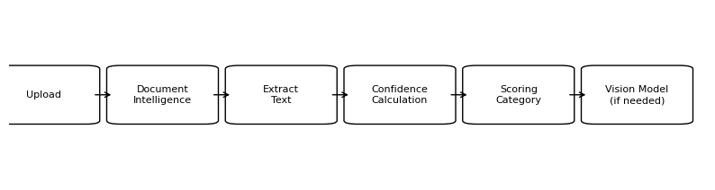

3. Confidence Score Calculation
Document Intelligence OCR Engine: Every extracted word contains metadata including a confidence value between 0 and 1.
Confidence Score | Percentage | Meaning
0.95 | 95% | Very high confidence
0.87 | 87% | Reliable extraction
0.52 | 52% | Moderate confidence
0.18 | 18% | Poor extraction quality

4. Scoring Categories Implemented in DocNav
Category | Condition | Status | Action
Green | Document has no pages with confidence below 80% | No Vision Needed | Document is accepted directly
Yellow | Maximum 3 pages have confidence below 80% | Partial Review Needed | Low confidence pages are reviewed or enhanced
Red | More than 3 pages have confidence below 80% OR confidence falls below 30% | Critical | Document requires Vision Model processing

5. Example Scenario
Suppose a client uploads a 10-page PDF document.
• If all pages have confidence greater than 80%, the document is marked as GREEN.
• If only 2 or 3 pages have confidence lower than 80%, the document is marked as YELLOW.
• If more than 3 pages are below threshold OR confidence becomes critically low (below 30%), the document is marked as RED.
This approach ensures that only problematic pages require additional processing, improving performance and reducing unnecessary Vision Model usage.

6. Vision Model Integration
Some uploaded documents contain:
• Blurry scans
• Handwritten text
• Embedded images
• Low-quality PDFs
• Rotated or distorted content
In such cases, Azure Document Intelligence may produce lower confidence scores.
To improve extraction accuracy, DocNav sends these problematic pages to a Vision Model. The Vision Model performs advanced image understanding and text recognition to recover missing or unclear content.

7. Technical Implementation
The scoring system is implemented as part of the document processing pipeline.
Core Implementation Logic:
1. Extract text from every page.
2. Read confidence values for every word.
3. Calculate page-level confidence.
4. Compare against configured thresholds.
5. Categorize the document.
6. Route low-quality pages to Vision processing.
Advantages of this implementation:
• Faster processing
• Reduced AI cost
• Better accuracy
• Intelligent routing
• Scalable architecture

8. Business Benefits
- Improves document extraction reliability
- Automatically identifies problematic pages
- Reduces manual validation effort
- Optimizes Vision Model usage
- Provides transparent quality metrics
- Supports enterprise-scale document processing

9. Future Enhancements
- Dynamic threshold configuration
- AI-based adaptive scoring
- Confidence heatmaps per page
- User dashboard for document quality analytics
- Auto-reprocessing for failed pages
- Machine learning feedback loop for OCR improvement

10. Conclusion
The DocNav Confidence Scoring System provides an intelligent mechanism for evaluating OCR extraction quality. By combining Azure Document Intelligence confidence scores with a rule-based categorization model, the platform ensures reliable document processing while efficiently utilizing advanced Vision Models only when required.
This architecture improves accuracy, scalability, operational efficiency, and overall document quality assurance within the DocNav ecosystem.

