# Access Token

* Go to <https://developers.google.com/oauthplayground/>
* Select and authorize Drive API v3 (marked in yellow below)

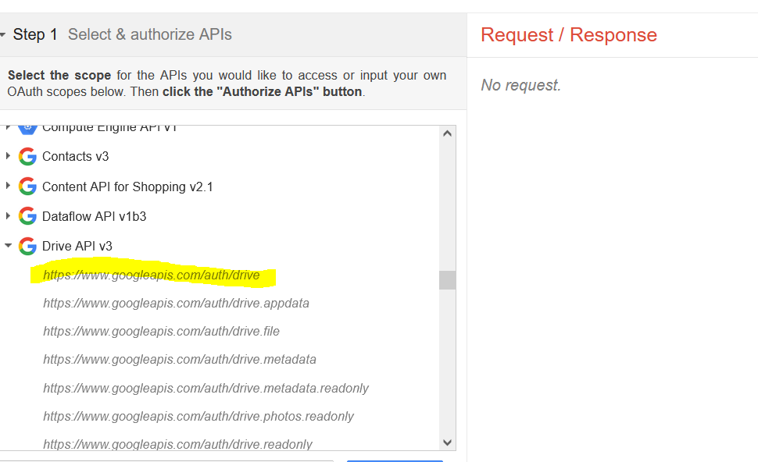

* After authorization, click “Exchange auth code for tokens” and copy the access token for the code. Note: It is valid for a few minutes only

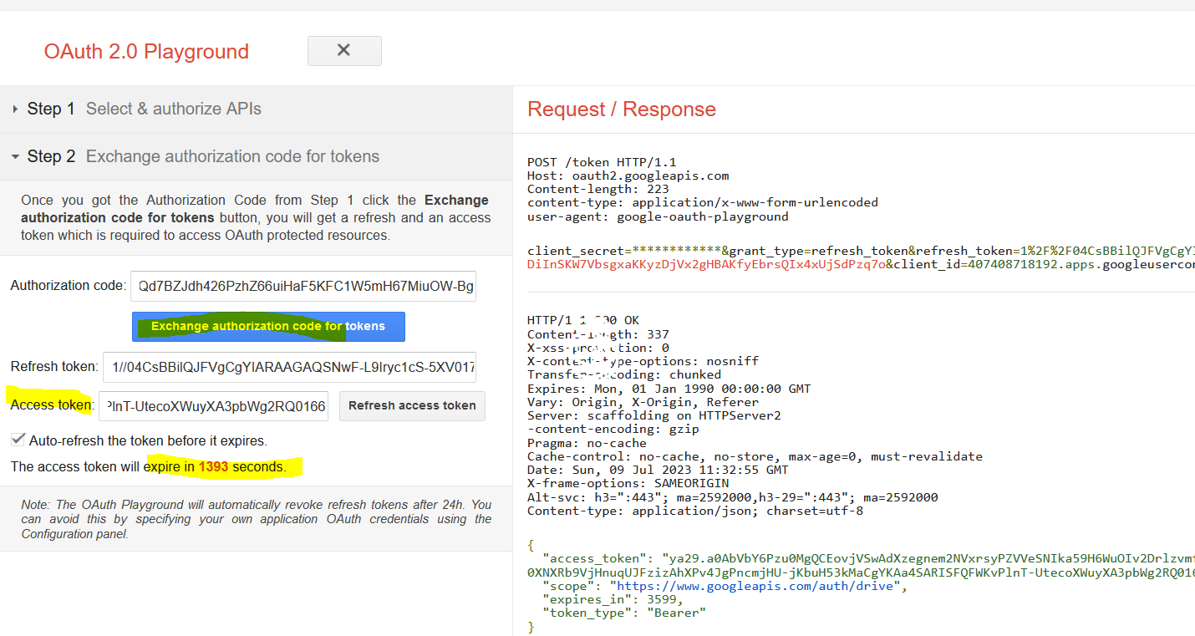

# Folder ID in drive

* Create/ Open a folder to drive
* In the address bar, it looks like “[https://drive.google.com/drive/u/0/folders/](https://drive.google.com/drive/u/0/folders/1NhXZFffz4zaph_palORWhzbW1qDbRohr)<Folder-ID>”
* Copy the Folder-ID put it in the code