Employee Salary Calculation & Payroll Reporting Project

Prepared to demonstrate MS-Excel proficiency.

Prepared by: Rohan Sakariya

Date: September 19th, 2025

Confidential Document – Prepared for Demonstration Purposes

# Executive Summary

This project demonstrates the structured preparation of employee payroll data using MS Excel. It covers data entry, salary calculations, and report generation, ensuring accuracy, transparency, and professional reporting standards. The report highlights my ability to manage organizational data and prepare company-ready outputs aligned with the requirements of a Data Entry Executive role.

# Project Objectives

* Create an organized payroll system using MS-Excel.
* Apply formulas for salary, bonus, and net payment calculation.
* Verify accuracy of employee records.
* Generate a consolidated payroll report for management use.

# Methodology & Process

1. Raw Data Entry

Employee data was entered systematically, including IDs, departments, salary, bonus, and attendance.

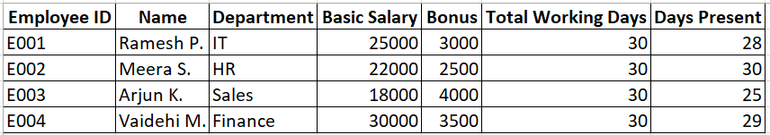

2. Salary Calculations

Excel formulas were applied to calculate per-day salary, salary earned, and net salary with accuracy checks.

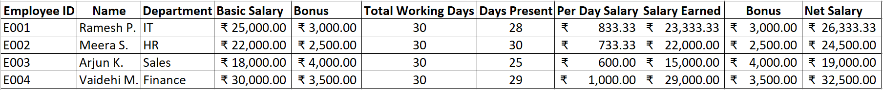

3. Final Report Preparation

A final payroll report was generated, including total salary distribution and payroll contribution percentages.

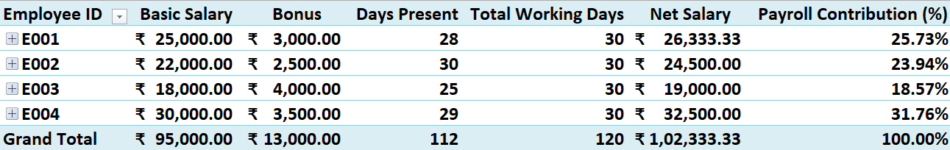

# Key Results

* Net salary for each employee was calculated accurately.
* The consolidated payroll amounted to ₹1,02,333.33.
* Clear payroll contribution percentages: IT = 25.7%, HR = 23.9%, Sales = 18.5%, Finance = 31.7%.

# Benefits & Impact

* Eliminates manual errors in payroll processing.
* Saves time through formula automation.
* Provides transparent reporting for managers.
* The system is scalable and can be applied to larger datasets.

# Conclusion

This project demonstrates my proficiency in MS-Excel and MS-Office reporting, along with the accuracy, attention to detail, and professionalism I would contribute to Axe Consultancy & Security Services LLC in the role of Data Entry Executive.

## Additional Reporting Demonstrations

📊 Final Payroll Summary (All Employees)



🔍 Drill-Down Report (Filtered Employee)

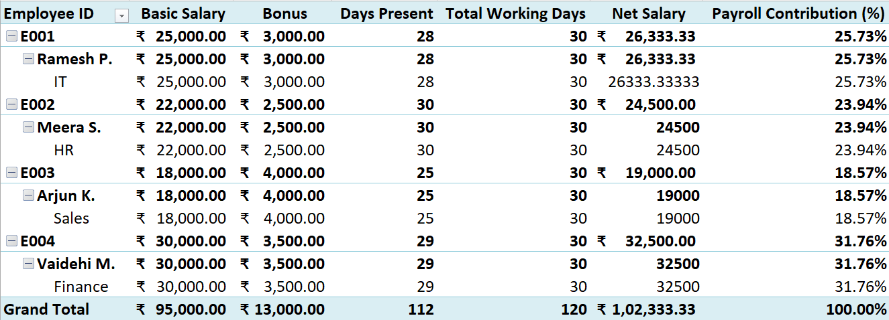

📈 Payroll Distribution Chart

