Learners have to come up with a Report to support the answers to the following questions and suggestions

Objective Questions

- Does any table have missing values or duplicates? If yes how would you handle it ?

Code

with duplicates as
(select *, row_number() over(partition by invoice_id, track_id,unit_price,quantity order by invoice_line_id ) as rn
from invoice_line ),

dups as
(select *, row_number() over(partition by name order by playlist_id ) as rn2
from playlist)

delete from invoice_line where invoice_line_id in (select distinct(invoice_line_id) from duplicates where rn>1);
delete from playlist where playlist_id in (select distinct(playlist_id) from dups where rn2>1);
delete from playlist_track where playlist_id in (select distinct(playlist_id) from dups where rn2>1);

check missing values
select * from customer
where customer_id is null or
first_name is null or last_name is null

we won’t be replacing missing values as that will give us wrong analytical result and in optional field we can just leave them be. NULL allows correct SQL operations.

- Find the top-selling tracks and top artist in the USA and identify their most famous genres.

Code:
with track_sales as
(select i.billing_country, il.track_id, t.name as track_name, il.quantity * il.unit_price as revenue,
g.genre_id, g.name as genre_name, ar.artist_id, ar.name as artist_name
from invoice i join invoice_line il on i.invoice_id = il.invoice_id
join track t on il.track_id = t.track_id
join genre g on t.genre_id = g.genre_id
join album a on t.album_id = a.album_id
join artist ar on a.artist_id = ar.artist_id
where i.billing_country = "USA")

select track_name, sum(revenue) as track_revenue from track_sales group by track_id, track_name order by track_revenue desc limit 1;
select artist_name, sum(revenue) as artist_revenue from track_sales group by artist_id, artist_name order by artist_revenue desc limit 1;
select genre_name, sum(revenue) as genre_revenue from track_sales group by genre_id, genre_name order by genre_revenue desc limit 1;

Output:

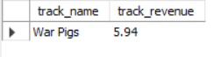
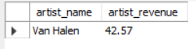
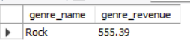

From this we see that Rock genre is sold mostly so tracks of this genre should be put more in stores. Similarly artist Van Halen tracks or albums should be recommended to customers.

- What is the customer demographic breakdown (age, gender, location) of Chinook's customer base?

Code:
select country, count(customer_id) as customer_count
from customer
group by country order by customer_count desc;

Output:

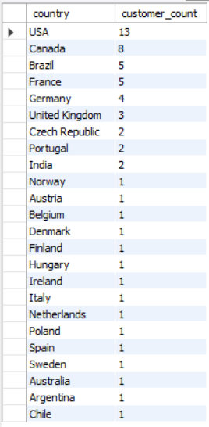

There is no age and gender given for customers nor it can be derived from anywhere.
We see that most countries have only 1 customer which wouldn’t give any analysis, USA, Canada, Brazil, France, Germany are top 5 countries which can provide insights as they have more customers so company should focus financially to these countries.

- Calculate the total revenue and number of invoices for each country, state, and city:

Code:

select billing_country, billing_state, billing_city,
sum(total) as total_revenue, count(invoice_id) as number_of_invoices
from invoice
group by billing_country, billing_state, billing_city
order by billing_country, total_revenue, number_of_invoices;

select billing_country, billing_city,
sum(total) as total_revenue, count(invoice_id) as number_of_invoices
from invoice
group by billing_country, billing_city
order by total_revenue desc, number_of_invoices limit 10;

Output:
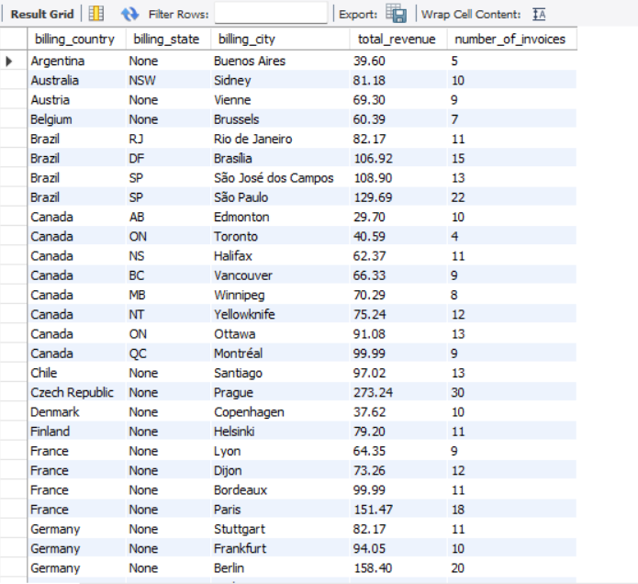
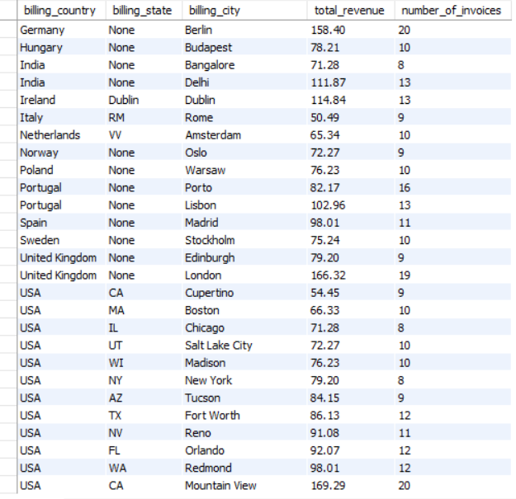

Query 2 output:

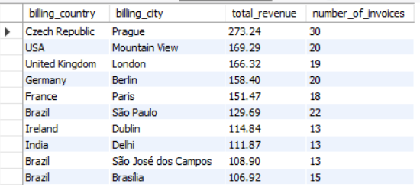

- Visualization: we make these charts using excel

This chart shows top 10 countries with highest revenue.

- This chart shows top 10 cities along with their countries

We didn’t do it for state as there are many fields which are not filled.

- Find the top 5 customers by total revenue in each country

Code:
with top_customers as
(select i.billing_country, c.customer_id, concat(c.first_name," ", c.last_name) as full_name, sum(total) as revenue,
rank() over(partition by i.billing_country order by sum(total) desc) as ranking
from customer c join invoice i
on c.customer_id = i.customer_id
group by i.billing_country, c.customer_id, concat(c.first_name," ", c.last_name))

select *
from top_customers where ranking <= 5;

Output:

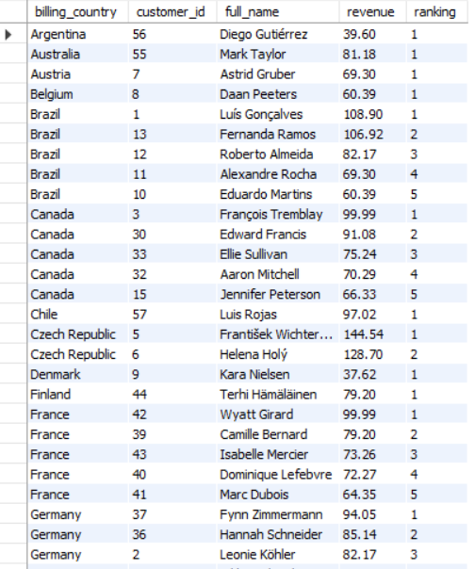

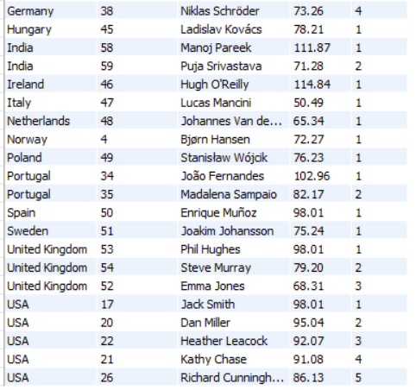

We don’t need customers personal sale data as that will not help in analysis but data as whole like countries, years, genres etc, so while it is not important KPI we can provide these customers some extra discount or offers to keep the retention.
- Identify the top-selling track for each customer

Code:
with track_rev as
(select concat(c.first_name," ",c.last_name) as full_name, t.name as track_name, sum(il.unit_price*il.quantity) as revenue,
rank() over(partition by c.customer_id order by sum(il.unit_price*il.quantity)) as rnk
from customer c join invoice i on c.customer_id = i.customer_id
join invoice_line il on i.invoice_id = il.invoice_id
join track t on il.track_id = t.track_id
group by c.customer_id, concat(c.first_name," ",c.last_name), il.track_id, t.name)

select *
from track_rev where rnk=1;

Output:

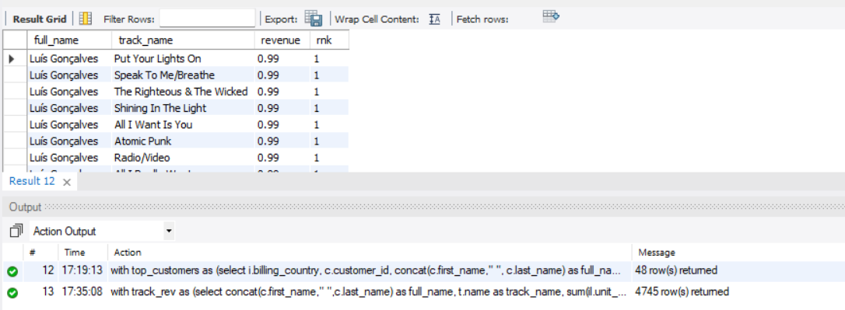

From the output we see 4745 rows with rank 1, which means a customers never bought the same track twice.

- Are there any patterns or trends in customer purchasing behavior (e.g., frequency of purchases, preferred payment methods, average order value)?

Code:

select year(i.invoice_date) as purchase_year, month(i.invoice_date) as purchase_month,
count(distinct i.invoice_id) as sales_count, sum(il.quantity*il.unit_price) as revenue_gen,
count(il.invoice_line_id) as tracks_bought
from invoice i join invoice_line il on i.invoice_id = il.invoice_id
group by year(i.invoice_date), month(i.invoice_date);

Output:

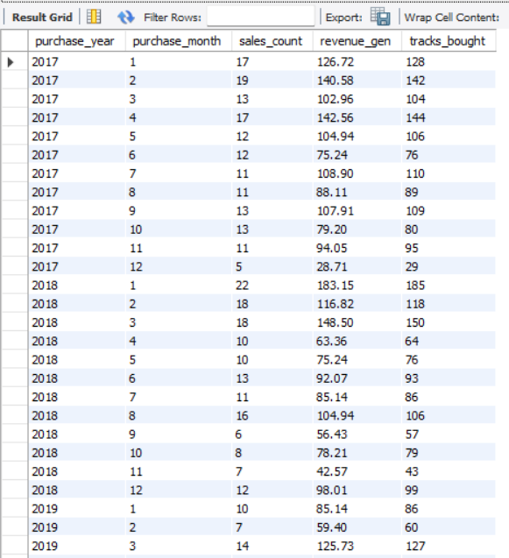
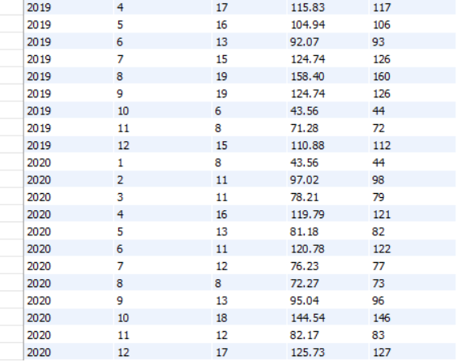

Result:

- From these charts we can see that mid year consistently performs well.
- 2018 show stronger revenue peaks.
- At the end of year we see increase for all years except 2017, which can be for festive reasons and new year too.
- 2020 shows more volatility.

- What is the customer churn rate?

Code:

with purchase_timeline as
(select customer_id, date(invoice_date) as purchase_date,
lead(date(invoice_date)) over(partition by customer_id) as next_purchase_date,
date_add(date(invoice_date), interval 1 year) as churn_threshold,
min(date(invoice_date)) over(partition by customer_id order by invoice_date) as first_date,
max(date(invoice_date)) over() as table_last_purchase
from invoice),

first_churn as
(select customer_id, min(churn_threshold) as first_churn_date
from purchase_timeline
where churn_threshold < coalesce(next_purchase_date,table_last_purchase)
group by customer_id),

first_purchase as
(select customer_id, min(first_date) as first_purchase_date
from purchase_timeline group by customer_id),

years as
(select distinct year(invoice_date) as purchase_year from invoice),

active_customers_yearly as
(SELECT y.purchase_year, COUNT(DISTINCT fp.customer_id) AS active_customers
FROM years y JOIN first_purchase fp
ON fp.first_purchase_date < DATE(CONCAT(y.purchase_year, '-01-01'))
LEFT JOIN first_churn fc ON fp.customer_id = fc.customer_id
WHERE fc.first_churn_date IS NULL OR
fc.first_churn_date >= DATE(CONCAT(y.purchase_year, '-01-01'))
GROUP BY y.purchase_year
ORDER BY y.purchase_year)

select purchase_year as year, round((churned_customers*100/active_customers),2) as churn_rate
from active_customers_yearly acy join
(select year(first_churn_date) as churn_year, count(customer_id) as churned_customers
from first_churn group by year(first_churn_date)) ccy
on acy.purchase_year = ccy.churn_year
order by purchase_year;

Output:

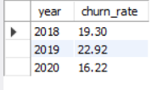

Visualization:

Which shows that there might have been some problems in 2019 which lead to higher churn rate, which they fixed in 2020 and decrease the churn rate

- Calculate the percentage of total sales contributed by each genre in the USA and identify the best-selling genres and artists.

Code:
with genre_sales as
(select distinct(g.name) as genre_name,
sum(il.quantity*il.unit_price) over(partition by g.genre_id) as genre_revenue,
sum(il.quantity*il.unit_price) over(rows between unbounded preceding and unbounded following) as total_revenue
from invoice i join invoice_line il on i.invoice_id = il.invoice_id
join track t on il.track_id= t.track_id
join album al on al.album_id = t.album_id
join artist a on a.artist_id = al.artist_id
right join genre g on t.genre_id = g.genre_id
where i.billing_country ="USA")

select genre_name, round(genre_revenue*100/total_revenue,2) as genre_percent
from genre_sales order by genre_percent desc;

Output:

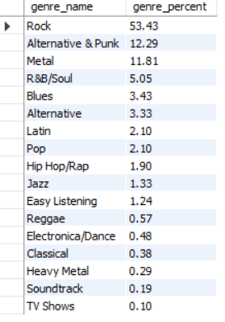

Visualization:

It shows that rock, alternative and punk, metal are most famous in USA.
For best selling artist we already did this for Q2, from there this is the result:

Artist – Van Halen
Genre – Rock
- Find customers who have purchased tracks from at least 3 different genres

Code:
select c.customer_id, concat(c.first_name," ",c.last_name) as full_name
from customer c join invoice i on c.customer_id = i.customer_id
join invoice_line il on i.invoice_id = il.invoice_id
join track t on il.track_id = t.track_id
group by c.customer_id, concat(c.first_name," ",c.last_name)
having count(distinct t.genre_id) >= 3;

Output:

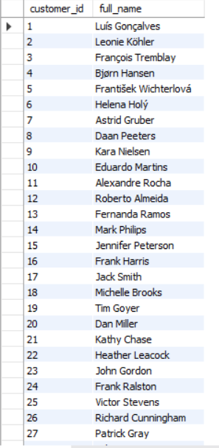
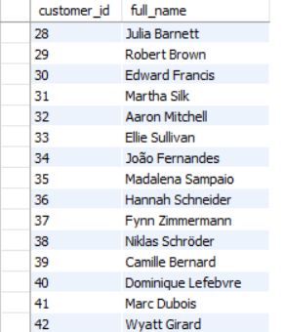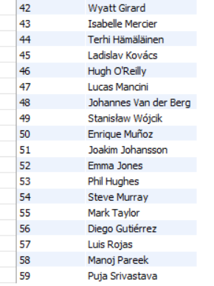

Result: it gives all the customers which means all customer have bought at least 3 different genres. This shows that customers have quite a variable taste for genre, so tracks recommended to them can be of many types.

- Rank genres based on their sales performance in the USA

Code:
this question uses CTE made in Q9, then this query is used:

select genre_name, genre_revenue, rank() over(order by genre_revenue desc) as ranking
from genre_sales;

Output:

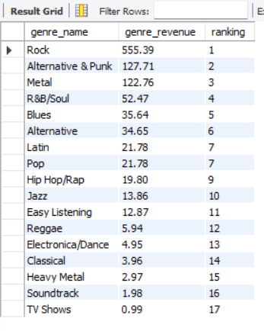

Visualization:

This give same conclusion as Q9 but with actual values, Rock is best selling, metal and Alternative & Punk are in top 3. Other genre’s in double digit are also bought occasionally but genre with single digit are rarely bought according to their revenue.

- Identify customers who have not made a purchase in the last 3 months
Code:
with last_purchase_date as
(select distinct c.customer_id, concat(c.first_name," ", c.last_name) as full_name,
max(i.invoice_date) over(partition by c.customer_id) as latest_date,
max(i.invoice_date) over(rows between unbounded preceding and unbounded following) as last_date
from customer c
join invoice i on c.customer_id = i.customer_id)

select customer_id, full_name
from last_purchase_date
where date_add(latest_date, interval 3 month) < last_date;

Output:

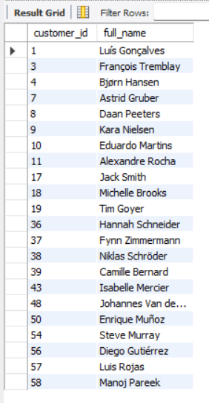

There are total 22 customers who didn’t make any purchase at end of year where sale usually increase.

Subjective Questions

- Recommend the three albums from the new record label that should be prioritised for advertising and promotion in the USA based on genre sales analysis.

Code:

with albums_usa as
(select t.album_id, g.genre_id, g.name as genre_name, t.track_id, il.quantity, il.unit_price
from invoice i join invoice_line il on i.invoice_id = il.invoice_id
join track t on il.track_id = t.track_id
join genre g on t.genre_id = g.genre_id
where i.billing_country="USA"),

genre_sales as
(select genre_id, genre_name, sum(quantity*unit_price) as revenue
from albums_usa
group by genre_id, genre_name order by revenue desc limit 1),

valid_albums as
(select a.album_id, a.title, g.genre_id, g.name as genre_name, count(*) as track_count
from album a join track t on a.album_id = t.album_id
join genre g on t.genre_id = g.genre_id
where a.album_id not in (select distinct album_id from albums_usa) and
g.genre_id in (select genre_id from genre_sales)
group by a.album_id, a.title, g.genre_id, g.name)

select t.album_id, va.title, sum(il.quantity*il.unit_price) as revenue
from track t join invoice_line il on t.track_id = il.track_id
join valid_albums va on t.album_id = va.album_id
group by t.album_id, va.title order by revenue desc limit 3;

Output:

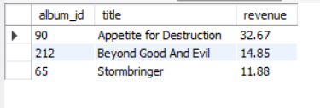

- Approach:
- First we join invoice, invoice line, track, genre and filter with billing country =”USA”, then get all album, genre, track ids, quantity, unit price, This is cte of albums_usa.
- Then using this cte we group by genre id, name and find revenue per genre. So it will give per genre sales in USA.
- Then we make new cte in which we join album, track, genre and filter it with albums which didn’t sold in USA, genres which sold in USA.
- Then group by this with album, genre and find out count of tracks. So this cte gives how many genre are present in each album.
- Now finally we join tables track, invoice line, and this new cte.
- Then group by album id, title and get revenue per album and get top 3 according to revenue.

Result:

Insights:

- These albums belong to high-performing genres in the USA market (Rock)
- Customer purchase behaviour shows clear genre loyalty, meaning promotion efforts in these genres are more likely to convert.
- Investing in low-performing albums would dilute marketing ROI, while focusing on these top performers maximizes impact.

Recommendations:

- Recommend the other two albums to customers who purchase Appetite for Destruction and vice-versa.
- This leverages existing customer interest to boost secondary album sales.
- Use these albums as flagship albums.
- Promote these albums through Rock playlists.

- Determine the top-selling genres in countries other than the USA and identify any commonalities or differences.

Code:

with country_genre as
(select i.billing_country as country, g.genre_id, g.name as genre_name, sum(il.quantity*il.unit_price) as revenue,
rank() over(partition by i.billing_country order by sum(il.quantity*il.unit_price) desc) as ranking
from invoice i join invoice_line il on i.invoice_id = il.invoice_id
join track t on il.track_id = t.track_id
join genre g on t.genre_id = g.genre_id
where i.billing_country!="USA"
group by i.billing_country, g.genre_id, g.name)

select *
from country_genre
where ranking = 1;

Output:

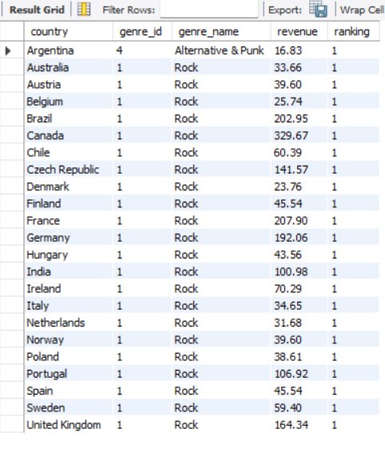

- Approach:
- We first join invoice, invoice line, track, genre. Then filter where country in not USA.
- Group by country, genre then select country, genre, revenue and rank genre per country based on revenue.
- Then use this as cte and select where ranking = 1.

Result:

Insights:
- From here we see that Argentina has Alternative & Punk as top selling genre.
- While all countries have same Rock genre as top genre.
- Rock dominates both emerging and developed markets.
- Customers show similar genre loyalty.

Recommendations:

- Rock should be the primary target for inventory and physical distribution across countries.
- Tailor bundles, promotions to local preferences.
- High revenue markets are ideal for exclusive physical editions.

- Customer Purchasing Behavior Analysis: How do the purchasing habits (frequency, basket size, spending amount) of long-term customers differ from those of new customers? What insights can these patterns provide about customer loyalty and retention strategies?

Code:

with cust_purchase_behav as
(select i.customer_id, i.invoice_date, i.invoice_id, count(il.invoice_line_id) as total_track, i.total as spending,
min(i.invoice_date) over(partition by i.customer_id) as first_purchase
from invoice i join invoice_line il
on i.invoice_id = il.invoice_id
group by i.customer_id, i.invoice_date, i.invoice_id
order by customer_id),

cust_type as
(select customer_id, date(invoice_date) as inv_date, total_track, spending,
case
when invoice_date < date_add(first_purchase, interval 12 month) then "new"
else "old" end as classify
from cust_purchase_behav)

select customer_id, classify, count(*)/(timestampdiff(month, min(inv_date), max(inv_date)) +1) as frequency,
round(avg(total_track),2) as avg_basket_size, round(avg(spending),2) as avg_amount
from cust_type
group by customer_id, classify;

Output:

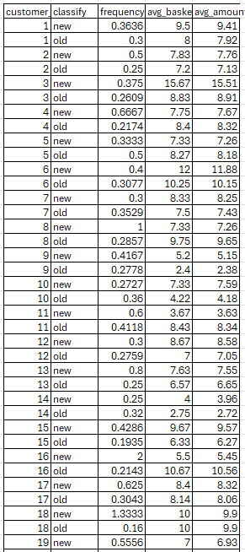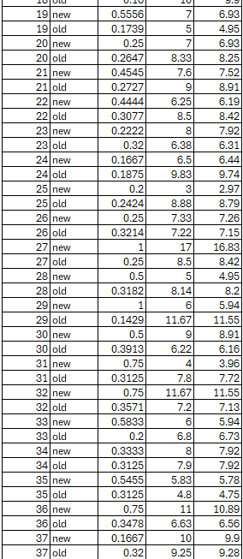

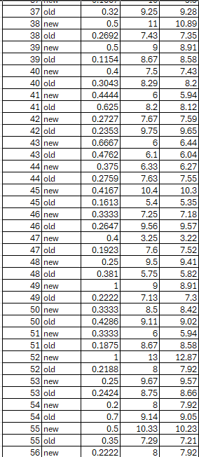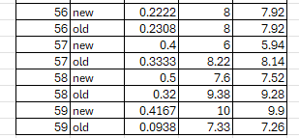

Approach:
- First we join invoice, invoice line.
- Then group by customer id, invoice date, invoice id
- Then select total tracks bought for that invoice id, total spend, first purchase date for that customer. This will be made a CTE.
- Now we will just add column when we add 12 months to first purchase date and invoice date less than that will be considered new else old.
- This means a time period when those customers were new and when they were old.
- Then finally we use:
select customer_id, classify, count(*)/(timestampdiff(month, min(inv_date), max(inv_date)) +1) as frequency,
round(avg(total_track),2) as avg_basket_size, round(avg(spending),2) as avg_amount
from cust_type
group by customer_id, classify;

Result:

Insights:

- New customers exhibit higher purchase frequency and slightly larger basket sizes during their first year, indicating strong initial engagement.
- Over time, customers transition into more stable but less frequent purchasing behavior, with slightly reduced spending per transaction.
- Old customers have low engagement, are habit driven, selective
- This suggests that retention strategies should focus on sustaining early engagement momentum through loyalty programs and personalized offers.

Recommendations:

- So for customers in their 1st year company should make sales, events annually to increase the engagement of customers which will increase the chances of retention.
- For old customers to increase their frequency we should give them recommendations according to their personal taste or sale on tracks of their top artists.

- Product Affinity Analysis: Which music genres, artists, or albums are frequently purchased together by customers? How can this information guide product recommendations and cross-selling initiatives?

Code:

with invoice_details as
(select i.invoice_id, i.customer_id, il.invoice_line_id, t.track_id, a.album_id, a.title, ar.artist_id,
ar.name as artist_name, g.genre_id, g.name as genre_name
from invoice i join invoice_line il on i.invoice_id = il.invoice_id
join track t on t.track_id = il.track_id
join album a on t.album_id = a.album_id
join artist ar on a.artist_id = ar.artist_id
join genre g on t.genre_id = g.genre_id),

-- Genre Pairs
diff_genre as
(select distinct id1.invoice_id, id1.genre_id, id1.genre_name,
id2.genre_id as genre_id2, id2.genre_name as genre_name2
from invoice_details id1 join invoice_details id2
on id1.invoice_id = id2.invoice_id
and id1.genre_id < id2.genre_id),

-- Album pairs
diff_album as
(select distinct id1.invoice_id, id1.album_id, id1.title,
id2.album_id as album_id2, id2.title as title2
from invoice_details id1 join invoice_details id2
on id1.invoice_id = id2.invoice_id
and id1.album_id < id2.album_id),

-- Artist pairs
diff_artist as
(select distinct id1.invoice_id, id1.artist_id, id1.artist_name,
id2.artist_id as artist_id2, id2.artist_name as artist_name2
from invoice_details id1 join invoice_details id2
on id1.invoice_id = id2.invoice_id
and id1.artist_id < id2.artist_id)

select genre_name, genre_name2, count(distinct invoice_id) as pairs_count
from diff_genre group by genre_id, genre_id2, genre_name, genre_name2
order by pairs_count desc limit 5;

select title, title2, count(distinct invoice_id) as pairs_count
from diff_album group by album_id, album_id2, title, title2
order by pairs_count desc limit 5;

select artist_name, artist_name2, count(distinct invoice_id) as pairs_count
from diff_artist group by artist_id, artist_id2, artist_name, artist_name2
order by pairs_count desc limit 5;
Output:

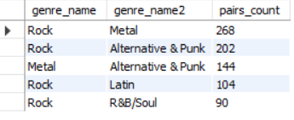

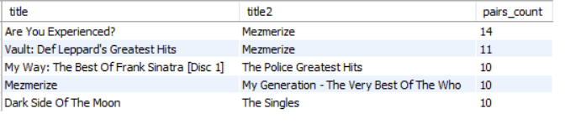

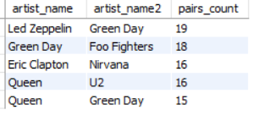

- Approach:
- First we join invoice, invoice line, track, album, artist, genre.
- We get customer id, invoice id, invoice line, album, artist, genre id. Then we make this a CTE.
- Then we use this cte to do self join on invoice id and genre id< other genre id.
- This will give us all the pairs bought without duplication.
- We will do this for artist and album too.
- Then with genre cte we group them by genre id1 and id2 and find the number of pairs and get top 5 pairs. We do the same for album, artist.

Result:

Insights:
- From album: pairs we see that Mesmerize is in majority of pairs, so it should be recommended when buying albums or tracks of this album.
- For genres: Rock, metal, alternative & punk are pairing with others mostly so they should be recommended as a pack or group with offers or as a bundle in sale.
- For artist: green day and queen are bought with others.

Recommendations:

- For any customer if they are buying either of pair they should be recommended the other pairs.
- Tracks of same album, artist should be in bundle for reduced prices.

- Regional Market Analysis: Do customer purchasing behaviors and churn rates vary across different geographic regions or store locations? How might these correlate with local demographic or economic factors?

Code:

with cust_purchase_behav as
(select i.customer_id, i.invoice_date, i.invoice_id, i.billing_country,
count(il.invoice_line_id) as total_track, i.total as spending
from invoice i join invoice_line il
on i.invoice_id = il.invoice_id
group by i.customer_id, i.invoice_date, i.invoice_id, i.billing_country
order by customer_id),

cust_habits as
(select customer_id, billing_country, count(*)/(timestampdiff(month, min(invoice_date), max(invoice_date)) +1) as frequency,
round(avg(total_track),2) as avg_basket_size, round(avg(spending),2) as avg_amount
from cust_purchase_behav
group by customer_id, billing_country)

select billing_country, count(customer_id) as total_customers, round(avg(frequency),3) as country_freq,
round(avg(avg_basket_size),2) as country_basket, round(avg(avg_amount),2) as country_spent
from cust_habits
group by billing_country;

-- churn

with purchase_timeline as
(select customer_id, billing_country, date(invoice_date) as purchase_date,
lead(date(invoice_date)) over(partition by customer_id) as next_purchase_date,
date_add(date(invoice_date), interval 1 year) as churn_threshold,
min(date(invoice_date)) over(partition by customer_id order by invoice_date) as first_date,
max(date(invoice_date)) over() as table_last_purchase
from invoice),

first_churn as
(select customer_id, billing_country, min(churn_threshold) as first_churn_date
from purchase_timeline
where churn_threshold < coalesce(next_purchase_date,table_last_purchase)
group by customer_id, billing_country),

first_purchase as
(select customer_id, billing_country, min(first_date) as first_purchase_date
from purchase_timeline group by customer_id, billing_country),

years as
(select distinct year(invoice_date) as purchase_year from invoice),

active_cust as
(select y.purchase_year, fp.billing_country, count(distinct fp.customer_id) as active_customer
from years y join first_purchase fp
on fp.first_purchase_date< date(concat(y.purchase_year, '-01-01'))
left join first_churn fc on fp.customer_id = fc.customer_id and
fp.billing_country = fc.billing_country
where fc.first_churn_date is null or
fc.first_churn_date >= date(CONCAT(y.purchase_year, '-01-01'))
group by y.purchase_year, fp.billing_country
),

churn_cust_year as
(select year(first_churn_date) as churn_year, billing_country, count( distinct customer_id) as churned_customers
from first_churn
group by year(first_churn_date), billing_country)

select acy.purchase_year as year, acy.billing_country,
round((coalesce(ccy.churned_customers,0)*100/acy.active_customer),2) as churn_rate
from active_cust acy left join
churn_cust_year ccy on acy.purchase_year = ccy.churn_year and
acy.billing_country = ccy.billing_country
order by year, billing_country;

Output:

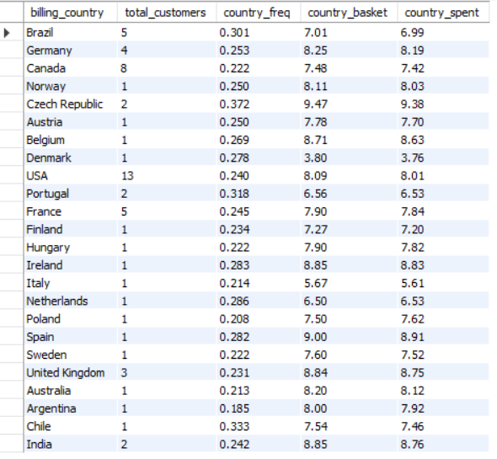

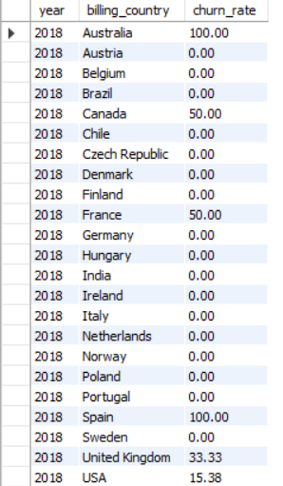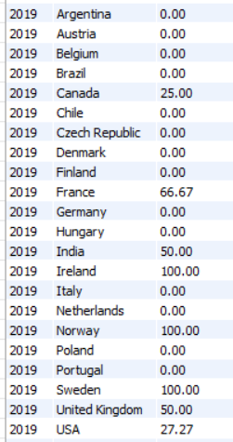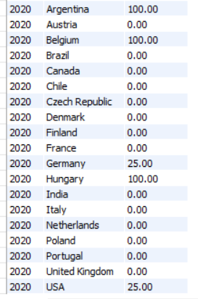

- Approach:
- First we find frequency, basket size, spending per country.
- We will make cte of where customer invoice billing comes from.
- Then using that we group them by customer, country and get frequency, average basket size, spending per group.
- Then use that as cte and group by country we find total customers, frequency basket size, spending per country.
- Churn: then we find churn rate per country per year too.
- First we find first churn date per customer per country and their first purchase per country.
- Then we use previously used logic of finding active customers but now for every year per country.
- And also find churned customers per year per country.
- Next we join both of cte and find churn rate per year per country.

Result:
- Frequency, basket size, spending:

Insights:
- Due to the small number of customers per country, churn rates in smaller regions are highly sensitive and should be interpreted directionally rather than absolutely.
- As we see in churn rates chart that there are some countries which have 100% churn rate, it is because there are many countries which have only 1 customer, which is why it didn’t give result from which we can learn.
- From customer behaviour chart we see frequency is around 0.25 for all countries, for countries that have some customers we see their basket size and spending is about 8. Which shows constant behaviour in them.

Recommendations:

- For the countries with 1 or 2 customers aggregate them into regional clusters for mor stable analysis.
- Launch loyalty programs, discounts, or bundles in high-volume markets where churn metrics are statistically meaningful.
- Use a global baseline pricing and product mix, adjusting only where strong local signals exist.

- Customer Risk Profiling: Based on customer profiles (age, gender, location, purchase history), which customer segments are more likely to churn or pose a higher risk of reduced spending? What factors contribute to this risk?

Code:

with cust_purchase_behav as
(select i.customer_id, i.invoice_date, i.invoice_id, count(il.invoice_line_id) as total_track, i.total as spending,
min(i.invoice_date) over(partition by i.customer_id) as first_purchase
from invoice i join invoice_line il
on i.invoice_id = il.invoice_id
group by i.customer_id, i.invoice_date, i.invoice_id
order by customer_id),

behavior as
(select customer_id, count(*)/(timestampdiff(month, min(invoice_date), max(invoice_date)) +1) as frequency,
round(avg(total_track),2) as avg_basket_size, round(avg(spending),2) as avg_amount
from cust_purchase_behav
group by customer_id),

thresholds as
(select avg(frequency) as avg_freq, avg(avg_amount) as avg_spend
from behavior),

segmented_customers as (
select b.customer_id, b.frequency, t.avg_spend,
case when b.frequency >= t.avg_freq then 'High Frequency'else 'Low Frequency'
end as freq_segment,
case when b.avg_amount >= t.avg_spend then 'High Value' else 'Low Value'
end as value_segment
from behavior b cross join thresholds t
),

purchase_timeline as
(select customer_id, billing_country, date(invoice_date) as purchase_date,
lead(date(invoice_date)) over(partition by customer_id) as next_purchase_date,
date_add(date(invoice_date), interval 1 year) as churn_threshold,
min(date(invoice_date)) over(partition by customer_id order by invoice_date) as first_date,
max(date(invoice_date)) over() as table_last_purchase
from invoice),

first_churn as
(select customer_id, billing_country, min(churn_threshold) as first_churn_date
from purchase_timeline
where churn_threshold < coalesce(next_purchase_date,table_last_purchase)
group by customer_id, billing_country),

churn_flag as
(select customer_id, 1 as churned from first_churn),

churn_table as
(select sc.customer_id, sc.freq_segment, sc.value_segment,
coalesce(cf.churned,0) as churned
from segmented_customers sc left join churn_flag cf
on sc.customer_id = cf.customer_id)

select freq_segment, value_segment, count(*) as total_customers, sum(churned) as churned_customers
from churn_table
group by freq_segment, value_segment;

Output:

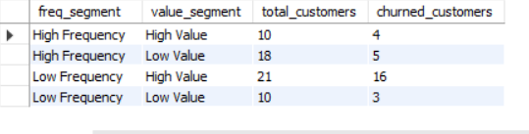

- Approach:
- For this the segments we will take are:
  - New vs old customers
  - Country wise segment
  - Frequency and spending segment
- For 1 and 2 segments we have already found their customer behaviour and churn rates per country.
- We will do the segment for frequency and spending.
- For first cte we join invoice, invoice line then group by customer, invoice id, invoice date.
- Then we get how many tracks customer bought per invoice, spending per invoice, first purchase date per customer.
- Then using this cte we find frequency, avg basket size, avg spending per customer.
- Then we make threshold using this cte which is average of frequency and spending.
- Then we categorize customer on high and low frequency and spending if their frequency, spending is less than or greater than threshold.
- Then we have cte which has customer id, billing country, purchase date, next purchase date using lead, churn threshold of 1 year, first purchase date per customer, table last date.
- Then we will use this cte to find customer who have churned and their churned date.
- Then we will assign 1 to any customer who has churned and 0 for who does not.
- Finally, we group by freq, spending segment and found total customers and churned customers for the group.

Result:

Insights:
- New and old segment: customers of new segment have higher chance of churn if there are no promotions or incentives to make them into stable customers.
- Country segment: country which has 1 or 2 customers have higher chance of churning.
- Frequency and value segment: from this we see customers of low frequency are at high risk of churning.
- Targeting strategies focused on increasing customer frequency may yield better retention results.

Recommendations:

- Introduce re-engagement campaigns (email reminders, personalized offers) targeting customers with declining frequency for low frequency – high value customers
- Implement loyalty programs, early access to new albums, or reward points to reinforce repeat purchasing behavior to high frequency customers.
- Set up early churn flags based on purchase gaps and intervene before complete disengagement occurs.

- Customer Lifetime Value Modeling: How can you leverage customer data (tenure, purchase history, engagement) to predict the lifetime value of different customer segments? This could inform targeted marketing and loyalty program strategies. Can you observe any common characteristics or purchase patterns among customers who have stopped purchasing?

Code: we will add these more CTEs after the previous Q6 ctes and use them for this question

customer_clv as
(select customer_id, min(invoice_date) as first_purchase, max(invoice_date) as last_purchase,
(timestampdiff(month, min(invoice_date), max(invoice_date)) +1) as tenure,
count(*)/(timestampdiff(month, min(invoice_date), max(invoice_date)) +1) as frequency,
round(avg(total_track),2) as avg_basket_size, round(avg(spending),2) as avg_amount, sum(spending) as clv
from cust_purchase_behav
group by customer_id),

segment_clv as
(select cv.customer_id, cv.tenure, cv.frequency, cv.avg_basket_size, cv.avg_amount,
ct.freq_segment, ct.value_segment, ct.churned, cv.clv
from customer_clv cv join churn_table ct
on cv.customer_id = ct.customer_id)

select churned, case when churned=1 then "churn" else "active" end as churn_segment, avg(clv) as avg_clv
from segment_clv group by churned;

select freq_segment, avg(clv) as avg_clv
from segment_clv group by freq_segment;

Output:

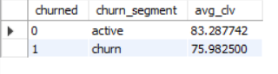

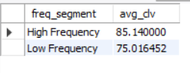

- Approach:
- First we will find customer, its first and last purchase date, tenure, frequency, avg basket size, avg spending, total spending as clv.
- Then from before we join tables where we found segments with it, segments are freq_segment, value_segment, churned.
- Then we group by churned once to find average clv for churned and active segment.
- We do the same for freq segment.

Result:

Insights:

- Instead of predicting individual customer lifetime value, we analyzed average realized CLV across customer segments.
- Results indicate that high-frequency exhibit significantly higher CLV.
- While churned customers generate lower lifetime revenue, reinforcing the importance of engagement-driven retention strategies.

Recommendations:

- For low frequency customers trigger automated campaigns when purchase gaps exceed a threshold (e.g., 60–90 days).
- Use personalized recommendations to encourage repeat purchases.
- Allocate retention budgets toward:
  - High-value, low-frequency customers
  - Recently inactive customers with strong historical spend

- If data on promotional campaigns (discounts, events, email marketing) is available, how could you measure their impact on customer acquisition, retention, and overall sales?

- Approach:
- If the following details are available, then for events:
  - We will see during the time of event if there are any new customer.
  - Frequency of customers during event, average spending.
  - Since it is an event which likely have discount price then average spending might remain same but frequency and basket size should increase.
  - We will check if any customer who have churned before this have returned again or not, and what is the returning rate.
  - We will check post event churn rate to see if doing events prevent customer from churning.
  - We will see if low frequency customers have increase in frequency during and after the event or sale.
  - We will see if customers acquired during different events churn or not, their customer behaviour, check which event bring more customers and have low churn rate, then we can arrange these events seasonally.

- How would you approach this problem, if the objective and subjective questions weren't given?

- Approach:
- First, I would have total revenue per genre, album, artist.
- Next, I would find countries revenue, their top genres.
- Which countries have more customers.
- Which country customers purchase more from.
- In which month/year do sales increase or decrease as a potential for any sales, events etc.
- Customers average spending, basket size, frequency of visits.
- Customers churn rates according to countries, date, frequency etc.
- We can also find which tracks that are part of playlist, so it means if any playlist’s tracks are selling more then we can recommend other tracks of that playlist as playlist are made by users only.
- We will also find which media type is selling more, so that we can format tracks in that type for physical stores.

Code for this:
select mt.media_type_id, mt.name as media_name, sum(il.quantity*il.unit_price) as revenue
from invoice_line il join track t on il.track_id = t.track_id
join media_type mt on t.media_type_id = mt.media_type_id
group by mt.media_type_id, mt.name
order by revenue desc;
Output:

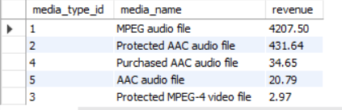

Visualization:

- This shows that people mostly buy MPEG audio file, so company should sell their physical copies in this format or protected AAC audio file.
- With the help of all these table we can do accurate analysis for the company physical store.

- How can you alter the "Albums" table to add a new column named "ReleaseYear" of type INTEGER to store the release year of each album?

Code:
alter table album
add ReleaseYear int;

we use this query to add this new column, for now column is null.

- Chinook is interested in understanding the purchasing behavior of customers based on their geographical location. They want to know the average total amount spent by customers from each country, along with the number of customers and the average number of tracks purchased per customer. Write an SQL query to provide this information.

Code:

with cust_country_behav as
(select c.country, i.customer_id, sum(il.unit_price*il.quantity) as total_spent,
count(il.track_id) as tracks_purchased
from customer c join invoice i on c.customer_id = i.customer_id
join invoice_line il on i.invoice_id = il.invoice_id
group by c.country, i.customer_id)

select country, count(customer_id) as customer_count, round(avg(total_spent),2) as cust_avg_amount,
round(avg(tracks_purchased),2) as cust_avg_basket
from cust_country_behav
group by country;

Output:

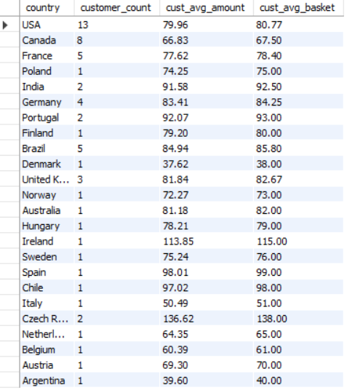

- Approach:
- We will join customer, invoice, invoice line.
- Then group by customer country, customer.
- We will select how much each customer from their country has spent and how many tracks they bought.
- Then using that as CTE we will group by country.
- This will give for every country: count of customers, average amount spent by customers, average number of tracks purchased per customer.

Result:

Insights:
- We see that USA, Canada, France, Brazil have most number of customers so investing in them seems good choice.
- We also see their basket size and amount spent are around 70 – 80, which shows that they have high customer count and avg amount spent. So they should focus on retention and upselling.
- Countries which have low customers and low values too like Denmark, Argentina, Italy etc have high chance of churn, so we should give price sensitive promotions, offers.
- Countries such as Ireland, Czech republic have highest revenue despite low number of customers which shows their willingness to spend quite high. They are prime targets of premium pricing.
Recommendations:
- Introduce upselling and cross-selling strategies (e.g., album bundles, artist collections) to increase average basket size.
- Maintain consistent availability of top-selling genres in these regions, as they drive volume-led revenue.
- Use price-sensitive promotions (discounts, bundle offers, seasonal sales) to stimulate demand.
- Test localized campaigns to understand genre preferences before scaling investment.
- Keep marketing spend limited and experimental until customer adoption improves.
- Allocate higher marketing budgets to regions with strong customer bases and stable spending behavior.

