

**ReComm**

**Phase II System**

**Requirements**

RL-SR001-02

##### Revision 2.0

Table of Contents

1. SCOPE 3

2. PURPOSE 3

3. DEFINITIONS 3

4. REFERENCED DOCUMENTS 4

5. FORMAT AND CONVENTIONS 4

6. ReComm HIGH LEVEL PHASE II REQUIREMENTS 4

6.1. System Access 4

6.2. Registration 5

6.2.1. Customer Registration 5

6.2.2. Employee Registration 5

6.2.3. Administrator Registration 5

6.3. Customer Profiles 5

6.4. Item Selection 5

6.4.1. Wish List 5

6.4.2. Shopping Cart 6

6.4.3. Checkout 6

6.5. Administration 6

6.5.1. Inventory 6

6.5.2. User Records 6

6.5.3. Database Interface 6

6.6. Employee Functions 6

6.6.1. Report Generation 6

6.6.2. Inventory Maintenance 7

6.6.3. Customer Purchase Assistance 7

6.7. Security 7

6.7.1. Phase II Security 7

7. SYSTEM REQUIREMENTS 7

7.1. Use Cases 7

7.1.1. Inventory Management Use Case Diagram 8

7.1.2. User Registration 10

7.1.3. User Login 11

7.1.4. Update Inventory Item Record 12

7.1.5. Inventory Display 13

**Table of Figures**

Figure 6.2: Inventory Management Use Cases 9

# SCOPE

This document contains the Phase II requirements for the ReComm project. This document includes an overview of the application requirements as well as the detailed requirements necessary for the design and implementation of Phase II of the project.

# PURPOSE

The purpose of Phase II is to continue the development of ReComm beyond that of Phase I defined in *ReComm Requirements RL-SR001*. The major focus of this phase is to move the project into a Java 2 Enterprise Edition application. Most of the work for this phase will involve the User Interface (UI)

The requirements herein were developed from the ReComm Charter and various Random Logic client eCommerce system requirements.

# DEFINITIONS

| Abbreviation | Definition |
| --- | --- |
| AJAX or Ajax | AJAX stands for Asynchronous JavaScript and XML.AJAX is a technique for creating better, faster, and more interactive web applications with the help of XML, HTML, CSS, and Java Script. Ajax uses XHTML for content, CSS for presentation, along with Document Object Model and JavaScript for dynamic content display. |
| API | Application Programming Interface. A set of commands or interfaces that can be used by external systems to interface with a system. |
| CRUD | Create, Read, Update, Delete. An abbreviation for an interface or set of interfaces that provide this functionality. Note that in this system Deletions never happen, but instead records are marked as “Deleted”. |
| HTML5 | HyperText Markup Language version 5. A simple scripting language used to create modern interactive web pages that can be read by a web browser so that it can display the web page to the user. |
| JavaScript | JavaScript is most commonly used as a client-side scripting language. This means that JavaScript code is written into an HTML page. When a user requests an HTML page with JavaScript in it, the script is sent to the browser and it's up to the browser to do something with it. |
| jQuery | jQuery simplifies HTML document traversing, event handling, animating, and Ajax interactions for rapid web development. jQuery is a JavaScript toolkit designed to simplify various tasks by writing less code. |
| JSF | Java Server Faces. Java Server Faces (JSF) is a Java-based web application framework intended to simplify development integration of web-based user interfaces. Java Server Faces is a standardized display technology, which was formalized in a specification through the Java Community Process. |
| JSP | JavaServer Pages (JSP) is a technology that helps software developers create dynamically generated web pages based on HTML, XML, or other document types. Released in 1999 by Sun Microsystems, JSP is similar to PHP and ASP, but it uses the Java programming language. |
| PCI or PCI DSS | The Payment Card Industry (**PCI**) Data Security Standard (**PCI DSS**) is a set of security standards designed to ensure that all companies that accept, process, store or transmit credit card information maintain a secure environment. |
| UID | User IDentification. The user name that is used when someone logs in to the system. |

# REFERENCED DOCUMENTS

ReComm Requirements, v. 1.0 RL-SR001 Phase I ReComm Requirements

RL Security AI Requirements, v. 1.0 RL-SR002 Rand Logic Security AI Requirements

# FORMAT AND CONVENTIONS

The format of the requirements in this document are such that system test results and procedures can directly reference every individual requirement. As such all requirements are presented in numbered lists with use cases for direct reference by the engineering and test teams.

Referenced documents are shown in *Italic*.

Mandatory requirements are indicated by the words **shall** or **will**.

Recommended requirements are indicated by the word **should**.

Optional requirements are indicated by the word **may**.

# ReComm HIGH LEVEL PHASE II REQUIREMENTS

This section contains the High Level Requirements for Phase II of the project. For complete ReComm High Level Requirements, Refer to *ReComm Requirements, Section 6*.

The focus of this phase shall be to add customer registration and login, convert the application into a J2EE application, and add simple customer security to the system. All user interfaces for the application shall be converted from a Java desktop application using a Spring based UI to a web-based interface. The web interfaces may include HTML5, JavaScript, JSP, JSF, and AJAX.

## System Access

All users of the system require some level of system access. Guest customers (see the Registration section) have default access allowing the use of the storefront to browse and purchase items. A system user name (UID) and secure password shall be selected by the user along with at least three security questions. Registered customers shall have more functions available to them for an enhanced shopping experience. Employees shall have access to interfaces suitable to their roles in the store. Administrators shall have access to reporting interfaces, APIs, financial data, database and system maintenance functions, etc. supporting their specific roles.

## Registration

### Customer Registration

Customers may register with ReComm, but are not required to. One-time purchases may be performed as a “Guest” without the system storing any sensitive information about the purchase. Registered customers may store their billing information, name and address, and a customized “user experience” profile in the system.

The registration process shall capture the customer’s full name, address, and contact information, including a valid e-mail address. At the customer’s choice, it may also securely store billing information including credit card information.

### Employee Registration

Employees shall be registered by an Administrator with appropriate access rights. Employees shall not be required to provide contact information or an address as employee records outside of system access are beyond the scope of the ReComm system.

### Administrator Registration

Administrators shall be registered by the System Administrator or an Administrator with user management access rights. The system shall have only one user with the System Administrator role (and access to all systems and interfaces). The System Administrator is the user that initially installs ReComm. Administrators shall be required to provide contact information only.

## Customer Profiles

Registered customers shall be able to modify their profile information at any time. E-mail address shall require verification and is used for password resets and UID reminders. The profile shall also contain saved Wish Lists, saved searches, and customized user experience settings.

## Item Selection

The system shall provide a searchable list of items for purchase. The search mechanism shall allow custom searches by item category, brand, price, type, color, size, date, description, as well as custom searches. In stock, out of stock, and expired items may also be selected or filtered out.

When items are displayed, they may be sorted by name, brand, price, category, color, and size. Displayed items shall be summarized with a clickable link to view the details of the item. In addition, a link to purchase a selected quantity of the item will be present. Registered customers will have a link to add the item to their Wish List.

### Wish List

Registered customers will have a Wish List of items that they wish to purchase in the future. Items may be added to the Wish List while browsing by clicking the “Add to Wishlist” link provided. Items may be removed from the Wish List when viewing the Wishlist page. The Wish List may be accessed at any time after the customer logs into the system by clicking a link provided in the header of every page.

### Shopping Cart

The Shopping Cart (Cart) page may be accessed by any customer, registered or not, through a link provided in the header of each page. Items that are added to the Cart while browsing shall be listed on this page with the quantity, unit price, and total for each. Quantities may be updated and items removed from the Cart if needed. A link on the Cart page shall take the customer to the Checkout page for completing a purchase.

### Checkout

The Checkout page shall be determined by the payment processor selected and is outside the scope of this document. The Checkout link provided shall provide a mechanism to access the payment processor and send the processor the appropriate purchase information.

## Administration

Administration of the system shall be performed by users with the Administrator role and applicable access. Administration shall comprise maintaining inventory records, updating user records, and managing common database issues.

### Inventory

A web interface supporting CRUD operations for Inventory maintenance shall be provided. This interface shall only be accessible to Administrators with the appropriate access level. The interface may include REST APIs.

### User Records

A web interface supporting CRUD operations for user maintenance shall be provided. This interface shall only be accessible to Administrators with the appropriate access level. The interface may include REST APIs.

### Database Interface

A web interface supporting limited database maintenance and monitoring operations for the databases shall be provided. This interface shall only be accessible to Administrators with the appropriate access level. The interface may include REST APIs.

## Employee Functions

### Report Generation

All authorized Employees shall have the ability to generate reports pertinent to their system access. These reports shall include:

* Sales Reports (Daily, Weekly, Monthly, Quarterly, Yearly, Custom)
* Inventory reports (Shortages, Totals, Custom)
* Custom reports

### Inventory Maintenance

All authorized Employees with inventory management access shall have the ability to update inventory records. Maintenance processes include adding new items, updating quantities, removing old items, and updating current item prices, descriptions, and other data.

### Customer Purchase Assistance

Authorized Employees with sales access shall have interfaces allowing them to assist customers with purchases in-store or over the phone.

## Security

ReComm security shall be based upon the RL Security AI System (RLSAI) Type I as defined in *RL Security AI Requirement*. In summary, the security system shall exceed PCI standards for storing customer data. The system shall implement a separate database for encryption and decryption purposes as well as separate supporting software modules. All sensitive customer and ReComm data shall be encrypted using the RLSAI system.

### Phase II Security

Phase II security shall implement Argon2i encryption of user passwords. In addition, the encryption shall include at a minimum one random salt for the password.

# SYSTEM REQUIREMENTS

## Use Cases

The following is a list of use cases by priority:

* Add Item to inventory
* Display inventory Items
* Remove inventory Item
* Search inventory Items
* Update inventory Item
* Register new Customer
* Customer login (authentication)
* Customer logout
* Customer timeout
* Reset Customer password
* Remind Customer of UID
* Manage Customer Profile
* Add Brand
* Display Brands
* Remove Brand
* Update Brand
* Add to Cart
* Cart Management
* Add to Wishlist
* Wishlist management
* Checkout
* Complete purchase
* Add Employee
* Remove Employee
* Update Employee
* Add Administrator
* Remove Administrator
* Report Generation
* Load inventory database
* Backup inventory
* Sales reports

### Inventory Management Use Case Diagram

**Figure 6.2** depicts a typical Use Case diagram for an authenticated User as the main actor performing the inventory management tasks Add, Display, Remove, and Update of an inventory item.

Figure 6.2: Inventory Management Use Cases

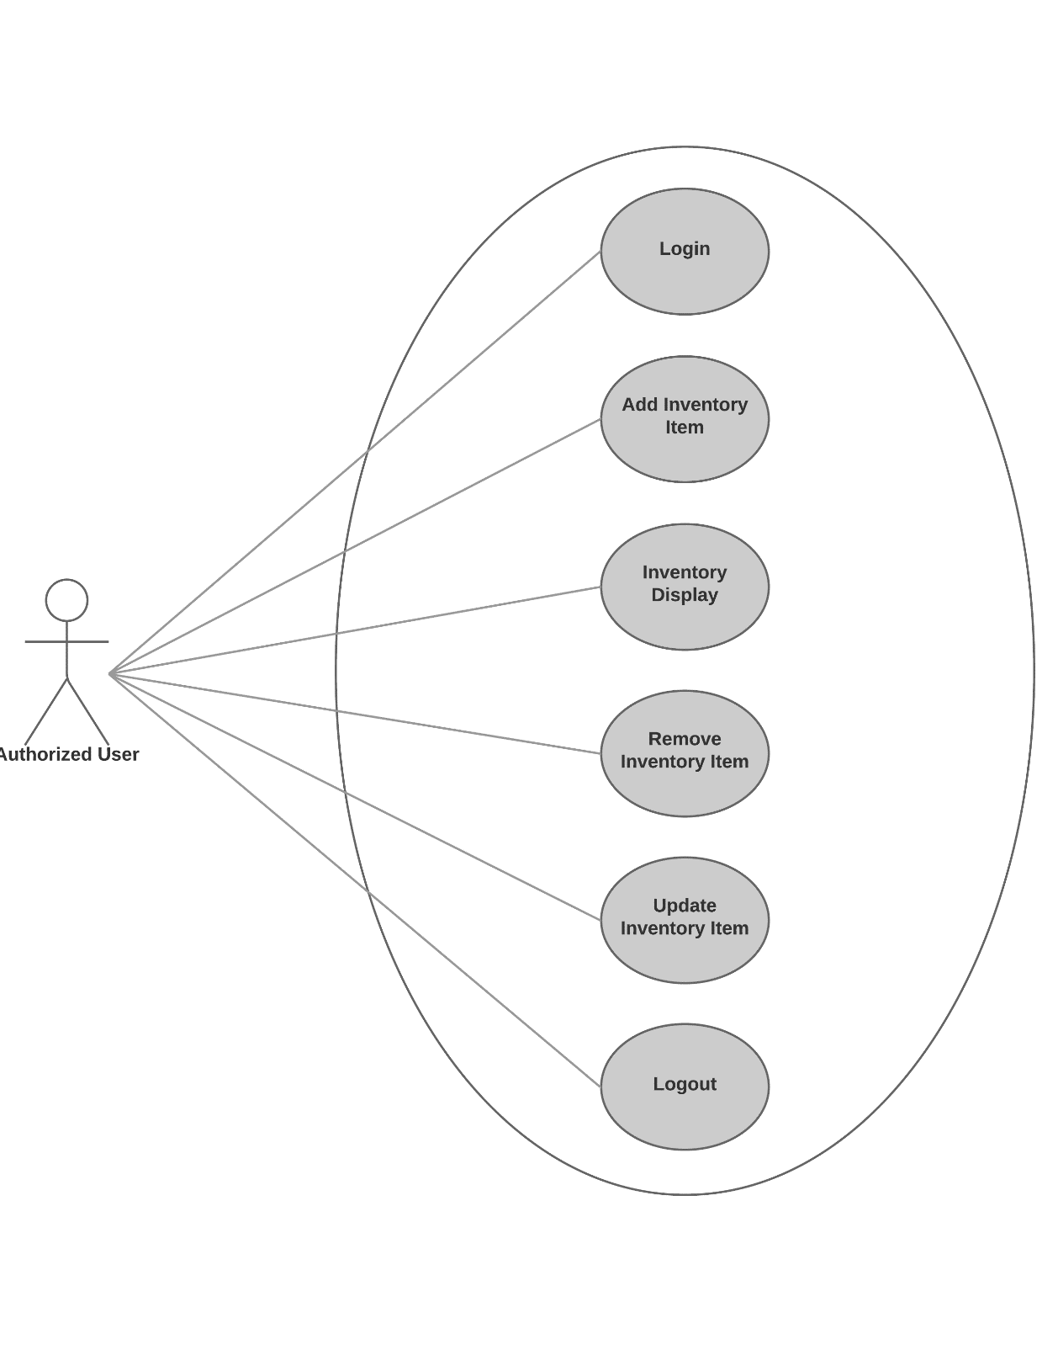

### User Registration

**Primary Actor**: Any User

Assumptions:

* Any User of the system
* Client is a purchaser of the ReComm system

Stakeholders:

* Client must be able to verify that a User has successfully registered in the system.

Pre-conditions:

* Data Store exists for User and Customer data storage
* Only the minimum amount of data required for registration shall be required

Post-conditions (Success Guarantee):

* Data Store contains the User entered even after system is shut down and restarted.
* User is able to log in to the system (See **Section 8.1.3**).

Flow of Events:

1. User is presented with a Registration/Login interface with a *“Login”* button, a *“Register”* button, and a *“Clear”* button. In addition, the Registration portion of the interface shall have a form providing input fields for the following data:
   1. First Name (text field)
   2. Last Name (text field)
   3. Login Name or UID (text field)
   4. E-mail Address (text field)
   5. Password (password field)
   6. Confirm Password (password field)
2. User enters data into the text fields and password field.
   1. The UID field shall have real-time validation displayed to the user
      1. Only alphanumeric characters allowed
      2. Must be unique – not currently used in the system
   2. The Password fields shall have real-time validation displayed to the user
      1. Password must be greater than eight (8) characters
      2. Password must have a CAPITAL letter
      3. Password must contain a number
      4. Password must contain punctuation
      5. Password must not contain HTML tags
      6. Both password fields must match
3. User clicks the *“Register”* button.
4. System validates that data is present in every field and validates the following:
   1. No HTML tags in any fields.
   2. No SQL text (SQL injection prevention).
   3. System validates passwords match and meet the criteria in Step 2.
   4. System validates that UID meets criteria from Step 2.

**Alternate Flow**

* 1. Upon validation failure, a message is displayed suggesting which field(s) need(s) to be corrected. The contents of all valid fields in the interface are left intact.

1. System encrypts User password using Argon2i encryption with salt and stores the User data in the data store.
2. A registration confirmation page is presented to the user.
3. Clicking *Clear”* in the interface clears all fields.

### User Login

**Primary Actor**: Authorized User

Assumptions:

* Authorized User (User) is already registered

Stakeholders:

* Client must be able to verify that a registered user can log into the system

Pre-conditions:

* Data Store exists for User and Customer data storage
* Only the minimum amount of data required for registration shall be required

Post-conditions (Success Guarantee):

* The ReComm application shows the user is logged in

Flow of Events:

1. User is presented with a Registration/Login interface with a “*Login*” button, a “*Register*” button, and a “*Clear*” button. In addition, the Login portion of the interface shall have a form providing input fields for the following data:
   1. Login Name or UID
   2. Password
2. User enters UID and password.
3. User clicks the *“Login”* button.
4. System validates that the UID exists in the system and that the password is correct.
5. Password is compared with the Argon2i encrypted password previously stored.
6. The password is re-encrypted with a new salt and the data store updated.

**Alternate Flow**

1. Upon validation failure, a message is displayed stating that the information given is incorrect. No indication of which information (UID or password) is incorrect.
2. The form is cleared of the UID and password.
3. When data is validated a page is displayed indicating login success and welcoming the user by their First name.
4. All other interfaces in the application indicate that the user is logged in during the session.

### Update Inventory Item Record

**Primary Actor**: Authorized User

Assumptions:

* Authorized User (User) is already registered and logged in to the system
* Client is a purchaser of the ReComm system

Stakeholders:

* Client must be able to add individual Inventory items to the data store

Pre-conditions:

* Data Store exists for inventory Item storage
* Data Store exists for item Image storage containing fifteen (15) image files.
* Data Store exists and is populated with data for three (3) Brands
* Data Store exists for Price storage

Post-conditions (Success Guarantee):

* Data Store contains the item(s) entered even after system is shut down and restarted.

Flow of Events:

1. User is presented with an Inventory interface with a *“Submit”* button, a *“Clear”* button, a dropdown box for Brand selection labeled *“Brand”*, a Dropdown box for Image selection labeled *“Image”*, a Status box labeled *“Status”*, and several entry fields with the following labels:
2. Item Name
3. Item Description
4. Item Price
5. Item SKU
6. User enters data into the fields displayed and selects a Brand and an Image.
7. User clicks the *“Submit”* button.
8. System validates the data in every field and that a Brand and an Image are selected:
9. All fields must contain data.
10. All fields are validated for HTML and SQL safe data.
11. A Brand must be selected.
12. An Image must be selected.
13. The image is validated to be an actual image file.

**Alternate Flow**

1. Upon validation failure, a message is displayed in the Status box suggesting which item needs to be corrected. The contents of all valid items in the dialog are left intact.
2. When data is validated, and the inventory item is successfully added, the Status box displays the item added if successful, and *“Error: Item not saved”* if not successful.
3. The entries in the dialog are cleared to their default values.

### Inventory Display

**Primary Actor:** User

Assumptions:

* Any User, registered or not, may use the interface
* Client is a purchaser of the ReComm system

Stakeholders:

* Client must be able to view data that is in the data store
* All Users must be able to view Item data that is in the data store

Pre-conditions:

* Data Store exists for Item, Brand, and Image storage and contains data for at least fifteen (15) valid Items, with fifteen (15) images, and three (3) Brands.

Post-conditions (Success Guarantee):

* A list of ten (10) inventory Items in the data store is displayed. Clicking *“Next”* in the Display interface displays the next five (5) items followed by *“End List”*.

Flow of Events:

1. User is presented with a Display interface with a *“Next”* button and a list of up to ten (10) inventory Items showing the following data for each:
   1. Item Name
   2. Item Description
   3. Item Brand
   4. Item Price
   5. Item SKU

Alternate Flow

* 1. A failure to read the data store will result in a pop-up window with an *”OK”* button and the message *“Error: Failure to read data store.”*. Clicking the *“OK”* button will close the window.
  2. Clicking *“Next”* in the Display interface will cause the application to attempt to read the data store again.

1. User clicks *“Next”* button and the next ten (10) Items are listed.
   1. . If there are less than ten (10) left in the data store, the last Item name is *“End List”.*