

**Janardan Bhagat Shikshan Prasarak Sanstha’s**

**CHANGU KANA THAKUR**

**Arts, Commerce, Science College**

**New Panvel (W)**

**CASE STUDY**

**DEVELOPED BY**

**Mr. Rohan Kiran Thakur**

**UNDER THE GUIDENCE OF**

**PROF.MRS. Anjali Kulkarni**

**ACEDEMIC YEAR**

**2019-2020**

**PROJECT TITLE**

**PRESENTATION ON AGENTS ON AI**

**Presentation:**

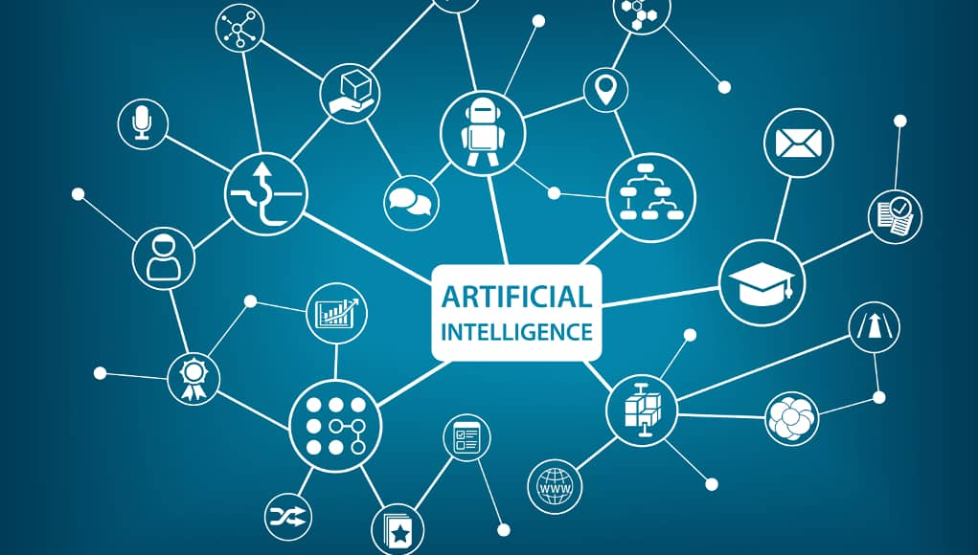

Contents

**Artificial Intelligence**

* **1 Introduction**
* 1.1 What Is AI?
* 1.2 The Foundations of Artificial Intelligence
* 1.3 The History of Artificial Intelligence

**Intelligent Agents**

* 2.1 Agents and Environments
* 2.2 Sensor, Actuators, Effectors
* 2.3 PEAS
* 2.4 Types of AI Agents

**Artificial Intelligence**

* In computer science, **artificial intelligence** (**AI**), sometimes called **machine intelligence**, is intelligence demonstrated by machines, in contrast to the **natural intelligence** displayed by humans.
* the term "artificial intelligence" is often used to describe machines (or computers) that mimic "cognitive" functions that humans associate with other human minds, such as "learning" and "problem solving".

**The History of Artificial Intelligence**

* influential founders of AI, including John McCarthy(2007), Marvin Minsky (2007), Nils Nilsson (1995, 2005) and Patrick Winston (Beal andWinston, 2009), have expressed discontent with the progress of AI.
* They think that AI shouldput less emphasis on creating ever-improved versions of applications that are good at a specific task, such as driving a car, playing chess, or recognizing speech.

**Intelligent Agents**

* An **agent** is anything that can be ENVIRONMENT viewed as perceiving its **environment** through **sensors** and SENSOR acting upon that environment through **actuators**.
* A human agent has eyes, ears, and other organs for sensors and hands, legs, vocal tract, and soon for actuators.
* A robotic agent might have cameras and infrared range finders for sensors and various motors for actuators.
* A software agent receives keystrokes, file contents, and network packets as sensory inputs and acts on the environment by displaying on the screen,writing files, and sending network packets.

**Sensor, Actuators, Effectors**

Before moving forward, we should first know about sensors, effectors, and actuators.

* **Sensor:** Sensor is a device which detects the change in the environment and sends the information to other electronic devices. An agent observes its environment through sensors.
* **Actuators:** Actuators are the component of machines that converts energy into motion. The actuators are only responsible for moving and controlling a system. An actuator can be an electric motor, gears, rails, etc.
* **Effectors:** Effectors are the devices which affect the environment. Effectors can be legs, wheels, arms, fingers, wings, fins, and display screen.

**Types of AI Agents**

* Simple Reflex Agent
* Model-based reflex agent
* Goal-based agents
* Utility-based agent
* Learning agent