

**Janardan Bhagat Shikshan Prasarak Sanstha’s**

**CHANGU KANA THAKUR**

**Arts, Commerce, Science College**

**New Panvel (W)**

**MINI PROJECT ON**

**PAINT 3D**

**DEVELOPED BY**

**Mr. Rohan Kiran Thakur**

**UNDER THE GUIDENCE OF**

**PROF.MRS.AARTI PARDESHI**

**ACEDEMIC YEAR**

**2019-2020**

**PROJECT TITLE**

**ANDROID WITH 3D NAME (PAINT 3D)**

**AND**

**SCENE CREATION IN UNITY (3D CHESS)**

**INDEX**

|  |  |  |
| --- | --- | --- |
| **Sr. No.** | **Case Study Document** | **Page No.** |
| **1.** | **Unity Introduction** |  |
| **2.** | **AR VR MR Technology** |  |
| **3.** | **PAINT 3D** |  |
| **4.** | **Introduction to Visual Studio** |  |
| **5.** | **Mini Project** |  |
| **6.** | **Presentation** |  |
| **7.** | **Reference** |  |

**UNITY**

**Unity** is a [cross-platform](https://en.wikipedia.org/wiki/Cross-platform) [game engine](https://en.wikipedia.org/wiki/Game_engine) developed by [Unity Technologies](https://en.wikipedia.org/wiki/Unity_Technologies), first announced and released in June 2005 at [Apple Inc.](https://en.wikipedia.org/wiki/Apple_Inc.)'s [Worldwide Developers Conference](https://en.wikipedia.org/wiki/Apple_Worldwide_Developers_Conference) as a [Mac OS X](https://en.wikipedia.org/wiki/MacOS)-exclusive game engine. As of 2018, the engine had been extended to support more than 25 platforms. The engine can be used to create [three-dimensional](https://en.wikipedia.org/wiki/Three-dimensional_space), [two-dimensional](https://en.wikipedia.org/wiki/Two-dimensional_space), virtual reality, and augmented reality games, as well as [simulations](https://en.wikipedia.org/wiki/Computer_simulation) and other experiences. The engine has been adopted by industries outside video gaming, such as [film](https://en.wikipedia.org/wiki/Film_industry), [automotive](https://en.wikipedia.org/wiki/Automotive_industry), [architecture](https://en.wikipedia.org/wiki/Architecture), [engineering](https://en.wikipedia.org/wiki/Engineering) and [construction](https://en.wikipedia.org/wiki/Construction).

**AR VR MR TECHNOLOGY**

**Augmented Reality**

* Making an Augmented Reality encounter is a multi-organize process, from the improvement of the 3D models to the innovation that powers the image and sensing. Each progression is a natural procedure. 3D craftsmen utilize a few programs like Sketch Up, Cinema 4D, Blender and numerous more to rake 3D models.
* The procedure begins with a rough sketch then it goes through various series of approval that aides in refining the thought and hence prompts finish image. After the image is acknowledged, the modelling starts.
* Following stage is to apply the model's skin, which is called the texture map. Texture map offers authenticity to the model and can be styled to fit the requirements of task. After the completion of the 3D model, it experiences the rendering process for a total AR encounter.
* **Applications of AR**

1. Medical
2. Military
3. Marketing
4. Navigation
5. Entertainment
6. Education and Training
7. Office

* **Entertainment**

Augmented reality is used in the field of entertainment for games, sports like (swimming, football fields, race tracks and different games condition), virtual advertisements, placements and numerous more For example, Fox-Trax framework utilized for ice hockey, different AR recreations like Quake, Game City and numerous more.

* **Education and Training**

Installed markers can be utilized as a part of educational materials which when checked by AR gadget produces data in multimedia format which causes the student to think about different subjects.

* **Office**

Cooperation in office spaces is another zone where AR may be important by giving joint effort among various associates in a work force by methods for gatherings with the help of bona fide and virtual individuals

**Virtual Reality**

Eyes are a certain width isolated, which suggests when some individual looks challenge, each eye sees a to some degree indisputable perspective of that that question. Their mind then strategies these two pictures to outline a 3D picture. VR gadgets work comparably. The underlying section of die system is reproducing both the left and right eyes' purposes of see with two one beside alternate pictures. This is known as 'stereoscopic imaging'.

* The second some portion of the system is to use an OLED show of high assurance what's more, adequately immense to make an immersive field of vision. At the moment that these are joined a radical new world in confined prior to the eyes.
* The Immersive picture is the gadgets capacity to track the head development with no slack or inactivity as the looks at the virtual world. This requires a couple of sensors, including gyro meters, accelerometers what's more, that is only the start. For Virtual Reality headsets, they screen the right position of customer's head over the 'six degrees of adaptability' i.e. two headings of pitch, yaw and roll.
* **Applications of VR**

1. Modelling, designing and planning
2. Training and education
3. Telepresence and Tele-operation
4. Cooperative working
5. Entertainment

**1.Modelling , designing and planning**

Virtual Reality permits the user to see the virtual objects in real time and space in a virtual environment. For example, the models developed by the Fraunhofer Institute Virtual Design, Virtual Kitchen — tools for interior designers who can visualize their sketches. By using tool you can change the texture, color and the objects position observing them at once to see how the whole neighbouring would look-like.



**2.Training and education**

Utilization of VR is expanded in civil industries also because they are safe and give Iowa operating cost than the actual flight training. In this manner, astronauts were trained utilizing virtual reality as it is more proficient and they can likewise perform hazardous tasks in space without any fear. Another application is pharmaceutical where they permit study and preparing of performing surgeries of different parts of body. Another case is Virtual classes; wherestudent introduce at wherever can

examine with virtual teachers.

**3.Tele-presence and Tele-operation**

Tele-presence technology allows the user to perform the medical operations in a distant widely different condition with the assistance of VR user connections. The Nan controller undertaking demonstrates an alternate nature of tele-presence in distant broadly unique working conditions.

**Mixed reality**

Mixed reality is a blend of virtual reality and augmented reality. It Is also known as hybrid reality. Mixed reality gadgets work by a 3D guide of client’s environments and filtering a physical condition so the gadgets known how and where to put the mechanized contents into that space sensibly while enabling the customer to team up with utilizing movements.

MR encounters welcome mechanized content into client’s continuous condition, enabling the client to work with them. The visualizations can carry on like certifiable questions and surroundings around them because of the utilization of straightforward focal points, comprehension of physical situation and sounds.

For instance, think about the outsiders smashing through the rooftops and discharging rockets, weapons at the clients. It isn't just inhale taking yet in addition and in exciting background.

* **Applications of MR**
* Industries
* Medicine
* Collaboration
* Navigation
* Entertainment

1. **Industries**

The first MR system is developed by Steve feiner in 1993 at Colombia university. This system directs the user for the basic maintenance and repairing Rhee, Lee exhibited MR .ca Framework that was circulated and cooperation arranged.

Their system fuses Mobile phones and likewise PC terminals, related with server and mysticism-based setting affirmation structure to render the information in the setup fitting to the client and the situation.

One more application magic book was utilized to fabricate the 3D model of the items on the pages of the book diverse point of the models can be seen by moving the book and seeing from various angles.

1. **Medicine**

To visualize the medical images like CT scan, MRI of different body parts of the patient the mixed reality is very useful. It helps to direct the surgeon to operate the patient these medical images are displayed on the monitor that are in the operating room. It has been observed that accuracy ratio is increased by using these technologies.

1. **Collaboration**

It is another zone of utilization for mixed reality. Here for instance, a remote expert offers direction to an operator on field. The operator makes utilization of portable mixed reality to catch the situation around him and forward it to the expert which investigation it and aides the expert in like manner through visual show of the expert’s mixed reality framework or the sound channel. For medicinal utilizations, Welch had recommended a framework which imagines the patient’s body caught by different cameras and after that showed on a high determination show or PDA of a specialist at his place.

1. **Navigation**

Mixed reality is used in navigation for the assistance purpose. Here operator observe the virtual symbols anchored to the real world. It is very similar to a compass where the signs demonstrate the best possible course without getting influenced by the introduction of the device. It could be used to manage visitors inside the house or structure or for explorers in another city.

Entertainment

A few energizing applications were recommended, in which handlers must be connected with engineered characters or gadgets which show up in their real environment. Mixed reality can be utilized as a part of games which helps to build the competition and additionally coordinated efforts among the players. For instance, MR variant of the quake computer game, the human Pac man game, moon lander game, and so forth.

**PAINT 3D**

**Paint 3D**, a refresh of [Microsoft Paint](https://en.wikipedia.org/wiki/Microsoft_Paint), is one of several [applications](https://en.wikipedia.org/wiki/Application_software) introduced with the [Windows 10](https://en.wikipedia.org/wiki/Windows_10) Creators Update and one of several [3D modelling](https://en.wikipedia.org/wiki/3D_modeling) and [printing](https://en.wikipedia.org/wiki/Additive_manufacturing) applications introduced or improved with the Windows 10 Creators Update, along with [View 3D](https://en.wikipedia.org/wiki/View_3D), [Windows Mixed Reality](https://en.wikipedia.org/wiki/Windows_Mixed_Reality), Holograms, and 3D Builder. Developed by [Microsoft](https://en.wikipedia.org/wiki/Microsoft_Studios)'s [Lift London](https://en.wikipedia.org/wiki/Lift_London) studio, Paint 3D incorporates features of the Microsoft Paint and 3D Builder applications to combine a lightweight hybrid 2D-3D editing experience that allows users to pull in a variety of shapes from the app, their personal computer, and Microsoft's [Remix 3D](https://en.wikipedia.org/wiki/Remix_3D) service.

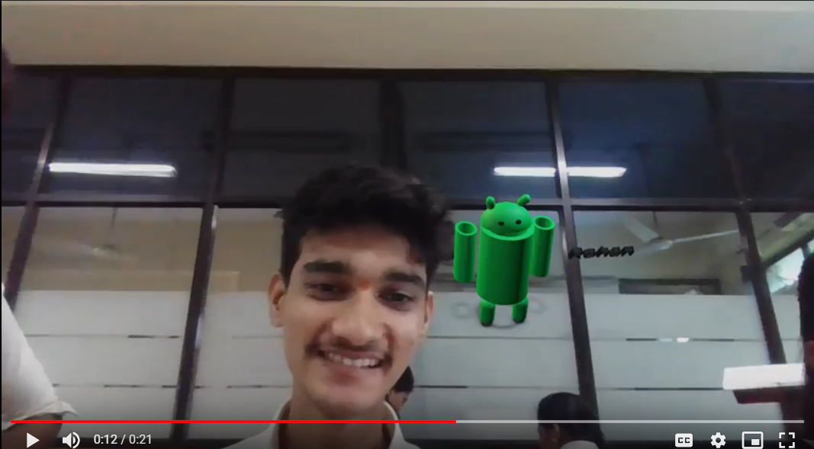

**Introduction to Visual Studio**

Visual Studio is an **Integrated Development Environment (IDE)** developed by Microsoft to develop GUI(Graphical User Interface), console, Web applications, web apps, mobile apps, cloud, and web services, etc. With the help of this IDE, you can create managed code as well as native code. It uses the various platforms of Microsoft software development software like Windows store, Microsoft Silverlight, and Windows API, etc. It is not a language-specific IDE as you can use this to write code in C#, C++, VB(Visual Basic), Python, JavaScript, and many more languages. It provides support for 36 different programming languages. It is available for Windows as well as for macOS.

**Evolution of Visual Studio:** The first version of VS(Visual Studio) was released in 1997, named as Visual Studio 97 having version number 5.0. The latest version of Visual Studio is 15.0 which was released on March 7, 2017. It is also termed as Visual Studio 2017. The supported *.Net Framework Versions* in latest Visual Studio is 3.5 to 4.7. Java was supported in old versions of Visual Studio but in the latest version doesn’t provide any support for Java language.

**Visual Studio Editions**

There are 3 editions of Microsoft Visual Studio as follows:

**1. Community:** It is a **free** version which is announced in 2014. *All other editions are paid*. This contains the features similar to Professional edition. Using this edition, any individual developer can develop their own free or paid apps like *.Net applications*, Web applications and many more. In an enterprise organization, this edition has some limitations. For example, if your organization have more than 250 PCs and having annual revenue greater than $1 Million(US Dollars) then you are not permitted to use this edition. In a non-enterprise organization, up to five users can use this edition. Its main purpose is to provide the Ecosystem(Access to thousands of extensions) and Languages(You can code in C#, VB, F#, C++, HTML, JavaScript, Python, etc.) support.

**2. Professional:** It is the commercial edition of Visual Studio. It comes in Visual Studio 2010 and later versions. It provides the support for XML and XSLT editing and includes the tool like Server Explorer and integration with Microsoft SQL Server. Microsoft provides a free trial of this edition and after the trial period, the user has to pay to continue using it. Its main purpose is to provide Flexibility(Professional developer tools for building any application type), Productivity(Powerful features such as CodeLens improve your team’s productivity), Collaboration(Agile project planning tools, charts, etc.) and Subscriber benefits like Microsoft software, plus Azure, Pluralsight, etc.

**3. Enterprise:** It is an integrated, end to end solution for teams of any size with the demanding quality and scale needs. Microsoft provides a 90-days free trial of this edition and after the trial period, the user has to pay to continue using it. The main benefit of this edition is that it is highly scalable and deliver high-quality software.

**Mini project**

**Step2: Open new SCENE.**

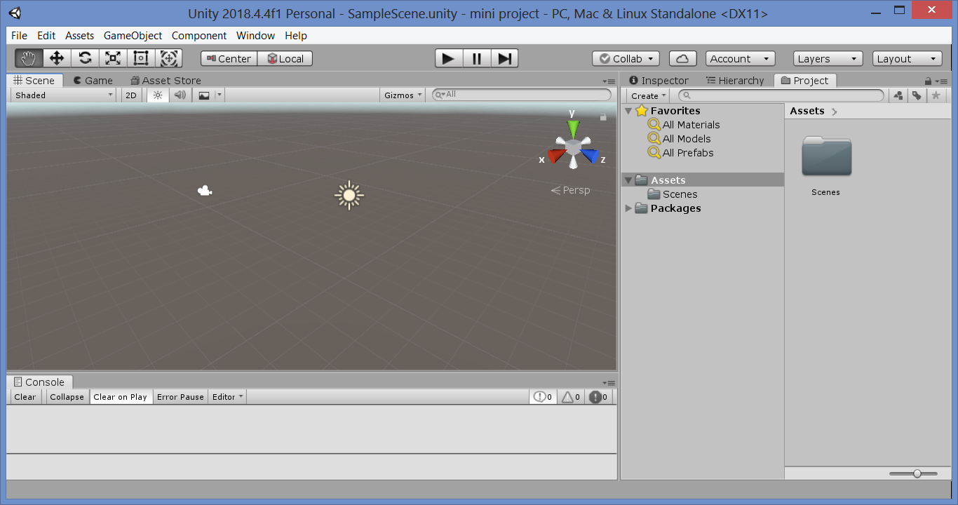

**Step2: import Chess Set asset.**

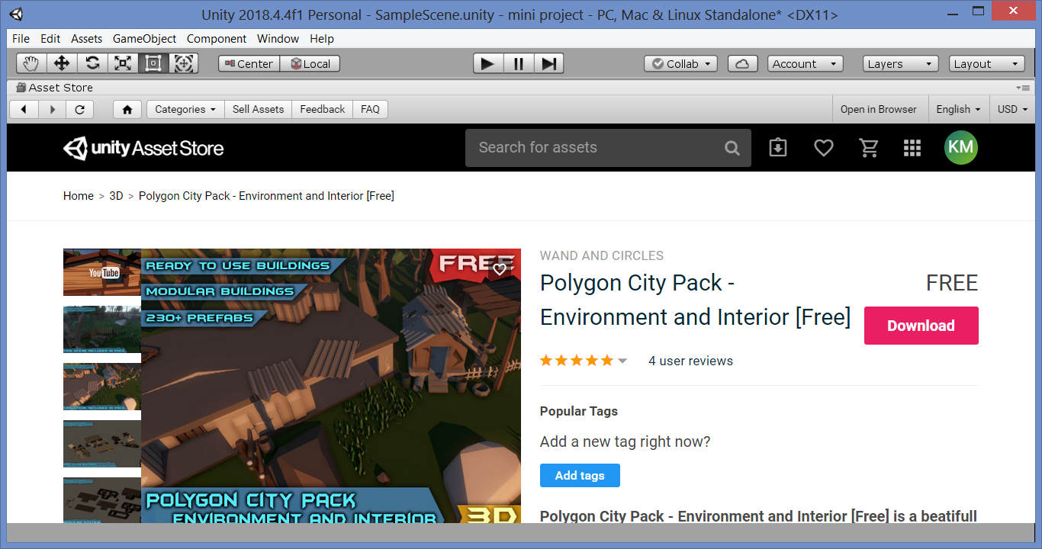

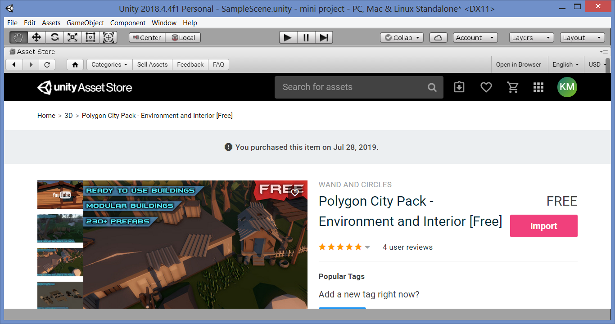

**Step 3: Add terrain on scene.**

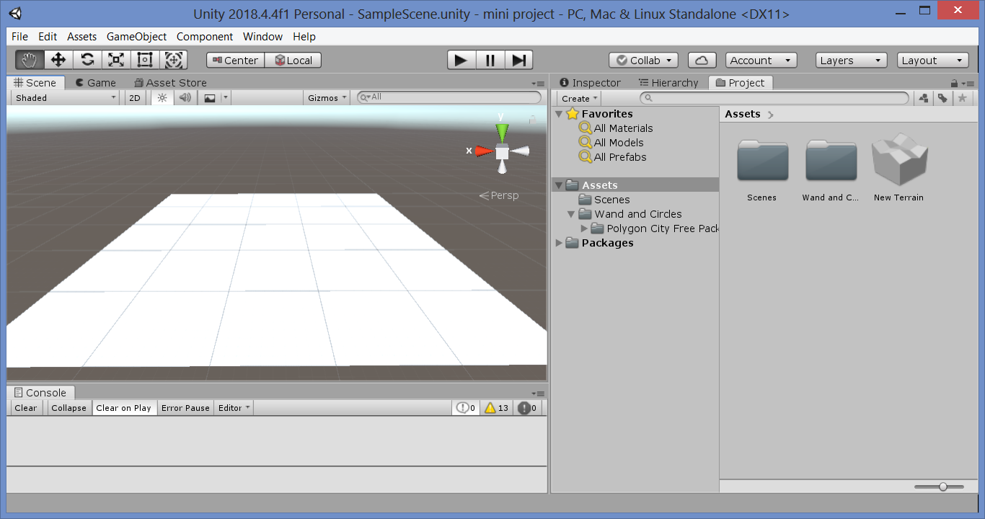

**Step 3: Add foundation on terrain.**

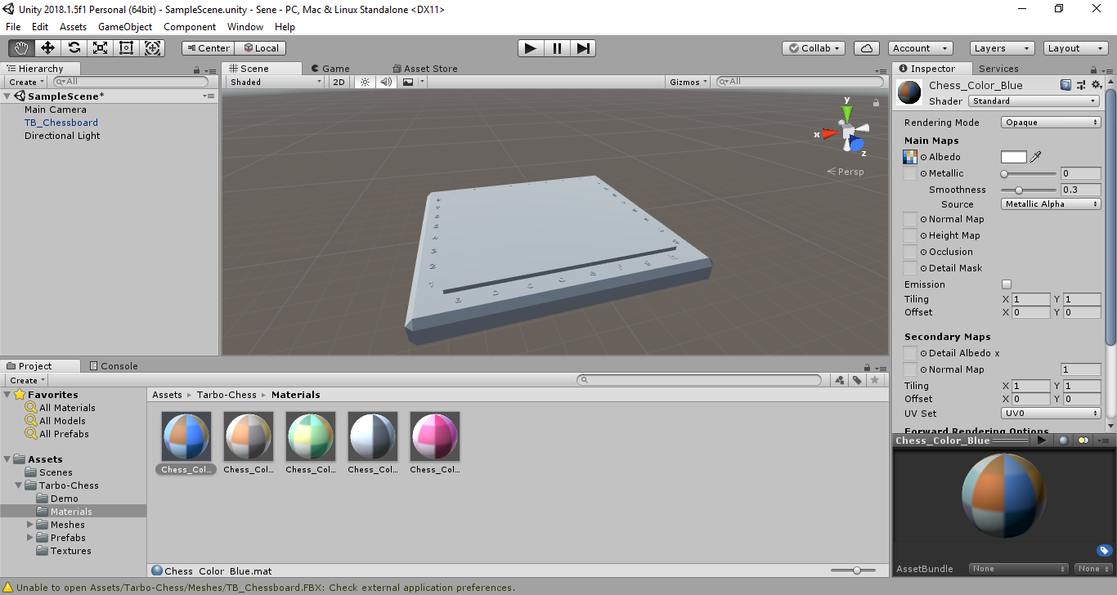

**Step 4: Colour to terrain.**

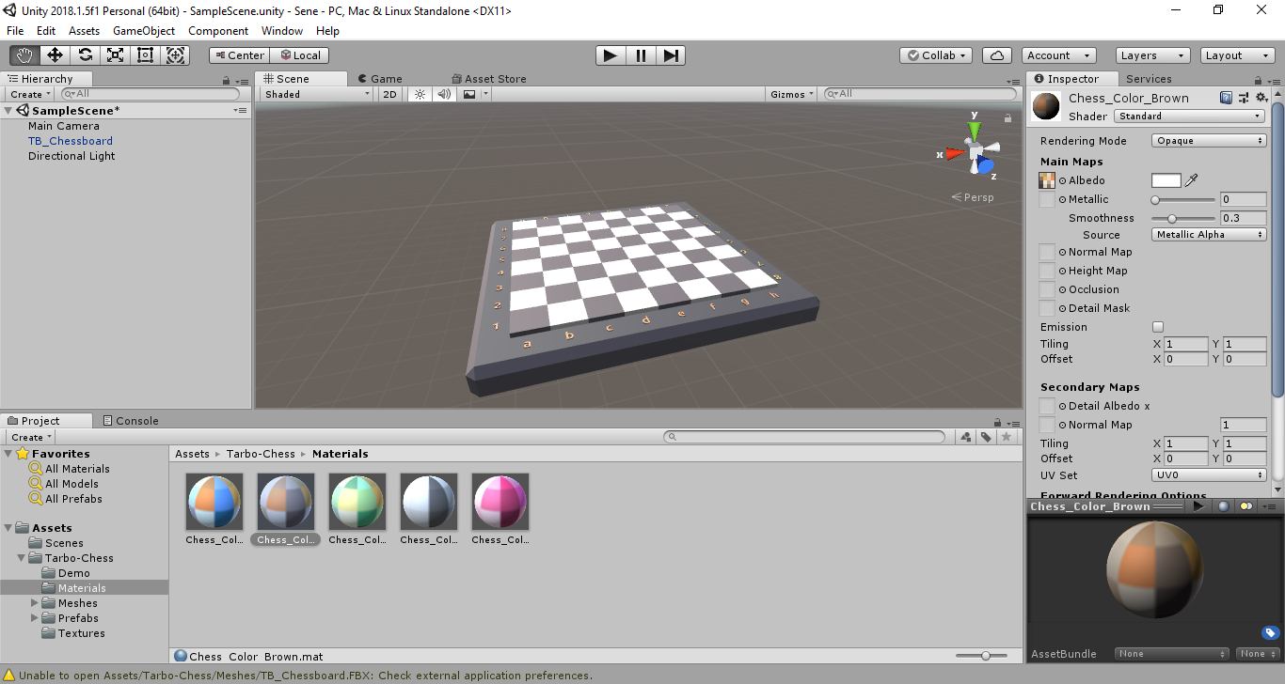

**Step 5: set the Chess players Settings and its Position.**

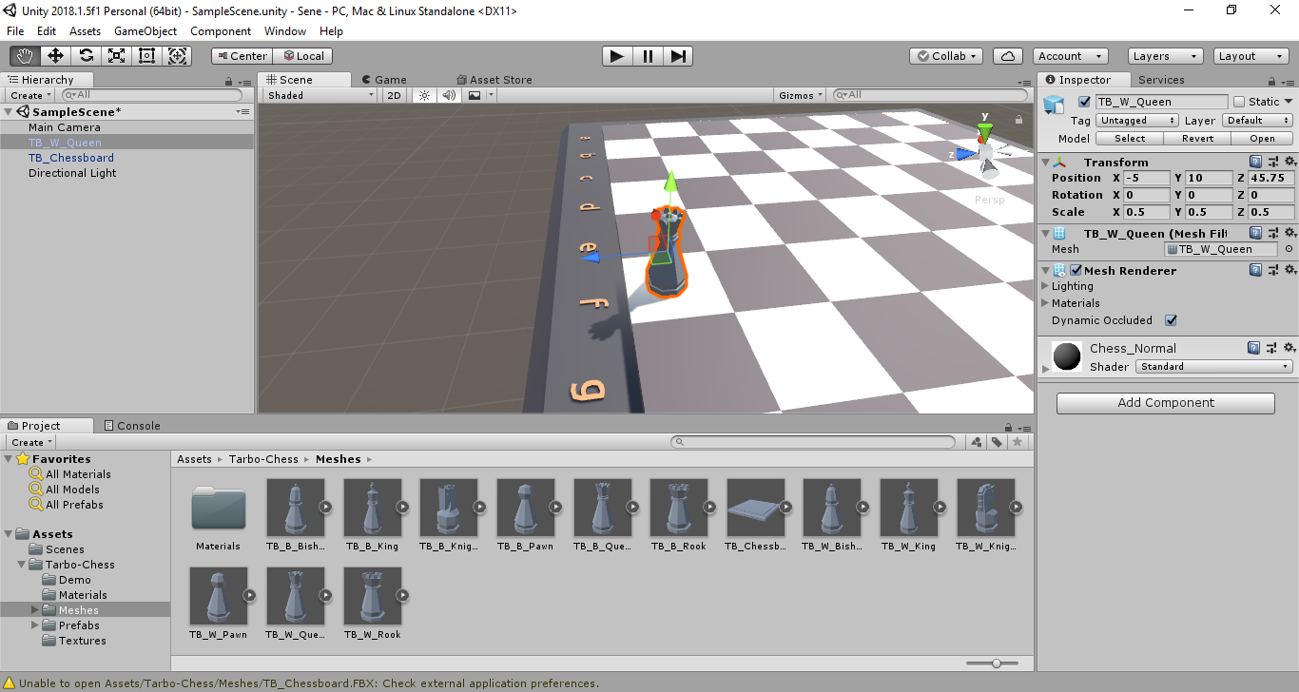

**Step 6: Set all the players on Chess Board and Colour it**

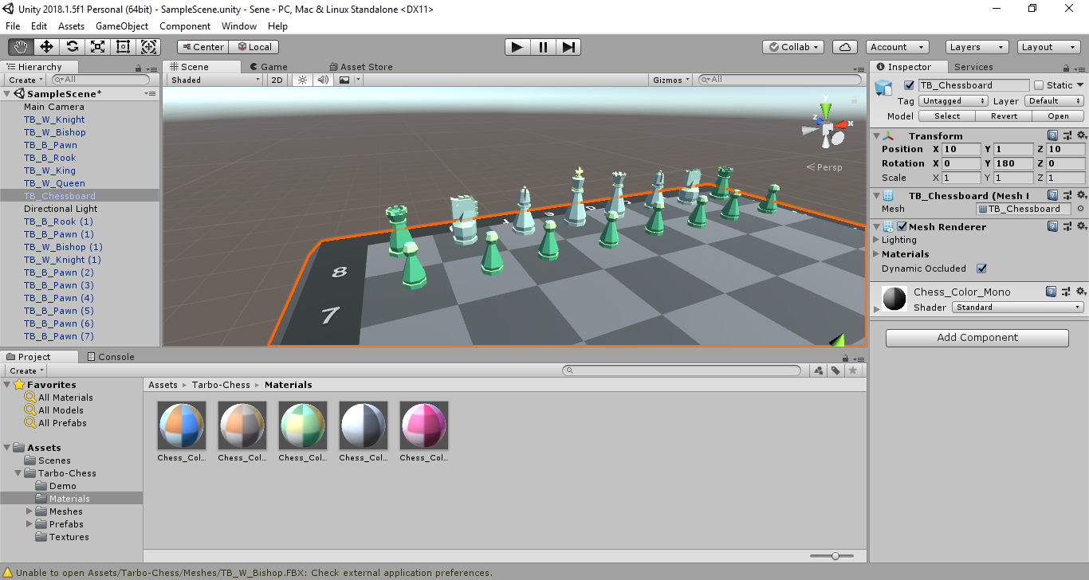

**Step7: Add Players On both the sides and colour it.**

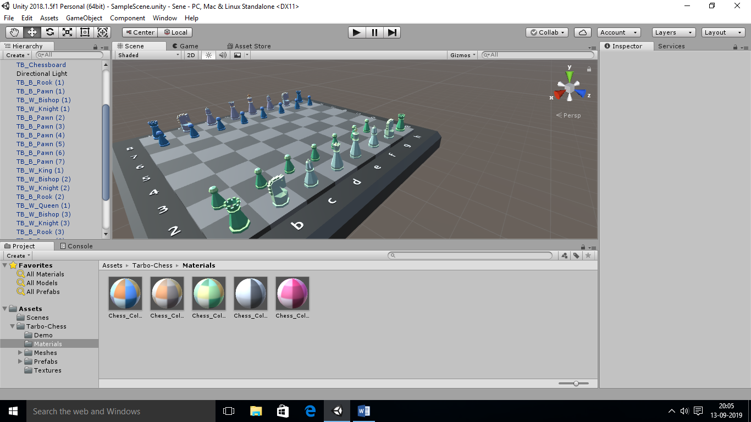

**Presentation:**



**James Gosling:**

**James Arthur Gosling**,  (born May 19, 1955) is a Canadian computer scientist, best known as the founder and lead designer behind the Java programming language.

Java was originally developed by James Gosling at Sun Microsystems (which has since been acquired by Oracle) and released in 1995 as a core component of Sun Microsystems' Java platform.

|  |  |
| --- | --- |
| Born | May 19, 1955 (age 64) Near Calgary, Alberta, Canada |
| Residence | San Francisco Bay Area, California, U.S. |
| Nationality | Canadian |
| Alma mater | * Carnegie Mellon University * University of Calgary |

**Education:**

* James Gosling received a Bachelor of Science from the University of Calgary  and his M.A. and Ph.D. from Carnegie Mellon University, all in computer science.
* He built a multi-processor version of Unix for a 16-way computer system while at Carnegie Mellon University, before joining Sun Microsystems while working toward his doctorate.

**Contribution:**

* He created the original design of Java and implemented the language's original compiler and virtual machine.
* Gosling initially became known as the author of Gosling Emacs, and also invented the windowing system NeWS, which lost out to X Window because Sun did not give it an open source license.
* He also developed several compilers and mail systems there.

**CAREER:**

* Gosling was with Sun Microsystems between 1984 and 2010 (26 years).
* He got the idea for the Java VM while writing a program to port software from a PERQ by translating Perq Q-Code to VAX assembler and emulating the hardware.
* He left Sun Microsystems on April 2, 2010 after it was acquired by the Oracle Corporation, citing reductions in pay, status, and decision-making ability, along with change of role and ethical challenges

**REFERENCE:**

* Mathematics for Computer Graphics, John Vince, Springer-Verlag London, 5th Edition,2017
* Mathematics for 3D Game Programming and Computer Graphic, Eric Lengyel, Delmar Cengage Learning, Delmar Cengage Learning,2011
* Introduction To 3D Game Programming With Directx® 11,Frank D Luna, Mercury Learning And Information,2012.
* <https://docs.unity3d.com/Manual/index.html>
* <https://unity3d.com/get-unity/download>