

**Janardan Bhagat Shikshan Prasarak Sanstha’s**

**CHANGU KANA THAKUR**

**Arts, Commerce, Science College**

**New Panvel (W)**

**CASE STUDY**

**DEVELOPED BY**

**Mr. ROHAN KIRAN THAKUR**

**UNDER THE GUIDENCE OF**

**PROF.MRS. Rani Gaikawad**

**ACEDEMIC YEAR**

**2019-2020**

**Software testing:-**

**Software testing** is a process, to evaluate the functionality of a software application with an intent to find whether the developed software met the specified requirements or not and to identify the defects to ensure that the product is defect free in order to produce the quality product.

**Selenium:-**

**Selenium** is a portable framework for testing web applications. Selenium provides a playback tool for authoring functional tests without the need to learn a test scripting language (Selenium IDE). It also provides a test domain-specific language (Selenese) to write tests in a number of popular programming languages, including C#, Groovy, Java, Perl, PHP, Python, Ruby and Scale. The tests can then run against most modern web browsers.

**Automation:-**

**Automation** is the technology by which a process or procedure is performed with minimal human assistance. Automation Testing means using an automation tool to execute your test case suite.

The automation software can also enter test data into the System Under Test, compare expected and actual results and generate detailed test reports. Test Automation demands considerable investments of money and resources.

**Steps :**

1. Create new java project

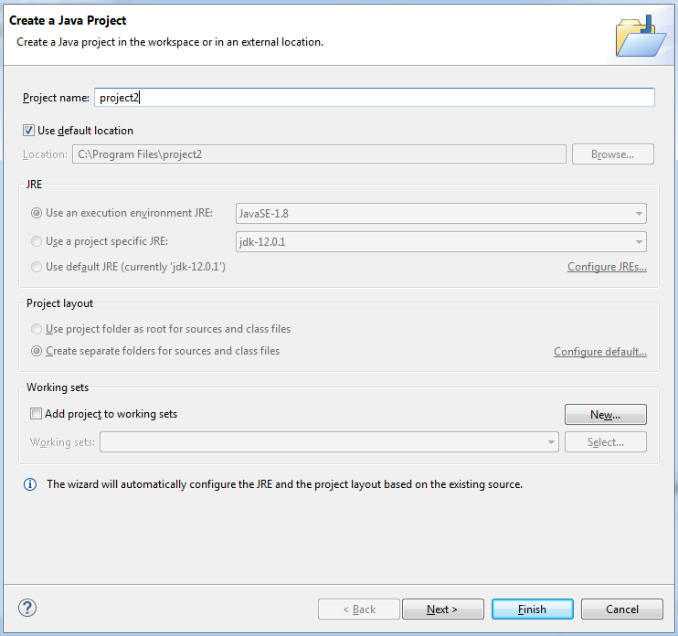

1. Expand the project then right click on src build path and configure build path.
2. Add all jar files

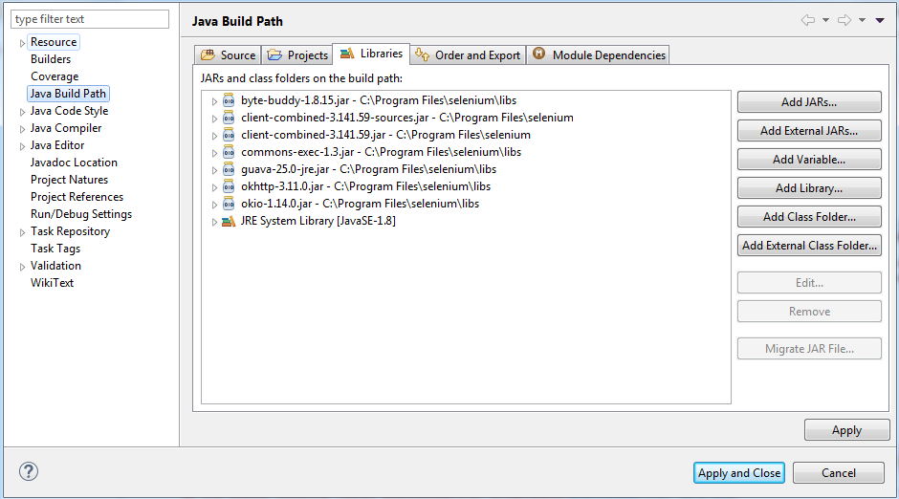

4)Then right click on src then click on new and create a package.

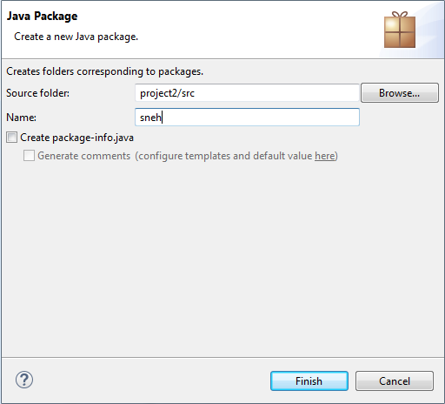

5) Create java class

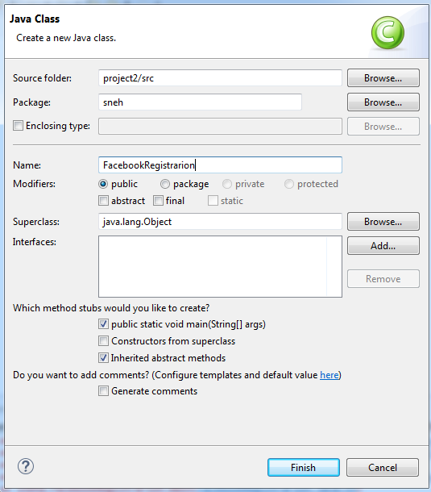

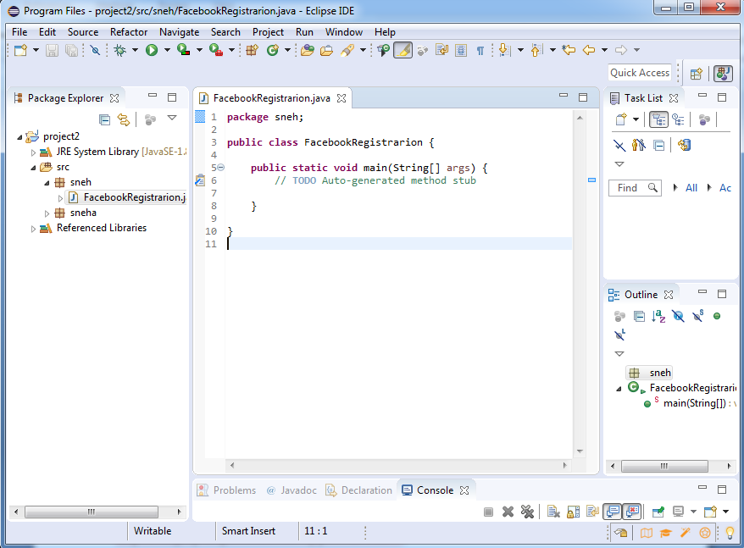

**Program:**

**package** practical;

**import** org.openqa.selenium.By;

**import** org.openqa.selenium.WebDriver;

**import** org.openqa.selenium.firefox.FirefoxDriver;

**public** **class** Pract {

**public** **static** **void** main(String[] args) {

System.*setProperty*("webdriver.gecko.driver","D:\\Users\\Rohan\\Downloads\\selenium\\geckodriver.exe");

WebDriver driver=**new** FirefoxDriver();

driver.navigate().to("http://thedemosite.co.uk/login.php");

driver.manage().window().maximize();

//Logging to thedemosite Check the user available or not...

driver.findElement(By.*xpath*("/html/body/table/tbody/tr/td[1]/form/div/center/table/tbody/tr/td[1]/table/tbody/tr[1]/td[2]/p/input")).sendKeys("admin");

driver.findElement(By.*xpath*("/html/body/table/tbody/tr/td[1]/form/div/center/table/tbody/tr/td[1]/table/tbody/tr[2]/td[2]/p/input")).sendKeys("password");

driver.findElement(By.*xpath*("/html/body/table/tbody/tr/td[1]/form/div/center/table/tbody/tr/td[1]/table/tbody/tr[3]/td[2]/p/input")).click();

//If no login then create new user

driver.navigate().to("http://thedemosite.co.uk/addauser.php");

driver.findElement(By.*xpath*("/html/body/table/tbody/tr/td[1]/form/div/center/table/tbody/tr/td[1]/div/center/table/tbody/tr[1]/td[2]/p/input")).sendKeys("admin");

driver.findElement(By.*xpath*("/html/body/table/tbody/tr/td[1]/form/div/center/table/tbody/tr/td[1]/div/center/table/tbody/tr[2]/td[2]/p/input")).sendKeys("password");

driver.findElement(By.*xpath*("/html/body/table/tbody/tr/td[1]/form/div/center/table/tbody/tr/td[1]/div/center/table/tbody/tr[3]/td[2]/p/input")).click();

//After creating new user Logging to thedemosite

driver.navigate().to("http://thedemosite.co.uk/login.php");

driver.findElement(By.*xpath*("/html/body/table/tbody/tr/td[1]/form/div/center/table/tbody/tr/td[1]/table/tbody/tr[1]/td[2]/p/input")).sendKeys("admin");

driver.findElement(By.*xpath*("/html/body/table/tbody/tr/td[1]/form/div/center/table/tbody/tr/td[1]/table/tbody/tr[2]/td[2]/p/input")).sendKeys("password");

driver.findElement(By.*xpath*("/html/body/table/tbody/tr/td[1]/form/div/center/table/tbody/tr/td[1]/table/tbody/tr[3]/td[2]/p/input")).click();

}

}

**Output:**

1. **First visit** <http://thedemosite.co.uk/login.php> login page.

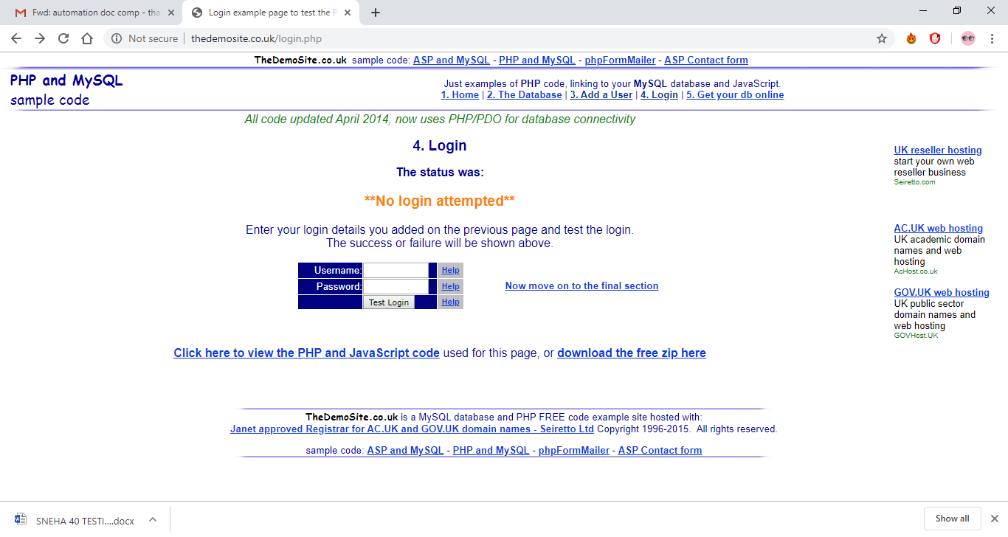

1. **If the user created then it will be login else not.**

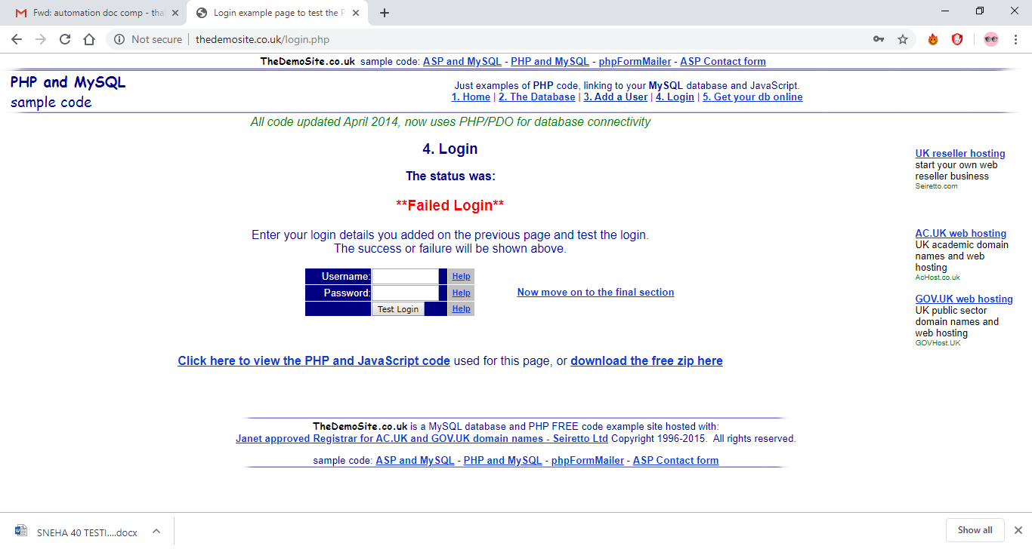

1. **If no login then create new user**

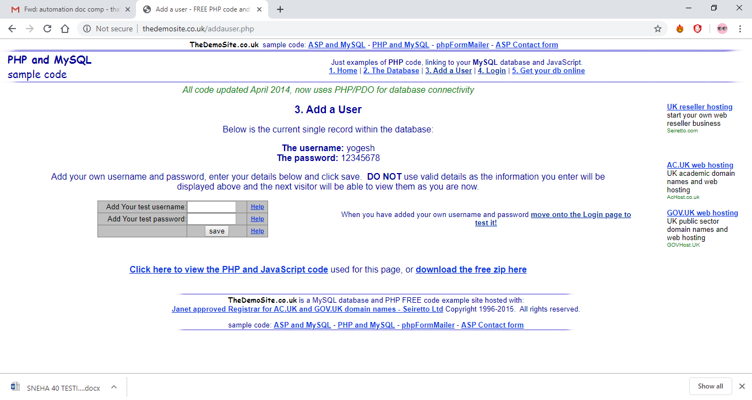

1. **After that Move to ‘Add a User’ page to create user.**

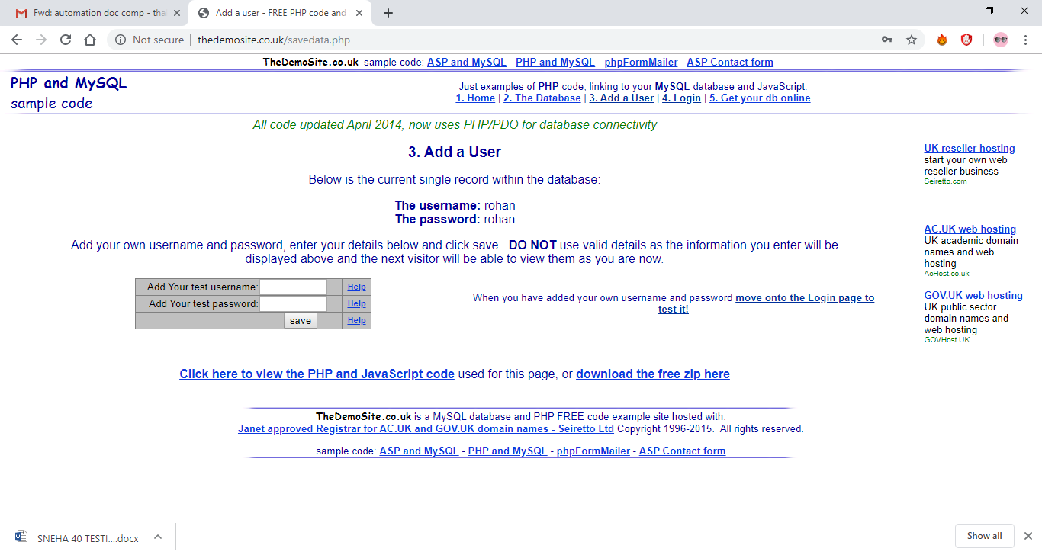

1. **After successfully user create it will be login.**

