

ACTIVITY
Department | Artificial Intelligence and Data Science
Course Code / Course Name | DSA0601 / Data Handling and Visualization
Name / Register Number | ROHAN P T / 192424112
Date / Day | 10/10/2026

DATA HANDLING AND VISUALIZATION
Complete Solutions with Visualizations and Detailed Explanations
Reference solution for the activity “Identify Skewness Using Violin Plots”. The white circle on each plot marks the median. The violin width represents estimated data density at each value.

How to read a violin plot
A violin plot combines a distribution shape with a vertical or horizontal value scale. Wider regions indicate values that occur more densely; narrow regions indicate relatively fewer observations. The ends are tails. A longer tail on the high-value side suggests right (positive) skew; a longer tail on the low-value side suggests left (negative) skew. A roughly balanced shape suggests approximate symmetry.
Mean and median: the mean is the arithmetic average and can be pulled toward extreme values. The median is the middle observation and is more resistant to extremes. Typical patterns are: right skew → mean > median; left skew → mean < median; approximately symmetric → mean ≈ median. These are useful rules of thumb, not guaranteed identities.

Chart 1: Server response time
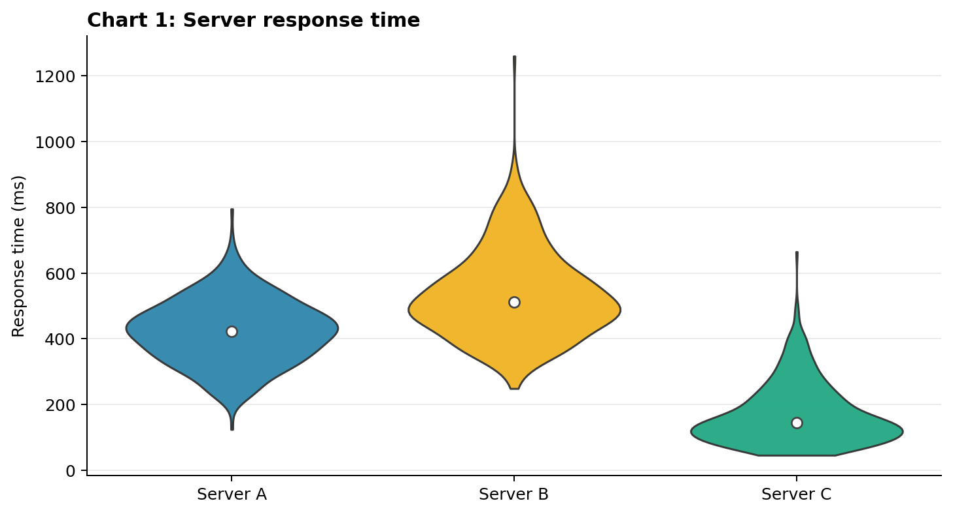
Group | Skewness | Mean vs median | Detailed explanation
Server A | Approximately symmetric | Mean ≈ median | The body is fairly balanced around its centre, with no clearly dominant tail.
Server B | Right-skewed | Mean > median | The upper end extends toward larger response times. A few slower responses can pull the mean upward.
Server C | Right-skewed | Mean > median | Most density is at lower response times, with a thinner tail toward higher values.

Chart 2: Monthly rainfall
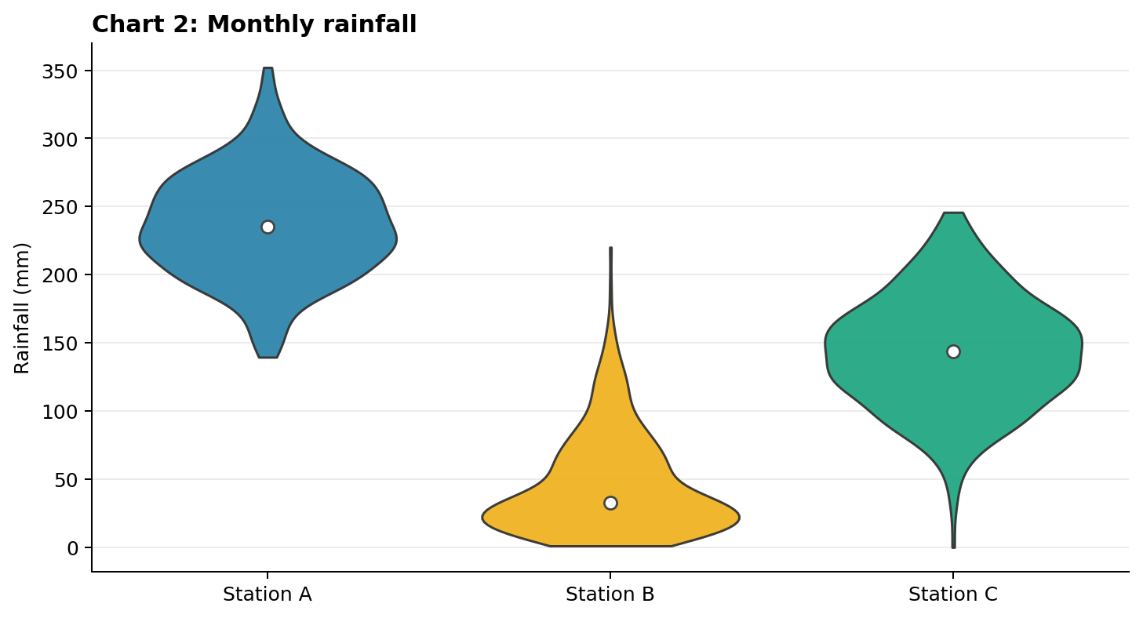
Group | Skewness | Mean vs median | Detailed explanation
Station A | Approximately symmetric | Mean ≈ median | The shape is relatively balanced above and below the centre.
Station B | Right-skewed | Mean > median | Rainfall values cluster near the low end, while some larger rainfall values create a longer upper tail.
Station C | Approximately symmetric | Mean ≈ median | The shape is broadly balanced around its central value, though it has some spread.

Chart 3: Daily steps
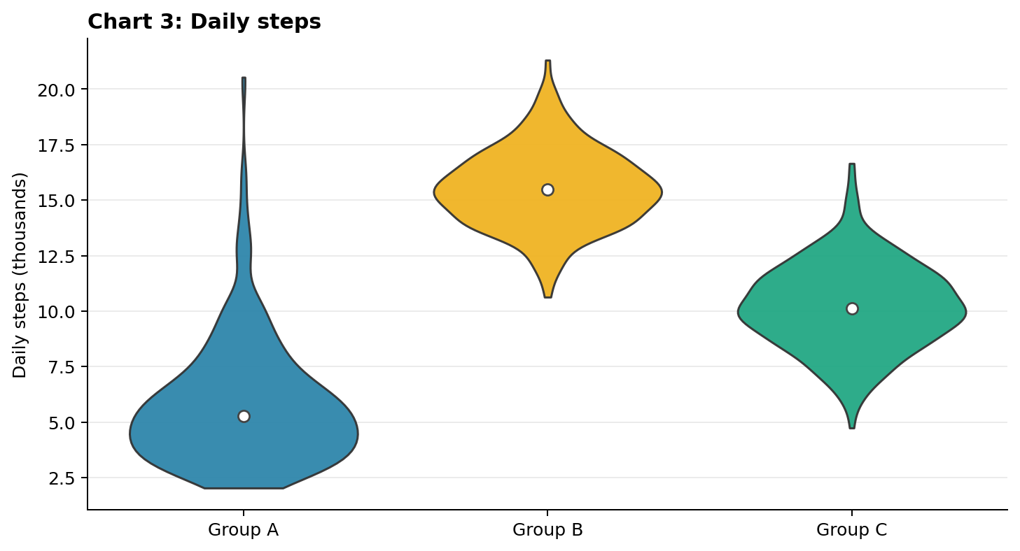
Group | Skewness | Mean vs median | Detailed explanation
Group A | Right-skewed | Mean > median | Many observations are at lower step counts, with a tail extending to higher counts.
Group B | Approximately symmetric | Mean ≈ median | The violin is concentrated around the centre and appears fairly balanced.
Group C | Approximately symmetric | Mean ≈ median | The distribution has values on both sides of the centre without a strongly longer tail.

Chart 4: House prices
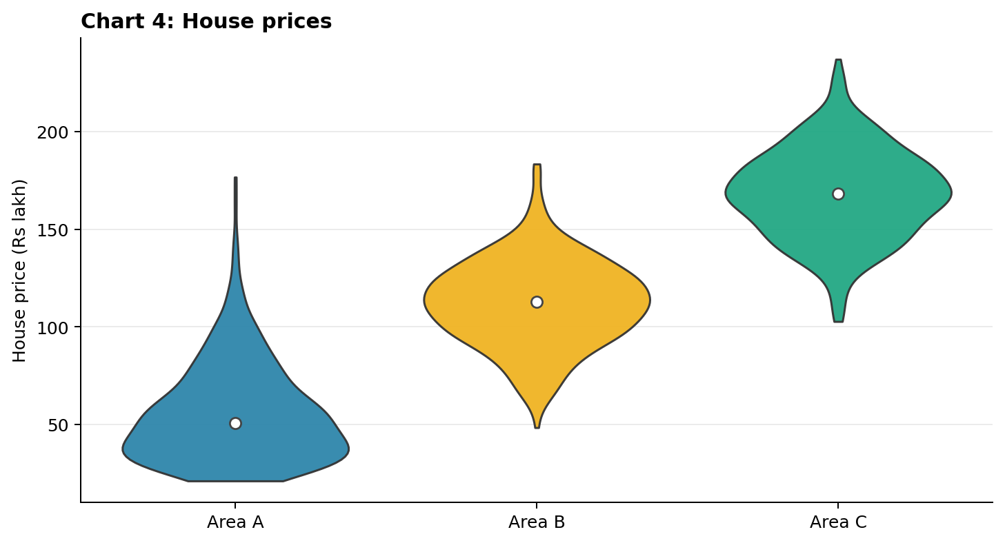
Group | Skewness | Mean vs median | Detailed explanation
Area A | Right-skewed | Mean > median | Most house prices are relatively low, while a few expensive houses stretch the upper tail.
Area B | Approximately symmetric | Mean ≈ median | Prices cluster around the centre with a roughly balanced shape.
Area C | Approximately symmetric | Mean ≈ median | The distribution is centred at a higher price, but its shape is comparatively balanced.

Chart 5: Delivery time
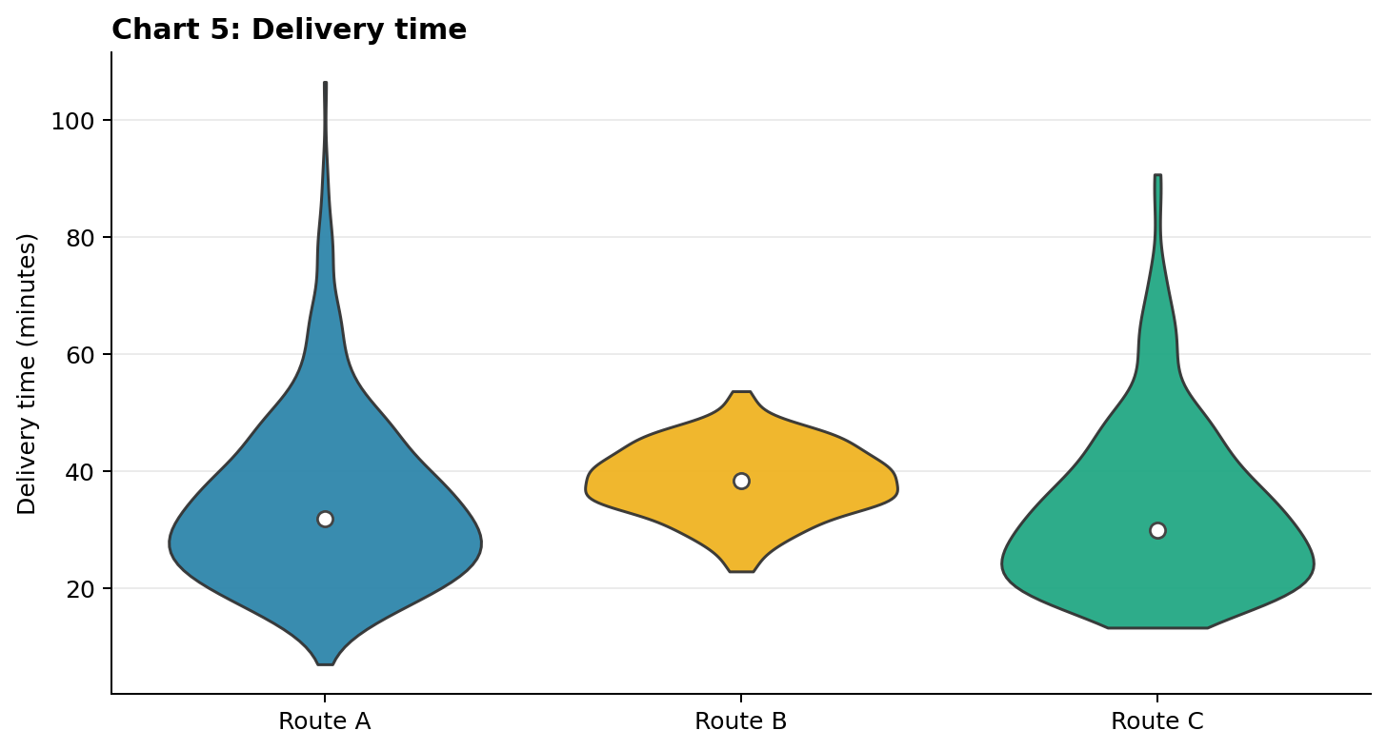
Group | Skewness | Mean vs median | Detailed explanation
Route A | Right-skewed | Mean > median | Most deliveries take a moderate amount of time, but a few much longer deliveries extend the upper tail.
Route B | Approximately symmetric | Mean ≈ median | Delivery times are spread fairly evenly around the centre.
Route C | Right-skewed | Mean > median | The distribution extends farther toward longer delivery times than toward very short times.

Chart 6: Quiz scores
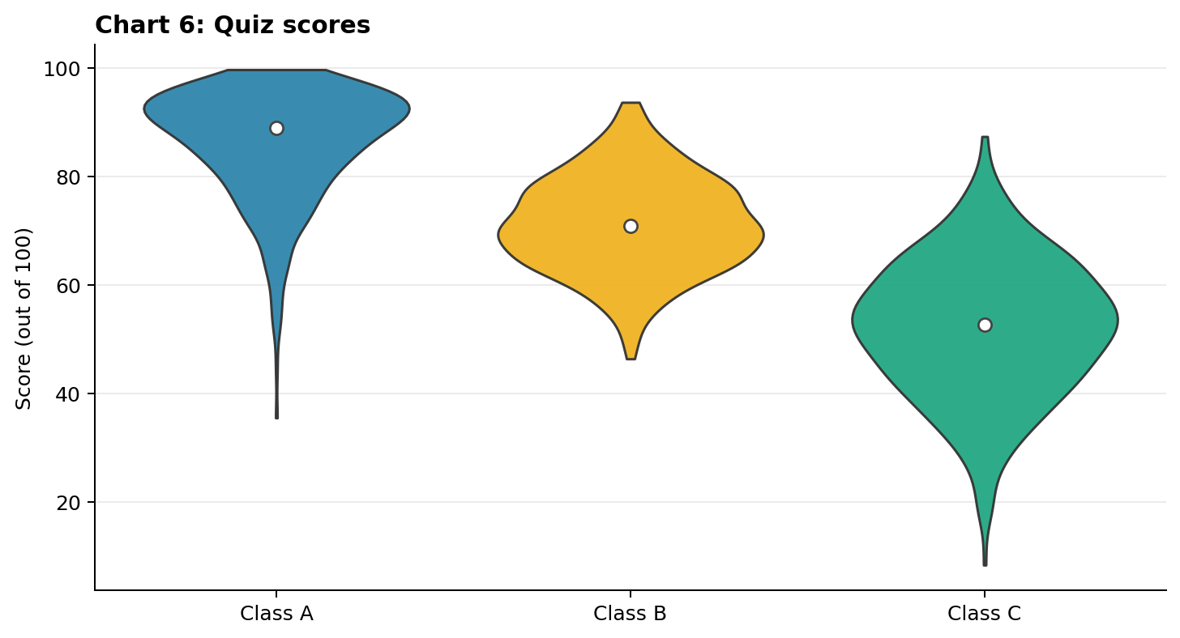
Group | Skewness | Mean vs median | Detailed explanation
Class A | Left-skewed | Mean < median | Many scores are high, with a tail toward lower scores. The lower scores pull the mean down.
Class B | Approximately symmetric | Mean ≈ median | Scores are fairly balanced around the centre.
Class C | Approximately symmetric | Mean ≈ median | The intended pattern is broadly balanced, though the group has a wider spread.

Concept questions — worked answers

1. What does the width of a violin plot tell you?
The width represents estimated data density. A wider section means more observations are concentrated around those values; a narrow section means fewer observations there.
2. What does the white circle represent?
The white circle marks the median: the middle value after the observations are ordered.
3. Explain a right-skewed example and its mean–median relationship.
Server B in Chart 1 is a suitable example. Its tail extends toward larger response times. A few high values pull the arithmetic mean upward, so mean > median is expected.
4. Explain a left-skewed example and its mean–median relationship.
Class A in Chart 6 is a suitable example. Its tail extends toward lower scores. A few low scores pull the mean downward, so mean < median is expected.
5. A distribution has a long tail to the right. What is its skew and typical relationship?
It is positively (right) skewed. The mean is typically greater than the median.
6. A distribution has a long tail to the left. What is its skew and typical relationship?
It is negatively (left) skewed. The mean is typically less than the median.
7. Can a violin plot show where values are concentrated?
Yes. The widest regions indicate the ranges where observations are densest.
8. Two groups have the same median but different shapes. What does that mean?
Their middle values are alike, but their spread, density peaks, tail lengths, or skewness differ. The median alone does not describe the full distribution.
9. Why is the mean more sensitive to unusually large observations than the median?
The mean adds all values, so an extreme value can substantially increase the total and the average. The median depends on the middle position and is less affected by extremes.
10. Give one limitation of a violin plot.
Its outline is a smoothed density estimate, not a display of every individual observation. Different sample sizes or smoothing choices can affect the appearance.
11. In Chart 3, which group has the highest typical value and which is most right-skewed?
Group B has the highest typical value because its median marker is highest. Group A is the most right-skewed because it has a long tail toward larger step counts.
12. For strongly right-skewed house prices, which summary better represents a typical home?
The median is often more representative because a small number of very expensive houses can pull the mean above the price of a typical home.

Application questions — worked answers

1. Most parcels arrive in about 30 minutes, but a few take much longer.
The distribution is likely right-skewed because the tail points toward long delivery times. The mean is usually greater than the median, since the very long deliveries pull the average upward.
2. Most students score highly, while a few score very low.
The distribution is likely left-skewed. The tail extends toward low scores, and the mean is usually less than the median because the low scores pull the average downward.
3. Why may the mean alone hide useful rainfall information?
The mean does not show whether rainfall is concentrated around one value, highly variable, skewed, or affected by extreme rainfall events. Two stations can have the same mean but different distributions.
4. Give a right-skewed dataset with at least six values.
Example: 2, 3, 3, 4, 5, 12, 20. The median is 4. The large values create a right tail and pull the mean above the median.
5. Describe a left-skewed violin and label the median.
Draw a violin with most of its width toward the higher values and a long narrow tail toward lower values. Mark the median within the body. The typical relationship is mean < median.
6. A violin is balanced on both sides of its centre. What do you conclude?
It is approximately symmetric. The mean and median are expected to be close, so mean ≈ median.
7. How can you compare consistency and typical values for two groups?
Compare the median markers to compare typical values. Compare the overall spread and widths to assess variation: a narrower distribution generally indicates more consistency. Also inspect tails for skewness.
8. Write a conclusion comparing two groups.
Example: Group A in Chart 3 has a lower median and is right-skewed. Most people in this group take fewer steps, but a few take many more; the mean is likely above the median. Group B has a higher median and is roughly symmetric, so its mean and median should be close.

