
DATA HANDLING AND VISUALIZATION
ASSIGNMENT

NAME | ROHAN P T
REGISTER NUMBER | 192424112
COURSE CODE | DSA0601
COURSE | DATA HANDLING AND VISUALIZATION
ASSESSMENT | ASSIGNMENT

1. Master Concepts You Should Use Throughout

1.1 Choosing the correct colour scale
Data situation | Correct colour strategy | Reason
Magnitude from low → high | Sequential | One direction of meaning; darker/lighter intensity naturally represents increasing magnitude.
Values below/above a meaningful midpoint | Diverging | Two sides have different meanings and meet at a neutral midpoint such as 0.
Named categories | Qualitative | Categories have no inherent numerical order; use distinct hues.
One category/value must stand out | Accent/highlight | Keep most marks neutral and use one strong accent so attention is directed to the intended item.

1.2 Golden rule for highlighting
- Use a neutral baseline (usually grey) for items that are not the focus.
- Use one saturated accent colour for the item(s) that need attention.
- Keep the meaning of the colour consistent throughout the chart.
- Do not use many unrelated bright colours just because they look attractive.
- For accessibility, never make colour the only way to identify the important group; add labels, symbols, patterns, direct annotation, or a threshold line where appropriate.

1.3 Rainbow palettes: why they are usually poor choices
- Hue changes are not perceived as a reliable ordered progression.
- Some adjacent rainbow colours have similar perceived brightness, while other transitions appear artificially strong.
- The visual ordering can therefore be misleading for numerical data.
- Rainbow palettes are also problematic for some colour-vision deficiencies and for grayscale printing.
- For ordered numerical data, a carefully designed sequential or diverging palette is usually clearer.

Q1. Diverging Colour Scales [10 marks]
Question setup
The variable is temperature deviation from a long-term mean (°C), with values from −3 to +4. The key conceptual point is that 0°C is meaningful: negative values mean below average and positive values mean above average.

Q1(a) Appropriate scale and midpoint [3]
Answer: A diverging colour scale is the appropriate choice, with 0°C as the midpoint (neutral centre).
- Negative anomalies (−3 to below 0) should use one colour family.
- Positive anomalies (above 0 to +4) should use a contrasting colour family.
- Zero should be a neutral colour, commonly white, very light grey, or another low-saturation centre.
- The scale should be visually balanced around the meaningful reference point, even though the numerical range is asymmetric (−3 to +4).

Q1(b) Suitable R palette [3]
Example: ColorBrewer's "RdBu" diverging palette. A suitable interpretation is:
- Negative end: blue
- Neutral midpoint: white/light neutral
- Positive end: red
- In R/ggplot2, a practical implementation is scale_fill_distiller(palette = "RdBu", direction = 1) or scale_fill_gradient2(low = "blue", mid = "white", high = "red", midpoint = 0).

Q1(c) Why rainbow is a poor choice [2]
- Rainbow colours do not provide a perceptually uniform ordered scale, so equal numerical changes can look unequal.
- They can introduce false visual boundaries and are less accessible for colour-blind viewers and grayscale reproduction.
- A diverging palette directly communicates the two-sided meaning around zero.

Q1(d) Legend sketch [2]
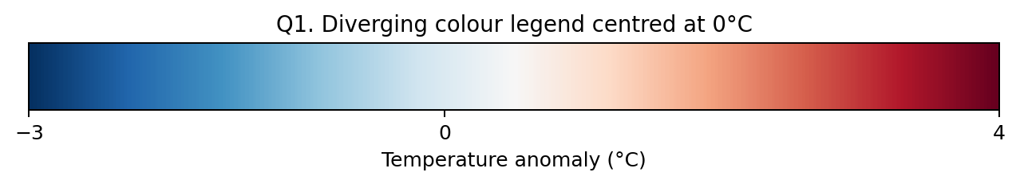
Sketch-ready interpretation: −3 | 0 | +4, with the neutral colour at 0.

Q2. Visual to Table: Reading a Colour Scale [10 marks]
Legend decoding
The heat map has five ordered classes: 0–20, 20–40, 40–60, 60–80, and 80–100. Darker blue means a higher energy-use score.

Q2(a) Reconstructed 4 × 5 table [5]
Block | Jan | Feb | Mar | Apr | May
Block A | 90 | 30 | 30 | 50 | 50
Block B | 50 | 70 | 50 | 50 | 70
Block C | 70 | 90 | 10 | 10 | 50
Block D | 70 | 10 | 10 | 90 | 30

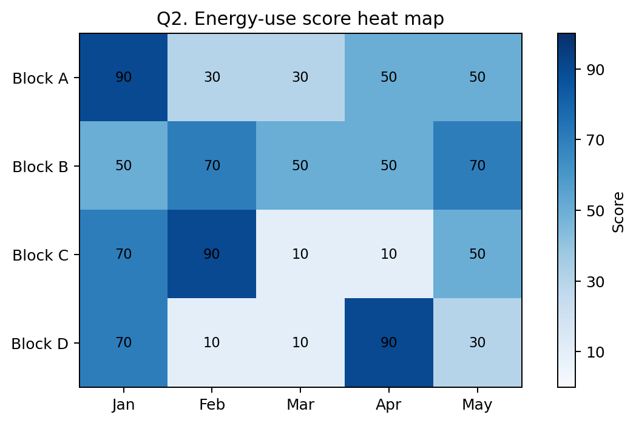
The numerical values above are representative values from the centre of each displayed class and reproduce the class structure.

Q2(b) Type of colour scale and justification [3]
Answer: Sequential colour scale.
- The values represent increasing magnitude from low to high.
- The palette changes in a single visual direction, from very light to darker blue.
- There is no meaningful positive/negative midpoint that would require two contrasting colour families.
- Because the legend is classed into intervals, it is specifically a binned/classified sequential scale.

Q2(c) Cells in the highest class [2]
Highest class = 80–100. The cells are:
- Block A – January
- Block C – February
- Block D – April
Exam tip
Do not infer exact numbers when the legend only gives intervals. The defensible answer is the class interval (80–100), unless the question explicitly asks for an exact reconstructed value.

Q3. Table to Visual: Colour as a Tool to Highlight [10 marks]

Given data
Product | Units_K
Salt | 75
Rice | 90
Oil | 60
Soap | 45
Biscuit | 95
Tea | 85
Milk | 105

Q3(a) Which products should be highlighted? [2]
Target = 77 units. Products below 77 are: Salt (75), Oil (60), and Soap (45).
- These three products are the exceptions that require managerial attention.
- Rice, Biscuit, Tea and Milk remain in the neutral baseline because they are not below the target.

Q3(b) Sketch a bar chart and choose colours [2]
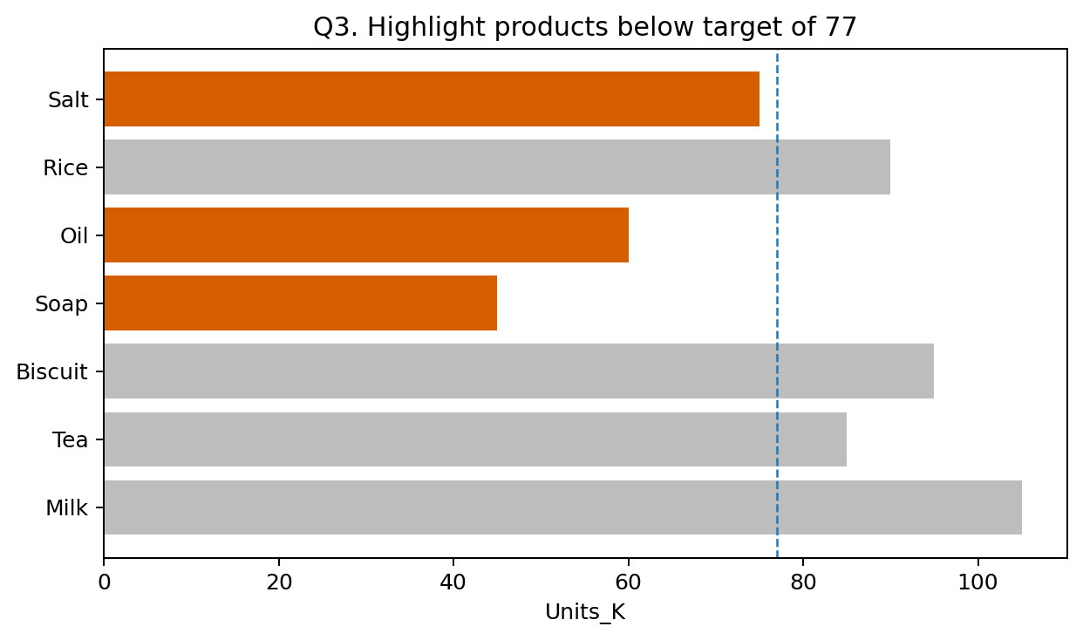
Recommended encoding: below-target bars = orange accent (#D55E00); all other bars = neutral grey (#BDBDBD). A dashed reference line at 77 can make the target explicit.

Q3(c) Colour-scale type and why rainbow is poor [4]
Best description: accent/highlight scheme rather than a conventional sequential or diverging scale.
- The purpose is not to encode seven numerical values with seven colours; the purpose is to separate one meaningful condition (below target) from the baseline.
- Grey communicates “ordinary/not the focus”, while the accent colour communicates “attention required”.
- If the lecturer requires one of the listed formal palette families, describe it as a qualitative/accent treatment because the highlighted group is a categorical condition.
- A rainbow palette would assign many hues without adding useful meaning and would weaken the visual hierarchy.

Q3(d) Keeping the highlight visible for colour-blind readers [2]
- Use colour plus a second cue: direct labels, a distinct pattern/texture, an outline, or a symbol.
- Choose an accent with strong luminance/contrast against grey; avoid relying on red versus green alone.
- A text annotation such as “Below target” or a target line at 77 makes the message understandable even without colour.

High-content R/ggplot2 implementation (useful for revision)
library(ggplot2)
df <- data.frame(
Product = c("Salt", "Rice", "Oil", "Soap", "Biscuit", "Tea", "Milk"),
Units_K = c(75, 90, 60, 45, 95, 85, 105)
)
df$Below_Target <- df$Units_K < 77
ggplot(df, aes(x = reorder(Product, Units_K), y = Units_K,
fill = Below_Target)) +
geom_col() +
geom_hline(yintercept = 77, linetype = "dashed") +
scale_fill_manual(values = c("FALSE" = "grey70",
"TRUE" = "#D55E00")) +
coord_flip() +
guides(fill = "none") +
labs(x = NULL, y = "Units_K")

Q4. R Code to Visual: Colour as a Tool to Highlight [10 marks]

Given R code
library(ggplot2)
df <- data.frame(
Name = c("R1", "R6", "R8", "R5", "R3", "R2"),
Riders_K = c(65, 60, 70, 85, 15, 90)
)
df$Top <- df$Riders_K == max(df$Riders_K)
ggplot(df, aes(x = Riders_K, y = Name, fill = Top)) +
geom_col() +
coord_flip() +
scale_fill_manual(values = c("FALSE" = "grey70",
"TRUE" = "#D55E00")) +
guides(fill = "none")

Q4(a) Sketch the chart [5]
Important values: R1=65, R6=60, R8=70, R5=85, R3=15, R2=90. The maximum is R2 = 90.
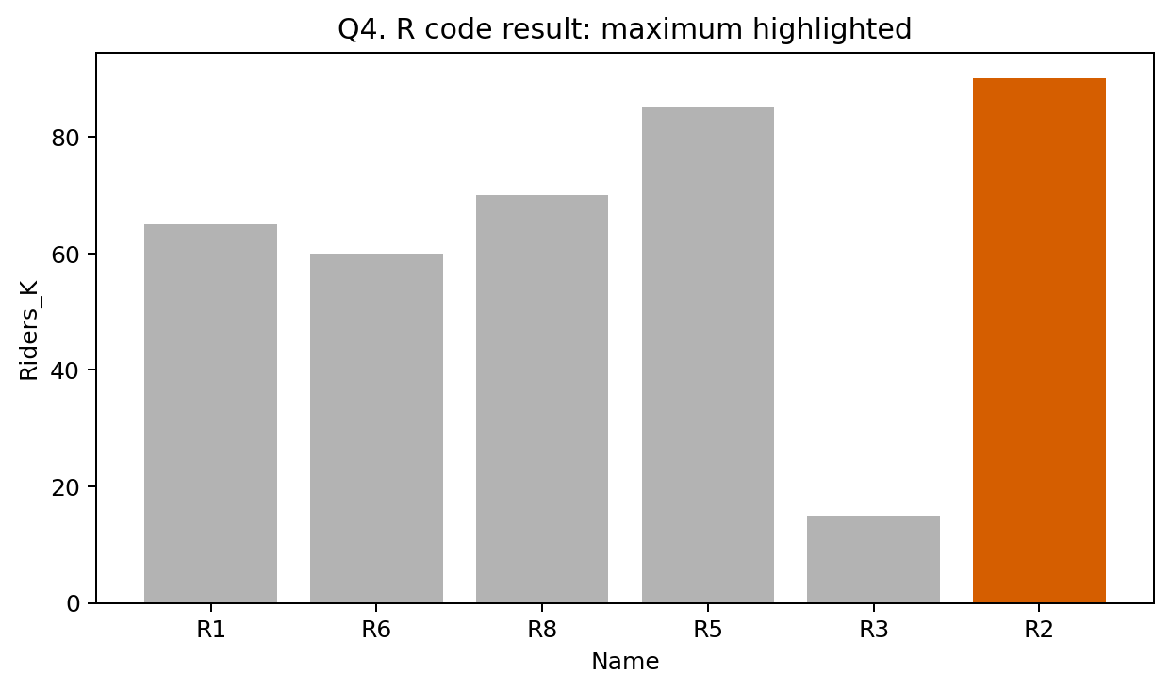
- R2 is highlighted orange because it is the only observation equal to max(Riders_K).
- All other bars are grey.
- The supplied code uses coord_flip(), so the orientation is changed from the original mapping; the key thing to show in the exam sketch is the correct names, values, and highlighted maximum.
Potential sketch wording
Show six bars with values 65, 60, 70, 85, 15 and 90. The bar for R2 is the accent colour; the remaining five are grey. Label the numeric axis Riders_K and the categorical axis Name according to the final flipped coordinate system.

Q4(b) Aesthetics, scales and coordinate system [3]
Component | Mapping / setting | Meaning
x aesthetic | Riders_K | Numeric variable controlling bar magnitude.
y aesthetic | Name | Categorical variable identifying each rider/group.
fill aesthetic | Top | Logical TRUE/FALSE variable controlling highlight colour.
geom_col() | Bar height/length | Uses the supplied numeric values directly; unlike geom_bar(), it does not count rows.
scale_fill_manual() | FALSE=grey70; TRUE=#D55E00 | Explicit discrete colour mapping.
coord_flip() | Coordinate transformation | Swaps the coordinate axes for the final displayed orientation.

Q4(c) Role of Top; what if fill = Name? [2]
Top is a logical flag. The expression df$Riders_K == max(df$Riders_K) returns TRUE only for the maximum observation (R2=90) and FALSE for every other row. That makes it ideal for an on/off highlight.
If fill = Name were used: each rider/name would become its own fill category, so the bars would receive different colours by name instead of using a single accent for the maximum. The highlight logic would therefore be lost, and a legend would normally be generated for the name categories unless explicitly removed.

Q5. Visual to R Code: Colour as a Tool to Highlight [10 marks]

Given table
Department | Placement_pct
BIO | 80
AIDS | 55
ECE | 95
EEE | 90
CSE | 50
IT | 85

Q5(a) Complete R program [7]
library(ggplot2)
df <- data.frame(
Department = c("BIO", "AIDS", "ECE", "EEE", "CSE", "IT"),
Placement_pct = c(80, 55, 95, 90, 50, 85)
)
# Sort departments from highest to lowest placement
df$Department <- reorder(df$Department, -df$Placement_pct)
# Highlight the department to be emphasised
df$Highlight <- df$Department == "ECE"
ggplot(df, aes(x = Department, y = Placement_pct, fill = Highlight)) +
geom_col() +
scale_fill_manual(
values = c("FALSE" = "grey70", "TRUE" = "#D55E00")
) +
guides(fill = "none") +
labs(x = "Department", y = "Placement percentage") +
theme_minimal()
- The reorder() step gives the intended descending order: ECE (95), EEE (90), IT (85), BIO (80), AIDS (55), CSE (50).
- The logical Highlight variable is TRUE only for ECE, so ECE receives the accent colour.
- guides(fill = "none") removes an unnecessary TRUE/FALSE legend because the colour is self-explanatory in the chart.
- The code is robust: if the placement values change, the sorting still follows Placement_pct; if the highlighted department remains ECE, only the intended category stays accented.

Alternative compact highlight logic
ggplot(df, aes(x = reorder(Department, -Placement_pct),
y = Placement_pct,
fill = Department == "ECE")) +
geom_col() +
scale_fill_manual(values = c("FALSE" = "grey70",
"TRUE" = "#D55E00")) +
guides(fill = "none")

Q5(b) Colour technique and why the other bars are grey [3]
Technique: accent highlighting / selective highlighting.
- ECE is the focal category, so it receives a saturated accent colour (#D55E00).
- All other departments are grey to create a neutral baseline and reduce visual competition.
- This creates a strong figure–ground effect: the reader's attention is pulled first to ECE, while the grey bars remain available for comparison.
- Grey does not mean “bad”; it means “not the current focus”.
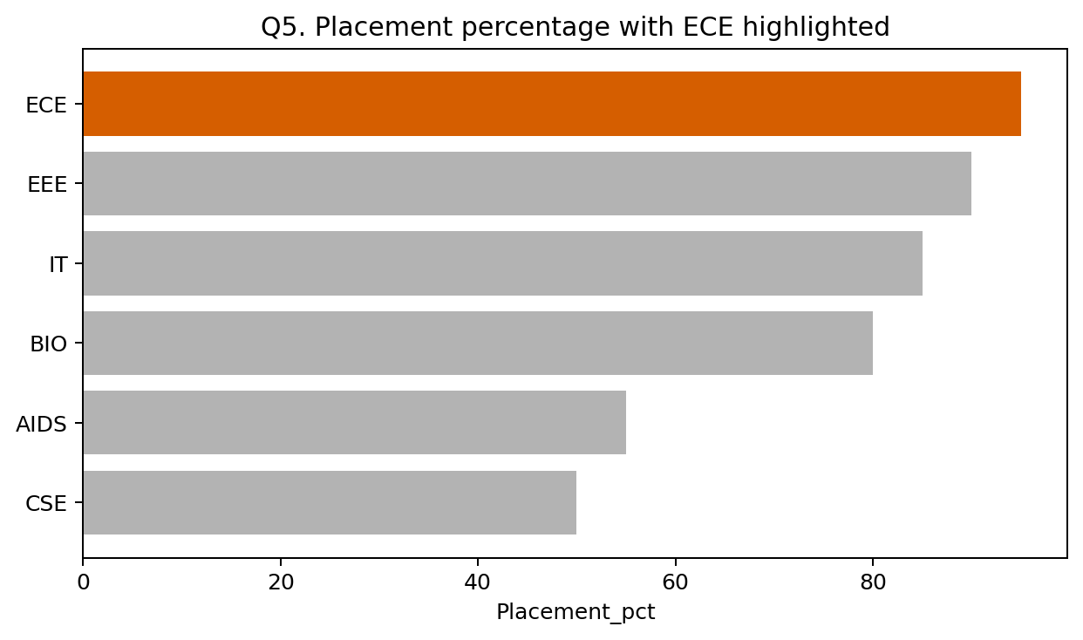
Expected order and highlight: ECE 95 (orange), EEE 90, IT 85, BIO 80, AIDS 55, CSE 50 (grey).

