

LAB EXPERIMENT RECORD

SET 1: Monthly Sales Data

Department | Artificial Intelligence and Data Science
Course Code / Course Name | DSA0601 / Data Handling and Visualization
Name / Register Number | ROHAN P T / 192424112
Date / Day | 29/09/2026

Aim
To analyze monthly sales using the requested visualizations and dashboard views.

Dataset
Monthly Sales Data
Month | Sales | Advertising_Budget
January | 15000 | 5000
February | 18000 | 6000
March | 22000 | 7000
April | 20000 | 8000
May | 23000 | 9000
.

PROGRAM 1: Line Chart of Monthly Sales
Create a line chart to visualize monthly sales. Label both axes and title the chart.
R code
dat <- data.frame(
Month = c("January", "February", "March", "April", "May"),
Sales = c(15000, 18000, 22000, 20000, 23000),
Advertising_Budget = c(5000, 6000, 7000, 8000, 9000)
)
plot(dat$Sales, type="o", xaxt="n", xlab="Month", ylab="Sales ($)", main="Monthly Sales", col="#276B9A")
axis(1, at=seq_len(nrow(dat)), labels=dat$Month)

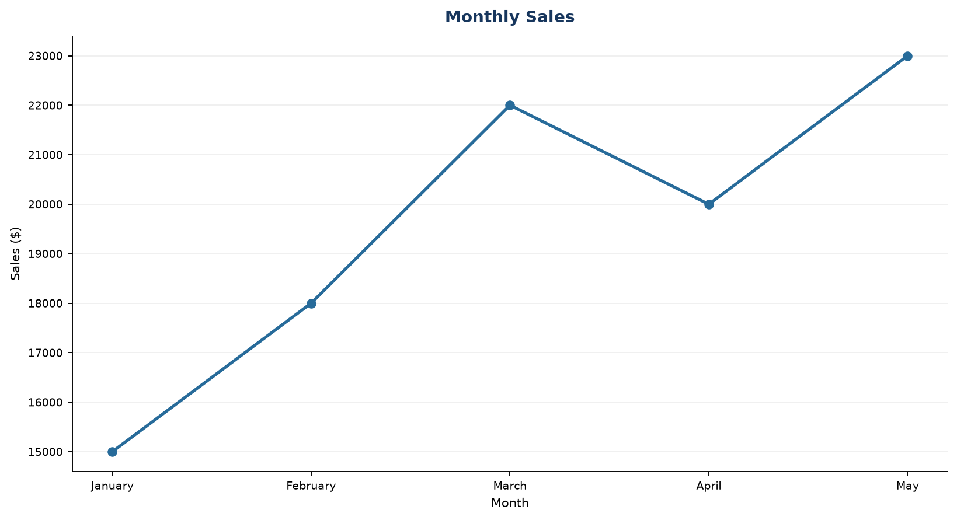
Output 1: Line Chart of Monthly Sales

Observation: Sales rise from January to March, dip slightly in April, and reach the highest value in May.

PROGRAM 2: Bar Chart of Top Selling Products
Generate a bar chart of the top-selling products for the year and label the chart elements.

R code
barplot(c(50000, 35000, 45000, 60000), names.arg=c("Product A", "Product B", "Product C", "Product D"), col="skyblue3", xlab="Products", ylab="Sales ($)", main="Illustrative Annual Sales by Product")

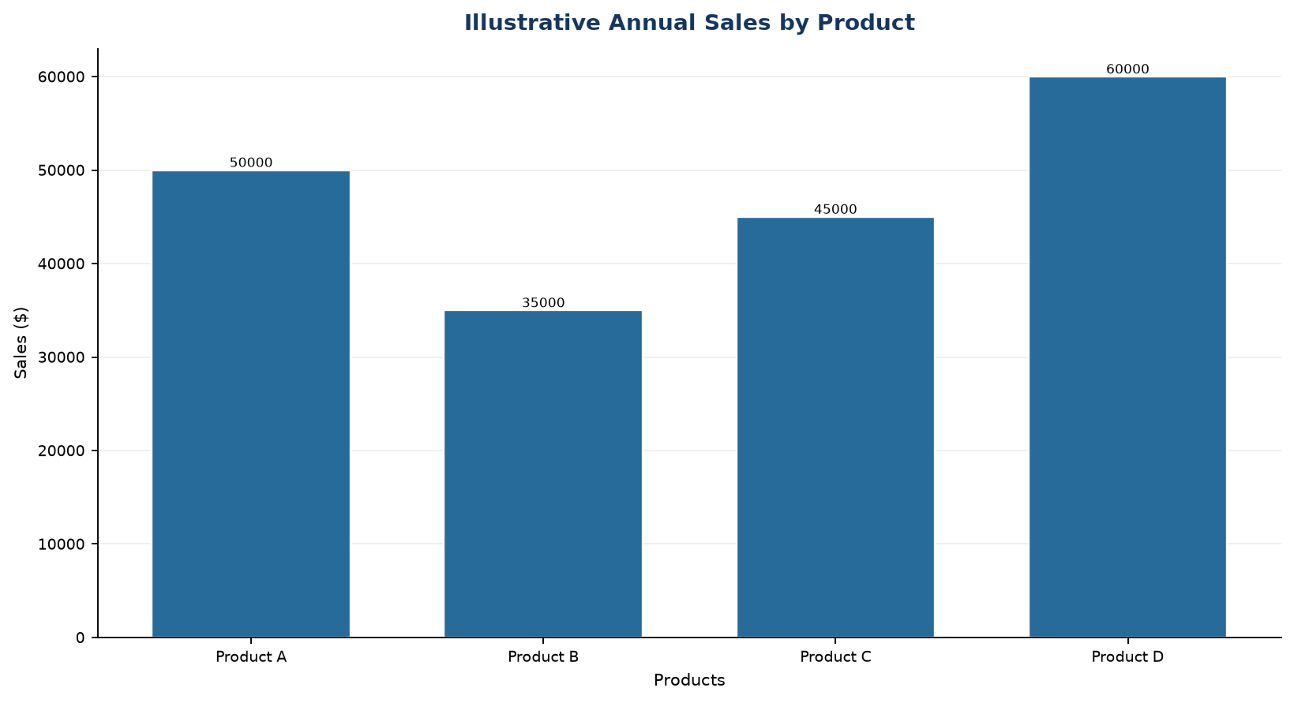
Output 2: Bar Chart of Top Selling Products

Observation: In the illustrative product series, Product D has the highest annual sales and Product B has the lowest.

PROGRAM 3: Scatter Plot of Advertising Budget and Sales
Explore the relationship between advertising budget and monthly sales with a labeled scatter plot. Explain the pattern.
R code
plot(dat$Advertising_Budget, dat$Sales, pch=19, col="#276B9A", xlab="Advertising Budget ($)", ylab="Monthly Sales ($)", main="Advertising Budget vs Monthly Sales")

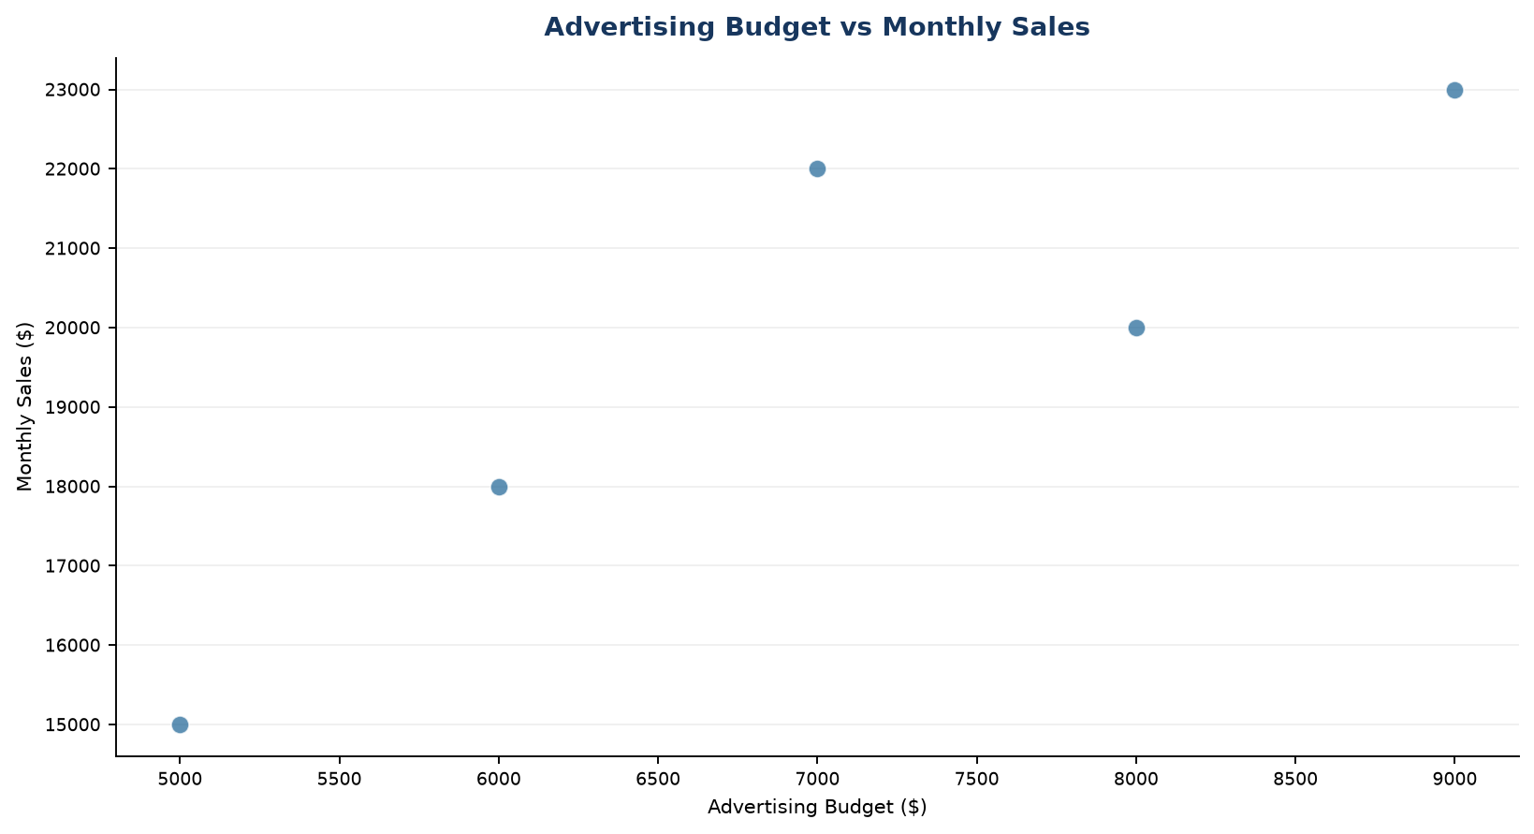
Output 3: Scatter Plot of Advertising Budget and Sales

Observation: The plotted values show a positive association: higher illustrative ad budgets align with higher monthly sales. This small series does not establish causation.

PROGRAM 4: Interactive Monthly Sales Dashboard
Build an interactive Shiny dashboard that lets the user switch between the monthly line chart and the product bar chart.
R code

library(shiny)
ui <- fluidPage(titlePanel("Monthly Sales Dashboard"),
selectInput("chart", "Select chart", c("Line Chart","Bar Chart")), plotOutput("salesPlot"))
server <- function(input, output) { output$salesPlot <- renderPlot({
if (input$chart == "Line Chart") { plot(dat$Sales, type="o", xaxt="n", xlab="Month", ylab="Sales ($)", main="Monthly Sales"); axis(1,1:nrow(dat),dat$Month) }
else { product <- c(50000,35000,45000,60000); barplot(product, names.arg=c("A","B","C","D"), main="Illustrative Product Sales", ylab="Sales ($)") }
}) }
shinyApp(ui, server)

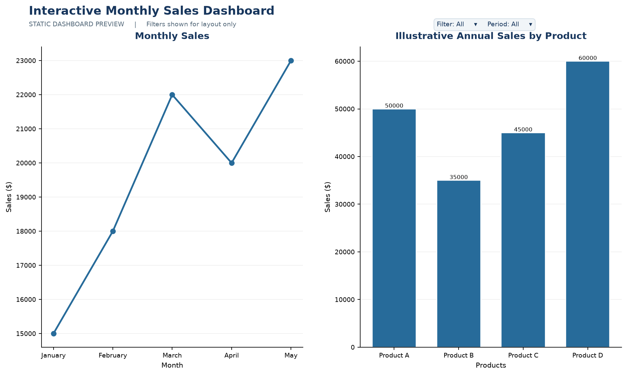
Output 4: Interactive Monthly Sales Dashboard

Observation: The preview combines the monthly trend and product comparison. The Shiny selector in the code switches between the two chart views.

Procedure
1. Review the dataset table and confirm any illustrative fields noted in the record.
2. Run the R setup block once, then run the requested program code.
3. Compare the output screenshot with the observation and replace illustrative values when actual data is available.
4. For Tableau tasks, connect to the displayed data and follow the dashboard build steps.

Result
The requested charts and dashboard views for Set 1 were prepared from the displayed dataset. Outputs include labels, short observations, and code or dashboard construction steps.

Key Functions Used
plot(), axis(), barplot(), renderPlot(), selectInput(), shinyApp().

