

LAB EXPERIMENT RECORD
SET 2: Customer Feedback Analysis

Department | Artificial Intelligence and Data Science
Course Code / Course Name | DSA0601 / Data Handling and Visualization
Name / Register Number | ROHAN P T / 192424112
Date / Day | 29/09/2026

Aim
To analyze customer feedback analysis using the requested visualizations and dashboard views.

Dataset
Customer Feedback Analysis
Customer_ID | Age | Satisfaction_Score | Age_Group
1 | 25 | 4 | 18-30
2 | 30 | 5 | 18-30
3 | 35 | 3 | 31-40
4 | 28 | 4 | 18-30
5 | 40 | 5 | 31-40

PROGRAM 1: Histogram of Customer Ages
Create a labeled histogram of customer ages.
R code
dat <- data.frame(
Customer_ID = c(1, 2, 3, 4, 5),
Age = c(25, 30, 35, 28, 40),
Satisfaction_Score = c(4, 5, 3, 4, 5),
Age_Group = c("18-30", "18-30", "31-40", "18-30", "31-40")
hist(dat$Age, col="skyblue3", border="white", xlab="Age (years)", main="Customer Age Distribution")

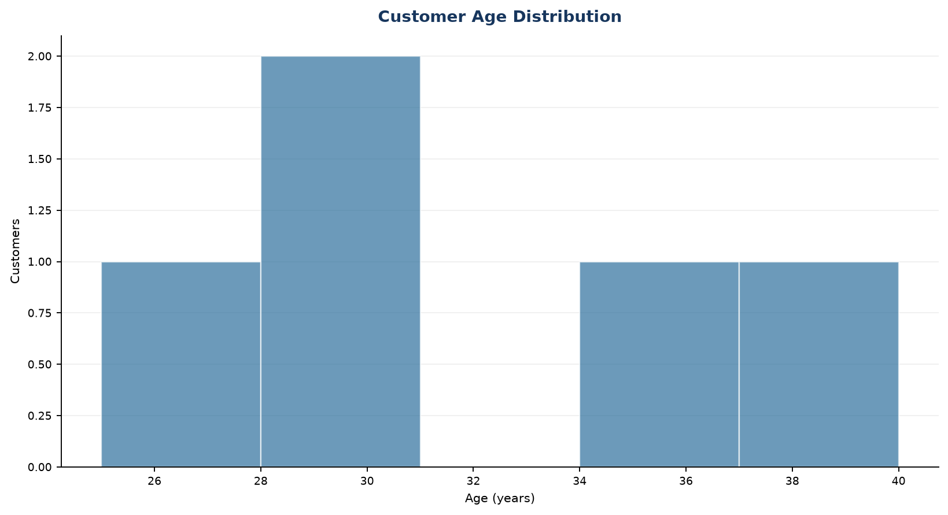
Output 1: Histogram of Customer Ages
Observation: The five customers range from age 25 to 40, with most observations in the 25-30 range.

PROGRAM 2: Pie Chart of Satisfaction Scores
Create a labeled pie chart showing the distribution of satisfaction scores.
R code
dat <- data.frame(
Customer_ID = c(1, 2, 3, 4, 5),
Age = c(25, 30, 35, 28, 40),
Satisfaction_Score = c(4, 5, 3, 4, 5),
Age_Group = c("18-30", "18-30", "31-40", "18-30", "31-40")
pie(table(dat$Satisfaction_Score), main="Customer Satisfaction Scores", col=rainbow(length(unique(dat$Satisfaction_Score))))

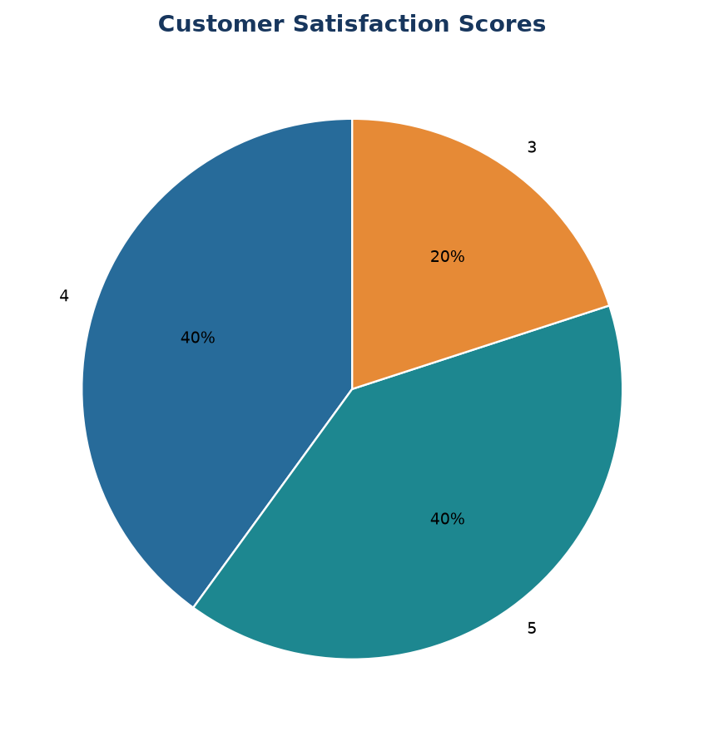
Output 2: Pie Chart of Satisfaction Scores

Observation: Scores 4 and 5 are the most frequent ratings; score 3 occurs once.

PROGRAM 3: Stacked Bar Chart by Age Group
Build a stacked bar chart showing satisfaction-score counts by age group.
R code
dat <- data.frame(
Customer_ID = c(1, 2, 3, 4, 5),
Age = c(25, 30, 35, 28, 40),
Satisfaction_Score = c(4, 5, 3, 4, 5),
Age_Group = c("18-30", "18-30", "31-40", "18-30", "31-40")
age_score <- table(dat$Age_Group, dat$Satisfaction_Score)
barplot(t(age_score), col=rainbow(ncol(age_score)), legend=TRUE, xlab="Age group", ylab="Customer count", main="Satisfaction Scores by Age Group")

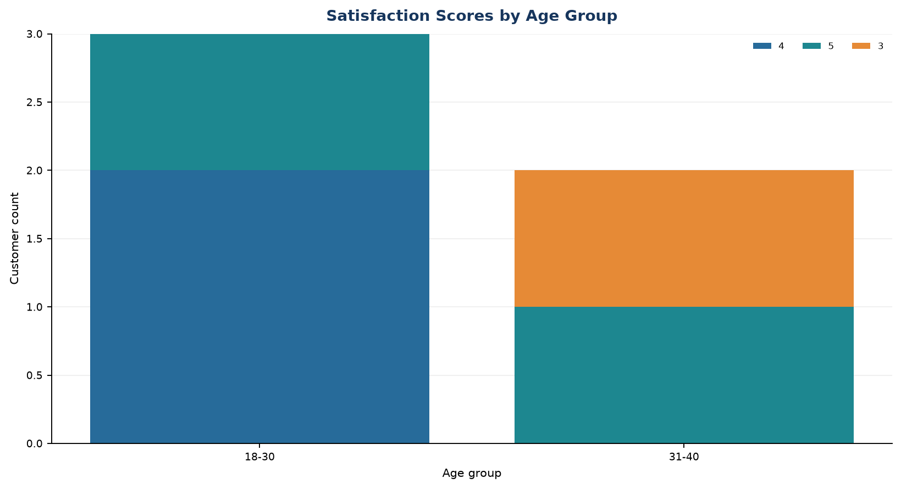
Output 3: Stacked Bar Chart by Age Group

Observation: The 18-30 group contains three customers with scores 4 or 5; the 31-40 group contains scores 3 and 5.

PROGRAM 4: Word Cloud of Customer Sentiments
Create a word cloud from open-ended customer feedback to identify common sentiments.
R code
dat <- data.frame(
Customer_ID = c(1, 2, 3, 4, 5),
Age = c(25, 30, 35, 28, 40),
Satisfaction_Score = c(4, 5, 3, 4, 5),
Age_Group = c("18-30", "18-30", "31-40", "18-30", "31-40")
install.packages("wordcloud") # run once if needed
library(wordcloud)
wordcloud(words=c("helpful", "easy", "support", "satisfied", "friendly", "quick", "clear", "reliable"), freq=c(10, 8, 7, 6, 5, 4, 3, 3), colors=c("#276B9A","#1D8790","#E68A36","#8B6BB1"), random.order=FALSE)

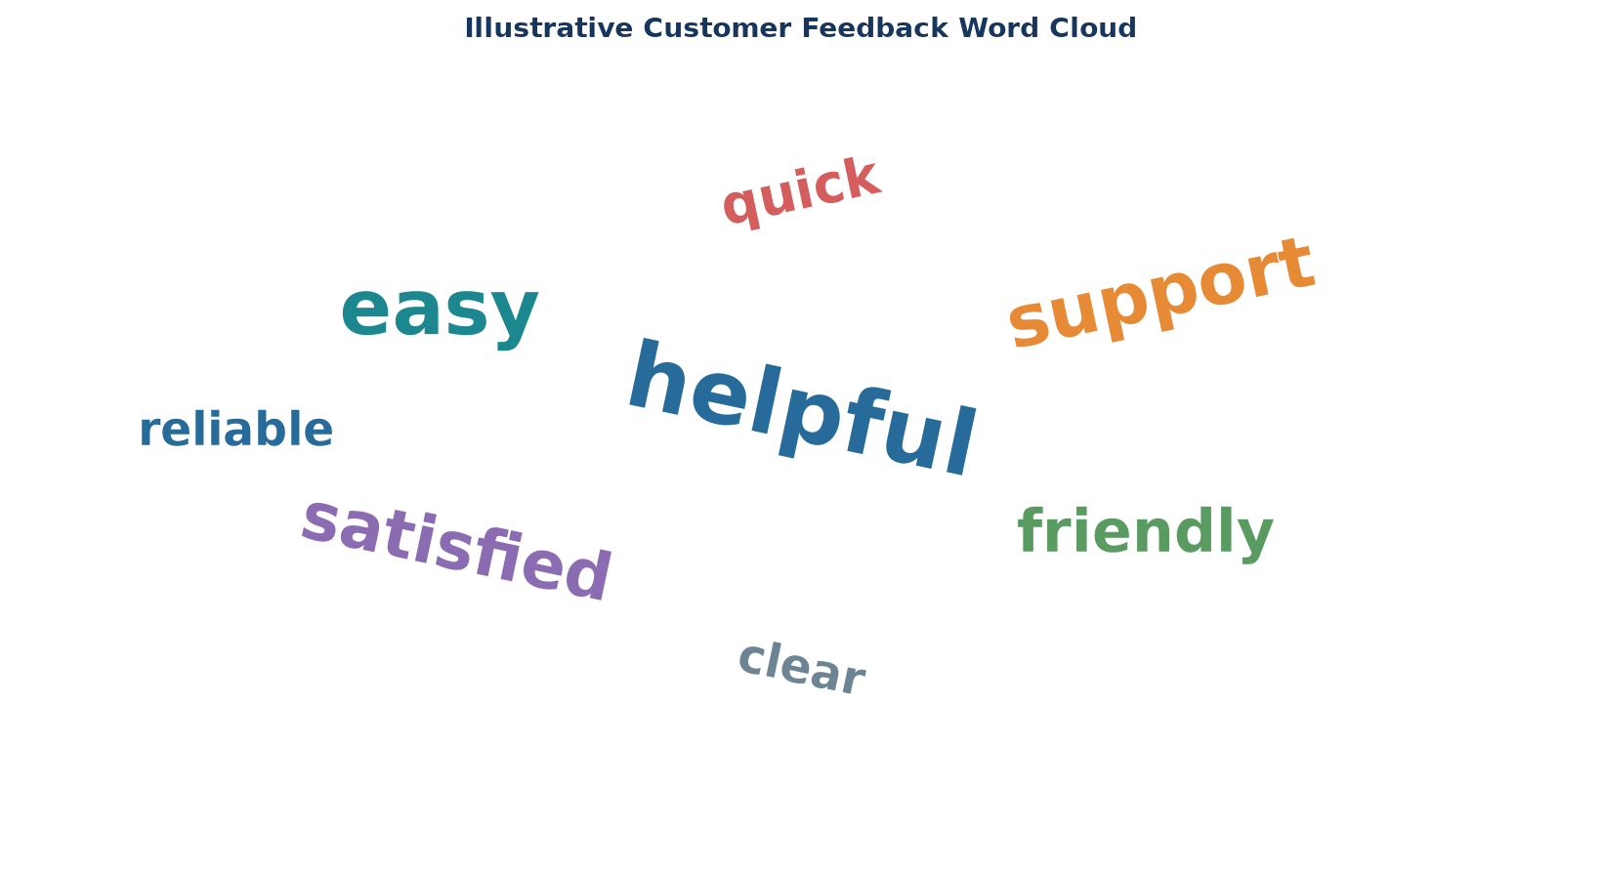
Output 4: Word Cloud of Customer Sentiments
Observation: The displayed terms illustrate the intended word-cloud output. No open-ended feedback text was included in the source data.

Procedure
1. Review the dataset table and confirm any illustrative fields noted in the record.
2. Run the R setup block once, then run the requested program code.
3. Compare the output screenshot with the observation and replace illustrative values when actual data is available.
4. For Tableau tasks, connect to the displayed data and follow the dashboard build steps.

Result
The requested charts and dashboard views for Set 2 were prepared from the displayed dataset. Outputs include labels, short observations, and code or dashboard construction steps.

Key Functions Used
plot(), barplot(), hist(), boxplot(), table().

