**3/17/2024**

Not applicable to jalr

Not added nop

Operational for add,addi

@00000000

00500293 Addi t5 t0 5

00300313 addi t6 t0 3

00002403

00100493

00940533

006283B3 add t7 t5 t6

00100493

00940533

00002403

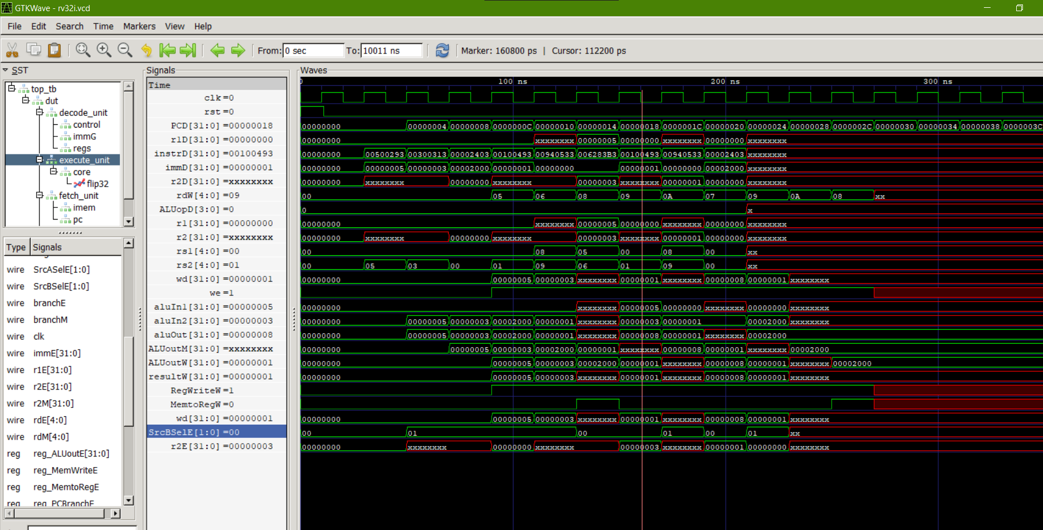

**19/3**

**Added nop**

@00000000

00500293

00300313

00000000

00000000

00000000

006283B3

00000000

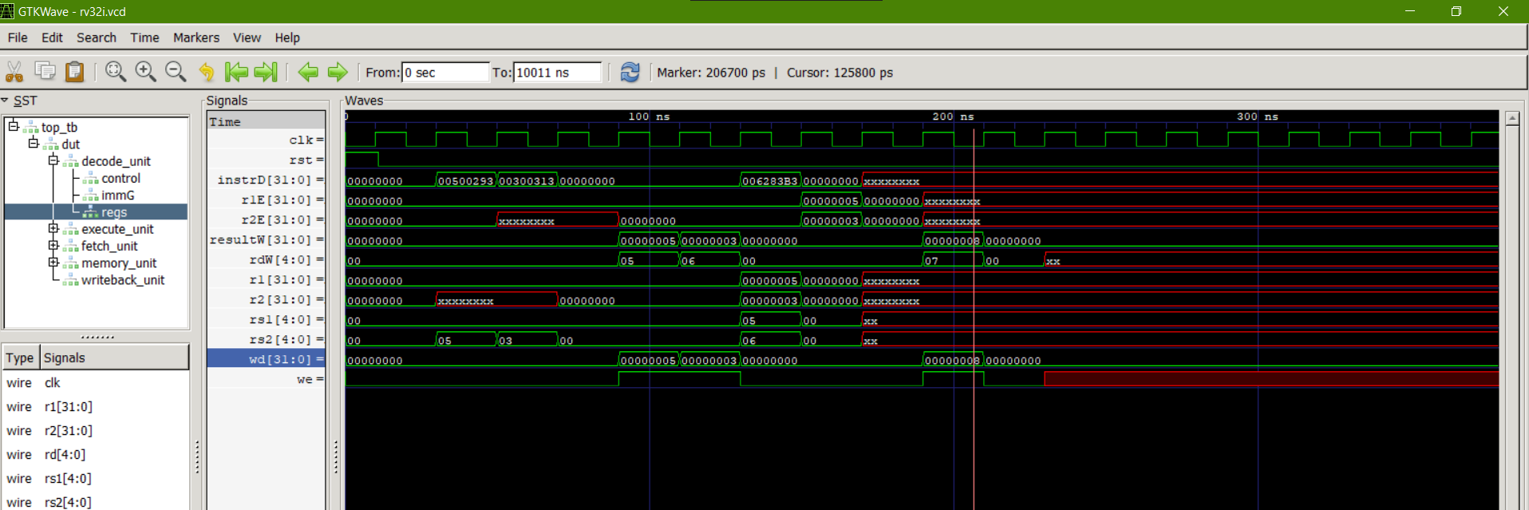

**19/3**

Load, store data path working

Data memory not working properly

Cannot handle hazards

@00000000

00500293

00300313

00000000

00000000

00000000

006283B3

00000000

00000000

00000000

00701123

00000000

00202483

00000000

00000000

00000000

00000000

00000000

00000000

