

**B2-G4**

**Course Name: Software Engineering Lab**

**Course Code: CSE-322**

**Group Id: B2-G4**

**Project Name**

QR-based E-Commerce System

|  |  |
| --- | --- |
| **Submitted to**  **Fahad Ahmed**  **Lecturer**  **Department of CSE**  **University of Asia Pacific** | **Submitted by**  **Md.Shahnaouj Alam Rohan**  **Najib Hasan Khan**  **Istiak Ahmed**  **Fatema Akter**  **Section:B-2**  **Dept.of CSE** |

**Project Version Control Link**

<https://github.com/Rohan8874/geekzone>

**Project Team Leader**:

**Md.Shahnaouj Alam Rohan ,Id:**20101092

**Team Members:**

**Najib Hasan Khan Id:**20101100

**Istiak Ahmed Id:**20101112

**Fatema Akter Id:**20101088

**Motivation**

As usual, if many students are attending the lectures, their attendance tracking may become time-consuming. Furthermore, there are some possibilities that students could cheat the lecturers of their attendance in the classroom. Therefore, a reliable method to manage attendance tracking has become a critical issue. This paper aims to propose an attendance tracking system using an Android smartphone equipped with Global Positioning System (GPS) and Near Field Communication (NFC) technologies. Lecturers and students can constantly connect by using smartphones to check and show their attendance automatically if they download and install the software Application (App). Finally, the experimental results have shown that our proposed system can successfully reduce some time for tracking students’ attendance. It also allows users to use their own Android smartphones without purchasing other electronic devices.[1]

In our project, we develop a QR-code-based tracking system where a person can track parcel information by scanning a QR code. Which is similar to the GPS.

The process of purchasing, offering for sale, or transferring goods, services, and information over computer networks is known as electronic commerce (e-commerce). E-commerce is a subset of e-business, which has a broader definition that includes business partners, customer support, and job openings in addition to commercial activities. A database or database (database), e-mail or electronic mail (e-mail), non-computer technology in the form of different delivery systems, and a method of-commerce payment are additional requirements for e-commerce in addition to networking technologies. Given that e-commerce is electronic, customers can access and place orders from many locations. Given the current state of modern technology, a client wishing to access online shopping need not physically be there, as the numerous locations in Indonesia's major cities offer Fi-enabled internet access via laptop, notebook, or Personal Digital Assistant (PDA). So, this is a crucial time for businesses to establish e-commerce services. E-commerce is still largely unused in Indonesia. Following some background information, the author talks about the benefits of e-commerce to his business goals.[2]

The choice of this work arises from my interest in the topics of entrepreneurship and technology transfer toward launching more innovative products/services. It focuses on delivering a technology, QR code, which brings more innovation to a product, especially with the current growth of mobile activities. Then, with the help of a strategic plan, it evaluates the level of potential acceptance and adoption of the proposed service and widespread use of QRs in Portugal. Thus, an interactive prototype of the supporting platform is described and used for its validation with users. Most participants in this project know the technology and consider the idea interesting and promising. They even suggest add-ons such as more video functions and a higher variety of events and/or resources for combination. However, through deeper analysis, aspects related to the effective use of the service, eventual payment, and explaining how it works reveal lower enthusiasm. Thus, although there is a promising scenario for its implementation in the Portuguese market, the training aimed at effectively knowing and using QR-code technology must evolve. Given the challenges of today’s society, the future application of this product/service shall pass through an innovation accelerator program to launch a business model that can deal with several trends such as quick and contactless use of specialized information or resources for activities in the areas of tourism, banking, health, etc. [3]

**Problem Definition**

E-commerce (electronic commerce) is the buying and selling of goods and services online. While it has become increasingly popular in recent years, there are still several problems that can arise with e-commerce. Here are some problems with e-commerce:

1. Security issues: One of the biggest problems with e-commerce is security. Consumers are often concerned about the safety of their personal and financial information when making purchases online.
2. Technical difficulties: E-commerce websites can experience technical difficulties such as slow loading times, website crashes, or payment processing errors. These issues can lead to a frustrating shopping experience for customers.
3. Shipping and delivery problems: E-commerce businesses often rely on shipping companies to deliver their products to customers. Shipping delays, damaged goods, or lost packages can cause dissatisfaction and frustration among customers.
4. Product quality issues: Customers cannot physically inspect products when shopping online. This can lead to misunderstandings about product quality or false expectations, resulting in returns and customer complaints.
5. Customer service issues: E-commerce companies must provide excellent customer service to maintain customer satisfaction. Poor customer service can result in negative reviews and loss of business.
6. Competition: E-commerce businesses face fierce competition from other online retailers, making it difficult to stand out and attract customers.
7. Fraudulent activities: E-commerce businesses are also vulnerable to fraud, such as fake reviews, payment fraud, and identity theft. These fraudulent activities can harm the reputation of the business and lead to financial losses.

From our system, we provide a Qr code scanning tracking system where the customer can easily track the order. Which enriched security issues and shipping and tracking issues.

**Objective**

The objective of e-commerce is to facilitate the buying and selling of goods and services online, making it easier, faster, and more convenient for consumers to make purchases from the comfort of their own homes or mobile devices.

The goals of e-commerce are:

1. Providing a seamless shopping experience: E-commerce websites aim to provide customers with a seamless and enjoyable shopping experience by offering user-friendly interfaces, fast page loading times, and easy navigation.
2. Increasing sales and revenue: E-commerce businesses aim to increase their sales and revenue by reaching a wider audience, reducing costs associated with physical storefronts, and creating targeted marketing campaigns.
3. Building customer loyalty: E-commerce companies strive to build customer loyalty by providing excellent customer service, offering loyalty programs, and creating personalized shopping experiences.
4. Enhancing brand awareness: E-commerce companies aim to enhance brand awareness by creating a strong online presence, using social media, and developing effective marketing strategies.
5. Streamlining business operations: E-commerce businesses aim to streamline their operations by automating processes such as inventory management, order processing, and payment processing, which can reduce costs and increase efficiency.

The objective of our project is to create an online e-commerce community where We provide a convenient, efficient, and profitable way for businesses to sell their products and services online while offering customers a fast, easy, and satisfying shopping experience the customer can buy any kind of electronic product and also sell his old products. Our priority is safely delivering products to customer Appling Qr code scanner tracking system. Where no chance of missing the product of the customer.

**Project Outputs**

E-Commerce website development is an effective tool that can help you accelerate your E-Commerce business growth and success. An E-Commerce development agency can help you build a robust website that will generate more traffic, and quality leads, as well as increase sales and business revenue.

**Impact on society**

Electronic commerce expands the marketplace to national and international markets. It decreases the cost of creating processing, distributing, and retrieving paper-based information. The Importance of E-Commerce is very wide because it reduces the transaction cost. Reduced transaction cost leads to consumer empowerment.

**Requirement analysis:**

**Basic Requirement-**

1. User-Friendly Design: The website has a clean, easy-to-navigate layout that allows users to quickly find the products they're looking for.

2. Secure Payment Gateway: The website has a secure payment gateway that allows users to make transactions safely and securely.

3. Product Catalog: The website should have a comprehensive catalog of products with clear descriptions, pricing, and availability.

4. Shopping Cart: The website must have a shopping cart feature that allows customers to add items to their cart and checkout when ready.

5. Order Management: The website should have a system for managing orders, including tracking, shipping, and handling returns.

6. Customer Support: The website must have a customer support system in place to assist customers with any questions or issues they may have.

7. Mobile Responsiveness: The website should be optimized for mobile devices since a significant portion of e-commerce traffic comes from mobile devices.

8. Search Engine Optimization: The website should be optimized for search engines to increase visibility and drive traffic to the site.

9. Analytics: The website should have analytics tools to track traffic, user behavior, and sales data to improve the site's performance and user experience.

10. Compliance: The website must comply with all relevant laws and regulations, including data privacy, online advertising, and consumer protection laws.

**Functional Requirement:**

1. User registration and authentication: The website should allow users to create accounts and log in securely, ensuring that only authorized users can access their personal information.
2. Product catalog and search: The website should have a comprehensive product catalog, including images, descriptions, and pricing. It should also allow users to search for products based on various criteria.
3. Shopping cart: The website should have a shopping cart feature that allows users to add items to their cart, review their orders, and proceed to checkout.
4. Payment gateway: The website should integrate with a secure payment gateway to process transactions, ensuring that users' financial information is protected.
5. Order management: The website should have a system for managing orders, including tracking, shipping, and handling returns or cancellations.
6. Customer support: The website should have a customer support system in place to assist users with any questions or issues they may have, such as live chat, email, or phone support.
7. User reviews and ratings: The website should allow users to review and rate products, providing valuable feedback to other users and helping them make informed purchase decisions.
8. Wish list: The website should allow users to create and manage a wish list of products they are interested in purchasing in the future.
9. Promotions and discounts: The website should allow users to apply promotional codes or discounts to their orders, providing an incentive to complete the purchase.
10. Analytics and reporting: The website should have analytics tools to track traffic, user behavior, and sales data to improve the site's performance and user experience.

**Technical Requirement:**

We Will use Agile Methodology for our project. Because of,

1. Agile is a project management methodology that emphasizes flexibility, collaboration, and iterative development. In e-commerce agile is highly effective in e-commerce, where businesses must be able to quickly adapt to changing customer needs, market trends, and technological advancements.

2. It was developed as a response to the limitations of traditional project management approaches, which often result in lengthy.

3. E-commerce companies can develop and deploy new features and functionality in a more timely and efficient manner.

4. Agile methodologies prioritize customer satisfaction, teamwork, and continuous improvement. They are designed to be highly adaptable, enabling teams to adjust their approach based on feedback and new information.

5. Agile teams work in short, focused bursts called sprints, during which they deliver incremental improvements to a project.

We Use **MVC- Model-View-Controller** for our design pattern.

Because it is a software architectural pattern commonly used in the development of web applications. The main idea behind MVC is to separate an application into three interconnected components: the model, the view, and the controller.

In an e-commerce application, the model component would typically be responsible for managing product information, customer information, orders, and transactions. The view component would be responsible for displaying the products to the user, allowing them to browse and search for items, and displaying the contents of their shopping cart. The controller component would handle the user's interactions with the application, such as adding items to the cart, placing an order, and processing payments.

**Methodology:**

**Use-Case Diagram-**

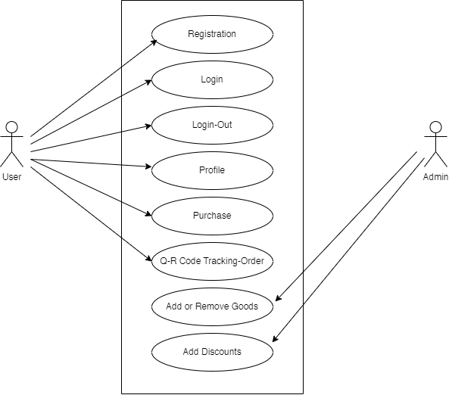

**E-R Diagram-**

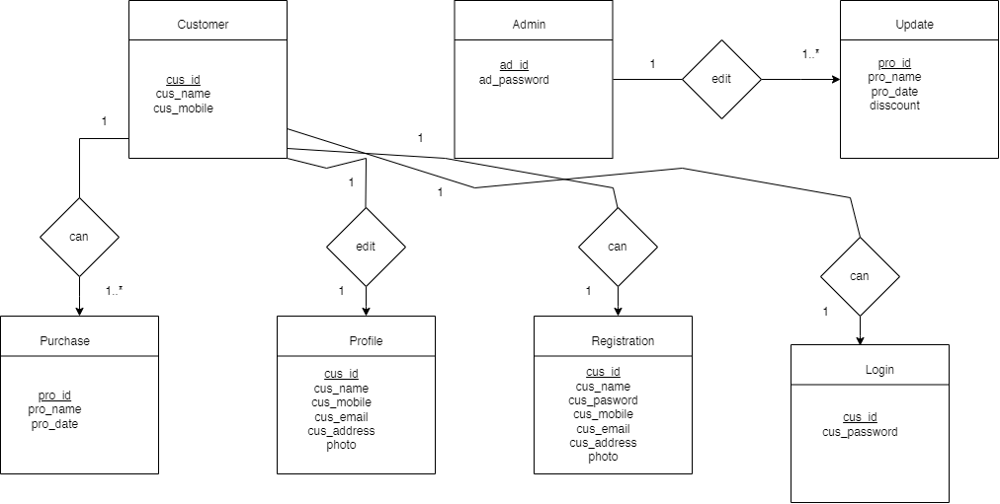

**We follow Agile methodology; We will have 10 modules-**

|  |  |  |  |
| --- | --- | --- | --- |
| **Module-1(Pre-Production)** | | | |
| Sprint | Steps | Activity | Backlog |
| 1. Assemble the development  team.  2. Define the E-commerce concept  and design.  3. Create the website design  document.  4. Logo Design. | Analysis | Team ready | - |
| Design | E-R and use case diagram  Draw.io |
| Code | - |
| Test | - |
| Feedback | - |

|  |  |  |  |
| --- | --- | --- | --- |
| **Module-2(Front-end)** | | | |
| Sprint | Steps | Activity | Backlog |
| 1. Navigation  2. Homepage  3.Based.html  4.Alpha Testing | Analysis | Set navbar | * Set navigation bar * Add search box white * Cart, wishlist button add white |
| Design | Figma |
| Code | - |
| Test | - |
| Feedback | ok |

|  |  |  |  |
| --- | --- | --- | --- |
| **Module-3(Database)** | | | |
| Sprint | Steps | Activity | Backlog |
| 1. Make Models 2. Develop a user interface 3. Created Banners 4. Create the pages of the website 5. Alpha Testing | Analysis | - | * Add states |
| Design | dbsql |
| Code | - |
| Test | Ok |
| Feedback | ok |

|  |  |  |  |
| --- | --- | --- | --- |
| **Module-4(Authentication)** | | | |
| Sprint | Steps | Activity | Backlog |
| 1.Set profile  2.Update profile  3.Develop a user interface  4.Create the pages of the websites  5. Alpha Testing | Analysis | - | * Mail address add * Personal information |
| Design | Figma |
| Code | ok |
| Test | ok |
| Feedback | ok |

|  |  |  |  |
| --- | --- | --- | --- |
| **Module-5(User-Profile)** | | | |
| Sprint | Steps | Activity | Backlog |
| 1. Set profile information 2. Add personal information 3. Develop a user interface 4. Create pages for the website 5. Alpha Testing | Analysis | - | * Customers add personal information * Name * City * Zip code * Mobile number |
| Design | Figma |
| Code | Ok |
| Test | Ok |
| Feedback | ok |

|  |  |  |  |
| --- | --- | --- | --- |
| **Module-6(Add-cart)** | | | |
| Sprint | Steps | Activity | Backlog |
| 1. Finalize cart 2. Add personal information 3. Develop a user interface 4. Create pages for the website 5. Alpha Testing | Analysis | - | * Customers add products * Name * City * Zip code   Mobile number |
| Design | Figma |
| Code | Ok |
| Test | Ok |
| Feedback | ok |

|  |  |  |  |
| --- | --- | --- | --- |
| **Module-7(Order)** | | | |
| Sprint | Steps | Activity | Backlog |
| 1. Customer will place their order 2. Add personal information 3. Develop a user interface 4. Create pages for the website 5. Alpha Testing | Analysis | - | * Customers add products that they want buy * Name * City * Zip code   Mobile number |
| Design | Figma |
| Code | Ok |
| Test | Ok |
| Feedback | ok |

|  |  |  |  |
| --- | --- | --- | --- |
| **Module-8(Tracking)** | | | |
| Sprint | Steps | Activity | Backlog |
| 1. Customer will track the order 2. Add personal information 3. Develop a user interface 4. Create pages for the website 5. Alpha Testing | Analysis | - | * Customers track the goods * Name * City * Zip code   Mobile number |
| Design | - |
| Code | Ok |
| Test | Ok |
| Feedback | ok |

|  |  |  |  |
| --- | --- | --- | --- |
| **Module-9(Testing)** | | | |
| Sprint | Steps | Activity | Backlog |
| 1. Beta testing 2. Bug fixing | Analysis | - | - |
| Design | - |
| Code | - |
| Test | Beta Testing ok |
| Feedback | ok |

|  |  |  |  |
| --- | --- | --- | --- |
| **Module-10(Release)** | | | |
| Sprint | Steps | Activity | Backlog |
| 1. Release the website 2. Address any issues and bugs. 3. Implement any updates or new features. | Analysis | - |  |
| Design | - |
| Code | - |
| Test | Ok |
| Feedback | - |

**Project Developing Resources-**

* Model: Agile
* Design Pattern: MVC – The Model-View-Controller Pattern
* Framework: Django Framework
* Database: DbSQLite
* API: Qr genera
* Testing and Debugging: Selenium
* User-Interface: Adobe Xd

**Final Result:**

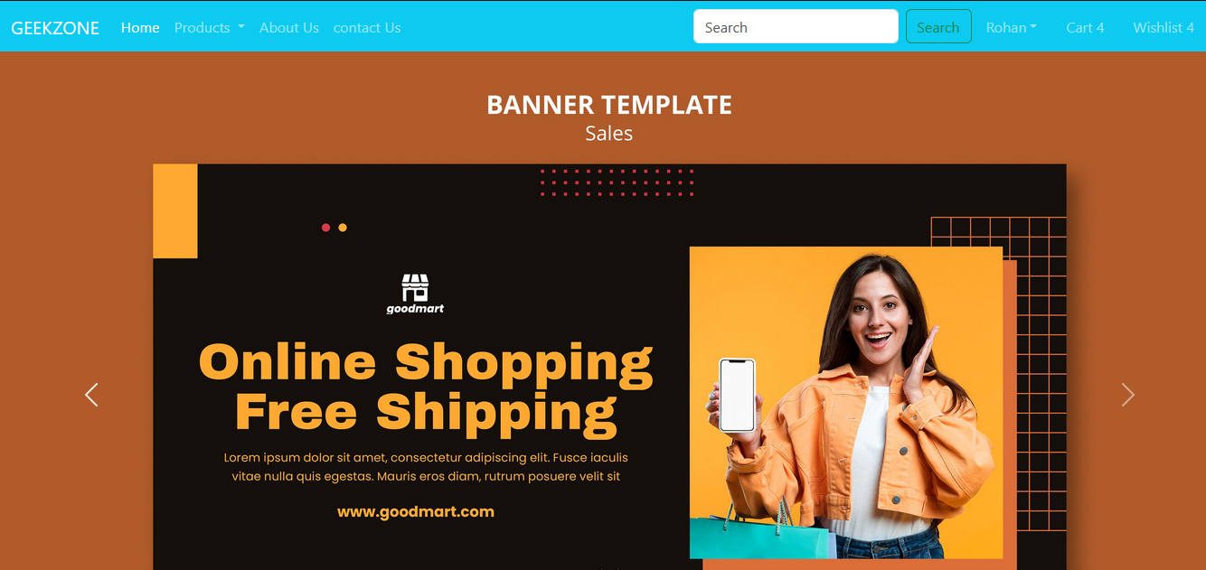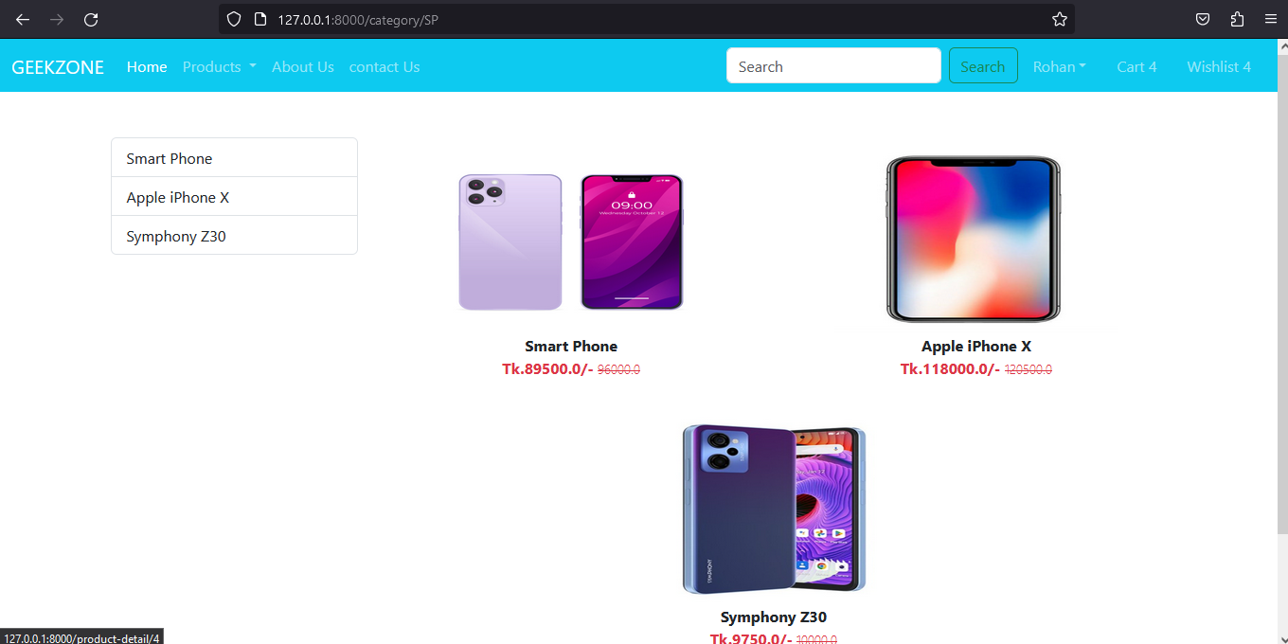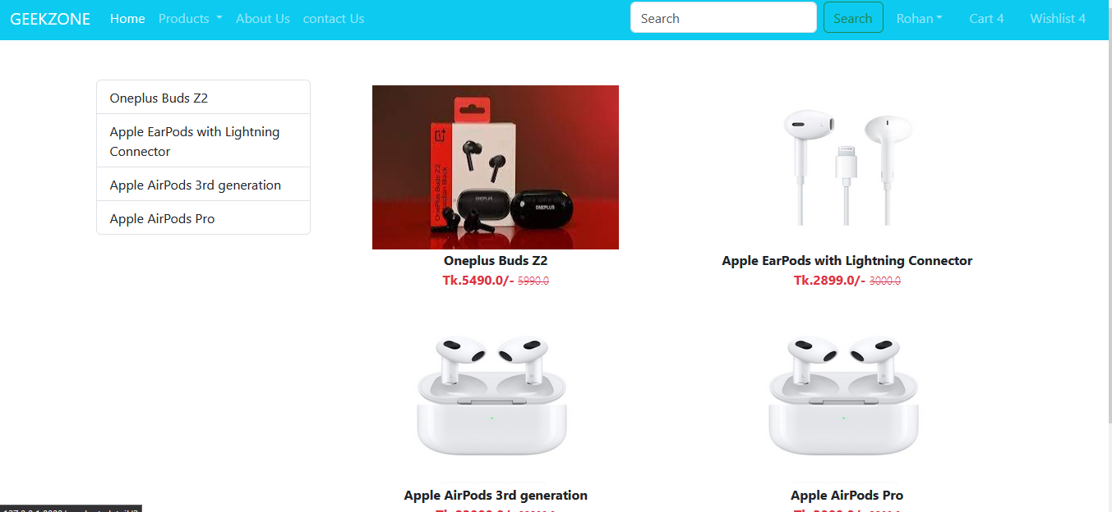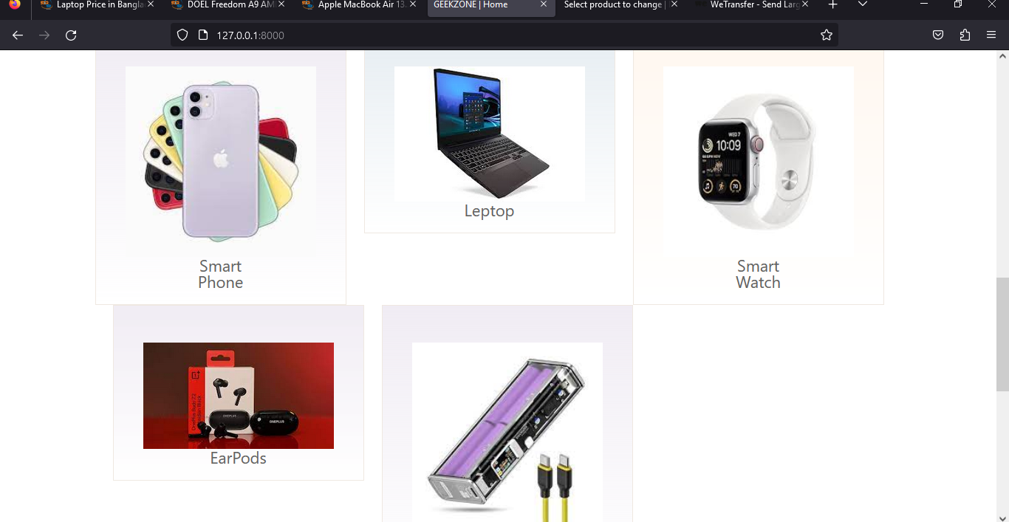

**Project Management:**

**Project Timeline-**

|  |  |  |  |
| --- | --- | --- | --- |
| **Phase** | **Name** | **Activity** | **Duration** |
| Module-1 | **Pre-Production** | Assemble the development  team.  2. Define the E-commerce concept  and design.  3. Create the website design  document.  4. Logo Design | 10 Days |
| Module-2 | Front-end | Navigation  2. Homepage  3.Based.html  4.Alpha Testing | 15 Days |
| Module-3 | **Database** | 1. Make Models 2. Develop a user interface 3. Created Banners 4. Create the pages of the website 5. Alpha Testing | 7 Days |
| Module-4 | **Authentication** | 1.Set profile  2.Update profile  3.Develop a user interface  4.Create the pages of the websites  5. Alpha Testing | 12 Days |
| Module-5 | **User-Profile** | 1. Set profile information 2. Add personal information 3. Develop a user interface 4. Create pages for the website   Alpha Testing | 7 Days |
| Module-6 | **Add-cart** | 1. Finalize cart 2. Add personal information 3. Develop a user interface 4. Create pages for the website 5. Alpha Testing | 10 Days |
| Module-7 | **Order** | 1. Customer will place their order 2. Add personal information 3. Develop a user interface 4. Create pages for the website | 10 Days |
| Module-8 | **Tracking** | 1. Customer will track the order 2. Add personal information 3. Develop a user interface 4. Create pages for the website   Alpha Testing | 20 Days |
| Module-9 | **Testing** | 1. Beta testing   Bug fixing | 7 Days |
| Module-10 | **(Release)** | 1. Release the website 2. Address any issues and bugs.   Implement any updates or new features. | 5 Days |

**Grant-Chart:**

**Version Control System Commit Snapshot:**

**Finance Management- According to the Project Module:**

|  |  |  |
| --- | --- | --- |
| **Activity** | **Hours** | **Cost in Taka** |
| Data Collection | 60 | 10000 |
| Background study | 55 | 12000 |
| Data labeling | 50 | 15000 |
| User Interface Development | 70 | 50000 |
| Testing Website | 40 | 25000 |
| Documentation | 350 | 30000 |
| Total | 625 | 142000 |

**Conclusion and Future Work:**

In conclusion, E-commerce has become an integral part of modern-day businesses, providing a convenient and efficient way for customers to shop for products and services online. The global e-commerce market has experienced rapid growth in recent years, and this trend is expected to continue as more consumers shift toward online shopping. E-commerce has also brought about new business models, such as drop shipping, subscription-based services, and social commerce, which have disrupted traditional retail models.

To succeed in the e-commerce market, businesses must prioritize user experience, mobile optimization, and customer engagement.

**Future work:**

The e-commerce market is constantly evolving, and businesses must adapt to stay relevant. Some of the key areas that require attention in the future include:

1. Sustainable e-commerce: As consumers become more conscious of their environmental impact, businesses must prioritize sustainable practices in their operations, including the use of eco-friendly packaging and shipping methods.
2. Cross-border e-commerce: With the growth of international trade, cross-border e-commerce is becoming increasingly important. Businesses must develop strategies to navigate the challenges of global e-commerce, including language barriers, cultural differences, and legal regulations.
3. Voice commerce: As voice assistants become more prevalent, businesses must develop strategies to optimize their e-commerce platforms for voice-based interactions.
4. Privacy and security: With the increasing amount of personal data being shared online, businesses must prioritize privacy and security to build trust with their customers.

Overall, the e-commerce market offers immense opportunities for businesses to grow and expand their reach. By prioritizing user experience, embracing emerging technologies, and adapting to changing consumer preferences, businesses can succeed in the competitive e-commerce landscape.

**Report quality and Formatting:**

**References:**

1. Mercel Vubangsi, Fadi Al-Turjman. (2022) Design and Implementation of a Conference Attendance Monitoring System Using Blockchain and AI Technologies. *2022 International Conference on Artificial Intelligence in Everything (AIE)*, pages 197-202.

2. Kedah, Zulkarnain. 2023. “Use of E-Commerce in The World of Business”. Startupreneur Bisnis Digital (SABDA Journal) 2 (1):51-60. <https://doi.org/10.34306/sabda.v2i1.273>.

3. Bolzan, R., Ventura, P., Fernandes, S., & L. Carvalho, F. (2022, September 30). QR Codes: A Case of its Level of Adoption in Portugal. Journal of Tourism, Sustainability and Well-Being, 10(3), 189-200. <https://doi.org/https://doi.org/10.34623/shz5-fs67>.

**Appendix-A:**

**CEP MAPPING-**

**How Ks is addressing the project:**

|  |  |  |
| --- | --- | --- |
| **Ks** | **Attribute** | **How Ks is addressed through the project** |
| K2 | Mathematics | In math, we use the total of purchases, count the number of product |
| K3 | Engineering Fundamentals | Python |
| K4 | Specialist Knowledge | Gps and Q-r code implement in Django |
| K5 | Engineering Design | Agile methodology, ER Diagram, Use Case Diagram, the MVC architectural model. |
| K6 | Engineering Practice | Github, Website Testing |
| K8 | Research Literature | Gps tracking through Q-r code regenerating  Socially impact on flexible shopping  Secure delivery development |

**How Ps is addressing the Project:**

|  |  |  |  |  |
| --- | --- | --- | --- | --- |
| **Ps** | **Attribute** | **How Ps is addressed through the project** | **CO** | **PO** |
| P1 | Depth of Knowledge Requirement | * (K-3) Engineering Fundamentals: The project requires knowledge of E-KYC and a good understanding of concepts of the Django framework. Knowledge of Programming languages (Python, HTML, CSS), Data Analysis is also required. * (K-5) Engineering Design: Here we are using modern engineering design to identify and solve the problem with a powerful and more efficient approach * (K-6) Engineering Practices: On this proposed system there will be a web-based frontend and integration of different components in the backend. Which will be great engineering practices for this system. * (K-8) research literature: P1: Our project requires the study of existing models with similar goals such as a similar international e-commerce site like Amazon, or Alibaba. We have identified and analyzed all the features and Qr code Scanner tracking product system and tried to implement the simplest features for our project. | CO-1  CO-3  CO-4  CO-6 | PO-(l)  PO-(c)  PO-(e)  PO-(h) |
| P2 | Range of Conflicting requirement | * Customers insist on more choices regarding where, when, and how they can purchase goods – including buying directly from brand manufacturers. * As they continue to become more digitally connected, there is a growing demand from * buyers who prefer to make their purchases outside of traditional channels | CO-1 | PO-(l) |
| P3 | Depth of Analysis Required | * Market research for conduct thorough market research to identify potential customers, competitors, and market trends. * Understanding customer behavior is critical for e-commerce businesses to improve customer satisfaction and retention. | CO1  CO2 | PO(l) |
| P6 | Diverse Group of Stakeholders | * The diverse group of stakeholders like the Shop owners Retailers and purchasers will be benefited from this project. | CO3 | PO(k) |
| P7 | Interdependence | * The project involves only software-based and application models | CO-2  CO-7 | PO(b)  PO(i) |

**How As is Addressing the Project:**

|  |  |  |  |  |
| --- | --- | --- | --- | --- |
| **As** | **Attribute** | **How As is addressed through the project** | **COs** | **POs** |
| A1 | Ranges of Resources | Python for backend development, Django for framework, HTML CSS JavaScript, and bootstrap and relational database dbSQL.Using Gps tracking system,  People,money | CO8 | PO(j) |
| A3 | Innovation | We use QR code generetation tracking system where scanning qr code the person will show the current position of the percel | CO1  CO2  CO3 | PO(a)  PO(b)  PO© |
| A4 | Consequences for Society and Environment | Electronic commerce expands the marketplace to national and international markets. It decreases the cost of creating processing, distributing, and retrieving paper-based information. The Importance of E-Commerce is very wide because it reduces the transaction cost. Reduced transaction cost leads to consumer empowerment. | CO8 | PO(j) |