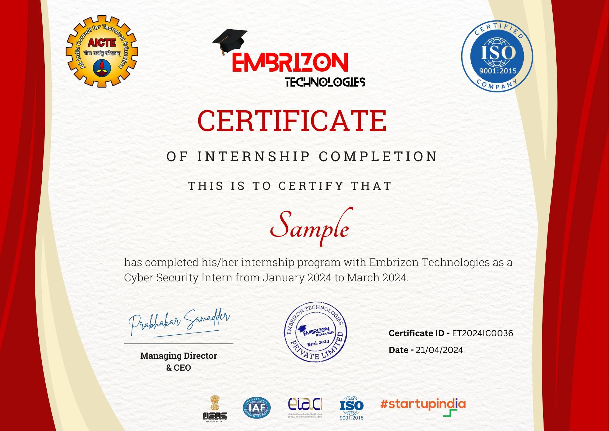

**Kabde Shruthi**

has completed his/her internship program with **Embrizon Technologies** as **Front-End Web Development** Intern from October 2024 to November 2024

15-12-2024

ET2024IC2038