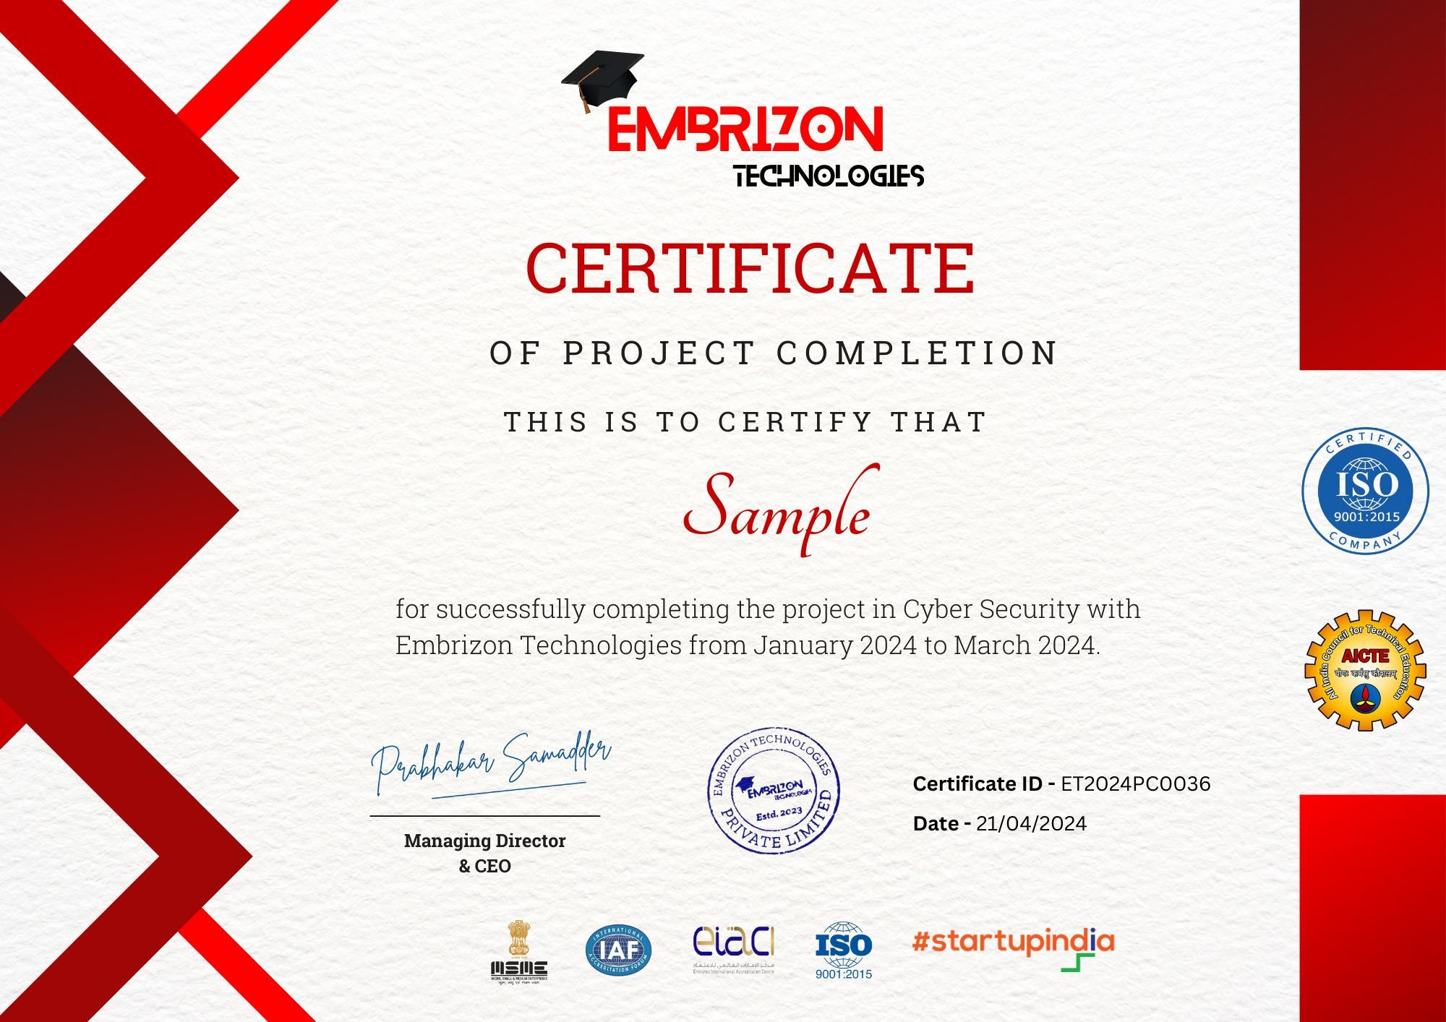

For successfully completing the Project in **Front-End Web Development** with **Embrizon Technologies** from October 2024 to November 2024

CERTIFICATE

**Kabde Shruthi**

OF PROJECT COMPLETION

THIS IS TO CERTIFY THAT

**Certificate ID -** ET2024PC2038

**Date –** 15-12-2024