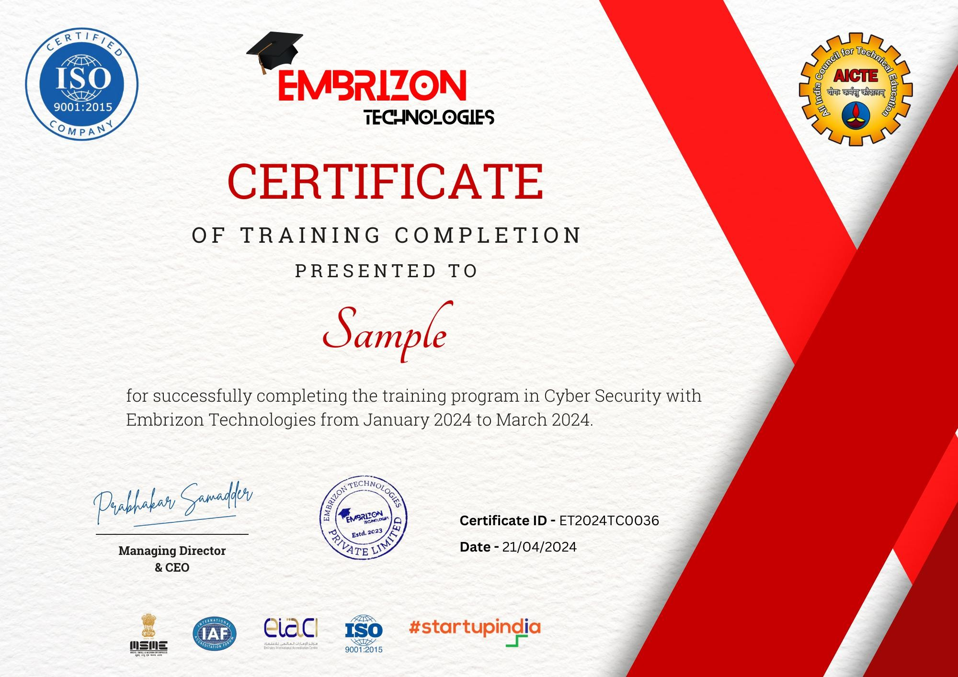

<TC>

For successfully completing the training program in **<Domain>** with **Embrizon Technologies** from October 2024 to November 2024

15-12-2024

**<Name>**