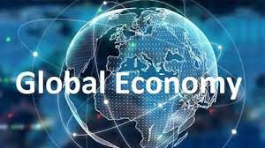

Challenge Title: IBM Hack challenge 2023

Project ID:SPS_PRO_3589

Project Title: Global Economic Data

Technology Track: Data Analytics

Team Name: Economy Team

Team Size:4

College Name: Narasaraopeta Engineering College

**INTRODUCTION**

**1.1 Overview:**

Global economic data refers to the comprehensive collection of statistical information and indicators that provide insights into the overall health, performance, and trends of the world's economies. This data encompasses various aspects of economic activity, including gross domestic product (GDP), inflation rates, unemployment rates, trade balances, consumer spending, industrial production, and more. These indicators are collected and reported by government agencies, international organizations, and private institutions. Global economic data serves as a crucial tool for policymakers, businesses, investors, researchers, and the general public to assess the state of the global economy, make informed decisions, and formulate strategies. It helps in monitoring economic growth, identifying potential risks, evaluating the effectiveness of economic policies, and comparing the performance of different countries or regions. Key sources of global economic data include organizations like the International Monetary Fund (IMF), World Bank, World Trade Organization (WTO), United Nations (UN), and various national statistical agencies. These sources compile and disseminate data regularly, enabling stakeholders to analyze and interpret economic trends on both a macro and micro level.



1.2 **Purpose:**

* The use of global economic data can lead to a wide range of achievements and benefits across various aspects of society and the economy. Some of the key achievements that can be realized through the use of global economic data include: Informed
* Decision-Making: Global economic data provides accurate and up-to-date information that helps individuals, businesses, and governments make informed decisions. This leads to better resource allocation, improved strategies, and more effective policies.
* Stable and Sustainable Economies: By analyzing economic indicators, policymakers can implement measures to promote economic stability and sustainable growth. This includes managing inflation, controlling unemployment, and avoiding economic downturns.
* Effective Monetary and Fiscal Policies: Central banks and governments can use economic data to fine-tune monetary and fiscal policies. This can result in controlled inflation, stable interest rates, and overall economic resilience.
* Risk Management: Businesses, financial institutions, and regulators can identify potential risks in the economy and financial markets using economic data. This helps prevent or mitigate financial crises and disruptions. Accurate Investment Decisions: Investors can make more accurate investment decisions by analyzing economic data. This leads to better returns on investments and reduced exposure to financial volatility.
* Optimized Trade Strategies: Countries can formulate trade policies based on economic data, leading to enhanced export opportunities, improved trade balances, and economic growth.
* Poverty Reduction and Development: Economic data guides development efforts by targeting interventions to specific areas of need. This leads to poverty reduction, improved living standards, and overall human development.
* Transparent Governance: Economic data fosters transparency in government activities and economic management. This helps build trust between governments and citizens and reduces the potential for corruption.
* Innovation and Entrepreneurship: Entrepreneurs and innovators use economic data to identify market trends and consumer demands, leading to the creation of products and services that cater to the needs of the economy
* 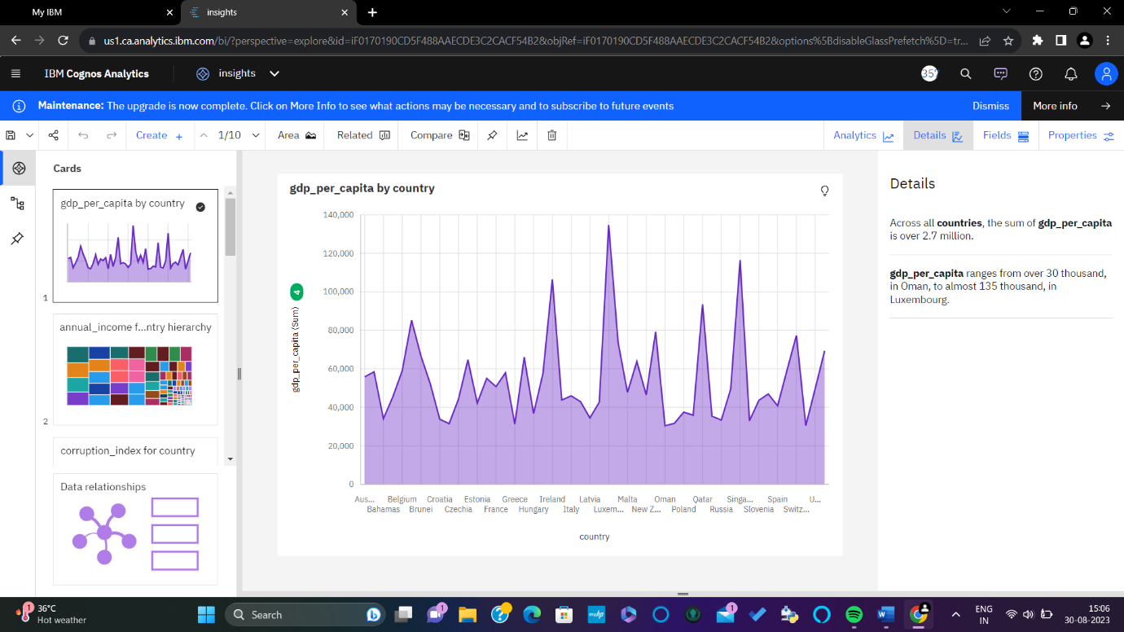

**LITERATURE SURVEY**

2.1 **Existing Problem**:

Solving global economic data challenges involves a combination of approaches, methods, and technologies to improve data collection, accuracy, analysis, and dissemination. Here are some existing approaches and methods that contribute to addressing these challenges

1. Standardization and Harmonization: Establishing standardized definitions, classifications, and methodologies for collecting economic data helps ensure consistency and comparability across countries and regions. International organizations like the United Nations and World Bank play a role in setting these standards.
2. Technology-Driven Data Collection: Utilizing technology such as satellite imagery, remote sensing, and mobile surveys can help collect economic data in regions with limited infrastructure or remote areas. Mobile apps and digital platforms can enable more efficient data collection.

**2.2Proposed Solution:**

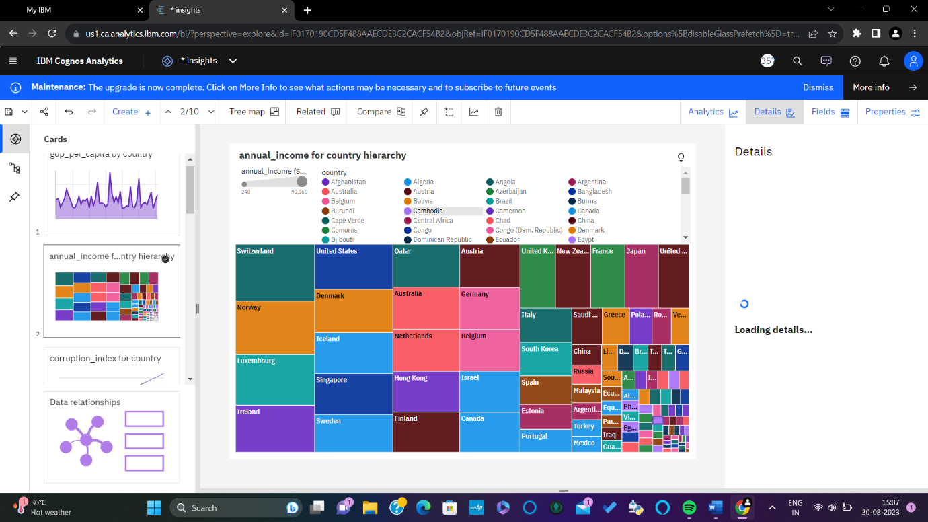

Addressing the challenges related to global economic data requires a multifaceted approach that combines technological advancements, international collaboration, and improved data governance. Here's a proposed solution framework:

1. Global Data Standards and Collaboration: Establish standardized definitions, methodologies, and classifications for economic data collection across countries and regions. Foster international collaboration through organizations like the United Nations, World Bank, and G20 to create a unified framework for economic data reporting.
2. Technology-Enabled Data Collection: Invest in technology-driven data collection methods, such as satellite imagery, remote sensing, and mobile surveys, to capture economic activities in remote or data-scarce areas. Develop user-friendly mobile apps and digital platforms for efficient and real-time data reporting.

**THEORITICAL ANALYSIS**

**3.1 Block Diagram:**

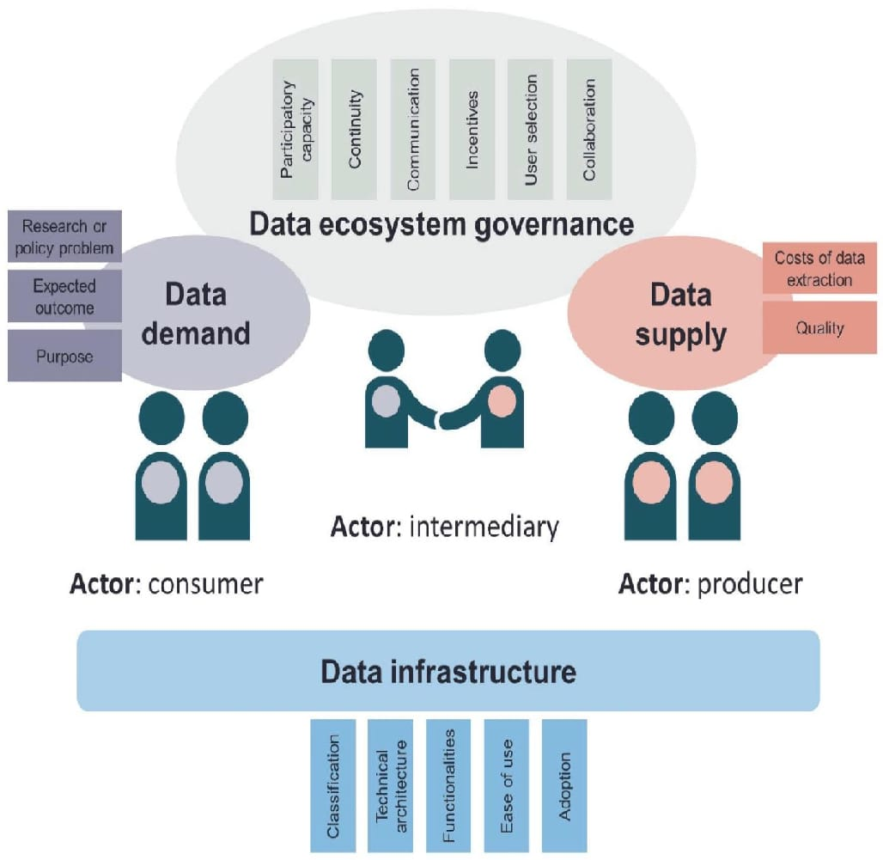

**3.2 Hardware/Software Designing:**

Designing hardware or software specifically for global economic data involves creating tools, platforms, or systems that facilitate the collection, analysis, visualization, and dissemination of economic data on a global scale. Here's an outline of both hardware and software components that could be included in such a design:

* Hardware Design: Data Collection Devices: Develop specialized devices equipped with sensors and connectivity options for remote data collection, such as satellite imagery receivers, weather stations, and mobile data collection units. Data Processing Units: Design high-performance servers or clusters capable of handling large-scale economic.

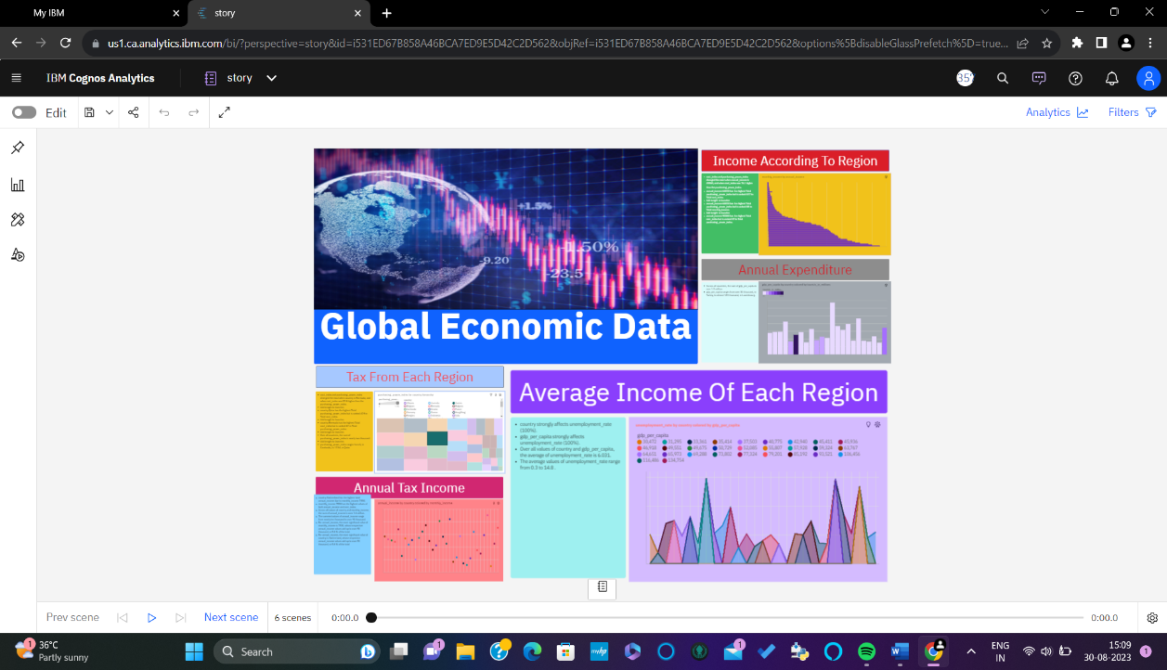

EXPERIMENTAL INVESTIGATIONS

Analyzing global economic data involves examining various indicators, trends, and patterns that provide insights into the health and performance of the global economy. Here's an overview of the types of analysis that can be conducted on global economic data:

4.1 **Gross Domestic Product (GDP) Analysis:**

Assess GDP growth rates to understand the overall economic expansion or contraction. Compare GDP growth among countries to identify regions with strong or weak economic performance. Analyze GDP components (consumption, investment, government spending, net exports) to understand the drivers of economic activity.

**4.2 Inflation Analysis:**

Examine inflation rates to gauge the general increase in prices over time. Analyze the causes of inflation, such as demand-pull or cost-push factors. Study inflation differentials among countries to identify potential currency and trade impacts.

**4. 3 Unemployment Analysis:**

Analyze unemployment rates to assess labor market conditions. Examine long-term vs. short-term unemployment trends. Investigate youth and structural unemployment rates for policy insights.

**4.4 Trade Balance Analysis:**

Analyze trade balances to understand a country's trade surplus or deficit. Examine trade partners and commodities to identify export and import trends. Study trade balances in relation to currency exchange rates.

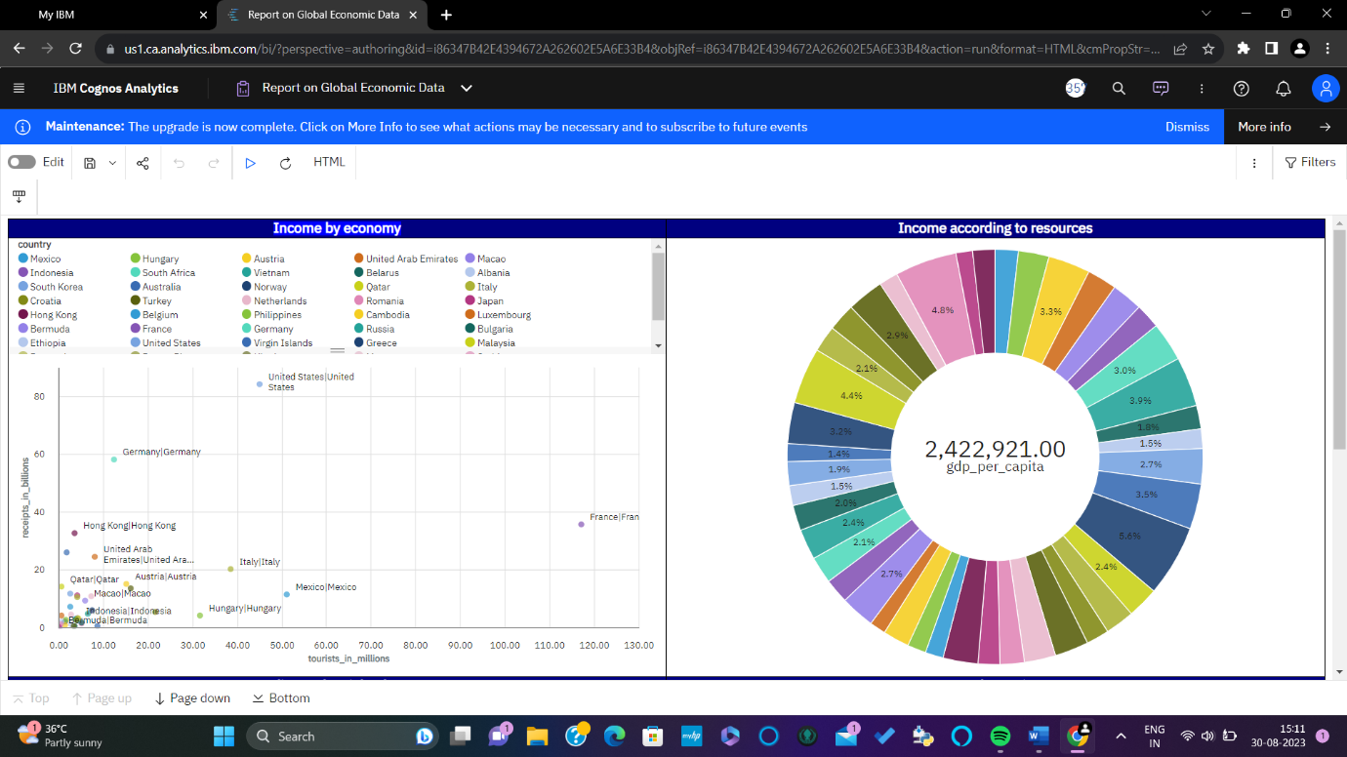

**FLOWCHART**

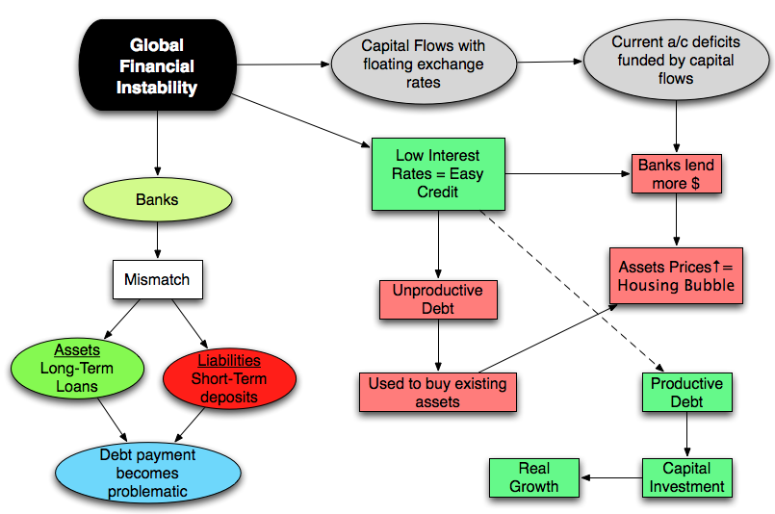

Begin the flowchart with an oval shape labeled "Start."

Data Collection Use a rectangle to represent the process of data collection from various sources. Arrows can flow into this step from different directions to indicate data sources such as government agencies, international organizations, financial institutions, and research firms.

Data Compilation and Aggregation Represent the step of compiling and aggregating raw data into meaningful economic indicators. This could involve activities like calculating GDP, inflation rates, unemployment rates, trade balances, etc. Use a rectangle with rounded corners to depict this step.

Data Verification Illustrate the process of verifying data accuracy and consistency. This could involve cross-checking data from multiple sources and ensuring data integrity. Use a diamond shape.

**RESULT**

Results from analyzing global economic data could include:

**Gross Domestic Product (GDP):** GDP growth rates for different countries or regions. GDP per capita comparisons to gauge economic well-being.

Inflation Rate:

Inflation rates indicating changes in the general price level of goods and services. Analysis of factors affecting inflation, such as monetary policy and supply chain disruptions.

**Unemployment Rate:** Unemployment rates indicating the proportion of the labor force that is unemployed. Comparison of unemployment rates across countries and demographic groups. Trade Balance: Balance of trade, comparing exports and imports of goods and services. Trade deficits or surpluses and their implications for economies.

**Consumer Confidence:** Measures of consumer sentiment and confidence in the economy. Consumer spending trends and their impact on economic growth.

**Investment Trends:** Analysis of investment flows, both domestic and foreign. Examination of trends in business investments and capital expenditure.

**Currency Exchange Rates:** Exchange rates between different currencies and their fluctuations. Effects of exchange rate changes on trade and investment.

**Interest Rates:** Central bank policy rates and their influence on borrowing, lending, and investment. Relationship between interest rates and economic growth.

**Global Supply Chains:** Insights into how disruptions, geopolitical events, or pandemics affect supply chains. Impacts on production, distribution, and pricing.

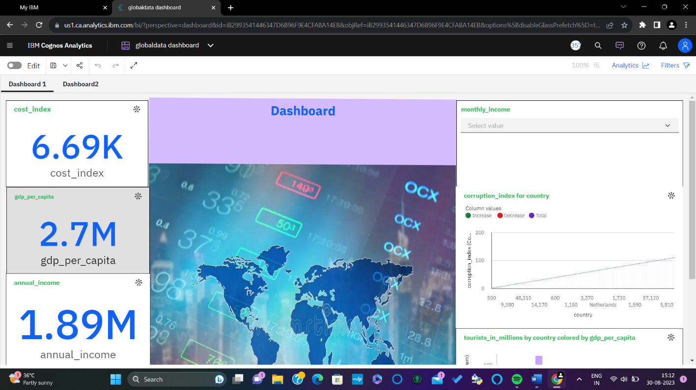

**ADVANTAGES AND DISADVANTAGES**

**Advantages:**

**Global Perspective: Global economic data provides a comprehensive view of the worldwide economic landscape. It allows for comparisons between different countries, regions, and economies, enabling a better understanding of interconnectedness and trends.**

**Informed Decision Making: Policymakers, businesses, and investors can make well-informed decisions by analyzing global economic data. This includes decisions related to international trade, investment, monetary policy, and fiscal planning.**

**Early Warning Signs: Global economic data can serve as early warning signs for potential economic crises. Patterns and trends in data such as trade imbalances or currency fluctuations can alert decision-makers to impending issues.**

**Market Insights: Investors use global economic data to gauge the health of economies and markets. This information aids in making investment decisions and managing risks across different countries.**

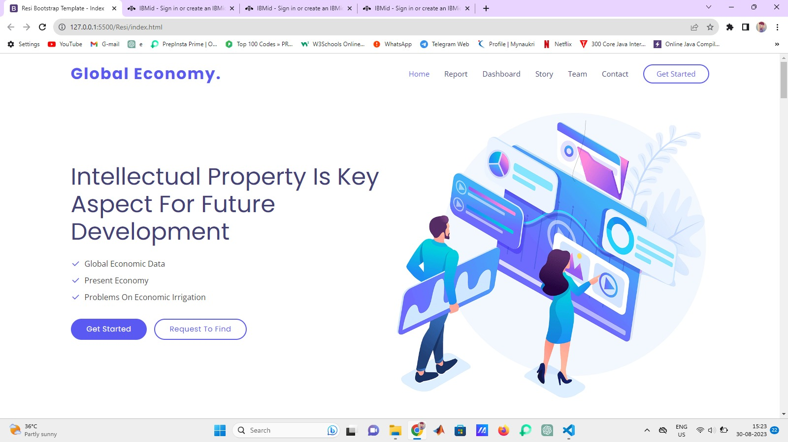

**Disadvantages:**

**Data Quality Issues: Global economic data can vary in quality, accuracy, and comparability between countries. Inconsistent data collection methodologies and reporting practices can lead to inaccuracies in analysis.**

**Data Availability and Timeliness: Not all countries provide timely and comprehensive economic data. Some countries might have limited resources or political reasons for not sharing accurate information, which can impact the validity of global analyses.**

**Cultural and Contextual Factors: Economic data might not fully capture cultural, social, and contextual factors that can significantly influence economic behaviors and outcomes.**

**APPLICATIONS**

Global economic data has a wide range of applications across various sectors and disciplines. Here are some key applications:

**Policy Making**: Governments and central banks use global economic data to formulate and adjust fiscal and monetary policies to manage inflation, unemployment, and overall economic stability. Economic data informs trade policies, exchange rate decisions, and strategies for economic growth.

**Business Strategy:** Corporations use global economic data to make informed decisions about expansion, investment, and market entry. Economic indicators guide business planning, resource allocation, and risk management strategies.

**Investment and Finance:** Investors use economic data to assess the potential risks and returns of investments in different countries and industries. Economic indicators influence investment decisions, portfolio allocation, and asset pricing.

**International Trade**: Global economic data informs export and import decisions for businesses and governments. Trade data helps identify potential markets, understand trade balances, and assess the impact of trade agreements.

**Academic Research**: Economists and researchers analyze global economic data to study economic theories, test hypotheses, and contribute to the field of economics. Economic research can inform policy debates and provide insights into economic phenomena.

**Risk Assessment and Management**: Businesses and financial institutions use economic data to assess the risks associated with lending, borrowing, and investment activities. Economic indicators provide insights into potential market volatility and economic downturns.

**Market Analysis**: Financial analysts and traders use economic data to predict market trends, make trading decisions, and manage risks in financial markets. Economic data influences stock prices, exchange rates, and commodity prices.

**CONCULSION**

In conclusion, global economic data serves as a vital lens through which we gain insights into the intricate tapestry of the world's economies. Its significance lies not only in its ability to illuminate current economic conditions but also in its power to shape policies, guide investments, and foster informed decision-making across a multitude of sectors and disciplines. Through the careful collection, compilation, and analysis of economic indicators spanning GDP growth, inflation rates, unemployment figures, trade balances, and more, global economic data reveals patterns, trends, and interdependencies that underlie the complex global economic ecosystem.

While harnessing the advantages of global economic data, including its ability to provide a global perspective, inform decision-making, and offer early warnings of potential crises, it is imperative to acknowledge its limitations. Data inaccuracies, disparities in reporting practices, and the challenge of capturing qualitative aspects amidst quantitative metrics can cast shadows of doubt on the insights drawn.

Yet, armed with an understanding of these advantages and limitations, stakeholders ranging from governments to businesses, researchers to investors, can navigate the dynamic currents of the global economy with greater precision. By leveraging the applications of global economic data, they can strive for optimal policy outcomes, mitigate risks, explore new market opportunities, and contribute to the collective endeavor of fostering sustainable and prosperous economies worldwide.

As the global economy continues to evolve, so does the significance of global economic data. In a world marked by unprecedented challenges and opportunities, the data remains a beacon of knowledge that illuminates our understanding and empowers us to navigate the complexities of our interconnected economic landscape. Through its careful analysis and discerning interpretation, we can endeavor to chart a course towards a more stable, equitable, and resilient global economic future.

**FUTUTRE SCOPE**

**10.1: Enhancements that can be made in future**

The future scope of global economic data is rich with possibilities driven by technological advancements, increasing connectivity, and evolving economic landscapes. Here are some key areas where we can expect to see significant developments and opportunities:

**Advanced Data Analytics:** The application of advanced analytics techniques, including artificial intelligence (AI), machine learning (ML), and big data analytics, will enable more sophisticated and accurate analysis of global economic data. These technologies can reveal hidden patterns, predict trends, and offer insights that were previously challenging to uncover.

**Real-Time Data:** With the advent of IoT (Internet of Things) devices and improved data sharing infrastructure, real-time economic data collection and analysis will become more feasible. This will enhance decision-making speed and accuracy, especially for industries sensitive to rapid market changes.

**Alternative Data Sources:** The integration of alternative data sources, such as social media sentiment, satellite imagery, and online consumer behavior, will provide a more comprehensive view of economic activities. These unconventional sources can complement traditional economic indicators and offer insights into emerging trends.

**Predictive Modeling:** Enhanced by AI and ML algorithms, predictive models will become more accurate in forecasting economic trends and potential crises. These models will provide decision-makers with valuable lead times to strategize and respond effectively.

**Global Supply Chain Insights:** Economic data will play a critical role in understanding and optimizing global supply chains, especially in a world marked by disruptions and geopolitical shifts. Enhanced supply chain data can enable businesses to anticipate risks and devise resilient strategies.

**BIBILOGRAPHY:**

**Problem: Global Economic Data**

**Tools: Ibm Cognos Account**

**APPENDIX**

**Source Code:**

**C:\Users\khaja\OneDrive\Desktop\bootstrap_1\Resi\index.html**

**http://127.0.0.1:5500/Resi/index.html**

**https://github.com/Shareef2845**