**Name**

2D Chess

**Genre**

Board game

**Style**

2D

**Description**

It is normal chess game which we play. It has a white king, queen, bishop, rook, knight, pawn and same for black, with all the rules.

**Sprites used**

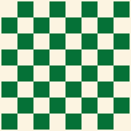

Board



Black King



Black Queen



Black Bishop

Black Knight

Black Rook



Black Pawn



White King



White Queen



White Bishop



White Knight



White Rook



White Pawn



Move Plate