MID-TERM REPORT

**Mini Project - II (2020-2021) “GEEK SEEK”**

# Synopsis



## Team Members:

Rohan Bhardwaj (University Roll No-181500589)

Shashank Kumar Pandey (University Roll No-181500654)

Shivani Chauhan (University Roll No-181500678)

Vanshika Mahle (University Roll No-181500781)

Vimal Mishra (University Roll No-181500792)

## Supervised By:

Mr. Anand Parkash Gupta Technical Trainer

Department of Computer Science Engineering & Applications

# Introduction of the Project:

Geek Seek is a full stack social network application for developers to be developed using Node.js, React, Redux, MongoDB, along with Express.

The platform will be developed in two parts – Front-end development and Back- end development. We will be building an extensive backend API using Node.js & Express and JWT will protect the endpoints. We will use Postman for testing our backend API and to handle requests. The front-end will be integrated with the backend in an elegant way to create a great workflow. For application state management, we will use Redux and create reducers and actions for our resources. Also, we will test our application using Redux Chrome extension. The application will be deployed to Heroku using Git.

# Technologies Used:

* MongoDB
* Express
* React
* Node.js
* Redux
* VS Code Editor
* JWT (JSON Web Tokens)
* Git
* Postman

**Objective:**

The project aims to build a full stack social network application for geeks which includes user authentication, user profiles and forum posts. The platform will be developed using MongoDB, Express, Node.js, Redux and React technologies.

The platform allows geeks to create their profile, update it or add additional details about them. They can also link their GitHub profiles by providing their GitHub username. The geeks can view profiles of other users and get connected with each other. They can post their views in the forum section, like other’s posts and put comments too.

# Features:

* New users can create a profile and register themselves
* Authentication for existing users
* Viewing profiles of geeks without logging in to the account and connect
* Add additional details to the profiles and edit them
* Link GitHub accounts by providing the GitHub username
* View five latest git repositories in the user profiles
* Add posts in the forum
* View and Like posts of other geeks
* Comment on the posts of other geeks

# Flow Diagram:

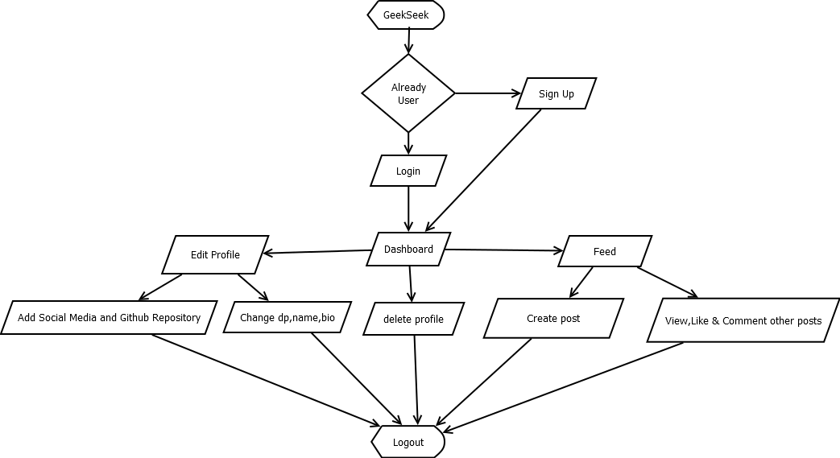

# Backend-

We are testing our backend through Postman and Storing the data in mongoDB-Atalas(nosql cloud database).We are using Postman application to send and receive data from mongoDB-Atlas through POST and GET request.

Currently we are able to register users through POST request and genearate a token So that they can edit their own profile through a POST request Moreover we are also able to view all the profiles as well as individual profile created in data base by a GET request.

We are also able to authenticate users for Login Through POST request.

**Registering user using Post request –**

**SIGN UP**

1.we have put some validation like email checker and password length should be greater than 6.

If it doesn’t follow an error is generated.

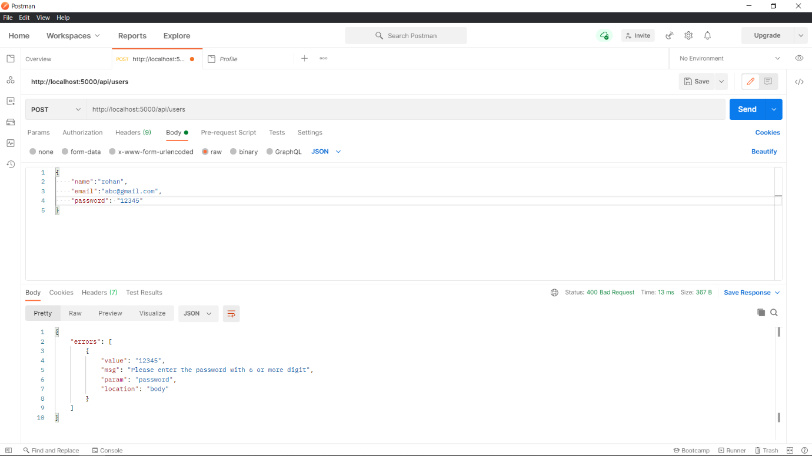

**2.A successful registration-**

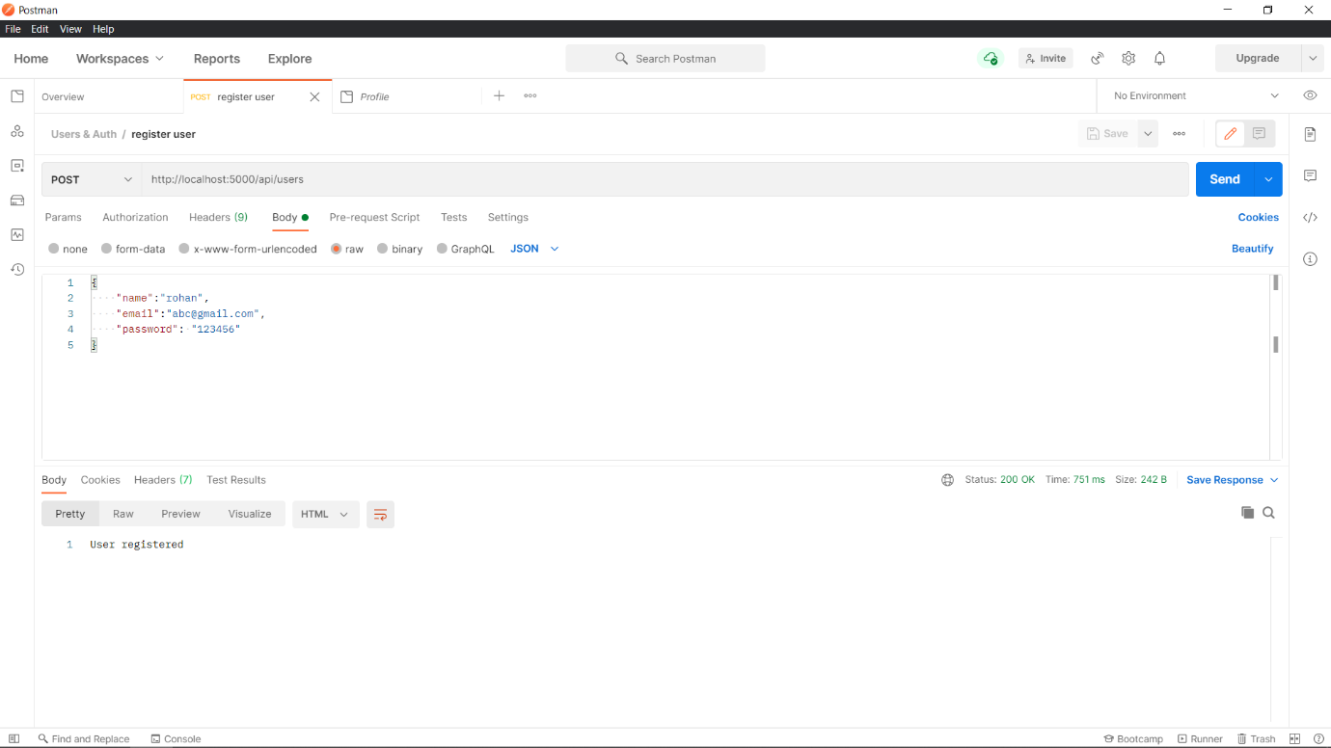

The registered information is stored in mongoDB atalas.

**Note:** the password the user entered during registration is stored in an encrypted format

**Database After Registration -**

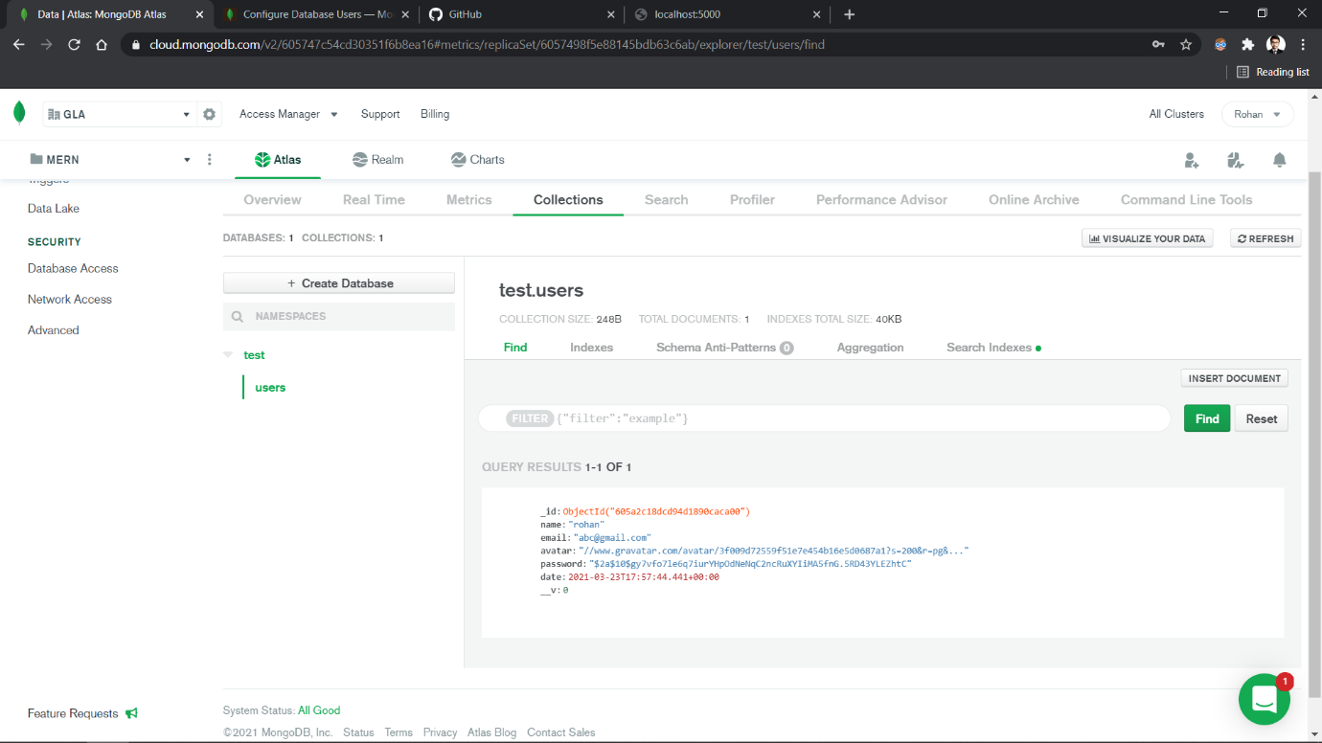

**4.The registered email Id cannot be re-registered again**

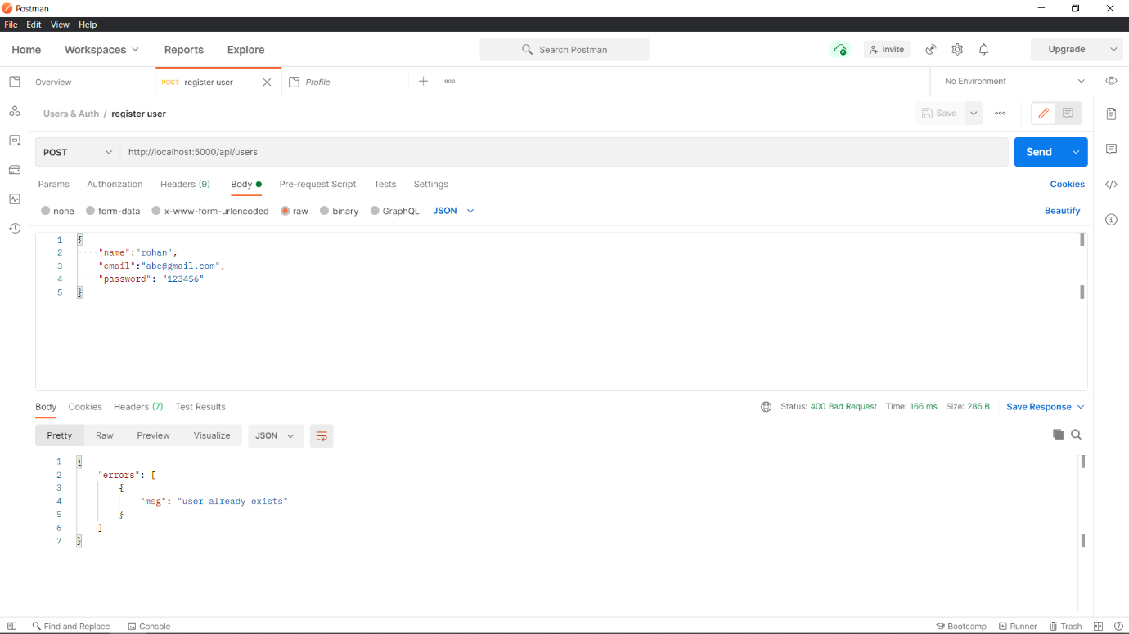

**5.Generating Token for the registered user when user signs up-**

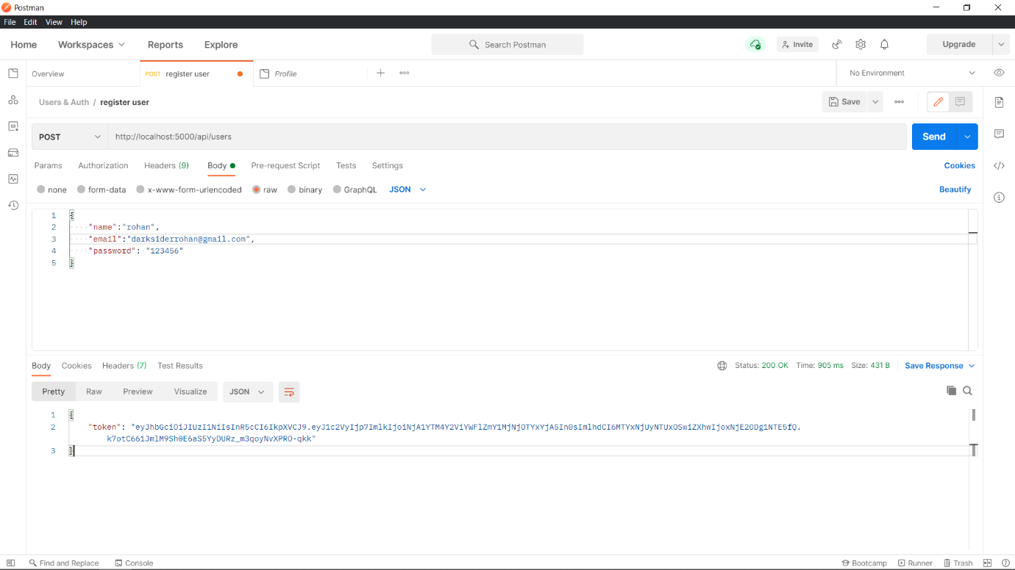

**LOG IN –**

1.If user doesn’t exists or enters invalid credentials it doesn’t authenticate and sends a message of invalid credentials

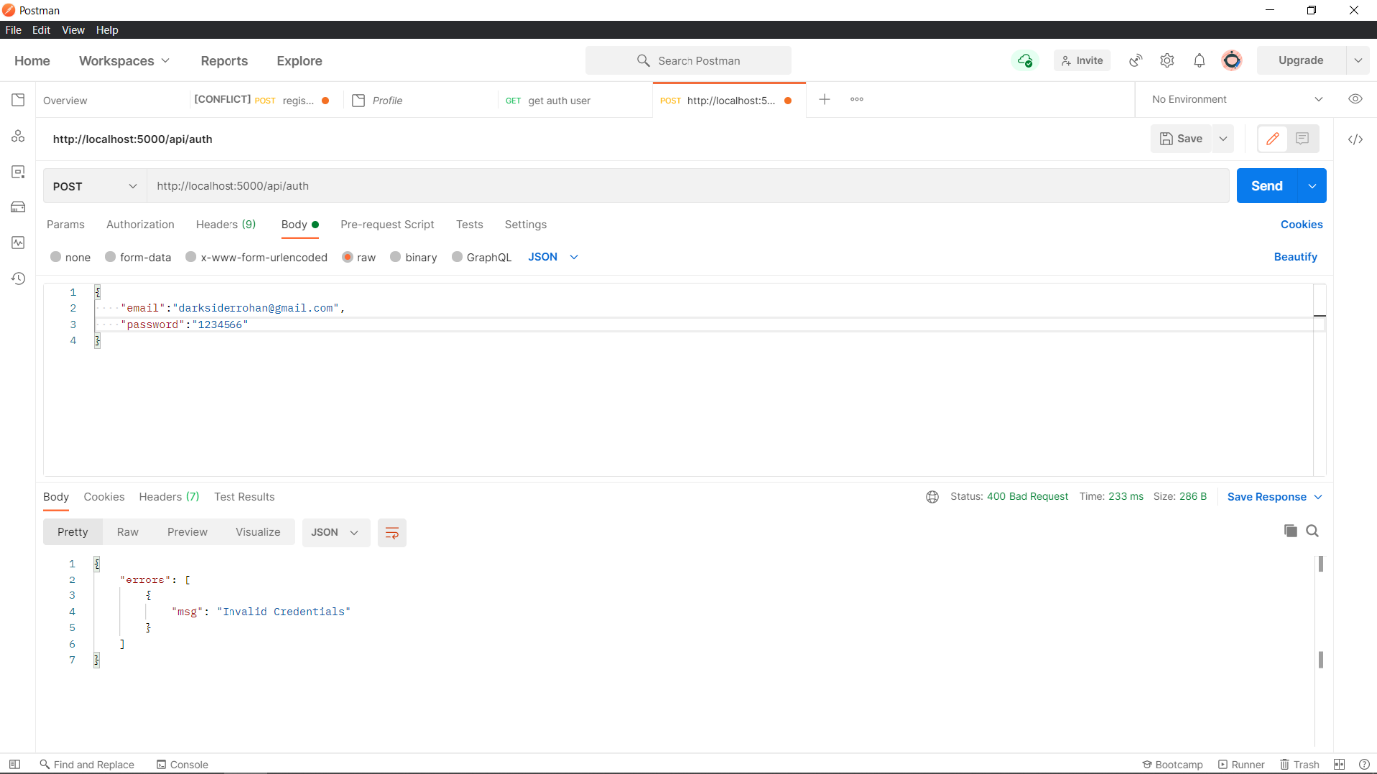

**2.If user enters correct credentials a token is generated-**

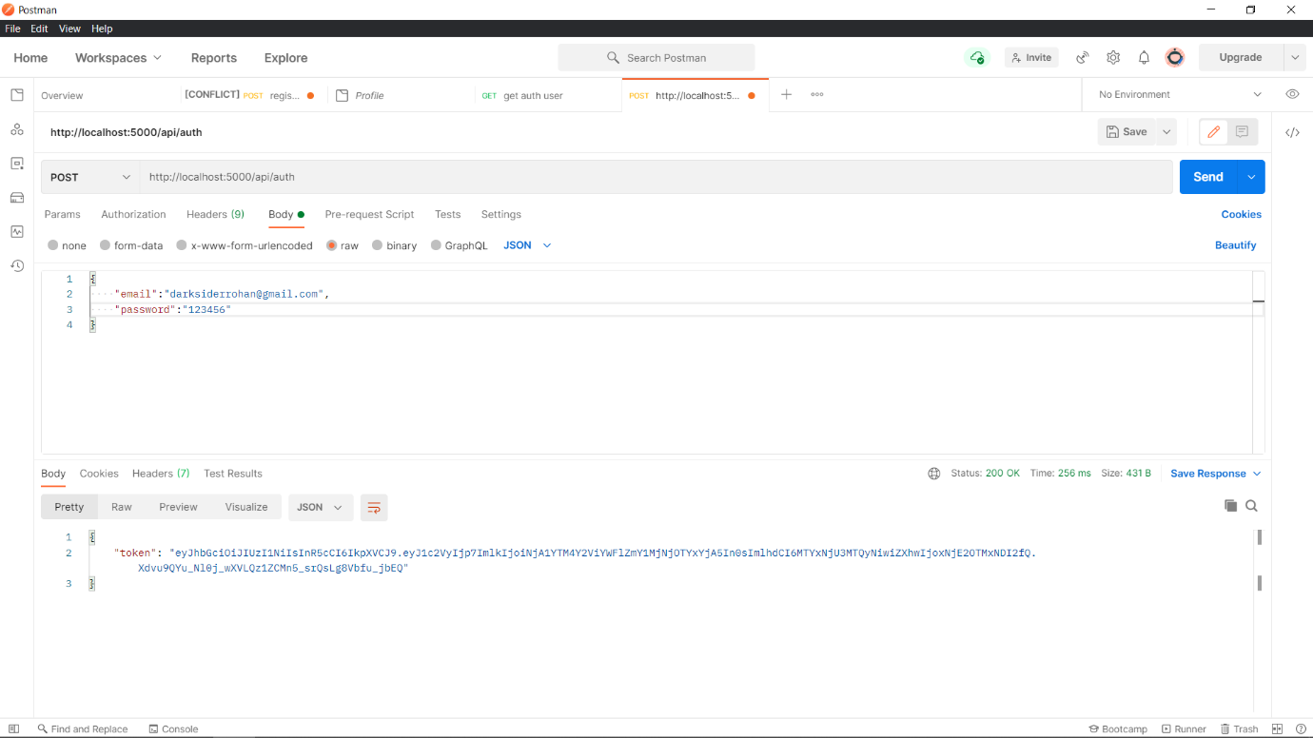

**Profile-**

**1.Adding Profile using POST request**

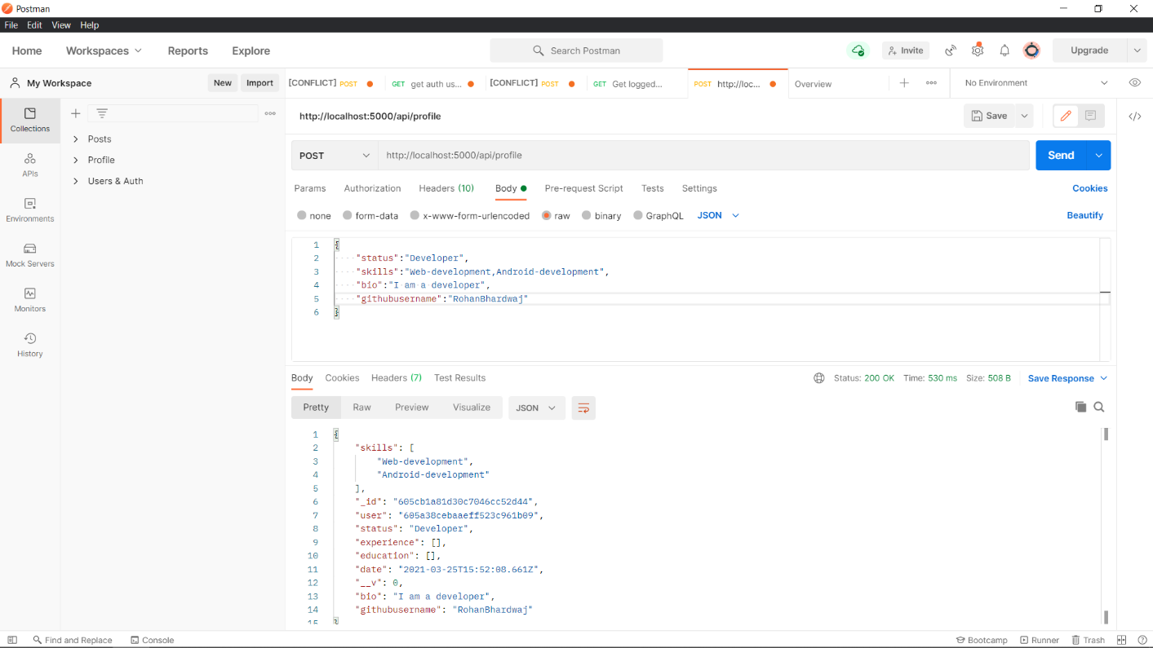

**2.Snapshot of added profile added in the database**

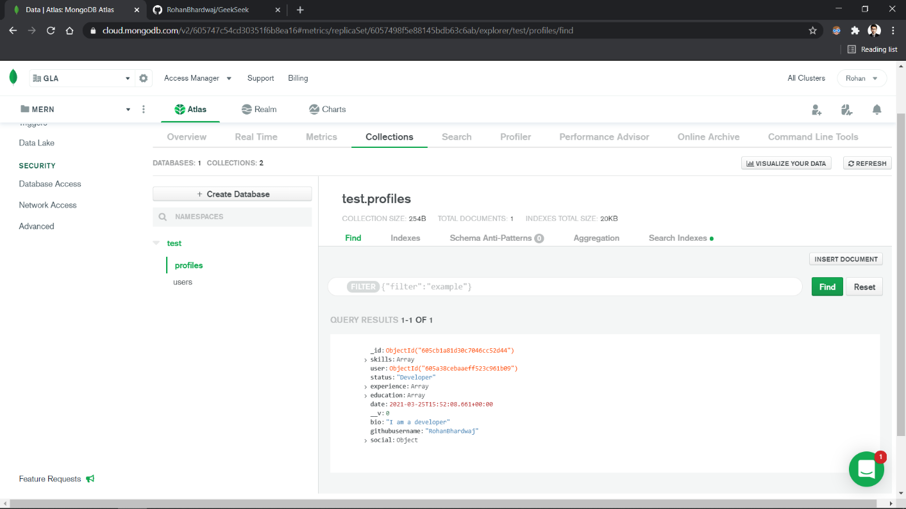

**3. We can also view all the profile with the help of GET request**

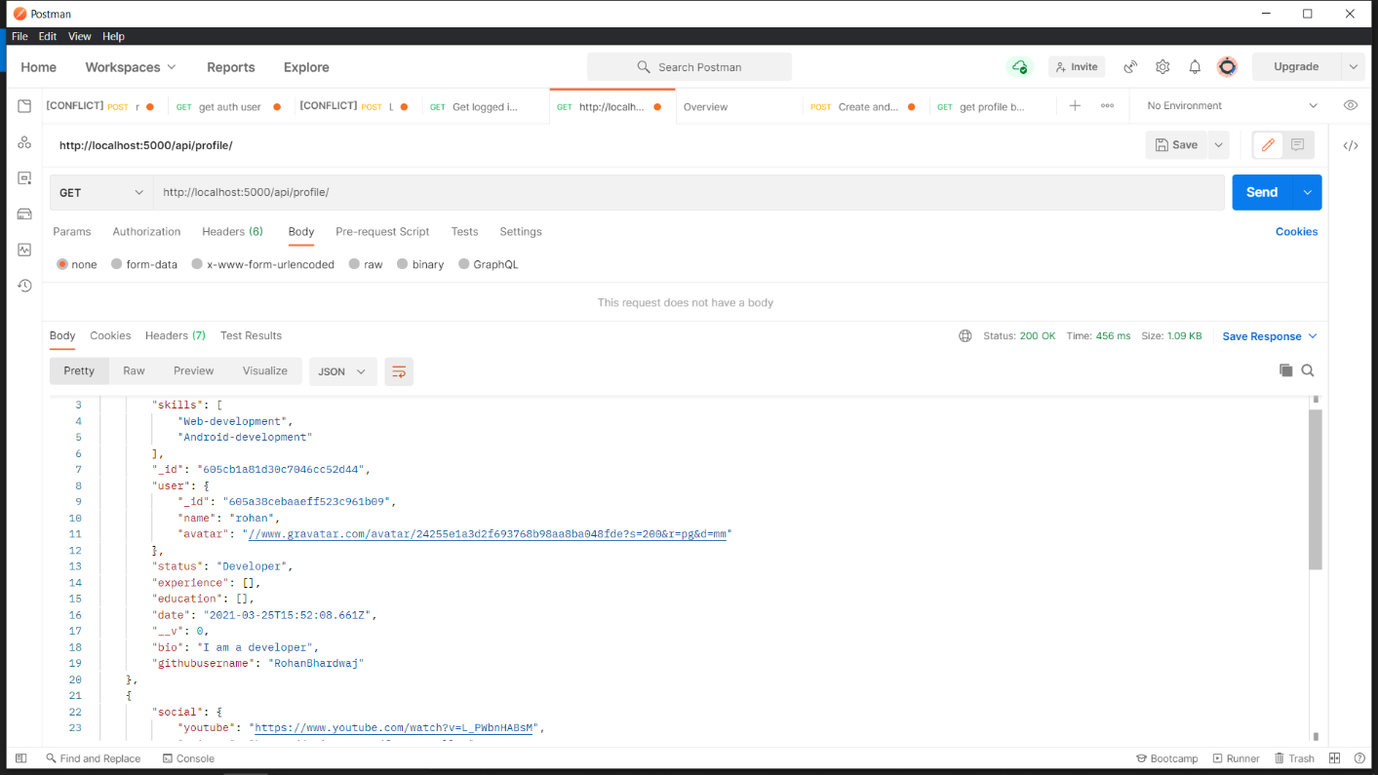

**4.We can also view specific user profile just by putting its user id in the URL** e.g.( http ://localhost:5000/api/profile/user/605d9bfc7f4acb26bc87a088) that number is the user ID which mongoDB generates automatically at the time of creation of new user.

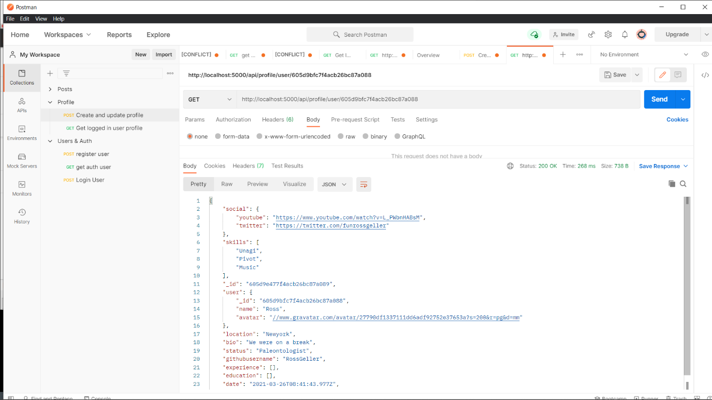

**GeekSeek Frontend Templates Screenshots-**

**Landing Page-**

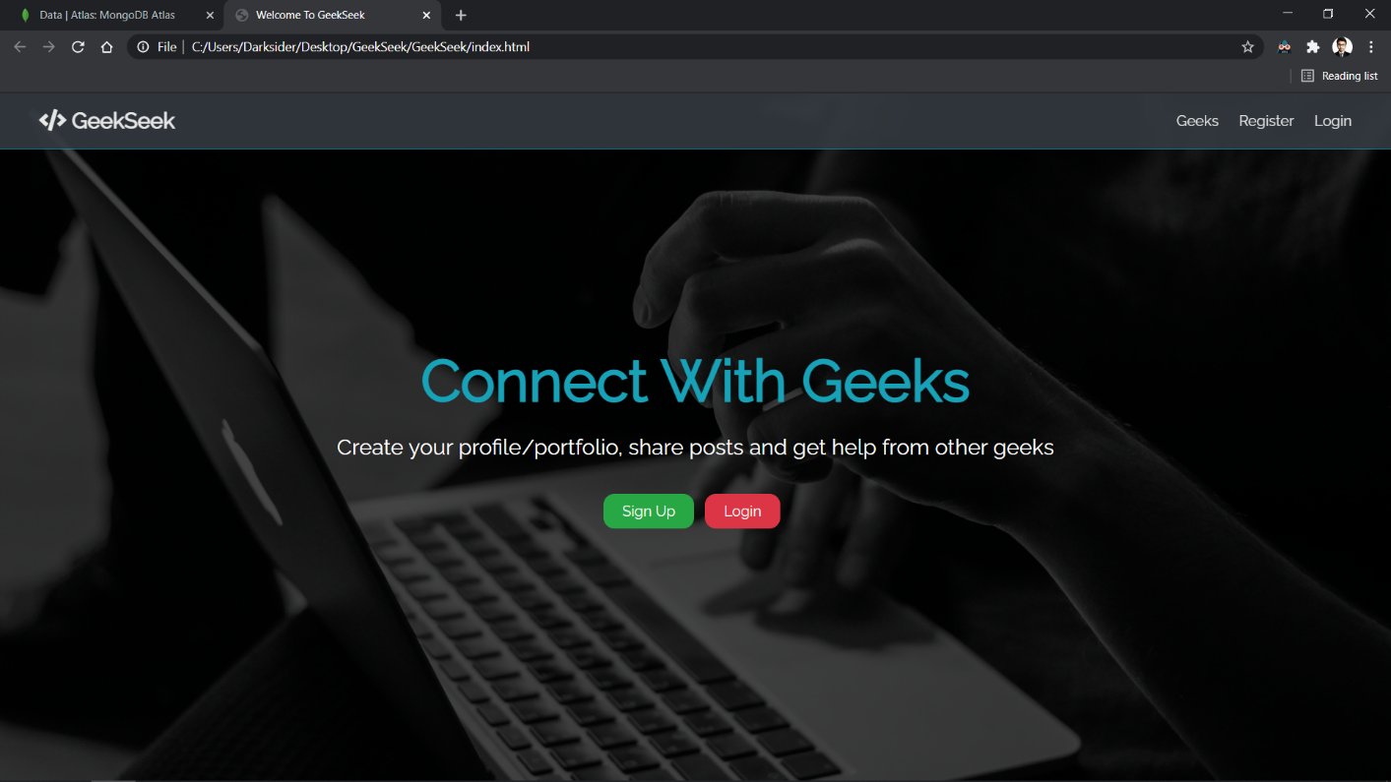

**SignUp Page-**

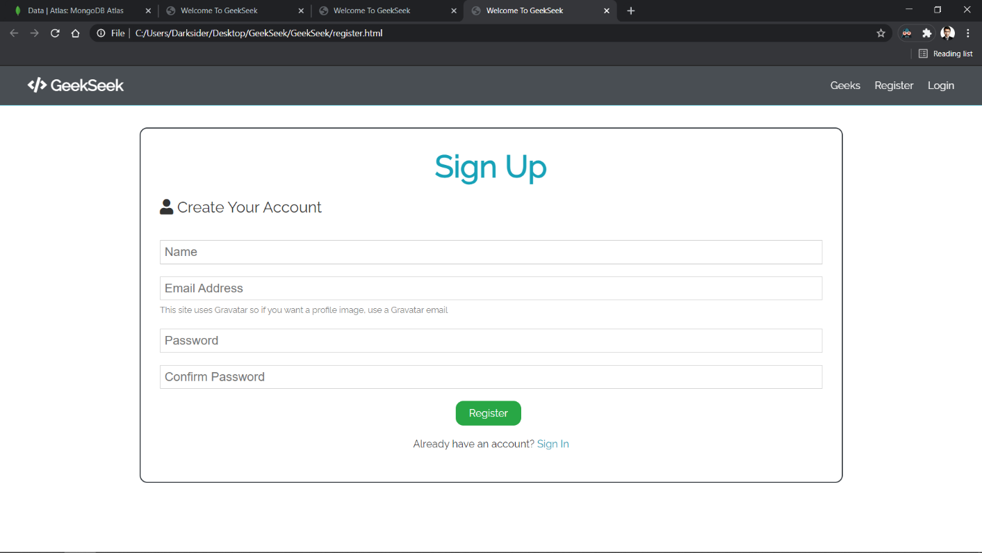

**Login Page-**

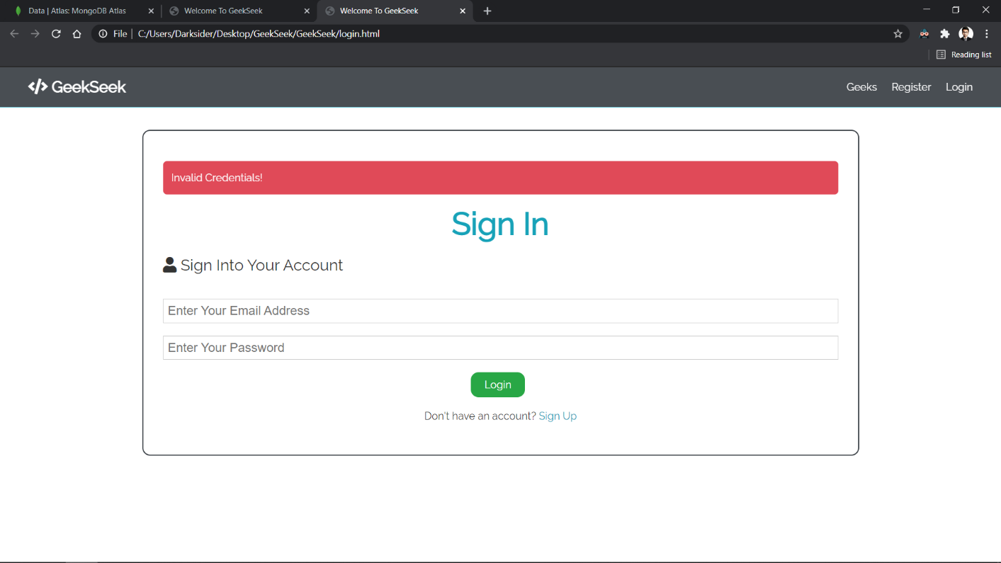

**Create Profile Page-**

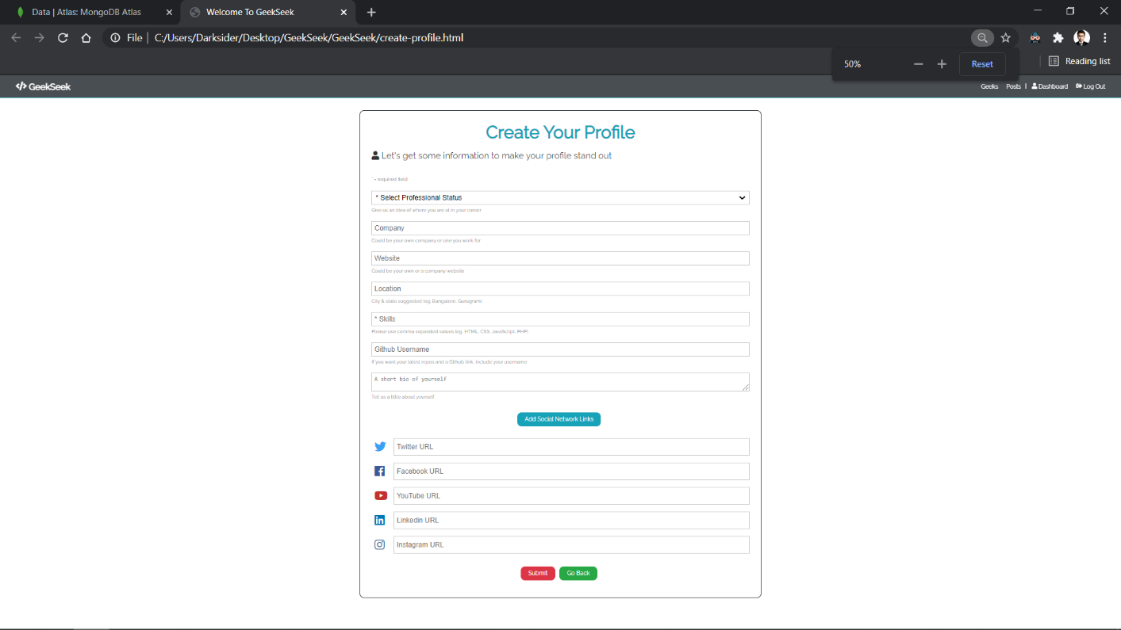

**GitHub Repository-**

<https://github.com/RohanBhardwaj/GeekSeek>

