SE Lab - Vibe coding

Name: Rohan Rajeev Chirbi
SRN: PES2UG24CS408
Sec: G
Date: 30-09-2026

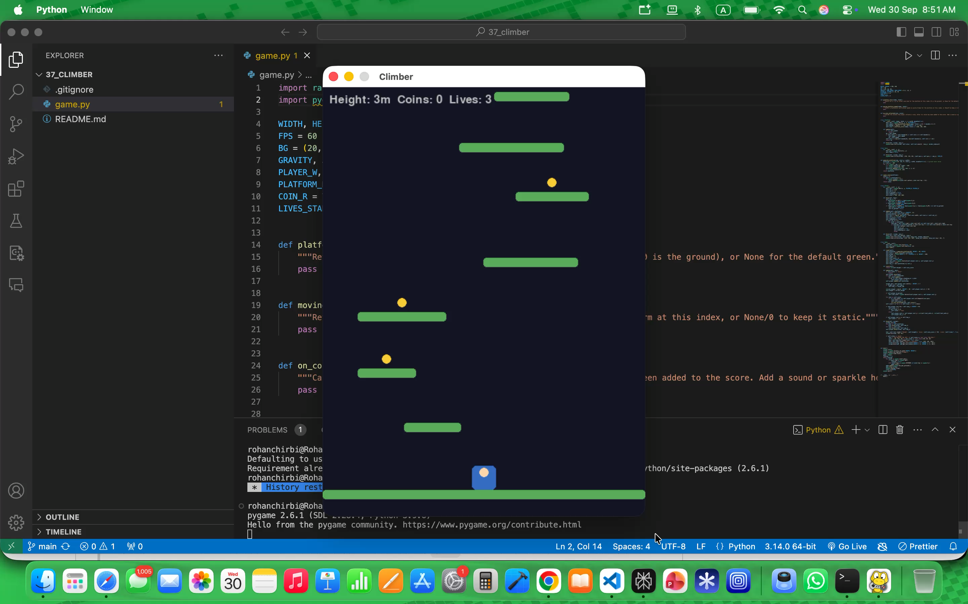
1. Before-changes gameplay
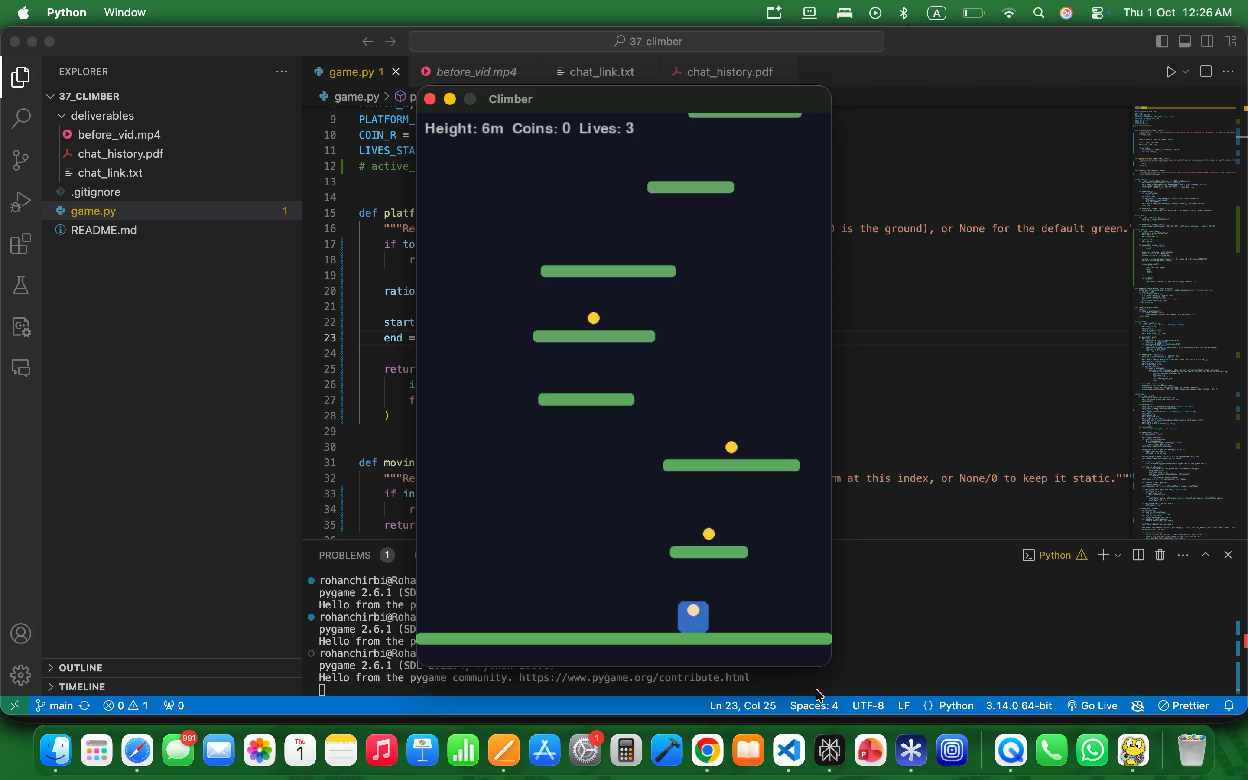
2. After-changes gameplay
3. LLM conversation

LLM Used: ChatGPT
Complete shared conversation: https://chatgpt.com/share/6abd5c2e-aa54-83e8-b416-9c32ed242367

4. Implementation summary

The implementation fixes the height-score bug by retaining the maximum height reached rather than overwriting it with the player’s current height, adds a gradual platform color gradient based on platform index, and makes every third non-ground platform horizontally oscillate while preserving the existing player-carrying behaviour. It also implements coin collection sparkles through on_coin_collected(), with sparkles stored, updated, camera-adjusted, drawn after the coin is removed, and cleared on reset. The existing collision detection, upward-only camera scrolling, coin scoring (+50), lives, respawning, and win/lose logic were left unchanged.

Screenshots

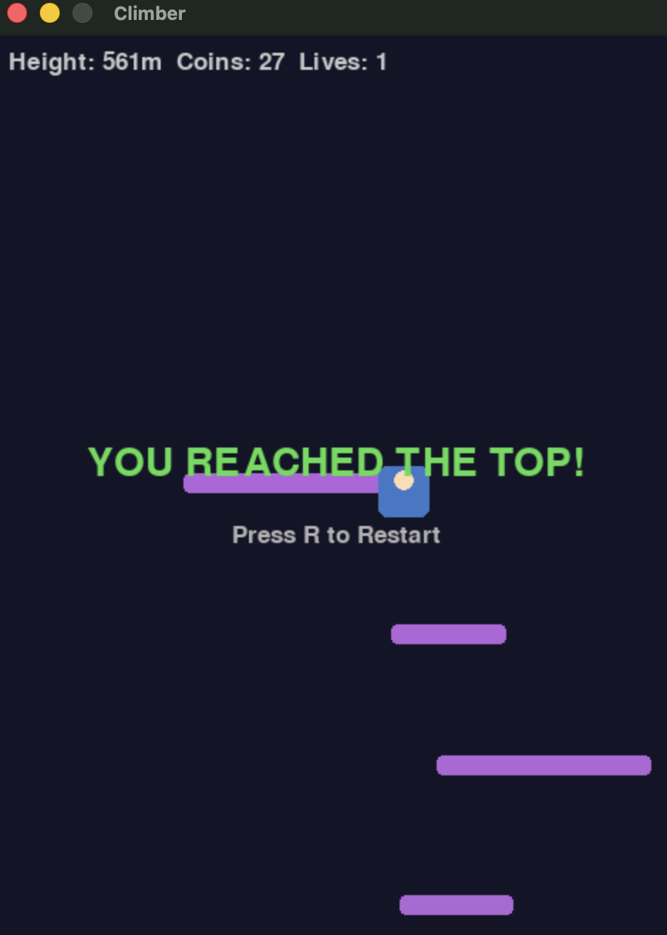
Success state - platform colour changed due to gradient settings (r, g, b)

