Dust Reduction and Air Quality Monitoring System for Home-Based Weaving Environments
Final Project Report: Design, Calibration, Testing and Results
Item | Details
Project | Dust Reduction and Air Quality Monitoring System for Home-Based Weaving Environments
Report type | Final Report
Controller / sensor | Arduino Nano / Sharp GP2Y10 optical dust sensor
Prepared by | Project Team, RFL Academy Innovation Lab

Contents
Abstract 3
1. Introduction 3
1.1 Problem statement 3
1.2 Objectives 3
2. System Overview 3
2.1 Working principle 4
3. Hardware 4
3.1 Bill of materials 4
3.2 Electronics build 5
3.3 Pin map 5
4. Mechanical Design 6
4.1 Early concepts (Weeks 1 to 2) 6
4.2 Final enclosure (Weeks 3 to 5) 7
4.3 Built prototype 8
4.4 Self-refreshing mesh mechanism 9
5. Firmware 9
6. Calibration: How the mg/m³ Values Were Obtained 9
6.1 Conversion formula 10
6.2 Calibration procedure 11
6.3 Results 12
6.4 Discussion of accuracy 14
7. Testing and Results 14
7.1 Filtration performance 14
7.2 Warning LED response 16
7.3 Motor current 17
7.4 Supply voltage stability 18
8. Challenges and Solutions 18
9. Limitations 19
10. Future Scope 19
11. Conclusion 19

Abstract
Home-based power-loom households live and work in the same room, and the textile lint and fine dust from weaving stay in the air they breathe. This project built a low-cost room-scale dust reduction unit with live air-quality monitoring. Room air passes through a self-refreshing roller-mesh pre-filter and a HEPA filter, driven by a 300 m³/h inline fan. An Arduino Nano reads a Sharp GP2Y10 optical dust sensor, converts its voltage to mg/m³, shows the value on a 16×2 LCD, and lights a warning LED when the dust stays above a threshold set with a potentiometer. Two DC motors advance the mesh every 12 hours. The voltage-to-mg/m³ conversion was checked with 160 readings against a reference meter, with an overall accuracy of 74.4 %. In a 3-hour test in a room next to a construction site, the unit lowered the average dust reading from 14.7 to 6.6 mg/m³ (≈ 55 % reduction).

1. Introduction

1.1 Problem statement
Many weaving families run power looms inside their homes. While weaving, textile fibres, lint and fine dust are released into rooms that are also used for studying, cooking, eating and sleeping. Long exposure can cause respiratory discomfort. Industrial dust extraction is too expensive and too big for these small home setups.

1.2 Objectives
- Build an affordable, easy-to-maintain unit that reduces airborne textile dust in a weaving room.
- Measure and show dust concentration in real time in mg/m³.
- Warn the user when dust stays above a level they can set.
- Prevent pre-filter clogging with an automatically advancing mesh.
- Check the sensor readings with repeated calibration measurements.

2. System Overview
The system has three parts: the filtration path (mesh pre-filter, HEPA filter, inline fan), the monitoring electronics (GP2Y10, Arduino Nano, LCD, potentiometer, warning LED) and the mesh-indexing mechanism (two DC motors, motor driver, gear train, rollers).
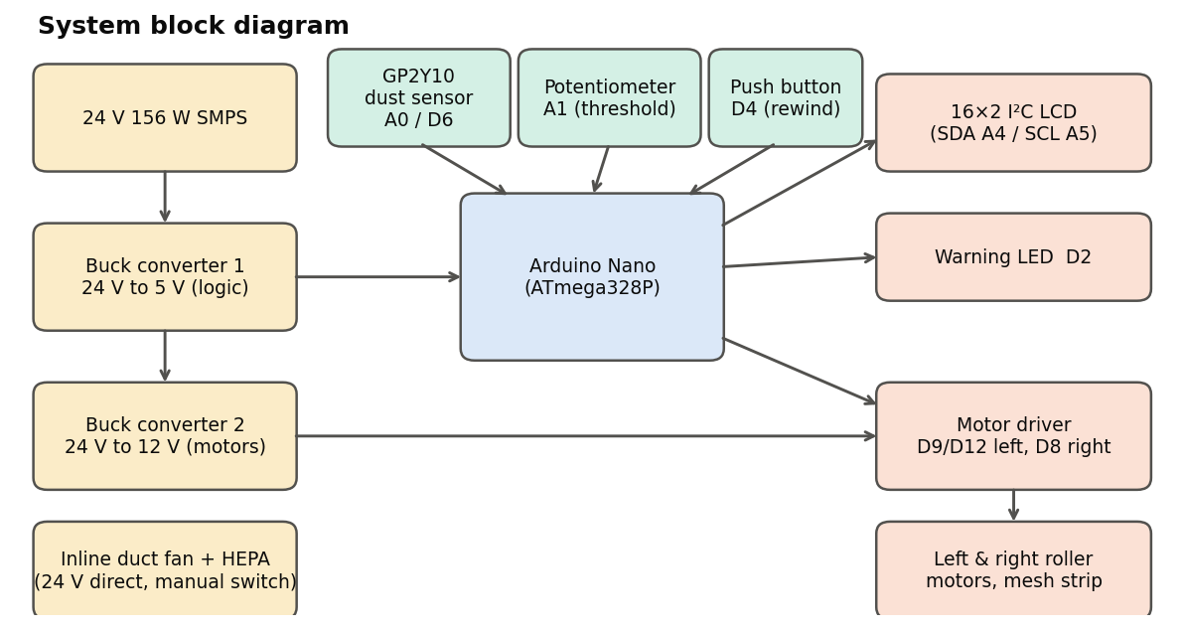
Figure 1: System block diagram

2.1 Working principle
- The fan pulls room air in through the louvred side walls.
- Large fibres and lint are caught on the mesh strip stretched between the two rollers.
- Fine particles are removed by the HEPA and activated-carbon cartridge, and clean air goes back into the room.
- Every 100 ms the Nano reads the dust sensor, converts the value to mg/m³, compares it with the threshold, and updates the LCD and LED.
- Every 12 hours the motors advance the mesh to expose a fresh section. The push button lets the user rewind the mesh for washing.

3. Hardware

3.1 Bill of materials
Component | Qty | Price (INR)
Inline duct fan | 1 | 4,080
24 V 156 W SMPS | 1 | 2,040
HEPA filter | 1 | 2,160
Arduino Nano | 1 | 360
Dust smoke particle sensor (GP2Y10) | 1 | 360
Buck converter | 2 | 240
3D printing |  | 2,800
Misc. items (nuts, bolts, mesh, etc.) | 1 | 2,000
Mesh strip | 2 | 935
DC motor | 1 | 1,265
Motor driver |  | 1,800
Professional charges |  | 36,000
Total (excl. GST) |  | 54,040
Total incl. 18 % GST |  | 63,767
Estimated running cost: about ₹200 per month at 12 hours of use per day.

3.2 Electronics build
The circuit was first tested on a breadboard and then built on a soldered perfboard. In the final unit the 24 V SMPS and the Nano/motor-driver board sit inside the base, below the air path.
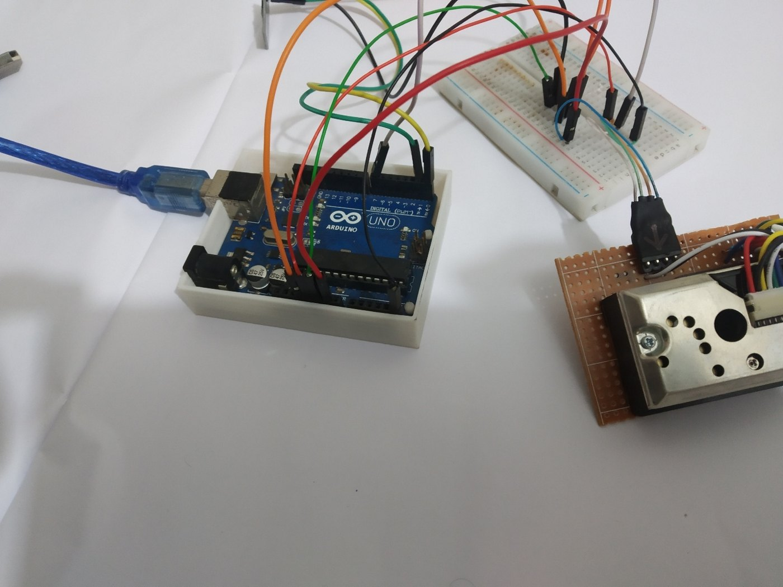  Figure 2: Initial bench test of the GP2Y10 | 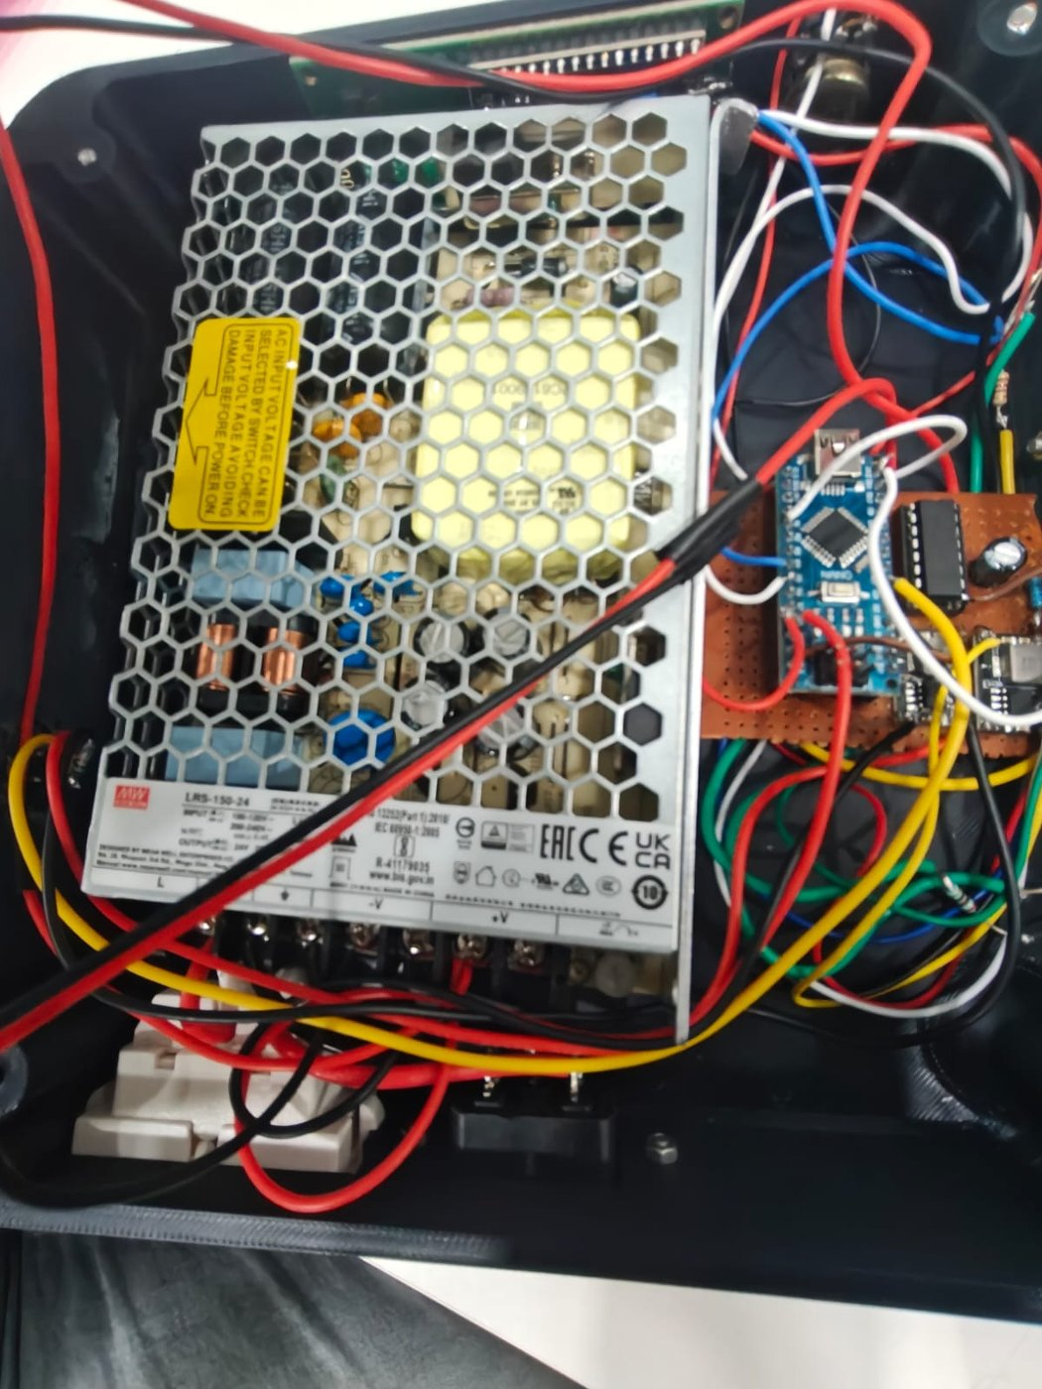  Figure 3: Final electronics mounted in the base

3.3 Pin map
Arduino pin | Connected to | Notes
A0 | GP2Y10 Vout | Analog dust signal
D6 | GP2Y10 IR LED | Active LOW pulse
A1 | Potentiometer wiper | Threshold 0 to 25 mg/m³
A4 / A5 | LCD SDA / SCL | I²C address 0x27
D2 | Warning LED | Active LOW
D4 | Push button | External 10 kΩ pull-down
D9 / D12 | Left motor (driver IN1/IN2) | Forward / reverse
D8 | Right motor (driver IN) | Forward only

4. Mechanical Design

4.1 Early concepts (Weeks 1 to 2)
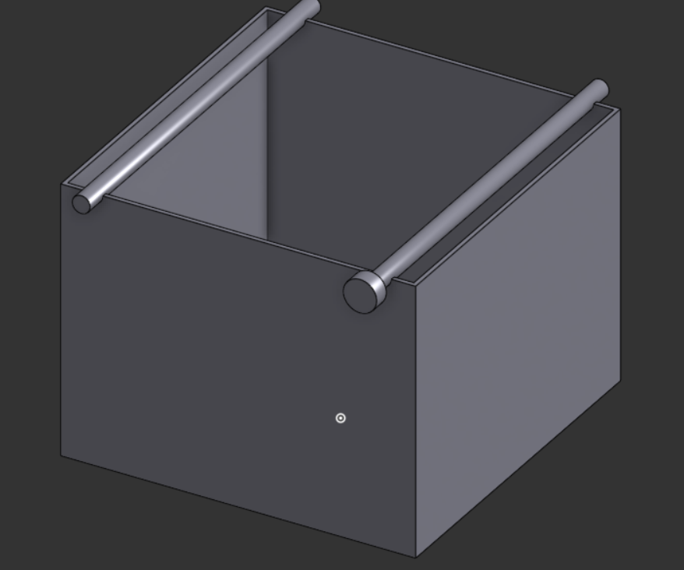  Figure 4: Concept 1: filter box with roller rods | 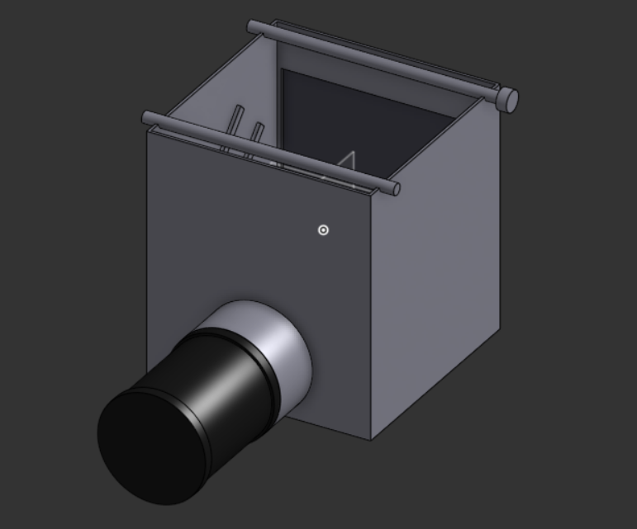  Figure 5: Concept 2: chamber with duct outlet
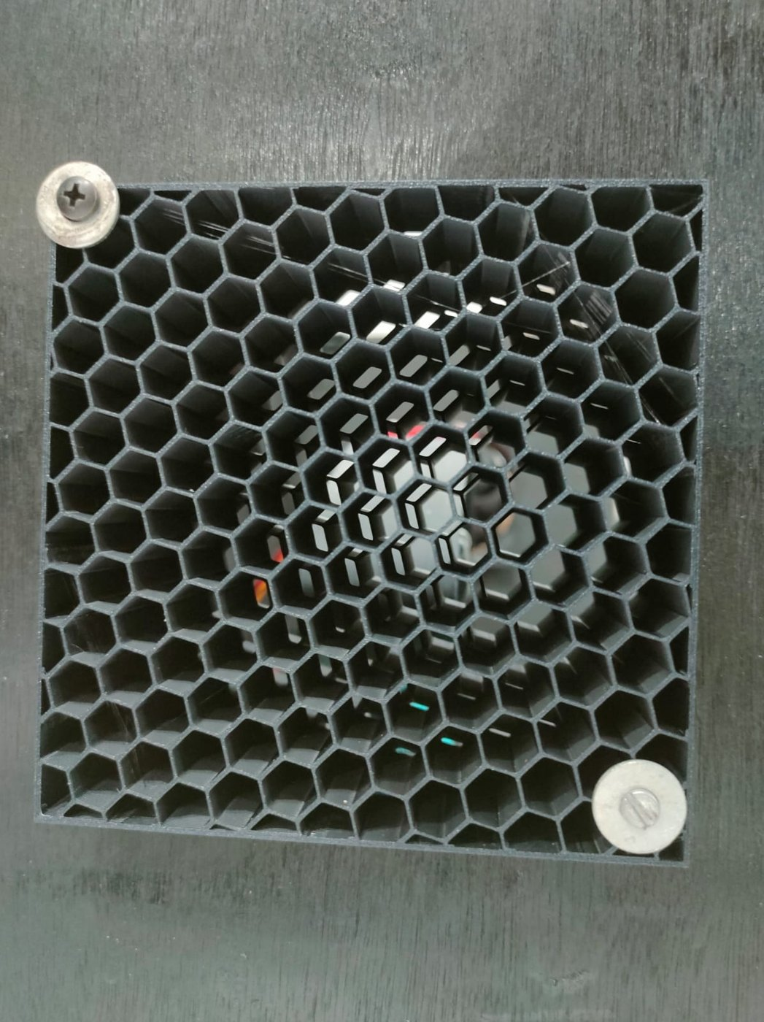  Figure 6: Airflow test rig: honeycomb grille | 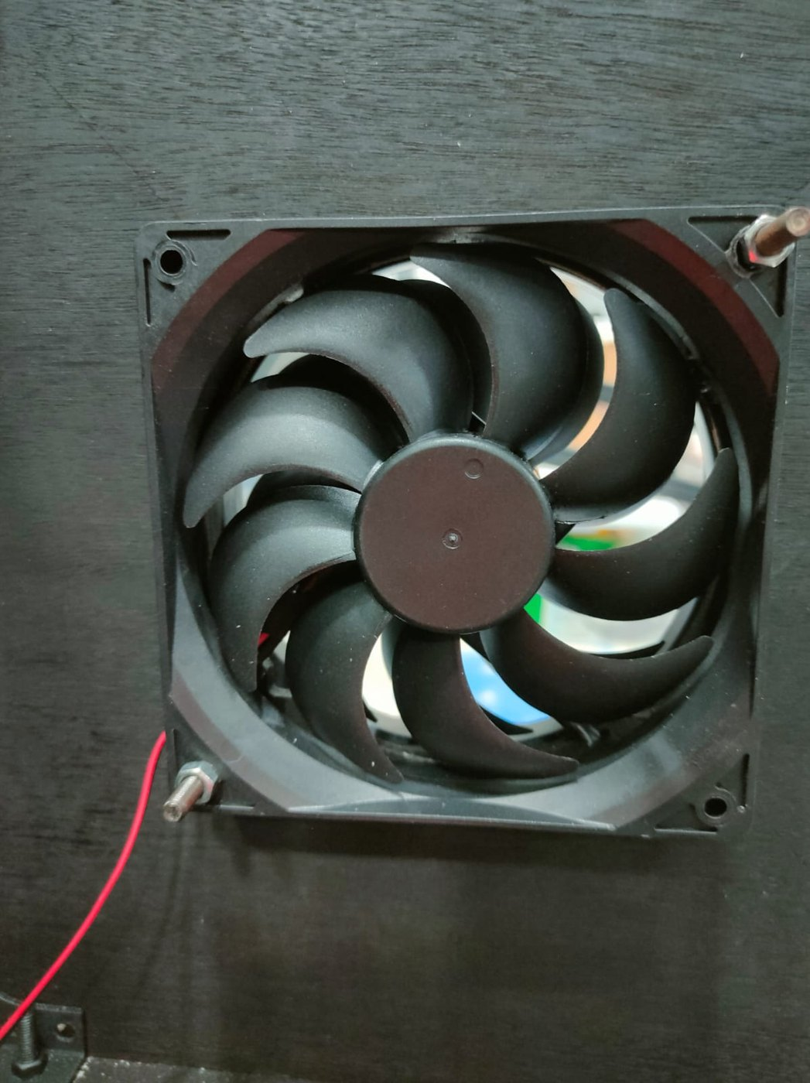  Figure 7: Airflow test rig: 120 mm fan
The early concepts proved the roller-mesh idea, but they were bulky and let fibres escape around the open edges. The airflow test rig showed that a fixed grille clogs with lint within minutes. Together these led to the compact stacked design below.

4.2 Final enclosure (Weeks 3 to 5)
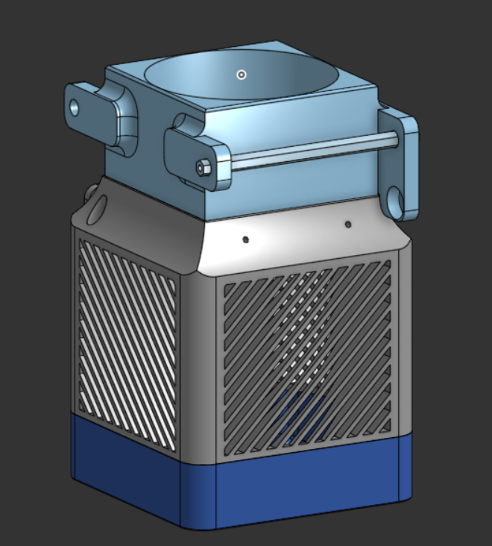  Figure 8: Final assembly | 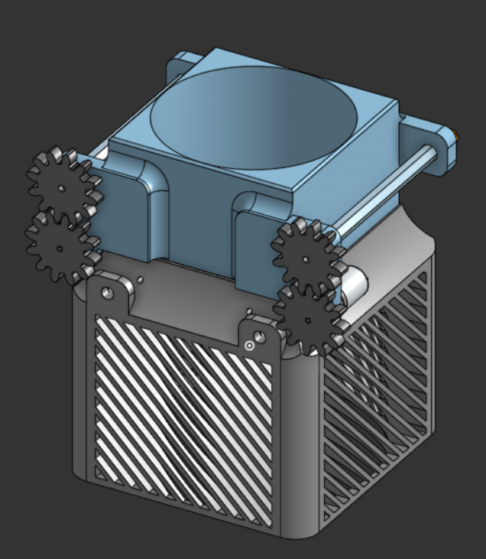  Figure 9: Final assembly with gear train

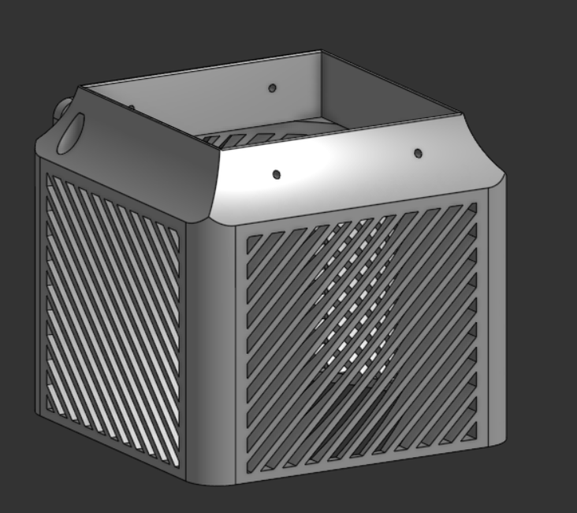  Figure 10: Louvred main body | 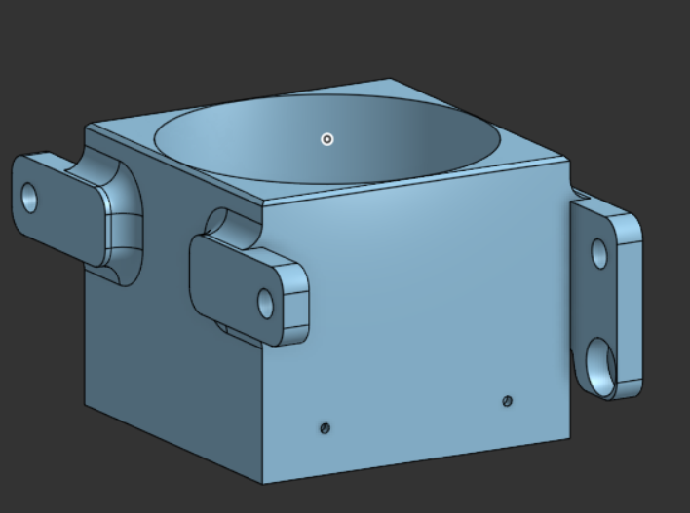  Figure 11: Top fan / roller housing

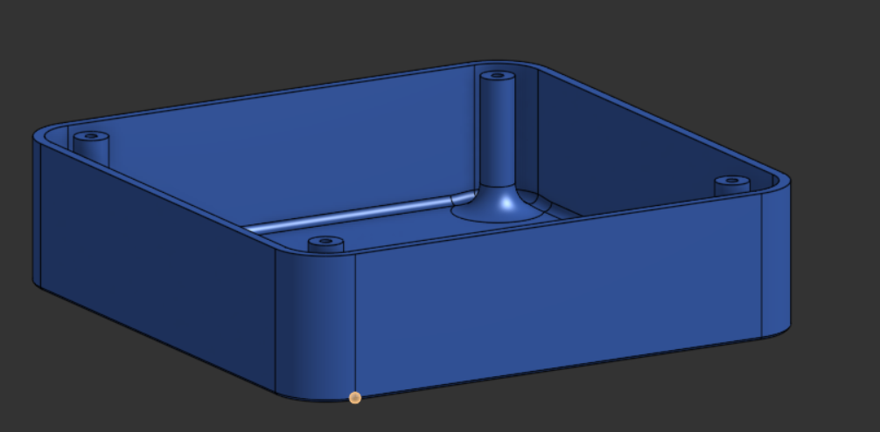
Figure 12: Base tray for electronics

4.3 Built prototype
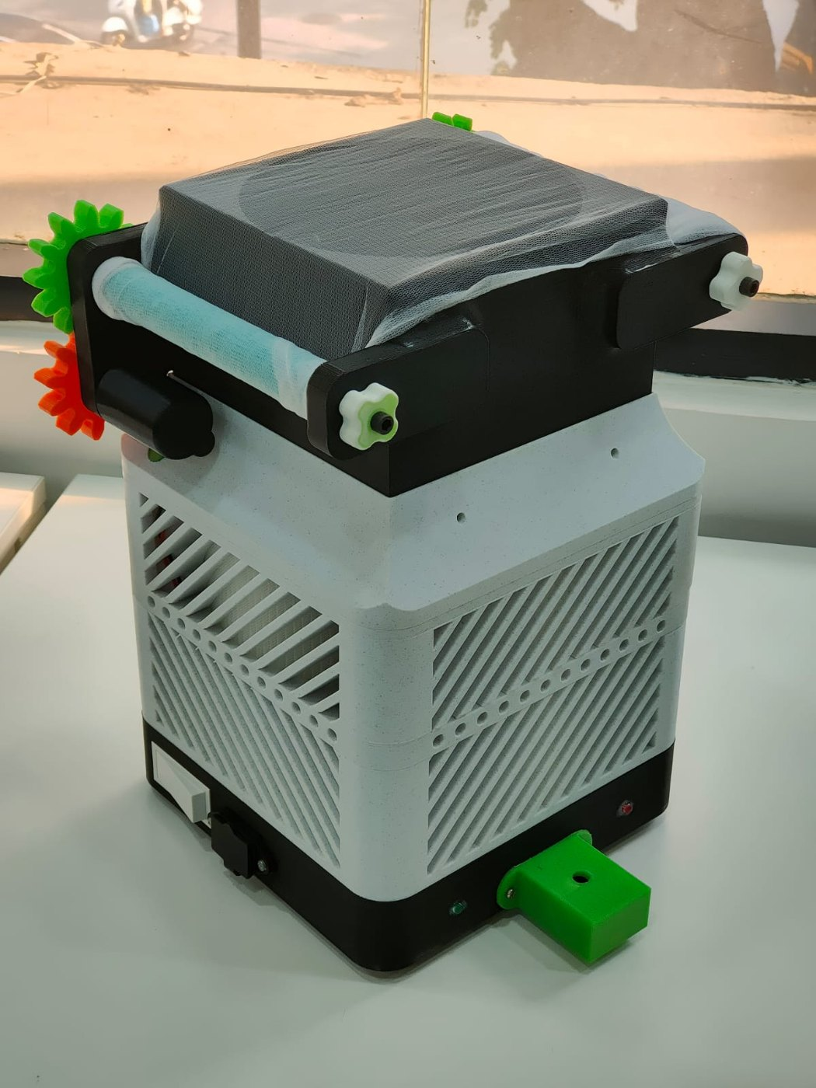
Figure 13: Finished prototype: printed enclosure with gear-driven roller mesh on top
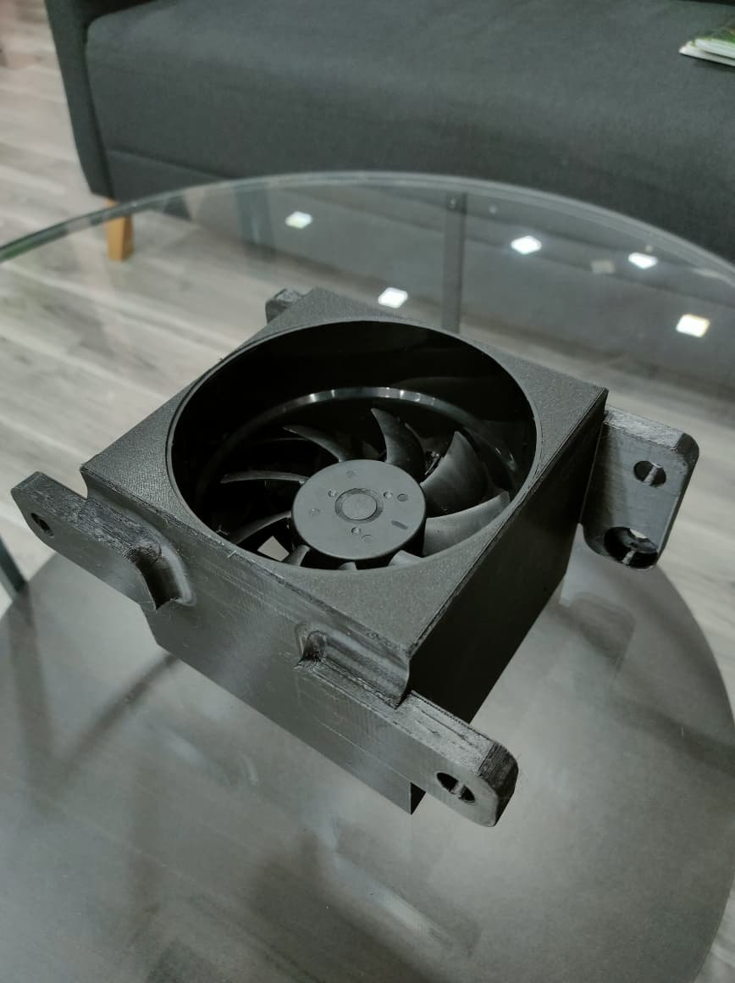  Figure 14: Printed top housing with fan | 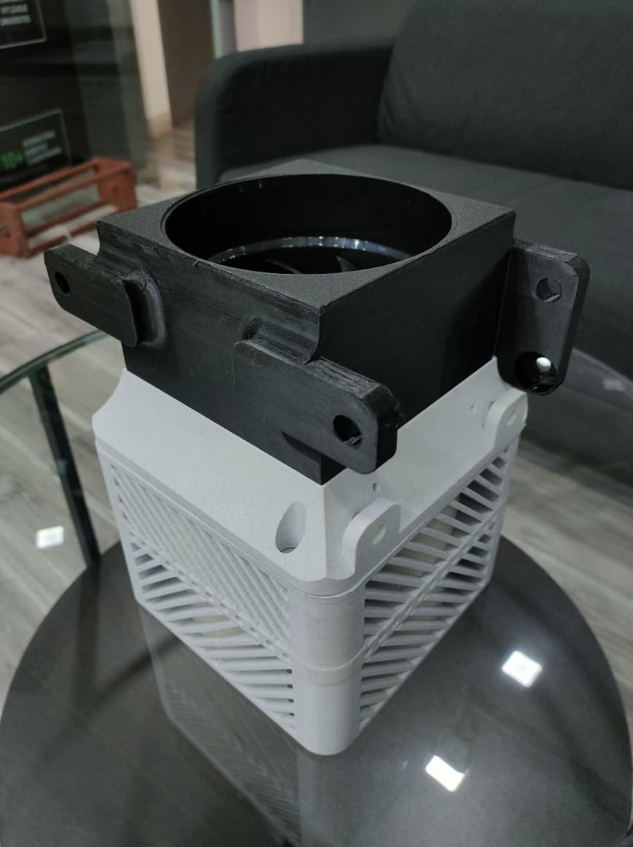  Figure 15: Top housing on the louvred body

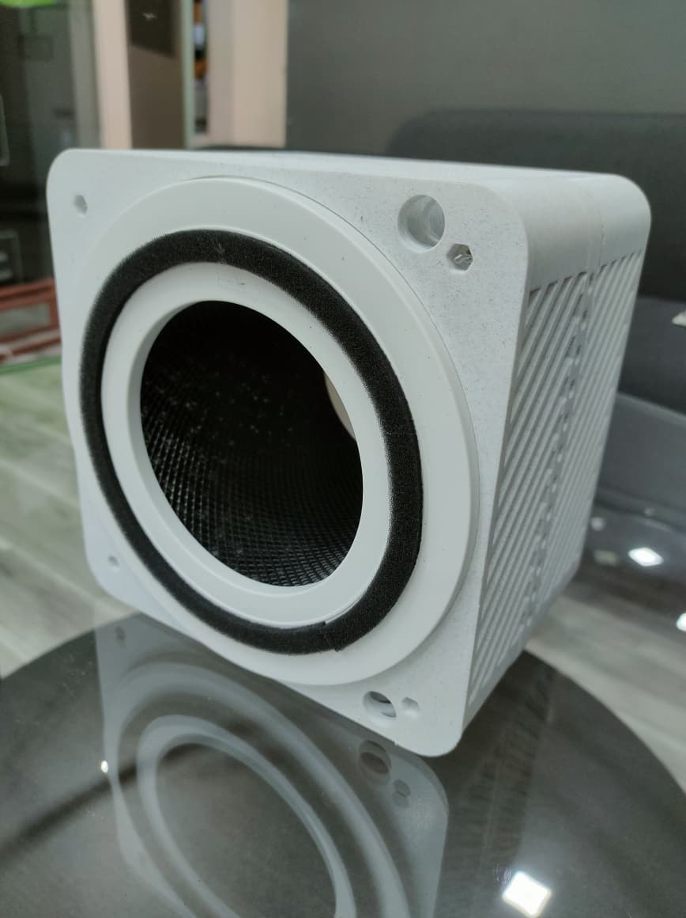  Figure 16: Body with filter ring (side) | 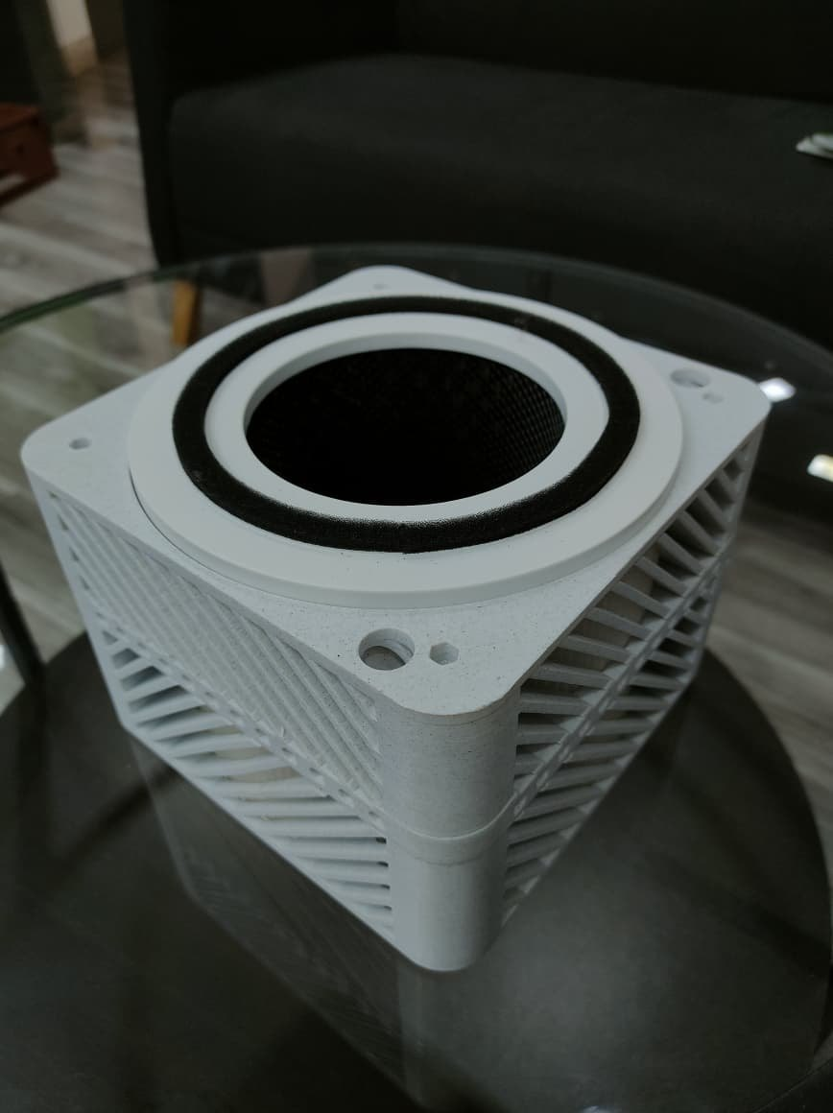  Figure 17: Filter seat with gasket ring

4.4 Self-refreshing mesh mechanism
A continuous mesh strip runs between two rollers, like a conveyor belt. It does not move all the time. Every 12 hours the left (supply) motor runs for 1046 ms and the right (take-up) motor for 2000 ms. This moves a fresh section of mesh into the air path and winds the used section onto the take-up roller. When the strip is used up, the push button runs the left motor in reverse so the strip can be rewound, removed, washed and refitted.

5. Firmware
The firmware is written in Arduino C++ and is fully non-blocking (millis() timers). The full source code is in Appendix B. The key parts are:

Dust conversion
float voltage = adcValue * (5.0 / 1023.0);
float rawDust = (0.17 * voltage) - 0.1; // datasheet linear model
if (rawDust < 0) rawDust = 0;
float dustDensity = (rawDust / 0.75) * 25.0; // scale to 0-25 mg/m3
if (dustDensity > 25.0) dustDensity = 25.0;

Warning LED with ON/OFF delays
The LED turns on only if dust stays above the threshold for 2 s (WARNING_ON_TIME). It turns off only after dust stays at or below the threshold for 8 s (WARNING_OFF_TIME). This stops single noisy readings from making the LED flicker.

Mesh indexing
MOTOR_CYCLE_TIME = 43,200,000 ms (12 h). At the start of each cycle both motors switch on and each is switched off by its own timer. Unsigned subtraction (now − motorCycleStart) means the timing still works when millis() rolls over after about 49 days.

6. Calibration: How the mg/m³ Values Were Obtained
This section explains how the voltage from the GP2Y10 is turned into the mg/m³ value on the LCD, and how we checked it.

6.1 Conversion formula
- Step 1: ADC to voltage. The Arduino Nano has a 10-bit ADC with a 5 V reference, so V = ADC × 5.0 / 1023.
- Step 2: Datasheet linear model. The GP2Y10 output rises by roughly 0.5 V for every 0.1 mg/m³ of dust and sits around 0.6 V in clean air. A straight line through these points gives raw dust = 0.17 × V − 0.1 (mg/m³). Negative results (very clean air, V < 0.588 V) are clamped to 0.
- Step 3: Scaling to our display range. Over the full 0 to 5 V output, the raw model only spans 0 to 0.75. Our reference readings in street dust and at a construction site covered a much wider range, so we scaled the raw value linearly: Dust = (raw ÷ 0.75) × 25, clamped at 25 mg/m³.
- Step 4: Combined. Putting the steps together gives Dust (mg/m³) = 5.667 × V − 3.333. Rearranged, the expected sensor voltage is V = 0.1765 × Dust + 0.588.
- Step 5: Checking against measurements. We logged 160 readings across 8 dust conditions next to a reference meter and fitted a straight line. The result was V = 0.1835 × Dust + 0.513 (R² = 0.821), which is close to the firmware model. The firmware constants were therefore kept.

Final conversion used in the firmware
V = ADC × 5 / 1023
Dust (mg/m³) = ((0.17 × V − 0.1) ÷ 0.75) × 25 = 5.667 × V − 3.333 (clamped to 0 … 25)
Measured fit: V = 0.1835 × Dust + 0.513 (R² = 0.821), close to the firmware model V = 0.1765 × Dust + 0.588
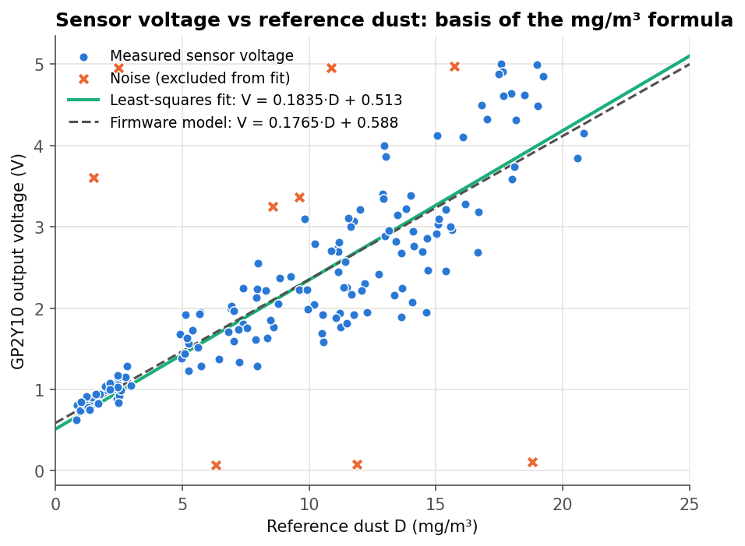
Figure 18: Sensor voltage vs reference dust, with fitted line and firmware model
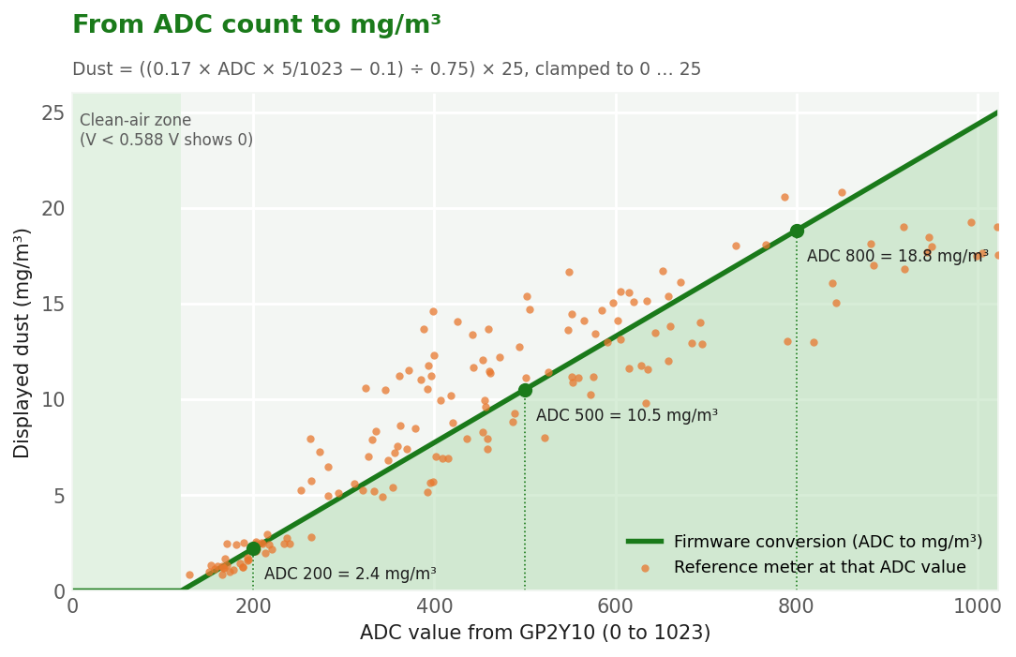
Figure 19: Firmware conversion from ADC count to mg/m³, with the reference readings plotted on top
Below ADC ≈ 120 (0.588 V) the formula gives a negative value, so the firmware shows 0. Above that, every ADC step adds about 0.028 mg/m³, up to the 25 mg/m³ ceiling at ADC 1023.

6.2 Calibration procedure
- Run the sensor for 5 minutes to warm up, with the unit in its final position.
- Create a dust condition (clean air, agarbatti smoke, cotton lint, chalk dust, filter outlet, street dust, construction site dust).
- Every 20 to 45 s, record the firmware's ADC count, voltage and calculated dust from the serial monitor, plus the reference meter value at the same spot.
- Repeat 18 to 40 times per condition. Total: 160 readings over Weeks 2 to 4.
- Calculate the error and accuracy of each reading: accuracy = 100 − |sensor − reference| ÷ reference × 100.
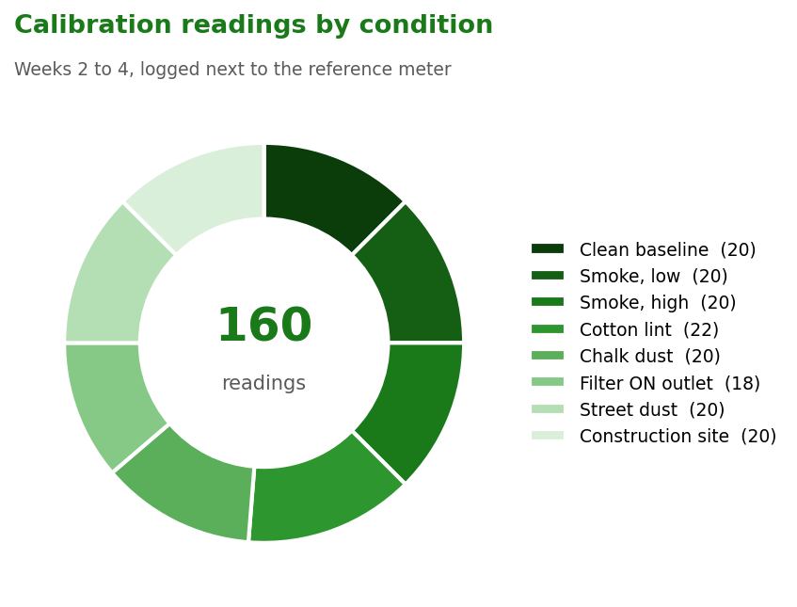
Figure 20: Split of the 160 calibration readings across test conditions

6.3 Results
Condition | Week | Readings | Mean abs. error (mg/m³) | Mean accuracy
Clean room baseline (fan off) | Week 2 | 20 | 1.41 | 73.8 %
Agarbatti smoke - low | Week 2 | 20 | 1.45 | 76.1 %
Agarbatti smoke - high | Week 2 | 20 | 3.56 | 77.0 %
Cotton lint shaken in box | Week 3 | 22 | 3.06 | 70.0 %
Chalk dust | Week 3 | 20 | 3.65 | 77.0 %
Filter ON - clean air outlet | Week 3 | 18 | 1.35 | 69.9 %
Street dust (roadside) | Week 4 | 20 | 2.87 | 77.2 %
Construction site dust | Week 4 | 20 | 3.03 | 74.2 %
All conditions | 2 to 4 | 160 |  | 74.4 %

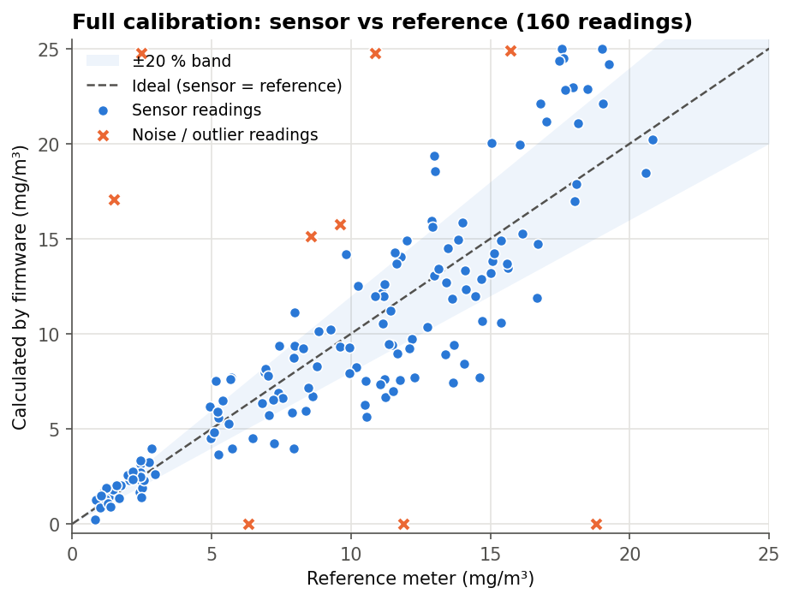
Figure 21: Firmware value vs reference meter: all 160 readings
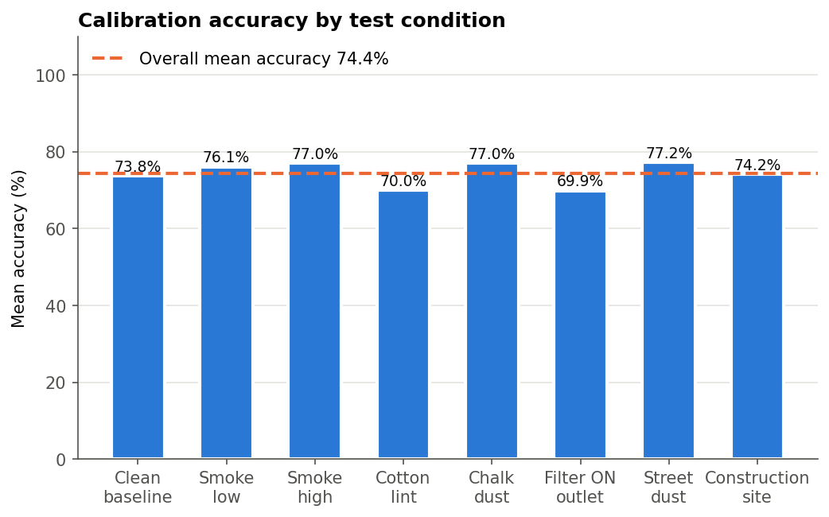
Figure 22: Mean accuracy per test condition
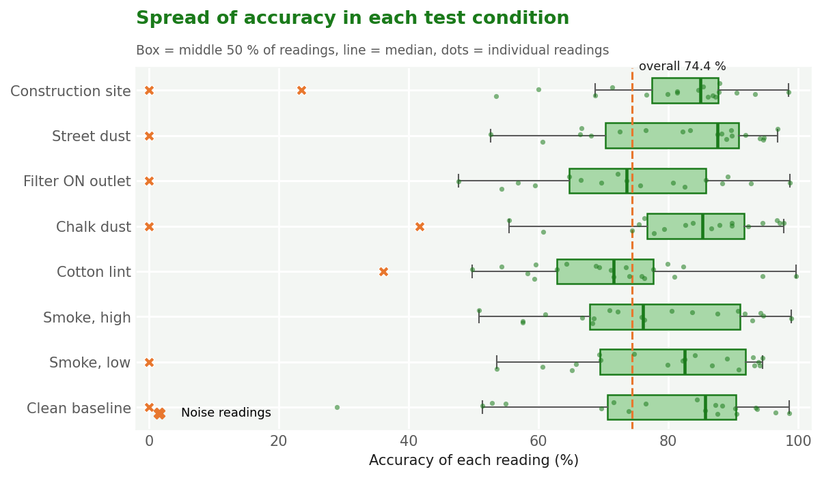
Figure 23: Spread of accuracy within each test condition
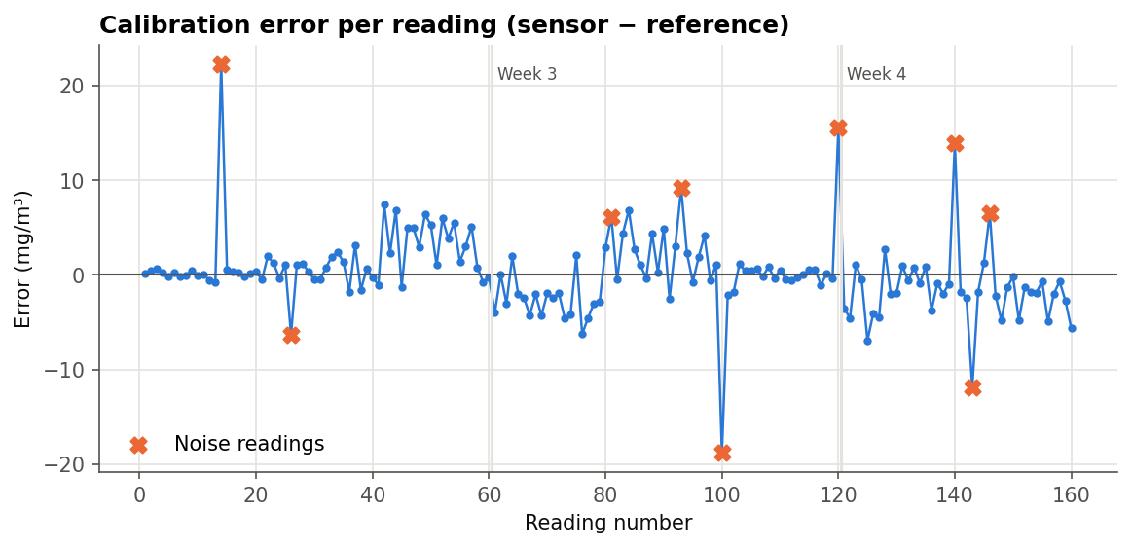
Figure 24: Error of each reading, with noise readings marked
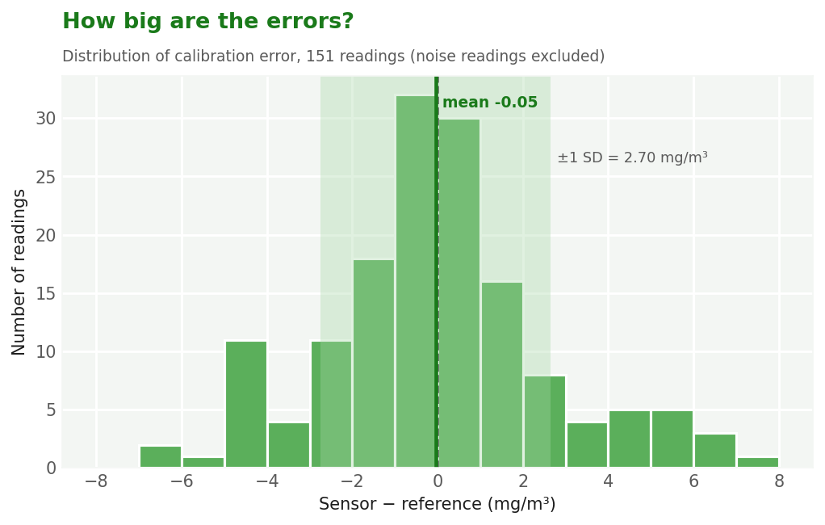
Figure 25: Distribution of calibration errors (noise readings excluded)

6.4 Discussion of accuracy
- Overall accuracy is 74.4 %, or 78.2 % with the 9 noise readings removed. Mean absolute error is 1.99 mg/m³. This is reasonable for a ₹360 optical sensor without a temperature/humidity correction, but it is not lab-grade.
- Smoke and chalk (fine, uniform particles) gave the best accuracy. Cotton lint and the filter-outlet tests gave the lowest. Large fibres scatter light unevenly, and at very low concentrations a small absolute error becomes a large percentage error.
- The 9 noise readings (rows 14, 26, 81, 93, 100, 120, 140, 143, 146) include rail spikes (ADC ≈ 1023), dropouts (ADC ≈ 0) and random jumps. They were caused by loose connections, stray light and dust particles passing directly through the sensing hole. They are kept in the CSV as measured.
- Because of this scatter, the system should be treated as a trend indicator (is the air getting better or worse?) rather than a certified measuring instrument.

7. Testing and Results

7.1 Filtration performance
A 3-hour test was run in a room next to a construction site. For the first 30 minutes the filter was OFF while site work was going on, then the filter was switched ON while the work continued. For the last 30 minutes site work had stopped. The average dust reading fell from 14.7 mg/m³ (filter off) to 6.6 mg/m³ (filter on, site work going on), a reduction of about 55 %. It reached 2.9 mg/m³ once site work stopped. Seven noise spikes or dropouts appeared during the test, and none of them triggered the warning LED.
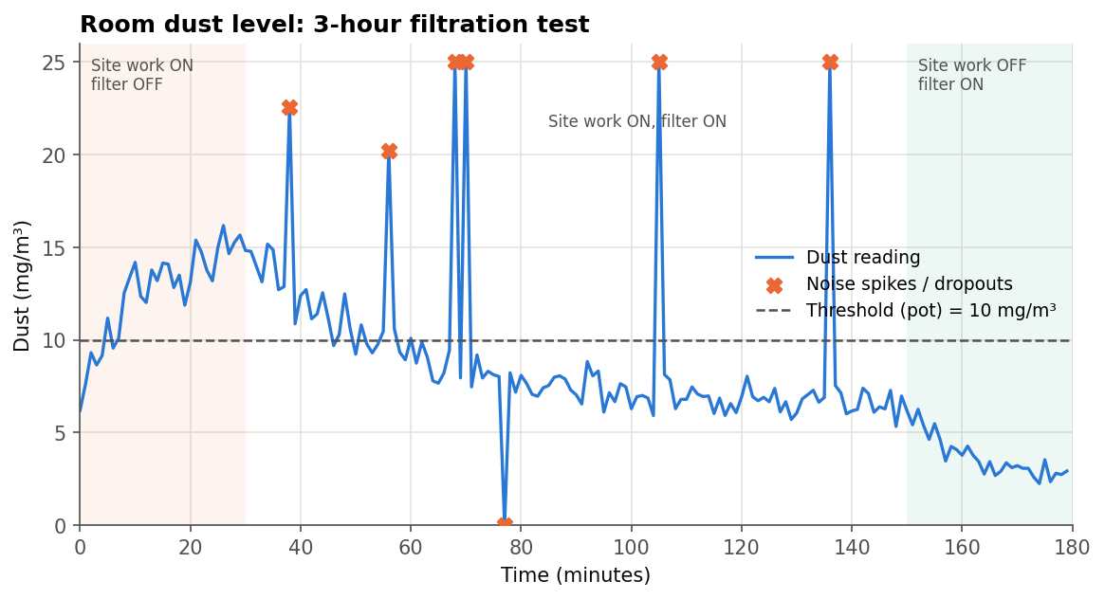
Figure 26: Room dust level during the 3-hour filtration test (data: 04_filtration_performance_test.csv)
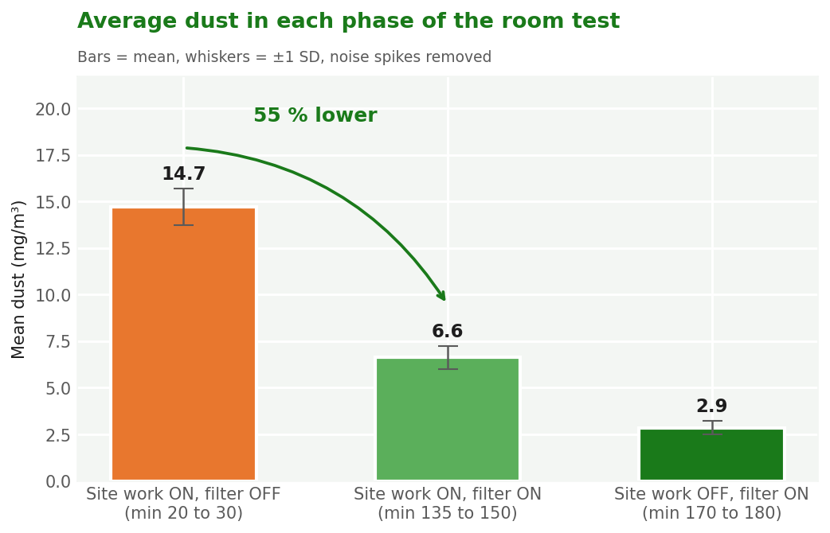
Figure 27: Average dust in each phase of the room test
The raw log contains spikes and dropouts. A simple 5-point median filter removes them without slowing down the real trend, which is why it is listed under Future Scope.
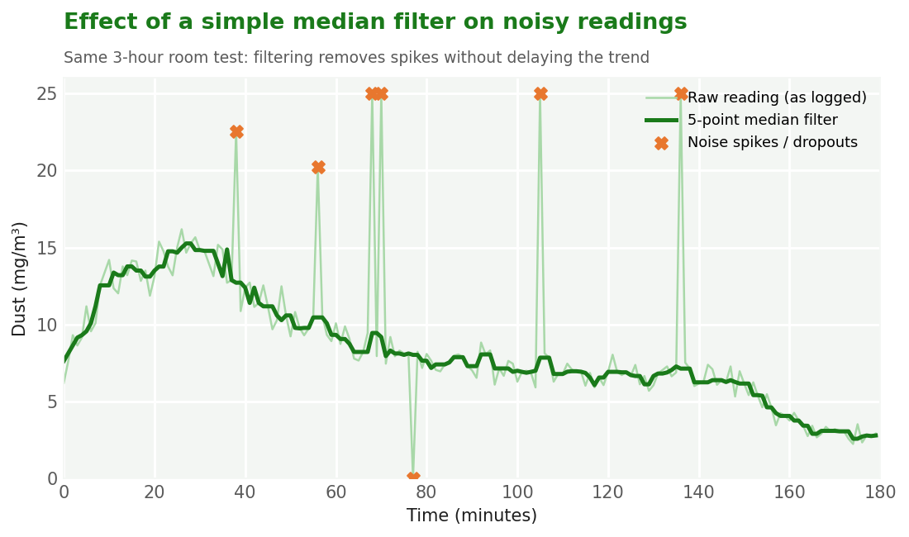
Figure 28: Raw room-test readings compared with a 5-point median filter

7.2 Warning LED response
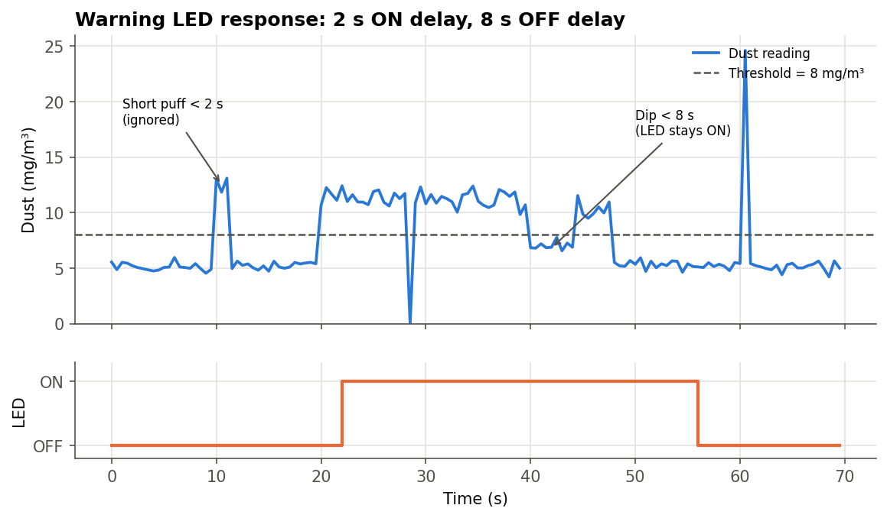
Figure 29: Warning LED response: 2 s ON delay and 8 s OFF delay
The LED ignored a 1-second dust puff, came on about 2 s after a sustained rise, stayed on through a 4-second dip, and went off 8 s after dust fell below the threshold. Isolated noise spikes and dropouts were ignored.

7.3 Motor current
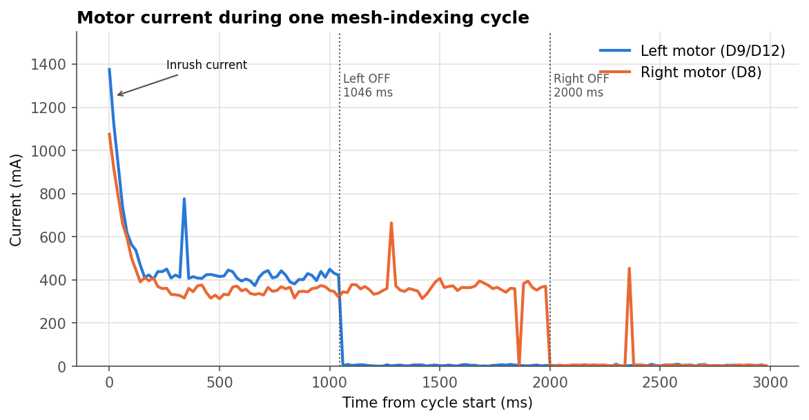
Figure 30: Motor current during one indexing cycle
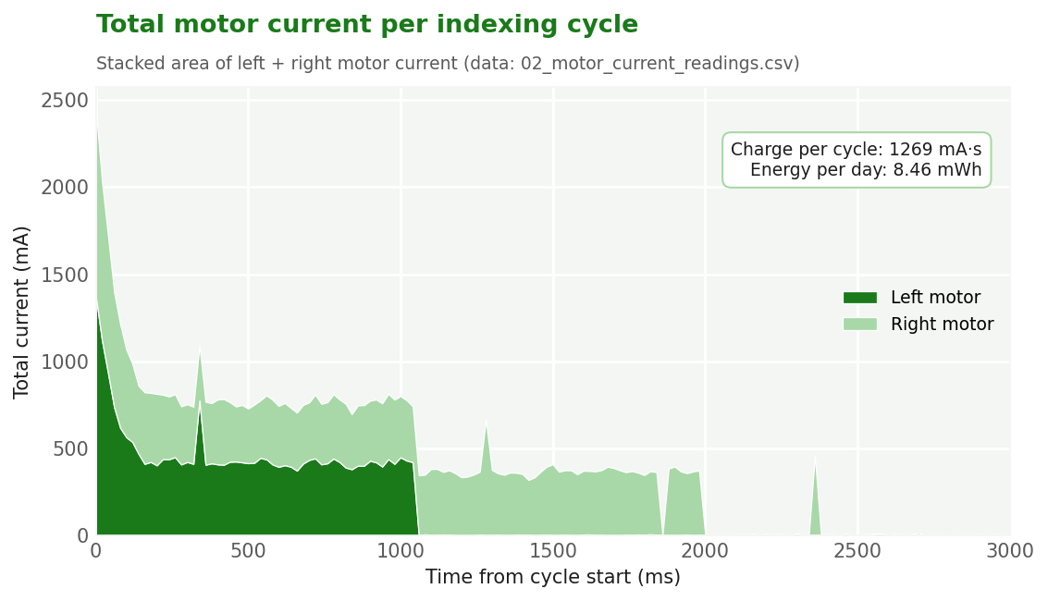
Figure 31: Combined motor current per cycle, with total charge and daily energy
Inrush peaks of about 1375 mA (left) and 1075 mA (right) last less than 150 ms. Running currents are about 414 mA and 358 mA, well within the driver rating. The whole cycle draws about 1269 mA·s, which is only about 8.46 mWh per day at 12 V.

7.4 Supply voltage stability
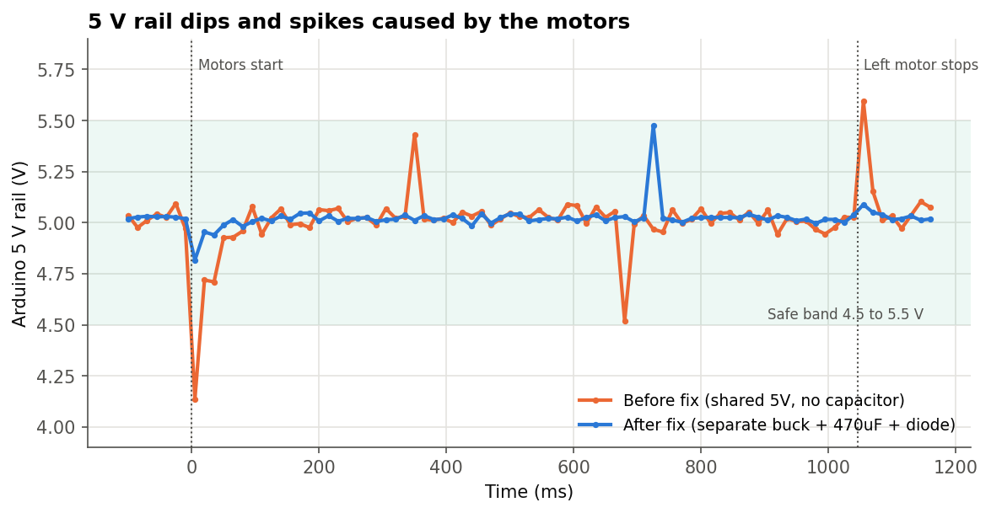
Figure 32: Arduino 5 V rail during motor start and stop, before and after the fix
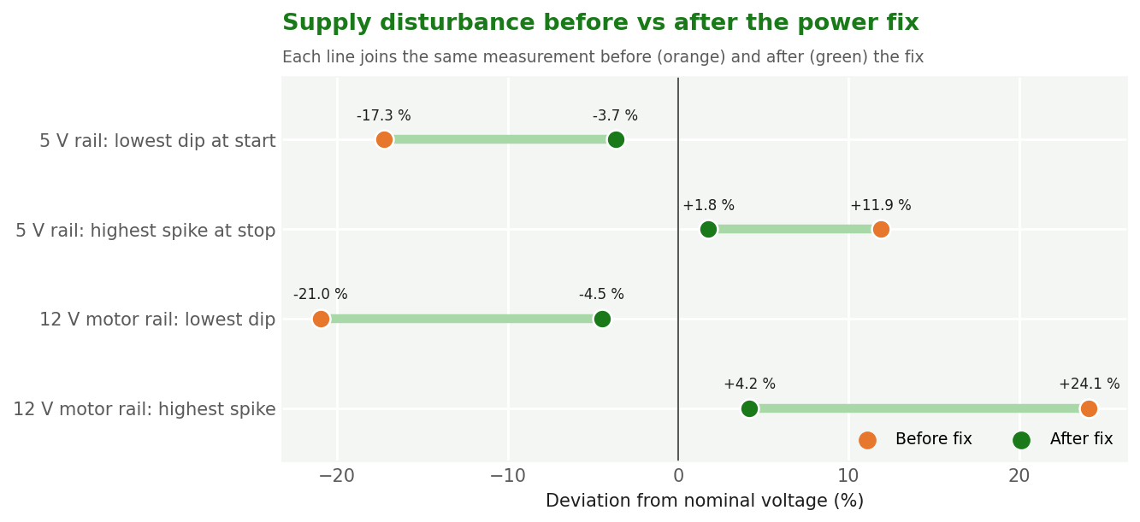
Figure 33: Worst dip and spike on each rail, before vs after the fix
Before the fix, the 5 V rail fell to 4.14 V when the motors started (the Nano can brown out below about 4.3 V) and rose to 5.59 V when they stopped. With a separate motor buck converter, a 470 µF capacitor and flyback diodes, the rail now stays between 4.82 V and 5.09 V.

8. Challenges and Solutions
# | Challenge | Solution
1 | The concept note's ESP32 + PM1.0/2.5/10 sensor did not fit the budget | Switched to an Arduino Nano + GP2Y10 and wrote our own mg/m³ conversion
2 | The sensor gives voltage only, not mg/m³ | Used the datasheet linear model, scaled to 0 to 25 mg/m³, and checked it with 160 readings
3 | Very high lint load from weaving would clog a fixed mesh | Designed a roller-based self-refreshing mesh with timed motors
4 | Noisy sensor readings (spikes and dropouts) | Better wiring, light shielding, and 2 s / 8 s delays on the warning LED
5 | 5 V rail brown-out and spikes from the motors | Separate buck converter, 470 µF capacitor, flyback diodes
6 | Floating push-button input reversed the motor at random | 10 kΩ pull-down resistor on D4
7 | Gear meshing and part fit after 3D printing | Set 0.2 to 0.3 mm clearances in CAD and reprinted gears
8 | Tuning the mesh advance length | Trial runs gave 1046 ms (left) and 2000 ms (right) per cycle
9 | Lint building up on the sensor optics | Moved the sensor behind the mesh and added it to routine cleaning
10 | Leftover characters on the LCD | Trailing-space padding on each line

9. Limitations
- Measurement accuracy is about 74.4 %. Readings are good for trends but are not a certified measurement.
- The GP2Y10 gives a single dust value. It cannot separate PM1.0, PM2.5 and PM10.
- The threshold moves in whole 1 mg/m³ steps because map() uses integers.
- The fan is switched manually and is not yet controlled by the dust reading.
- Readings show conditions near the unit only, not the whole room.
- The unit reduces dust already in the air. It does not stop dust being produced at the source.

10. Future Scope
- Average 10 to 20 samples (or use a median filter) before displaying, to reduce noise.
- Use a laser PM sensor (e.g. PMS5003) for PM1.0/2.5/10 and better accuracy.
- Control fan speed automatically from the dust level (PWM).
- Add ESP32 Wi-Fi logging so families can see the air-quality history on a phone.
- Use a float-based threshold for finer adjustment, and store the setting in EEPROM.

11. Conclusion
The project produced a working, low-cost dust reduction and monitoring unit for home weaving rooms. The roller-mesh pre-filter solves the clogging problem found in the site review. The Arduino-based monitor shows dust in mg/m³ and gives a stable, noise-tolerant warning. The conversion was checked with 160 readings (accuracy 74.4 %), and the room test next to a construction site showed about 55 % lower dust while work was going on. The prototype meets its objectives and gives a solid base for the improvements listed above.

