Dust Reduction and Air Quality Monitoring System for Home-Based Weaving Environments
Progress Report 1: Week 1 and Week 2
Item | Details
Project | Dust Reduction and Air Quality Monitoring System for Home-Based Weaving Environments
Report type | Progress Report 1 of 2
Platform | Arduino Nano + Sharp GP2Y10 optical dust sensor
Prepared by | Project Team, RFL Academy Innovation Lab

1. Summary of Progress
During the first two weeks the team turned the concept note into a working layout and a first 3D model. We also brought up the core electronics on the bench. The main focus areas were:
- Sketching the enclosure, airflow path and positions of the fan, HEPA filter and sensor in 2D.
- Building first-concept CAD models of the filter box, inlet hopper and roller-mesh chamber.
- Finalising the electronics platform. We moved from the ESP32 and PM1.0/2.5/10 sensor in the concept note to an Arduino Nano with a GP2Y10 dust sensor, to stay within the BOM.
- Getting the GP2Y10 sensor, the 16×2 I²C LCD and the serial monitor working together.
- Starting sensor calibration. The first 60 readings were taken, and accuracy against the reference meter is 75.6 %.

Status at the end of Week 2
Overall: On track. The 2D layout and first CAD concept are done, the electronics bench test has passed, and calibration has started.
Calibration: 60 of the planned 160 readings logged (Week 2 accuracy 75.6 %; 78.3 % excluding 2 noise readings).
Biggest open issue: The site review showed that weaving produces far more fibre than expected. This needs the roller-based self-refreshing mesh, which adds mechanical work in Weeks 3 to 5.

2. Objectives for this Period
# | Objective (from Session Timeline) | Week
1 | Sketch the overall layout of the enclosure, airflow path and component positions in 2D | 1
2 | Define key dimensions and mark where the fan, HEPA filter and sensor go, for use as the CAD reference | 1
3 | Assemble and bench-test the circuit: Arduino Nano, dust sensor, LCD, buck converter and SMPS | 1 to 2
4 | Build the enclosure body, fan housing and filter chamber in CAD using the 2D sketches | 2
5 | Write first firmware to read the dust sensor and show the value on the LCD | 2
6 | Start calibration readings to convert sensor voltage into mg/m³ | 2

3. Week 1: 2D Sketching and Component Selection

3.1 Layout and airflow path
The first session went into 2D sketches of the unit. The airflow path was fixed as: inlet grille, then the mesh pre-filter, then the HEPA and activated-carbon cartridge, then the inline duct fan, and out through the outlet. This order means the large textile fibres are caught before they reach the expensive HEPA filter.
- We sized the design for a typical weaving room of about 15 ft × 15 ft × 10 ft (≈ 64 m³).
- The 300 m³/h inline duct fan gives a theoretical 2 to 3 air changes per hour. After filter losses we expect 1 to 2 effective changes per hour.
- The sensor is placed on the inlet side so it measures room air, not the filtered air at the outlet.
- We kept the electronics bay at the bottom of the unit, away from the lint-loaded air stream.

3.2 Component selection
After comparing prices and availability, the team settled on the following core components (full BOM in the final report):
Component | Qty | Purpose
Arduino Nano | 1 | Main controller (replaces ESP32 in the concept note)
Sharp GP2Y10 dust/smoke sensor | 1 | Optical dust sensing, analog voltage output
16×2 I²C LCD (0x27) | 1 | Live dust value and threshold display
Inline duct fan, 300 m³/h | 1 | Room air circulation through the filters
HEPA filter | 1 | Fine particle removal
24 V 156 W SMPS + 2 buck converters | 1 + 2 | Main supply; separate 5 V logic and motor rails
DC motors + motor driver | 2 + 1 | Roller mesh advance and take-up
Potentiometer, push button, LED | 1 each | Threshold setting, manual rewind, warning

3.3 Electronics bench test
The first sensor test was done on a breadboard with the lab's Arduino Uno, with the GP2Y10 soldered onto a small perfboard together with its 150 Ω resistor and 220 µF capacitor. In parallel, an early controller board (an ESP32 dev board with a buck converter, as in the concept note) was wired to the 24 V SMPS. Once the BOM was fixed, the same circuit was moved to the Arduino Nano.
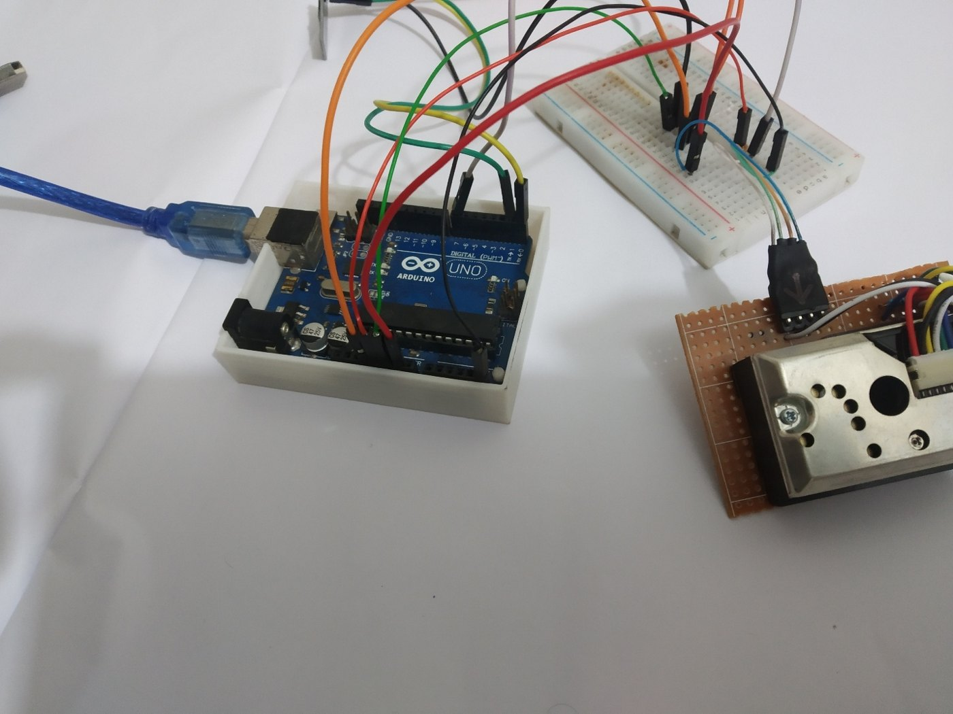  Figure 1: First bench test: GP2Y10 on perfboard with Arduino Uno and breadboard | 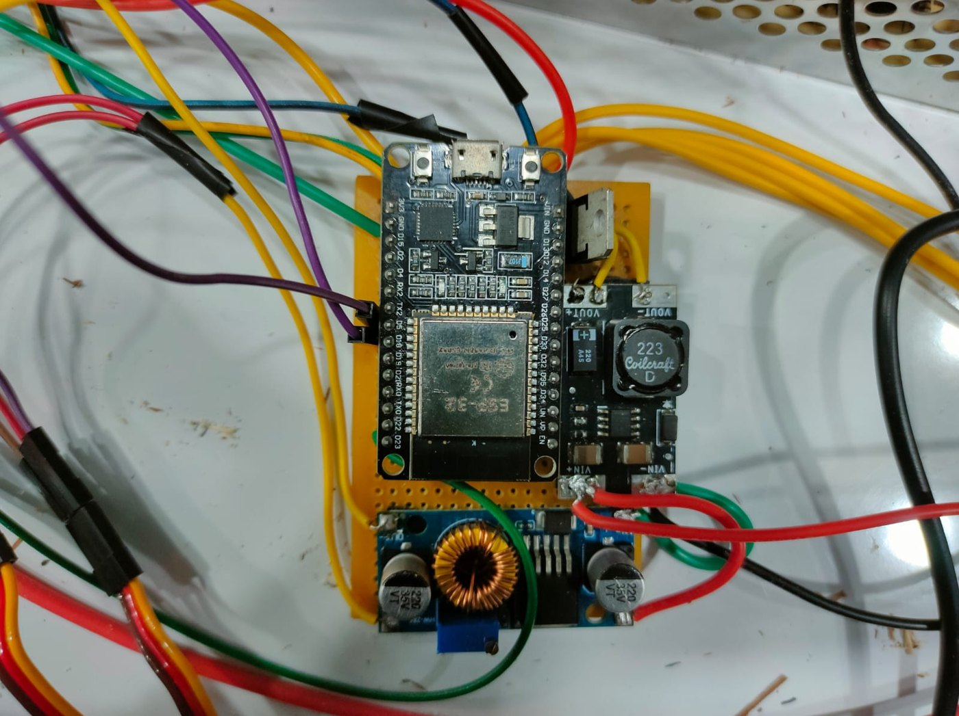  Figure 2: Early controller board with buck converter (later replaced by the Nano)

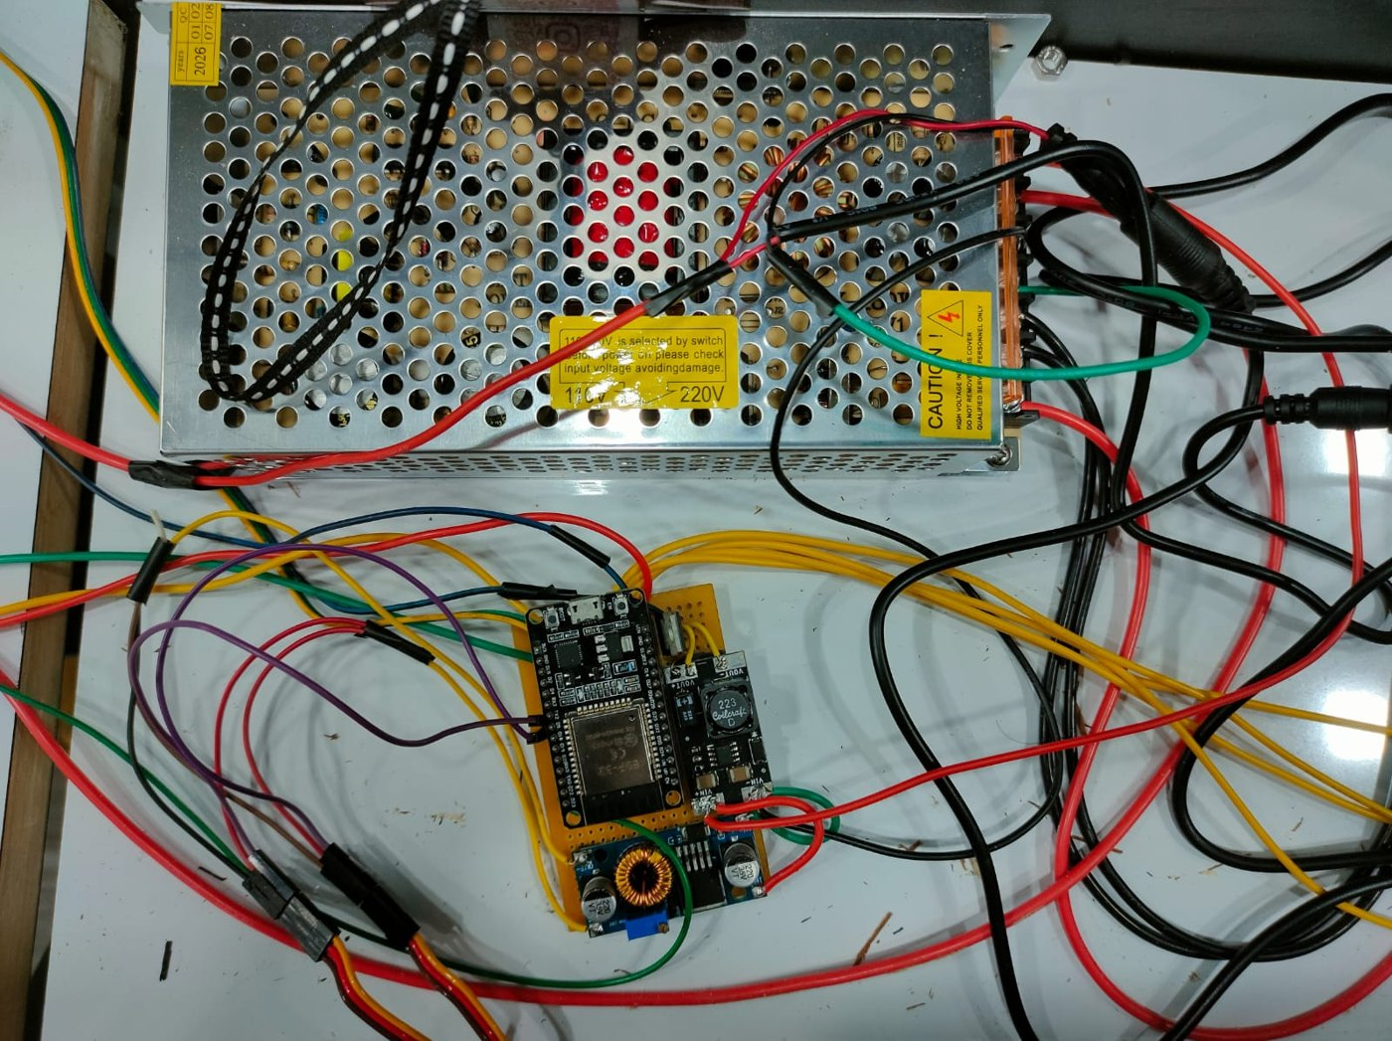
Figure 3: Early wiring of the 24 V SMPS, buck converter and controller board on the test panel
The sensor's internal IR LED must be pulsed with exact timing, which our firmware does as follows:
- Switch the IR LED ON (pin D6 LOW), wait 280 µs, read A0, wait 40 µs, switch the LED OFF, then wait 9680 µs. This gives the 10 ms cycle from the datasheet.
- We ran an I²C scanner to find the LCD address (0x27) and adjusted the contrast trimmer on the backpack.
- Serial output at 9600 baud prints the ADC count, voltage and calculated dust. We used this log for calibration.

4. Week 2: 3D Design and Sensor Calibration Start

4.1 First CAD concepts
Using the 2D sketches, the first CAD models were built. These early concepts test the roller-mesh idea and the duct connection before we commit to the final enclosure shape.
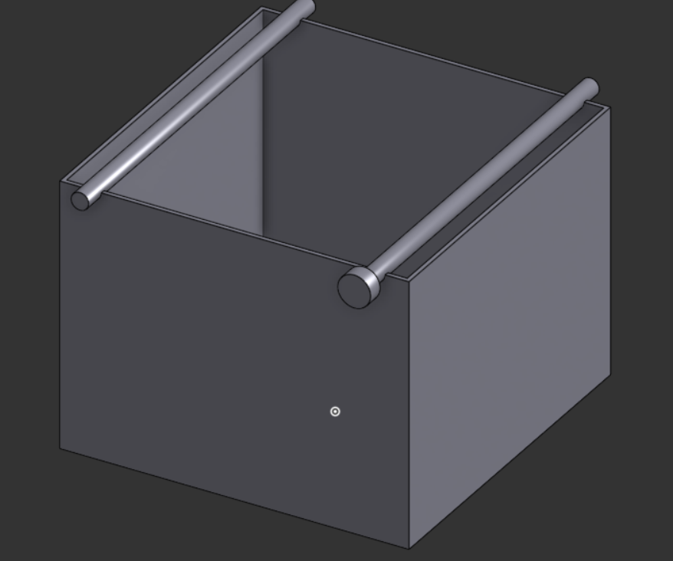  Figure 4: Concept filter box with two roller rods for the mesh strip | 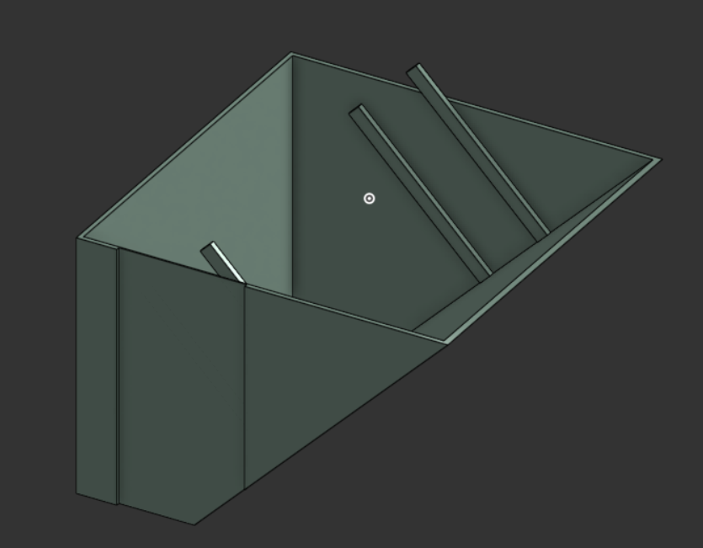  Figure 5: Inlet hopper with internal guide ribs

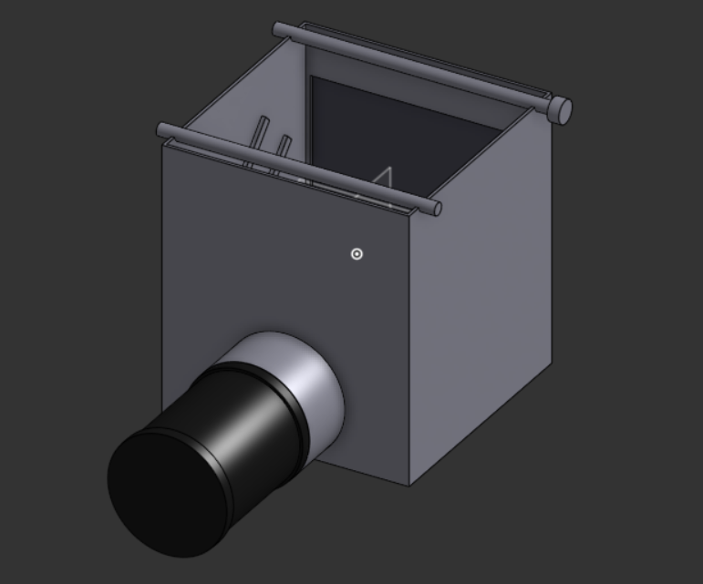
Figure 6: Concept chamber with rollers on top and duct outlet for the inline fan
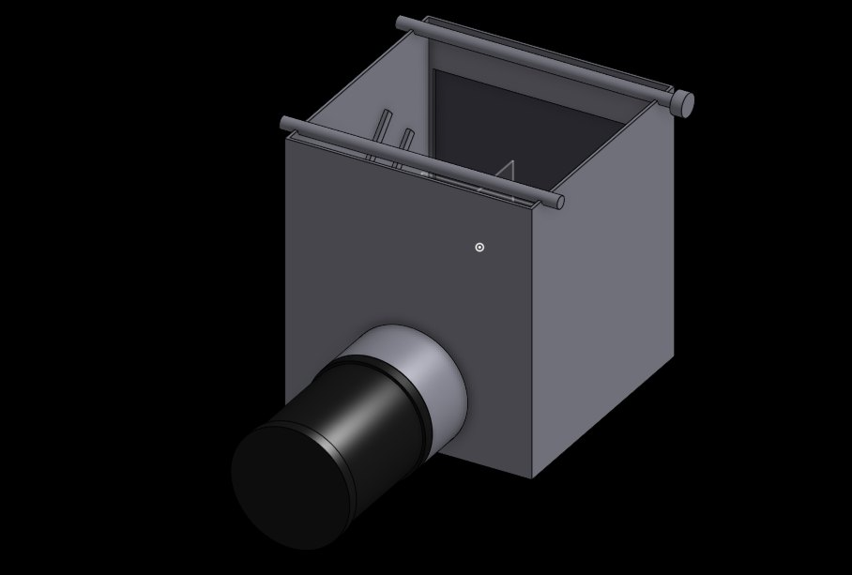  Figure 7: Concept chamber: rollers on top, duct outlet on the side | 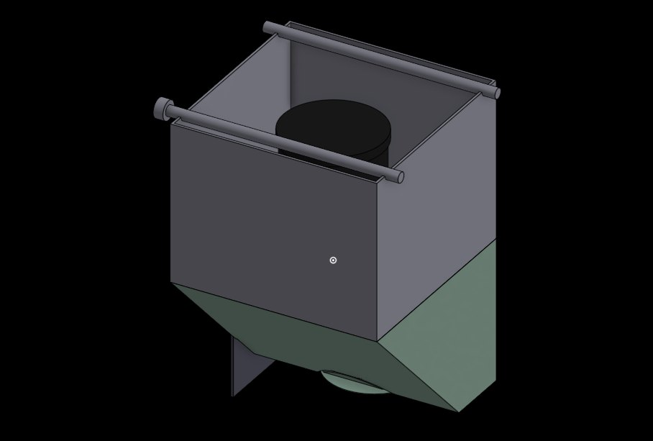  Figure 8: Concept chamber with lower hopper and fan seat

4.2 Airflow test rig
Before printing anything, we mounted a 120 mm fan behind a printed honeycomb grille on a wooden test panel. This let us feel the airflow, check noise, and see how quickly lint collects on a grille before deciding on the final inlet design.
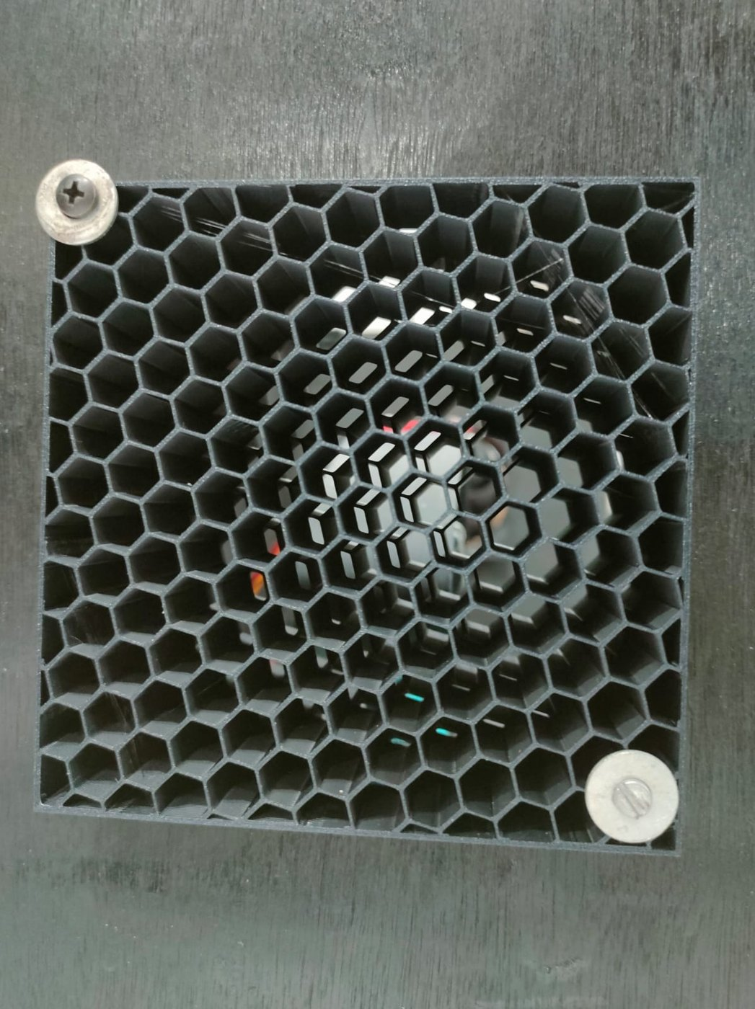  Figure 9: Printed honeycomb grille on the airflow test panel | 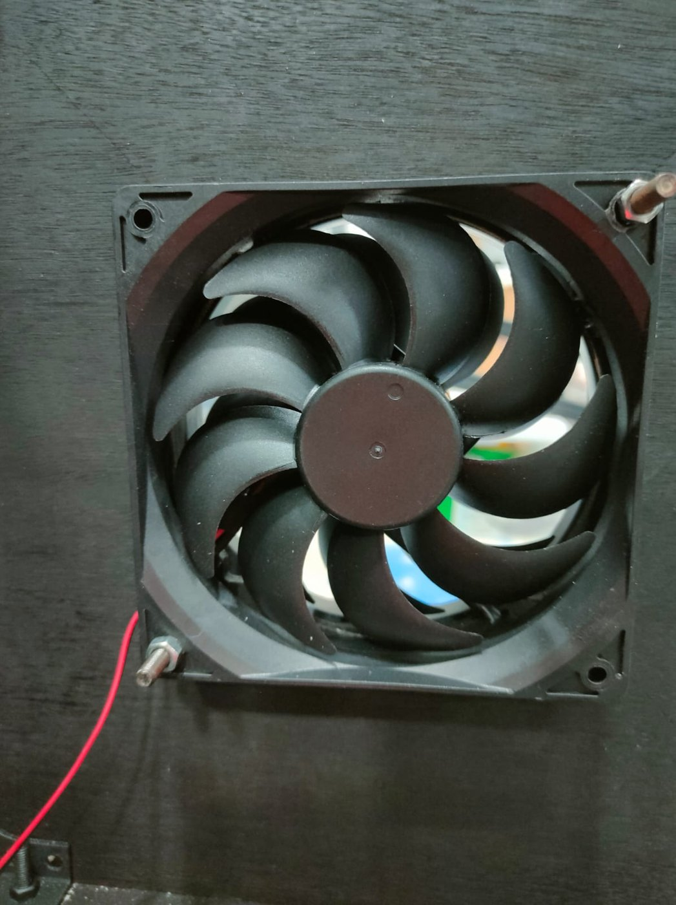  Figure 10: 120 mm fan mounted behind the grille

Observations from the first concept and the test rig:
- A plain box with exposed rollers was too large, and its open edges let fibres escape around the mesh.
- The hopper ribs guide lint onto the mesh but make 3D printing harder because they need support material.
- The duct outlet needs a proper flange to the inline fan. This was carried into the Week 3 design.
- On the test rig, the fine honeycomb grille caught lint within minutes. This confirmed that a fixed grille or mesh alone would clog, and that the mesh needs to move.

4.3 How the sensor value is converted to mg/m³
The GP2Y10 does not output mg/m³ directly. It gives an analog voltage that rises with the amount of light scattered by dust. To display mg/m³ we use the conversion below, then check it with repeated readings against a reference meter.
- Step 1: ADC to voltage. The Arduino Nano has a 10-bit ADC with a 5 V reference, so V = ADC × 5.0 / 1023.
- Step 2: Datasheet linear model. The GP2Y10 output rises by roughly 0.5 V for every 0.1 mg/m³ of dust and sits around 0.6 V in clean air. A straight line through these points gives raw dust = 0.17 × V − 0.1 (mg/m³). Negative results (very clean air, V < 0.588 V) are clamped to 0.
- Step 3: Scaling to our display range. Over the full 0 to 5 V output, the raw model only spans 0 to 0.75. Our reference readings in street dust and at a construction site covered a much wider range, so we scaled the raw value linearly: Dust = (raw ÷ 0.75) × 25, clamped at 25 mg/m³.
- Step 4: Combined. Putting the steps together gives Dust (mg/m³) = 5.667 × V − 3.333. Rearranged, the expected sensor voltage is V = 0.1765 × Dust + 0.588.
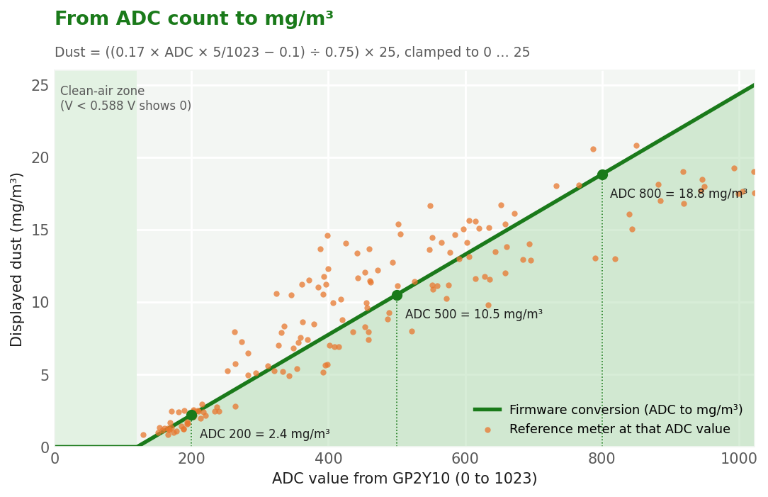
Figure 11: Conversion curve used by the firmware, with the Week 2 to 4 reference readings plotted on top

4.4 First calibration readings (Week 2)
In Week 2 we took 60 readings under three controlled conditions: a clean room with the fan off, low agarbatti smoke, and dense agarbatti smoke inside a closed box. For each reading we logged the ADC count, the sensor voltage, the value calculated by the firmware, and a reference meter reading taken at the same moment.
Condition | Week | Readings | Mean abs. error (mg/m³) | Mean accuracy
Clean room baseline (fan off) | Week 2 | 20 | 1.41 | 73.8 %
Agarbatti smoke - low | Week 2 | 20 | 1.45 | 76.1 %
Agarbatti smoke - high | Week 2 | 20 | 3.56 | 77.0 %

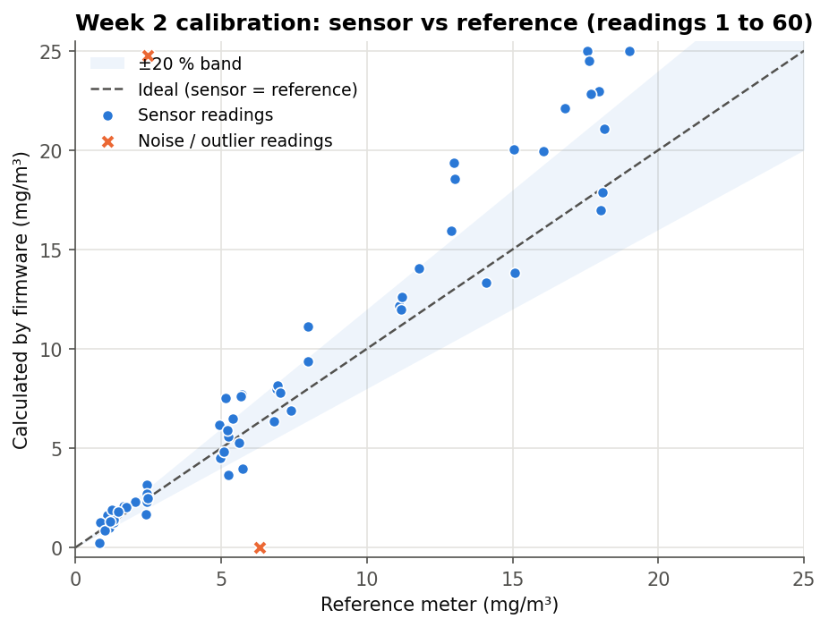
Figure 12: Week 2 calibration: firmware value vs reference meter (readings 1 to 60)
The readings follow the ideal line, but with clear scatter. Overall Week 2 accuracy is 75.6 %. Readings 14 and 26 are obvious noise: one ADC value jumped close to the 5 V rail and another dropped to near zero. We traced both to a loose breadboard jumper and stray light entering the sensor's hole. They are kept in the data file as they were measured.
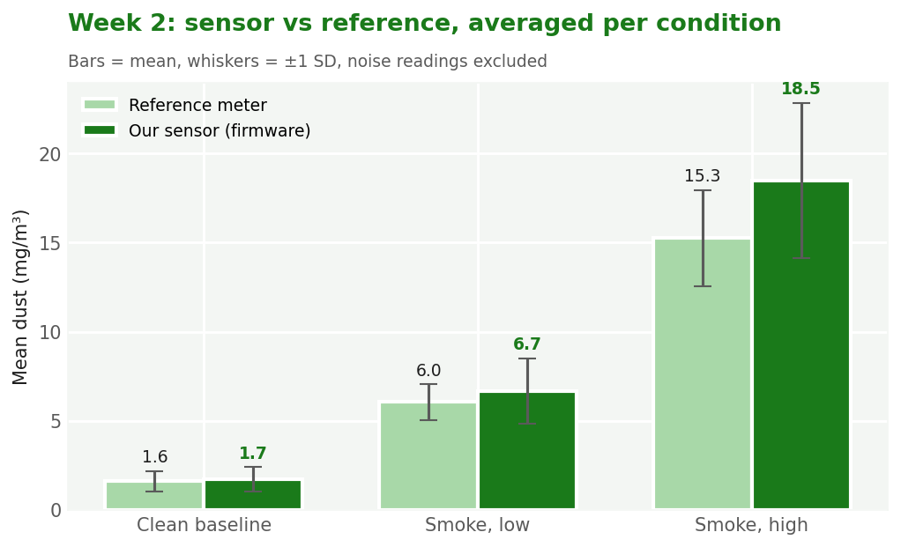
Figure 13: Week 2: average sensor value vs reference meter for each condition
On average the sensor is within about 10 % of the reference in clean air and low smoke, and reads about 20 % high in dense smoke. Fine smoke particles scatter more light per gram than the reference meter assumes.
Sample rows from the calibration log:
# | Condition | ADC | Voltage (V) | Sensor (mg/m³) | Reference (mg/m³) | Accuracy
1 | Clean room baseline (fan off) | 167 | 0.816 | 1.29 | 1.18 | 90.5 %
7 | Clean room baseline (fan off) | 203 | 0.992 | 2.29 | 2.45 | 93.4 %
14 | Clean room baseline (fan off) | 1014 | 4.956 | 24.75 | 2.49 | 0.0 %
23 | Agarbatti smoke - low | 343 | 1.676 | 6.17 | 4.92 | 74.7 %
26 | Agarbatti smoke - low | 15 | 0.073 | 0.0 | 6.31 | 0.0 %
35 | Agarbatti smoke - low | 458 | 2.239 | 9.35 | 7.96 | 82.5 %
47 | Agarbatti smoke - high | 844 | 4.125 | 20.04 | 15.04 | 66.7 %
58 | Agarbatti smoke - high | 552 | 2.698 | 11.96 | 11.16 | 92.9 %

5. Challenges Faced
Challenge | What we observed | Action taken / planned
Change of controller and sensor | The concept note used an ESP32 and a PM1.0/2.5/10 sensor. The approved BOM only had budget for an Arduino Nano and a GP2Y10. | Redesigned around the Nano and GP2Y10. We now show one dust value instead of three PM channels.
Sensor gives voltage, not mg/m³ | There was no direct mg/m³ output, and the datasheet curve is only typical, not exact for our unit. | Built the conversion formula and started logging readings against a reference meter.
Noisy / jumping readings | Single readings jumped to the rail or dropped to 0 (readings 14, 26). The value also flickered by ±0.5 mg/m³. | Re-seated the wiring and shielded the sensor opening from light. A software delay is planned for the warning LED.
Fibre load higher than expected | The site review showed that weaving releases far more lint than a fixed mesh could handle. | Adopted the roller-based self-refreshing mesh (two rollers + motors).
LCD showed blank boxes | The I²C address and contrast were unknown at first. | Ran an I²C scanner (0x27) and tuned the contrast trimmer.
CAD fit and printability | The first box was too big, the open roller edges leaked fibres, and the hopper ribs needed supports. | Week 3 will produce a compact, closed enclosure with louvred side walls.

