Dust Reduction and Air Quality Monitoring System for Home-Based Weaving Environments
Progress Report 2: Week 3, Week 4 and Week 5
Item | Details
Project | Dust Reduction and Air Quality Monitoring System for Home-Based Weaving Environments
Report type | Progress Report 2 of 2
Platform | Arduino Nano + Sharp GP2Y10 optical dust sensor
Prepared by | Project Team, RFL Academy Innovation Lab

1. Summary of Progress
Weeks 3 to 5 took the project from a first concept to a working, integrated prototype. Main achievements:
- Final compact enclosure designed in CAD, then 3D printed and assembled: louvred main body, top fan/roller housing, base tray and gear train.
- Firmware completed. It handles dust sensing, a potentiometer-set threshold, a warning LED with ON/OFF delays, the LCD, the serial log and the 12-hour mesh-indexing motor cycle.
- Calibration completed with 160 readings over 8 conditions. Overall accuracy is 74.4 %.
- Electronics mounted inside the base. Motor and power tests done. The 5 V rail dip at motor start-up was reduced from 4.14 V to 4.82 V after the power fix.

Status at the end of Week 5
Overall: The prototype is functionally complete. All Session 3 to 5 tasks are done.
Calibration: 160/160 readings. Accuracy 74.4 % overall (78.2 % with the 9 noise readings excluded). Mean absolute error 1.99 mg/m³.
Remaining: A long-duration room test and the final report (covered in the Final Report).

2. Week 3: 3D Assembly
Building on the Week 2 concepts, the enclosure was redesigned as a compact stacked unit with three printed parts. All parts were assembled in CAD to check clearances before we exported print files.
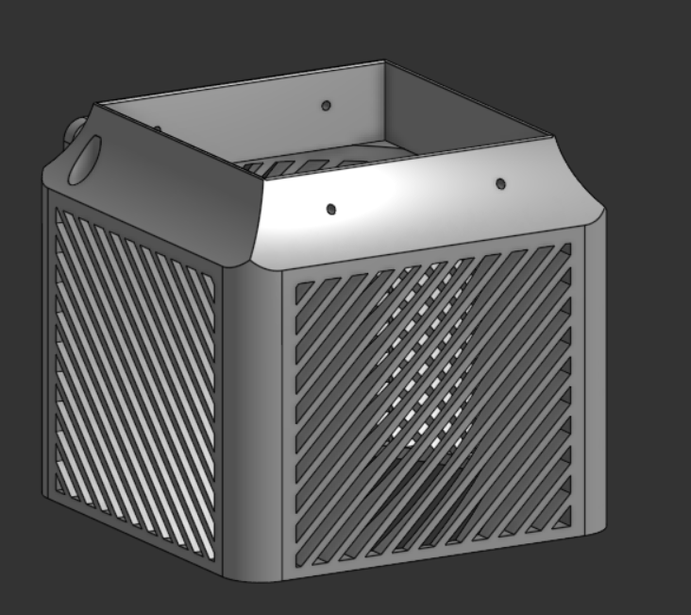  Figure 1: Main body with diagonal louvres on all sides | 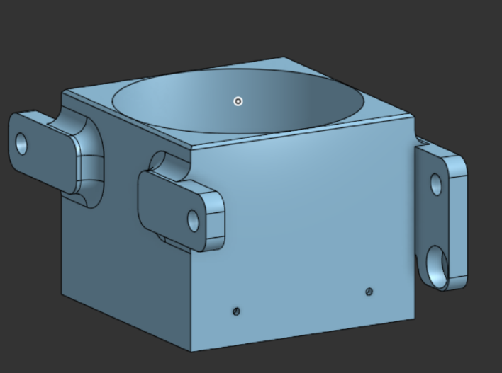  Figure 2: Top housing: fan seat and roller mounting lugs

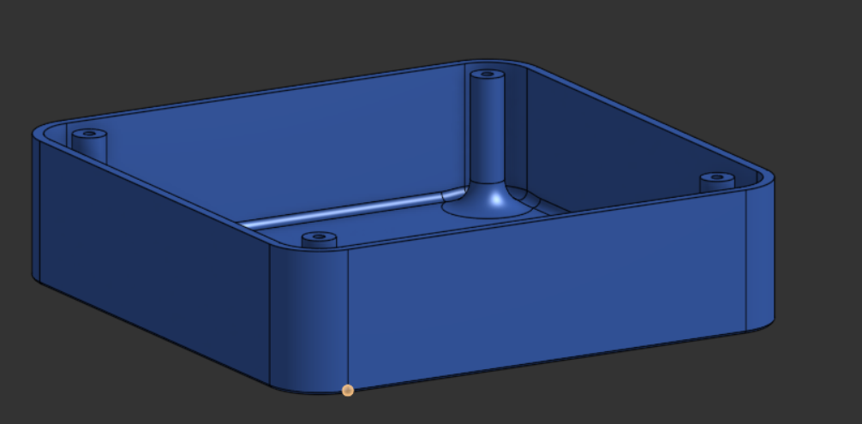  Figure 3: Base tray with screw bosses and cable channel | 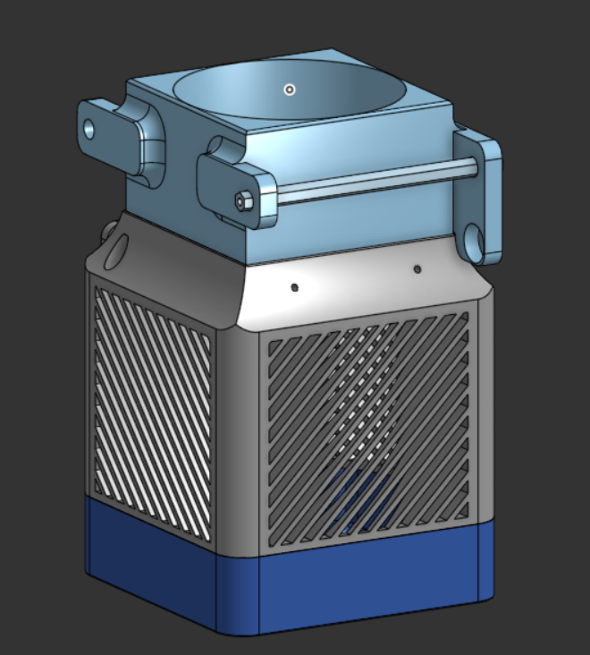  Figure 4: Full assembly: base, body, top housing and roller rod

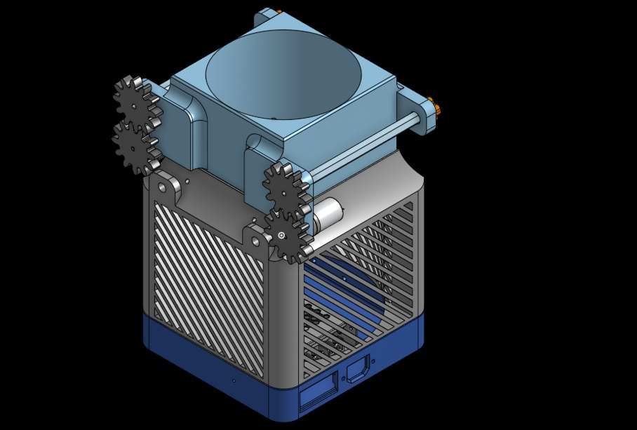
Figure 5: Updated CAD assembly: gear train, roller shafts and switch cut-outs in the base

2.1 Design decisions
- Diagonal louvres on the side walls let air enter from all directions while keeping fingers and large debris out.
- Top housing holds the circular fan seat and has side lugs for the two roller shafts, so the mesh passes across the air path.
- Base tray has four screw bosses and a central post. The electronics sit here, below the dusty air stream.
- Wall thickness was checked at 2.5 to 3 mm. Mating parts got 0.3 mm clearance so they fit after printing.

2.2 3D printing
The print-ready files were exported and the parts printed: the top fan housing in black and the louvred body in white. The fan was test-fitted in its seat and the housing placed on the body to check alignment of the mounting holes and roller lugs.
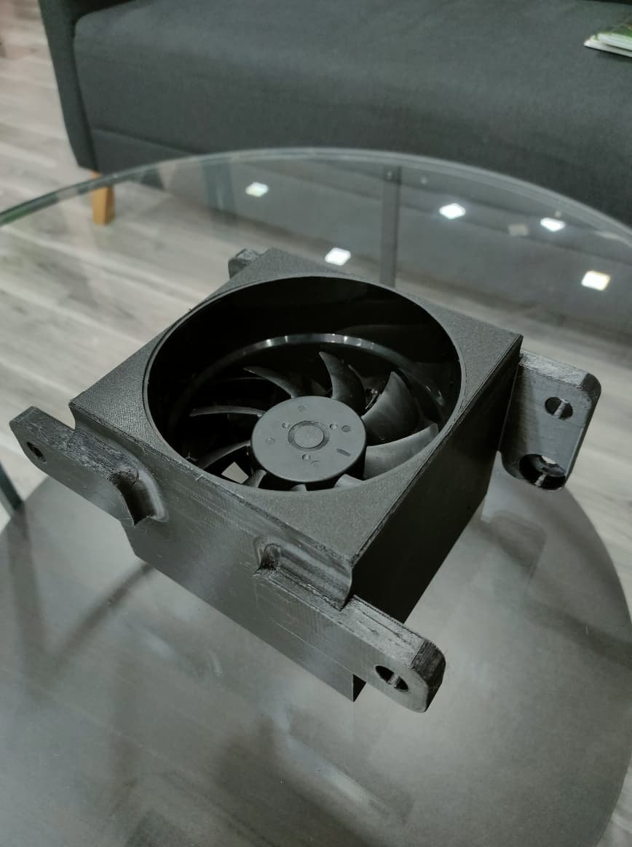  Figure 6: Printed top housing with the fan fitted in its seat | 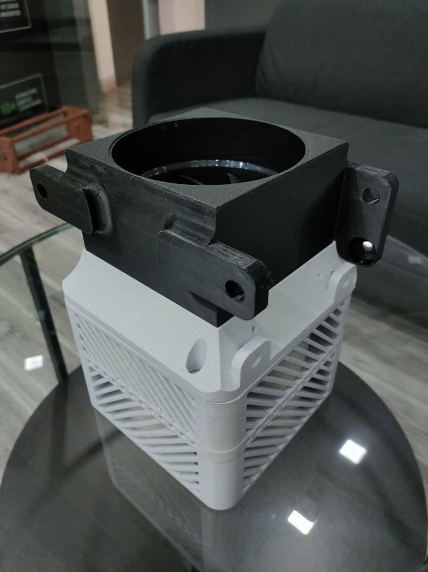  Figure 7: Top housing test-fitted on the louvred body

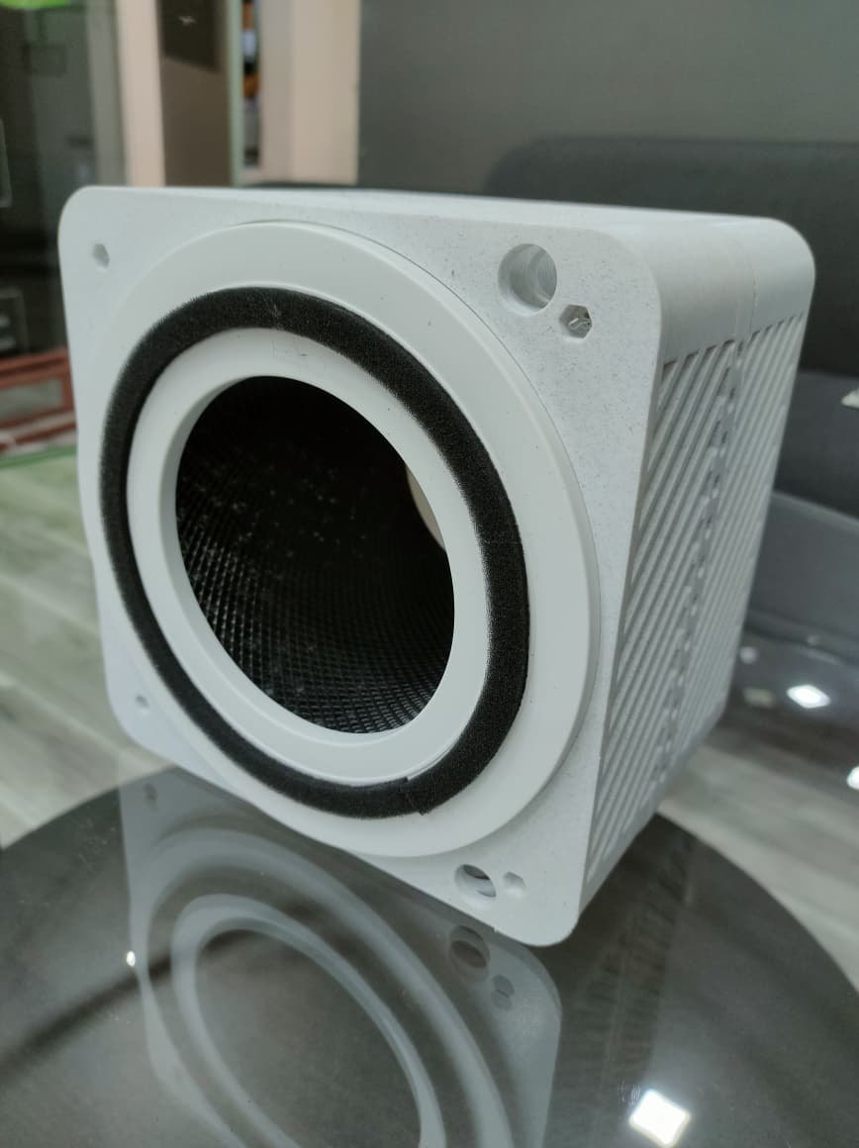  Figure 8: Printed body: filter ring and louvres (side view) | 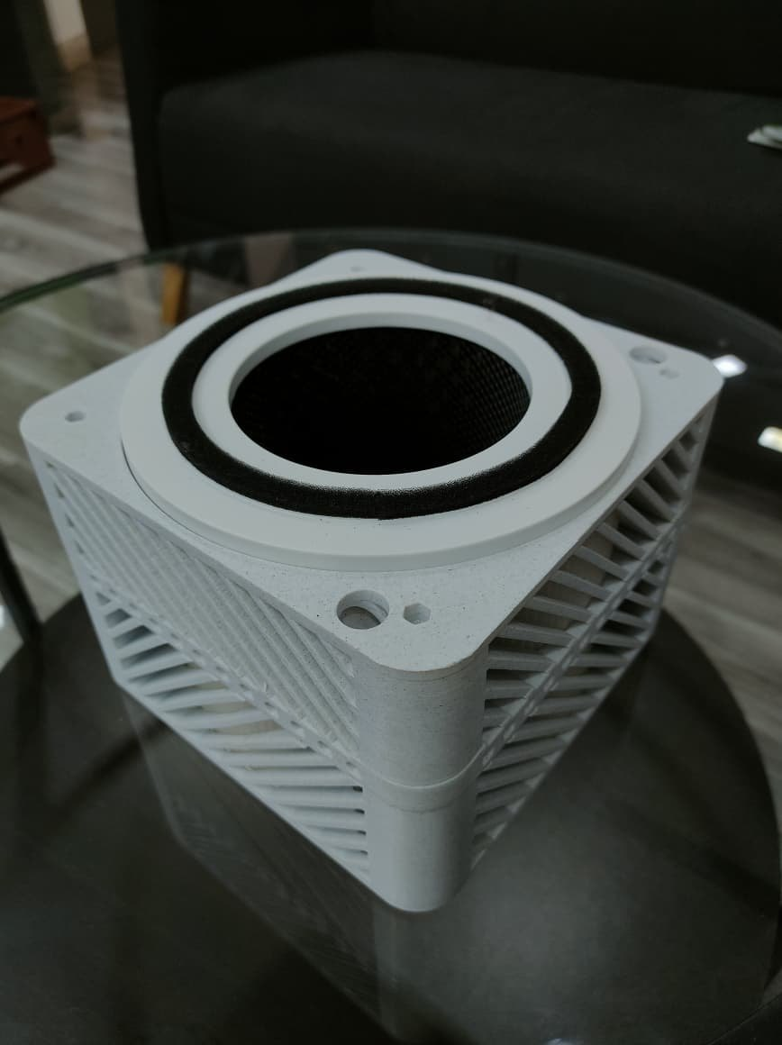  Figure 9: Printed body: filter seat with gasket ring

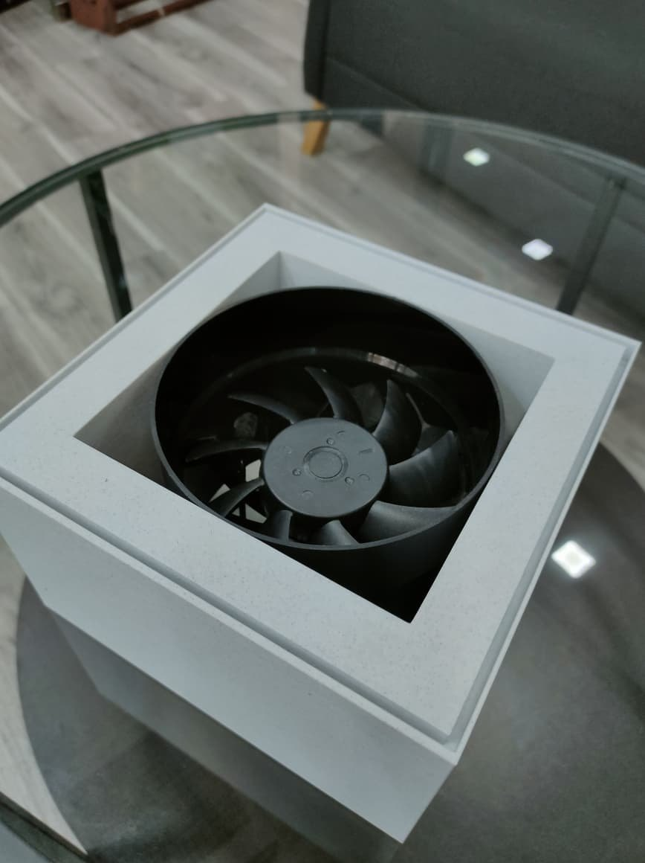
Figure 10: Fan fitted in the square transition frame

2.3 Calibration: Week 3 conditions
We took 60 more readings with cotton lint shaken in a closed box, chalk dust, and clean air at the filter outlet. Lint gave the lowest accuracy because large fibres scatter light differently from fine smoke particles.
Condition | Week | Readings | Mean abs. error (mg/m³) | Mean accuracy
Cotton lint shaken in box | Week 3 | 22 | 3.06 | 70.0 %
Chalk dust | Week 3 | 20 | 3.65 | 77.0 %
Filter ON - clean air outlet | Week 3 | 18 | 1.35 | 69.9 %

3. Week 4: Coding

3.1 Firmware structure
The firmware is non-blocking. It uses millis() timers instead of delay(), so the motors, LED and display all update without holding each other up.
Function | What it does
readDustSensor() | Pulses the GP2Y10 IR LED (280 µs / 40 µs / 9680 µs) and returns the ADC value from A0
calculateDustDensity() | Converts ADC to voltage, applies 0.17·V − 0.1, then scales the result to 0 to 25 mg/m³ (clamped at 0 and 25)
updateThreshold() | Reads the potentiometer on A1 and maps 0 to 1023 to a 0 to 25 mg/m³ threshold
updateWarningLED() | Turns the LED ON after dust stays above the threshold for 2 s, and OFF after it stays below for 8 s
updateLCD() | Line 1: Dust value. Line 2: Threshold. Spaces are padded to clear old characters
printStatus() | Serial log of ADC, potentiometer, threshold, voltage, dust, LED, button and motor states
updateMotors() | Every 12 h runs the left motor for 1046 ms and the right motor for 2000 ms. The button reverses the left motor
loop() | Sensor, threshold, LED, LCD and serial every 100 ms; motor control on every pass

3.2 Completing the calibration (street dust and construction site)
The last 40 readings were taken outdoors: 20 beside a busy road (street dust) and 20 at a construction site. These are the most realistic conditions and they include several noise readings: the sensor got a sudden gust of dust or a momentary signal dropout.
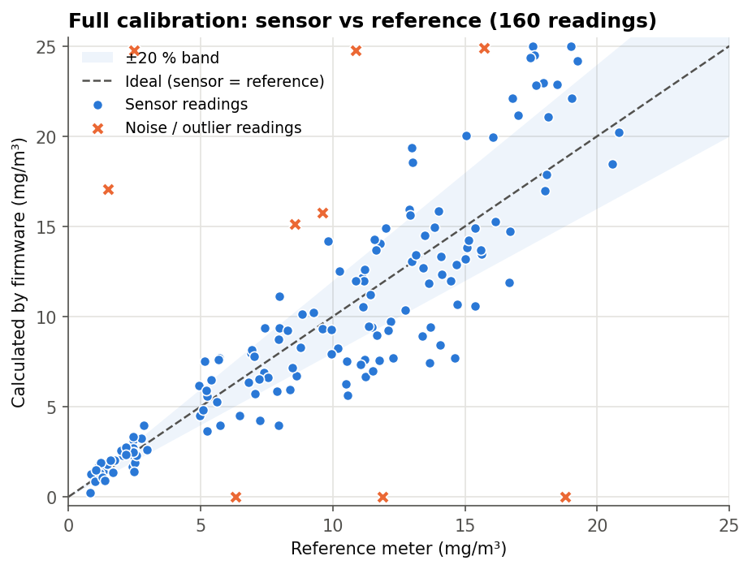
Figure 11: All 160 calibration readings: firmware value vs reference meter
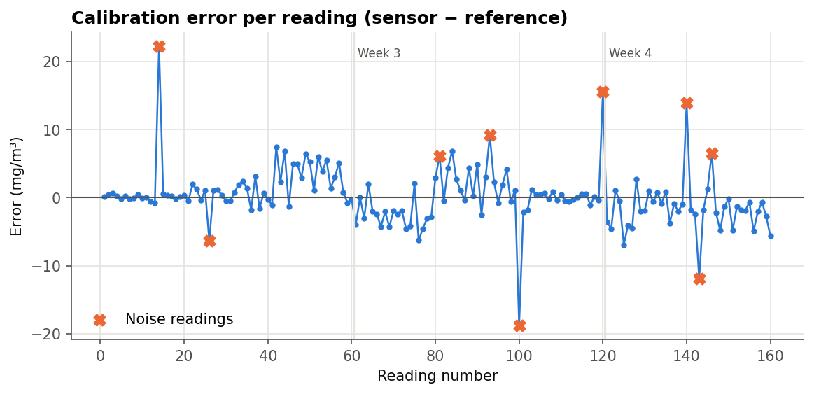
Figure 12: Error of each reading: noise readings marked with ×
The noise readings (rows 14, 26, 81, 93, 100, 120, 140, 143, 146) are kept in the data set because they show what the sensor really does in a dusty room. They are also the reason for the 2 s / 8 s delays in the warning logic.
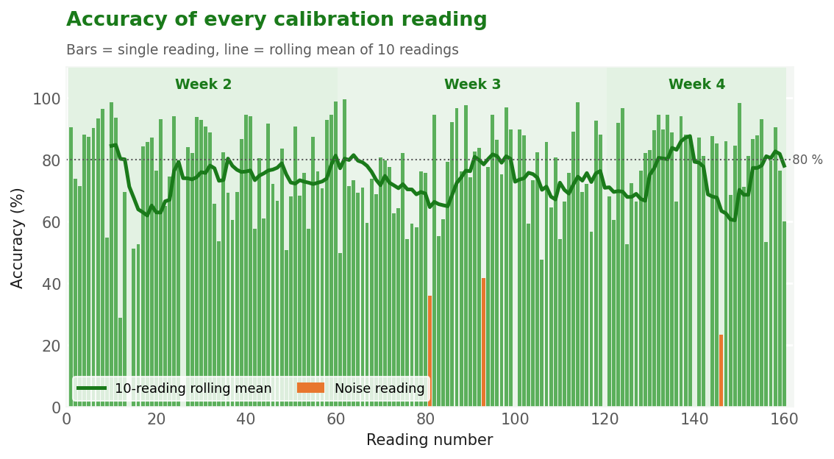
Figure 13: Accuracy of each calibration reading over Weeks 2 to 4, with a 10-reading rolling mean
The rolling mean stays between about 60 % and 88 % across all three weeks. The two lowest stretches are around readings 10 to 21 (including noise reading 14) and readings 140 to 149 at the construction site, where three noise readings fall close together.
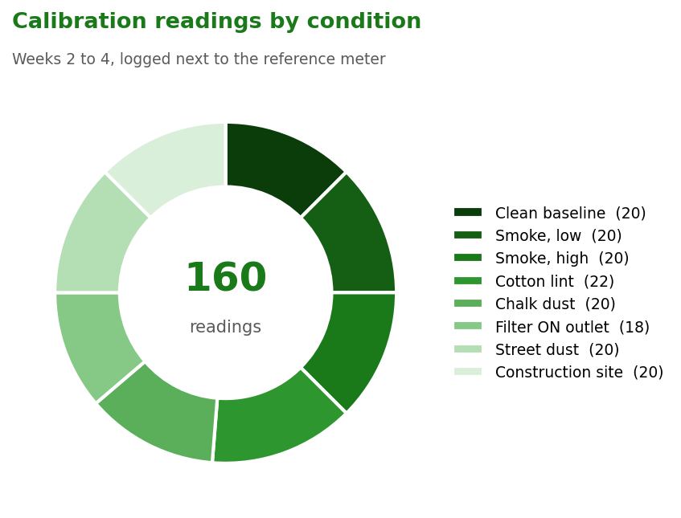
Figure 14: How the 160 calibration readings were split across test conditions

4. Week 5: Control System

4.1 Roller mesh drive
A gear train was added to the top housing so each roller is driven through a pair of spur gears. The left motor drives the supply roller and the right motor drives the take-up roller. Every 12 hours both motors are switched on; the left one stops after 1046 ms and the right after 2000 ms. The longer take-up run keeps the mesh tight.
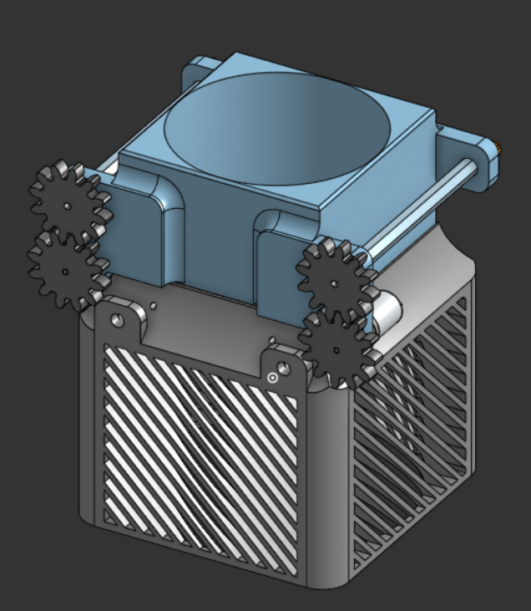
Figure 15: Assembly with gear train on both roller shafts

4.2 Electronics integration
All electronics were moved into the base: the 24 V SMPS on one side and the Arduino Nano with the motor driver on a soldered perfboard next to it. Wires were routed around the edges so the cover closes, and the LCD connector runs to the top edge of the base.
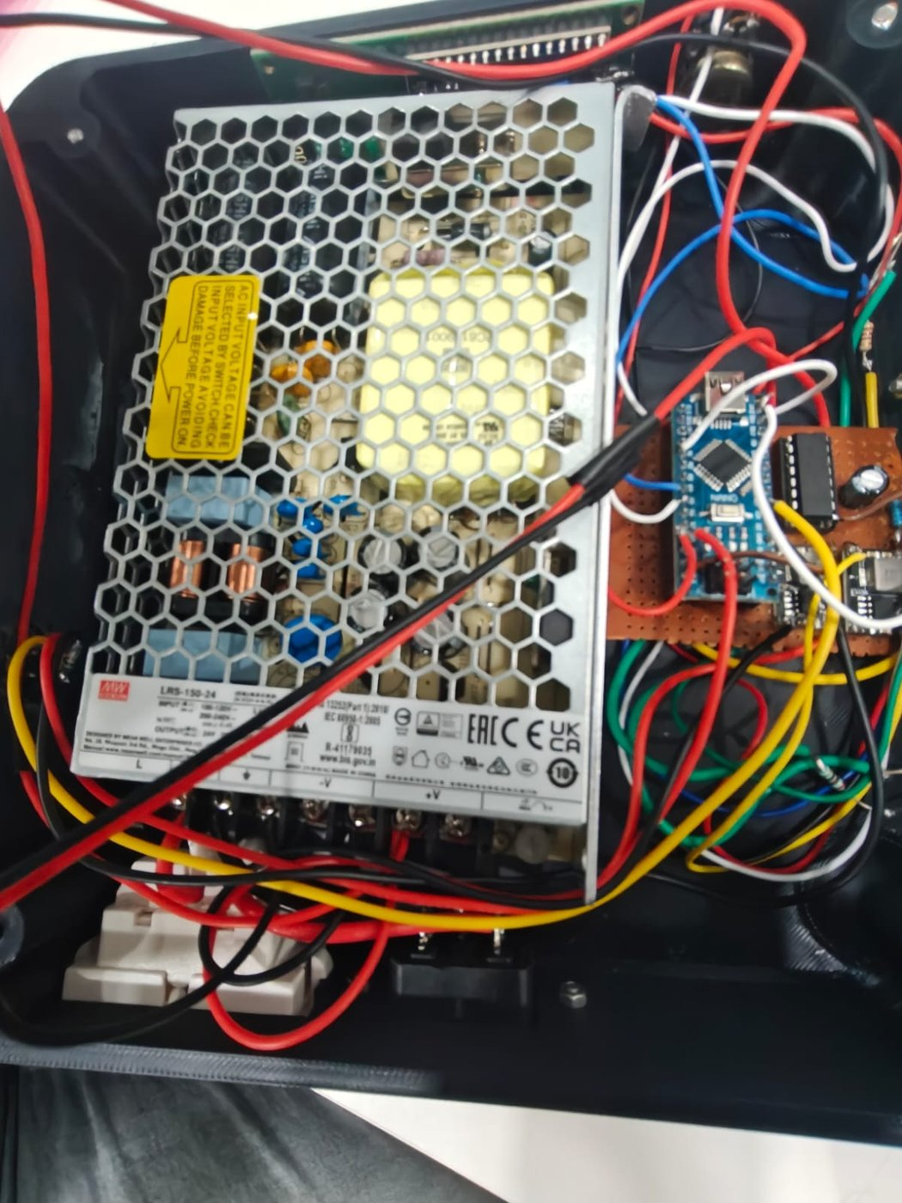  Figure 16: SMPS, Nano and motor-driver board mounted in the base | 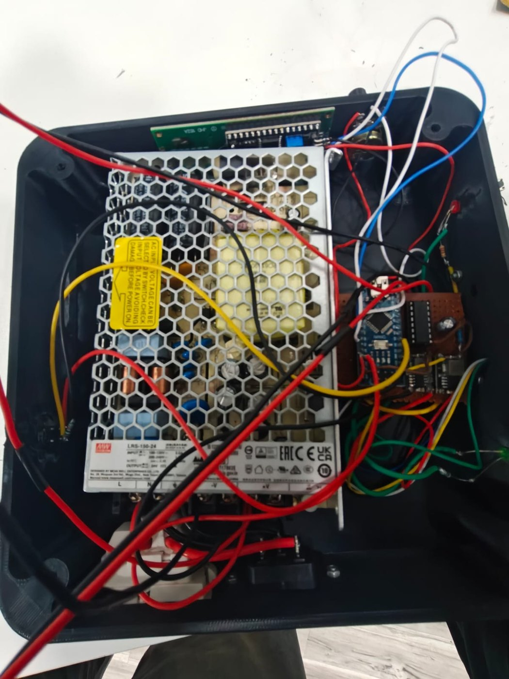  Figure 17: Wiring routed around the SMPS during integration

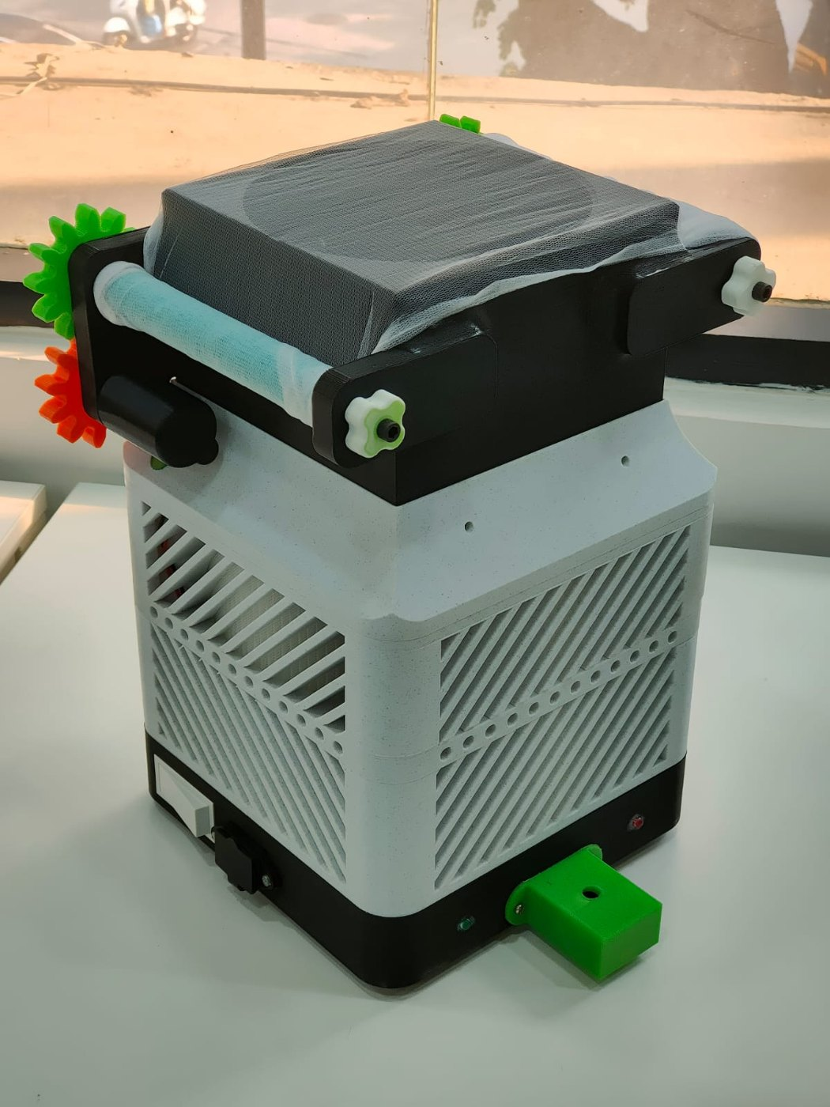
Figure 18: Assembled prototype with gear-driven rollers on the top housing

4.3 Motor current
We measured motor current with a multimeter-logger in series with each motor. Start-up inrush peaks were about 1375 mA (left) and 1075 mA (right). Running current then settled to about 414 mA and 358 mA. The right motor current rises slowly as mesh builds up on the take-up roller.
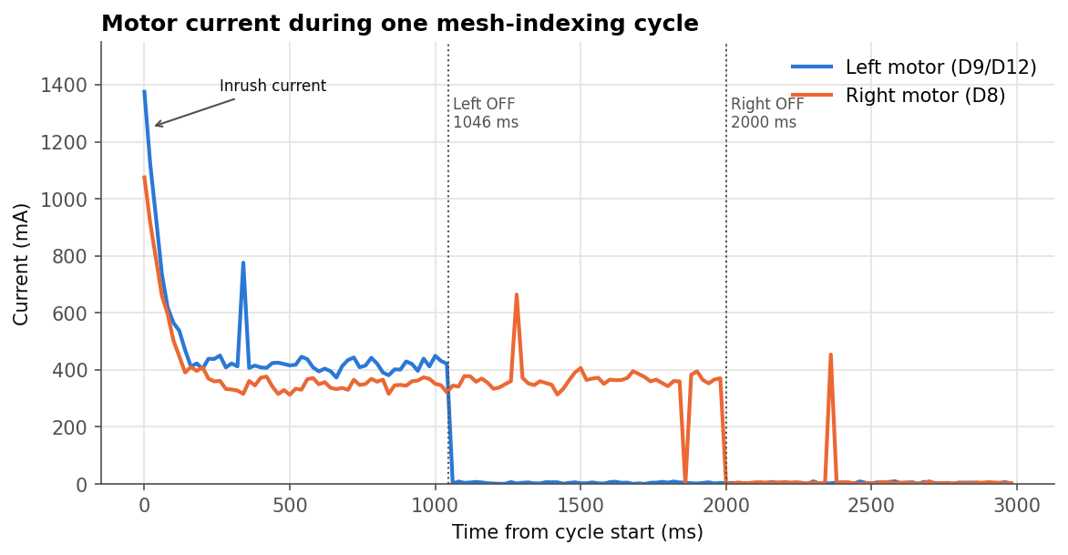
Figure 19: Motor current during one indexing cycle (data: 02_motor_current_readings.csv)
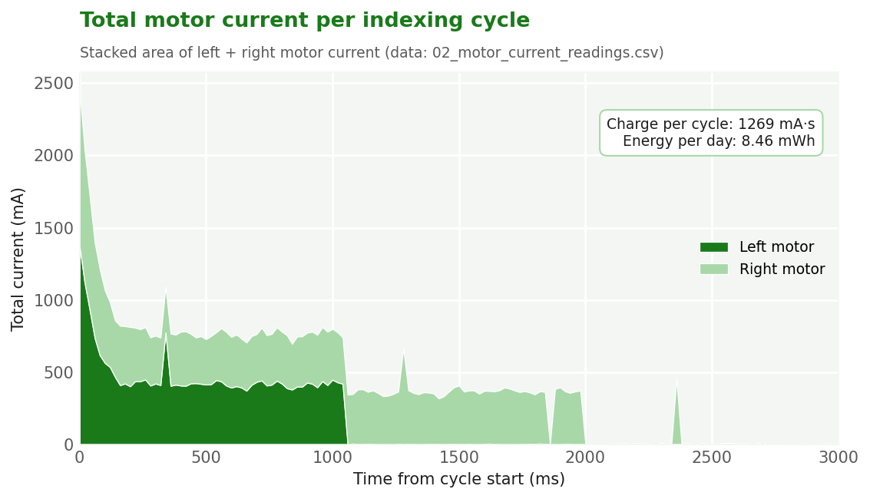
Figure 20: Combined motor current per cycle, with total charge and daily energy
Adding up the area under both curves gives about 1269 mA·s per cycle. At 12 V and two cycles a day, the mesh drive uses only about 8.46 mWh per day, so it has no real effect on the running cost.

4.4 Supply voltage spikes
During the first integration test the LCD showed garbage characters and the Nano sometimes reset when the motors started. Logging the 5 V rail showed a dip to 4.14 V at motor start and a spike to 5.59 V when the left motor stopped (inductive kick-back). After moving the motors to a separate buck converter, adding a 470 µF capacitor and flyback diodes, the dip was reduced to 4.82 V and the spike to 5.09 V.
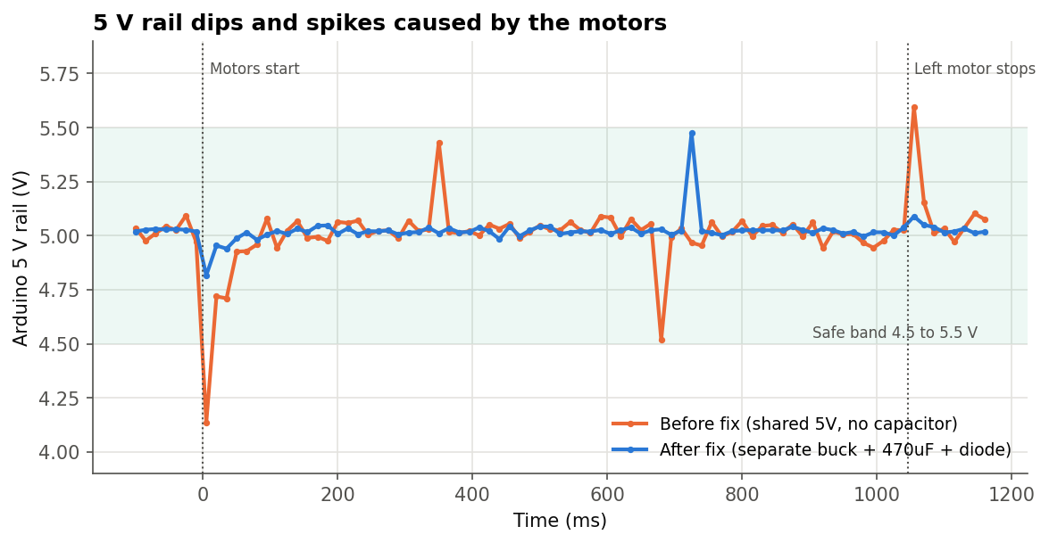
Figure 21: 5 V rail before and after the power fix (data: 03_supply_voltage_spike_readings.csv)
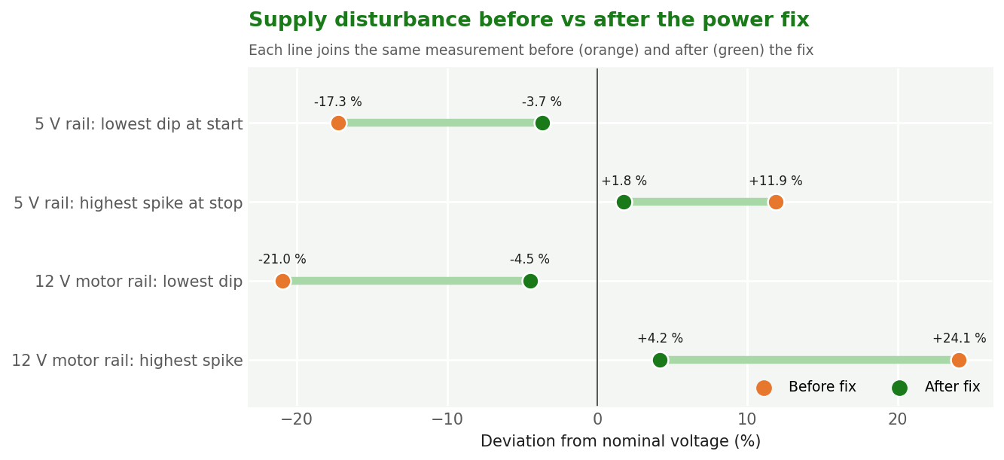
Figure 22: Worst dip and spike on each rail, before vs after the power fix

4.5 Warning LED response
The warning logic was tested by setting the threshold to 8 mg/m³ and creating short puffs and longer dust events. A puff shorter than 2 s did not trigger the LED. A dip below the threshold shorter than 8 s did not turn it off. Single noise spikes were ignored.
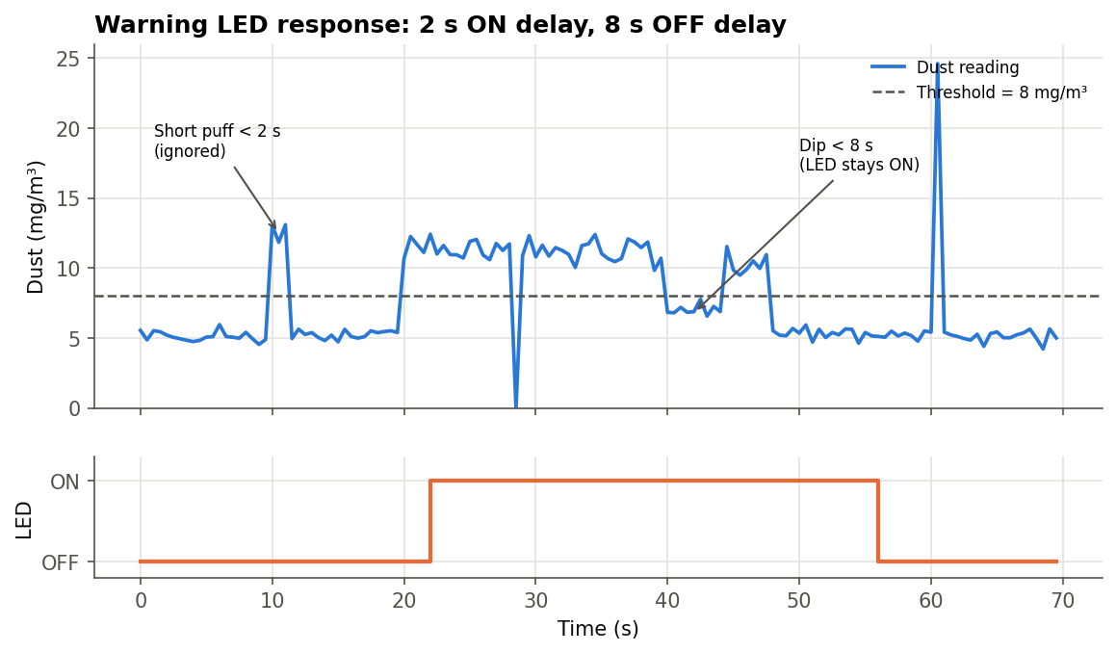
Figure 23: Warning LED test (data: 05_warning_led_response_test.csv)

5. Challenges Faced
Challenge | What we observed | Action taken
Brown-out at motor start | 5 V rail dropped to 4.14 V. The LCD printed garbage and the Nano occasionally reset. | Separate 12 V buck for the motors, 470 µF capacitor on the 5 V rail, common ground point.
Voltage spike at motor stop | Inductive kick of up to 5.59 V on the 5 V rail. | Flyback diodes across the motors. The spike is now 5.09 V.
Push button reading randomly | The pin is set as INPUT with no pull resistor, so it floated and sometimes reversed the left motor on its own. | Added an external 10 kΩ pull-down resistor on D4.
LED flickering with noise | Single noisy readings switched the warning LED on and off. | Added a 2 s ON delay and an 8 s OFF delay in updateWarningLED().
Tuning motor run times | Too short a run did not expose fresh mesh. Too long wasted mesh strip. | Trial runs gave 1046 ms (left) for one mesh section and 2000 ms (right) to keep it tight.
Gears slipping | The first printed gears were too tight, then too loose. | Adjusted centre distance and set 0.2 mm backlash in CAD.
Dust on the sensor lens | Readings drifted upward over a long session as dust settled on the optics. | Sensor moved behind the mesh. Weekly cleaning with a soft brush added to maintenance.
LCD leftover characters | When a value got shorter (for example from 10.25 to 9.80) old digits stayed on screen. | Padded each LCD line with trailing spaces.
Threshold in whole steps only | map() returns integers, so the threshold moves in 1 mg/m³ steps. | Accepted for the prototype. Noted as future work.

