*Mushroom Classification System*

***Wireframe Documentation***

# Homepage

Our Mushroom Classification System will have only one webpage that is Homepage.

1. Inside this Homepage, there will be multiple Selection options for users regarding physical nature of mushroom.

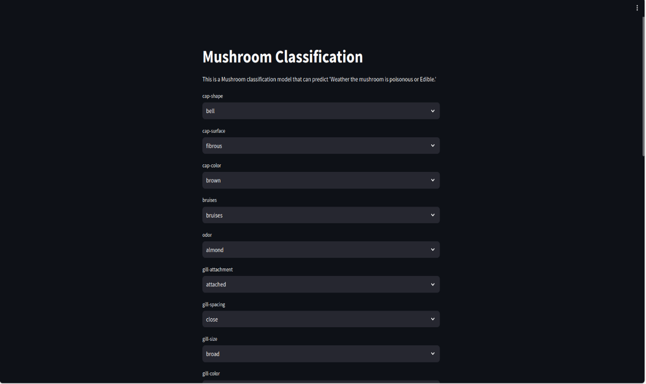

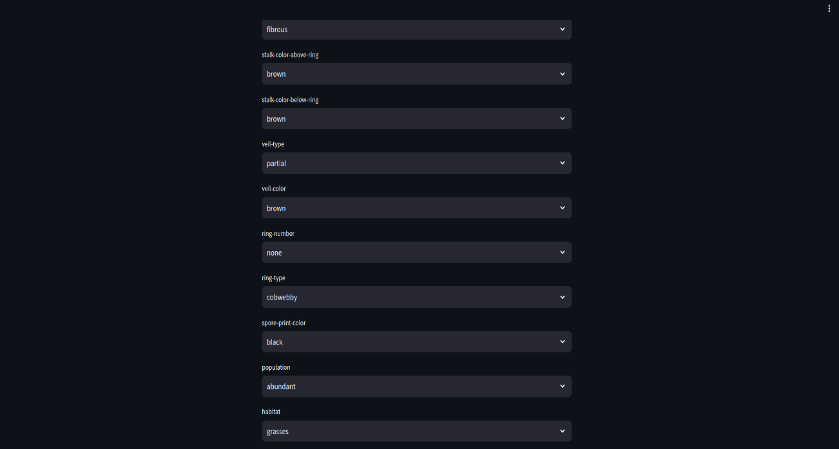

1. Once User has selected all the options correctly. They have click on Submit but right below all field.



1. Now you clicked submit button, it will return a text for you i.e. ‘whether mushroom is edible or poisonous’



1. This Prediction will be captured or saved in database for further use cases.