COMPANY BRAIN
Business Development Fund Proposal
Fund Request, Deployment Plan and Six-Month Milestone Schedule
Founder: Rohan Gaikwad | Department of Computer Science & Engineering

1. Purpose of This Request
Company Brain is an AI platform that makes an organization's own documents searchable through ordinary questions. A working prototype has been built and validated on real documents across multiple formats.
The purpose of this fund request is to move the platform from a validated prototype running on a single developer machine to a deployed system running live inside partner organizations, and to convert the first of those deployments into paying customers within six months.
The amount requested is ₹4,50,000 over a six-month period.

2. What This Fund Enables
Three specific constraints currently limit progress, and this fund addresses each of them directly.
- Compute capacity: the platform currently runs on a laptop with 4GB of graphics memory. This caps model quality, response speed and the number of users who can query the system at once. Adequate compute is the single largest unlock.
- Pilot deployment cost: moving from a demonstration to a live deployment requires data onboarding, configuration and support time at the partner organization. This work cannot be done remotely or for free.
- Market access: reaching institutions and businesses, running demonstrations and closing the first paid agreements requires travel, formal registration and basic commercial infrastructure.

3. Fund Allocation
The requested amount is allocated as follows. Every line is tied to a specific deliverable in the milestone schedule in Section 5.
Head | Purpose | Amount (₹)
Compute infrastructure | Server capacity beyond a single laptop | 1,50,000
Cloud and API costs | Inference, hosting and connectivity, six months | 45,000
Pilot deployment | Onboarding and support for three pilot sites | 60,000
Business development | Travel, demonstrations and client meetings | 50,000
Registration and compliance | Company registration and DPIIT filing | 40,000
Software and tooling | Development tooling, storage and services | 35,000
Contingency | Reserve against cost variation, 15 percent | 70,000
Total |  | 4,50,000
The platform is built entirely on open-source infrastructure and efficient local AI models, which is why the compute and running costs above are modest relative to comparable AI systems.

4. Deployment Plan
The six-month plan runs three workstreams in parallel.

4.1 Product Development (Months 1 to 2.5)
Completion of the analytical query engine, which allows the system to answer complex logical questions over structured institutional records rather than only retrieving text. This is the capability that most separates the platform from general-purpose AI tools, and it is the immediate development priority. Infrastructure setup and system hardening run alongside it.

4.2 Pilot Deployment (Months 2 to 5.5)
The first pilot organization is onboarded in Month 2, with a validation and iteration cycle following in Months 3 and 4. Two further pilots are onboarded from Month 4. Each pilot produces measured outcomes, specifically staff hours saved and query volume served, which become the evidence base for commercial conversations.

4.3 Business Development (Months 1 to 6)
Outreach runs continuously from Month 1, drawing on an existing professional network of over 7,200 industry connections. DPIIT recognition is filed in Month 3. Conversion of pilot users to paid subscriptions begins in Month 4.5, with a documented case study and revenue report completed by Month 6.

5. Milestone Schedule
The chart below sets out the six-month schedule across all three workstreams.
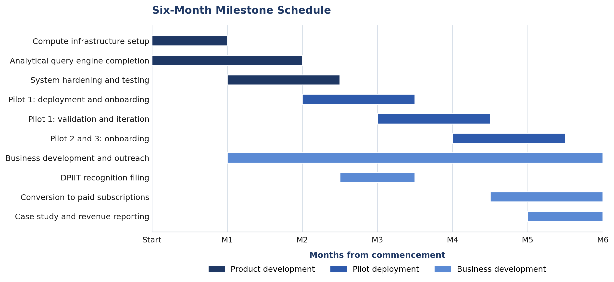

5.1 Milestone Deliverables
Month | Milestone | Verifiable Deliverable
Month 1 | Infrastructure operational | Platform running on funded compute
Month 2 | Analytical query engine complete | Complex queries answered on real records
Month 3 | First pilot live | Deployment in daily use, usage logs available
Month 3 | DPIIT recognition filed | Application acknowledgement reference
Month 4 | Pilot outcomes measured | Record of hours saved and queries served
Month 5 | Three pilots operational | Two further organizations onboarded
Month 6 | First revenue and case study | Signed subscription and written case study

6. Expected Outcomes at Month 6
The fund is judged against outcomes that can be independently verified, not activity.
- Three live deployments: three organizations with the platform deployed and in regular use.
- First paying customer: at least one signed paid subscription, establishing that organizations will pay for the product.
- Documented evidence: a written case study containing measured time savings and usage data from a real deployment.
- Formal recognition: DPIIT recognition secured, opening access to national startup schemes and benefits.
- Production-ready platform: a stable, deployed system capable of supporting further organizations without additional development.

7. Direction Beyond Month 6
Once the platform is proven and retained in its first deployments, the natural next step is to extend it from answering questions to surfacing issues without being asked.
For commercial customers, the highest-value application of that capability is operational and financial oversight: unbilled work, overdue receivables, duplicate payments and contract terms that lapse unnoticed. These losses are rarely detected because no single person reviews every document, and they accumulate quietly. A system that already holds and understands an organization's records is well placed to flag them.
This is stated here as the intended commercial direction for Phase 2, not as a current capability. It will be built only after the core platform demonstrates retention and paid usage in its first deployments.

8. Summary
Item | Detail
Amount requested | ₹4,50,000
Period | Six months from commencement
Primary use | Compute infrastructure, pilot deployment and market access
Key milestone | First paying customer and documented case study by Month 6
Current status | Working prototype validated on real documents
Company Brain: turning an organization's documents into answers.

