RESUME

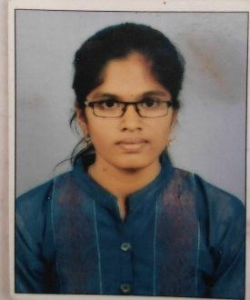

**SKILLS**

# CAREER OBJECTIVE

To Pursue career as an employee in a leading and innovative firm capable of producing leading edge products through state of art technology & to apply technical knowledge and innovative smart skills, which I have obtained through my education to assist a leading industry.

**ALEAKYA C H**

**PHONE: +91-6363250326 EMAIL:**

[**aleakya2028@gmail.com**](mailto:aleakya2028@gmail.com)

## PERSONAL DATA

FATHER’S NAME : GANDHI C H

MOTHER’S NAME : ASHALATHA C H DATE OF BIRTH : 28.06.2000 NATIONALITY : INDIAN

MARITAL STATUS : SINGLE

## PERMANENT ADDRESS

2ND Ward Upparahosalli post

Siruguppa (tq), Ballari, Karnataka

583122

## PRESENT ADDRESS

SS Layout, A Block Davngere, Davangere, Karnataka

577004

## LANGUAGES Known

English, Kannada, Telugu and Hindi

## HOBBIES

* Listening to music
* Cooking
* Playing outdoor games

## Strengths:

* Ability to work under pressure
* Good Communication Skills
* Positive thinking and
* Leadership qualities

**Achievements**

* District and state level Throw Ball Player
* And Athlete

**EDUCATION**

|  |  |  |  |  |
| --- | --- | --- | --- | --- |
| **Course** | **University/Board** | **College/School** | **Year Of passing** | **%Marks** |
| Bachelor of Computer Applications  (BCA) | Davanagere University | Bapuji Institute Of Hi-Tech Education, Danagere | 2022 | 80.66 |
| PUC 12th | Department of Pre-University Education Board | Vasavi comp PU college,  Ballari | 2019 | 64.33 |
| SSLC 10th | Karnataka Secondary Education Board | Vijayamarie School,  Siruguppa | 2017 | 56 |

**Programing Languages:**

* C and C++
* PHP

**Web Technologies:**

* HTML
* CSS
* JavaScript

**Other Technologies**

* MySql
* Tally
* MS Office Basic

**ACADEMIC PROJECT DETAILS**

Project name: Student Education And Sports Management System

## DECLARATION

I hear by declared that the above mention information is true and correct to the best of my knowledge and belief.