**Non Contact Vital Signs Monitoring System**

ECE4011 Senior Design Project

YZ1

Advisor: Ying Zhang

Alec Adamski (alec.adamski@gmail.com)

Rohan Iyengar (rohankiyengar@gatech.edu)

Kedar Manishankar (kedarjmfl@gmail.com)

Sai Sathiesh Rajan (srajan9@gatech.edu)

Submitted

11/21/2016

**Table of Contents**

**Executive Summary**  3

1. **Introduction**  4
   1. Objective 4
   2. Motivation 5
   3. Background 5
2. **Project Description and Goals**  6
3. **Technical Specification**  7
4. **Design Approach and Details** 
   1. Design Approach 8
      1. System Overview with block diagram
      2. Microcontroller and Communications
      3. Signal Processing
      4. Database Structure
      5. Mobile App
      6. User Interfaces
   2. Codes and Standards 17
   3. Constraints, Alternatives, and Tradeoffs 18
5. **Schedule, Tasks, and Milestones**  18
6. **Project Demonstration**  19
7. **Marketing and Cost Analysis** 
   1. Marketing Analysis 20
   2. Cost Analysis 21
8. **Current Status**  23

**References**  24

1. **Executive Summary**

Most vital signs monitoring systems require patients to strap into the device so that it can measure their heart rate, respiration rate, and blood pressure. A noncontact vital signs monitor does not require the user to touch the device. Instead, a radar transmits a signal to the patient which reflects and modulates. By analyzing vital sign information with a demodulation process, specifically the overall signals and transient, the heart rate and respiration rate can be deconstructed and examined separately. This concept is not novel, but has aspects that can be improved to provide more information to the user in a more intuitive manner. Some features, such as adding a user friendly interface with the ability to vary sampling rate and acquisition time, will increase the appeal and ease of use. In addition, by storing important data in a cloud database, a mobile app can keep track of past measurements to provide another level of analysis in a single glance. The radar transmitter and receiver have already been implemented, so this project focuses on sampling, processing and visualization of data that has been recorded. This project does not require any funding other than that of a microcontroller and external ADC evaluation board to sample and transmit the analog signal received from the radar. The resulting, finalized product will be able to read a patient’s heart and respiration rates simultaneously, display the two signals on a user friendly computer interface, and send the most important data to a cloud database that can be later accessed by a mobile app. The signal plots on the computer must be processed and displayed in real time so that a patient can view his or her vital signs immediately.

**Non-Contact Vital Signs Monitoring System**

**1. Introduction**

The Non-Contact Vital Signs Monitoring System Team requests $329.05 to build the prototype of a device that can accurately sample and analyze a given analog signal containing vital signs such as respiration and heart beat. The system consists of a microcontroller, an external analog to digital converter(ADC), a computer user interface(UI) and a mobile app.

* 1. **Objective**

The team will design and prototype a system that can accurately sample and process vital sign signals to produce data such as heartbeat and respiration. In addition, the final product will display information of physical conditions in real-time, without contact with the patient. Low-noise detection system to acquire vital signs exist, and is used to obtain an analog signal containing information of heartbeat and respiration. A microcontroller unit(MCU) samples the signal at a user controlled rate, and converts the incoming analog signal to digital for transmission to a computer. The raw digital data is processed to deconstruct the original signal into two separate signals, containing heartbeat and respiration respectively, and also to remove noise. The computer UI provides necessary functionality to control the sampling rate, display real-time respiration and heart beat signals, as well as store the large amounts of digital data which needs to be processed. The mobile app will have access to the computer UI, will not store any of the raw data, and will display modified versions of data for simplicity.

* 1. **Motivation**

Noncontact vital sign monitoring is a promising method in the field of home health care and biomedical monitoring. Real-time comparison and analysis of the obtained respiration and heartbeat signal of the patient, with that of an expected respiration and heartbeat signal is critical to search and rescue operations. Our team builds upon an existing practical, low-noise detection system that detects vital signs, in order to create a commercial product that is user friendly, can be accessed via mobile app and accurately displays heartbeat and respiration in real-time. This system is geared towards patients with disabilities, senior citizens as future improvements to our app can include automatic distress calls for abnormal physical activity, however all patients will be able to utilize the app to keep track of their vital signs.

* 1. **Background**

Noncontact vital sign monitoring systems utilize radar signals to determine the frequency and transient features of chest movements. There are existing algorithms to perform doppler processing to convert seemingly random data into meaningful information [1]. The current system setup uses a Doppler radar because of its better system complexity and high distance resolution, but it cannot return the distance information. This type of radar still does have the capability to extract the frequency and transient vital sign signals.

The use of radar in noncontact monitoring systems has been explored before [2]. Li and his team were able to determine heart rate and respiration rates from a Doppler radar signal, which is one of the project goals. Using a spectral estimation algorithm as well as a maximum-likelihood estimator and periodogram, the two frequencies of both signals can be discerned and separated. This project is heavily based upon Li and his team’s work. The most notable difference in design process is the noise suppression scheme to reduce the phase noise of the Doppler radar that has already been implemented. By building on Li’s work, the finished product will be able to incorporate more features such as a mobile app, real time processing and graphing, and variable sampling rates that have not been accomplished before.

**2. Project Description and Goals**

This project will cover the implementation of the final stages of the heart rate and breath rate monitor of the non-contact vital signs monitoring system. This includes what is shown below in Figure 1

Flow Chart of Project System.png

**Figure 1.** Block diagram of pre-established system and components that will be implemented.

The pre-established system is composed of a radar transmitter that sends a radar wave that will reflect off the individual to be monitored [3]. The signal will be received by a radar antenna and will be sent to the microcontroller. The microcontroller is composed of an analog-to-digital converter which is controlled by the computer. The resolution of the ADC is important, which explains the use of an external ADC evaluation board with a resolution of 24 bits, as opposed to the 12 bits max resolution of the ADC on the MCU.The signal will be converted and sent to the computer. As the digital signal is being received, the computer will process the data and display in real time both channels from the raw signal on the computer screen. The user can choose to measure a sample of data for a custom time value to access more detailed information. The computer will also send priority information to a database that will be accessed by a mobile application that can also display information.

**Project Goals:**

* Ensure reliable transmission of analog signal from demodulator to microcontroller
* Ensure reliable transmission of digital signal from microcontroller to computer
* Extract separate heart rate and breath rate signals from raw signal
* Display vital sign information signal in real time
* Create user interface for computer capable of controlling microcontroller activity
* Build functional database
* Create mobile application complete with user interface
* Pull data from cloud to display on mobile application

1. **Technical Specifications**

The technical features of the Non-Contact Vital Sign Monitoring system include a microcontroller which can perform analog-to-digital(A/D) conversion at a user defined sample rate. The resolution of the ADC should be at least 16 bits to obtain the small voltage heartbeat signal after sampling, without corruption. As shown in Table 1. the sampling rate of the analog-to-digital converter(ADC) should be a minimum of 1000 samples/second, due to the bandwidth of our signal being only several tens of hertz. A necessary feature is the use of two different sampling channels as the non-contact system monitors quadrature(I/Q) signals.

|  |  |
| --- | --- |
| **Table 1.** Technical Specifications | |
| **Feature** | **Specification** |
| Sampling rate | >1000 samples/second |
| Number of sampling channels | >2 |
| Microcontroller to Board controller interface | UART |
| Power Supply | 3.3 V |
| ADC | Resolution >16 bits |
| Connector on ADC side | SMA female |
| Resistors for differential input of Evaluation board | 50 ohm SMB terminators |

1. **Design Approach and Details**
   1. **Design Approach**

**4.1.1 System Overview with block diagram**

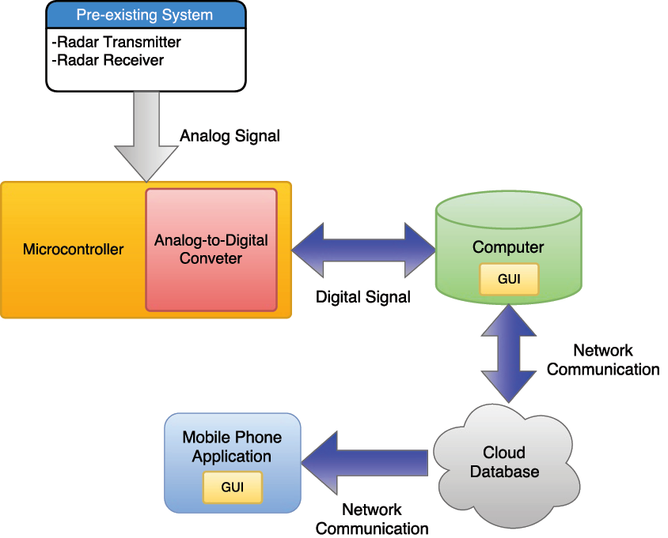

**Figure 2.** Detailed block diagram of entire system

As shown in Figure 2, the system begins with the pre-existing system of a CW Doppler radar that transmits a signal to the desired individual and collects the reflected, phase shifted signal at the receiver [3]. This signal will then be transmitted to a microcontroller with a built-in analog-to-digital converter. This microcontroller will be able to vary the sampling rate of the analog signal input and this rate will be controlled by the computer, or more specifically, the end user. The microcontroller will also simultaneously trigger the contact system that exists in the lab, so data from the exact same time interval can be recorded from both the contact and the non-contact system, and can be compared for accuracy. The sampled signal will then be sent to the computer for processing to extract the desired information. e.g heart rate and respiratory rate. The raw signal will be shown in real time and other data can be displayed on the GUI of the computer. Similarly, the outputs will be sent to a database. Other prevalent information such as historical data or average rates may also be sent but a final decision of the information that will be stored has yet to be determined. Finally, the mobile phone application will query this database and display the information it receives on its own GUI.

**4.1.2 Microcontroller and Communications**

Low-noise detection system to acquire vital signs exists in our senior design lab, and is used to obtain an analog signal containing information of heartbeat and respiration. A microcontroller unit(MCU) samples the signal at a user controlled rate, and converts the incoming analog signal to digital for transmission to a computer. The bandwidth of the incoming signal is only several tons of hertz, and a lower sampling rate of at least 1000 samples/second is required. The noncontact monitoring system outputs I/Q signals, resulting in the need for two sample channels for modulation and demodulation.

The microcontroller must be able to generate the trigger signal to the sampling chip so that the sampling rate can be user controlled. The microcontroller must also be able to trigger the existing contact vital sign monitoring system, so that data from the same time interval - which can be varied by the user - can be compared and analyzed. Communication between the microcontroller and the computer will occur through UART. Keeping in mind the above specifications, EFM8BB1 Busy Bee MCU in combination with an external AD7770 ADC has been chosen to implement ADC and communication of the raw digital data with the computer. The EFM8 MCU has a UART interface as well as a successive-approximation-register(SAR) ADC with variable 12-, 10-, and 8- bit modes which will aid in user controlled sampling rate of the vital signals [4]. However, due to the small voltage amplitude of the heartbeat, the signal may be lost or severely interrupted after sampling if the resolution of the ADC is not high enough. An external evaluation board ADC, AD7770 with a resolution of 24 bits will ensure that the ADC can more accurately record the voltage amplitude of the vital sign signals. Additional features include a 200 kilosamples/second sampling rate which is much higher than our base need, and also has the feature to operate in low power mode at lower conversion speeds, which is where our microcontroller will be operating. Our setup requires the ADC and the non-contact vital sign monitoring system to be connected via SMA cables, however our evaluation board only has SMB jack connectors. To setup the connection with the SMA cable on the receiver side, SMA plug to SMB plugs will be used, and will be terminated by 50 ohm SMB terminator plugs which account for the differential input of the external evaluation board. EFM8 Busy Bee MCU costs approximately $28.39, AD7770 ADC costs approximately $123.75, the appropriate SMA plug to SMB plugs which are needed to connect the receiver and the ADC will cost $53.94, and the required 50 ohm SMB terminator plugs will cost $109.20 resulting in a total base cost of $315.28, and a total cost of approximately $329.05 inclusive of shipping. The total cost of our system, which includes a high resolution ADC combined with the adequate features incorporated in the MCU, ensures that we will incur low prototype costs and lower development costs [5].

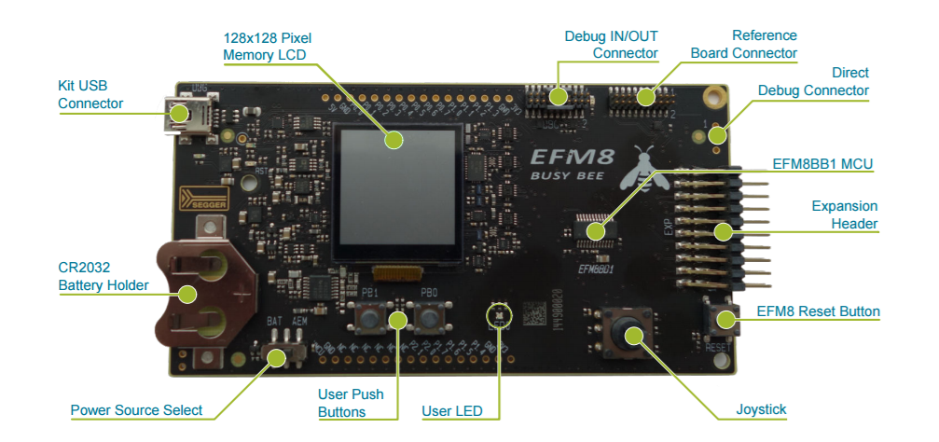

**Figure 3.** EFM8BB1-SLSTK2020A Hardware Layout

**4.1.3 Signal Processing**

*Signal Deconstruction*

The baseband signal obtained from the phase modulation of the wireless radar signal can be considered to be comprised of two components, namely heartbeat and respiration. Firstly, the signal from the microcontroller will be passed to the computer before performing computations in Matlab. In order to perform meaningful analysis on the two source signals, the signal must first be separated into the component signals without prior knowledge about the respective frequencies. Although both these signals are correlated, the team has decided to assume that the two signals are independent to simplify what is essentially a Blind Signal Separation (BSS) problem. For our project, the individual spectral composition of the two signals will first be determined by performing a Independent Component Analysis (ICA) on the received signal with the aid of a maximum likelihood estimator (MLE). In particular, we are looking into using a parametric and cyclic optimization algorithm known as the RELAX algorithm, proposed by Li and Stoica, due to its relative simplicity and reduced computational complexity [6]. This would allow us to satisfy the real time requirement of the project. Once the different spectral components are identified, the two signals will be reconstructed from the input signal.

**4.1.4 Database Structure**

This project will incorporate a relational database as a means for storing relevant data. The final decision of the totality of relevant data has yet to be determined but it may include, but is not limited to, the following:

* User login data
* Last measured heart rate and respiratory rate
* Lifetime/monthly/weekly heart rate or respiratory rate averages
* Raw signal data will be stored in separate tables for reference

The service by which this database will be implemented has yet to be determined but will be similar to utilities such as the Amazon Web Service (AWS). Resources such as this will provide a framework by which to implement the database required to facilitate wireless communication with the mobile application. Through these services tables of information will be created to archive the relevant data as given in the examples bulleted above.

**4.1.5 Mobile App**

The mobile application will be created using a free software development kit (SDK) over a paid development environment. The two candidate platforms are an Android application or a web application. Google provides a free download of the Android Studio SDK, and it can run on any operating system. Currently, the choice is leaning towards an Android application.

The mobile application is built for the end user that cares about his/her own data in a streamlined format. The mobile application will connect to the database described in 4.1.4 to access that user’s data using their login session and display the information in an interactive format. Historical trends will be displayed in addition to heart rate and breathing rate.

**4.1.6 User Interfaces**

*Computer Interface*

The computer GUI requires all data to be displayed that is received from the microcontroller to be displayed to the user. The computer GUI is geared towards medical professionals and received the data. Original data from the sensor will be displayed with processed data after mixed signal processing. The goal is this UI is comprehensive display of all data for experts. A possible UI screen is shown in Figure 4.

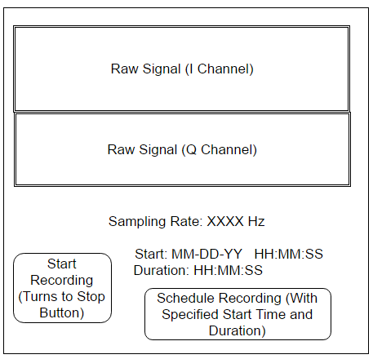

**Figure 4**. Computer interface main screen to view raw data.

The initial homepage displays both channels of the raw signal, separated for viewing convenience. The sampling rate on this page can be toggled before recording. There are two ways to start recording a signal for post-processing.

1. Use the start button and press the same button again to stop.
2. Set a date and duration to record (Note: The app must be running with proper setup at this date for the recording to start).

Completing either of these methods will take a user to the post processing screen, shown in figure 5 below.

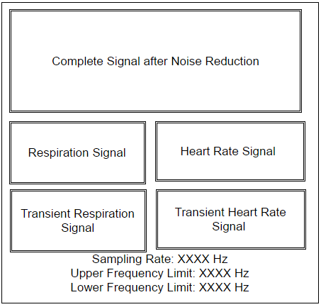

**Figure 5.** Computer interface second screen to display processed signals.

Figure 5 displays relevant data of interest after signal processing is completed as the post-processing stage. The sampling rate is set in this page. The user can choose to filter results to a certain frequency range to get a closer look at specific data. Respiration and heart rate signals, as well as their respective transients are also displayed.

*Mobile Application*

The mobile application user interface is focused on displaying streamlined information for everyday users. These users require heartbeat and breathing rate data, and they need this data to be related to past health data. The commonly requested data is displayed on the home screen with interactive buttons to provide access to other interactive pages. A template of the home screen is shown in Figure 5.

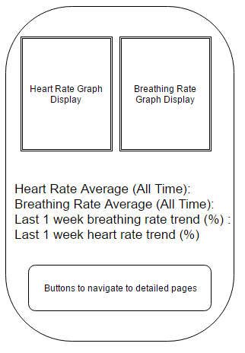

**Figure 6**. Candidate mobile application home screen.

* 1. **Codes and Standards**

The Health Insurance Portability and Accountability Act (HIPPA) was introduced in 1996 and affects how the system can store sensitive data. Only medical professionals using the data to assist the patient or the individual whose data is being measured is allowed to view health data related to that individual [8]. The mobile application to enter production will have to use password protection for accounts to fulfill legal obligations to keep health data confidential. Information at the database level will have to be encrypted and signed in the final product to be protected from exposure when viewing the database.

Another standard relevant to this design is ANSI/AAMI ES60601-1:2005, which has guidelines on medical instruments. This means the error rate after sampling must be low enough to not mislead users because of the sensitive medical data shown on these devices [9]. The noise cancellation must first be implemented then filtering algorithms will take more computational power to meet the accuracy standards of this guideline.

* 1. **Constraints, Alternatives, and Tradeoffs**

One of the biggests constraints this project faces is the display data in real-time. There might be some delay between recording the real-time signal and displaying it on the computer screen. Another constraint faced is the maximum amount of data that can be stored in the database without incurring additional costs. The cost to partition additional storage space is not factored into the design so it should be avoided. This constraint means that the heart rate and respiration rate may not be able to be graphed on the mobile app because graphing data requires many more data points than displaying static views. While this data would be useful to have on a mobile device, it may need to be added in later generations of the project in production.

Lastly, the decision to use wired transmission was made in order to save time and avoid additional design expenditure into wireless protocols. While wireless communication could give the monitoring system more mobility, it was deemed too much effort to create a consistent protocol for lossless data transfer that could go into improving core parts of the noncontact monitoring system.

1. **Schedule, Tasks, and Milestones**

The team will be designing and implementing the real time vital sign processing system over the course of the next semester. Appendix A consists of the all major milestones, the person(s) assigned to those tasks, and their relative risk levels. Appendix B consists of the Gantt chart while appendix C contains the detailed breakdown of the tasks and their associated timelines, start date, end date, and duration. Finally, appendix D has a Pert chart with the critical path and associated durations identified.

1. **Project Demonstration**

The project demonstration must provide proof the project goals have been met. Namely, the interface will show the following capabilities:

* The microcontroller can handle the complete input signal and transfer data to the computer. This will be demonstrated through graph display on computer interface.
* Raw data will first be displayed then noise will be removed from the raw signal to demonstrate noise filtering capabilities.
* The signal can be split through mixed signal analysis into breathing rate and heart rate signals. The split signals will be displayed on the computer interface.
* Relevant data for the mobile application is transferred to the database. This will be shown by displaying the user’s latest heart rate and breathing data on the mobile application.
* The user can view history data and other health statistics through the buttons on the mobile application. Navigating through the various views and screens on the mobile application and viewing correct data will confirm this feature.

The system can be used while attached to a computer through a physical medium to transfer the data to a computer. To use the device, the the non contact sensor, laptop controller, microcontroller, and any cell phone will be required. As long as these devices are all in the same room, this project is designed to be portable anywhere. A demonstration will consist of the following.

1. A user will be able to create a new account or add their health data to a precreated existing account.
2. Once the user is logged in, the raw signal data will be displayed on the screen. The user can set sampling rate and frequency range to analyze and then click a button to go to start recording.
3. The user views processed signal data like heartbeat and breathing rate on the computer interface to track the current sensor measurement. The transients will also be displayed on this screen.
4. After a brief delay of 1-2 seconds, can use the phone to access processed data with historical trends on the mobile application.
5. **Marketing and Cost Analysis**
   1. **Marketing Analysis**

The target market for this product is hospitals and other healthcare locations that need to monitor patients’ vital signs. Current vital sign monitoring systems range in price from about $1350 to $3895 according to Venture Medical [10]. These monitors perform analysis that the noncontact monitoring system will not be able to do, such as blood pressure and ECG for the most expensive models. A noncontact vital signs monitoring system should cost less than these comparisons because it cannot have many of these features. The main advantage that this product will have over its competitors is that it is noncontact, so patients do not need to be strapped in or have any invasive actions taken in order to receive aid.

* 1. **Cost Analysis**

The total development cost for a prototype of Non-Contact Vital Signs Monitoring System is approximately $175.34 [11]. The costs incurred in our prototype model is that of the EFM8 MCU, AD7770 ADC, SMA plug to SMB plugs, and 50 ohm SMB terminator plugs, as the existing Doppler radar which extracts the vital signs from the patient, as well as an SMA connector cable, will be provided free of cost by the advisor. The Non-Contact Vital Signs Monitoring System consists of the MCU, an external ADC as well as a computer UI which processes and displays the incoming vital signs in real-time, as well as a mobile app. The computer UI, processing of the signals and the mobile app require man hours to achieve, however they do not contribute to the base cost of the product or the prototype.

|  |  |
| --- | --- |
| **Table 2.** Developmental Hours Per Engineer | |
| Task | Hours |
| Class | 20 |
| Weekly Meetings | 13 |
| Reports | 12 |
| Research | 20 |
| Testing | 16 |
| Presentation | 1 |
| **Total** | **82** |

The developmental costs shown in Table 3. were determined with an engineer’s annual salary of $70,000. 82 hours of labor for 5 engineers as determined from table 2. totals $13798.07. Assuming 30% fringe benefits of labor and 120% overhead on materials/labor/fringe benefits, the total developmental costs of Non-Contact Vital Signs Monitoring Systems is shown below in Table 3.

|  |  |
| --- | --- |
| **Table 3.** Total Developmental Costs | |
| Development Component | Cost |
| Prototype | $329.05 |
| Labor | $13,798.07 |
| Fringe Benefits, % of Labor | $4139.42 |
| Subtotal | $17,983.12 |
| Overhead, % of Material, Labor, & Fringe Benefits | $21,579.74 |
| **Total Developmental Cost** | **$57,829.40** |

1. **Current Status**

Currently, the team has completed the initial survey of the microcontrollers and external evaluation board ADC, and identified the microcontroller and external ADC that will be used in the processing system. In addition, all the team members own laptops with Matlab that can be used for the actual processing of the data. However, the team is still finalizing the choice of the microcontroller before sending a purchase order. The team is also finalizing the software package distribution that will be used for the desktop GUI. Once the microcontroller arrives, the actual system will be built.

1. **References**

[1] J. J. M. de Wit, A. Meta and P. Hoogeboom, "Modified range-Doppler processing for FM-CW synthetic aperture radar," in *IEEE Geoscience and Remote Sensing Letters*, vol. 3, no. 1, pp. 83-87, Jan. 2006.

[2] C. Li, J. Ling, J. Li and J. Lin, "Accurate Doppler Radar Noncontact Vital Sign Detection Using the RELAX Algorithm," in *IEEE Transactions on Instrumentation and Measurement*, vol. 59, no. 3, pp. 687-695, March 2010.

[3] Z. Xia and Y. Zhang, “Dual-Carrier Noncontact Vital Sign Detection With  
a Noise Suppression Scheme Based on  
Phase-Locked Loop,” in *IEEE Transactions on Microwave Theory and Techniques*, vol. 64, no. 11, November 2016.

[4] Silicon Labs, "EFM8 Busy Bee Family EFM8BB1 Data Sheet," in www.silabs.com. [Online]. Available: http://www.silabs.com/Support%20Documents/TechnicalDocs/EFM8BB1-DataSheet.pdf. Accessed: Nov. 22, 2016.

[5] Silicon Labs, "Busy Bee Family UG236: EFM8BB1-SLSTK2020A User Guide," in www.silabs.com. [Online]. Available: http://www.silabs.com/Support%20Documents/TechnicalDocs/EFM8BB1-SLSTK2020A-UserGuide.pdf. Accessed: Nov. 22, 2016.

[6] J. Li and P. Stoica, “Efficient mixed-spectrum estimation with applications to target feature extraction,” IEEE Trans. Signal Process., vol. 44, no. 2, pp. 281–295, Feb. 1996.

[7] Jingdong Chen, J. Benesty, Yiteng Huang and S. Doclo, "New insights into the noise reduction Wiener filter," in *IEEE Transactions on Audio, Speech, and Language Processing*, vol. 14, no. 4, pp. 1218-1234, July 2006.

[8] “Health Insurance Portability and Accountability Act,” *California Department of Health Care Services*, 2016. [Online]. Available: http://www.dhcs.ca.gov/formsandpubs/laws/hipaa/Pages/1.00WhatisHIPAA.aspx. [Accessed: Nov 21, 2016]

[9] “ANSI/AAMI ES60601-1:2005,” AAMI Standards and Recommended Practices, 2012.

[10] V. M. R. Terms, "Patient Monitors for Sale," 2012. [Online]. Available: http://www.venturemedical.com/products/patient_monitors_and_accessories/patient_monitors/?gclid=Cj0KEQiA08rBBRDUn4qproqwzYMBEiQAqpzns-VIvcJt9YWD2-uO0FOOhUpHBjR-uGYbCGCaysHW0PsaAlh_8P8HAQ. Accessed: Nov. 21, 2016.

[11] S. Labs, "SLSTK2020A," in www.digikey.com. [Online]. Available: http://www.digikey.com/product-detail/en/SLSTK2020A/336-3160-ND/5115717?WT.mc_id=IQ_7595_G_pla5115717&wt.srch=1&wt.medium=cpc&WT.srch=1&gclid=Cj0KEQiA08rBBRDUn4qproqwzYMBEiQAqpzns67mfAczk-HkE9bZEddtHsK0Ug4W-rrUMBXEhX7r2e8aAg-L8P8HAQ. Accessed: Nov. 22, 2016.