Nisarga - Menstrual Health and Cycle Care App
Generated from README.md on 04 June 2026

Project Title
Nisarga - Menstrual Health and Cycle Care Application

Category
Healthcare Management System / Menstrual Health Tracking System

Overview
Nisarga is a Flutter-based healthcare application designed to help users track menstrual cycles, log daily health symptoms, book doctor appointments, chat with approved doctors, view prescriptions, receive reminders, and access educational content related to menstrual health, PCOD, and PCOS.
The project uses Firebase Authentication and Cloud Firestore for real-time backend services. The admin panel manages users, doctors, appointments, content, exercises, feedback, and Cloudinary image upload settings. Cloudinary is used for free image uploads without Firebase Storage.

Table of Contents
1. Chapter 1 - Introduction
2. Chapter 2 - Software Requirement Specification
3. Chapter 3 - System Design
4. Chapter 4 - Database Design
5. Chapter 5 - Detailed Design
6. Chapter 6 - Program Code Listing
7. Chapter 7 - Screens and Outputs
8. Chapter 8 - Testing
9. Deployment Guide
10. Conclusion
11. Future Enhancements
12. Bibliography

Chapter 1 - Introduction

1.1 Introduction of the System
Menstrual health tracking requires accurate cycle records, daily symptom logs, health reminders, doctor support, and reliable health education. Manual tracking or scattered notes can lead to missed dates, incomplete health history, and poor communication with healthcare providers.
Nisarga provides a centralized digital system where users can manage menstrual cycle data, book consultations, chat with doctors, view prescriptions, and receive reminders. Doctors can manage appointments, view patient information with granted access, and create prescriptions. Admins can manage doctors, users, content, feedback, and Cloudinary media uploads.

1.2 Background
Traditional menstrual health management often depends on paper notes, memory, or separate messaging apps. These approaches create problems such as:
- Difficulty tracking cycle history.
- Missed reminders for health tasks.
- No centralized doctor-patient communication.
- No structured prescription history.
- Limited admin control over doctors and educational content.
- Manual content image handling.
Nisarga solves these issues by using real-time Firebase data, structured panels for each role, and Cloudinary-based content image uploads.

1.3 Objectives of the System
- Provide secure user, doctor, and admin access.
- Track menstrual cycles and daily symptoms.
- Support appointment booking with approved doctors.
- Enable real-time doctor-patient chat.
- Allow doctors to view patient details after appointment access is granted.
- Generate and store prescriptions.
- Provide admin-managed PCOD/PCOS exercises and health content.
- Store feedback and notification preferences.
- Use Cloudinary for image uploads without Firebase Storage.
- Keep all operational data real and realtime, with no mock data.

1.4 Scope of the System
The system is designed for:
- Patients / users tracking menstrual health.
- Doctors managing appointments and prescriptions.
- Admins managing the healthcare platform.
The system supports authentication, email verification, doctor approval, appointment management, daily logging, cycle history, prescriptions, chat, content management, exercises, feedback, reminders, notifications, language preference storage, and Cloudinary uploads.

1.5 Structure of the System
Main modules:
- User Management
- Doctor Management
- Appointment Management
- Cycle Tracking
- Daily Health Logging
- Prescription Management
- Realtime Chat
- Reminder and Notification Management
- PCOD/PCOS Content and Exercise Management
- Admin Dashboard
- Feedback Management
- Cloudinary Media Upload Management

1.6 System Architecture
Figure 1 - System Architecture Diagram
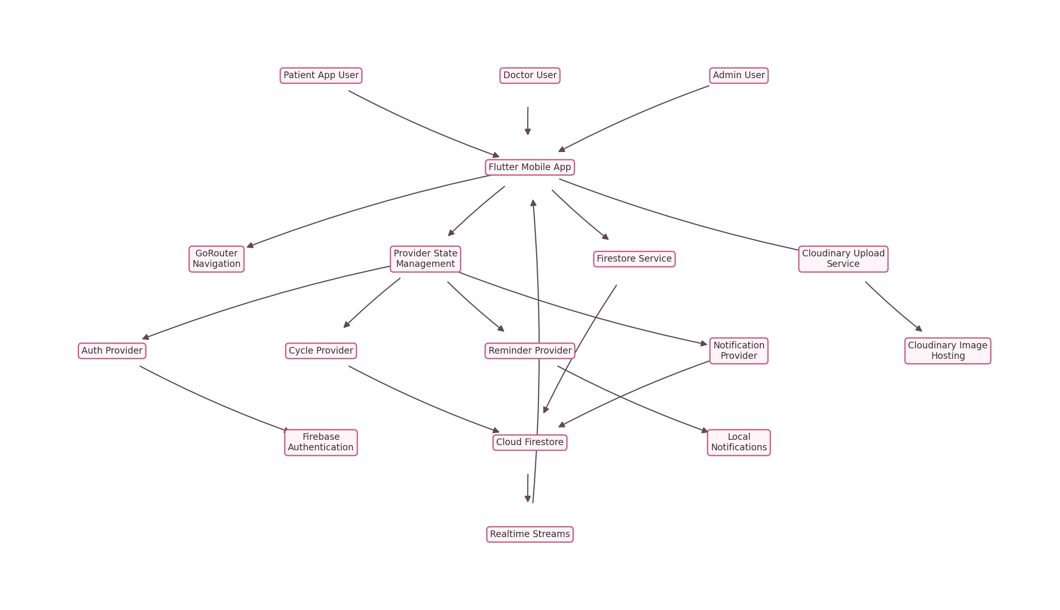
Figure 1 - Rendered diagram

1.7 End Users
- Patients
- Doctors
- Administrators

1.8 Software Used
Software / Tool | Purpose
Flutter | Cross-platform mobile application development
Dart | Application programming language
Firebase Authentication | Secure login, registration, and email verification
Cloud Firestore | Realtime database
Firebase CLI | Rules deployment
Cloudinary | Free image upload and hosting
Provider | State management
GoRouter | App routing
Flutter Local Notifications | On-device reminder notifications
Image Picker | Selecting content images from device
HTTP | Uploading selected images to Cloudinary
Android Studio / VS Code | Development environment
Git | Version control

1.9 Hardware Requirements
Hardware | Specification
Processor | Intel Core i3/i5 or higher
RAM | 4 GB or above
Hard Disk | 2 GB free space for source and dependencies
Mobile Device | Android phone or emulator
Internet | Required for Firebase and Cloudinary

Chapter 2 - Software Requirement Specification

2.1 Introduction
This Software Requirement Specification describes the functional and non-functional requirements of the Nisarga healthcare application.

2.2 Overall Description

Product Perspective
Nisarga is a mobile-first healthcare platform. It connects patients, doctors, and administrators through a Firebase-backed real-time application.

Product Functions
- User registration and login.
- Firebase email verification.
- Role-based access for patient, doctor, and admin.
- Doctor approval by admin.
- Cycle and daily symptom tracking.
- Appointment booking and status management.
- Doctor patient list based on appointment access.
- Realtime chat.
- Prescription creation and patient prescription view.
- Admin content management.
- PCOD/PCOS exercise management.
- Feedback submission and admin review.
- Cloudinary image uploads.

User Characteristics
User Type | Characteristics
Patient | Uses app for cycle care, logs, appointments, chat, prescriptions, and reminders
Doctor | Uses panel for appointments, patient details, chat, and prescriptions
Admin | Manages users, doctors, content, appointments, feedback, and media settings

Constraints
- Internet connection is required for Firebase and Cloudinary operations.
- Firebase Storage and Cloud Functions are not required in the free setup.
- Cloudinary uploads require a configured unsigned upload preset.
- Doctor data is visible to patients only after admin approval.

Assumptions
- Users have access to an Android device or emulator.
- Firebase project is configured.
- Admin creates Cloudinary unsigned upload settings before uploading images.
- Healthcare data is entered accurately by users and doctors.

2.3 Functional Requirements

Module 1 - User Management
- Register as user or doctor.
- Login using email and password.
- Verify email using Firebase verification link.
- Maintain personal profile.
- Store language preference.
- Submit feedback.

Module 2 - Doctor Management
- Register doctor profile.
- Wait for admin approval.
- Edit doctor profile and availability.
- View appointment-linked patients.
- View patient details, cycle history, and daily logs.
- Create prescriptions.

Module 3 - Appointment Management
- Browse approved doctors.
- Select allowed availability day and time.
- Book appointment.
- Doctor accepts, reschedules, completes, or cancels appointment.
- Admin monitors all appointments.

Module 4 - Health Monitoring
- Save cycle data.
- Save daily logs with flow, cramps, mood, notes, and remedies.
- View cycle history.
- Show health profile information from real logged data.

Module 5 - Communication and Prescription
- Realtime doctor-patient chat.
- Appointment-based chat routing.
- Doctor creates prescriptions.
- Patient views prescriptions.
- Notification records are stored in Firestore.

Module 6 - Admin and Content Management
- Manage users and roles.
- Approve, reject, or disable doctors.
- Add articles, medicines, products, home remedies, and exercises.
- Upload article/product/exercise images to Cloudinary.
- Review feedback.

2.4 System Attributes
Attribute | Description
Security | Firebase Auth, Firestore rules, role-based access
Reliability | Realtime Firestore streams and local state providers
Performance | Efficient model mapping and filtered Firestore queries
Maintainability | Layered structure using models, services, providers, routes, and screens
Scalability | Firebase collections support multiple users, doctors, and content records
Usability | Separate patient, doctor, and admin panels

Chapter 3 - System Design

3.1 Introduction
System design defines the structure, modules, workflow, and data flow of Nisarga.

3.2 Functional Decomposition
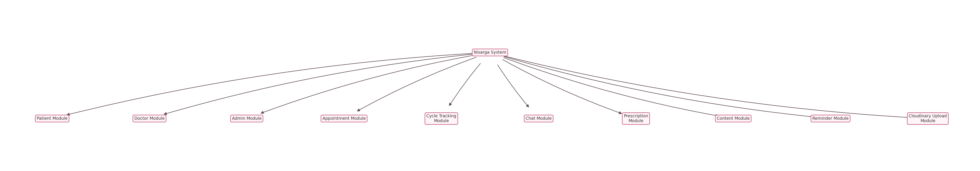
Figure 2 - Rendered diagram

3.3 Context Flow Diagram
Figure 2 - Context Flow Diagram
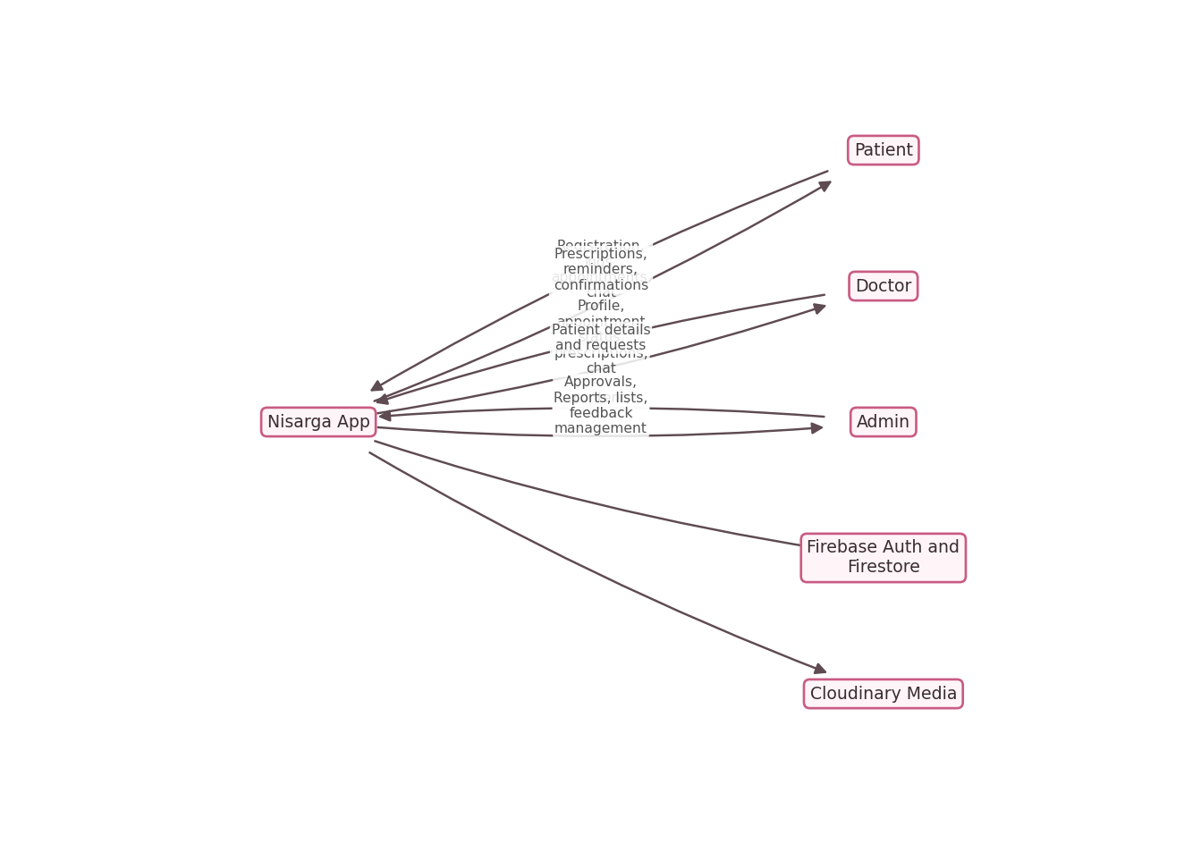
Figure 3 - Rendered diagram

3.4 Flow Chart
Figure 3 - Flow Chart
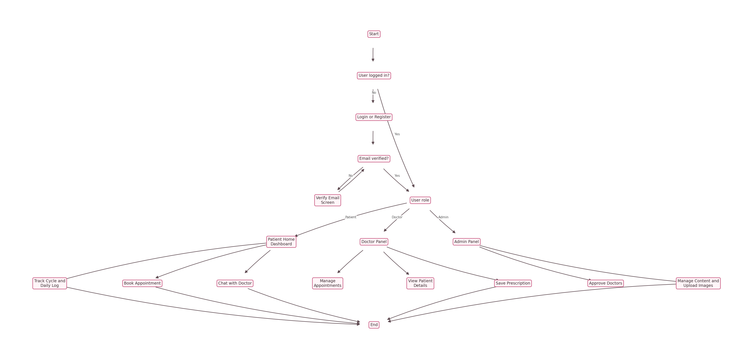
Figure 4 - Rendered diagram

3.5 Use Case Diagram
Figure 4 - Use Case Diagram
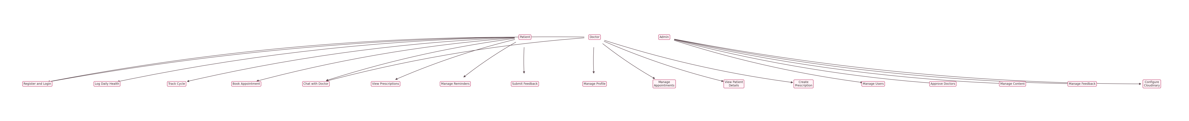
Figure 5 - Rendered diagram

3.6 Data Flow Diagrams

3.6.1 Context-Level DFD - Level 0
Figure 5 - DFD Level 0
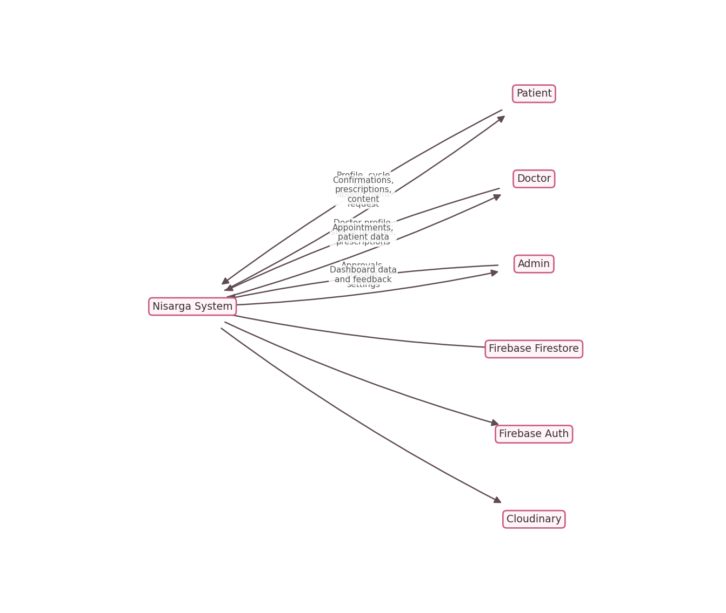
Figure 6 - Rendered diagram

3.6.2 Level 1 DFD
Figure 6 - DFD Level 1
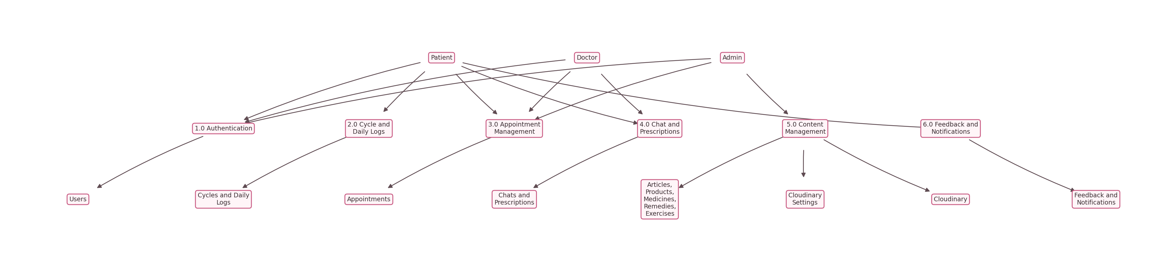
Figure 7 - Rendered diagram

3.6.3 Level 2 DFD
Figure 7 - DFD Level 2
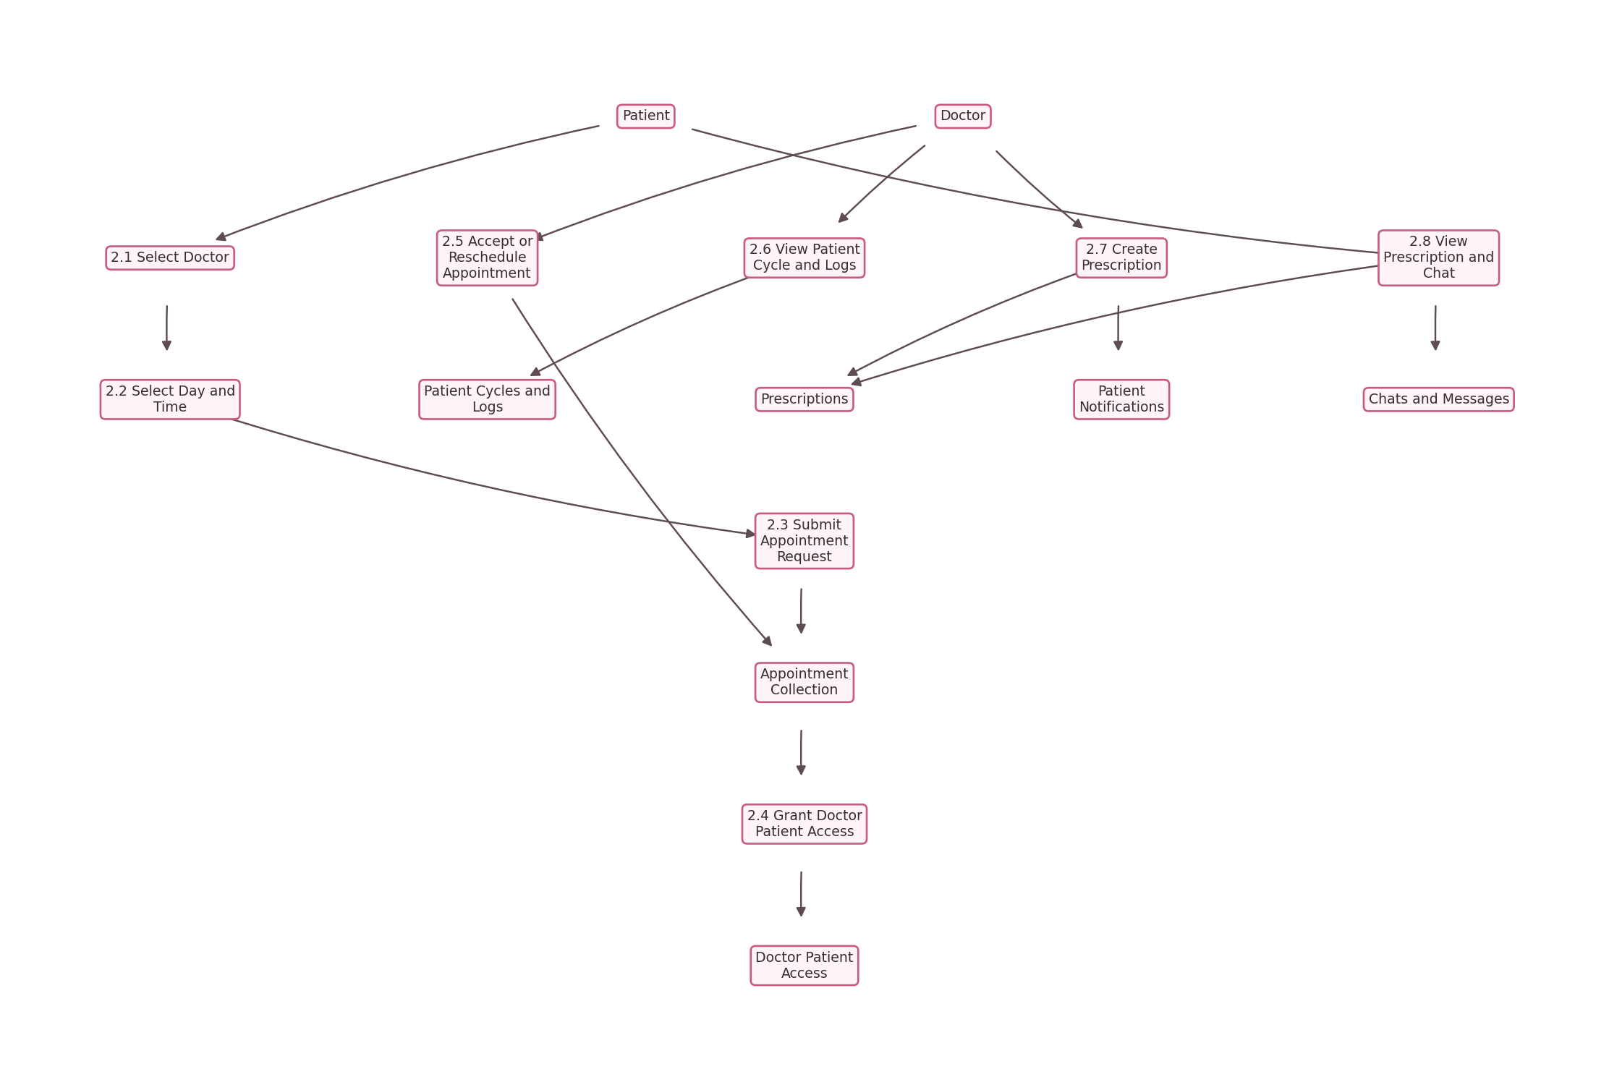
Figure 8 - Rendered diagram

Chapter 4 - Database Design

4.1 Introduction
Nisarga uses Cloud Firestore, a NoSQL realtime database. Data is organized into top-level collections and user subcollections. The structure is designed for secure role-based reads and writes.

4.2 Purpose and Scope
The database stores authentication profile details, doctors, appointments, cycles, daily logs, reminders, notifications, chat messages, prescriptions, content, feedback, and Cloudinary settings.

4.3 Collections Used

Table 1 - Users Collection
Field | Type | Description
id | string | Firebase Auth UID
firstName | string | User first name
lastName | string | User last name
email | string | User email
contact | string | Contact number
address | string | Address or doctor location
gender | string | Patient gender
dob | string | Date of birth
role | string | patient, doctor, or admin
status | string | active, pending, approved, rejected, disabled
language | string | Saved language preference
notificationPreferences | map | Push, sound, vibration preferences

Table 2 - Doctors Collection
Field | Type | Description
id | string | Doctor document ID
userId | string | Linked Firebase user ID
name | string | Doctor name
specialization | string | Medical specialization
clinic | string | Clinic or hospital
location | string | Practice location
qualifications | array | Qualifications
availability | array | Allowed day/time slots
status | string | pending, approved, rejected, disabled
active | boolean | Doctor visibility status

Table 3 - Appointments Collection
Field | Type | Description
id | string | Appointment ID
patientId | string | Patient user ID
patientName | string | Patient display name
doctorId | string | Doctor document ID
doctorUserId | string | Doctor user ID
doctorName | string | Doctor display name
day | string | Selected weekday
time | string | Selected time
status | string | requested, accepted, rescheduled, completed, cancelled
notes | string | Patient symptoms or notes
createdAt | string | Created timestamp
updatedAt | string | Updated timestamp

Table 4 - Daily Logs Subcollection
Path: users/{userId}/daily_logs/{logId}
Field | Type | Description
id | string | Log date ID
userId | string | Patient ID
date | string | Log date
flow | string | Bleeding flow
cramps | string | Cramp level
mood | string | Mood
notes | string | Health notes

Table 5 - Cycles Subcollection
Path: users/{userId}/cycles/{cycleId}
Field | Type | Description
id | string | Cycle ID
userId | string | Patient ID
startDate | string | Cycle start date
endDate | string | Cycle end date
cycleLength | number | Cycle length
periodLength | number | Period length

Table 6 - Prescriptions Collection
Field | Type | Description
id | string | Prescription ID
patientId | string | Patient ID
doctorId | string | Doctor document ID
doctorUserId | string | Doctor user ID
doctorName | string | Doctor name
appointmentId | string | Linked appointment
medicines | array | Medicine list
notes | string | Additional recommendations
createdAt | string | Created timestamp
updatedAt | string | Updated timestamp

Table 7 - Chats and Messages
Path: chats/{chatId}/messages/{messageId}
Field | Type | Description
id | string | Message ID
chatId | string | Direct chat ID
senderId | string | Sender user ID
senderRole | string | patient or doctor
text | string | Message text
sentAt | string | Sent timestamp

Table 8 - Content Collections
Collections: articles, medicines, products, home_remedies, exercises
Field | Type | Description
id | string | Content ID
title/name | string | Content title or product name
description/content | string | Main content
imageUrl | string | Cloudinary hosted image URL
active | boolean | Visibility status
updatedAt | string | Updated timestamp

Table 9 - Cloudinary Settings
Path: settings/cloudinary
Field | Type | Description
cloudName | string | Cloudinary cloud name
uploadPreset | string | Unsigned upload preset
folder | string | Upload folder
updatedAt | string | Last updated timestamp

4.4 Entity Relationship Diagram
Figure 8 - ER Diagram
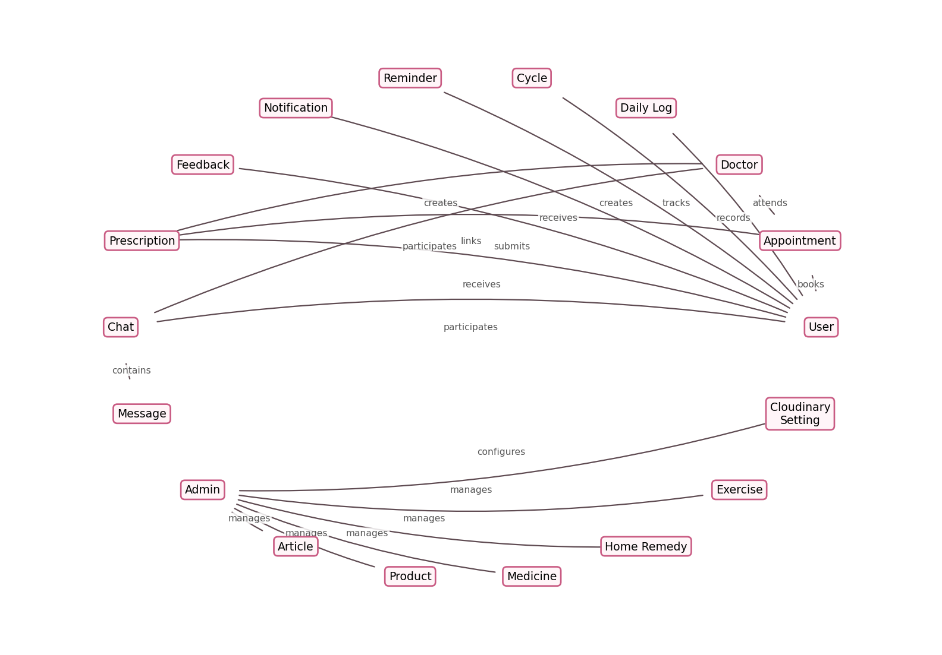
Figure 9 - Rendered diagram

4.5 Project Timeline Chart
Figure 9 - Gantt Chart
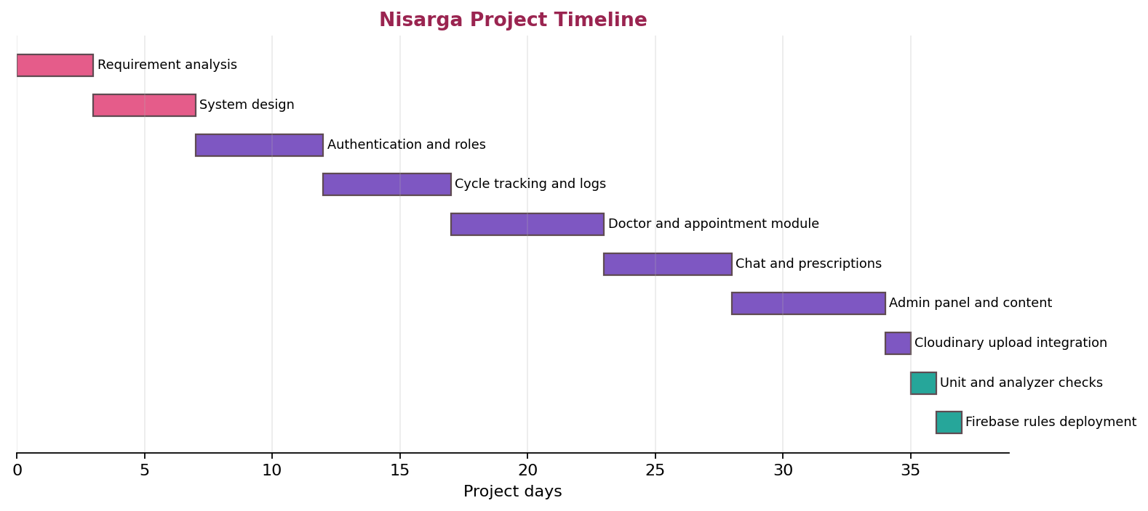
Figure 10 - Rendered diagram

Chapter 5 - Detailed Design

Module 1 - Admin Module
The Admin Module manages platform operations.
Functions:
- View and manage users.
- Change user roles and status.
- Approve, reject, or disable doctors.
- View and update appointment status.
- Add articles, medicines, products, home remedies, and exercises.
- Configure Cloudinary settings.
- Upload content images.
- View and resolve feedback.

Module 2 - Doctor Module
The Doctor Module enables approved doctors to manage consultations.
Functions:
- Doctor registration and email verification.
- Profile and availability management.
- Appointment list management.
- Patient list based on appointments.
- Patient personal information view.
- Patient period information, cycle history, and daily log view.
- Realtime chat.
- Prescription creation.

Module 3 - Patient Module
The Patient Module enables users to manage cycle care and consultations.
Functions:
- User registration and login.
- Daily log entry.
- Cycle tracking.
- Appointment booking.
- Doctor search and detail view.
- Realtime chat.
- Prescription view.
- Reminder management.
- Feedback submission.

Module 4 - Appointment Management Module
Functions:
- Approved doctor listing.
- Allowed day and time selection.
- Appointment request creation.
- Appointment status update by doctor/admin.
- Patient-doctor access creation.
- Appointment notifications.

Module 5 - Online Consultation Module
Functions:
- Direct doctor-patient chat.
- Firestore realtime message stream.
- Prescription generation.
- Patient health context access for doctors.
- Call/video request notifications stored in Firestore.

Module 6 - Content and Media Module
Functions:
- Admin-managed content records.
- PCOD/PCOS exercise content.
- Cloudinary unsigned image upload.
- Image preview before saving content.
- No Firebase Storage dependency.

Chapter 6 - Program Code Listing
This section highlights the main source files instead of listing complete code.
File | Purpose
lib/main.dart | Initializes Firebase, notifications, and providers
lib/app.dart | Configures app theme and router
lib/core/routes/app_router.dart | Defines app navigation
lib/core/providers/auth_provider.dart | Handles auth state, registration, login, roles, and email verification
lib/core/services/firestore_service.dart | Handles all Firestore operations
lib/core/services/cloudinary_service.dart | Uploads selected images to Cloudinary
lib/core/services/notification_service.dart | Handles local reminder notifications
lib/presentation/screens/admin/admin_panel_screen.dart | Admin dashboard and content management
lib/presentation/screens/doctor/doctor_panel_screen.dart | Doctor dashboard
lib/presentation/screens/doctor/chat_screen.dart | Realtime chat screen
lib/presentation/widgets/daily_log_sheet.dart | Daily log flow

Chapter 7 - Screens and Outputs

Figure 10 - Home Page
The home page displays cycle information, quick actions, doctors, articles, and navigation options.

Figure 11 - Login Page
The login page supports user and doctor login with email/password and password reset.

Figure 12 - Registration Page
The registration page provides separate forms for patient and doctor registration.

Figure 13 - Admin Dashboard
The admin dashboard includes Users, Doctors, Appointments, Content, and Feedback tabs.

Figure 14 - Doctor Dashboard
The doctor dashboard includes patient list, appointments, and profile/availability management.

Figure 15 - User/Patient Dashboard
The patient dashboard provides cycle tracking, doctor booking, reminders, prescriptions, profile, and content access.

Figure 16 - Appointment Booking Page
The appointment booking page allows choosing approved doctor availability using clickable weekday and time buttons.

Figure 17 - Health Tracking
The health tracking flow includes cycle history and daily logs.

Figure 18 - Prescription Page
Patients can view prescriptions created by doctors.

Figure 19 - Cloudinary Upload Setup
Admin can configure Cloudinary cloud name, unsigned upload preset, and upload folder.

Chapter 8 - Testing

8.1 Testing Strategy
Testing was performed using Flutter analyzer and unit tests for core model serialization.

8.2 Test Cases
Test Case | Input | Expected Result | Status
User login | Valid email and password | User enters correct dashboard | Passed
Email verification | New email account | Verification screen is shown until email is verified | Passed
Doctor registration | Doctor details | Doctor account is created as pending | Passed
Admin doctor approval | Pending doctor | Doctor becomes visible to patients | Passed
Appointment booking | Doctor day and time | Appointment request is saved | Passed
Doctor patient access | Appointment exists | Doctor can view linked patient details | Passed
Daily log | Flow, cramps, mood, notes | Log saved to Firestore | Passed
Prescription | Medicines and notes | Prescription visible to patient | Passed
Chat | Message text | Realtime message appears in chat | Passed
Feedback | Feedback message | Admin can view feedback | Passed
Cloudinary settings | Cloud name and preset | Settings saved in Firestore | Passed
Cloudinary upload | Selected image | Image uploads and URL is saved | Passed

8.3 Verification Commands
flutter pub get
dart format lib test
flutter analyze --no-fatal-infos --no-fatal-warnings
flutter test
firebase deploy --project nisarga-app-main --only firestore:rules

Latest verification:
- Flutter tests passed.
- Analyzer passed with no fatal infos or warnings.
- Firestore rules compiled and deployed successfully.

Deployment Guide

Firebase Setup
1. Create a Firebase project.
2. Enable Authentication.
3. Enable Email/Password sign-in.
4. Create Cloud Firestore.
5. Configure FlutterFire:
flutterfire configure

6. Deploy Firestore rules:
firebase deploy --only firestore:rules

Cloudinary Setup
Nisarga uses Cloudinary to avoid Firebase Storage Blaze requirements.
1. Create a Cloudinary account.
2. Copy the Cloud name.
3. Create an unsigned upload preset named nisarga_unsigned.
4. Set asset folder to nisarga.
5. In the app, open Admin Panel -> Content -> Cloudinary Uploads -> Set Up.
6. Enter:
Cloud name: dwituhokt
Unsigned upload preset: nisarga_unsigned
Folder: nisarga

Never store the Cloudinary API secret in the app.

Run the App
flutter pub get
flutter run

Build APK
flutter build apk

Output:
build/app/outputs/flutter-apk/app-release.apk

Project Structure
nisarga/
android/
ios/
lib/
app.dart
main.dart
firebase_options.dart
core/
models/
providers/
routes/
services/
theme/
presentation/
screens/
admin/
appointments/
articles/
auth/
cycle_history/
doctor/
home/
home_remedies/
medicines/
notifications/
pads/
pcod/
pcos/
prescriptions/
profile/
reminders/
search/
widgets/
test/
firebase.json
firestore.rules
pubspec.yaml

Conclusion
Nisarga provides a complete menstrual healthcare management system with patient, doctor, and admin roles. It supports real-time cycle tracking, daily logs, doctor appointments, patient detail access, prescriptions, chat, reminders, feedback, and admin-controlled content. The system uses Firebase for secure real-time data and Cloudinary for free media uploads without requiring Firebase Storage.

Future Enhancements
- Full multilingual translation instead of saved language preference only.
- Advanced cycle prediction analytics.
- Doctor video consultation integration.
- Exportable patient health reports.
- AI-based symptom insights.
- Push notifications through a backend when a paid backend is available.
- Admin analytics dashboard.
- Doctor verification document uploads.
- In-app medicine reminders with richer schedules.

Bibliography
- Flutter Documentation: https://docs.flutter.dev/
- Firebase Authentication Documentation: https://firebase.google.com/docs/auth
- Cloud Firestore Documentation: https://firebase.google.com/docs/firestore
- Firebase Security Rules Documentation: https://firebase.google.com/docs/rules
- Cloudinary Upload Presets Documentation: https://cloudinary.com/documentation/upload_presets
- Provider Package: https://pub.dev/packages/provider
- GoRouter Package: https://pub.dev/packages/go_router
- Image Picker Package: https://pub.dev/packages/image_picker

