WHATSAPP MANAGEMENT SYSTEM
Mini Project Documentation
Using Python Tkinter and Oracle Database

Submitted By:ROHAN kHADKA
LC No.:LC00014001926
Course:BCS IT
College:KFA BUSINESS SCHOOL AND IT
Submitted To:BIKASH KHADKA SAH
Submission deadline:4th septmber

Academic Year: 2026

CERTIFICATE
This is to certify that the mini project entitled “WhatsApp Management System” has been prepared as an academic project using Python Tkinter and Oracle Database. The project demonstrates database connectivity, user authentication, contact management, message management, and group management.
Project Guide:MR .BIKASH KHADKA SAH
Signature:
Date:2026,26th agust

ACKNOWLEDGEMENT
I would like to express my sincere gratitude to my teachers, project guide, college, and everyone who supported me during the development of this mini project. This project helped me understand Python GUI programming, Oracle database design, SQL, database connectivity, and basic software development practices.

ABSTRACT
The WhatsApp Management System is a desktop-based mini project developed using Python Tkinter and Oracle Database. The system provides a simple graphical interface for managing users, contacts, messages, and groups. Oracle stores application data while Python handles the user interface and application logic. The project demonstrates CRUD operations, relational database design, foreign-key relationships, user login, registration, and communication-related data management.

TABLE OF CONTENTS
1. Introduction
2. Objectives
3. Scope of the Project
4. Technologies Used
5. System Requirements
6. System Design
7. Database Design
8. Oracle Database Setup
9. Python Project Structure
10. Implementation
11. Testing
12. Screenshots and Where to Place Them
13. Advantages and Limitations
14. Future Enhancements
15. Conclusion
16. References

1. INTRODUCTION
The WhatsApp Management System is an educational desktop application. It does not connect to or control the real WhatsApp service. Instead, it demonstrates how a communication-management application can be implemented with a graphical user interface and a relational database.

2. OBJECTIVES
- Develop a desktop GUI using Python Tkinter.
- Connect Python with Oracle Database using the oracledb package.
- Implement user registration and login.
- Manage contacts using add, view, and delete operations.
- Send and display messages between registered users.
- Create groups and add registered users as group members.
- Demonstrate relational database concepts and foreign-key relationships.

3. SCOPE OF THE PROJECT
The system is suitable for a college mini project and demonstrates the basic database operations required by a communication-management application. It can later be expanded with profile management, message search, group member management, password hashing, chat-style interfaces, and improved validation.

4. TECHNOLOGIES USED
Technology | Purpose
Python 3 | Application programming
Tkinter | Graphical user interface
Oracle Database XE | Data storage and SQL operations
oracledb | Python–Oracle connectivity
Oracle SQL Developer | Database development and testing
Visual Studio Code | Code development and execution

5. SYSTEM REQUIREMENTS
Hardware:
- Computer/laptop
- At least 4 GB RAM
- At least 1 GB free storage

Software:
- Windows/Linux/macOS
- Python 3.x
- Oracle Database XE
- Oracle SQL Developer
- Visual Studio Code

6. SYSTEM DESIGN

6.1 Main Modules
- Login – authenticates registered users.
- Registration – creates new user accounts.
- Dashboard – provides access to main features.
- Contacts – adds, displays, and deletes contacts.
- Messages – sends, displays, and deletes messages.
- Groups – creates groups and adds registered users.

6.2 Basic System Flow
Start → Login/Register → Dashboard → Contacts / Messages / Groups → Oracle Database → Logout

7. DATABASE DESIGN
The project uses five main tables: USERS, CONTACTS, MESSAGES, WHATSAPP_GROUPS, and GROUP_MEMBERS. Foreign keys connect the related records and GROUP_MEMBERS implements the many-to-many relationship between users and groups.
Table | Primary Key | Purpose
USERS | user_id | Registered users
CONTACTS | contact_id | User contacts
MESSAGES | message_id | Messages
WHATSAPP_GROUPS | group_id | Groups
GROUP_MEMBERS | group_id + user_id | Group membership

8. ORACLE DATABASE SETUP
The project uses the Oracle service name XEPDB1. For the Python application, use a normal database account such as SYSTEM rather than SYS.
DB_USERNAME = "system"
DB_PASSWORD = "YOUR_SYSTEM_PASSWORD"
DB_DSN = "localhost:1521/XEPDB1"

Create the tables in this order: USERS → CONTACTS → MESSAGES → WHATSAPP_GROUPS → GROUP_MEMBERS.

9. PYTHON PROJECT STRUCTURE
WhatsApp_Management_System/
│
├── main.py
├── database.py
├── login.py
├── register.py
├── dashboard.py
├── contacts.py
├── messages.py
└── groups.py

10. IMPLEMENTATION

10.1 Database Connection
database.py contains the Oracle connection function used by the other Python modules.
import oracledb
DB_USERNAME = "system"
DB_PASSWORD = "YOUR_SYSTEM_PASSWORD"
DB_DSN = "localhost:1521/XEPDB1"
def get_connection():
try:
connection = oracledb.connect(
user=DB_USERNAME,
password=DB_PASSWORD,
dsn=DB_DSN
)
return connection
except oracledb.Error as e:
print("Database connection error:", e)
return None

10.2 Login and Registration
Registration inserts a new user into USERS. Login checks the entered username and password and opens the dashboard after successful authentication.

10.3 Contact Management
Users can add contacts with name, phone number, and email. Contacts are displayed using Tkinter Treeview and selected contacts can be deleted.

10.4 Message Management
A registered receiver username is used to find the receiver's user_id. The message is inserted into MESSAGES and displayed in the message list.

10.5 Group Management
The group module creates groups and adds registered users to groups through GROUP_MEMBERS.

11. TESTING
Test Case | Expected Result | Status
Oracle connection | XEPDB1 connection succeeds | Pass / verify
Registration | User inserted into USERS | Pass / verify
Login | Valid credentials open dashboard | Pass / verify
Invalid login | Error message displayed | Pass / verify
Add contact | Contact appears in list | Pass / verify
Delete contact | Contact is removed | Pass / verify
Send message | Message inserted/displayed | Pass / verify
Create group | Group appears in list | Pass / verify
Add member | Member inserted into GROUP_MEMBERS | Pass / verify

12. SCREENSHOTS AND WHERE TO PLACE THEM
Insert screenshots immediately after the related feature description. Add a caption such as “Figure 1: Successful Oracle connection”. The following placeholders show the recommended locations.
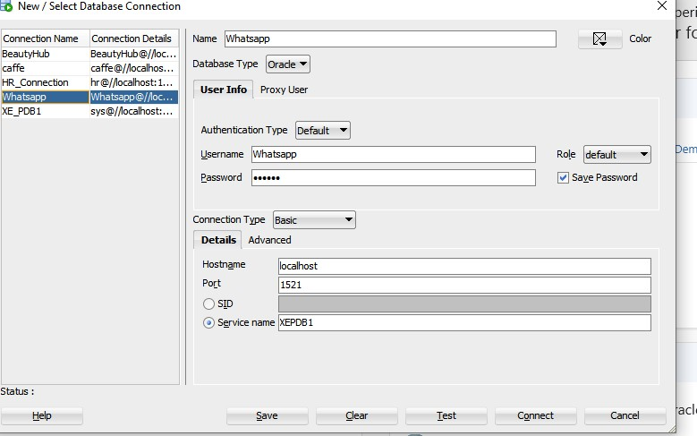
Figure 1 – SQL Developer XEPDB1 connection
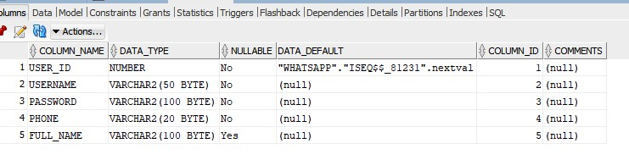

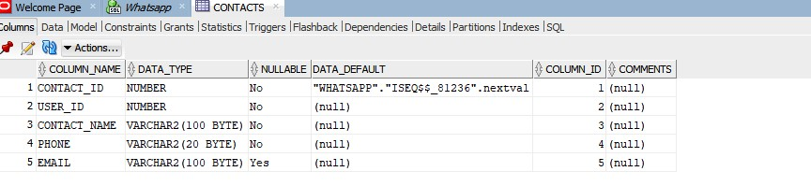

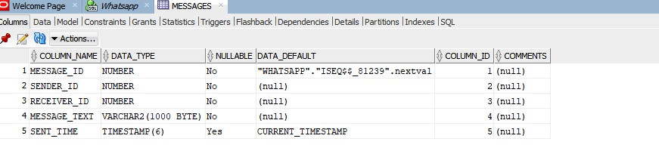
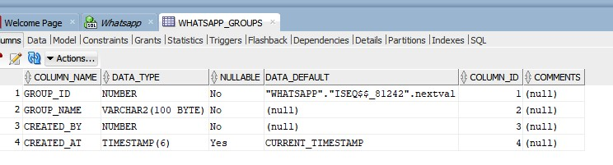
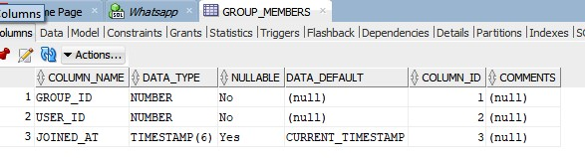
Figure 2 – Oracle tables created

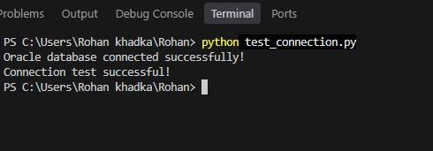

Figure 3 – Python/Oracle connection test
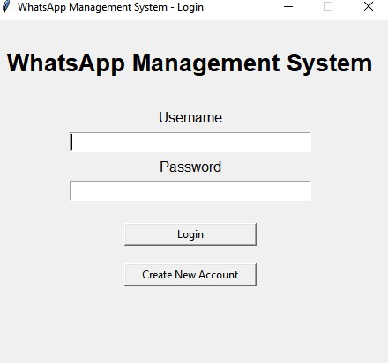
Figure 4 – Login screen

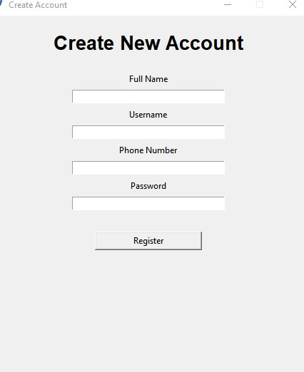
Figure 5 – Registration screen

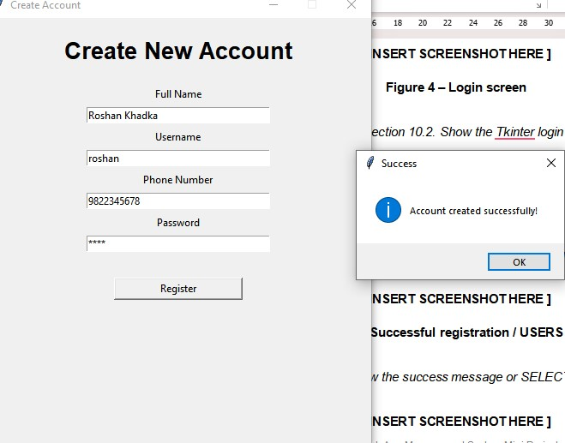

Figure 6 – Successful registration / USERS record

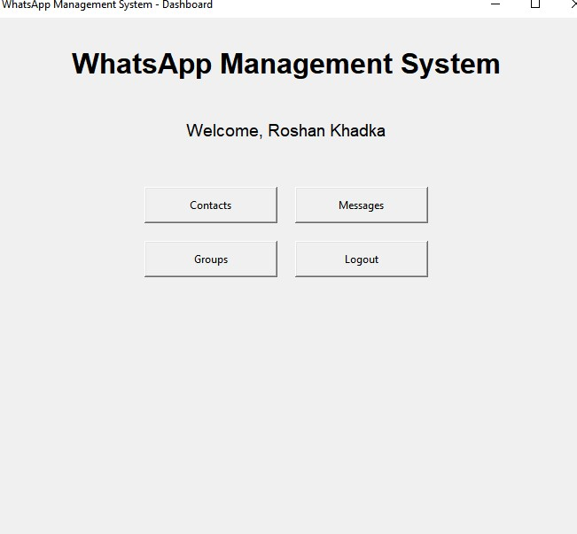
Figure 7 – Dashboard

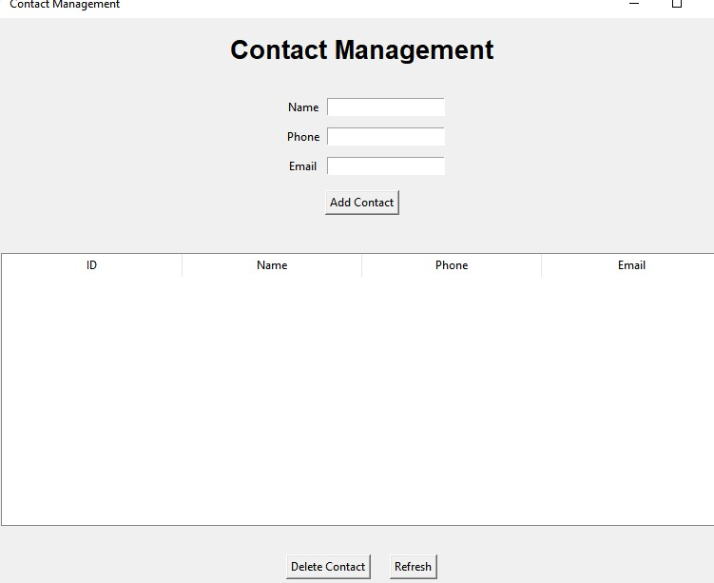

Figure 8 – Contact Management
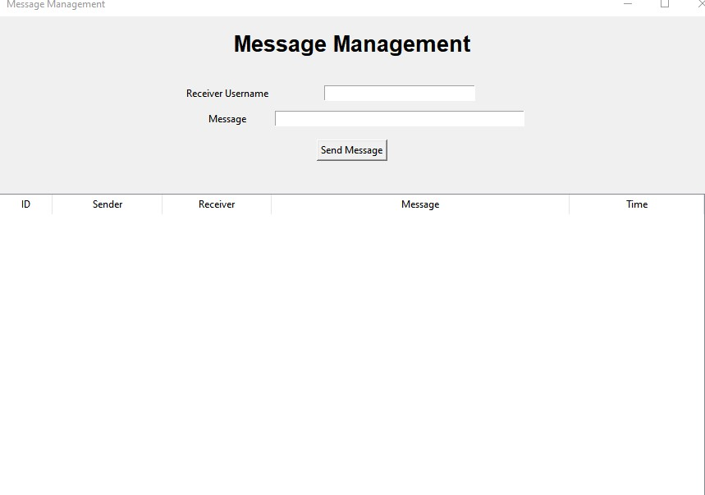
Figure 9 – Message Management

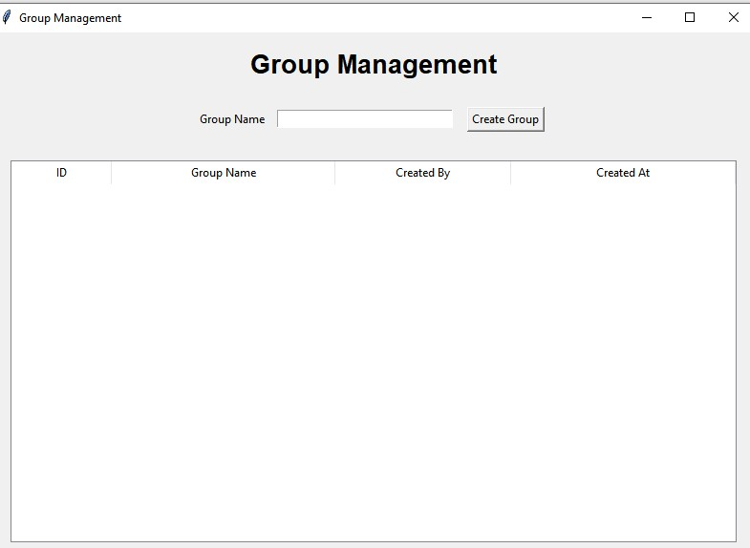
Figure 10 – Group Management
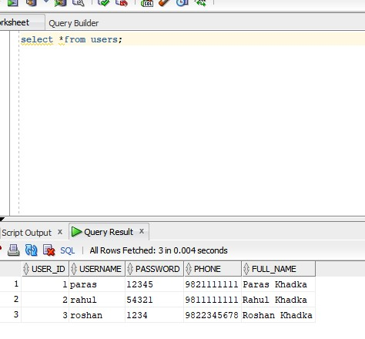
Figure 11 – Oracle records

13. ADVANTAGES AND LIMITATIONS

13.1 Advantages
- Simple desktop interface.
- Uses a relational Oracle database.
- Demonstrates CRUD operations.
- Separates GUI, database connection, and feature modules.
- Suitable for learning Python, Tkinter, SQL, and database connectivity.

13.2 Limitations
- It is a local educational system, not the real WhatsApp application.
- The basic version stores passwords as entered; production systems should use password hashing.
- It does not provide real-time internet messaging.
- Search, media sharing, notifications, and advanced profile features are limited.

14. FUTURE ENHANCEMENTS
- Password hashing and stronger authentication.
- Profile management.
- Chat-style conversation interface.
- Message search and filtering.
- Update contacts.
- View/remove group members.
- Message read status.
- File/image sharing simulation.
- Improved GUI design and themes.
- Role-based administration.

15. CONCLUSION
The WhatsApp Management System demonstrates how Python Tkinter can communicate with an Oracle relational database. The project covers registration, authentication, contact management, message management, and group management. It provides practical experience with GUI development, SQL, database relationships, and Python database connectivity.

16. REFERENCES
- Oracle Database documentation – SQL and database concepts.
- Python documentation – Python and Tkinter.
- python-oracledb documentation – Python and Oracle connectivity.
- Oracle SQL Developer – database development and SQL execution.

