# Running forecasting model on your time series data

2) Understand and explain your model output.

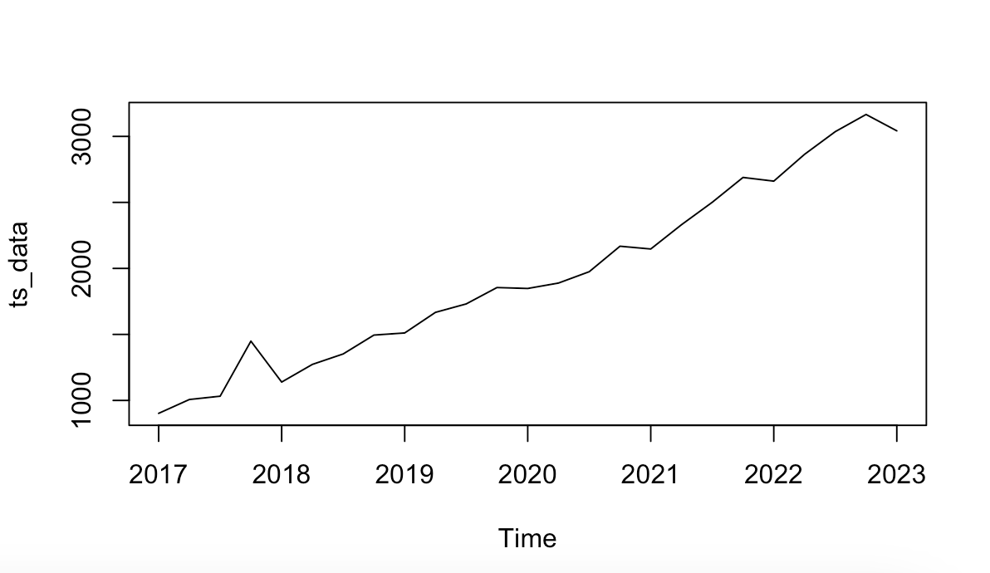

This is a Time Series Data plot of Spotify Quarterly Revenue Dataset. The time series starts in the third quarter of 2017 and has a quarterly frequency.

The x-axis represents time series and y-axis represents the forecasted values based on the mean forecast. The forecasted values will be relatively smooth and may resemble an average of the past three observed values.

Here, the Naive forecasted values will be identical to the observed values from three time periods ago [lag of 3 time periods compared to the original data].

Here, the random walk forecasted values will be identical to the most recent observed value for the next 3 time periods.

Adding a drift component to the random walk forecast allows it to capture and project linear trends in the data, making it more flexible and useful for time series with linear trends.

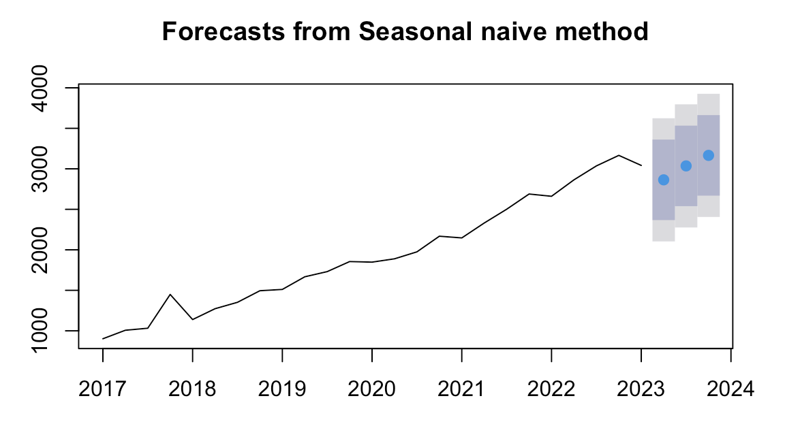

The seasonal naive forecasted values will be identical to the values from the same season (quarter) of the previous year for the next 3 time periods.

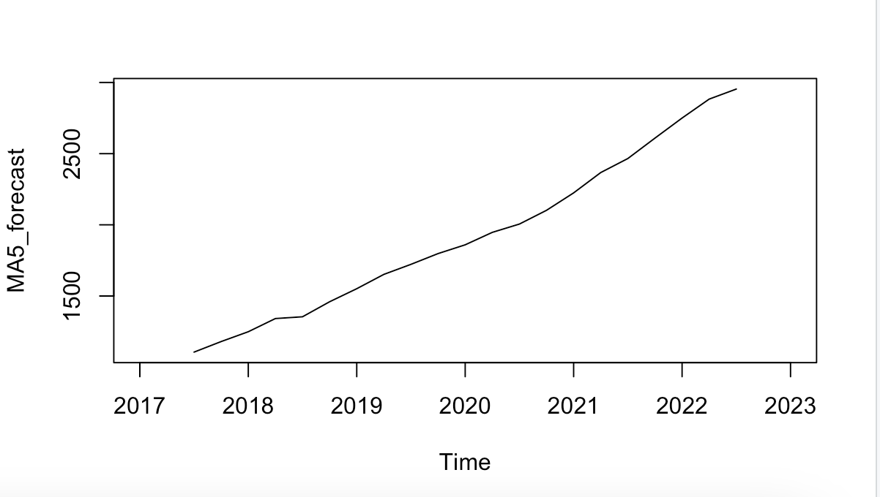

The moving average forecasted values are calculated by taking the average of the last 5 observed values at each time point.

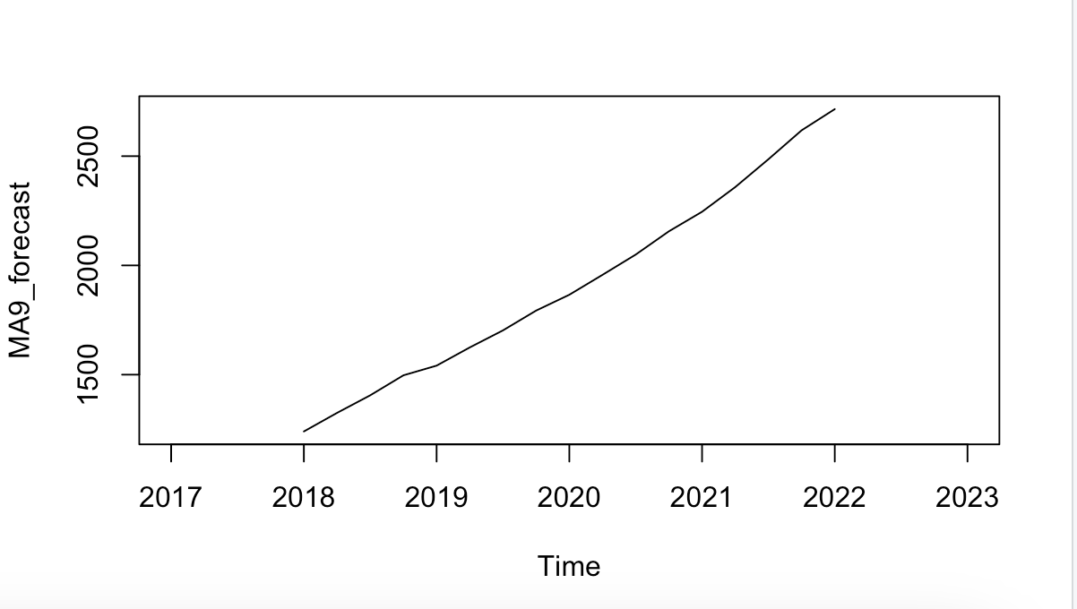

A moving average order of 9 means that the forecasted values will exhibit a high level of smoothing, providing a clear view of the overall trend in the data while filtering out short-term variations.

The ETS model is trying to understand and use the random fluctuations, trends, and repeating cycles in data to make predictions about what might happen next.

3) Plot the time series and different model forecasts in one chart.

4) Pick an accuracy measure, compare your models, and state the best model based on the accuracy comparison.

🡪 Model with lower values of RMSE, MAE, RMSE, MAPE, MPE, and ACF1 indicate better accuracy. In this case, ETS and MA9 models give the most accurate prediction.