# **Steady State Thermo-Mechanical Simulation and Data Driven Temperature Prediction of a Power Electronic Circuit on a Heat Sink**

This project aims to perform a steady-state thermo-mechanical simulation of a power electronic circuit mounted on a heat sink, focusing on predicting temperature distribution through data-driven modelling. By varying key design parameters of various elements of the electronic circuit, we aim to understand how these factors influence the temperature within the component. The ultimate objective is to optimize the design for improved performance and reliability, ensuring that the component operates within safe temperature limits under steady-state conditions.

The project will conduct multiple thermal analyses using parametric studies facilitated by OptiSlang. This approach enables the systematic exploration of various design parameters and their impact on temperature performance. The resulting labelled dataset will be used for training predictive models for optimizing the thermal management of the electronic circuit assembly. A data-driven model will be developed to predict the maximum temperature. Depending on the relationship between the design parameters and temperature, either a Convolutional Neural Network (CNN) or a tree-based model will be selected for the model. This approach aims to provide quick and reliable temperature predictions, facilitating the design optimization process. The ultimate goal is to enhance the thermal management of the electronic circuit.

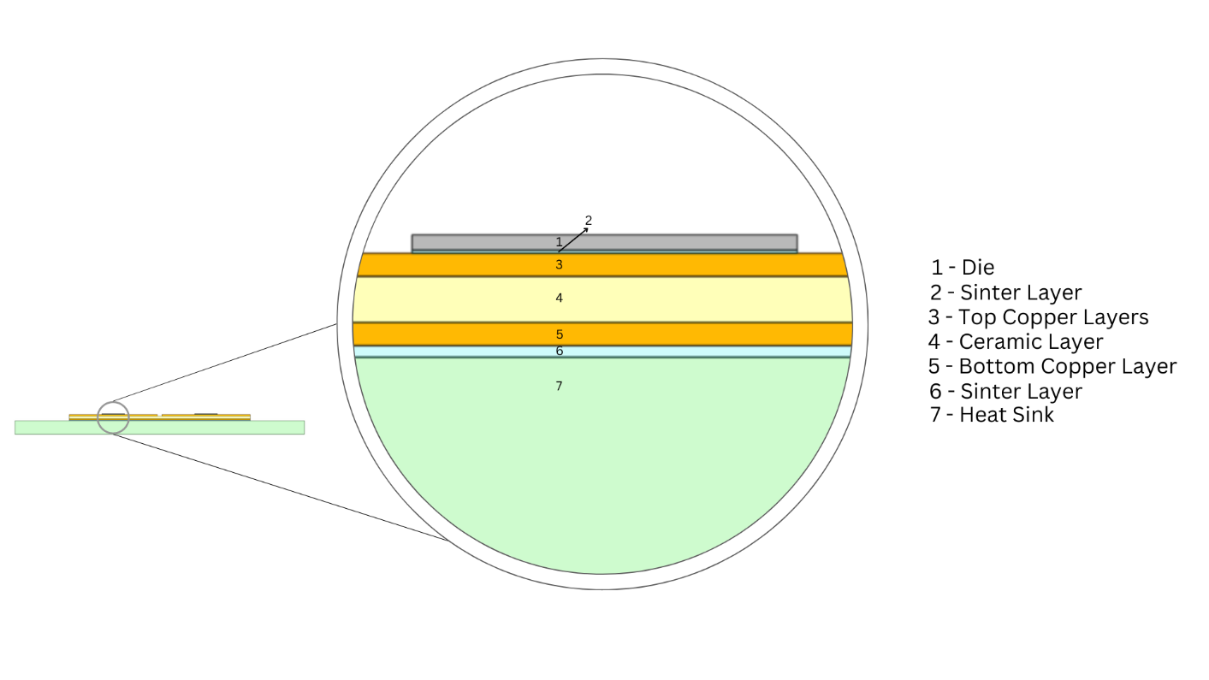

Fig 1. CAD model of the electronic circuit placed on a heat sink

## **CAE Model**

The model represents a layered power electronic circuit assembly optimized for thermal management. The topmost layer is a silicon die, responsible for the core electronic functions. Beneath the die is a sinter layer made of silver, enhancing thermal and electrical conductivity. Following this is a cast copper layer, providing an efficient heat transfer path. The next layer is ceramic, specifically Aluminum Nitride (AlN), an electrical insulator with good thermal conductivity. Below the ceramic is a complete copper layer, acting as a primary heat spreader to evenly distribute heat. Another sinter layer of silver ensures strong thermal and mechanical bonding to the final component, the heat sink. The copper heat sink is designed for superior heat dissipation, ensuring the entire assembly maintains optimal operating temperatures.

Internal heat generation is applied specifically to the dies to simulate the energy dissipated by electronic components during operation. Additionally, natural convection boundary conditions are applied to the bottom surface of the heat sink.

## **Prediction Model**

The process begins with the collection of temperature data for variations in design parameters of the layered circuit, and identifying the most important parameters for the study. A predictive model, such as a Convolutional Neural Network (CNN) or a tree-based algorithm, is then chosen based on the relationship between design parameters and temperature. This model undergoes training and evaluation to ensure accuracy using metrics like Mean Absolute Error (MAE) or Root Mean Squared Error (RMSE). Once trained, the model is deployed to predict temperature performance, undergoing continuous refinement to optimize design and enhance thermal management of the electronic circuit assembly.

The parameters under study are primarily the thickness of each layer within the layered power electronic circuit assembly. These parameters encompass the thickness of the silicon die, the silver sinter layers, the cast copper layer, the Aluminum Nitride (AlN) ceramic layer, and the copper heat sink. Alterations in each layer's thickness directly influence heat transfer, conductivity, and the overall thermal performance of the assembly. Furthermore, the investigation extends to examining the effect of the relative positions of the two dies within the assembly, and also the size of the insulation between them. Understanding the interplay of these parameters is essential for optimizing thermal performance and ensuring the efficient operation of the electronic circuit assembly.

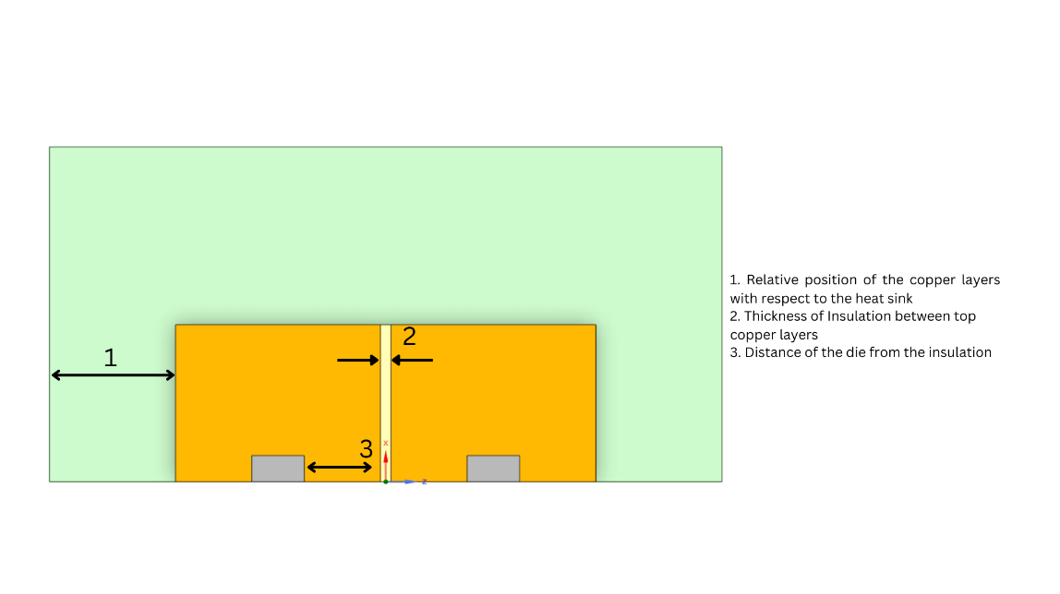

Fig 2. Top View of the CAD Model with the positional dimensions