REPORT NAME*

Author’s name:

Matr. Nr.:

International Automotive Engineering

Date of submission

Contents of Report

1. EXECUTIVE SUMMARY 3

2. TARGET 3

3. BACKGROUND/ INTRODUCTION 3

4. ASSUMPTIONS 3

5. CAE MODEL/MODELS 4

5. 1 CAD 4

5.2 CAE 4

5.3 Postprocessing 4

5.3 DOE 4

6. RESULTS and DISCUSSION 4

6.1 Mesh study/statement of discretization errors 5

6.2 Results and analysis 5

7. CONCLUSION and OUTLOOK 5

8. REFERENCES 6

9. Format and style 6

a. Naming convention of your submission PDF data 6

b. Identify the Headings 6

c. Abbreviations and Acronyms 6

d. Units 6

e. Equations 6

f. Figures and Tables 7

# EXECUTIVE SUMMARY

Formalitis: The template is used to format your report and style the text. All margins, column widths, line spaces, and text fonts are prescribed; please do not alter them. Please do not revise any of the current designations. The contents of report are strictly defined. To use this template, you can duplicate the template file by using the Save As command, and use the naming convention prescribed by chapter 9 for the name of your report. In this newly created file, highlight all of the contents and import your prepared text file. Or you can directly work on it by deleting text and keeping the contents, format and style of text. The last chapter, chapter 9, is only used to clarify the format and style, should be deleted in your report.

In the chapter executive summary you should introduce your project within 0.5-1 page, where you report briefly your Project?

* What is the Benefit of project.
* Crisp description of project, model and the simulation campaign / DOE.
* What did you do in this study to achieve your goals?
* Results and Conclusion.

# TARGET

In this chapter you are asked to define your project.

* Introduction, i.e. why is the project important, what is the background, what is the value of the analysis
* CAD description
* CAE model
* Post processing of data and interpretation.
* Design study, DOE

# BACKGROUND/ INTRODUCTION

A chapter where you introduce the simulation’s subject. In this chapter maintain all technical background which can be used later on to define or explain your assumptions and CAD- as well as CAE-Models. As an example you can explain the technical details of the sensor box, including in brief description of the components inside and their usages.

# ASSUMPTIONS

Technical description of physical phenomena, discussion and justification of assumption. Based on the background the geometry can be simplified with a certain assumptions. Also, some simulation settings can be defined due to assumptions. It is to be noted that all assumptions must be accompanied with explanations as to why that certain assumption will not be critical to results.

# CAE MODEL/MODELS

Introduce your CAD- and CAE models in details, so that the readers can rebuild your simulation project by following your description.

## 5. 1 CAD

Introduce your Geometry with assumptions and simplifications in figures and texts (you can referer to ASSUMPTIONS that you already specified and need not repeat it here). Explain parametric design.

As an example, Fig. 1 in below shows an assembly with three layers. The dimensions are …. Silicon was applied for Layer 1 … the material properties are shown in table x (list thermal conductivities of all materials).



Figure 1: schematic side view of assembly. only an example (even the materials, loads and boundary conditions can also be presented in this figure)

Material data and properties of surface (visible and IR emission/absorption when needed) including all required.

## 5.2 CAE

Introduce physics, boundary conditions, loads, contact information, material data and meshing approach (mesh study). You can discuss them separately by using sub-topics with Heading 3. Determination of loads, boundary condition based on the assumption.

We recommend you to explain your mesh dependency study with text and table. For example,

Table 1: settings of different mesh strategies

|  |  |  |  |
| --- | --- | --- | --- |
|  | Level of GM | location of LM | Level of LM |
| Mesh 1 |  |  |  |
| Mesh 2 |  |  |  |
| Mesh 3 |  |  |  |
| … |  |  |  |

## 5.3 Postprocessing

Explain postprocessing: What values are calculated, how and why.

## 5.3 DOE

Describe simulation campaign, DOE, parameters …

# RESULTS and DISCUSSION

Show your results with clear figures. Ensure your color plots and color scale can be read easily. Discussion your results to explain why is that.

## 6.1 Mesh analysis

Show your results of mesh study in table and figure (mesh plot, msh dependency plot). Based on that discussion and explain your decision of best mesh strategy. Example of results are shown in table 2 and Fig. 2.

Table 2: number of total cells and results by using different mesh strategies

|  |  |  |
| --- | --- | --- |
|  | Nr. of total cells | Results [unit] |
| Mesh 1 | 5000 | 90 |
| Mesh 2 | 7000 | 98 |
| Mesh 3 | 9000 | 94 |
| … | 11200 | 93 |

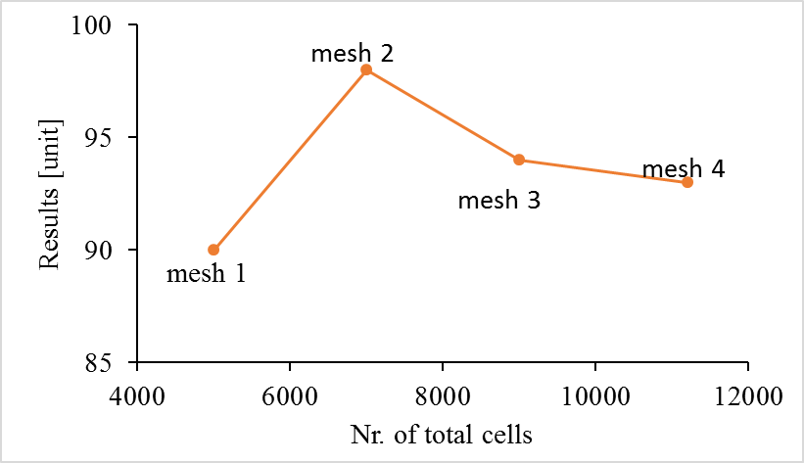

Figure 2: mesh dependency study.

## Results and Discussion

Plot your results in figures and explain or discuss them in text. Effect and Interaction evaluation. Parto Fronts and determination what is a good design All figures in the report must be discussed. If the figure is not discussed it is not important enough to be in the report. Results must discuss the goals that you wanted to achieve (described in the target). Anything apart from what is described in the target is not important unless they are extremely surprising and could lead to a change in which the project is defined or set-up.

# CONCLUSION/OUTLOOK

In this section you conclude what you found in your study. Discussing the results briefly and putting it in context to the real-life problem. (*Eg., This work was motivated by being a primary step in the process of developing a simulation model to investigate long-term thermal cycling of an optic module.. The zero-hour module was developed by introducing new aspects of the manufacturing process, there by comprehensibly increasing the complexity*.) It is imperative to discuss whether the target was achieved or not and what do you think are the reasons for it. (Eg. *Comparison of results between simulations and experiments showed that the simulations correctly captured the general qualitative behavior of the package deformation during heating up. However, there was overestimation of the quantity of bending which was understood to be mainly because of improperly fitted material parameters*.) In outlook you discuss where you see future scientific prospects and scope of improvement in the study you performed.

# REFERENCES

All relevant references following a citing standard of choice.

# Format and style

## Naming convention of your submission PDF data

Use the “First name Surname_THI account_exam date” as template of your PDF’s name. For example, “E Liu_eliu0000_19072022”

## Identify the Headings

Headings, or heads, are organizational devices that guide the reader through your report. There are two types: component heads and text heads.

Component heads identify the different components of your report and are not topically subordinate to each other. Examples include References and, for these, the correct style to use is “Heading 5”. Use “caption” for your Figure captions and table title.

Text heads organize the topics on a relational, hierarchical basis. For example, the report title is the primary text head because all subsequent material relates and elaborates on this one topic. If there are two or more sub-topics, the next level head (uppercase Roman numerals) should be used and, conversely, if there are not at least two sub-topics, then no subheads should be introduced. Styles named “Heading 1”, “Heading 2”, “Heading 3”, and “Heading 4” are prescribed.

## Abbreviations and Acronyms

Define abbreviations and acronyms the first time they are used in the text, even after they have been defined in the abstract. Abbreviations such as IEEE, SI, MKS, CGS, sc, dc, and rms do not have to be defined. Do not use abbreviations in the title or heads unless they are unavoidable.

## Units

* Use either SI (MKS) or CGS as primary units. (SI units are encouraged.)
* Avoid combining SI and CGS units, such as current in amperes and magnetic field in oersteds. This often leads to confusion because equations do not balance dimensionally. If you must use mixed units, clearly state the units for each quantity that you use in an equation.
* Do not mix complete spellings and abbreviations of units: “Wb/m2” or “webers per square meter”, not “webers/m2”. Spell out units when they appear in text: “. . . a few henries”, not “. . . a few H”.
* Use a zero before decimal points: “0.25”, not “.25”.

## Equations

The equations are an exception to the prescribed specifications of this template. You will need to determine whether or not your equation should be typed using either the Times New Roman or the Symbol font (please no other font). To create multileveled equations, it may be necessary to treat the equation as a graphic and insert it into the text after your report is styled.

Number equations consecutively. Equation numbers, within parentheses, are to position flush right, as in (1), using a right tab stop. To make your equations more compact, you may use the solidus ( / ), the exp function, or appropriate exponents. Italicize Roman symbols for quantities and variables, but not Greek symbols. Use a long dash rather than a hyphen for a minus sign. Punctuate equations with commas or periods when they are part of a sentence, as in

       

Note that the equation is centered using a center tab stop. Be sure that the symbols in your equation have been defined before or immediately following the equation. Use “(1)”, not “Eq. (1)” or “equation (1)”, except at the beginning of a sentence: “Equation (1) is . . .”

## Figures and Tables

Positioning Figures and Tables: Place figures and tables at the top and bottom of the page. Avoid placing them in the middle of the page. Figure captions should be below the figures; table heads should appear above the tables. Insert figures and tables after they are cited in the text. Use the abbreviation “Fig. 1”, even at the beginning of a sentence.

Please see section 5 for AN EXAMPLE of a Figure and Table.

Figure Labels: Use 10 point Times New Roman for Figure labels. Use words rather than symbols or abbreviations when writing Figure axis labels to avoid confusing the reader. As an example, write the quantity “Magnetization”, or “Magnetization, M”, not just “M”. If including units in the label, present them within parentheses. Do not label axes only with units. In the example, write “Magnetization (A/m)” or “Magnetization {A[m-1]}”, not just “A/m”. Do not label axes with a ratio of quantities and units. For example, write “Temperature (K)”, not “Temperature/K”.

1. Reference

List and number all bibliographical references at the end of your report. When referenced in the text, enclose the citation number in square brackets, for example [1]. Where appropriate, include the name(s) of editors of referenced books. The template will number citations consecutively within brackets [1]. The sentence punctuation follows the bracket [2]. Refer simply to the reference number, as in [3]—do not use “Ref. [3]” or “reference [3]” except at the beginning of a sentence: “Reference [3] was the first . . .”

1. Page limit and figures

The whole document should not be more than 20 pages. As a rule of thumb, it is easier to cut down on pages if the number of figures is limited. Unnecessary figures should be avoided. Multiple figures depicting the same things should be avoided. For example, if you can show the temperatures, flow vectors and the mesh refinements in one figure you can reduce the total figures by two. Also, it is to be ensured that the scales (legend in the plots) are clearly visible without zooming in multiple times. Remember, God is in the details. To be precise, finer details.