**CONTENTS**

1.Certificate

2.Acknowledgement

3.Abstract

4.Technologies Used

5.Features Provided

6.A Working Example

7.Summary

8.Future Enhancements

9.References

Department of Computer Science & Engineering National Institute of Technology, Rourkela Odisha, India – 769008.

**CERTIFICATE**

|  |  |
| --- | --- |
| This is to certify that the project titled ***Roll Call , Android Application for NITR Attendance Management System*** submitted by ROHAN KUMAR BHOI *,* bearing Roll No. 112CS0140, and BHUBANANANDA CHHATRIYA *,*bearing Roll No. 112CS0144, is a record of authentic work carried out under my supervision and guidance in partial fulfilment of the requirements for the final submission of product for PRODUCT DEVELOPMENT LAB - 1(CS-367) during the session 2014-2015.  **Dr. Pankaj Kumar Sa**  Place: Rourkela Department of Computer Science & Engineering  Date: National Institute of Technology, Rourkela  Odisha, India – 769008 |  |
| **ACKNOWLEDGEMENT**  We owe a great many thanks to all friends, peers & the many people who helped and supported our idea and work on this very project. Our sincere gratitude to Dr. Pankaj Kumar Sa, Department of Computer Science & Engineering, NIT Rourkela for having faith in us and thus allowing us to carry out a project on a technology completely new to us. He helped immensely by guiding us throughout the course of the project, inspiring us to take up new challenges along the road, and at the same time providing valuable suggestions & constructive criticisms.We would also thank our Institution & other faculty members of Department of Computer Science & Engineering without which this project would have been a distant reality. We also extend my heartfelt thanks to all well wishers. |  |

Rohan Kumar Bhoi

112CS0140

Bhubanananda Chhatriya

112cs0144

**ABSTRACT**

Accounting for more than half of the presently used hand-held devices, Android, as an operating system, has provided users with great opportunity to innovate and get things done in a mobile device. Starting as a phone OS, the array of devices compatible with Android is even driving the market in the direction of PC experience with rumours that Intel and some of the partners are working on laptop prototypes with Atom processors. And so, the need for portability has risen by leaps and bounds. People have started developing apps for every other need.

The project involves porting the Attendance System of NIT Rourkela onto Android enabled devices. The present system in intranet only, but with the new application, the extranet system would serve as an effective management tool resulting in the reduction of the number of man hours spent in uploading the attendance for each of the subjects for the semester. The professors won’t have to double up the work as to take pen & paper attendance and then upload onto the online management. Instead a single swipe would take care of everything. Even the intuitive interface is easy to understand so that professors can easily adapt themselves to use it.The concerned faculty can take select subject,take class attendance and just submit the sheet.The data is dynamically updated in the server which much lessens the need for daily updating and calculating the attendance of students.Also, the application is secure allowing only one user per phone.

**TECHNOLOGIES USED**

**1.Eclipse IDE** with adt-bundle for providing platform for writing the codes.Eclipse is an integrated development environment for multi-language software & web application development. Its extensible plug-in system helps in customizing the IDE to work on a particular technology, like Android in this case. It supports Java as the principal coding language and through plug-ins; it supports C, C++, Python, Ruby, PHP, JavaScript, Perl etc. Under Eclipse Public License, the SDK is free and open source. For android application development, we need to download the Android Development Tools (ADT) plug-in for eclipse and install it. After this, we need to run the SDK manager so as to download the Android SDKs for developing onto newer android OS versions and also the Google APIs and other support functions so as to use Google licensed android services like Maps, OAUTH 2.0 etc to full use.

**2.Adobe Dreamweaver** ,which is a smart IDE for html,php,xml,etc. web-scripting languages, for PHP codes

**3.WAMP Server** as local server

**4.PHP Scripting**

It serves as a server side scripting language. The interpreter used at server end is a dedicate PHP processor module and interprets the chunk of code within the delimiters. Acronym for Hypertext Preprocessor, PHP helps in designing dynamic web content. PHP code is processed in command-line mode performing desired operating system operations and producing program output on its standard output channel. The three main reasons to work with PHP are: first, it fits in greatly with HTML, being interchangeable with it, and only adds new content. Secondly, its user interface provides a richer experience as compared to HTML only. Third and foremost, it’s easy to learn and we can easily get started by using only a few functions.

**4.Bluestacks Android Emulator** for Testing and Debugging

**5.MySQL Database**

MySQL is a world renowned open source Relational DBMS supporting standard SQL. At the server end, it can be configured to provide single user or multi user access to a number of databases and tables. Some of the best features are: cross-platform support, updatable views, cursors, information schema, query caching etc. It can easily be integrated into PHP scripts. It is developed, distributed & supported by Oracle foundation.

**FEATURES PROVIDED**

1. Secure Login Facility for Faculties where they can take or submit the attendance of the class which reduces the paper work.

2. Selection of a Course from wide range of take courses by faculty which reduces the need for pen and paperwork.

3. Teacher may either think of taking the attendance or submit the same or do both.By taking the attendance,the teacher keeps the record of the students.If submitted,the data gets updated in the server.In case of special leave allowances,the admin can directly edit the attendance of the student.

4. By a single touch,the faculty takes marks a student absent or present,which makes it much easier for taking attendance.

5. Faculty can select either dark or light theme whichever he/she finds comfortable.

6. Error handling features makes it more dependable.

7. Zero paperwork and calculation required.

8. Dynamic updation of database at runtime reduces effort by faculty side.

9. Small apk size(4.0 MB) makes its room in any android devices.

10. Supported by Android version 14+.

**A WORKING EXAMPLE**

1.Database is as follows.

->Professors table



->Student table

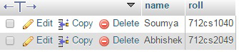

2.The professor login by entering correct Username and Password.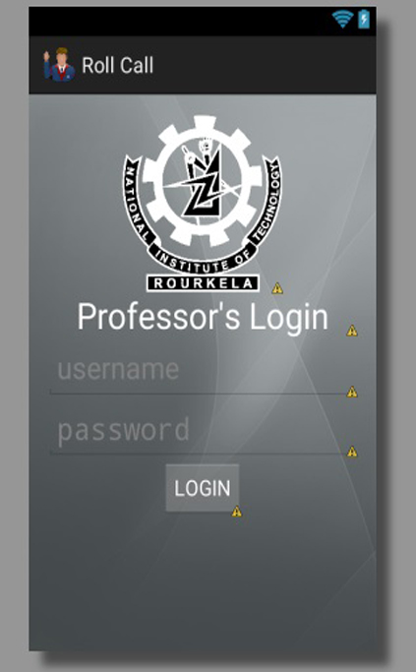

3.After login,the faculy is provided with options to take or submit the attendance.

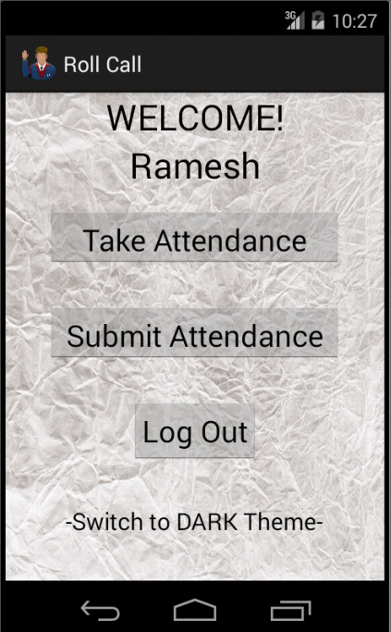

4.Faculty takes option to take attendance.

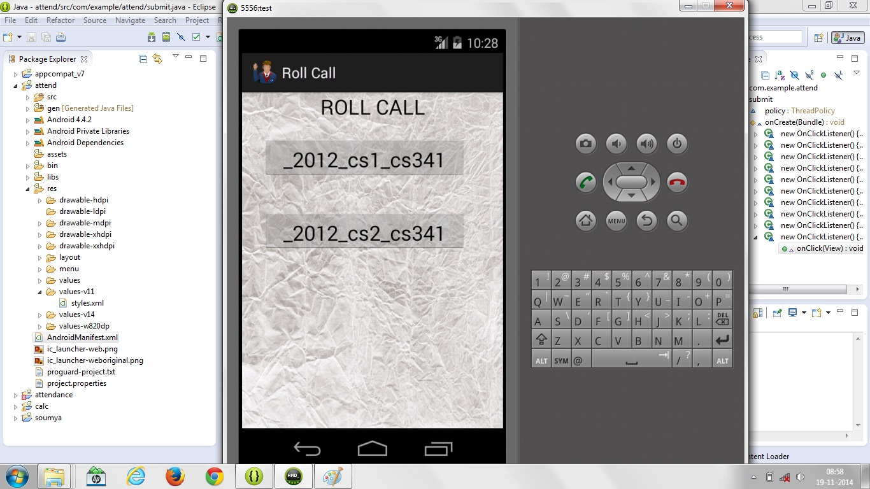

5.Faculy selects subject 1.

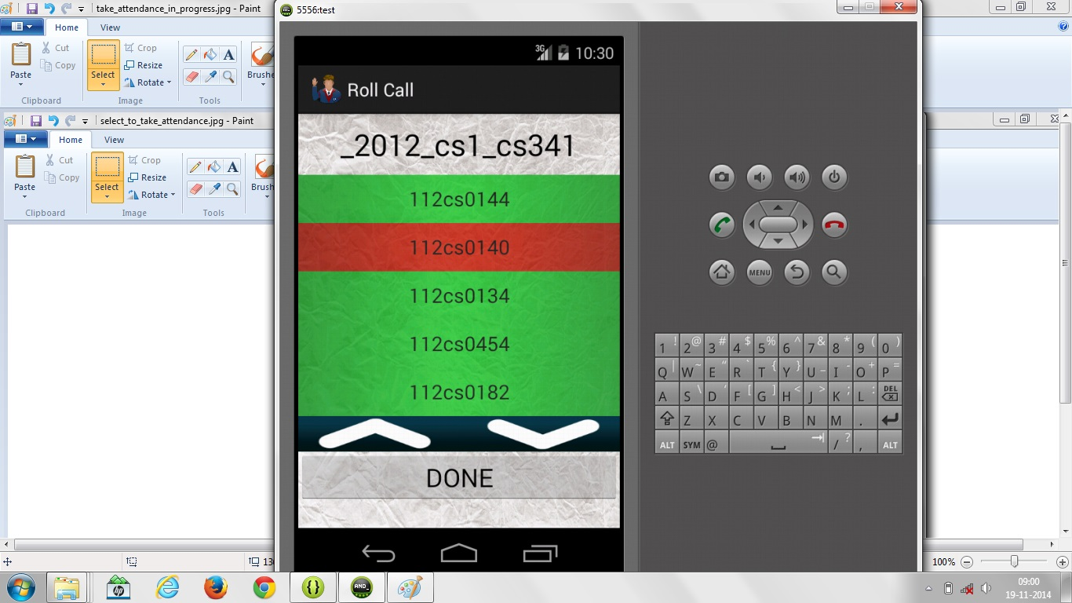

6.Faculty marks present or absent just by clicking the corresponding roll no.

7.Faculty takes to submit the attendance.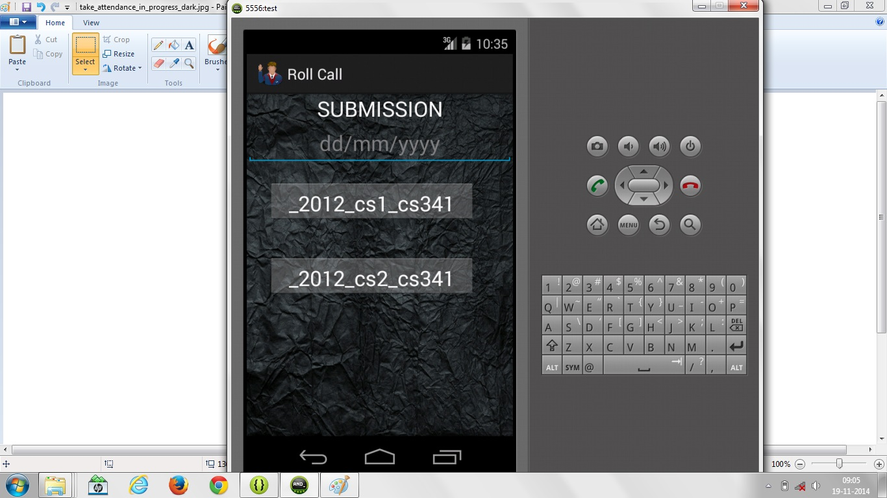

8.Faculty inputs the correct date and clicks the correct subject which gets submitted.

**SUMMARY**

The project deals with NITR Attendance Management System. The android app for the above was designed keeping in mind the present structure of the system i.e. the Category 1 & Category 2 student have different type of attendance storage in main database at server. Also, as in previous cases the test results in the form of screenshots were shown & workflow sequences depicted in figures. The special modules detailed here are the Swipe Detector module which recognises finger swipes on the name of students & SQLite DBMS module which handles local storage of attendance in the android device.

**FUTURE ENHANCEMENTS**

1.Deployment of Attendance Application throughout the institute requires scripting for connecting the database to main NIT Rourkela server.

2.The UI can definitely be improved by using Action Bars & other new end graphics introduced in Ice Cream Sandwich & Jelly Bean versions of Android.

3.It can reduce paperwork and calculation for the process of taking attendance.

4.It can be implemented similarly in other institutes.

5.A website for admin to easily manage the database can be made.

**REFERENCES**

1.[WEB-SOURCES]http://www.stackoverflow.com

2.[WEB-SOURCES]http://www.androidhive.com

3.[WEB-SOURCES] <http://developer.android.com/index.html>

4. Travis Cornelius, *New Boston Series : Android Application Development Tutorials*