**C1**



**PUZZLE**

**GUI APPLICATION**

Submitted to : Prof. Thanapal P.

Submitted by :

Priya Gupta – 14BIT0162

Nitesh Kumar Agrawal – 14BIT0198

Rohan Kumar Sachdeva – 14BIT0172

##### CONTENTS

* OBJECTIVES
* ABSTRACT
* MODULE DETAILS
* CONCEPTS USED
* SAMPLE CODE

##### Objectives:

1. The objective of the program is to design a GUI format application using JAVA.
2. The various concepts of the object oriented language or the object oriented paradigm is utilized to build the puzzle.
3. The puzzle is all about arranging the numbers from 1-8 in correct order.
4. The game provides interactive interface.
5. It also helps the user by providing hints in case needed.
6. The tab “Solution exists” tells the user to solve current situation.

##### Abstract:

The various concepts of the object oriented language or the object oriented paradigm is utilized to build the puzzle.

The puzzle is all about arranging the numbers from 1-8 in correct order. The game provides interactive interface. It also helps the user by providing hints in case needed. The tab “Solution exists” tells the user to solve current situation.

The randomise button restarts the game by disturbing the correct order. The user is also notified about the number of moves the user took to complete the game.

##### Module details:

1. Class proj : implements KeyListener, Runnable, ActionListener and extends applet.
2. Void init() : this function initializes all the labels and buttons including all the background frame colors, fonts.
3. public void destroy() : this function destroys the object created
4. void solvable() : this functions aids the user to identify all possible solutions in a given situation.
5. void resume() : resumes the game from where user has left.
6. void showstatus(String msg) : this function displays the appropriate messages.
7. public void keyPressed() : it holds the buttons which is pressed by the user.
8. public void actionPerformed(ActionEvent ae) : it handles all the action listener to the buttons.
9. public void run() :it runs the pain function.

##### cONCepts used:

**Classes & Objects**: various predefined classes are used such as applet, util, io.IOException, swing

**Encapsulation**: The data members and member functions which are dependent on each other and are encapsulated into a single class and enumeration is also present.

**Applet:** The original data files are opened in the program and necessary manipulation is done. The files are written into files and saved at desired location.

**AWT**: Only the essential features are shown and the other features are protected from the user so that no meddling with the algorithm occurs.

**Action Listener**: This class takes input of the pressed buttons and performs the appropriate action.

**Inheritance and packages**: the predefined classes are imported in the program. The text editor package is made which contains the frame class.

##### SAMPLE CODE:

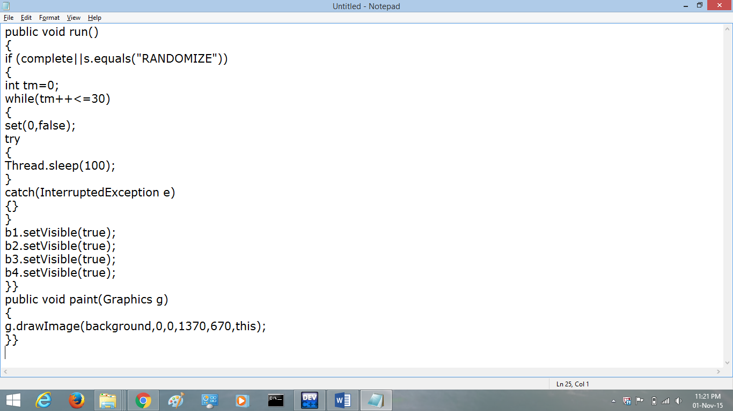

##### SAMPLE INPUT OUTPUT:

