

**TRIBHUVAN UNIVERSITY**

**FACULTY OF HUMANITIES AND SOCIAL SCIENCES**

**Project Report**

**on**

**“E-commerce Site(E-store)”**

**Submitted to**

**Department of Computer Application**

**National College of Computer Studies**

*In partial fulfillment of the requirements for the Bachelors in Computer*

*Application*

**Submitted by**

**Rohan Maharjan (55102044)**

**2024**

**Submitted to  
Sachita Maharjan**

**TRIBHUVAN UNIVERSITY**

**FACULTY OF HUMANITIES AND SOCIAL SCIENCES**

**National College of Computer Studies**

# **Supervisor’s Recommendation**

We hereby recommend that this project prepared under our supervision by **Rohan Mahrajan** entitled **“Ecommerce Site for Books: E-Store”** in partial fulfillment of the requirements for the degree of Bachelor of Computer Application is recommended for the final evaluation.

**SIGNATURE**

**____________**

**SUPERVISOR**

**Sachita Maharjan**

Faculty Member

Department of Computer Application

National College of Computer Studies

Paknajol, Kathman

# **Abstract**

# 

Business is conducted through the use of computers, allowing individuals seated in front of their computer screens to access the internet. This convenience has significantly diminished the need for extensive physical effort, streamlining various aspects of online commerce through partial or fully operating commerce stores. However, the growth of online commerce, including e-commerce for books, has been impeded by security concerns, prompting the ongoing need for improvements. One of the primary advantages of technology lies in its ability to enable users to peruse online stores, compare prices, and effortlessly order products, including books, from the comfort of their homes, using PCs, mobile devices, or other electronic tools. This project aims to enhance the online shopping experience for customers, making it user-friendly and facilitating the ease of purchasing books and gifts for loved ones over the internet.  
Finally, we shall be grateful to those people who read this project and who shall benefit from this project at present and in future.

**Supervisor’s Recommendation** **i**

**Abstract** **ii**

**Chapter 1: Introduction** **1**

1.1 Introduction of project 1

1.2 Problem Statement 1

1.3. Objectives 2

1.4. Scope and Limitation 2

1.5. Report Organization 3

1.5.1. Introduction 3

1.5.2. Background Study 3

1.5.3. System Analysis and Design 3

1.5.4. Implementation and Testing 3

1.5.5. Conclusion and Future Recommendations 3

**Chapter 2: Background Study** **4**

2.1. Background Study 4

2.1.1. Study of existing system 4

2.1.2. Literature Review 5

**Chapter 3: System Analysis and Design** **6**

3.1. System Analysis 6

3.1.1. Requirement Identification 7

3.1.1.1. Functional Requirements 7

3.1.1.2. Non-Functional Requirements 10

3.1.2. Feasibility Study 11

3.1.2.1. Technical Feasibility 11

3.1.2.2. Operational Feasibility 12

3.1.2.3. Economic Feasibility 13

3.1.2.4. Schedule Feasibility 14

3.1.3. Data Modeling 15

3.1.4. Process Modeling 17

3.1.5. Activity Diagram 18

3.1.6. Sequence Diagram 19

3.2. System Design 20

3.2.1. Architectural Design 20

**Chapter 4: Implementation and Testing** **21**

4.1 Implementation 21

4.1.1 Tools Used 21

4.1.2 Implementation Details of Modules 21

4.2 Testing 22

**Chapter 5: Conclusion** **24**

5.1 Lesson learnt/outcome: 24

5.2 Conclusion 24

5.3 Future Recommendations 24

**References** **30**

# **Chapter 1: Introduction**

## **1.1 Introduction of project**

E-commerce, short for electronic commerce, refers to the buying and selling of goods or services over the internet. E-commerce allows consumers to electronically exchange goods and services with no barriers of time or distance. It has expanded rapidly over the past few decades and now includes a wide variety of products and services, from personal items like clothing and appliances to professional services like consulting and accounting. There are several different types of e-commerce, including business-to-consumer (B2C), business-to-business (B2B), consumer-to-consumer (C2C), and consumer-to-business (C2B).

"Books" are a quality product that is a kind of item which is equally the same wherever you buy if it's authorized from a publisher. When you get one book on your hand every single copy is similar to other copies that you get often in every store or library with the same version of its publication year. Unlike other products having different variations or craft, books are the only thing you can get equally distributed content wherever you purchase on this planet.

E-store is an online store that sells Books at an affordable price. It is an online platform where customers can easily access a wide range of books. This makes the shopping experience easy, seamless, and safe. It's designed to cater to the needs of customers by providing a convenient and hassle-free way to purchase the necessary books for their reading, at cheaper pricing.

## **1.2 Problem Statement**

Readers here in Nepal face challenges when it comes to purchasing books that they don't get discounts; if even some discount it maybe on occasions or any particular clearance sale. The goal of this ecommerce platform is to provide a convenient and secure solution for customers to purchase books online.

## **1.3. Objectives**

The main objective is:

* To provide customers with a wide range of book options at competitive prices, along with a seamless and secure online shopping experience through integration of multiple payment options.

## **1.4. Scope and Limitation**

The scope of ecommerce site might include:

* A wide range of book options: The site offers a variety of books as per genre to different applications.
* Competitive prices: The site aims to offer competitive prices to attract readers and make book purchases more affordable.
* Integration of multiple payment options: The site offers a variety of payment options such Khalti digital wallet and cash on delivery, to provide students with a secure and convenient shopping experience.
* Easy and secure online purchasing: The site is designed to be easy to use and navigate, with a user-friendly interface and secure online purchasing capabilities to protect personal and financial information of students.
* Delivery Services: The site provides a reliable and timely delivery service for the purchased copies.

Some limitations of the site might include:

* Limited geographical coverage: The site may only be accessible and delivered to certain geographical regions within the nation.
* Limited product selection: The site may not have every single copy that is needed by every reader and may have limited options for certain genres.
* Dependence on the internet connection: Site's functionality may be limited by the availability and reliability of internet connection. Limited access for users without internet connection and E-wallet, who cannot make online payment or cash on delivery option is not available.
* Lack of proper legal framework for electronic payments or delivery methods in some areas.

## **1.5. Report Organization**

### **1.5.1. Introduction**

This chapter introduces the concept of the project. It describes the problem the existing problems faced and our objectives to tackle it. It also briefs about the project objective, scope, and limitations.

### **1.5.2. Background Study**

This chapter focuses on study of existing systems and review of different articles studied.

It also explores the base ideology for building the system.

### **1.5.3. System Analysis and Design**

This chapter covers the project's requirements collecting, feasibility assessment, and design. Diagrams, functionality analysis, a technique for obtaining requirements, and a process model are all included.

### **1.5.4. Implementation and Testing**

This chapter is intended to provide details on how the project was implemented, the software and tools that were utilized, and the types of testing that the project underwent.

### **1.5.5. Conclusion and Future Recommendations**

This chapter discusses the project's potential outcomes, as well as the conclusion and future recommendations.

# **Chapter 2: Background Study**

## **2.1. Background Study**

Here, we explain the systems we used and studied along with literature and articles we have reviewed in the field of e-commerce platform development. Our research focuses on the design and implementation, an e-commerce platform that caters to readers by offering a convenient and hassle-free way to purchase copy online. Through our background study, we aim to understand the current state of e-commerce platforms and how they can be optimized to meet the specific needs of book readers. Additionally, we will also review the various payment options and technologies that are available and commonly used in the industry, and how they can be integrated into to provide a seamless and secure shopping experience for our users.

### **2.1.1. Study of existing system**

In our study of the existing e-commerce systems, we extensively reviewed and used BooksMandala as a reference for the development of our platform.

One of the key strengths of BooksMandala is its wide range of tailored marketing, data, and service solutions which have helped it to attract many readers to its platform. Currently, it hosts over 400,000 books across all genres and leading online books in Nepal.

In terms of product offerings, BooksMandala has an extensive selection of more than 400,000 plus books that is continually expanding across a diverse range of genres such as fiction, history, kids, manga, learning, religion etc(MandalaBooks, 2023). As an e-commerce platform that caters to readers by offering a convenient and hassle-free way to purchase copy online, we have adopted similar strategies and solutions employed by BooksMandala, such as integration of multiple payment options, focus on user convenience and a wide range of products, as we aim to provide a seamless and efficient shopping experience for our target audience.

### **2.1.2. Literature Review**

In our literature review, we examined various online sources related to the use of Khalti and Esewa as an online payment option for building e-commerce platforms. Our research focused on the capabilities and limitations of these technologies, as well as best practices for implementing them in the context of e-commerce.

Next, we reviewed online sources related to the Khalti payment option, these sources highlighted the convenience of using Khalti, as it allows users to make payments using various methods such as mobile banking, e-banking, and credit/debit cards (TechSathi, 2022). Additionally, it has a mobile application, which makes it easy for customers to make transactions from anywhere and at any time. Furthermore, online sources discussed the security of Khalti, as it has implemented various security protocols like 3D-secure and OTP-based transactions, which make the transactions more secure. Additionally, it has a fraud detection and prevention system in place to detect any suspicious activities (Khalti Private Limited, 2022). User and merchant testimonials, which we reviewed, indicate the reliability and satisfaction of Khalti as a payment option (Google Play Store, 2023).

We also found online sources that discuss the limitation of Khalti, such as its relatively new in the market, which means that it's less popular among some people and not yet widely accepted (Mero Kalam, 2019).

In terms of integrating Khalti, we found various resources and tutorials on how to integrate Khalti into e-commerce. These resources discussed the ease of integration and the various functionalities offered by these plugins, such as easy checkout and automated payment processing (Khalti Private Limited, 2022).

In conclusion, our literature review highlighted the benefits and limitations of both Esewa and Khalti, as well as best practices for implementing them in the context of e-commerce. The integration of these two technologies can offer an efficient and secure platform for conducting online transactions.

# **Chapter 3: System Analysis and Design**

## **3.1. System Analysis**

Systems development is done in two phases, namely, system analysis and design. And this chapter focuses on analyzing the research data and describing a logical view of the whole process, by modeling the data analyzed in the form of diagrams to visualize the design and specifications of the system in an object-oriented manner.

This project is on a small scale and has well-defined requirements with a focus on flexibility and adaptability to changing market trends. Under such development circumstances, the Iterative development model, specifically the Kanban methodology, is applicable.

We have chosen to use the iterative development model, specifically the Kanban methodology, for this e-commerce project due to its focus on flexibility and adaptability to changing market trends. Kanban allows for the optimization of workflow, management of the backlog, and prioritization of the most important features. It allows for rapid delivery of functional increments and continuously improving the delivery process throughout the project using Kanban board for real-time visualization and adjustments as needed.

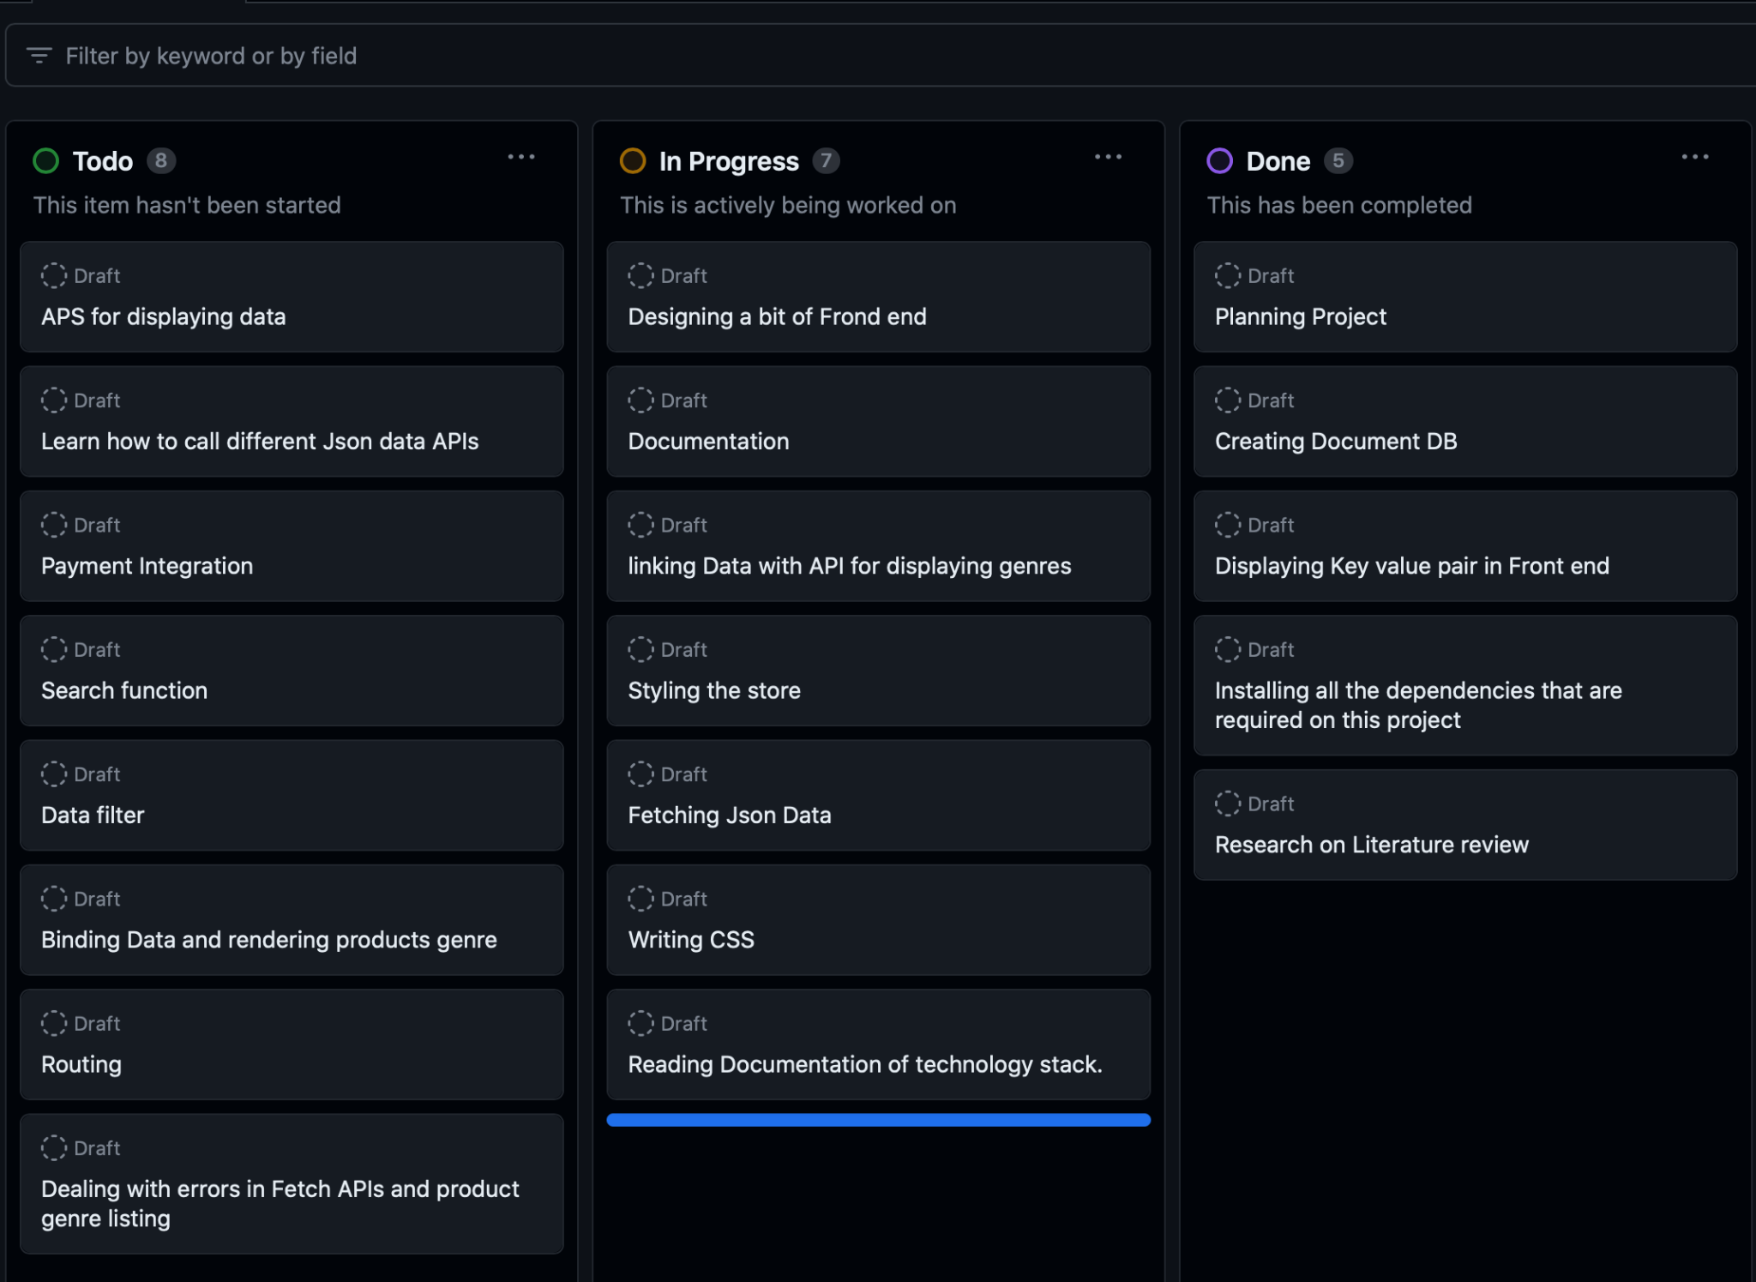

*Figure 1: Kanban Board of E-store*

### **3.1.1. Requirement Identification**

Requirements of the system are identified through personal research of visiting various ecommerce sites.

#### **3.1.1.1. Functional Requirements**

Functional requirements for Kapi e-commerce platform:

1. User registration and login - Users should be able to create an account and log in to the platform to access the full functionality of the site.
2. Product browsing and search - Users should be able to browse and search for products on the platform, with the ability to filter by category, price, and other attributes.
3. Shopping cart and checkout - Users should be able to add items to their cart and proceed to checkout, where they can review their order, choose a shipping method, and make a payment.
4. Payment processing - The platform should support multiple payment options, including digital wallet integration and cash on delivery.
5. Order tracking and management - Users should be able to track the status of their orders and manage them through their account.
6. Product and category management - Admins should be able to add, edit, and delete products and categories, and manage inventory levels.
7. User account management - Users should be able to update their personal and billing information, view previous orders, and change their account settings.
8. Security and privacy - The platform should have proper security measures in place to protect user's personal and financial information.
9. Customizable themes - The platform should have customizable themes so that the website's look and feel can be modified to match the client's preference.
10. Order history - Users should be able to view their order history.
11. Responsive design- The platform should be responsive and compatible with different devices such as Desktop, Tablets and Mobile to provide a seamless user experience.

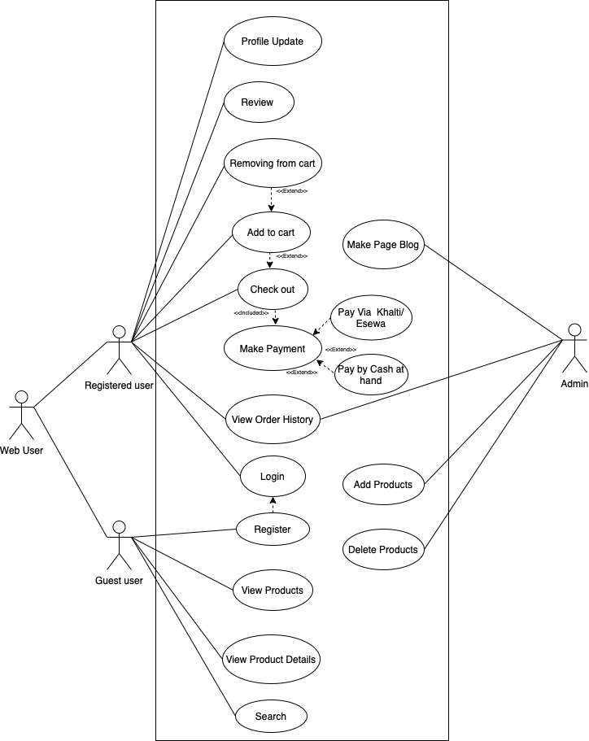

*Figure 2: Use Case Diagram of E-Store*

The use case diagram for e-commerce platforms represents the functionalities and user interactions of the system. It consists of actors such as Customers and Administrators and use cases that describe the different actions that can be performed by the actors, such as searching for products, adding products to cart, checking out, making payments, viewing order history, registering, logging in, and managing copies. The use cases are connected to the actors through relationships, such as a customer being able to search and purchase products, an administrator being able to manage the inventory of copies. The diagram also includes boundaries that define the scope of the system, and extension points to indicate that a specific use case can have additional functionality in certain conditions. The use case diagram effectively conveys the different interactions and functionalities provided by the system and helps to understand the system's behavior and user interactions.

#### **3.1.1.2. Non-Functional Requirements**

Non-Functional requirements for e-commerce platform:

1. Performance - The platform should be able to handle a high number of concurrent users and transactions without any significant degradation in performance.
2. Scalability - The platform should be able to handle an increasing number of users and transactions as the business grows.
3. Availability - The platform should be available 24/7, with minimal downtime for maintenance or updates.
4. Compliance - The platform should adhere to all applicable laws, regulations, and industry standards.
5. Easy to use - The system should be easy to use for both administrators and end-users.
6. Mobile compatibility- The platform should be optimized for mobile devices and have a responsive design to provide a seamless user experience.
7. User experience - The platform should provide a positive user experience, with a clear and intuitive navigation, responsive design and satisfying user interface.

### **3.1.2. Feasibility Study**

A feasibility study assesses the operational, technical, and economic merits of the proposed project. The feasibility study is intended to be a preliminary review of the facts to see if it is worthy of proceeding to the analysis phase. From the systems analyst perspective, the feasibility analysis is the primary tool for recommending whether to proceed to the next phase or to discontinue the project. The feasibility study is a management-oriented activity. The objective of a feasibility study is to find out if an information system project can be done and to suggest possible alternative solutions.

#### **3.1.2.1. Technical Feasibility**

Technical feasibility was the process of determining whether the proposed project or solution could be achieved with the available technology and resources. For making this e-commerce platform, the technical feasibility of the project was evaluated to determine whether the platform could be built and deployed successfully.

In terms of the technical requirements, the e-commerce platform uses the Laravel tech stack which is a popular tech stack for building e-commerce.

Furthermore, the platform also supported multiple payment options including the integration of a digital wallet, Khalti, which is a reliable and secure online payment gateway. This integration allowed for easy and secure transactions which was an important aspect of the e-commerce platform.

In terms of the hardware and software requirements, the platform was built to be compatible with standard web hosting environments and could be deployed on a variety of servers such as Apache or Nginx.

In terms of the team and resources, we had the necessary skills and experience to build and deploy the platform, including proficiency in Laravel. We also had the resources available to ensure the platform was properly maintained and supported over time. Overall, the e-commerce platform had a high degree of technical feasibility, and all necessary technology and resources were available to build and deploy the platform successfully.

#### **3.1.2.2. Operational Feasibility**

Operational feasibility is the process of determining whether a proposed project or solution can be implemented and integrated with the existing business operations and processes. For the e-commerce platform, operational feasibility must be evaluated to determine whether the platform can be integrated and adopted successfully by the target users and customers.

In terms of the target user and customers, readers are the main user group for the e-commerce platform. The platform is designed to cater to their needs and provide a convenient and hassle-free way to purchase copies online. This is something that is greatly needed by the students and is likely to be adopted by a significant number of students.

In terms of the integration with existing business operations, the e-commerce platform is designed to be integrated with the existing supply chain and logistics operations. This will ensure that products are delivered to the customers in a timely and efficient manner. Additionally, the platform is also designed to be easily integrated with the existing financial and accounting systems, which will ensure that financial transactions are handled seamlessly.

In terms of the support and maintenance, the e-commerce platform will be supported by a dedicated developer. This developer will be responsible for ensuring that the platform is running smoothly and addressing any issues that may arise. He will also be responsible for ensuring that the platform is regularly updated and maintained to meet the changing needs of the students and market trends.

Overall, the e-commerce platform has a high degree of operational feasibility, it is designed to cater the readers needs and can be easily integrated with the existing business operations and processes. The platform also has a dedicated developer for its support and maintenance which will ensure the smooth operation and continuously update the platform as per the market trends.

#### **3.1.2.3. Economic Feasibility**

Economic feasibility is the process of determining whether a proposed project or solution is economically viable, in other words, whether the benefits of the project outweigh the costs of its development and operation. For the Kapi e-commerce platform, economic feasibility must be evaluated to determine whether the platform is a financially viable solution.

In terms of development costs, the e-commerce platform is built on Laravel, which is free to use. However, there may be additional costs associated with customizing the platform to match the client's preferences, advertising the site, and any additional features may be added in near future. The platform also requires a web hosting and domain name to operate, which incurs an annual cost. Additionally, there may be costs associated with integrating digital payment options, such as Khalti.

In terms of operational costs, the platform will require ongoing maintenance and support, including regular updates and security patches. There may also be costs associated with the customer service and order fulfillment. However, the platform is expected to generate revenue through sales of products and services, which can offset these costs.

In terms of revenue generation, the platform targets the readers community who are expected to use the platform for purchasing the books online. The platform is designed to provide a wide range of options and have them delivered to their doorstep with just a few clicks. This is expected to attract a significant number of users and generate significant revenue from sales.

Overall, while there are costs associated with developing and operating the e-commerce platform, it is expected to generate revenue through sales and offset these costs. The platform is targeting a large customer base and providing the service, which is greatly needed by them, this makes the platform economically feasible.

#### **3.1.2.4. Schedule Feasibility**

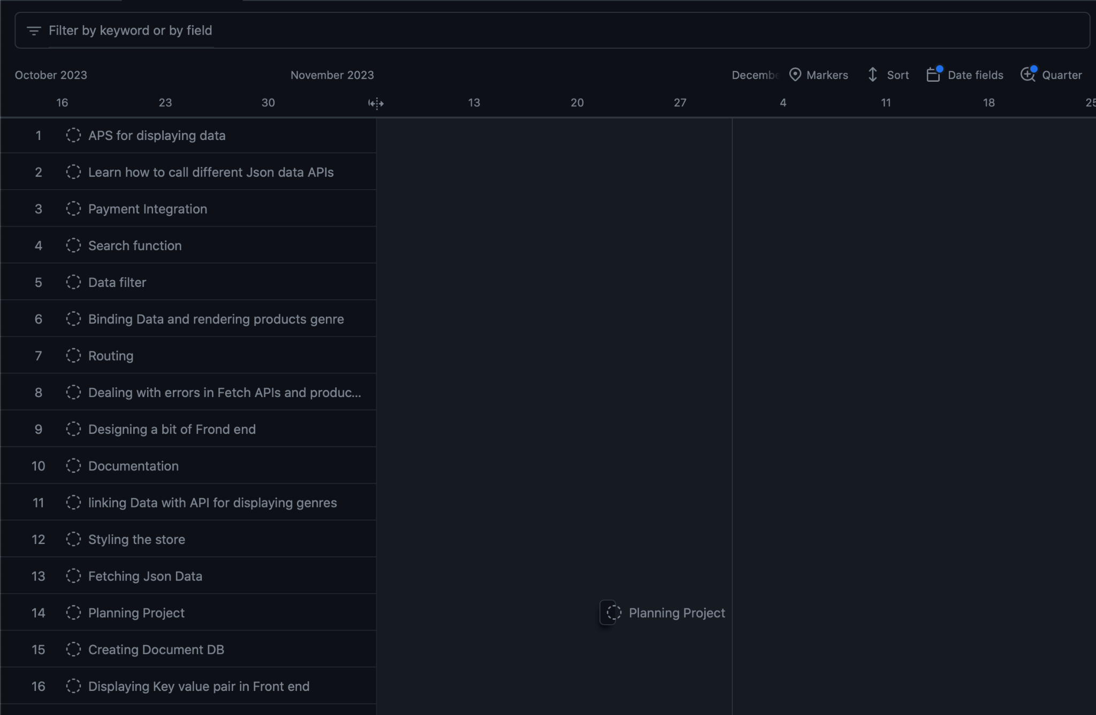

The schedule feasibility of the e-commerce platform was high, utilizing Github and Kanban boards, along with Iterative methodology for project management, careful planning, and regular progress reviews, the project was completed within the available time frame.

### **3.1.3. Data Modeling**

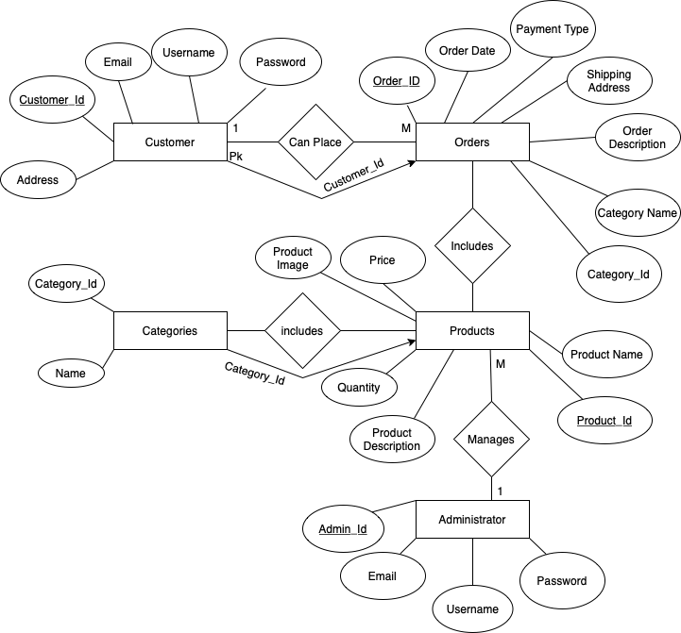

The ER diagram is a visual representation of the entities and relationships that make up the e-commerce platform. It provides a detailed view of the data model and shows how the various entities are connected and related to each other. The main entities in the ER diagram are: Customer, Order, Product, Administrator and Categories. Each of these entities is represented by a rectangle, with the name of the entity and its attributes inside.

The relationships between these entities are represented by lines connecting them, with a cardinality notation on each side. The main relationships that are represented in the ER diagram are:

* A customer can place multiple orders, and an order can be placed by one customer, this is represented by a 1: N relationship between the Customer and Order entities.
* An order can include multiple products, this is represented by a 1: N relationship between the Order and Product entities.
* A Product belongs to a category, this is represented by a 1:1 relationship between the Product and Categories entities.
* One administrator manages multiple products, this is represented by a 1: N relationship between the Administrator and Products entities.

There also exist foreign keys between entities. The major foreign keys in the ER diagram of ABN are:

* Customer_ID becomes the foreign key of the Orders entity.
* Category_ID becomes the foreign key of the Products entity.

### **3.1.4. Process Modeling**

The DFD (Data Flow Diagram) for E-commerce Website describes the overall “flow” of data on the project. It is used to document the transformation of data (input - output) for project development.

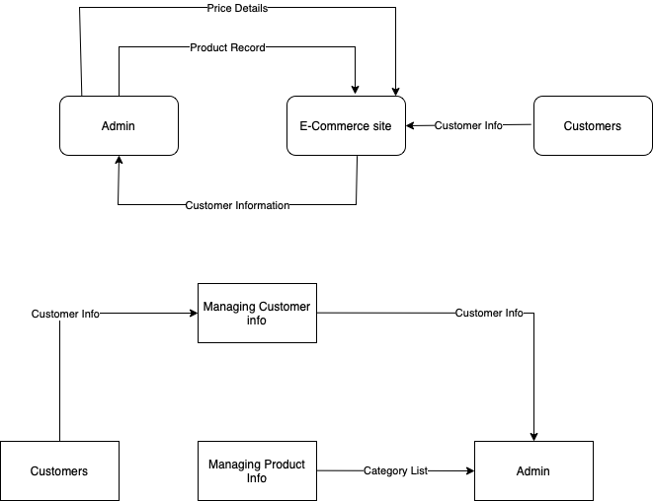

level 0 DFD diagram showing the product record and details of it. It also shows the flow of customer info.

level 1 DFD diagram showing basic inner operations of the system. Admin manages the product information and also manages the customer information.

### **3.1.5. Activity Diagram**

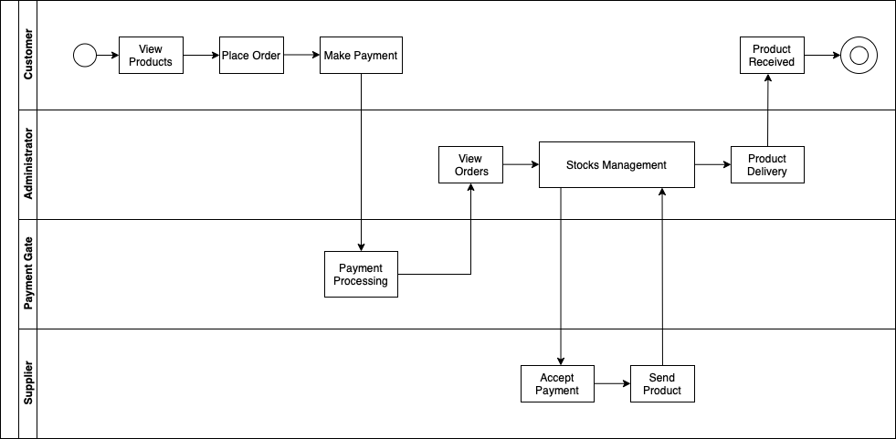

The activity diagram that we've created, it models the flow of activities or actions within the system, it allows us to visualize the coordination of tasks within the system and the flow of control between them. It helps to understand the behavior of the system, to identify potential issues and to communicate the functionality to the stakeholders. The activities represented in the diagram include customer browsing and purchasing the product, payment gateway processing the payment, administrator managing and delivering the product, supplier sending the product and customer receiving the product. It is a valuable tool to help understand how the system works in practice, and how the different actors or roles involved interact with each other.

### **3.1.6. Sequence Diagram**

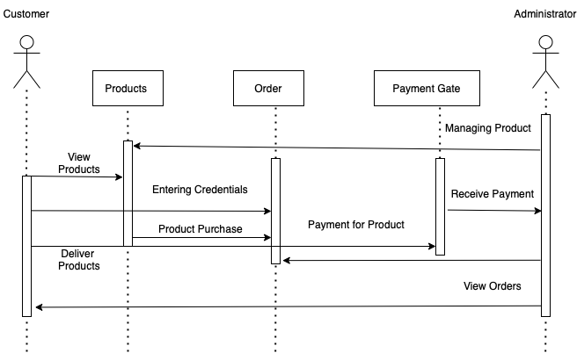

The sequence diagram is a visual representation of the interactions between the main objects or components in the system, such as the customer, administrator, product, order, and payment gateway. It shows the order in which the interactions occur and the messages that are passed between the objects.

The customer initiates the interaction by viewing the available products, then providing their credentials to place an order, and ultimately purchasing the product by making the payment. The payment gateway processes the payment and sends a confirmation to the customer.

On the other hand, the administrator receives the payment, views the placed orders, and manages the products. Then the administrator delivers the ordered products to the customer.

The sequence diagram captures the dynamic behavior of the system, from the customer browsing the available products, to the payment being processed, to the order being fulfilled by the administrator. It also shows the flow of control and data between the objects and helps identify potential issues in the system's behavior.

## **3.2. System Design**

### **3.2.1. Architectural Design**

The three-tier architecture has been used for this project. This architecture is a client- server architecture in which the functional process logic, data access, computer data storage and user interface are developed and maintained as independent modules on separate platforms.



**Figure 3.9: Three-Tier Architecture of E-store**

Three-Tier Architecture has the following layers.

* **Presentation Layer:** Occupies the top level and displays information related to services available on a website. The tier communicates with other tiers by sending results to the browser and other tiers in the network.
* **Application Layer:** Also called the middle tier, logic tier, business logic or logic tier, this tier is pulled from the presentation tier. It controls application functionality by performing detailed processing. It is managed by localhost.
* **Data Layer:** Houses database servers where information is stored and retrieved. Data in this tier is kept independent of application servers or the business logic.

Database we have used here is Mongo database(document db).

Following are the reasons behind choosing three tier-architecture:

* An ability to update the technology stack of one tier, without impacting other areas of the application.
* It makes the logical separation among three different layers.

# **Chapter 4: Implementation and Testing**

## **4.1 Implementation**

### **4.1.1 Tools Used**

Browsers: Brave, Google Chrome, Microsoft Edge.

Platform : Linux, Windows.

Server : Apache Web Server.

### **4.1.2 Implementation Details of Modules**

The modules that are provided are:

**Module 1: Add Products/ Categories**

In this module only admin can add and edit the details of the books and the genre so that users could see it.

**Module 2: Product list**

In this module, the packages that have been added are easily viewed by customers in real time.

**Module 3: Edit the product and categories**

In this module, if the added book and genre information are wrong the admin can easily edit the information that has been wrong.

**Module 4: Delete products and categories**

Here, added products and categories are deleted by the admin from the database if the admin does not want to display that on the website.

**Module 5: View Products**

Here, all the customers can easily view the products that have been added by the admin.

## **4.2 Testing**

*Table 4.1: Test Case for Unit Testing of login and out operation*

| Test case | Steps | results | Status |
| --- | --- | --- | --- |
|  | Enter a valid email and password. Then press the login button. | The user should redirect to the home page. | pass |
|  | Enter invalid email or password. | The user should not be redirected to the home page and stay in the login page until a valid email or password is inserted. | pass |
|  | Do not fill any field. | Alert box will be displayed | pass |
|  | If you do not have any account click on register. | It will display to form a filling page. | pass |
|  | valid information should be filled. | Your account will be created. | pass |
|  | Press signout | Redirected to the index page. | pass |

*Table 4.2: Test case of unit testing for admin*

| Test case | Steps | Results | Status |
| --- | --- | --- | --- |
|  | Log in as an admin | Redirected to dashboard page. | Pass |
|  | Press users panel | Admin can add and delete users. | Pass |
|  | Press products panel | Admin can add,delete,edit and view products. | Pass |
|  | Press orders panel | Admin can process, cancel, complete the order. | Pass |
|  | Press logout | Redirected to the sign in page. | pass |

*Table 4.2.3: Test case for system testing:*

| Test case | Steps | Results | Status |
| --- | --- | --- | --- |
|  | Login with valid email and password | User is directed to the home page and can use all the features. | Pass |
|  | Press on home panel | Can view the sorts of available features. | Pass |
|  | Click on shop | Can see the list of available products and its details | Pass |
|  | Click on search | Can search products | pass |
|  | Click on add to cart | Can buy products by adding to the cart | pass |

# **Chapter 5: Conclusion**

## **5.1 Lesson learnt/outcome:**

From this project we learned about website builder and its plugins that are used in order to create a web application. Different ways to manage a project and backup all the codes to a cloud storage. With each different project we learn different languages, frameworks and the technology required to build each project.

## **5.2 Conclusion**

This project is made in order to learn eCommerce which is very trendy in the modern terms as every business is going online. This project is expected to deliver a high performance website with attractive and easy to use UI.This project will meet all of its objectives as well as address the shortcomings that has been observed in most of the Ecommerce sites.

## **5.3 Future Recommendations**

The project will be upgraded and extended in the following features:

* Suggest product with highest number of searches.
* Project Deployment.
* Search bar and filter in outcome.
* Payment system integration.

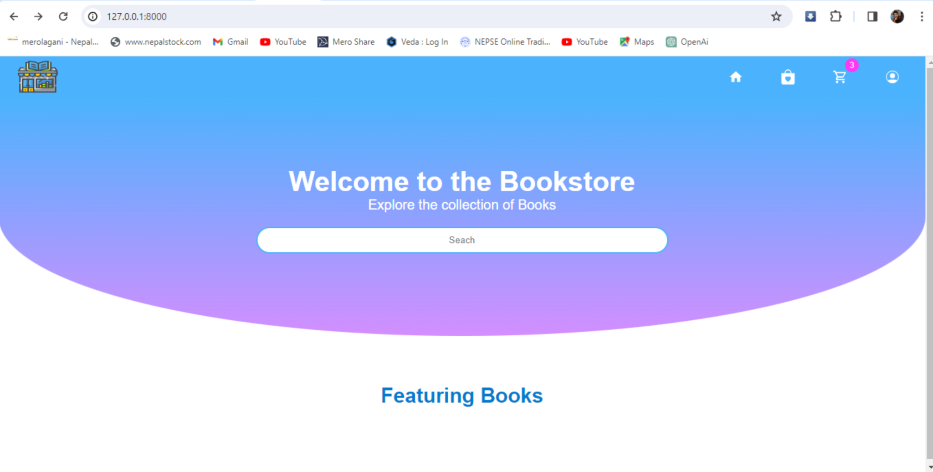

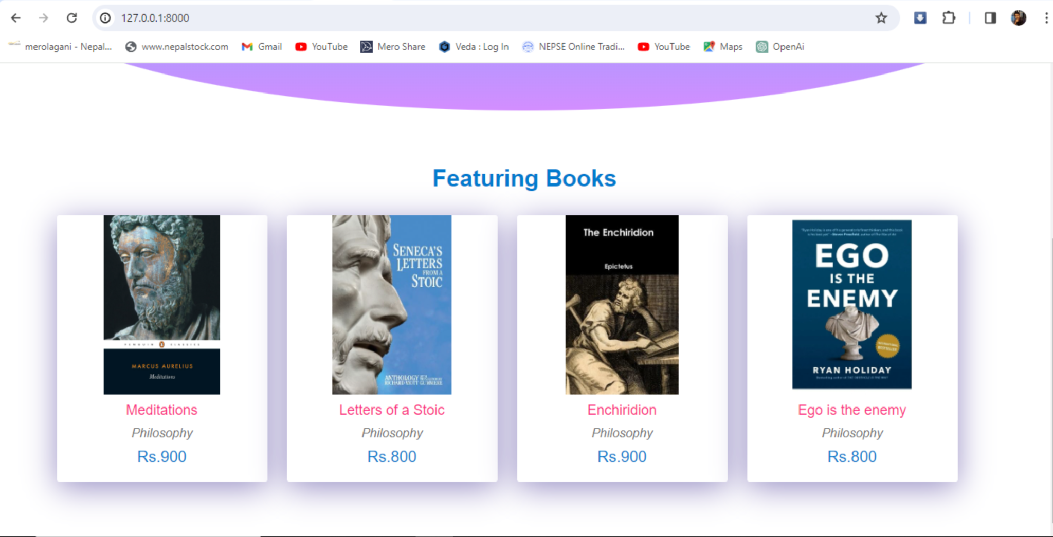

Figure : Displaying Books

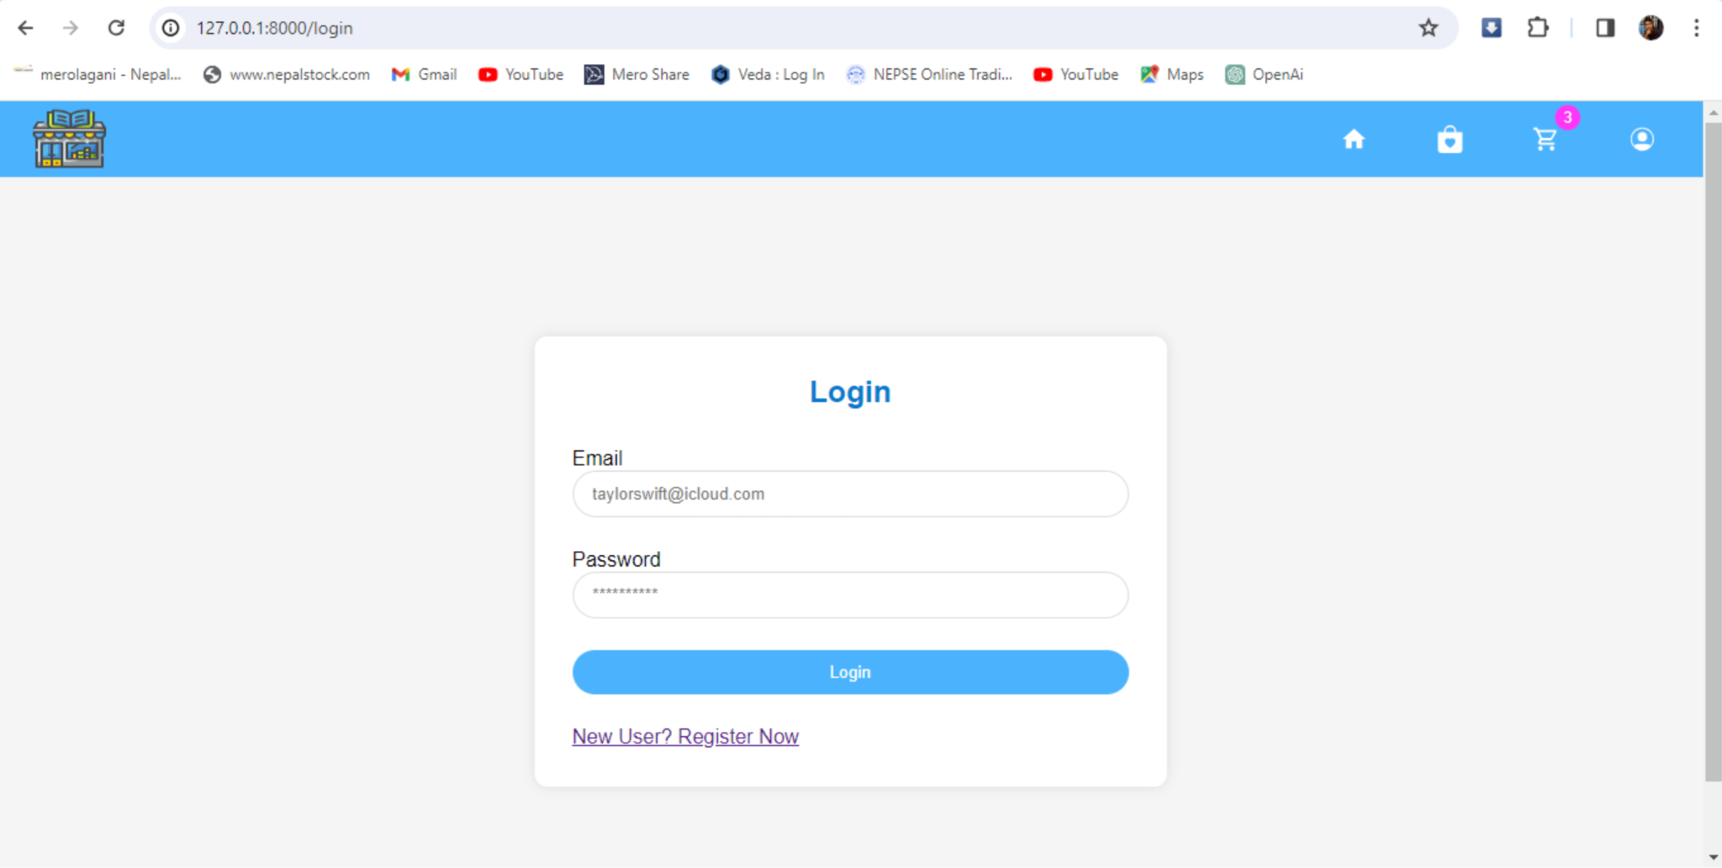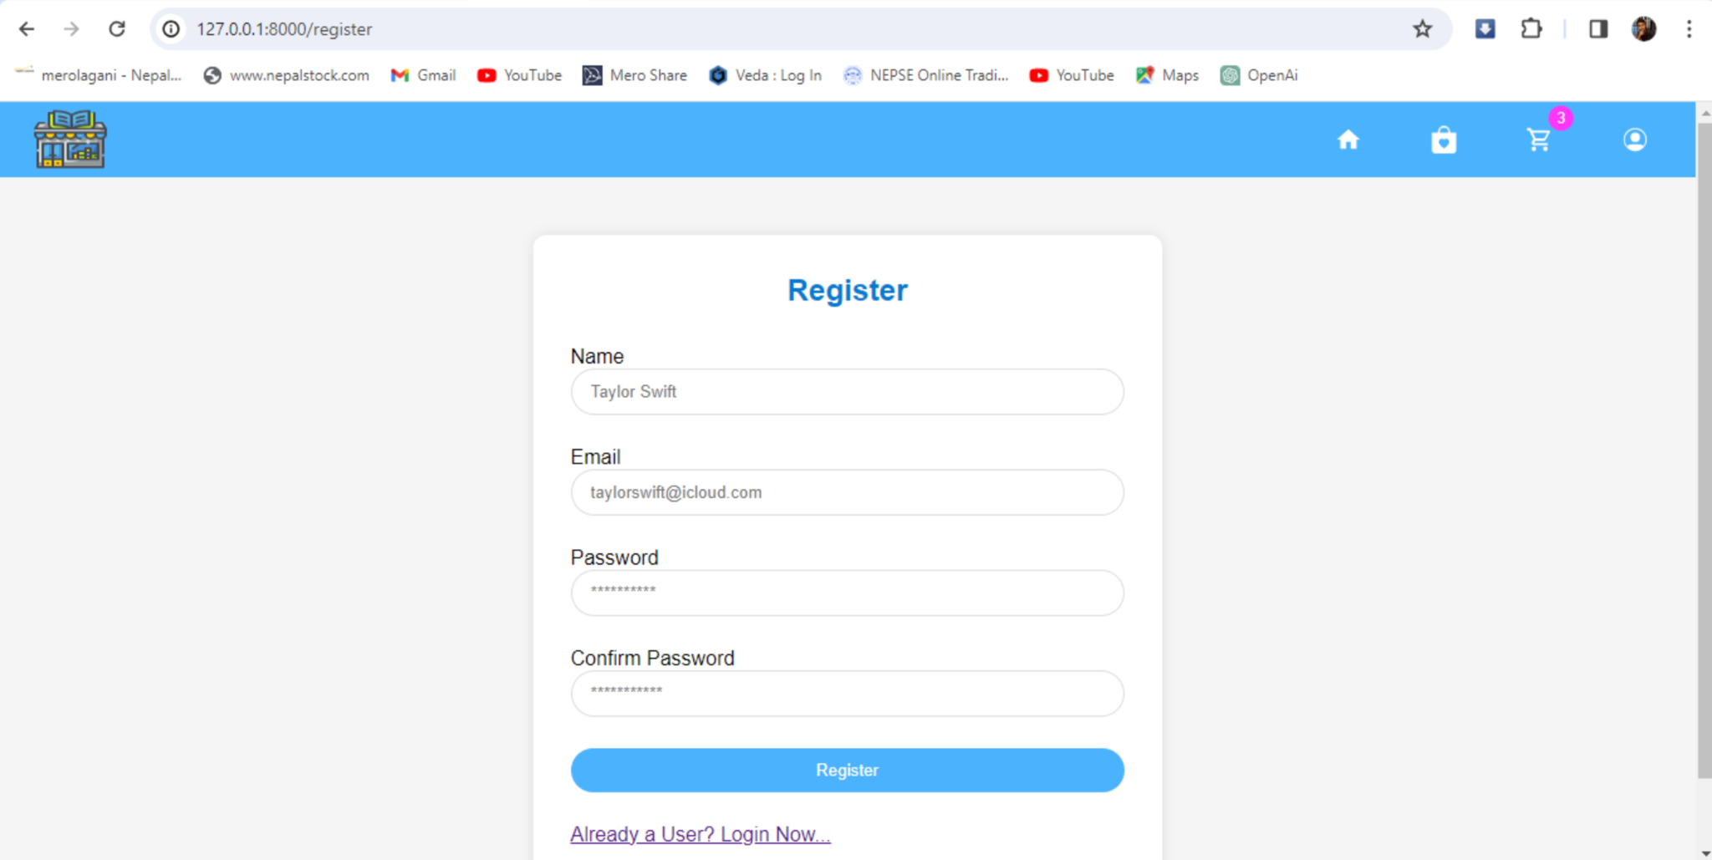

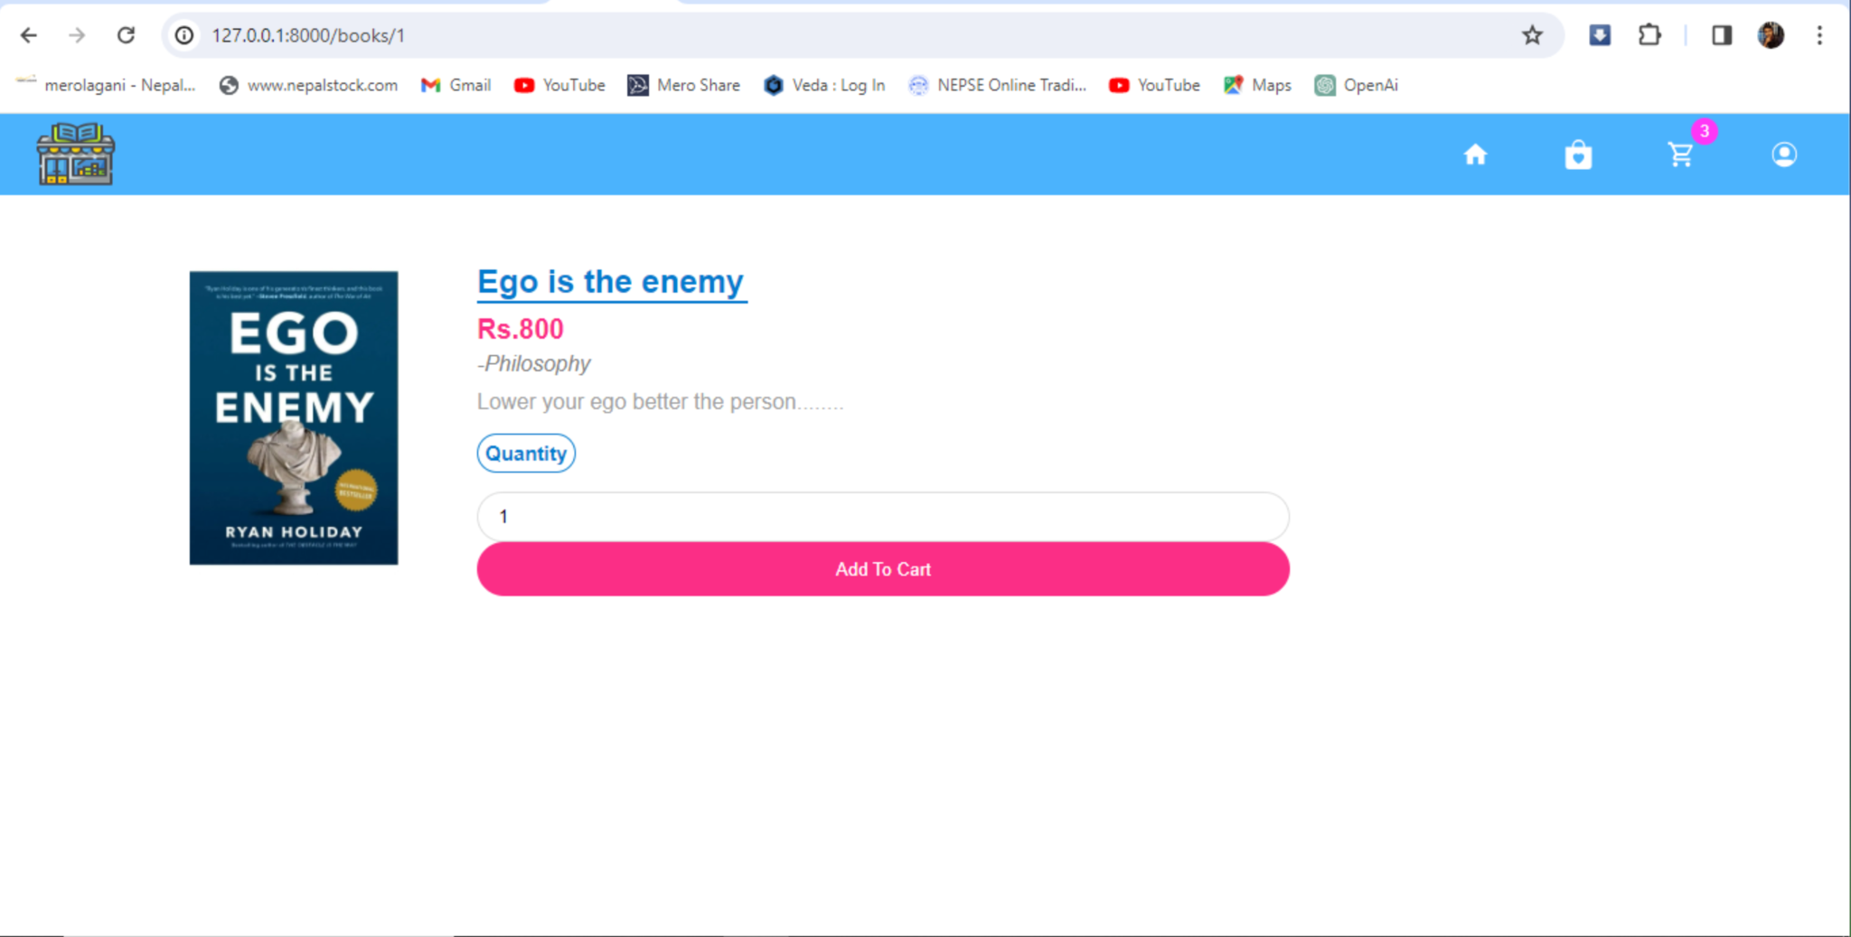

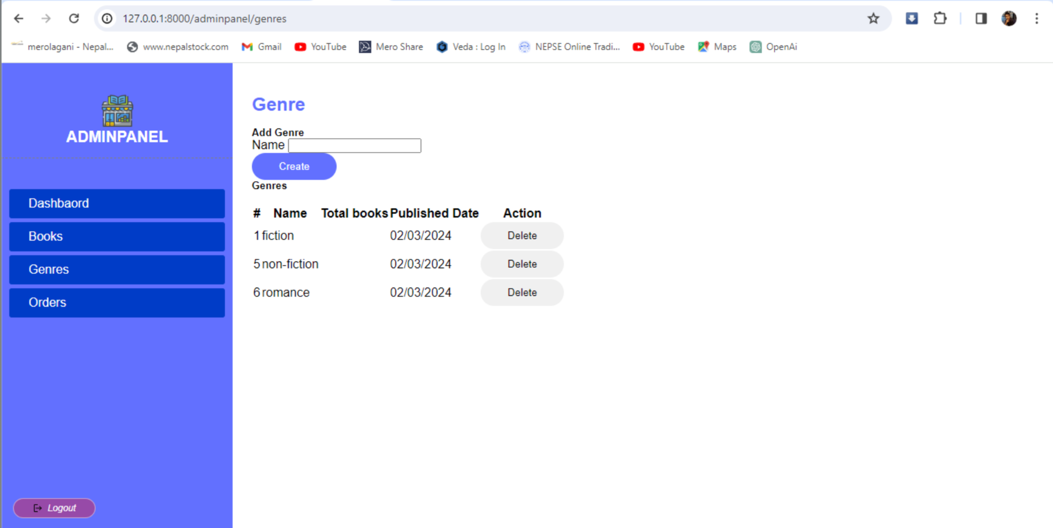

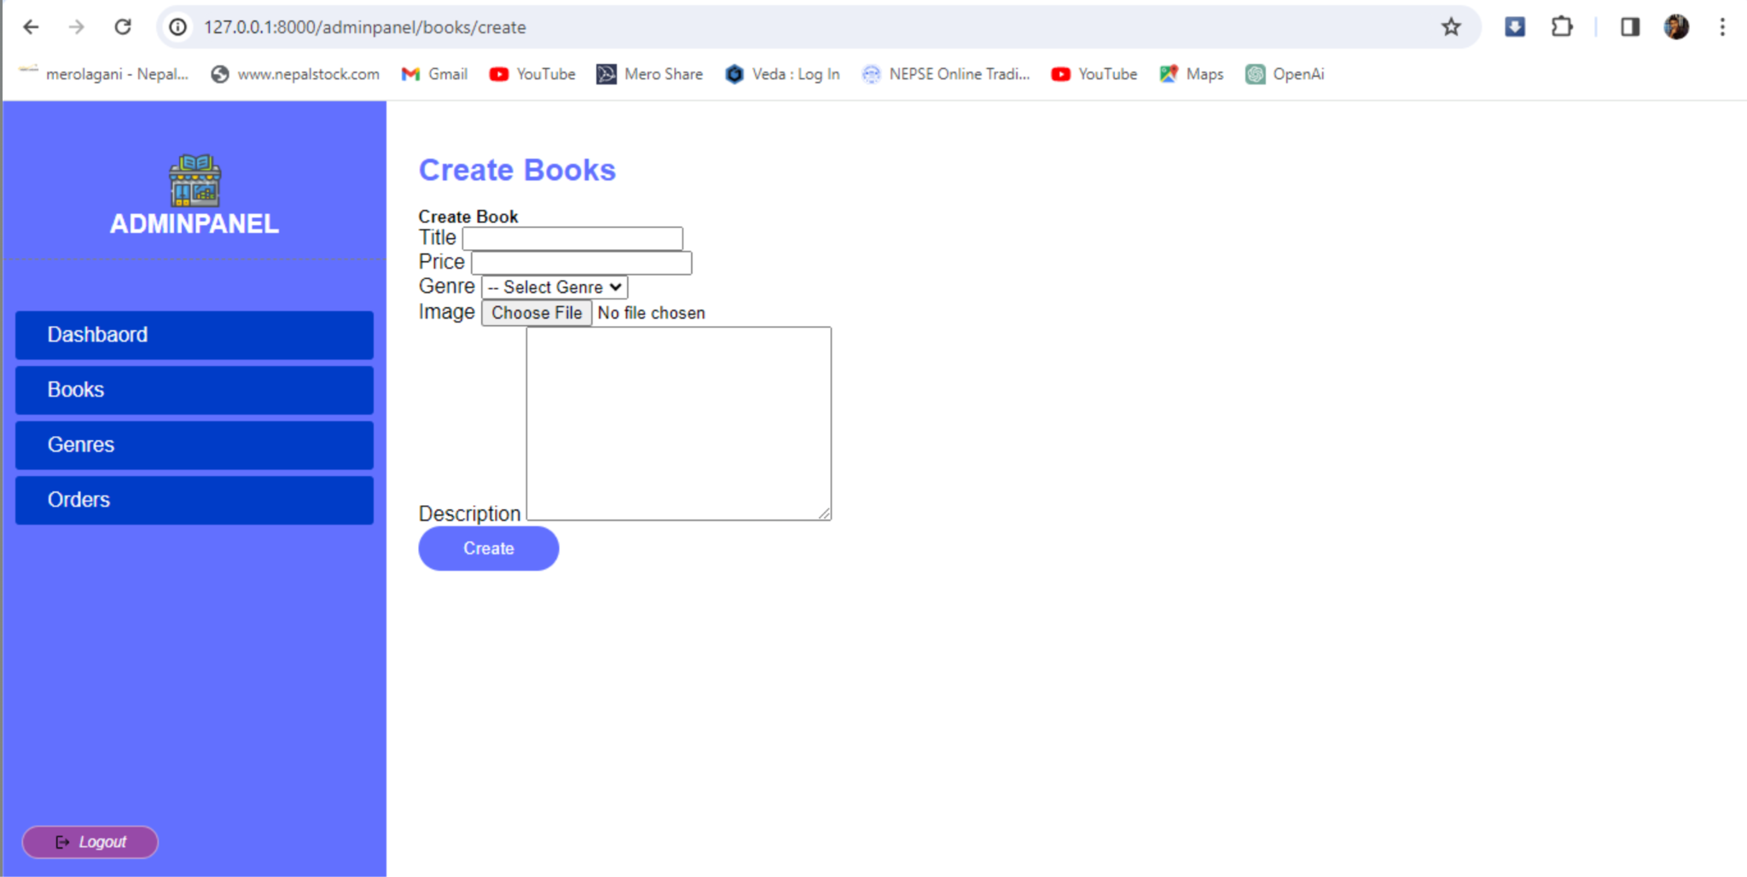

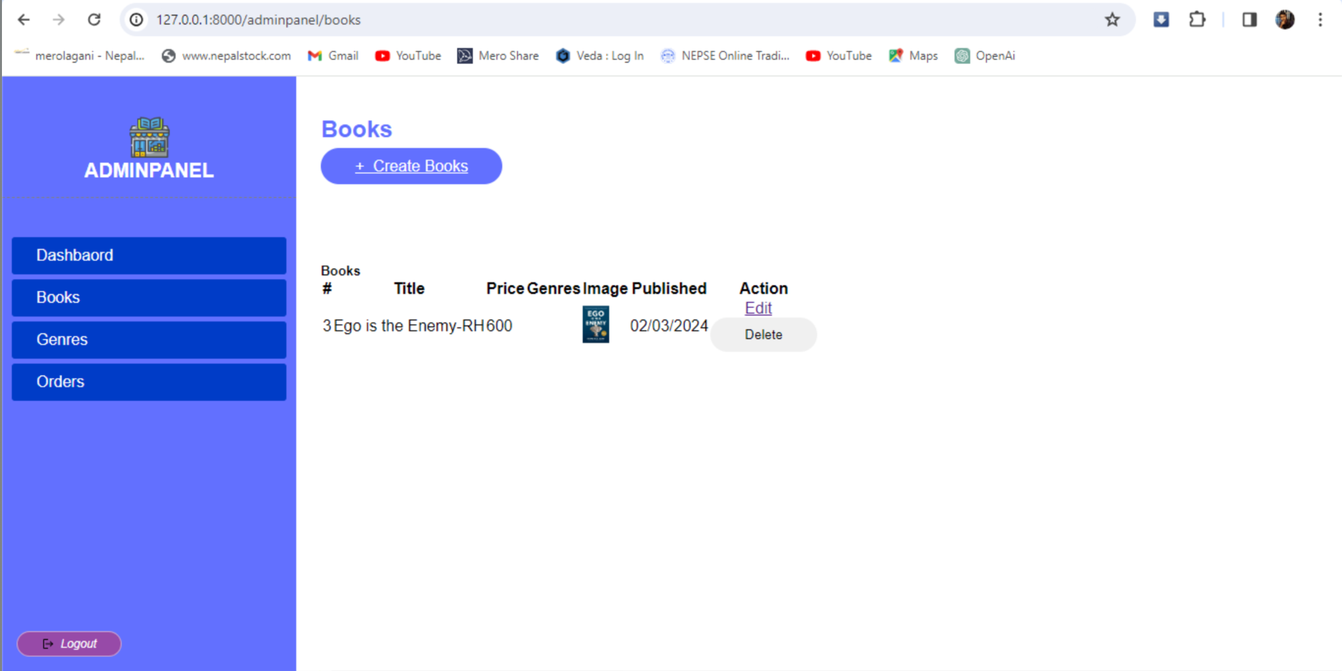

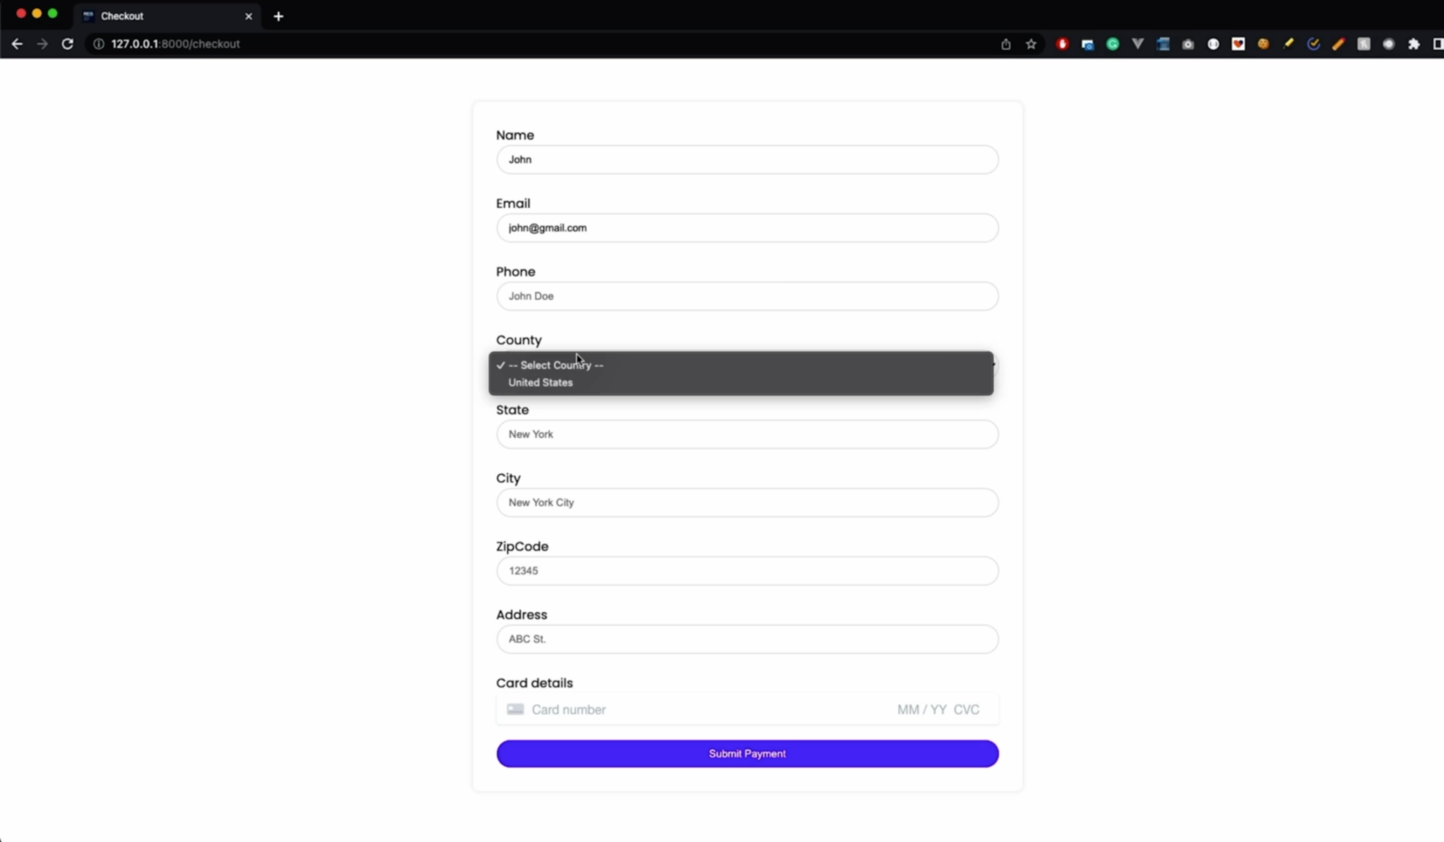

# **References**

[1] *Books Mandala: Buy Books Online in Nepal | Worldwide Shipping*. (n.d.). Booksmandala. https://booksmandala.com/en