**Table of Contents**

1. Introduction 2

1.1 Project Overview 2

1.2 Purpose 2

1.3 Literature Review 3

1.4 Feature: 4

1.5 Objectives: 4

2. System Requirement and Methodology 5

2.1 Hardware Requirements: 5

2.2 Software Requirements: 5

2.3 Python Libraries: 5

3. System Design 6

3.1 System Methodology 6

3.2 Algorithm: 8

3.4 Cosine Similarity: 9

3.3 Flow Diagram 10

3.5 Gantt Chart 11

3.6 Use-case Diagram 12

Conclusion 13

Future Scope 13

SOURCE CODE 14

## 1. Introduction

The **Book Recommender System** is a web-based application designed to help users find new books based on the preferences of other users. The system uses a collaborative filtering approach, where it analyzes user ratings to recommend books that similar users have enjoyed. Instead of looking at the content of the books, the system focuses on the patterns of user behavior to suggest books that are likely to match a user's tastes.

### 1.1 Project Overview

The system is built on preprocessed datasets that contain book information, user ratings, and computed similarity scores between books. When a user enters the name of a book they enjoy, the algorithm scans the similarity scores to recommend books that other users with similar tastes have scored highly. This project is developed with Python and the Flask web framework, with data handled via precomputed pickle files. The user interface is easy to use, allowing users to quickly search for books and view popular titles. By focusing on collaborative filtering, the Book Recommender System successfully assists users in discovering new books by using shared user preferences.

### 1.2 Purpose

The Book Recommender System is intended to help users find new books by recognizing and recommending titles that have been appreciated by others with similar interests. The technology uses collaborative filtering, which means it looks at user ratings and behaviors to produce personalized book recommendations. Unlike content-based systems, which rely on book categories or extensive descriptions, this method focuses solely on identifying patterns in user preferences and interactions. This allows the algorithm to make recommendations even when users have a limited interaction history, without having detailed information about the books themselves.  
  
The system's purpose is to make book selection easier and faster for users, allowing them to discover new books that match their reading preferences. By assessing ratings provided by users with similar habits, the system may successfully identify books that are likely to appeal to each individual. Whether readers are looking for something similar to their favorite titles or want to broaden their reading horizons, the Book Recommender System offers suitable suggestions based on their interests. As a result, it improves the reading experience by reducing the effort required to discover new books and boosting the likelihood that users will encounter novels they really appreciate.

### 1.3 Literature Review

In many digital platforms, recommendation systems are now essential tools that assist users in finding content that suits their interests. These systems are frequently used in social media, streaming services, and e-commerce, among other sectors. Although there are many other kinds of recommendation systems, collaborative filtering, and content-based filtering are two of the most widely utilized strategies.

1. **Collaborative Filtering:** Collaborative filtering is a method that suggests products to users by analyzing their actions and preferences in relation to one another. Patterns in user interaction data, like ratings or purchase histories, are the basis of this strategy rather than the objects' content or features. One of the first models of collaborative filtering, the GroupLens system was presented by Resnick et al. (1994). It used the preferences of people with similar tendencies to speculate on what users would like. Many recommendation systems, especially in the retail and media streaming industries, now rely on collaborative filtering. Collaboration filtering can be broadly classified into two categories: user-based and item-based. Collaborative filtering based on user activity identifies users who have shown interest in the same things and makes product recommendations accordingly.
2. **Hybrid Recommendation Systems:** Many times, content-based filtering or collaborative filtering has restrictions. When new users or products lack enough interaction data to generate correct recommendations, collaborative filtering may find difficulty with the cold-start issue. Conversely, content-based systems may be unduly limited by merely suggesting products like those the user has already consumed. Combining the qualities of both methods, hybrid recommendation systems help to solve these problems. In order to get beyond their respective constraints, Burke (2002) explored several ways for merging content-based approaches with collaborative filtering. These hybrid models have shown in suggestions better relevance and accuracy. For example, Netflix employs a hybrid recommendation system combining collaborative filtering with other elements including user behavior, item qualities, and implicit feedback.

In the context of book recommendation systems, collaborative filtering has been widely used. **Koren et al. (2009)** demonstrated how collaborative filtering could be adapted for large-scale datasets, such as those used in e-commerce and media platforms. The **Amazon** book recommendation system is a notable example, using collaborative filtering to suggest books based on user ratings and purchase history. This approach has proven to be effective in promoting user engagement and increasing sales.

### 1.4 Feature:

1. **User-Based Recommendations**: The system recommends books based on their ratings and preferences. It detects books that have received high ratings from individuals with similar reading patterns, allowing them to discover new titles that they may love.
2. **Popular Book Display**: The system has a function that displays popular books based on total user ratings. This allows users to discover books that have been well received by the community.
3. **Preprocessed Data Usage**: The project employs precomputed similarity scores and book data stored in pickle files. This guarantees that recommendations are provided fast, hence increasing the system's efficiency and user experience.
4. **Collaborative Filtering Methodology**: The system recommends books based on user behavior and preferences rather than the books' content or category.
5. **Web-Based Interface**: The system is implemented as a Flask web application, with a straightforward and user-friendly interface. An easy-to-navigate interface allows users to browse for books, view recommendations, and discover popular titles.
6. **Scalability**: The system may be expanded to accommodate larger databases of books, users, and ratings. With minimal changes, it may incorporate additional data, such as user input, and improve the recommendation system.

### 1.5 Objectives:

1. **Develop a Personalized Recommendation Engine**: The primary objective is to provide book recommendations based on users' preferences using collaborative filtering and machine learning techniques.
2. **Enhance User Experience**: The system aims to enhance the user experience by suggesting books that are popular or aligned with the user's past interests.
3. **Data Analysis**: Analyze user data (ratings, interactions) to build a recommendation model that delivers accurate and reliable suggestions.

## 2. System Requirement and Methodology

The **Book Recommender System** requires a basic setup to run effectively. It is compatible with most modern operating systems, including Windows, macOS, and Linux. A minimum of 4 GB of RAM is recommended to ensure smooth operation, though 8 GB would provide better performance.

2.1 Hardware Requirements:

* **Processor:** Minimum 1 GHz or Higher
* **Memory:** Minimum 4GB (8GB for better performance)
* **Storage**: Minimum 2 GB of available disk space
* **Display**: 1024 x 768 resolution or higher

2.2 Software Requirements:

* **Operating System**:
  + Windows 10 or later
  + macOS 10.12 or later
  + Linux distributions such as Ubuntu 18.04 or later
* **Python Version**: Python 3.x (preferably Python 3.7 or later)
* **Web Browser**:
  + Google Chrome (latest version)
  + Mozilla Firefox (latest version)
  + Microsoft Edge (latest version)

2.3 Python Libraries:

* **NumPy**: For numerical operations and handling arrays.
* **Flask**:Web framework for building the application.
* **Pandas**: For data manipulation and management.
* **Scikit-learn**: For machine learning algorithms like cosine similarity.
* **Pickle**: For loading preprocessed data files (popular books, similarity scores, etc.).

**Additional Requirements:**

* **Internet Connection:** Required to download dependencies and for future updates.
* **IDE/Text Editor:**
  + VS Code (Visual Studio Code)
  + PyCharm
* **Git:** Version control system to clone the repository and manage changes.

## 3. System Design

### 3.1 System Methodology

The development of Book Recommender System followed the Agile development process model. Here's how the iterative model phases were implemented:

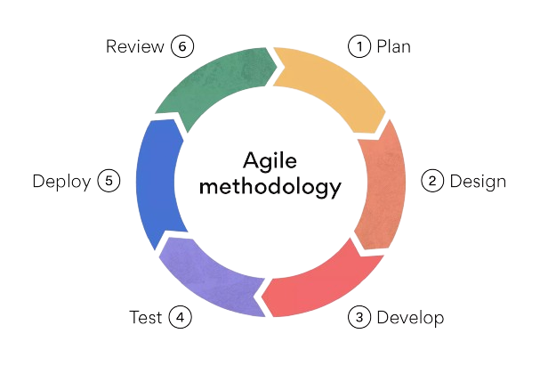

Plan: This stage involves outlining the project scope, defining objectives, and creating a prioritized backlog of features and tasks. In Agile, planning is typically done in short increments, such as during sprint planning meetings in Scrum. The team collaboratively selects items from the backlog to work on in the upcoming iteration, considering factors like customer priorities and team capacity.

Design: Once the team has a clear understanding of what needs to be done, they move into the design phase. Design in Agile is often done incrementally, with a focus on creating simple, flexible solutions that can evolve over time. Rather than creating detailed upfront designs, Agile teams may use techniques like user stories, wireframes, and prototypes to guide their development efforts.

Develop: In this stage, developers write the code to implement the features and functionality outlined in the plan and design phases. Agile development emphasizes collaboration and communication within cross-functional teams, with developers, designers, testers, and other stakeholders working together to deliver working software increments.

Test: Testing is an integral part of Agile development and occurs throughout the development process, not just at the end. Agile teams often use practices like Test-Driven Development (TDD) or Behavior-Driven Development (BDD) to ensure that code is thoroughly tested and meets the specified requirements. Automated testing is also common in Agile projects to enable rapid feedback and continuous integration.

Deploy: Once the features are developed and tested, they are deployed to a staging environment for further validation and integration testing. Continuous Deployment (CD) and Continuous Integration (CI) practices are often used in Agile projects to automate the deployment process and ensure that new code is quickly and safely released to production.

Review: After deployment, the team conducts a review or demo to showcase the completed work to stakeholders and gather feedback. This review provides an opportunity to validate that the features meet the customer's expectations and identify any necessary adjustments or improvements.

### 3.2 **Algorithm:**

1. Start
2. Access System:
   1. User opens the web application in their browser.
   2. The homepage is loaded, displaying popular books and a search bar.
3. User Searches for a Book:
   1. Input Search Query:
      1. User types a book name into the search bar.
      2. As the user types, real-time search suggestions appear based on the query.
   2. Select from Suggestions :
      1. User clicks on one of the real-time suggestions, which fills the search bar with the selected book title.
   3. Submit Search:
      1. User presses the search button to submit the query.
4. System Provides Recommendations:
   1. Book Found:
      1. The system finds the searched book in its database.
      2. The system displays a carousel of recommended books similar to the searched book.
      3. User can browse through the recommended books by clicking on the carousel navigation buttons.
   2. Book Not Found:
      1. If the system cannot find the searched book, it displays a message saying "No books found related to [searched_book_name]."
5. Explore Popular Books:
   1. User scrolls down to explore the popular books section.
   2. The system initially displays 20 popular books.
   3. Show More Books:
      1. User clicks the "Show More" button to load and display additional books.
6. END

### 3.4 Cosine Similarity:

Cosine similarity is a metric used to measure how similar two vectors are in a multidimensional space. It is commonly used in text analysis and recommendation systems to determine the similarity between items such as books, documents, or users based on their features.

* **How Cosine Similarity Works**: Cosine similarity measures the cosine of the angle between two non-zero vectors in a multidimensional space. The cosine of 0° is 1, indicating perfect similarity, while the cosine of 90° is 0, indicating no similarity.

**Implementation in the Project**:

1. **Vectorization of Data**: The recommendation system starts by converting the data into a matrix form in which every row denotes a book and every column denotes a feature, say user ratings, genres, or other pertinent information. Comparatively between books, this matrix—often referred to as a utility matrix or pivot table—is indispensable. Every element in this matrix represents the degree of association a given feature has with a given book.
2. **Cosine Similarity Calculation**: The system uses cosine similarity—a metric that calculates the cosine of the angle between two non-zero vectors in a multidimensional space—to gauge book similarity. In this regard, every vector stands for a book, and the cosine similarity score shows, from their individual features, how similar the two books are.
3. **Recommendation Generation**: When a user selects or searches for a specific book, the system utilizes the similarity matrix to identify other books that are most similar to the selected book based on their cosine similarity scores. These recommendations are then presented to the user, helping them discover books that are closely related to the one they are interested in.

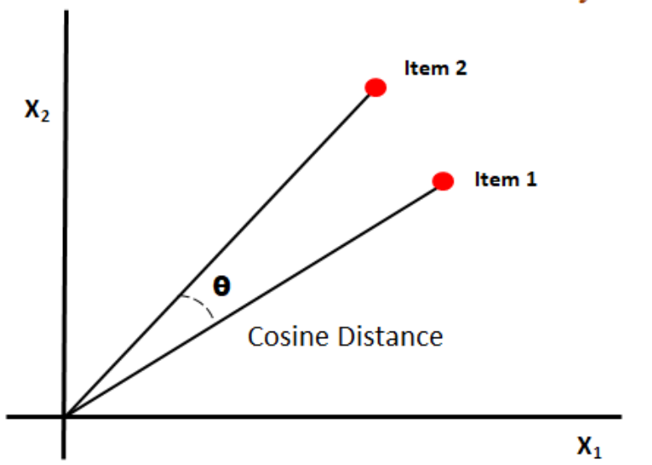

Fig: Cosine Similarity

### 3.3 Flow Diagram

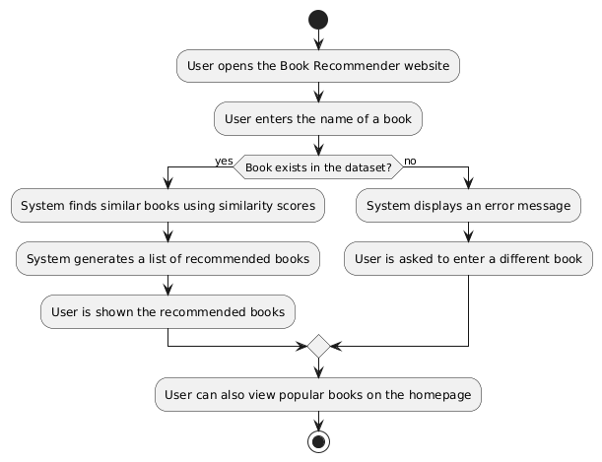

### 3.5 Gantt Chart

### 3.6 Use-case Diagram

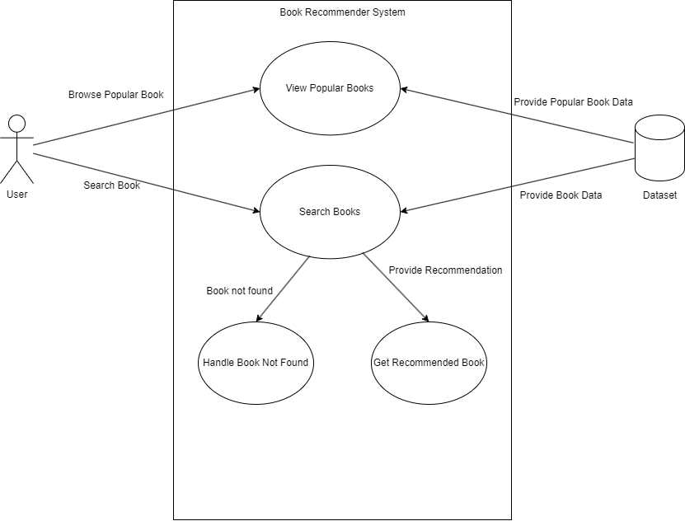

## Conclusion

The Book Recommendation System shows how well machine learning methods may offer consumers tailored recommendations. The system analyzes user preferences, ratings, and patterns using cooperative filtering and perhaps content-based techniques to propose books that fit certain tastes. This work emphasizes on building strong recommendation engines the need of data preparation, model selection, and fine-tuning.

The system is adaptable, which enables additional improvements as using deep learning techniques or increasing to bigger datasets for better accuracy. With modest tweaks, this project might also be expanded for usage in practical contexts as digital libraries, book retail stores, or interaction with e-commerce systems.

All things considered, the Book Recommendation System provides a strong basis for comprehending and implementing machine learning in the domain of recommendation systems. It provides insightful analysis of user behavior and shows how clever automation may produce interesting, customized user experiences.

## Future Scope

* **Scalability**: Enhance the system to handle a larger dataset and more complex recommendation models, potentially incorporating deep learning.
* **Real-time Recommendations:** Introduce real-time data processing and instant recommendations based on recent user behavior.
* **User Profile Customization**: Allow users to refine their preferences by customizing profiles with additional genres, ratings, and feedback.
* **Integration with APIs**: Integrate external data sources such as Goodreads or Google Books API to expand the variety of books available for recommendation.
* **Improved Algorithms**: Experiment with hybrid algorithms that combine collaborative filtering with content-based filtering for more accurate recommendations.

## SOURCE CODE

We are pleased to inform you that the complete source code for the Book Recommender System is available on GitHub. This open-source approach allows developers, users, and contributors to access, review, and collaborate on the codebase.

**GitHub Repository**

The GitHub repository for the File Transfer System can be found at the following URL: **https://github.com/RohanMishra101/Book-Recommendation-System**

**Accessing the Source Code**

To access the source code, please follow these steps:

1. Visit the Repository: Click on the provided link to access the GitHub repository.
2. Fork the Repository: If you would like to make contributions or modifications to the code, consider forking the repository. This creates a copy of the repository under your GitHub account, which you can freely modify.
3. Clone the Repository: To obtain a local copy of the source code on your computer, you can clone the repository using Git. Use the following command:

*git clone*

1. Explore the Code: Once you have the code locally, you can explore the files, review the documentation, and make changes as needed.