# Table of Content

**Table of Content**

**1. Introduction: [Project Name]** **1**

1.1 Objectives 2

**2. Future of the Project** **3**

**3. Why this Topic “[Project Name]”** **4**

**4. Methodology** **5**

**5. Giant Chatt** **7**

**6. System Analysis** **11**

6.1 Problems 11

6.2 Requirement and Solution 11

**7. System Design** **12**

7.1 Algorithm 12

7.2 Flowchart 12

7.3 Data Flow Diagram 12

7.3.1 Level-0 12

7.3.2 Level-1 12

7.4 Use-case diagram 13

7.5 ER diagram 14

**8. Hardware and Software Requirement** **15**

8.1 Hardware Requirement 15

8.2 Software Requirement 15

**9. Conclusion/Suggestion** **16**

**10. Annex** **17**

10.1 Screenshots 17

**11. References** **18**

# 

# 1. Introduction: [Project Name]

[Project Name] is a [mobile/web based application?] which helps users [To do what action?]. [What is the aim of the project?].

 This application is developed by using [Programming Language/Framework was used?] as its backend and [Which Database was used?] as its database. It is an easy and time-efficient way of storing and retrieving recorded data. These data can be easily accessed from the server through this app from any location with the internet.

It is based on GUI (Graphical User Interface) so it is easy to use. Here the database is centralized in the server where all members can access their data through this application. Anyone with internet access can access it.

## **1.1 Objectives**

The main objectives of the [Project Name] are as follows:

1. [What are the main objectives of your project].

The general objectives of the [Project Name] are as follows:

1. [What are the general objectives of your project].

# 

# 2. Future of the Project

In the future, the improved version of this [mobile/web based application?] will allow much more accessibility to the users, further simplifying and speeding up the process to save important time. The project right now is a simpler version so it lacks advanced features and is limited in some aspects.

These drawbacks will be added in the future to make this[mobile/web based application?] more efficient and effective.

Some of the future implementations of this [mobile/web based application?] are as follows:

1. [What features will be added in the future?].

# 

# 3. Why this Topic “[Project Name]”

The title is suitable for this project because [Why you decided to choose this application? Some of the questions to be answered are: Why this name?, how it is related to the application work?].

The system features as are as follows:

1. [What does your current application do?]

# 4. Methodology

To develop this application, we used the prototype model.

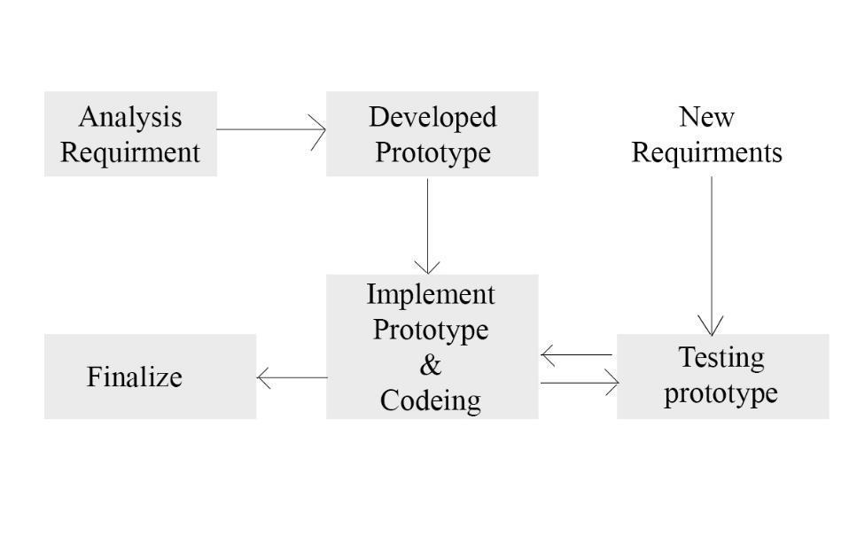

Steps:

1. Analyze Requirement: Analyzing various needs and requirements of the users and with system requirements to operate smoothly.
2. Feasibility Study: Assessment of the practicality of a proposed plan or method.
3. Design and develop prototype: Physical representation used to illustrate and verify aspects of conceptual design as part of the development process.
4. Starting coding, testing and debugging: Debugging is a cyclic activity involving execution testing and code correction. Debugging identifying a problem when bug/error occurs.
5. Finalize project**:** A finished form of project.

# 

# 5. Gant Chart (Project Development Timeline)

This project required about 4 months to be completed. The all-time period required for this project for the different task are shown in the table below:

**1st Month**

|  |  |  |  |  |  |
| --- | --- | --- | --- | --- | --- |
| **S.N** | **Jobs** | **1st week** | **2nd week** | **3rd week** | **4th week** |
| **1.** | **Analysis** |  |  |  |  |
| **2.** | **Design** |  |  |  |  |
| **3.** | **Coding** |  |  |  |  |
| **4.** | **Testing and debugging** |  |  |  |  |
| **5.** | **Implementation** |  |  |  |  |
| **6.** | **Maintenance** |  |  |  |  |

**2nd Month**

|  |  |  |  |  |  |
| --- | --- | --- | --- | --- | --- |
| **S.N** | **Jobs** | **1st week** | **2nd week** | **3rd week** | **4th week** |
| **1.** | **Analysis** |  |  |  |  |
| **2.** | **Design** |  |  |  |  |
| **3.** | **Coding** |  |  |  |  |
| **4.** | **Testing and debugging** |  |  |  |  |
| **5.** | **Implementation** |  |  |  |  |
| **6.** | **Maintenance** |  |  |  |  |

**3rd Month**

|  |  |  |  |  |  |
| --- | --- | --- | --- | --- | --- |
| **S.N** | **Jobs** | **1st week** | **2nd week** | **3rd week** | **4th week** |
| **1.** | **Analysis** |  |  |  |  |
| **2.** | **Design** |  |  |  |  |
| **3.** | **Coding** |  |  |  |  |
| **4.** | **Testing and debugging** |  |  |  |  |
| **5.** | **Implementation** |  |  |  |  |
| **6.** | **Maintenance** |  |  |  |  |

**4th Month**

|  |  |  |  |  |  |
| --- | --- | --- | --- | --- | --- |
| **S.N** | **Jobs** | **1st week** | **2nd week** | **3rd week** | **4th week** |
| **1.** | **Analysis** |  |  |  |  |
| **2.** | **Design** |  |  |  |  |
| **3.** | **Coding** |  |  |  |  |
| **4.** | **Testing and debugging** |  |  |  |  |
| **5.** | **Implementation** |  |  |  |  |
| **6.** | **Maintenance** |  |  |  |  |

# 

# 6. System Analysis

## **6.1 Problems**

1. [define what problem users are facing].

## 6.2 **Requirement and Solution**

1. [define how your software is the solution to those problems]

# 7. System Design

The design of an information system produces the details that clearly describe how a system will meet the requirements, identified during system analysis.

## **7.1 Algorithm**

## **7.2 Flowchart**

## **7.3 Data Flow Diagram**

### **7.3.1 Level-0**

### **7.3.2 Level-1**

## 

## **7.4 Use-case diagram**

## **7.5 ER diagram**

# 

# 

# 8. Hardware and Software Requirement

## **8.1 Hardware Requirement**

The Hardware required for proper operation of this application are as follows:

1. [Search for the minimum hardware requirement and write it]

## **8.2 Software Requirement**

The software required for the operation of this application are as follows:

1. Android (Linux).
2. iOS (Apple’s Operating System)
3. PostgreSqlserver connector.

# 9. Conclusion/Suggestion

We were successfully able to complete this project titled [Project Name], which is a [mobile/web based application?] developed using the [What programming languages were used?]. This project is developed to help people [with what?].

Also, we learn about [what?] and how we have to analyze and design the system to meet the user’s expectations.

However, it is not a complete system and there are many further improvements that can be done to make it more user-friendly and easier to access and use. Also adding additional features to make it more effective and efficient.

# 10. Annex

## **10.1 Screenshots**

# 11. References

1. [Reference should be written in APA format. You can install the following chrome/brave extension for it. ]