**PURBANCHAL UNIVERSITY**

**Biratnagar Nepal**



A Project report on

**“Futsal Booking System”**

In the partial fulfillment for the requirement of the 1st Semester Project-I (subject code-BIT 106 CO) in the completion of **Bachelor of Information Technology (BIT)** degree at **KIST college** **of Information Technology**, under **Purbanchal University.**

|  |  |
| --- | --- |
| **Submitted By: -** | **Submitted To: -** |
| 1. **Manish Dhungana** |  |
| 1. **Rohan Mishra** | **Purbanchal University** |
| 1. **Santosh kumar Yadav** |  |

**Under the Guidance of**

**Mr. Prawesh Dhungana**

**Lecturer, BIT**

**KIST COLLEGE OF INFORMATION AND TECHNOLOGY KAMALPOKHARI, KATHMANDU NEPAL**

**KIST COLLEGE OF INFORMATION AND TECHNOLOGY KAMALPOKHARI, KATHMANDU NEPAL**



**CERTIFICATE**

This is to certify that the project work entitled **“Futsal Booking System”** is carried out by **Manish Dhungana (5400), Rohan Mishra (5423), Santosh Kumar Yadav (5438),** bona fide students of **KIST COLLEGE OF INFORMATION AND TECHNOLOGY** in partial fulfillment for the award of **BACHELOR IN INFORMATION AND TECHNOLOGY** of the **PURBANCHAL UNIVERSITY, BIRATNAGAR NEPAL**, during the year **2021-2022**. It is certified that all corrections indicatedfor internal assessment have been incorporated in the report submitted in the department library. The project report has been approved, as it satisfied the academic requirements in respect of the project work prescribed for the said degree.

The details of the students are as follows: -

|  |  |  |
| --- | --- | --- |
| **NAME** | **REGISTRATION NO.** | **SYMBOL NO.** |
| Manish Dhungana | 058-3-2-04723-2020 | 313424 | |
| Rohan Mishra | 058-3-2-04734-2020 | 313435 | |
| Santosh Kumar Yadav | 058-3-2-04740-2020 | 313441 | |

Course Semester: - 1st Semester

Subject: - Project-I

Subject Code: - BIT 106 CO

Mr. Deepak Khadka

Program Coordinator, BIT



**KIST COLLEGE OF INFORMATION AND TECHNOLOGY**

**KAMALPOKHARI, KATHMANDU**

**Examiner’s Certification**

The Project Report

On

**“Futsal Booking System”**

**Developed by**

**Manish Dhungana**

**Rohan Mishra**

**Santosh Kumar Yadav**

Is approved and is acceptable in qualify form.

|  |  |
| --- | --- |
| **Internal Examiner** | **External Examiner** |
| Name: | Name: |
| Designation: | Designation: |

**ACKNOWLEDGEMENT**

It is with greatest satisfaction and euphoria that we are submitting our project report entitled **“FUTSAL BOOKING SYSTEM”.** We have completed it as a part of the curriculum of **PURBANCHAL UNIVERSITY.**

We also take this opportunity to express a deep sense of gratefulness to our **BIT Coordinator Mr.** **Deepak Khadka** and **BIT Lecturer Mr. Prawesh Dhungana** for their amiable support, valuableinformation and guidance which helped us in completing this task throughout its various stages. We are indebted to all members of **KIST College,** for the valuable support and suggestion provided by them using their specific fields’ knowledge. We are grateful for their cooperation during the period of our project.

Finally, we would also like to express our gratefulness towards **Purbanchal University** for designing such a wonderful course structure. It will help us to get more knowledge in the field of Information Technology & help us to have a bright future in the field of technology.

We hope our university will accept this attempt as a successful project.

Last but not the least, our sincere thanks to our parents, teaching and non-teaching staffs of our college and also my friends.

**Manish Dhungana (5400)**

**Rohan Mishra (5423)**

**Santosh Kumar Yadav (5438)**

**STUDENT’S DECLARATION**

We hereby declare that the project report entitled “**FUTSAL BOOKING SYTEM**” is a result of our own work. If we are found guilty of copying any other report or published information and showing as our original work, we understand that we shall be liable and punishable by **Purbanchal University**.

We further certify that this Project submitted in partial fulfillment of the requirement for the award of Bachelor in Information Technology (**BIT**) of the **Purbanchal University** is our original work and has not been submitted for award of any other degree or other similar title or prize.

|  |  |  |  |
| --- | --- | --- | --- |
| S.N. | Name | Registration No. | Symbol No. |
| 1 | Manish Dhungana | 058-3-2-04723-2020 | 313424 |
| 2 | Rohan Mishra | 058-3-2-04734-2020 | 313435 |
| 3 | Santosh Kumar Yadav | 058-3-2-04740-2020 | 313441 |

**TO WHOM IT MAY CONCERN**

This is to certify that Mr. Manish Dhungana, Mr. Rohan Mishra and Mr. Santosh Kumar Yadav of Bachelor in Information Technology (BIT) has studied as per the curriculum of BIT 1st Semester and completed the project entitled “**Futsal Booking System”**.This project is the original work of Mr. Manish Dhungana, Mr. Rohan Mishra and Mr. Santosh Kumar Yadav and was carried out under the supervision of Mr. Prawesh Dhungana as per the guidelines provided by Purbanchal University and certified as per the student’s declaration that project “**Futsal Booking System**” has not been presented anywhere as a part of any other academic work.

The detail of the student is as follows:

Name of Students : Manish Dhungana

Rohan Mishra

Santosh Kumar Yadav

Semester : 1st

Subject Code : BIT 106 CO

Project Title : **Futsal Booking System**

…………………………….

Mr. Deepak Khadka  
Program Coordinator, BIT  
KIST College of Information Technology

**ABSTRACT**

Futsal Booking System (FBS) is developed to give an efficient system to the Futsal Court management. In the existing system, customer needs to come to the futsal court to make a booking. However, by using FBS, they can make the online booking anywhere and anytime. This system is covering online booking for customer. This system is for the customers to booking court and view court availability via online system. Based on the existing system, all the booking data will be stored manually in a log book, this is dangerous because the probability the data will be lost or damage is high. So, Futsal Booking System is developed for all the booking data which can be stored in database which will be more secure for storing data of customers.

**Table of Contents**

**Chapter** **1** 4

INTRODUCTION 4

**1.1 Introduction** 4

**1.2 Problem Statement** 6

**1.3 Objectives** 7

**1.4 Scope** 7

**1.5 Advantages** 8

Chapter 2 9

System Design 9

2.1 ALGORITHM 9

2.2 FLOWCHART 10

**Chapter** **3** 11

**REQUIREMENT ANALYSIS AND IMPLEMENTATION** 11

3.1. SYSTEM REQUIREMENTS 11

3.2. SYSTEM METHODOLOGY 12

Fig: Waterfall Model 12

3.2.1. REQUIREMENT ANALYSIS 13

3.2.2. SYSTEM DESIGN 14

3.2.3.IMPLEMENTATION 15

3.2.4.INTEGRATION AND TESTING 16

3.2.5. DEPLOYMENT AND MAINTENANCE 17

**CHAPTER 4** 18

**CONCLUSION AND FUTURE SCOPE** 18

**4.1 CONCLUSION** 18

**4.2 FUTURE SCOPE** 19

**Chapter-5** 20

**5.** **APPENDICES** 20

**5.1 Screenshots** 20

**REFERENCES** 51

# **Chapter** **1**

INTRODUCTION

# **1.1 Introduction**

The system named as “Futsal Booking System”. It is divided to the two main services which are to support online management system and to give confirmation message to the customer.

Nowadays, futsal has become one of the major sports in many countries. It is being one of the favorite sports among teenagers, adult and kids, including mans and woman. That is why we can see a lot of futsal court has been opened everywhere. As in ABC Futsal Club, many other futsal courts today still use the manual booking system. This system is quite unfriendly to the user. By using the current system, users need to call or come to the futsal club by themselves to check the availability and to book the court which is wasting their time if the court is not available. Sometimes, there are happens the clashing when the booking data is not organized nicely. The booking data of the current system will be stored manually and it has a high probability that the data might lose or broken. Besides that, there are still so many lackage of using the current booking system. The other problem is the management of court resources and staffs. Though the number of staffs and resources are not as big as other company, but they are still need to be organized systematically since the staffs need to work every day. That is why, the system is need to be replaced with a new system which is more systematic and user friendly.

# **1.2 Problem Statement**

One of major problems related to the futsal court is about their booking service.

Besides that, the management services also need to be conducted efficiently.

1. Most of people today having a busy lifestyle. People must come to the Futsal Court to book court and other resources. And what if at the same time, all of the court has fully booked. For sure, they are just wasting their time.
2. The owner also keeps or records their booking data in a log book. The chance and probability the data might lose are high Another problem that occur are when the team want to booking the futsal court, there are always happens the clashing between another teams. This scenario happens because the manual system does not have a proper management to handle it.

# **1.3 Objectives**

The main aim of this project is to design, develop a system which would assist the people who love to play futsal and futsal court owner. The overall objectives of the project are:

1. Manage resource efficiently

The Futsal Court Management Centre will help to reduce the expenses cost of the company resources such as man power and paperwork.

1. Enhanced data storing system

Data of the customer booking will be directly store into the Futsal Booking database system and make the management staff easy to manage the customer data. So, there will be nothing missed out or misinterpreted by the staff when preparing the booking list.

1. To minimize time consumption.

User can book futsal court form anywhere and anytime so that it can save a lot of time of users.

# **1.4 Scope**

The system is developed for the several different scopes.

* Enable customers to book court and other resources by using system.
* It stores all the booking data securely.
* It enables customers to modify and view their booking.
* Allows users to cancel their booking.

# **1.5 Advantages**

The advantages are: -

1. Booking easily- only short time needed to add booking and view current booking.

2. Booking can be even made a month earlier.

3. Environment friendly – paperless.

4. Low development cost and literally zero maintenance cost.

**Chapter 2**

**System Design**

# **2.1 ALGORITHM**

Step 1. Start

Step 2. Shows Main menu,

Step 3. User choose for choices based on the menu given bellow:

1. Book a match.

2. View Booking.

3. Modify Booking.

4. Cancel your Booking.

5. Exit.

Step 4: Enter name, contact number, date, Starting-time, Ending-Time,

Step 5: View booking:

1. View booking,

2. Find Your booking,

3. Exit to main menu,

case 1: Enter Date and Time to know Either there is booking available,

case 2: Enter Booking name and Contact num to find full detail of your Booking,

case 3: Exit to main menu,

Step 6: Enter Booking Name and Contact num to check and modify your booking,

Step 7: Enter your Booking name and Contact number to cancel your booking permanently,

Step 8: Exit the program.

Step 9: Stop

# **2.2 FLOWCHART**

Flowchart is a diagram that represents workflow or process.

Display Main Menu

Choice

Book a Match

Condition1

View Booking

Condition 2

Condition 3

Modify Booking

Condition 4

Cancel Booking

Exit

Condition 5

# **Chapter** **3**

**REQUIREMENT ANALYSIS AND IMPLEMENTATION**

# **3.1. SYSTEM REQUIREMENTS**

Following hardware and software requirement should be met for flawless running of this system:

**Hardware:** Hardware is the collection of physical parts of a computer system. This includes the

computer case, monitor, keyboard, and mouse. It also includes all the parts inside the computer

case, such as the hard disk drive, motherboard, video card, and many others. Computer hardware

is what you can physically touch.

RAM: 256 MB

Hard Disk: 200MB or above free space available

Processor: Intel Pentium III or higher

**Software:** Software is a set of instructions, data or programs used to operate computers and

execute specific tasks. It is the opposite of hardware, which describes the physical aspects of a

Computer.

OS: Windows 7 or Higher

Applications: Turbo C compiler.

# **3.2. SYSTEM METHODOLOGY**

**WATERFALL MODEL**

The waterfall model is a linear, sequential approach to the software development life cycle (SDLC) that is popular in software engineering product and development. The waterfall model emphasizes a logical progression of steps.

Requirement Analysis

System Design

Implementation

Integration and Testing

Deployment and Maintenance

**Fig: Waterfall Model**

# **3.2.1. REQUIREMENT ANALYSIS**

**FUNCTIONAL REQUIREMENT**

In software and system engineering, a functional requirement defines a function of a system or its component, where a function is described as a specification of behavior between input and outputs

Futsal Booking System

User

System

Computer

**Fig: Use case diagram**

# **3.2.2. SYSTEM DESIGN**

System design is the process of defining the components, modules, interfaces, and data for a system to satisfy specified requirements. System development is the process of creating or altering systems, along with the processes, practices, models, and methodologies used to develop them.

Importance:

* If any pre-existing code need to be understood, organized, and pieced together.
* It is common for the project team to have to write some code and produce original programs that support the application logic of the system.

# **IMPLEMENTATION**

This phase is initiated after the designing is compete. In this phase, programmers code based on project requirements and specifications, with some testing and implementation taking place as well. We used C programming to implement our project.

* File Handling was used for the data and records.
* Functions for sub modules.
* The system is first developed in small programs called units, which are integrated in the next phase. The testing of each developed unit individually is referred as unit testing.

# **INTEGRATION AND TESTING**

The systems integration test function is to ensure that the developed systems meet all the technical requirements with the components and subsystems integrated. All the modules/functions are tested. Individual functions are provided and output is generated. The code is tested through the unit testing.

* **Unit Testing:** A testing technique using which individual modules are tested to determine if there are any issues to be fixed. It is concerned with functional correctness of the standalone modules. The main aim is to isolate each unit of the system to identify, analyze and fix the defects.

**Unit Testing Technique:**

* + **Black box Testing:** Black -box testing is a method of software testing that examines the functionality of an application without peering into its internal structures or workings.
  + **White box Testing:** White-box testing is a method of software testing that tests internal structures or workings of an application, as opposed to its functionality. In white box testing an internal perspective of the system, as well as programming skills, are used to design test case.

# **3.2.5. DEPLOYMENT AND MAINTENANCE**

Once the software has been deployed for customer uses the maintenance phase begins and any defects found and change requests are then taken care of with new updates. The tests of the product and the product passes each testing phase, the product is ready to go live. This means the product is ready to be used in a real environment by all end users of the product.

* Once the functional and non-functional testing is done, the product us deployed in the customer environment or released into the market.
* After the product is deployed to the user’s market from there the maintenance phase starts
* Once the product or the system is in use there will be many patches to be fixed.
* The user might ask for new features and enhancements. It is the responsibility of the maintenance team to attend to these requests and to fix the bugs that are found.
* The maintenance effort revisits all the other stages of the software life cycle.
* Each modification requires planning, specification, design, coding, testing, installation.

# **CHAPTER 4**

**CONCLUSION AND FUTURE SCOPE**

# **4.1 CONCLUSION**

We have chosen to develop the Futsal Booking System not just merely for the sake of doing a project. In fact, we believe that it is indeed a useful system in the coming future. It is where it really can help people who are doing the futsal business. Otherwise, in the present market people are using old method of writing information offline in the presence of player in the court which is truly ineffective and time consuming.

The Futsal Booking System details module are implemented to help the futsal business owner to manage and monitor all their business operation in proper way. By using this system, customer can easily choose and quickly get the reservation about any court they want which is one of our objectives.

The system made convenience enough for future integration with online booking interface which enables customer to directly reserve after viewing a court. By implementing the Futsal Booking System we believe that it can be replaced the current system that have in the market.

# **4.2 FUTURE SCOPE**

Futsal Booking System is just the initial system we have created for booking futsal court and to save data in the present, but it have future development potential and can be made into a full functional futsal court management system. Some of its future scope can be seen from below points.

We can add messaging function through which futsal owner can post notification, send messages to players as well as players can also send messages which will make the system more interactive between players and futsal owner as well as management department.

We can also add map through which players can find their way to futsal court easily.

We can make the payment method online through which player can send money online via e-sewa, IME pay etc.

# **Chapter-5**

# **5.** **APPENDICES**

# 5.1 Screenshots

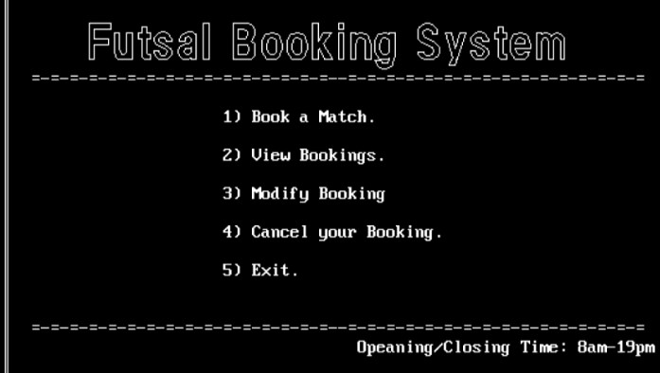

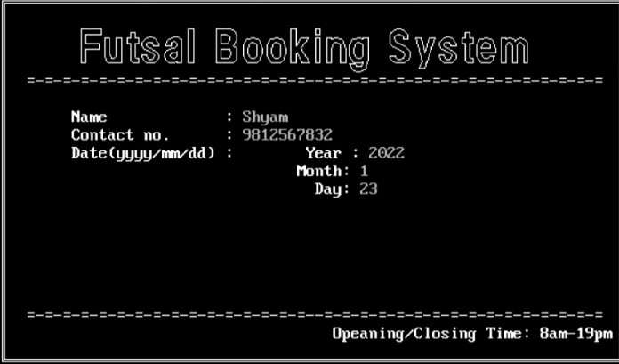

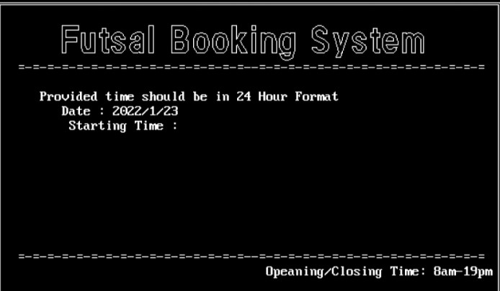

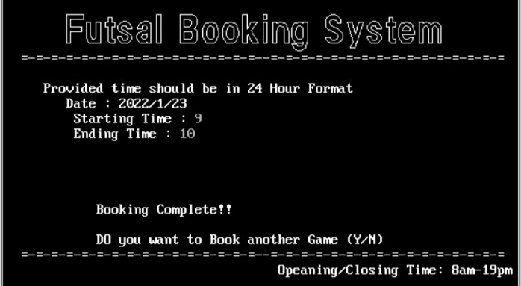

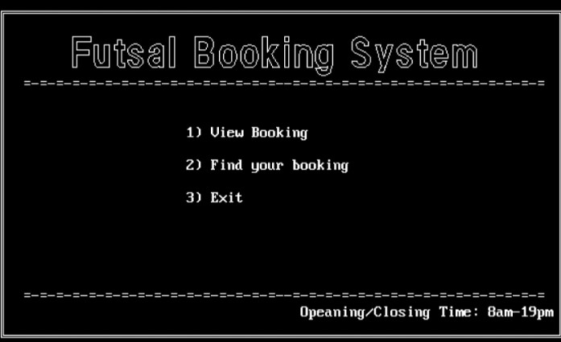

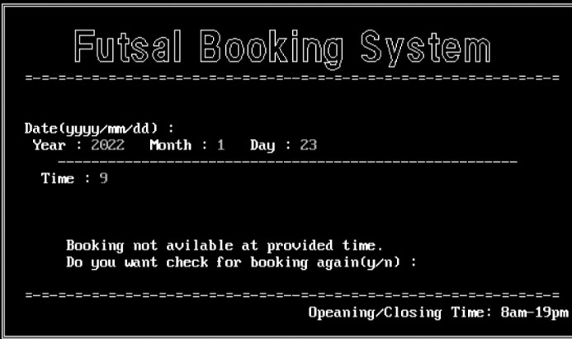

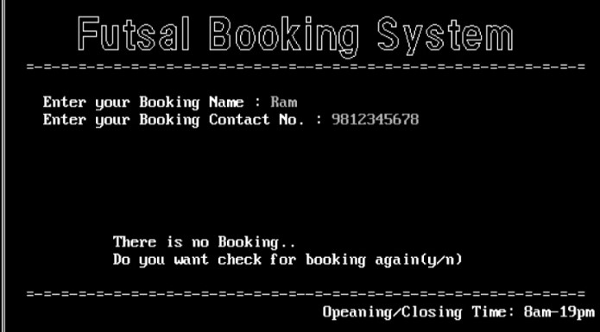

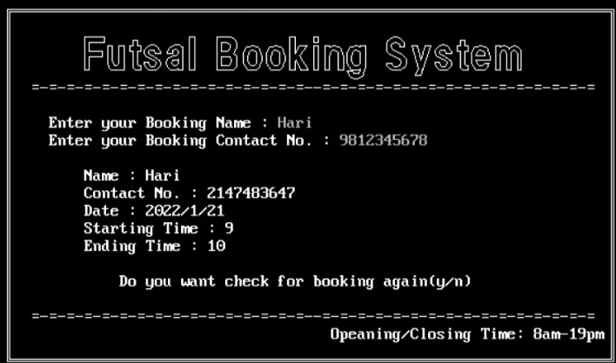

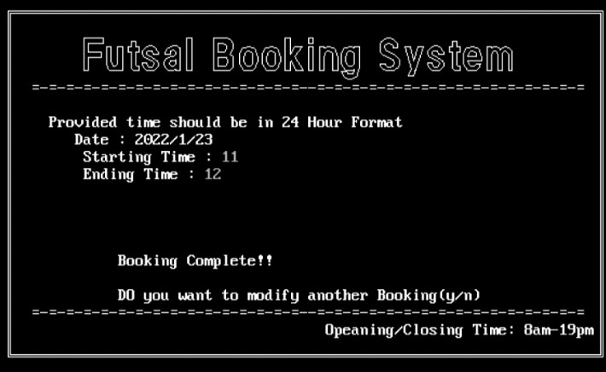

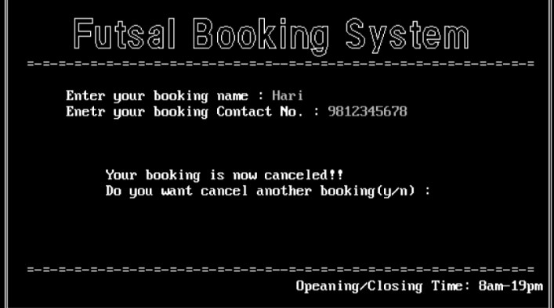

**SOURCE CODE**

#include<stdio.h>

#include<conio.h>

#include<stdlib.h>

#include<graphics.h>

#include<string.h>

struct booking_Details

{

char name[40];

int num;

int stime;

int etime;

struct booking_date{

int year;

int month;

int day;

}d;

}detail;

void menu();

void menu_start();

void booking();

void book();

void find_booking(void);

void view_booking(void);

void cancel_booking(void);

void modify_booking(void);

void main()

{

menu_start();

}

//Menu layout 1

void menu_start()

{

int choice;

int gd = DETECT,gm;

initgraph(&gd,&gm,"c:\\TURBOC3\\BGI");

menu();

settextstyle(1,HORIZ_DIR,4);

delay(500);

gotoxy(30,12);

printf("1) Book a Match.\n");

gotoxy(30,14);

printf("2) View Bookings.\n");

gotoxy(30,16);

printf("3) Modify Booking");

gotoxy(30,18);

printf("4) Cancel your Booking.\n");

gotoxy(30,20);

printf("5) Exit.");

choice = getche();

booking(choice);

//getch();

closegraph();

}

//Menu layout end

//UI Interface

void menu()

{

rectangle(50,80,600,400);

rectangle(52,82,598,398);

delay(500);

settextstyle(10,HORIZ_DIR,3);

outtextxy(90,90," Futsal Booking System");

delay(500);

gotoxy(10,10);

printf("=-=-=-=-=-=-=-=-=-=-=-=-=-=-=-=--=-=-=-=-=-=-=-=-=-=-=-=-=-=-=-=");

gotoxy(40,24);

printf(" Opening/Closing Time: 8am-19pm");

gotoxy(10,23);

printf("=-=-=-=-=-=-=-=-=-=-=-=-=-=-=-=--=-=-=-=-=-=-=-=-=-=-=-=-=-=-=-=");

}

//UI Interface end

void booking(ch)

{

int option;

int gd = DETECT,gm;

initgraph(&gd,&gm,"C:\\TURBOC3\\BGI");

switch(ch)

{

case '1':

{

fflush(stdin);

book(); //Booking function (it is used for booking a futsal game).

break;

}

case '2':

{

char c;

search_menu:

cleardevice();

menu();

gotoxy(30,13);

printf("1) See Booking Time");

gotoxy(30,15);

printf("2) Find your booking");

gotoxy(30,17);

printf("3) Exit");

option = getche();

fflush(stdin);

switch(option)

{

case '1':

{

fflush(stdin);

view_booking(); // used for searching available time.

break;

}

case '2':

{

fflush(stdin);

find_booking(); //used for finding your booking.

break;

}

case '3':

{

fflush(stdin);

menu_start(); //Exiting for main_menu.

break;

}

default: //used if user provide wrong inforamtion

{

gotoxy(28,20);

printf("Invalid choice!!");

c = getche();

goto search_menu;

}

}

}

break;

case '3':

fflush(stdin);

modify_booking(); //used for modifying bookings.

break;

case '4':

fflush(stdin);

cancel_booking(); //used for canceling bookings.

break;

case '5':

exit(0); //Exiting the program

break;

default:

{

fflush(stdin);

menu_start();

}

}

getch();

closegraph();

}

//------------------Book--------------------------

void book()

{

FILE *fp1;

int recsize,year1,month1,day1,time1,time2,stime,flag=0;

char name[50],i,another;

int num;

another = 'y';

while(another == 'y')

{

fp1 = fopen("c:\\TURBOC3\\BIN\\futsal\\dat.txt","rb+");

if(fp1 == NULL)

{

fp1 = fopen("c:\\TURBOC3\\BIN\\futsal\\dat.txt","wb+");

if(fp1 == NULL)

{

printf("File not found!!");

}

}

recsize = sizeof(detail);

fseek(fp1,0, SEEK_END);

flag:

cleardevice();

menu();

fflush(stdin);

gotoxy(15,12);

printf("Name : ");

gets(name);

fflush(stdin);

gotoxy(15,13);

printf("Contact no. : 98");

scanf("%d",&num);

// fflush(stdin);

rewind(fp1);

while(fread(&detail,recsize,1,fp1)>0)

{

if(num == detail.num)

{

gotoxy(15,14);

printf("Booking not available in provided information!!");

gotoxy(15,15);

printf("Please Enter different contact number!!");

i = getche();

goto flag;

}

}

gotoxy(15,15);

printf("Date(yyyy/mm/dd) : \t");

printf("Year : ");

scanf("%d",&year1);

fflush(stdin);

gotoxy(39,16);

printf(" Month: ");

fflush(stdin);

scanf("%d",&month1);

gotoxy(39,17);

printf(" Day: ");

fflush(stdin);

scanf("%d",&day1);

if(year1 <=2021 || month1 < 1 || month1 > 12 || day1 < 1 || day1 > 30)

{

gotoxy(20,18);

printf("Invalid Date!!, Refill the Form.");

i = getche();

goto flag;

}

time:

cleardevice();

menu();

gotoxy(13,12);

printf("Provided time should be in 24 Hour Format");

gotoxy(16,13);

printf("Date : %d/%d/%d",year1,month1,day1);

gotoxy(17,14);

printf("Starting Time : ");

scanf("%d",&time1);

fflush(stdin);

gotoxy(17,15);

printf("Ending Time : ");

scanf("%d",&time2);

fflush(stdin);

if(time1 < 8 || time1 > 19 || time2 < time1 || time2 > 19 || time2 < 8)

{

gotoxy(15,16);

printf("Invalid Time!! Refill the Form.");

i = getche();

goto time;

}

rewind(fp1);

while(fread(&detail,recsize,1,fp1)>0);

{

flag = 0;

if(detail.d.year == year1 && detail.d.month == month1 && detail.d.day == day1 && time1 >= detail.stime && time1 < detail.etime && time2 > detail.stime && time2 <= detail.etime )

{

flag = 1;

gotoxy(15,20);

printf("Booking not avilable at provided time.");

gotoxy(15,21);

printf("Do you want check for booking again(y/n) : ");

i = getche();

if(i=='y' || i=='Y')

{

goto time;

}

else

{

fclose(fp1);

menu_start();

}

}

}

if(flag == 0)

{

fflush(stdin);

strcpy(detail.name,name);

detail.num = num;

detail.d.year = year1;

detail.d.month = month1;

detail.d.day = day1;

detail.stime = time1;

detail.etime = time2;

fwrite(&detail,recsize,1,fp1);

gotoxy(20,20);

printf("Booking Complete!!");

gotoxy(20,22);

printf("DO you want to Book another Game (Y/N)");

fflush(stdin);

another = getche();

tolower(another);

fclose(fp1);

}

}

menu_start();

}

//------------------Find Booking------------------

void find_booking()

{

FILE *fp2;

int flag=0;

int unum;

char uname[50],c;

again2:

fp2 = fopen("c:\\TURBOC3\\BIN\\futsal\\dat.txt","rb");

if(fp2 == NULL)

{

printf("File not found!!");

exit(0);

}

cleardevice();

menu();

flag =0;

gotoxy(12,12);

fflush(stdin);

printf("Enter your Booking Name : ");

gets(uname);

fflush(stdin);

gotoxy(12,13);

printf("Enter your Booking Contact No. : 98");

scanf("%d",&unum);

fflush(stdin);

// rewind(fp2);

while(fread(&detail,sizeof(detail),1,fp2) >0)

{

if(strcmp(uname,detail.name)==0 && unum == detail.num)

{

flag = 1;

gotoxy(20,15);

printf("!! BOOKING DETAIL !!");

gotoxy(16,16);

printf("Name : %s",detail.name);

gotoxy(16,17);

printf("Date : %d/%d/%d",detail.d.year,detail.d.month,detail.d.day);

gotoxy(16,18);

printf("Starting Time : %d",detail.stime);

gotoxy(16,19);

printf("Ending Time : %d",detail.etime);

gotoxy(20,21);

printf("Do you want check for booking again(y/n)");

fflush(stdin);

c = getche();

if(c=='y' || c=='Y')

{

fclose(fp2);

goto again2;

}

else

{

fflush(stdin);

fclose(fp2);

menu_start();

}

}

}

if(flag == 0)

{

gotoxy(20,20);

printf("There is no Booking..");

gotoxy(20,21);

printf("Do you want check for booking again(y/n)");

fflush(stdin);

c = getche();

if(c=='y' || c=='Y')

{

fclose(fp2);

goto again2;

}

fflush(stdin);

fclose(fp2);

menu_start();

}

fflush(stdin);

fclose(fp2);

menu_start();

}

//--------------------View Booking-------------------

void view_booking()

{

FILE *fp3;

int flag3,time;

int year2,month2,day2;

char c;

again:

fp3 = fopen("c:\\TURBOC3\\BIN\\futsal\\dat.txt","rb");

if(fp3 == NULL)

{

printf("File not found!!");

exit(0);

}

cleardevice();

menu();

flag3=0;

gotoxy(10,13);

printf("Date(yyyy/mm/dd) : ");

gotoxy(10,14);

printf(" Year : ");

scanf("%d",&year2);

gotoxy(25,14);

printf("Month : ");

scanf("%d",&month2);

gotoxy(35,14);

printf(" Day : ");

scanf("%d",&day2);

gotoxy(14,15);

printf("-------------------------------------------------------");

gotoxy(12,16);

printf(" Time : ");

scanf("%d",&time);

fflush(stdin);

gotoxy(13,17);

printf(" =-=-=-=-=-=-=-=-=-=-=-=-=-=-=-=-=-=-=-=-=-=-=-=-=-=-=-=");

rewind(fp3);

while(fread(&detail,sizeof(detail),1,fp3)>0);

{

if(detail.d.year == year2 && detail.d.month == month2 && detail.d.day == day2 && time >= detail.stime && time < detail.etime)

{

flag3 = 1;

gotoxy(14,19);

printf("Booking not avilable at provided time.");

gotoxy(14,20);

printf("Do you want check for booking again(y/n) : ");

}

}

if(flag3 == 0)

{

gotoxy(15,19);

printf("Booking avilable at provided Time.");

gotoxy(15,20);

printf("Do you want check for booking again(y/n) : ");

gotoxy(15,21);

printf("Do you want to book a match(1) : ");

}

fflush(stdin);

c = getche();

if(c=='y' || c=='Y')

{

fclose(fp3);

goto again;

}

else if(c=='1')

{

fclose(fp3);

book();

}

else

{

fclose(fp3);

menu_start();

}

}

//-----------------Cancel Booking-------------------

void cancel_booking()

{

FILE *fp4,*fp5;

int unum1;

char uname1[50],c;

fp4 = fopen("c:\\TURBOC3\\BIN\\futsal\\dat.txt","rb+");

if(fp4 == NULL)

{

fp4 = fopen("c:\\TURBOC3\\BIN\\futsal\\dat.txt","wb+");

if(fp4 == NULL)

{

printf("File not found!!");

}

}

fp5 = fopen("c:\\TURBOC3\\BIN\\futsal\\tmp.txt","rb+");

if(fp5 == NULL)

{

fp5 = fopen("c:\\TURBOC3\\BIN\\futsal\\tmp.txt","wb+");

if(fp5 == NULL)

{

printf("File not found!!");

}

}

cleardevice();

menu();

gotoxy(15,12);

fflush(stdin);

printf("Enter your booking name : ");

gets(uname1);

fflush(stdin);

gotoxy(15,13);

printf("Enter your booking Contact No. : 98");

scanf("%d",&unum1);

fflush(stdin);

rewind(fp4);

while(fread(&detail,sizeof(detail),1,fp4)==1)

{

if(strcmp(uname1,detail.name)!=0 && unum1 != detail.num)

{

fwrite(&detail,sizeof(detail),1,fp5);

}

}

fclose(fp4);

fclose(fp5);

remove("c:\\TURBOC3\\BIN\\futsal\\dat.txt");

rename("c:\\TURBOC3\\BIN\\futsal\\tmp.txt","c:\\TURBOC3\\BIN\\futsal\\dat.txt");

gotoxy(20,17);

printf("Your booking is now canceled!!");

gotoxy(20,18);

printf("Press 'y'to continue: ");

fflush(stdin);

c = getche();

if(c=='y' || c=='Y')

{

menu_start();

}

}

//---------------Modify Booking-------------------

void modify_booking()

{

FILE *fp6;

int recsize,year3,month3,day3,mflag = 0,stime1,etime1;

int unum2,num2,mflag2=0;

char uname2[50],name2[50],c;

c_again2:

fp6 = fopen("c:\\TURBOC3\\BIN\\futsal\\dat.txt","rb+");

if(fp6 == NULL)

{

fp6 = fopen("c:\\TURBOC3\\BIN\\futsal\\dat.txt","wb+");

if(fp6 == NULL)

{

printf("File not found!!");

}

}

recsize = sizeof(detail);

mflag = 0;

mflag2 = 0;

cleardevice();

menu();

fflush(stdin);

gotoxy(15,12);

printf("Enter your booking name : ");

gets(uname2);

fflush(stdin);

gotoxy(15,13);

printf("Enter your booking Contact No. : 98");

scanf("%d",&unum2);

fflush(stdin);

rewind(fp6);

while(fread(&detail,recsize,1,fp6)==1)

{

mflag = 0;

if(strcmp(uname2,detail.name)==0 && unum2 == detail.num)

{

mflag = 1;

flag:

cleardevice();

menu();

fflush(stdin);

gotoxy(15,12);

printf("Name : ");

gets(name2);

fflush(stdin);

gotoxy(15,13);

printf("Contact no. : 98");

scanf("%d",&num2);

fflush(stdin);

gotoxy(15,15);

printf("Date(yyyy/mm/dd) : \t");

printf("Year : ");

scanf("%d",&year3);

gotoxy(39,16);

printf(" Month: ");

scanf("%d",&month3);

gotoxy(39,17);

printf(" Day: ");

scanf("%d",&day3);

if(year3 <=2021 || month3 < 1 || month3 > 12 || day3 < 1 || day3 > 30)

{

gotoxy(20,18);

printf("Invalid Date!!, Refill the Form.");

c = getche();

goto flag;

}

time:

cleardevice();

menu();

gotoxy(12,12);

printf("Provided time should be in 24 Hour Format");

gotoxy(15,13);

printf("Date : %d/%d/%d",year3,month3,day3);

gotoxy(16,14);

printf("Starting Time : ");

scanf("%d",&stime1);

fflush(stdin);

gotoxy(16,15);

printf("Ending Time : ");

scanf("%d",&etime1);

fflush(stdin);

if(stime1 < 8 || stime1 > 19 || etime1 < stime1 || etime1 > 19 || etime1 < 8)

{

printf("Invalid Time!! Refill the Form.");

c = getche();

goto time;

}

rewind(fp6);

while(fread(&detail,recsize,1,fp6)==1);

{

mflag2 = 0;

if(detail.d.year == year3 && detail.d.month == month3 && detail.d.day == day3 && stime1 >= detail.stime && stime1 < detail.etime && etime1 > detail.stime && etime1 <= detail.etime )

{

mflag2 = 1;

gotoxy(15,20);

printf("Booking not avilable at provided time.");

gotoxy(15,21);

printf("Press 'y' to check again : ");

fflush(stdin);

c = getche();

if(c=='y' || c=='Y')

{

goto time;

}

}

}

if(mflag2 == 0)

{

fflush(stdin);

strcpy(detail.name,name2);

detail.num = num2;

detail.d.year = year3;

detail.d.month = month3;

detail.d.day = day3;

detail.stime = stime1;

detail.etime = etime1;

fflush(stdin);

fseek(fp6,-recsize,SEEK_CUR);

fwrite(&detail,recsize,1,fp6);

fflush(stdin);

gotoxy(20,20);

printf("Booking Complete!!");

fclose(fp6);

gotoxy(20,22);

printf("Press Any Key to Continue! ");

fflush(stdin);

c = getche();

// fflush(stdin);

return menu_start();

}

menu_start();

}

menu_start();

}

if(mflag == 0)

{

gotoxy(15,15);

printf("There is no booking on provided Information!!");

fflush(stdin);

fclose(fp6);

c = getche();

goto c_again2;

}

fclose(fp6);

menu_start();

}

# **REFERENCES**

* Balagurusamy.E., Programming In ANSI C, the Tata McGraw-Hill Companies, 8th Edition, 2008.
* Kanetkar Yashavant, Let Us C, BPB Publication, 9th Edition, 2009.
* [**www.programiz.com**](http://www.programiz.com)