Sanity Checks for Attention Surgery:
Null Models and Matched Interventions for
Representation-Motivated Design
Anonymous authors
Paper under double-blind review
ABSTRACT
An attention head’s output can align with its own value vector because of both self-attention and shared representation geometry. This alignment alone does not establish that the aligned component is redundant. We examine it with three checks: split-half reliability of structural statistics and intervention effects, a null using values from earlier positions, and paired training runs with a fixed arbitrary-direction control. We measure geometry in twelve pretrained models and intervention reliability in three. The behavioural effect meets the reliable threshold only in GPT-2, whereas the structural statistics are highly reliable in all three models. The null-adjusted statistic has raw rank correlations of $0.189$ to $0.279$ with the intervention effect. In an eight-seed factorial at $4.0×{10}^{8}$ tokens per run, learned self-directed removal lowers validation loss by $0.00292$ nats (Holm-corrected $p=0.0023$). The arbitrary-direction arm has no statistically detectable difference from baseline ($+0.00106$ nats, $p=0.197$). These results support a benefit from learned self-directed removal at the tested scale, but do not establish that the component is dispensable in a frozen model or that its cosine alignment is a reliable guide to intervention effects.

1 Introduction
Multi-head self-attention (Vaswani et al. 2017) forms each head’s output as a weighted sum of value vectors. In a causal model, position $i$ can attend to its own value vector as well as to earlier positions. Exclusive self attention (XSA) removes the output component aligned with that value (Zhai 2026).

Research objective.
We examine whether this component is redundant and whether its cosine alignment identifies heads whose removal changes language-modelling loss. This is a question about a direction within a head, distinct from the whole-head pruning studied by Michel, Levy, and Neubig (2019; Voita et al. 2019).
Two measurements are needed to interpret such an intervention. First, high cosine alignment need not be specific to a token’s own value: contextual representations can be anisotropic (Ethayarajh 2019). A comparison with other values tests how much alignment survives that background geometry. Second, an edit’s loss effect must be measured reliably before it can be related to a structural statistic. A small observed correlation can reflect either a weak association or noisy measurements. Training with an arbitrary-direction edit provides a further control for whether an apparent benefit requires the own-value direction.
Our protocol addresses these questions in the following order.

Check 0: is the effect resolvable?
Before any correlation is interpreted, we estimate the split-half reliability $r_{Δ}$ of the behavioural effect and $r_{\text{stat}}$ of the structural statistic. Their geometric mean $\sqrt{r_{Δ}r_{\text{stat}}}$ provides an attenuation diagnostic. We classify the effect as reliable at $r_{Δ}≥0.6$, attenuated at $0.3≤r_{Δ}<0.6$, and unresolvable below $0.3$; the classification does not use the geometric mean as its threshold.

Check 1: is the self-directed cosine anisotropy?
We compare $cos\left(y_{i},v_{i}\right)$ against the same cosine computed with a null partner drawn uniformly from earlier positions in the same sequence. The difference measures excess alignment relative to this causal null.

Check 2: does the training benefit depend on direction?
We train self-directed and arbitrary-direction arms with the same gate parameterisation and compare each with baseline using paired seeds. The protocol specifies the arbitrary-direction comparison as primary.

Contributions.
We provide the three checks and a reconstruction gate for verifying the captured head layout (Sections 3 and 3.5). The experiments comprise an eight-seed training factorial, geometry measurements across twelve pretrained models, and reliability and correlation estimates for three models (Sections 5.3 and 5.2–5.5).

2 Related Work

Head importance and pruning.
Michel, Levy, and Neubig (2019) and Voita et al. (2019) show that many attention heads can be pruned with limited degradation on their evaluated tasks. Their results concern the importance of whole heads. We instead intervene along one direction within each head and use an arbitrary-direction arm to test the specificity of that choice.

Circuit-level accounts.
Elhage et al. (2021) decompose attention into $QK$ and $OV$ circuits and treat the diagonal of the attention pattern as one contribution to the output. Projecting the full head output onto its own value direction can also remove aligned contributions from earlier tokens. It therefore differs from deleting only the diagonal term.

Representation geometry.
Ethayarajh (2019) finds anisotropy in contextual representations from ELMo, BERT, and GPT-2. This motivates a geometric control; it does not establish the geometry of every head examined here. Check 1 measures that background using values from earlier positions in the same sequence.

Isotropy is not universal.
Timkey and Schijndel (2021) show that a small number of high-variance coordinates dominate cosine similarity in contextual spaces, so a raw cosine can be large without reflecting shared structure. Machina and Mercer (2024) further report that the large Pythia models have approximately isotropic embedding spaces, which bounds how much a generic anisotropy argument can explain. Our null is computed within the same run, at one stated sequence length, on the same documents as the observed statistic, so it measures the earlier-position background of each model directly rather than assuming a uniform anisotropy across the ladder.

Grouped-query attention.
Ainslie et al. (2023) share key and value projections across groups of query heads. We compare own-group and neighbouring-group values to assess the statistic’s dependence on that sharing in Section 5.5.

3 Method

3.1 The intervention
Let head $h$ at layer $ℓ$ produce output $y_{i}∈R^{d_{h}}$ at position $i$, and let $v_{i}$ be the value vector that same head writes at $i$. Write ${\hat{v}}_{i}=v_{i}/\left\|v_{i}\right\|$. The self-directed removal, which we call XSA, replaces the head output with
$$z_{i} = y_{i} − tanh\left(α\right) ⟨y_{i},{\hat{v}}_{i}⟩ {\hat{v}}_{i},$$
where $α$ is a gate for each layer and head. The edit acts before the output projection. For frozen models, we set the multiplier to one and intervene on one head at a time, excluding the first token. In the trained factorial, gates start at zero and are learned jointly with the model; all positions are included. A zero gate disables the edit, and a negative gate adds an aligned component. The implementation stabilises normalisation by using $v_{i}/\left(\left\|v_{i}\right\|+ϵ\right)$, with $ϵ={10}^{−8}$ for frozen measurements and ${10}^{−6}$ for training. Equation 1 states the idealised unit-direction form.
The random control uses the same gated edit with a fixed arbitrary direction for each layer and head. Directions are sampled by normalising isotropic Gaussian vectors, seeded by layer index, and held fixed across positions, training steps, and run seeds. Both arms use the same normalisation and gate parameterisation, but their projection magnitudes need not match. The harness also implements meanval and diagmask (Appendix A); neither appears in the reported three-arm factorial.

3.2 Check 0: resolvability
Split the evaluation corpus into halves $A$ and $B$ and measure each head’s effect $Δ$ and structural statistic on both halves. Spearman correlations across heads give the split-half reliabilities $r_{Δ}$ and $r_{\text{stat}}$. The archived analysis applies no Spearman–Brown correction and reports:
$$ρ_{max} = \sqrt{r_{Δ} r_{\text{stat}}}, ρ_{\text{disatt}} = ρ_{\text{raw}}/ρ_{max}.$$
We classify the effect as reliable at $r_{Δ}≥0.6$, attenuated at $0.3≤r_{Δ}<0.6$, and unresolvable below $0.3$. An unresolvable effect does not support interpreting a small correlation as absence of an association. Each structural statistic uses its own reliability estimate.
For $ρ_{\text{raw}}$, the statistic and effect are each averaged across the two halves before computing their Spearman correlation across heads. Because the denominator in Equation 2 uses half-sample reliabilities, the adjusted value is a diagnostic, not a calibrated estimate of the latent correlation between the pooled measurements. We retain the archived notation $ρ_{max}$, but do not interpret it as a strict bound on those pooled correlations.

3.3 Check 1: the anisotropy null
For each head and position, $cos\left(y_{i},v_{i}\right)$ is compared against $cos\left(y_{i},v_{j}\right)$ with $j$ drawn uniformly from $\{1,…,i−1\}$ using one-based indexing. The first token is excluded because it has no earlier partner and its head output equals its own value. The statistic, excess, is the mean paired difference between the cosines. It controls for alignment with earlier values, not all sources of anisotropy. The model-ladder figure reports point estimates; the harness supports layer-cluster bootstrap intervals for head-level data.
Two further diagnostics use different nulls. For attention sinks, we compare attention mass on the first token with the average mass on the next three tokens, using queries from the ninth token onward. For massive activations, we compare the mean maximum absolute hidden coordinate, scaled by the hidden tensor’s standard deviation, with the Gaussian reference $\sqrt{2logd}$ for width $d$. This reference is a scale approximation, not an exact finite-width expected maximum.

3.4 Check 2: matched intervention
Check 2 is run as a paired factorial over seeds. For each seed, all arms train from an identical initialisation on an identical token stream, so the paired difference controls for variation shared within a seed. Define $Δ$ as the arm’s validation loss minus baseline loss, so negative values indicate improvement. The protocol-specified primary endpoint is random versus baseline. The XSA comparison is secondary, with Holm correction (Holm 1979) restricted to secondary endpoints. XSA is the only secondary in the completed factorial, so its adjusted and unadjusted $p$-values coincide. We report two-sided paired $t$-tests and percentile bootstrap intervals over seed differences. Separate baseline comparisons do not constitute a direct test of XSA against random.
The analysis approximates the minimum detectable effect at $80\%$ power and $α=0.05$ by
$$\text{MDE} = 2.9 σ_{\text{paired}}/\sqrt{n},$$
using the observed $σ_{\text{paired}}$. We call this the realised MDE to distinguish it from the planning forecast. It describes sensitivity under the approximation, not achieved power or a hard threshold for detection.

3.5 The reconstruction gate
A head-layout error can preserve tensor shape while changing the intervention. We rebuild $y=A expand_kv\left(V\right)$ from the captured attention matrix and values, then compare it with the input to the output projection. The gate rejects a relative Frobenius error above ${10}^{−2}$ or a non-finite value. In each reliability run, it checks the first, middle, and last layers on one document before measuring head effects.
The implementation notes record an initial Pythia-160M error of $2.0×{10}^{−4}$ and errors of $1.39$ to $1.50$ after reversing heads, rolling the head axis, or omitting a transpose. These observations motivated the threshold. In the archived reliability runs, the maximum error across the checked layers is approximately $1.6×{10}^{−3}$ for each model, below the same threshold. A passed gate supports the tensor reconstruction at those checked layers; it does not validate the intervention’s semantic interpretation.

4 Experimental Setup

Frozen-model measurements.
Check 1 covers twelve pretrained models, including nine multi-head models from $124$M to $6.9$B parameters and three grouped-query models. These include the GPT-2 family (Radford et al. 2019) and the Pythia suite (Biderman et al. 2023). Model revisions are recorded by hash. The geometry measurements use WikiText-103 test documents and each run’s recorded block length. Check 0 is restricted to GPT-2, Pythia-160M, and Pythia-410M, using $64$ documents per half at a fixed length of $128$ tokens. Shorter documents are dropped rather than padded. This length constraint applies to the reliability runs, not to the full model ladder.

Trained factorial.
Check 2 uses a decoder-only model with eight layers, eight heads per layer, and hidden width $512$, approximately $50.9$M parameters. The data pipeline uses FineWeb-Edu’s sample-10BT stream with a fixed disjoint validation holdout. We trained from scratch on eight seeds (7, 42, 99, 512, 1337, 2024, 8191, 31337) under three arms (baseline, xsa, random), giving 24 cells. Each cell sees $399 900 672$ tokens, rounded down from the budget to a whole number of batches. Runs share initialisation, token order, learning-rate schedule, and validation batches within each seed. All three arms for a seed complete before the next seed starts.

Budget.
The completed factorial cost $15.58 against a $20 ceiling. The ledger records $16.98$ GPU-hours spent in training cells; billing covers pod uptime, including time outside those cells. An earlier $5×{10}^{7}$-token pilot is retained separately and is not pooled with the primary runs.

5 Results
Table 1: Check 0 split-half reliability, $n=144$ heads for GPT-2 and Pythia-160M and $n=384$ for Pythia-410M, at a fixed sequence length of $128$ tokens with $64$ documents per half. The verdict uses $r_{Δ}$; $r_{\text{stat}}$ here refers to self-cosine. $ρ_{max}$ is the attenuation factor in Equation 2.
Model | $r_{Δ}$ | $r_{\text{stat}}$ | $ρ_{max}$ | Verdict
GPT-2 | 0.795 | 0.997 | 0.890 | reliable
Pythia-160M | 0.419 | 0.994 | 0.645 | attenuated
Pythia-410M | 0.531 | 0.991 | 0.726 | attenuated
Table 2: Spearman correlation between the structural statistic and the measured behavioural effect, raw and adjusted using Equation 2. The raw correlation uses averages over both halves; the adjustment uses each statistic’s own half-sample reliability.
Model | Statistic | $ρ_{\text{raw}}$ | $ρ_{max}$ | $ρ_{\text{disatt}}$
GPT-2 | self-cosine | $+0.462$ | 0.890 | $+0.519$
 | excess | $+0.279$ | 0.891 | $+0.313$
Pythia-160M | self-cosine | $+0.149$ | 0.645 | $+0.231$
 | excess | $+0.189$ | 0.646 | $+0.292$
Pythia-410M | self-cosine | $−0.025$ | 0.726 | $−0.034$
 | excess | $+0.249$ | 0.727 | $+0.342$
Table 3: Check 2, eight complete paired seeds, $399 900 672$ tokens per run. Both contrasts are against baseline. Positive $Δ$ means higher loss. Intervals are $95\%$ percentile bootstrap intervals over paired seed differences. The realised MDE uses the observed $σ_{\text{paired}}$. Holm correction does not apply to the primary endpoint.
 | random | xsa
 | (primary) | (secondary)
Mean $Δ$ (nats) | $+0.001056$ | $−0.002924$
CI low | $−0.000298$ | $−0.003967$
CI high | $+0.002390$ | $−0.001709$
$t$ | $+1.43$ | $−4.67$
$p$ | $0.197$ | $0.0023$
Holm $p$ | n/a | $0.0023$
Cohen’s $d_{z}$ | $+0.504$ | $−1.649$
$σ_{\text{paired}}$ | $0.002095$ | $0.001773$
Realised MDE | $0.00215$ | $0.00182$
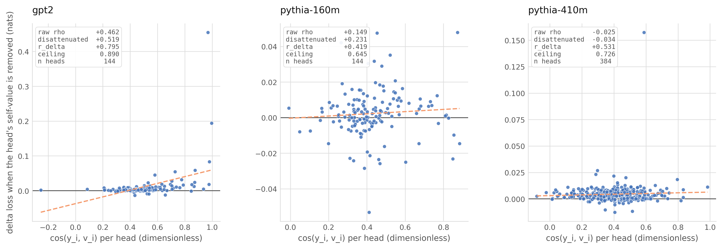
Figure 1: Self-cosine against the loss effect of frozen-head intervention. Points use the half-A statistic and the effect averaged over both halves; panel annotations report the pooled-statistic correlations in Table 2. Dashed least-squares lines are visual guides, not tests of significance. Vertical scales differ across panels.
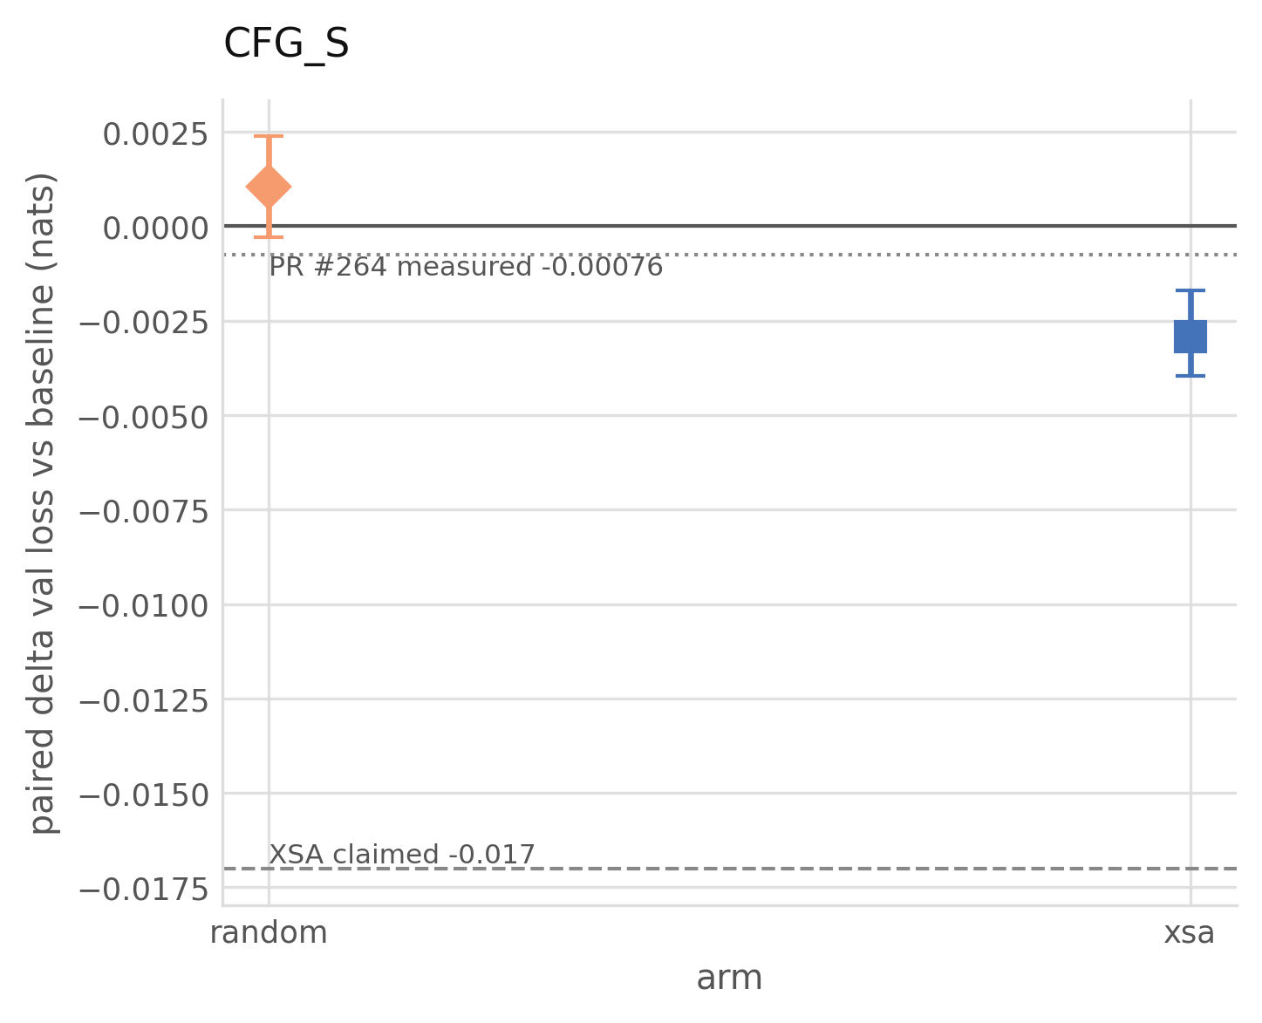
Figure 2: Paired difference in validation loss against baseline, with $95\%$ intervals, over eight paired seeds. The random interval crosses zero and the xsa interval lies below zero. The horizontal reference lines retain the project’s external reference values. The $−0.00076$ value comes from the H200 comparison in PR #264, which uses different training step counts between arms. The exact source configuration for $−0.017$ is unresolved. Neither is a matched replication target for this experiment.
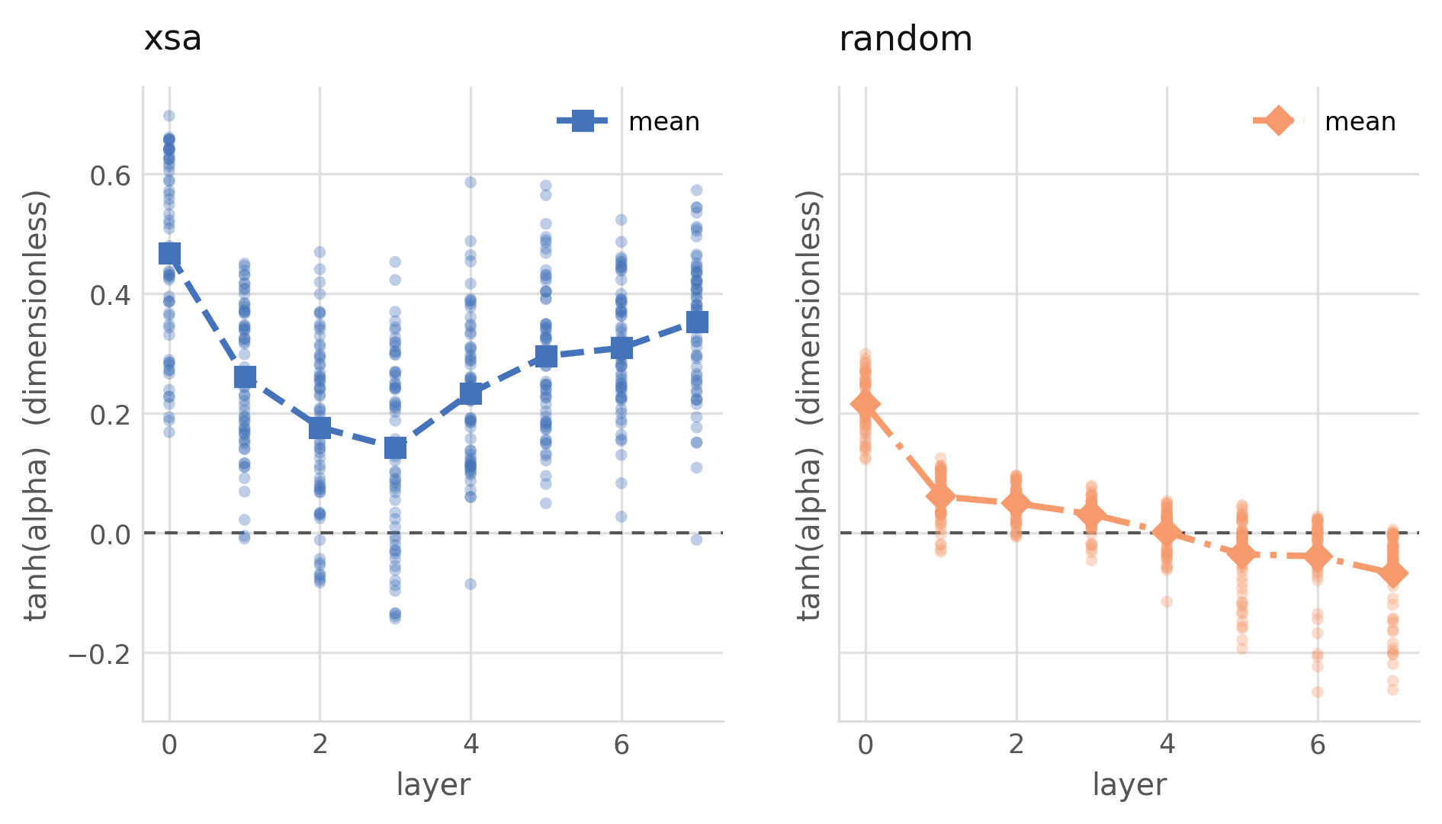
Figure 3: Final learned gates $tanh\left(α\right)$ for all heads and seeds, with markers at the layer mean. XSA has positive means at every layer. The random mean approaches zero by layer four and becomes negative in later layers. A negative gate adds the projected component. These are endpoint measurements, not gate trajectories during training.
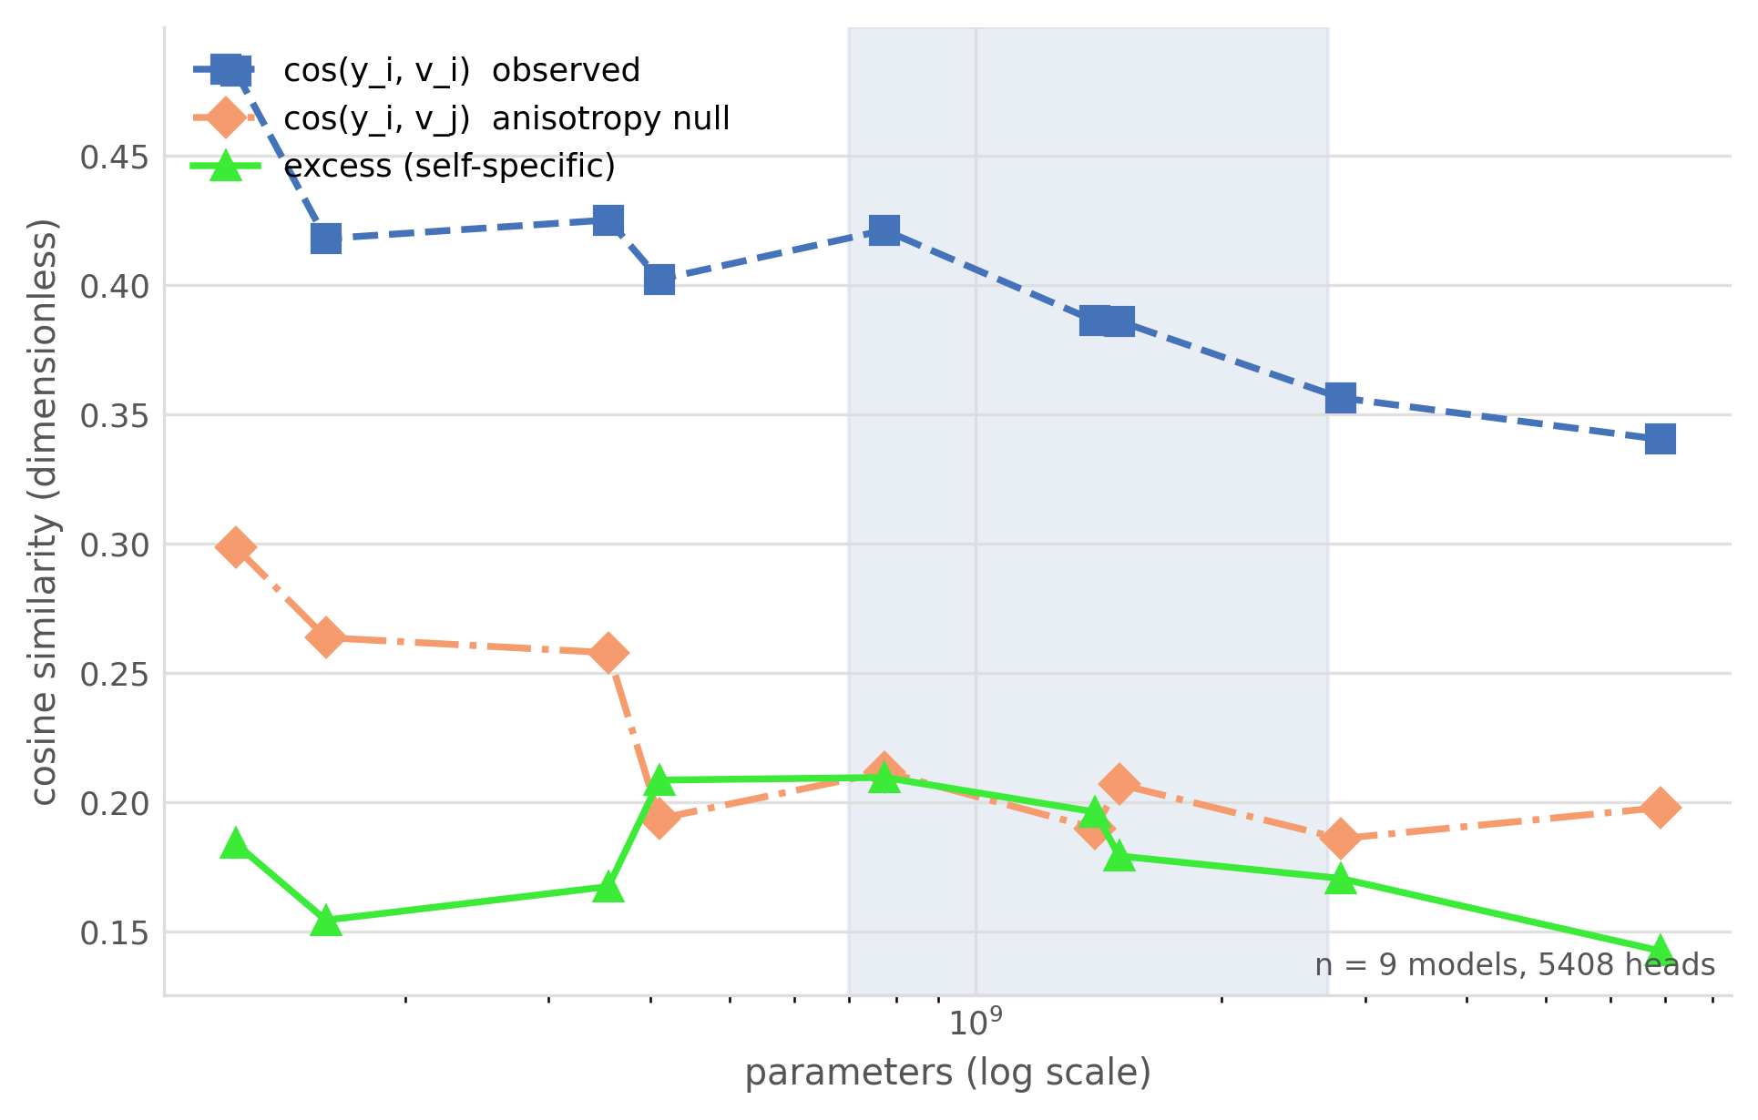
Figure 4: Check 1 across the nine multi-head models in the ladder, every model pinned by revision hash. Observed $cos\left(y_{i},v_{i}\right)$, the anisotropy null $cos\left(y_{i},v_{j}\right)$, and their difference. The observed curve generally declines with scale; the excess has no monotone trend.
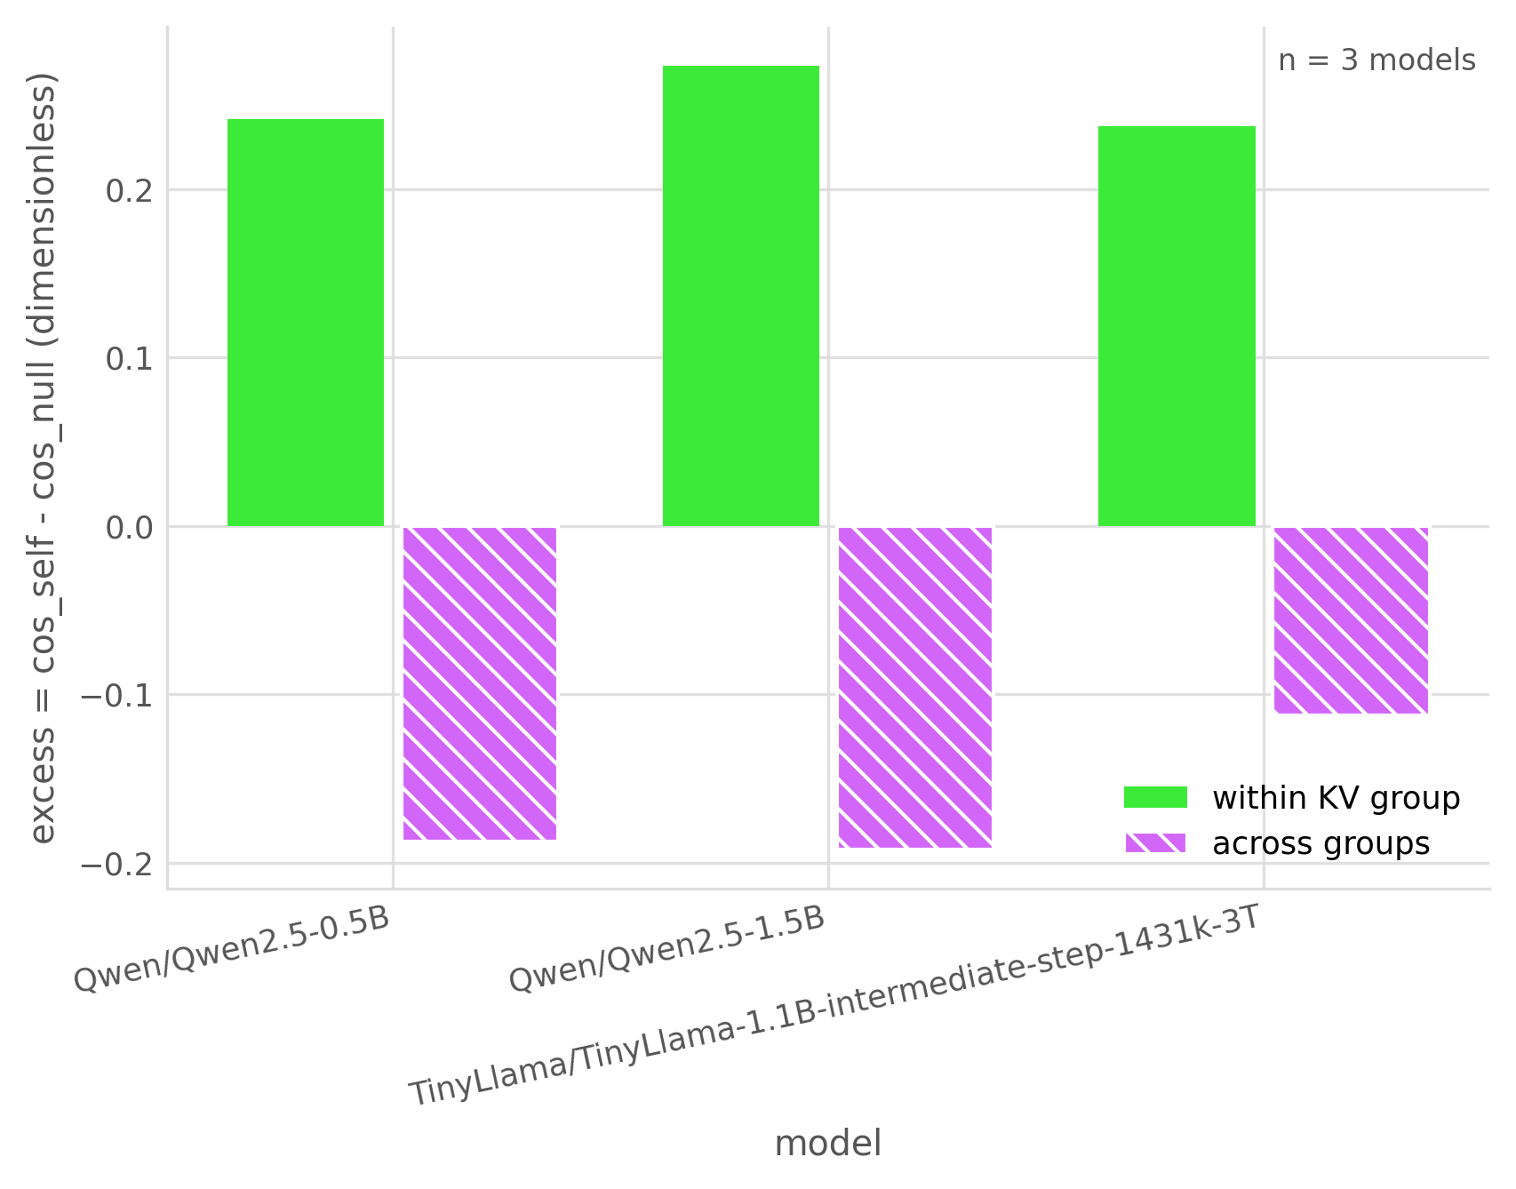
Figure 5: Within-group against across-group excess for the three grouped-query models. Both subtract the own-group earlier-position null. Own-group excess is positive and neighbouring-group excess negative in all three models. The harness does not report this grouping contrast for multi-head models.

5.1 Resolvability
The behavioural effect is reliable in GPT-2 and attenuated in both Pythia models under the Check 0 thresholds (Table 1). None of the three is classified as unresolvable. Structural self-cosine reliability is high in all three, from $0.991$ to $0.997$. The main source of attenuation is therefore the intervention-effect measurement. For Pythia-160M, dividing the raw self-cosine correlation of $0.149$ by the diagnostic factor $0.645$ gives $0.231$; this adjustment does not remove the uncertainty associated with an attenuated effect.

5.2 Structural statistic versus behavioural effect
The relation between self-cosine and the measured effect varies by model (Figure 1, Table 2). GPT-2 has a raw correlation of $+0.462$ and an adjusted value of $+0.519$; Pythia-410M has an adjusted value of $−0.034$, close to zero. For excess, the adjusted correlations are $+0.313$, $+0.292$, and $+0.342$ across the three models. These are descriptive rank associations, not estimates of explained loss variance or out-of-sample predictive accuracy.
An earlier Pythia-160M run reported a raw excess correlation of $+0.487$, compared with $+0.189$ in the current run. Several protocol changes accompanied the rerun (Appendix C), so their individual contributions to this difference are not isolated.

5.3 The paired factorial
All 24 training cells completed, giving eight paired seeds for each contrast in Table 3 and Figure 2.
For the primary endpoint, the random arm’s loss difference is $+0.001056$ nats ($p=0.197$). Its $95\%$ interval, $\left[−0.000298,+0.002390\right]$, includes both a small benefit and a small loss increase. The result is nonsignificant, without establishing equivalence.
The secondary endpoint, xsa versus baseline, is $−0.002924$ nats with interval $\left[−0.003967,−0.001709\right]$, $t=−4.67$, and Holm-corrected $p=0.0023$. XSA therefore lowers loss in this training setting. The realised MDE from Equation 3 is $0.00182$ nats for the XSA contrast and $0.00215$ for the control contrast. The observed XSA effect is about $1.6×$ its approximate MDE, whereas the control effect is smaller than its MDE. Figure 6 shows sensitivity estimates for the control at both token budgets.
The benefit concerns a model trained with learned removal. It does not show that the same component can be removed from an already trained model without cost, or establish a direct between-arm difference from the separate tests.
Final gates differ between arms (Figure 3). XSA’s layer means range from $0.14$ to $0.47$, indicating partial removal on average. The control’s later-layer means are negative, indicating addition along its direction. These endpoint measurements do not explain the loss difference.

5.4 Check 1 across the model ladder
Across nine multi-head models and $5408$ heads, self-cosine generally declines with model size (Figure 4). It is $0.483$ for GPT-2 at $124$M parameters and $0.340$ for Pythia-6.9B. The earlier-position null also declines overall. Excess remains between $0.14$ and $0.21$ without a monotone trend. These observations do not establish scale invariance, but show that the raw cosine’s trend is partly shared by its null. The grouped-query models are examined separately below.
Both additional GPT-2 diagnostics exceed their respective nulls (Figure 7). Attention mass on the first token is $0.403$, compared with $0.003$ on the matched early positions. The massive-activation statistic is $12.87$ against a Gaussian reference of $3.65$, leaving approximately $71.7\%$ after subtraction. Neither pattern is explained away by its chosen null. The two unexecuted diagnostics are shown as blank categories.

5.5 Grouped-query attention
For each grouped-query model, we compare the head output’s cosine with its own group’s value and with a neighbouring group’s value at the same position. Both excess values subtract the own-group earlier-position null. For Qwen2.5-0.5B ($14$ query heads over $2$ key–value heads), own-group excess is $+0.2415$ and neighbouring-group excess is $−0.1876$. Qwen2.5-1.5B and TinyLlama-1.1B show the same signs (Figure 5). The alignment thus depends on which group’s value is used. A negative across-group excess means alignment below the own-group null, not necessarily a negative raw cosine. The harness leaves this contrast undefined for multi-head models, which lack groups sharing a value projection.

6 Limitations

Training and scale.
Check 2 measures adaptation in a small model trained for $4.0×{10}^{8}$ tokens per run. It does not establish the effect’s sign or magnitude at larger scales. The frozen and trained experiments also differ in gate strength and first-token treatment, so their effects are not estimates of the same intervention.

One statistic family.
Both structural statistics are cosine-based. A statistic based on attention mass could have a different relation to intervention effects. The present analysis does not test that alternative.

Reliability and correlation.
Only three models underwent Check 0. Reliability for the other nine remains unmeasured, and the disattenuation uses half-sample reliabilities for pooled correlations. The adjusted values should therefore be read alongside the raw values, not as corrected ground truth. Neither rank correlations nor the fitted scatterplot lines establish predictive accuracy.

Control scope.
The random and XSA arms share a rank-one form, but their removed norms and final gates differ. The trained comparison does not isolate norm from direction. Reconstruction checks validate selected tensor layouts, not the claim that a value-aligned projection contains only self-position information.

Reference mismatch.
The GPT-2 geometry measurement did not reproduce the project’s reference triple within its stated tolerance of $0.01$. At block $512$ the measured self-cosine, null, and excess were $0.4828$, $0.2987$, and $0.1840$, against reference values $0.5406$, $0.3798$, and $0.1608$.
A length sweep accounts for most of that gap. The reference triple is quoted without a sequence length, and the null is strongly length-dependent while the observed self-cosine is close to flat. Across $64$ to $1024$ tokens the null moves by $0.096$, nine times the tolerance, and at $64$ tokens it sits $0.005$ from the reference value, inside it. The excess moves by $0.080$ and comes within $0.011$ at $256$ tokens. The self-cosine moves by only $0.016$ and never comes within $0.051$, so length does not account for that component; its residual gap is consistent with a difference in corpus, truncation, or head-level aggregation, and we have not identified which.
The consequence for Check 1 is narrow. The null is measured inside the same runs, at one stated length, on the same documents as the observed statistic, so the comparison the check makes is internally matched whatever the absolute level. The excess is positive at every length tested. What the sweep does show is that a self-specific fraction quoted without a length is not comparable across studies: the same GPT-2 gives $0.235$ at $64$ tokens and $0.412$ at $1024$. We therefore report the length everywhere and do not claim reproduction of the reference triple.

7 Conclusion
Learned self-directed removal improves validation loss by $0.0029$ nats in the eight-seed factorial, with Holm-corrected $p=0.0023$. The fixed arbitrary-direction arm has no statistically detectable difference from baseline. This supports the trained XSA variant at the tested scale, while leaving open whether its benefit generalises or reflects redundancy in a frozen model.
Own-value alignment exceeds an earlier-position null, but its association with intervention effects varies across models. Excess has modest rank correlations in all three examined. Interpreting such associations requires reliable effect measurements as well as a control suited to the intervention.

AI use statement
AI assistants were used during the development of this work. The authors defined the research question, experimental design, methodological choices, and interpretation of results. AI-assisted code was reviewed and validated by the authors, and reported results were verified against the stored result files. The authors take responsibility for every claim, citation, and number in this paper. Use by category:
- Synthetic data. None. All text is public corpora; no generated data enters any result.
- Hypotheses. Author-defined. The research question, the three checks, and the pre-registered primary endpoint were specified by the authors before any assistant was involved in the experimental programme.
- Theory, proofs, and conceptual frameworks. None. The paper contains no theorem or proof, and the conceptual framing of the three checks is author-originated.
- Methodology and experiment design. Author-defined. Assistants enumerated candidate controls and failure modes and drafted the power and token-budget arithmetic, which the authors reviewed before adoption.
- Core code. Assistant-written under author direction: the intervention, null sampling, the reconstruction gate, the statistical routines, the experiment drivers, and the tests. The authors reviewed it and specified the guards. Defects found this way are recorded in the repository.
- Data cleaning and analysis. Assistant-implemented from author-specified definitions. Every table cell and manifest claim is recomputed from the stored files by a checker rather than transcribed.
- Interpreting results. Author-owned. Assistants were used adversarially against the draft, and a second model from a different vendor reviewed the analysis; both surfaced errors the authors then corrected, including a reversed sign convention in an earlier draft.
- Figures. All figure code is assistant-written and reads only from the stored result files. No figure content was drawn or edited by hand.
- Writing and editing. The manuscript was drafted with assistant help and revised by the authors, who also used assistants to check the draft against the archived results and the cited sources.
- Translation. None. The work was written in English throughout.
- Literature search, references, and structure. Assistants were used for literature search and summarisation, reference formatting, and suggestions on section structure and title wording. The authors verified every cited work against its original source.

Ethics statement
This work analyses the internal structure of publicly released pretrained language models and trains small models from scratch on public text. It introduces no new data collection, no human subjects, and no deployed system. The small-model training result does not establish that attention components can be pruned safely in deployed models. Any such use requires evaluation in the intended model and setting.

Reproducibility statement
The repository contains per-run factorial records, paired-test summaries, per-head geometry and intervention measurements, and revision hashes for all twelve pretrained models. Code for the intervention, null sampling, reconstruction gate, and statistical calculations accompanies the results. The pilot runs are stored apart from the primary factorial and are labelled as such. An anonymised copy of the repository is available at ANONYMOUS-ARTIFACT-URL.
Every figure is generated from these stored results. The tables are written by hand, so a checker recomputes each of their 48 cells from the archived result files and compares against the printed value at the precision shown. Cells that the manuscript derives are recomputed rather than read back: $ρ_{max}$ from its two reliabilities, $ρ_{\text{disatt}}$ from the raw correlation and that factor, and the realised MDE from the observed paired standard deviation and seed count. Tables 1–3 currently agree with their sources on all 48 cells. The checker also reports any table row it does not know how to verify, so an unchecked row cannot pass silently.
Separately, a manifest recomputes 31 numerical claims from the committed artifacts and fails on any that does not reproduce within a stated tolerance. All 31 reproduce at the commit this manuscript was built from.
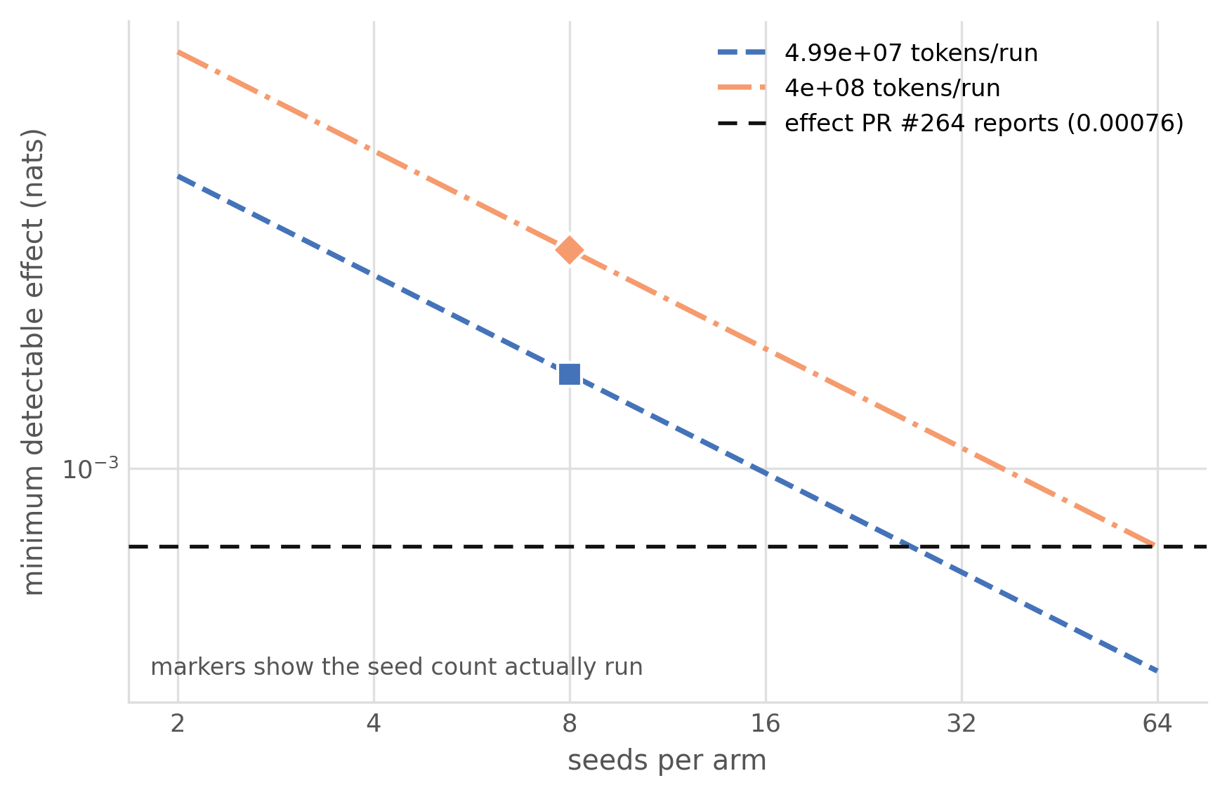
Figure 6: Approximate MDE for the random-versus-baseline contrast, using the observed paired standard deviation at each token budget. Markers show the eight seeds actually run; the remaining points extrapolate at fixed variance. Both eight-seed estimates exceed the external reference magnitude of $0.00076$ nats from the PR #264 comparison described in Figure 2.
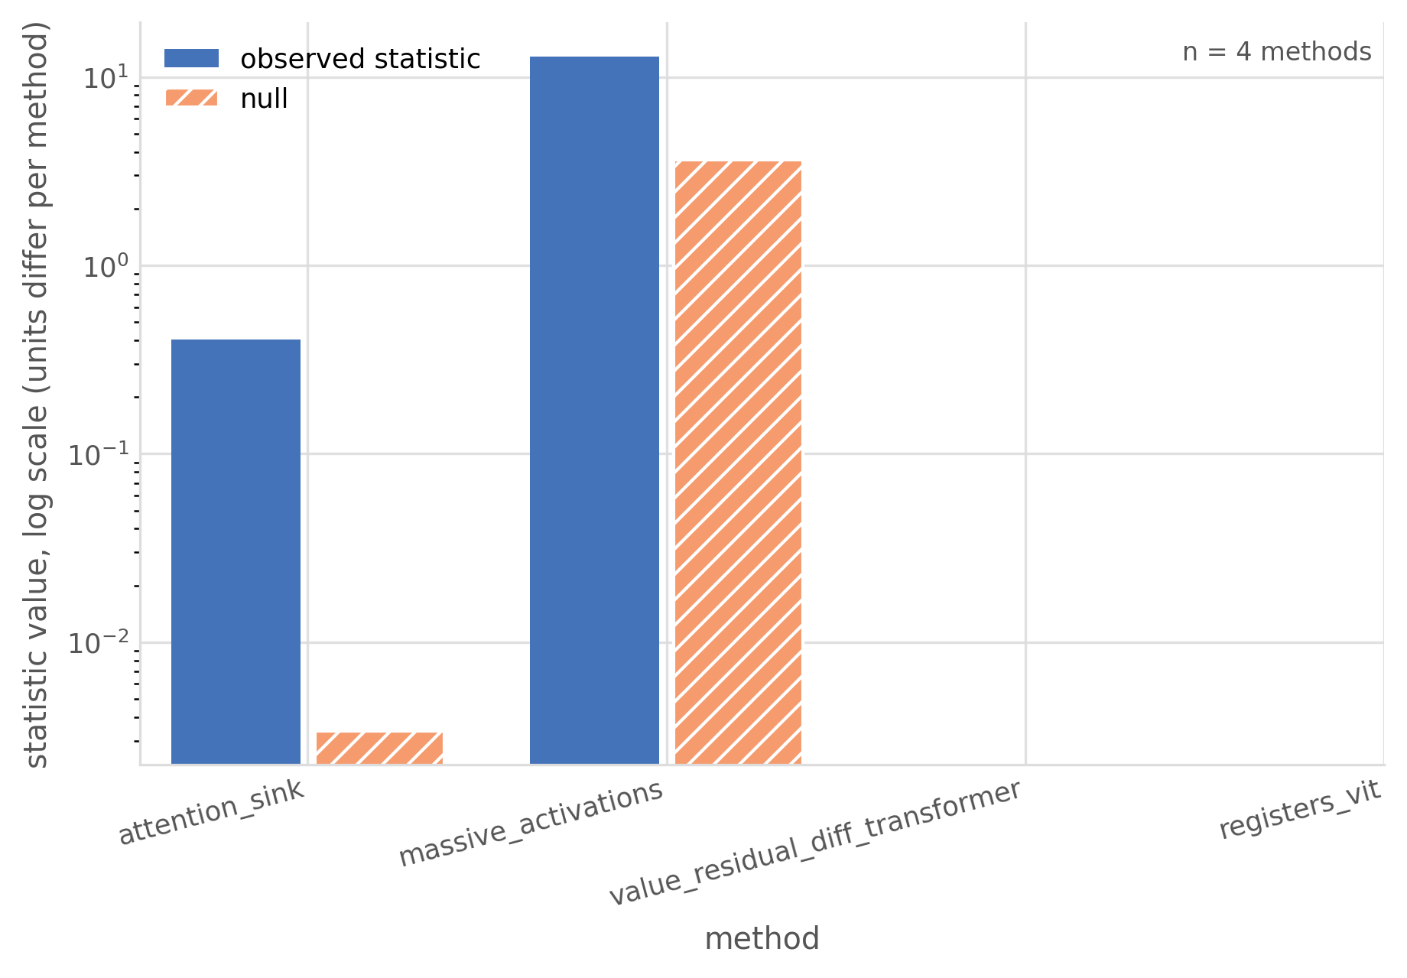
Figure 7: Observed statistics and their respective nulls for two GPT-2 diagnostics: attention mass for attention sinks and standard-deviation units for massive activations. Both exceed their nulls. The logarithmic axis accommodates different magnitudes; values across diagnostics have different units. The two blank categories were not run: one requires training matched models, and the other requires a vision-model harness.

8 Arm Definitions
baseline leaves the head output unchanged. xsa uses Equation 1, with a learned gate in the factorial and a unit multiplier in the frozen-head measurements. random substitutes a fixed arbitrary direction per layer and head and learns the same type of gate.
The two additional harness arms were not evaluated in the primary factorial. meanval uses a detached exponential moving average of the head’s batch-mean value, updated only during training. diagmask operates on logits. Its default gated form subtracts $30tanh\left(α\right)$ from diagonal logits before softmax; the optional hard-mask form sets them to $−∞$. Both leave the first token unmasked because it has no alternative key. These implementations should not be read as completed experimental arms.

9 Budget Ledger
The ledger records completed seed blocks and separates training-cell time from billed pod uptime. Adding cell hours to uptime would count training twice. An earlier forecast of $18.16 made that error; the corrected projection at the same stage was $13.41. The final billed total was $15.58.

10 Changes to the Measurement Protocol
The reliability runs now use a fixed length of $128$ tokens. Earlier runs allowed the common length to depend on the selected documents: $142$ tokens at $24$ documents per half and $137$ at $64$. This changes the null partner set as well as the measurement budget. The analysis also now pools both halves of the statistic and effect and uses statistic-specific reliability for disattenuation. The earlier Pythia-160M raw excess correlation of $+0.487$ and the current value of $+0.189$ belong to different runs; their difference does not isolate the contribution of any single correction. Earlier outputs are retained for comparison.
Ainslie, Joshua, James Lee-Thorp, Michiel de Jong, Yury Zemlyanskiy, Federico Lebrón, and Sumit Sanghai. 2023. “GQA: Training Generalized Multi-Query Transformer Models from Multi-Head Checkpoints.” arXiv Preprint arXiv:2305.13245.
Biderman, Stella, Hailey Schoelkopf, Quentin Anthony, et al. 2023. “Pythia: A Suite for Analyzing Large Language Models Across Training and Scaling.” arXiv Preprint arXiv:2304.01373.
Elhage, Nelson, Neel Nanda, Catherine Olsson, et al. 2021. “A Mathematical Framework for Transformer Circuits.” Transformer Circuits Thread.
Ethayarajh, Kawin. 2019. “How Contextual Are Contextualized Word Representations? Comparing the Geometry of BERT, ELMo, and GPT-2 Embeddings.” arXiv Preprint arXiv:1909.00512.
Holm, Sture. 1979. “A Simple Sequentially Rejective Multiple Test Procedure.” Scandinavian Journal of Statistics 6 (2): 65–70.
Machina, Anemily, and Robert Mercer. 2024. “Anisotropy Is Not Inherent to Transformers.” In Proceedings of the 2024 Conference of the North American Chapter of the Association for Computational Linguistics: Human Language Technologies (Volume 1: Long Papers). https://doi.org/10.18653/v1/2024.naacl-long.274.
Michel, Paul, Omer Levy, and Graham Neubig. 2019. “Are Sixteen Heads Really Better Than One?” In Advances in Neural Information Processing Systems.
Radford, Alec, Jeffrey Wu, Rewon Child, David Luan, Dario Amodei, and Ilya Sutskever. 2019. “Language Models Are Unsupervised Multitask Learners.” OpenAI Technical Report.
Timkey, William, and Marten van Schijndel. 2021. “All Bark and No Bite: Rogue Dimensions in Transformer Language Models Obscure Representational Quality.” In Proceedings of the 2021 Conference on Empirical Methods in Natural Language Processing, 4527–46.
Vaswani, Ashish, Noam Shazeer, Niki Parmar, Jakob Uszkoreit, Llion Jones, Aidan N Gomez, Lukasz Kaiser, and Illia Polosukhin. 2017. “Attention Is All You Need.” In Advances in Neural Information Processing Systems.
Voita, Elena, David Talbot, Fedor Moiseev, Rico Sennrich, and Ivan Titov. 2019. “Analyzing Multi-Head Self-Attention: Specialized Heads Do the Heavy Lifting, the Rest Can Be Pruned.” In Proceedings of the 57th Annual Meeting of the Association for Computational Linguistics.
Zhai, Shuangfei. 2026. “Exclusive Self Attention.” arXiv Preprint arXiv:2603.09078. https://arxiv.org/abs/2603.09078.

