FPGA-Based Hardware/Software Co-design for Real time Image Dehazing: Implementation on ZedBoard
Rohan Muthyala¹[0009-0001-5199-424X] , Sai Tharun Reddy Yennam²[0009-0005-8185-6648]
K. Srikanth3[0009-0005-5787-4109], V. Krishna Mohan 4[0009-0005-3341-5629]
P. Sreehari Rao5[0000-0003-4061-4851]

¹Vasavi College Engineering, Hyderabad, Telangana
²NIT Warangal , Warangal, Telangana
rohanmuthyala1234@gmail.com
Abstract. Image dehazing constitutes a foundational preprocessing operation that enhances the reliability of subsequent computer vision tasks
such as surveillance, ADAS systems, and remote sensing, where
atmospheric conditions degrade image quality and visibility.
Traditional software implementations are limited by high computational
complexity and time complexity, limiting their suitability for real-time
deployment. This paper presents a MATLAB simulation, python simulation and FPGA-based hardware/software co-design for real-time image dehazing,
implemented on the Xilinx ZedBoard (Device: XC7Z020-CLG484).
The proposed architecture integrates optimized Verilog hardware accelerator with software control to exploit parallel pixel-level processing and efficient memory management. Experimental evaluation demonstrates a significant reduction in latency and improved frame throughput compared to software-only implementations, while maintaining low power consumption. The results highlight the potential of FPGA-based co-design in achieving real-time, energy-efficient image enhancement for computer vision systems.
Keywords: Hardware/Software Co-design, Image Dehazing, FPGA, ZedBoard, Vivado, Vitis
- Introduction
Dehazing an image is a vital task in computer vision, particularly for real-world
scenarios where image clarity is essential, such as ADAS systems, aerial surveillance, remote sensing[8]. In outdoor environments, captured images are often degraded by
adverse atmospheric conditions such as haze, fog, and smoke. These scattering
phenomena reduce image contrast, wash out color information, and obscure essential structural details, making it difficult for downstream vision algorithms such as object detection, tracking, and recognition to perform reliably [9]. As a result, effective dehazing methods are essential to ensure the robustness and accuracy of modern computer vision systems.

Over the past decade, to address this issue, several image dehazing algorithms have been proposed, among which the Dark Channel Prior (DCP) is widely recognized for its effectiveness and strong theoretical foundation and ability to restore both contrast and scene visibility. The Dark Channel Prior method assumes that at least one color channel has very low intensity in hazy-free outdoor images.By estimating the transmission map value and atmospheric light value based on this prior, DCP can effectively recover scene radiance and produce visually clear results. Despite its effectiveness, DCP is computationally demanding, as it involves per-pixel operations, patch-based statistics, and guided filtering. However, software-based implementations of DCP are the high computational demands make them impractical for real-time embedded vision systems.

GPU-based acceleration of dehazing algorithms, including DCP, have been proposed to overcome the limitations of CPUs. While GPUs offer massive parallelism and significantly provides higher throughput but often comes with high power consumption, which restricts its use in energy-constrained platforms such as unmanned aerial vehicles (UAVs), autonomous robots, or edge devices, where both performance and energy efficiency are critical.[11]

Field-Programmable Gate Arrays (FPGAs) offer a promising alternative by providing parallelism, flexibility of reconfigurable, and energy efficiency. Moreover, through hardware/software co-design, tasks can be partitioned between software running on an arm processor and hardware modules synthesized on the FPGA fabric. Computationally heavy image operations can be offloaded to dedicated Verilog-based accelerators, while system level control, communication, and less demanding tasks are managed in software. Such a design approach ensures both high performance and adaptability.

In this work, we present the design and implementation of a real-time image dehazing system on FPGA, based on DCP algorithm. The system is implemented on the Xilinx ZedBoard, which integrates an ARM Cortex-A9 processor with FPGA fabric, making it well-suited for hardware/software co-design. The proposed design emphasizes modularity, speed, and efficient resource utilization, leveraging Verilog hardware accelerator integrated with software control[14]. Experimental results demonstrate significant improvements in latency and throughput compared to software-only implementations, validating the potential of FPGA-based co-design for image enhancement.

The proposed research contributes in the following ways:
- MATLAB and Python simulation.
- A hardware/software co-design framework for real time image dehazing using the DCP algorithm.
- FPGA-based hardware accelerators for parallel pixel-level processing and optimized memory handling.
- Experimental validation on the Xilinx ZedBoard, showing improved performance and energy efficiency compared to GPU-only approaches.

- Literature Review
Several approaches have been proposed in the literature for image dehazing, ranging from traditional software-based algorithms to hardware-accelerated implementations. Early works mainly focused on software algorithms implemented in MATLAB and Python for offline processing of hazy images. MATLAB was widely used to test algorithms such as Dark Channel Prior (DCP) [10], Contrast Enhancement [12], and Transmission Map Estimation [5], providing flexible simulation and visualization environments. Python-based implementations further enabled integration with deep learning frameworks such as TensorFlow and PyTorch for improved haze removal using convolutional neural networks (CNNs) [2]. However, these software-based solutions were computationally intensive, limiting their applicability for real-time deployment on embedded platforms. The process of haze formation in images can be described using the classical atmospheric scattering principle introduced by Koschmieder (1924). This physical model has been widely adopted as the foundation for several image dehazing techniques [2], [3], [5], [7]–[12]. The model expresses the observed hazy image I(x) as a combination of the scene radiance J(x), the medium transmission t(x), and the global atmospheric light A:

I(x)=J(x)t(x)+A(1−t(x)) -------------(1)

Traditional methods relying on software-based image processing pose challenges for real-time applications [3]. With advancements in hardware, particularly FPGAs, there has been a growing shift toward implementing computationally intensive dehazing algorithms in hardware for faster and energy-efficient processing [6].
Narasimhan and Nayar [12] introduced the concept of the dark channel prior to estimate both the atmospheric light estimation value and the transmission map in hazy images. This approach has been shown to produce superior scene recovery compared to several other dehazing techniques [2], [3], [5], [7], [9]–[11]. The process begins by calculating the dark channel of the hazy image I. For a given pixel x, the dark channel $Idark\left(x\right)$ is computed as the minimum intensity among all color channels within a local patch w(x), mathematically expressed as:

$I^{dark} \left(x\right){minimum}_{y∈w\left(x\right)}=\left({minimum}_{c∈\{R,G,B\}}I^{c}\left(y\right)\right)$ -------(2)
In parallel, research on hardware implementation has aimed to address the limitations of software-only approaches. FPGA-based accelerators, particularly on Xilinx platforms like the ZedBoard, have been explored to achieve low-latency dehazing suitable for real-time video streams [1]. These designs leverage parallelism and pipelining in Verilog/VHDL or High-Level Synthesis (HLS) tools to optimize throughput. Some practical implementation references include tutorials on FPGA-based image processing [15], which guide integration with hardware platforms. Despite these advances, most implementations remain isolated from broader IoT ecosystems, limiting their applicability in smart surveillance, autonomous driving, and remote sensing scenarios [4].
In the above formulation, w(x) represents a local square patch centered at pixel x, used for the minimum filtering operation. The term $Ic$denotes the intensity of the input image I in the respective R, G or B color channel. The atmospheric light A is then estimated by selecting the highest 0.1 percentile of pixel intensities within the dark channel $Idark$. Using equations (1) and (2), the transmission map t(x) is calculated as:

$t\left(x\right) =1-ω^{'} \underset{y∈w\left(x\right)}{minimum}\left(\underset{c∈\{R,G,B\}}{minimum}{\frac{I^{c}\left(y\right)}{A^{c}}}\right)$ --------------------(3)

From the reviewed works, it is clear that while MATLAB and Python simulations provide strong algorithmic validation [10] and FPGA-based designs enable acceleration [13], there exists a research gap in combining real-time hardware dehazing with embedded-enabled platforms. Addressing this gap can lead to scalable, low-power, and high-performance solutions suitable for real-world deployments. Where ω’ is a weight factor that retains a small portion of haze to prevent over-saturation, and $Ac$ is the atmospheric light in each color channel. To mitigate halo artifacts in the reconstructed scene, Narasimhan and Nayar [12] applied a soft matting technique to refine the transmission map. For faster computation, He et al. [14] proposed using a guided filter instead, which achieves comparable results while significantly reducing processing time. To prevent noise amplification in the recovered image, a lower limit $t0$is imposed on t(x) The final haze-free scene J(x) is then recovered using:

$J\left(x\right)=\frac{I\left(x\right)-A}{\max\left(t\left(x\right),t_{0}\right)}+A$ ------------------------------(4)

- System architecture
The proposed system architecture for image dehazing in real-time consists of four main layers:

  - Image Acquisition Layer
The image acquisition layer is responsible for capturing the input images from external environment. A standard camera sensor (OV7670) is used to capture hazy images under varying atmospheric conditions such as fog, mist, or smoke. The acquired raw data forms the foundation for subsequent processing stages. High resolution images ensure that sufficient detail is preserved. In addition, the raw data is stored temporarily in a buffer for synchronization with hardware processing unit.

  - Preprocessing Layer
Now data is acquired, it undergoes preprocessing to ensure compatibility with dehazing pipeline. The preprocessing includes resizing, normalization, and conversion into a suitable pixel format for FPGA processing. MATLAB and Python simulations are initially carried out to evaluate the algorithm performance in a software environment. These simulations help fine-tune preprocessing parameters such as intensity scaling and noise reduction before mapping the design into hardware. By this we can achieve a balance between accuracy and resource utilization.

  - Dehazing Core and Transfer Layer
The FPGA-based dehazing core integrates four different modules i.e, atmospheric light estimation, transmission map and saturation & scene recovery as parallel hardware blocks for real-time performance. The transfer layer uses DDR, BRAM of 18kb and DMA controllers to enable high-speed data flow between FPGA fabric and Zynq ARM. This reduces latency, ensures module interaction, and achieves superior throughput to MATLAB/Python simulations.

  - Display Layer
The dehazed image transmitted to a display device i.e personal computer (PC) or monitor. The processed data sent through standard interfaces HDMI or USB(UART protocol) on the Hardware board. This layer allows end-users to visualize the improvement in image clarity and quality. Simultaneously, the results can be compared with MATLAB and Python simulation outputs to validate the correct output of the FPGA implementation. This analysis highlights the accuracy of hardware implementation while showcasing its advantages in terms of speed and resource efficiency.

Fig. 1. Architecture
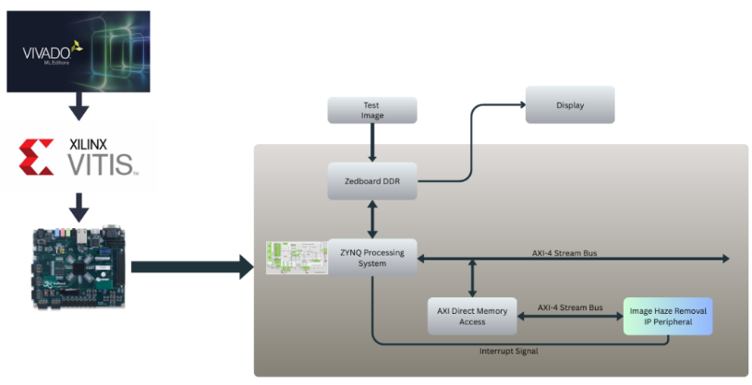

- Design and Methodology
The design methodology involves image dehazing algorithm using Verilog on FPGA. Key modules include Dark Channel Calculation, Atmospheric Light Estimation, Transmission Map Computation, and Image Restoration. Each module is optimized for parallelism and integrated as custom IPs to achieve real-time performance on the FPGA platform.

  - Window Generator
The window generator module serves as the initial stage in the FPGA-based image dehazing pipeline. It captures and stores a 3×3-pixel window from the input image, separating RGB components of each pixel and organizing them in a structured manner this is done using line buffers. This spatially grouped pixel data is essential for subsequent processing stages like atmospheric light estimation and transmission calculation.
By maintaining a rolling buffer of 9 pixels, the Window generator ensures efficient access to neighborhood pixel values required for spatial algorithms. It also generates a correct signal (i.e. indicating when 3×3 window is ready for down stream processing)
  - Dark Channel Calculation
The Dark Channel Calculation is a fundamental component in the image dehazing pipeline, where it aims to estimate the transmission map of a hazy image. This module adopts the Dark Channel Prior (DCP) algorithm , which takes as its assumption that in most natural outdoor images, there exists at least one colour channel (R, G or B) whose intensity is low in some local patch. The module evaluates the image pixel-by-pixel and compiles taking the minimum intensity value in each patch across all three colour channels.
The dark channel image is the primary output of this stage, which shows haze-affected areas. It is essential for further processing steps including transmission map generation and atmospheric light estimation. The Verilog module implementation enables parallel processing of FPGA that processes the data at a higher speed. The fact that it can cope with large size images and performance real-time dehazing, ultimately makes the proposed method suitable for applications like autonomous driving and surveillance systems.

  - Atmospheric Light Estimation (ALE)
The Atmospheric Light Estimation module is especially important in knowing how to spread light over the image, which is critical for a good performance of restored images from haze affected ones. To do that we estimate the global atmospheric light first by selecting the brightest pixel in dark channel image, as it is usually believed to be the most significant light. The top of the brightest pixels in the dark channel is selected by the module, which is further to collect such corresponding pixels from original image to estimate atmospheric light.
This estimation provides by eq. (5,6) to simulate the haze effect on the image radiance in order to help faithfully recover the underlying scene. The module was implemented in Verilog. It can also be efficiently implemented on FPGA platforms, greatly reducing the computational overhead. Constituting accurate atmospheric light does increase the effectiveness of the dehazing method to a great extent, where these values are used in order to calculate the transmission map. With the hardware realization, the dehazing system can be used in real time and is suitable for fast-processing applications such as traffic monitoring and environmental surveillance.

$I^{\left(dark^{'}\right)}\left(i,j\right)=minimum\left(minI^{R}\left(i,j\right),minI^{G}\left(i,j\right),minI^{B}\left(i,j\right)\right)$ -----------(5)

$A^{dark}={\max\left(i,j\right)}_{∈l}I^{\left(d{ark}^{'}\right)}\left(i,j\right)$ -----------(6)

  - Transmission Map Calculation Module (TE)
This Calculation module plays a key role in determining the level of haze present in each pixel of the image. Transmission map is calculated from dark channel image and atmospheric light estimation which denotes the amount of haze penetrates by the light. Low-transmission pixels are interpreted as the thick obscuring haze.
The transmission is learned by modeling the relationship between observed and true scene radiance in an image and the transmission factor, taking into account atmospheric scattering effects using eq. (7,8,9). A physical model is used to estimate the atmospheric light, from which a transmission map is derived indicating how the image should be corrected in order to dehaze it. This map is fundamental to the dehazing process, as it informs how each pixel’s intensity should be adjusted to recover the original scene appearance.
Implementing this module in Verilog enables hardware acceleration on FPGA platforms, leading to faster processing times and making it suitable for real-time applications. Such efficiency is particularly valuable in scenarios where quick response times are critical, such as in autonomous driving systems or live surveillance setups.

$$F^{c}\left(i,j\right)=\frac{\left[I\right]* \left[K\right]}{16\left(Edge Detected\right), 9\left(No Edge Detected\right)}$$
-------------(7)

Where:
I₁₁ | I₁₂ | I₁₃
I₁₂ | I₂₂ | I₂₃
I₃₁ | I₃₂ | I₃₃

Input 3x3 Hazy Window [I] =

Filter Kernel [K]= {

2 | 1 | 2
1 | 4 | 1
2 | 1 | 2

If a diagonal edge exists in the input 3x3 hazy window

1 | 2 | 1
2 | 4 | 2
1 | 2 | 1

If a horizontal or vertical edge exists in the input 3x3 hazy window

1 | 1 | 1
1 | 1 | 1
1 | 1 | 1

No edge Detected in the Input 3x3 Hazy Window

}

Transmission Value$t\left(i,j\right)=1-\left(\left(\frac{15}{16}\right)×\min_{c∈\{R,G,B\}}\left(\frac{\left(F^{c}\left(i,j\right)\right)}{A^{c}}\right)\right)$
-------------(8)

  - Scene Recovery and Saturation Correction Module (SRSC)
The Image Restoration block is the last step in the dehazing algorithm which reconstructs a haze-free image based on the recovered transmission map and atmospheric light knowledge. Using a physical haze model, this module eliminates the effects due to haze by adjusting the pixel intensity using the calculated transmission values. Specifically, the restoration process adjusts the color channels of each pixel by incorporating the atmospheric light and transmission estimates, resulting in an image with enhanced clarity and visibility, which is especially beneficial in foggy or hazy conditions.
The module is implemented in Verilog to efficiently process image data using eq. (9, 10), with parallel computations applied across pixels to speed up the restoration process. The FPGA-based design enables high-speed execution, supporting real-time dehazing for applications where fast and accurate image enhancement is critical, such as autonomous driving and surveillance. By shifting the image restoration tasks to hardware, this approach greatly improves processing efficiency, allowing clearer images to be generated quickly for further interpretation or display purposes.

$J \left(i,j\right) = \frac{I^{c}\left(i,j\right) - A^{c}}{\operatorname{maximum}{\{} t\left(i,j\right), 0.35 \}} + A^{c}, ∀ c ∈ \{R,G,B\}$ -----------(9)

$J^{C}\left(i,j\right)={\left(A^{c}\right)}^{0.3}×{\left(J \left(i,j\right)\right)}^{\left(1-0.3\right)}, ∀c∈\{R,G,B\}$ ----------(10)

Fig. 2. Methodology
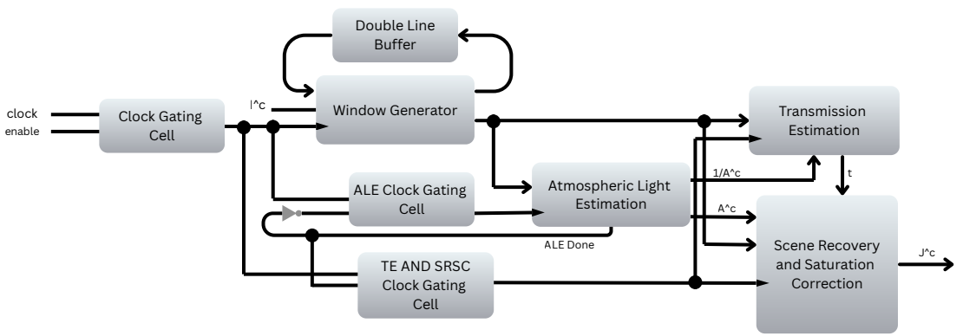

- Hardware Architecture

The implementation of this dehazing system was accomplished through Verilog HDL on a Xilinx FPGA platform. The complete dehazing pipeline—comprising Dark Channel Calculation, Atmospheric Light Estimation, Transmission Map Calculation, and Image Restoration—was modularly designed to optimize performance and resource utilization. Each module was written in Verilog and tested independently using simulation tools in Vivado to ensure functional correctness. After simulation, the modules were synthesized, implemented, and integrated into a top-level design. Vivado was used for synthesis, placement, routing, and generation of the bitstream for configuring the FPGA. Custom IPs were generated for each processing stage, enabling reuse and scalability. The design was deployed on a Zynq based FPGA platform, with real-time image data being processed through the pipeline. By leveraging the parallelism of the FPGA, the system achieved low-latency, high throughput dehazing performance suitable for real-time applications like surveillance and autonomous navigation.

Fig. 3. Custom Intellectual Property
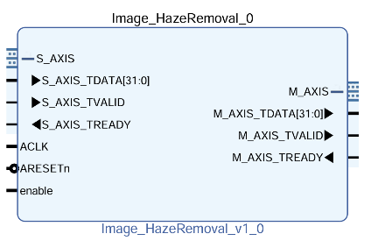

Fig. 4. Block Diagram
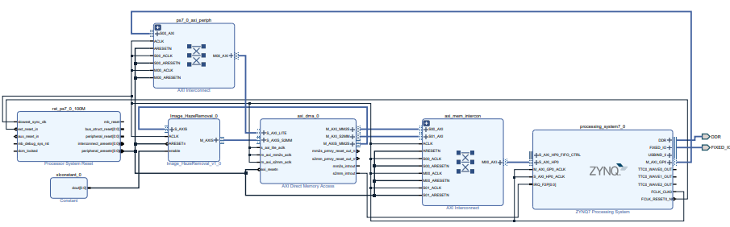

TABLE I. Resource Utilization
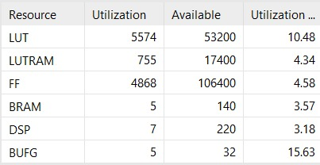
- Results
TABLE II. FPGA results
Hazy Image | Dehazed image
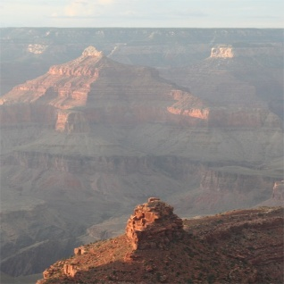 | 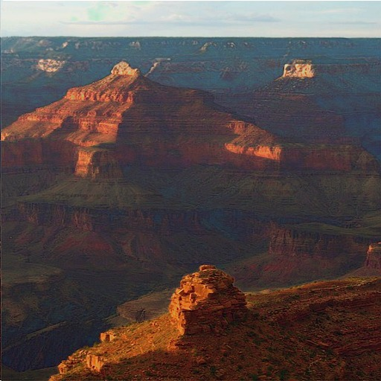
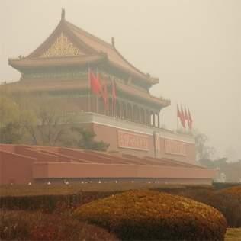 | 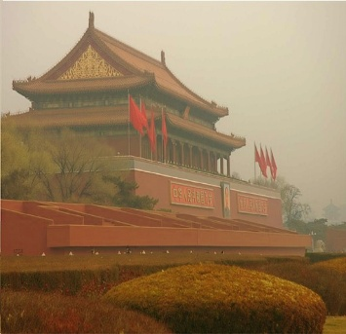
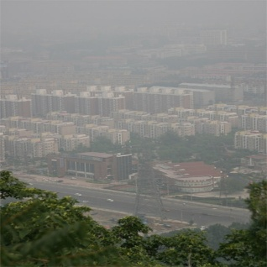 | 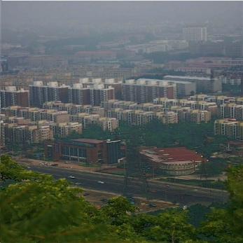
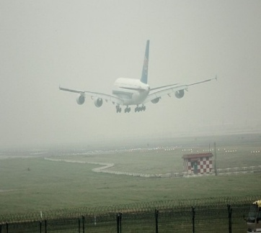 | 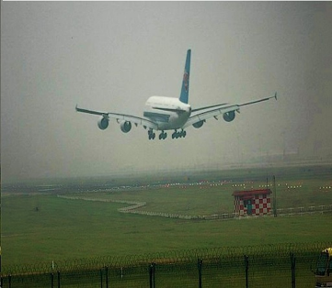

TABLE III. Execution time comparison for 512×512 images
(Hardware v/s Software)
Platform/  Environment | Hardware | Clock  (GHz) | Simulation/Tool | Execution Time (ms)
FPGA  (ZedBoard) | ARM Cortex-A9 + FPGA | 0.1 | Xilinx Vivado  And Vitis 2021.2 | 5.2
Python  Implementation | Intel i5-13450HX | 2.4 | Python 3.12 | 80
MATLAB  Implementation | Intel i5-13450HX | 2.4 | MATLAB 2024a | 300

- Conclusion
This work i.e Dark Channel Prior (DCP) algorithm for image dehazing in real-time was successfully implemented on a ZedBoard using Verilog HDL, with Vivado 2021.2 and Vitis 2021.2 tools. The design efficiently demonstrated the FPGA’s capability i.e parallel and high-speed computation to process images of size 512×512 in real time, exhibiting how hardware acceleration can be effectively utilized for this application. These benefits are particularly valuable in applications that require quick and reliable image enhancement, such as autonomous navigation, outdoor surveillance, and advanced driver-assistance systems.
The use of DCP, a widely known methodology for haze removal, proved to be computationally demanding. Implementing it on an FPGA facilitated efficient execution while maintaining image quality. The real-time performance achieved by this system confirms that FPGA platforms can handle complex vision tasks without compromising speed or power efficiency.
CNN-based approaches can offer adaptive learning capabilities, which can help further refine the estimation process and enhance the final image output. Combining neural networks with FPGA-based acceleration opens the door to more sophisticated and responsive dehazing solutions, improving both performance and robustness across varying environmental conditions. As future work, we propose integrating a CNN accelerator for transmission map estimation to further improve speed and enhance image quality, enabling real-time applications in outdoor vision and autonomous systems.
These proposed enhancements will empower such systems to process visual data more efficiently and with greater reliability, ultimately supporting safer and more intelligent solutions across a wide range of operational environments.

References
- Xiaohui X. “FPGA Implementation of Dark Channel Prior for Image Dehazing.” Master Thesis, University of Electronic Science and Technology of China, 2022.
- Tang Q , Yang J , and He X , “Nighttime Image Dehazing Utilizing Retinex and Dark Channel Prior Enhanced by Taylor Series Expansion.” Computer Vision and Image Understanding, vol. 202, 2021, article 103086.
- Lee S, Yun S, Nam J, Won C, and Jung S . “A Comprehensive Review of Image Dehazing Techniques Based on Dark Channel Prior.” EURASIP Journal on Image and Video Processing, 2016, pp 1–23.
- Shiau Y-H, Yang H-Y, Chen P-Y and Chuang Y-Z. “Efficient Hardware Design for Fast Haze Removal.” IEEE Transactions on Circuits and Systems for Video Technology, vol. 23, no. 8, 2013, pp 1369–1374.
- He K, Sun J, and Tang X. “Removing Haze from a Single Image Using Dark Channel Prior.” IEEE Transactions on Pattern Analysis and Machine Intelligence, vol. 33, no. 12, 2011, pp 2341–2353.
- Upadhyay BB and Sarawadekar K. “VLSI Architecture for Saturation-Based Image Dehazing Algorithm.” IEEE Transactions on Very Large Scale Integration (VLSI) Systems, vol. 31, no. 7, 2023, pp 987–999.
- He K, Sun J, and Tang X. “Guided Filtering for Image Processing.” Proceedings of the 11th European Conference on Computer Vision (ECCV), Part I, 2010, pp 1–14.
- Fattal R. “Dehazing a Single Image.” Proceedings of ACM SIGGRAPH, 2008, pp 72:1–72:9.
- Oakley J P, and Bu H. “Correcting Contrast Loss in Color Images.” IEEE Transactions on Image Processing, vol. 16, no. 2, 2007, pp 511–522.
- He K, Sun J, and Tang X. “Single Image Haze Removal Utilizing Dark Channel Prior.” IEEE Transactions on Pattern Analysis and Machine Intelligence, vol. 33, no. 12, 2010, pp 2341–2353.
- Tarel J-P and Hautiere N. “Restoring Visibility Quickly from a Single Image in Color or Grayscale.” Proceedings of the IEEE International Conference on Computer Vision (ICCV), 2009, pp 2201–2208.
- Narasimhan SG and Nayar SK. “Contrast Restoration in Weather-Degraded Images.” IEEE Transactions on Pattern Analysis and Machine Intelligence, vol. 25, no. 6, 2003, pp 713–724.
- Majoka MN and Raja G. “FPGA-Based Image Dehazing Architecture for Real-Time Applications.” Proceedings of the 2017 Intelligent Systems Conference (IntelliSys), IEEE, 2017, pp. 1089–1094.
- Vipin kizheppatt :YouTube Playlist: Image Processing Tutorials on zynq
- HUI HU,: FPGA Image Processing(Udemy Course)

