**Question**

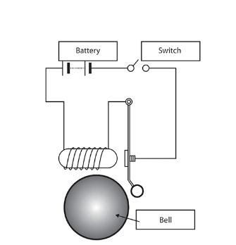

1. **Make a Simulink model of Doorbell using *solenoid* block with the following details:**

In the above arrangement, when the switch is closed the electromagnet receives electrical power from the battery and pulls the metal arm to hit the bell producing sound.

Create a situation where the switch is closed for 2 seconds and then released. Observe the physical movement of the plunger.

**Assume remaining parameters.**

     2.**Use a thermistor to sense the temperature of a heater & turn on or turn off the fan as per the below conditions:**

Temperature source: 20 °C from 0 to 10 seconds, 27 °C from 10 to 30 seconds, 23 °C from 30 to 50 seconds

Fan conditions: ON if the temperature above 25 °C, OFF otherwise

**NOTE:** If you are using Matlab R2021a above versions, kindly convert you to lower or equal to R2021a version and attach it in the submission.

Conversion: Save > Pervoius Version > Choose R2021A or lower version.

**Grading Policy :**

1. Upload the supporting results as images or by any other means

2. Write a detailed report

3. Report attached as an image will lead to zero marks

4. plagiarism is not tolerated

5. upload Simulink files if needed through the google drive, any external links will not be accepted

**Your Answers**

Challenge 1-Listed blocks where used to create the model.

1. Signal Builder

2. Solenoid

3. Battery

4. Ideal tranlational motion sensor

5. Electrical and mechanical references

6. Solver configure

7. Display and scope

8. Convertors

To create required situation in simulink model, signal builder block was used and signal was replicated as per problem requirement. This signal was then given to battery via switch and simulink to ps convertor, further battery was connected to solenoid, and to sense the plunger translational motion ideal translational motion sensor was used. Output of this sensor are given to a scope(Plunger position) and display (Translational velocity) blocks.

Challenge 2-Listed blocks where used to create the model.

1. Signal Builder

2. Constant Temperature Source

3. Thermister

4. Dc Voltage Source

5. Voltage sensor and current sensor

6. Product block

7. Switch

8. Constant volatge source

9. DC motor

10. Ideal rotational sensor

11. Convertor

12. Display and scope

13. References and solver

Firstly the required temperature condition was created with the help of signal builder block, with help of excel import building a signal is quiet simple in simulink block. This signal was given to temperature source, which is further connected to thermister. Thermister circuit consist of voltage source, current sensor and voltage sensor whose outputs are given to product block- According to Ohm's law voltage is directly proportional to current, using same principle resistance against each temperature value was measured with help of this circuit. Output of this product block was given to a switch whose trigerring threshold value was set equal to value corresponding to 24 degree celcius, in order to model fan DC motor circuit was used. This circuit consists of DC motor, controlled voltage source and ideal rotational sensor. Output of this circuit is shown with help of scope and display.