PROJECT GUIDE · VERSION 1.0 · OCTOBER 2026
SunsetGuard
End-to-End Project Guide
How to retire deprecated APIs safely — and how this project is designed to do it, from the first client request to the final safe-to-remove verdict.

Prepared for | Rohan Meshram
Project | SunsetGuard — API deprecation tracking and safe endpoint retirement
Repository | github.com/rohanmeshram/SunsetGuard
Current status | Phase 0 foundation: structure, infrastructure, CI, and design docs
Runtime code | Planned for Phases 1–8; not implemented yet
Document version | 1.0 · October 2026
License | Apache License 2.0

READ THIS FIRST
• This guide is honest about the gap between design and implementation. The repository today is a Phase 0 foundation; the full pipeline is the target architecture.
• Every major feature is labelled Built today, Planned, or Design choice. Use those labels in interviews so you never overclaim.

This document is both a product explanation and an interview preparation workbook. Read Parts I–III to understand the system, Parts IV–V to defend the decisions, and Part VI to rehearse.

About this guide
This guide explains SunsetGuard end to end: the problem it solves, how a request travels through the system, why each technology is used, what is built today, what is still planned, and how to explain all of it clearly in an interview.

Purpose
The goal is simple: after reading this document, you should be able to draw the architecture on a whiteboard, trace one API call through every component, justify the main technology choices, and answer follow-up questions without hiding behind buzzwords. The language is deliberately plain. Technical terms are explained the first time they appear and collected again in the glossary.

Who this guide is for
• You, the author. Use it as a single source of truth while building the project phase by phase.
• Interviewers and reviewers. Use it to understand the design, the trade-offs, and the current status.
• Future contributors. Use it to see how the modules, data model, and delivery plan fit together.

How status is labelled
SunsetGuard is being built in phases. A design document that pretends everything is finished is worse than useless in an interview. This guide therefore uses four labels consistently:
Table 1 — Status labels used throughout this guide
Label | Meaning | How to read it
Built today | Present in the repository now. | You can point to the file and explain it.
Planned | Designed but not coded yet. | You can explain the intent, but must say it is planned.
Design choice | A decision with alternatives and trade-offs. | You can defend it and name what it costs.
Interview tip | A suggested way to explain or rehearse. | Use it to structure an answer, not to invent facts.

How to use the guide
1. Read Part I and Part II first. They give you the product story and the end-to-end flow.
2. Read Part III and Part IV with a pen. Sketch the architecture and the data model from memory.
3. Read Part V to understand the build, test, and delivery plan.
4. Use Part VI as a rehearsal workbook. Cover the answers, say them out loud, then compare.

Source material
The factual claims in this guide come from the repository itself:
• README.md, QUICKSTART.md, CONTRIBUTING.md, and CHANGELOG.md
• adr/ADR-001-rabbitmq-over-kafka.md and adr/ADR-002-client-side-aggregation.md
• The parent pom.xml and all four module POMs
• docker-compose.yml and .github/workflows/build.yml
• docs/SETUP.md, docs/PHASE-0-CHECKLIST.md, and docs/PHASE-0-SUMMARY.md
Where the repository does not yet define a detail — for example, the exact verdict thresholds or the final API key hashing algorithm — the guide presents a recommended design and says so. Those details are open questions, not hidden facts.
THE HONESTY RULE
Never say “I built the whole pipeline” when the repository only contains the foundation. The stronger answer is: “I designed the full pipeline, documented the decisions, and built the Phase 0 foundation; here is exactly what comes next.” That answer is credible, specific, and easy to defend.

Executive summary
SunsetGuard is a safety system for retiring deprecated APIs. It tells a team who still calls an old endpoint, how usage is changing, and whether removal is safe — with evidence instead of guesswork.

The problem
Every API eventually has an old endpoint that nobody wants to own. The team marks it “deprecated”, writes a note in the documentation, and moves on. Six months later someone asks the expensive question: can we delete it yet? The honest answer is usually “let me search the logs”, followed by hours of grepping that still does not identify the old mobile app, the partner integration, or the nightly cron job that depends on it.
The risk is asymmetric. Keeping an endpoint costs a little maintenance. Deleting one that is still in use can break a customer, trigger an incident, and damage trust. Most teams therefore keep dead endpoints forever, or delete them on a guess and hope nothing breaks.

The solution
SunsetGuard answers three questions automatically:
• Who still calls this endpoint? Not just a count — the application, version, and last time it was seen.
• How much, and is it declining? Hourly and daily trends, not a single unhelpful number.
• Is it safe to delete now? A plain-English verdict with a confidence level and the reasons behind it.
It also closes the loop: teams can mark an endpoint as deprecated, send standard deprecation and sunset headers, notify known consumers, and block pull requests that remove an endpoint still in use.

How it works in one breath
Client request → monitored API + SunsetGuard starter → local counters → periodic usage report → ingest API → Redis checks → RabbitMQ queue → worker → PostgreSQL rollups → verdict engine → dashboard, CLI, notifications, and pull-request checks.

What exists today
Table 2 — The honest snapshot: foundation built, runtime pipeline planned
Area | Status | Evidence in the repository
Maven multi-module build | Built today | Parent POM + four module POMs (server, starter, CLI, demo)
Local infrastructure | Built today | PostgreSQL 16, Redis 7, and RabbitMQ 3.13 in Docker Compose
CI pipeline | Built today | GitHub Actions build, test, coverage, and Trivy scan workflow
Architecture decisions | Built today | Two ADRs covering RabbitMQ and client-side aggregation
Runtime Java code | Planned | No application class, controllers, entities, filter, or worker yet
Database schema | Planned | Schema described in the README; no Flyway migrations yet
Dashboard, CLI, GitHub Action | Planned | Designed in the roadmap; no implementation yet
Tests and load results | Planned | Test stack configured; no tests or benchmarks run yet

Why it matters
• Evidence beats intuition. A verdict with reasons and confidence is easier to defend than “I think it is safe”.
• Consumer-aware, not just traffic-aware. Knowing that 412 calls came from android-app v2.3 is actionable; knowing there were 412 calls is not.
• Fail-open by design. The monitored API keeps serving traffic even if SunsetGuard is unavailable.
• Built for the whole lifecycle. Mark, track, notify, decide, and block unsafe deletions — not just a dashboard.
• Realistic scope. It runs on a normal development laptop and uses a stack that is common in enterprise Java teams.

What success looks like
Table 3 — Product goals and proposed measurements — targets, not measured results
Goal | Target | How it would be measured
Answer “who still calls this?” | Under 1 minute | Dashboard lookup; no log search
Keep the monitored API fast | Filter overhead below 1 ms | Microbenchmark and load test
Reduce reporting traffic | 100× to 10,000× fewer writes | Compare per-request events with 10-second aggregates
Detect unsafe removals | Block PR before merge | GitHub Action failure on an in-use endpoint
Operate on modest hardware | 8 GB development laptop | Docker Compose memory footprint
Contents
The contents are generated from the heading styles. Page numbers update automatically when the document opens; if your viewer does not update fields, right-click the list and choose “Update Field”.
Right-click and choose Update Field to build the table of contents.
PART I · UNDERSTAND THE PRODUCT

1. The problem SunsetGuard solves
Deprecated APIs are easy to create and hard to remove. The technical work is small; the uncertainty is large. SunsetGuard exists to replace that uncertainty with evidence.

1.1 A familiar Monday-morning question
A team replaces GET /v1/users/{id} with GET /v2/users/{id}. The old endpoint is marked deprecated in the documentation, a ticket is opened, and everyone moves on. Six months later a manager asks: “Can we delete `/v1/users/{id}` yet?”
The engineer opens the access logs and starts searching. The logs are large, rotated, and spread across several services. They show IP addresses, not application names. They show raw URLs, not route templates. They cover seven days, not the ninety days the team agreed on. After three hours the answer is still a shrug: maybe the old mobile app still calls it; maybe a partner does; maybe a nightly batch job does.
The expensive part of deleting an API is not deleting it. It is proving that nobody still depends on it.

1.2 Why deprecated endpoints stay alive
• No ownership. The endpoint may have been written by someone who has left the team.
• No consumer identity. A request count does not tell you which application, version, or team made the call.
• No reliable time window. Log retention is often shorter than the deprecation notice period.
• No shared definition of “safe”. One engineer says “no calls for a week is enough”; another wants a month of evidence.
• No feedback loop. Consumers are not told that the endpoint is going away, so they keep using it.
• Asymmetric risk. Keeping dead code is cheap; breaking a customer is expensive. The safe default is to do nothing.

1.3 The hidden consumers
Table 4 — Why anonymous traffic counts are not enough
Consumer type | Typical example | Why logs often miss it | What SunsetGuard would record
Old mobile app | android-app v2.3 still installed on 5% of devices | User-agent strings are noisy or missing | App name, version, last seen, call count
Partner integration | A partner's nightly order sync | Traffic comes from a shared IP or proxy | Stable consumer identity from a header or key
Scheduled job | A cron job at 02:00 every Sunday | A seven-day log window may show nothing | Last seen plus a long observation window
Internal script | A one-off reporting script nobody documented | The script uses a shared service account | API-key identity and first/last seen
Another service | A service that should have migrated but did not | Logs are split across services | Service name, version, and route template

1.4 Why “just search the logs” is not enough
Table 5 — Comparison of approaches (adapted from the project README)
Question | Raw logs | API gateway | SunsetGuard
Who is calling? | Maybe, if the user-agent is useful | Usually IP or key, not app version | Consumer identity, version, and last seen
How much, over time? | Manual counting | Yes, if the gateway is in the path | Hourly and daily rollups
Is usage declining? | Manual comparison | Partial | Trend plus active-consumer count
Is removal safe? | No | No lifecycle model | Verdict with confidence and reasons
Works across services? | Only if logs are centralised | Only behind one gateway | Any Spring Boot service with the starter
Blocks an unsafe PR? | No | No | CLI and GitHub Action

Logs answer “what happened?”. SunsetGuard answers “what should we do next?”. Those are different products. An API gateway can help if every service already sits behind one, but it still does not model the deprecation lifecycle, the consumer relationship, or the pull-request decision.

1.5 What a good answer looks like
Table 6 — The five ingredients of a trustworthy deprecation decision
Requirement | A useful answer | Why it matters
Identity | “android-app 2.3 and partner-sync are still calling it.” | You know who to contact and what to migrate.
Volume | “412 calls in the last 7 days, down 38% from the previous week.” | You can distinguish a trickle from a dependency.
Recency | “Last call was 5 minutes ago.” | A recent call is strong evidence of active use.
Coverage | “All four instances reported in the last 24 hours.” | You know the data is not missing a deployment.
Confidence | “Not safe to remove — high confidence, 90 days of data.” | The decision is explainable and auditable.

INTERVIEW FRAMING
“The problem is not that teams cannot delete code. It is that they cannot prove it is safe. Logs are optimised for debugging, not for lifecycle decisions. SunsetGuard turns raw traffic into consumer-aware evidence and a verdict that a team can defend.”

2. What SunsetGuard does
SunsetGuard is a drop-in Spring Boot starter plus a server that turns endpoint traffic into a defensible safe-to-remove decision.

2.1 The product in one sentence
ONE SENTENCE
SunsetGuard tells you who still calls a deprecated API endpoint, how that usage is changing, and whether it is safe to remove — then helps you prevent an unsafe removal.

That sentence contains three jobs. Observe the traffic without slowing the monitored service. Analyse the traffic by consumer and over time. Act on the result through a dashboard, a notification, and a CI check. The product is deliberately narrower than an observability platform: it is a safety system for one decision.

2.2 Capabilities and status
Table 7 — MVP capabilities and the phase in which each is planned
Capability | What it does | Status
Drop-in Spring Boot starter | One dependency; auto-configured filter and reporter | Planned — Phase 2
Consumer-aware tracking | Records app, version, API key, or user-agent identity | Planned — Phase 2
Deprecation annotation | Marks an endpoint with a sunset date and replacement | Planned — Phase 2
Standard HTTP headers | Deprecation, Sunset, and Link headers on responses | Planned — Phase 2
Usage ingestion | Validates, rate-limits, deduplicates, and queues reports | Planned — Phase 3
Hourly/daily rollups | Stores additive counters in PostgreSQL | Planned — Phase 3
Verdict engine | Produces IN_USE, LOW_USAGE, SAFE_TO_REMOVE, or INSUFFICIENT_DATA | Planned — Phase 4
Notifications | Slack, Discord, and email for important changes | Planned — Phase 4
Dashboard | Server-rendered endpoint and consumer views | Planned — Phase 5
CLI + GitHub Action | Checks a pull request for unsafe endpoint removals | Planned — Phase 6
Prometheus + Grafana | Operational metrics and dashboards | Planned — Phase 7
OpenTelemetry | Trace and metric export | Planned — post-MVP

2.3 The user journey
1. Install the starter. Add one dependency to a Spring Boot service and set the server URL and API key.
2. Mark an endpoint. Add @DeprecatedEndpoint with a sunset date and a replacement route.
3. Let traffic accumulate. The filter counts requests locally; the sender reports aggregates every ten seconds.
4. Watch the dashboard. See which consumers call the endpoint, how often, and when they were last seen.
5. Notify consumers. Send a deprecation notice to the teams or partners recorded in the consumer registry.
6. Read the verdict. When the policy window is satisfied, the engine produces a verdict with reasons and confidence.
7. Remove or wait. A human makes the final call. If a pull request removes an endpoint still in use, CI blocks it.

2.4 Who uses it
Table 8 — Who the product serves and what each persona needs
Persona | Primary question | What they use
Backend engineer | Is this endpoint safe to delete? | Endpoint detail page, verdict, consumer list
Platform team | Which teams own the risky dependencies? | Project overview, consumer-to-team mapping (future)
Engineering manager | Are we making progress on deprecations? | Trends, aging endpoints, weekly digest (future)
Partner / consumer | What do I need to change, and by when? | Deprecation headers, sunset date, replacement link
SRE / on-call | Did a removal cause an incident? | Verdict history, audit log, notifications

2.5 The deprecation lifecycle
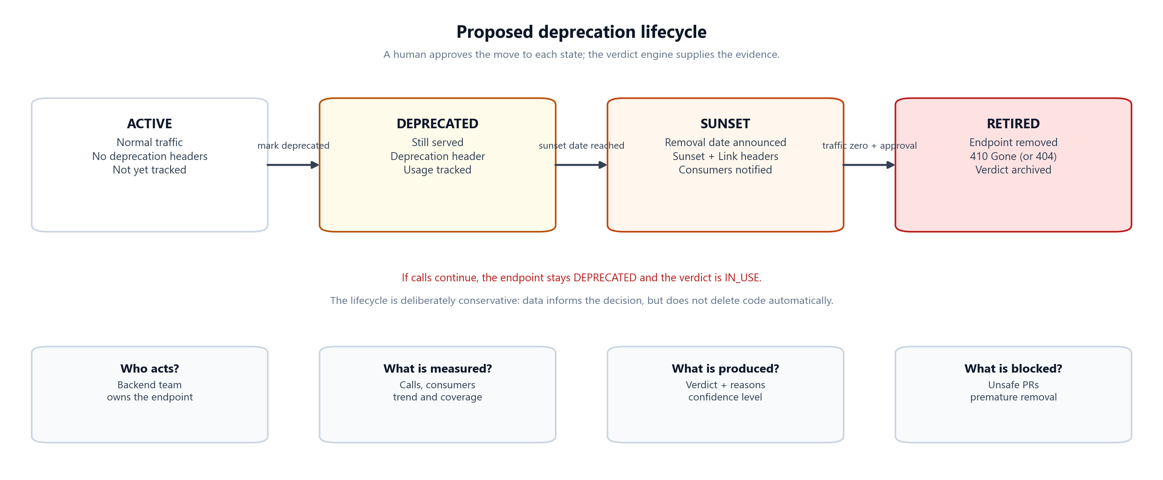
Figure 1 — The proposed lifecycle. SunsetGuard supplies evidence; a human approves each state change.
The lifecycle is deliberately conservative. An endpoint moves from ACTIVE to DEPRECATED when the team announces the replacement. It moves to SUNSET when a removal date is published and consumers have been notified. It becomes RETIRED only after the evidence supports removal and a human approves it. The verdict engine can recommend a move, but it never deletes code by itself.

2.6 What SunsetGuard is not
• Not an APM tool. It does not capture traces, spans, or per-request latency. Use Datadog, New Relic, or OpenTelemetry for that.
• Not an API gateway. It does not route or block production traffic. It observes and advises.
• Not a log aggregator. It stores aggregates, not raw request logs.
• Not a replacement for communication. A dashboard does not migrate a partner integration; a human does.
• Not a runtime dependency. The monitored API must keep working if SunsetGuard is unavailable.
• Not a generic feature-flag system. It is specialised for endpoint deprecation and removal.
PRODUCT FRAMING
“Think of it as a smoke detector for API deprecations. It does not put out the fire, but it tells you where the smoke is coming from and whether it is safe to close the door.”

3. Current status: built today vs planned
The repository is a Phase 0 foundation. That is a real achievement, but it is not the runtime product. This chapter draws the line clearly so the rest of the guide can describe the target design honestly.

3.1 Repository snapshot
Table 9 — What the repository actually contains at the time of writing
Item | Current state
Working branch | rohan/phase-1-development (up to date with origin)
Latest commit | Java 25 upgrade; build and tests reported successful
Project phase | Phase 0 — foundation complete; Phase 1 runtime work not started
Modules | Server, Spring Boot starter, CLI, demo orders API
Build | Maven multi-module; Java 25; Spring Boot 4.1.2 BOM
Infrastructure | PostgreSQL 16, Redis 7, RabbitMQ 3.13 via Docker Compose
CI | GitHub Actions build, unit/integration test steps, JaCoCo, Trivy
Documentation | README, quickstart, setup, phase checklists, two ADRs
Runtime code | No Java source files, controllers, entities, filter, worker, or templates yet
Tests | Test dependencies configured; no test classes or measured results yet

3.2 What is built today
Table 10 — Phase 0 deliverables that genuinely exist
Area | Concrete evidence | Why it matters
Multi-module structure | Parent POM plus four child POMs | Clean boundaries between server, client library, CLI, and demo
Dependency management | Spring Boot BOM, Testcontainers BOM, shared versions | One place to upgrade versions
Local infrastructure | Docker Compose with health checks and volumes | The full stack can run on a laptop
CI pipeline | .github/workflows/build.yml | Every push gets a build, test, coverage, and security scan
Architecture decisions | ADR-001 and ADR-002 | The two most important trade-offs are documented
Project documentation | README, QUICKSTART, SETUP, phase docs | A new contributor can understand the intent
Licensing and contribution | Apache 2.0, CONTRIBUTING, CHANGELOG | Open-source hygiene from day one

3.3 What is deliberately not built yet
Table 11 — The runtime work still ahead
Planned area | What is missing | Phase
Server application | Spring Boot main class, configuration, profiles | 1
Database schema | Flyway migrations, JPA entities, repositories | 1
Projects and API keys | CRUD endpoints, key hashing, authentication | 1
Starter library | Servlet filter, consumer identity, aggregator, sender | 2
Ingestion pipeline | Ingest controller, Redis controls, RabbitMQ producer | 3
Worker | Queue consumer, idempotent upserts, dead-letter handling | 3
Verdict engine | Scheduled analysis, confidence rules, verdict history | 4
Notifications | Slack, Discord, email adapters | 4
Dashboard | Thymeleaf templates, htmx interactions | 5
CLI and GitHub Action | Picocli commands, PR diff check | 6
Hardening | Metrics, load tests, security review, retention jobs | 7

3.4 Configured is not the same as implemented
This distinction matters in interviews. A dependency in a POM or a service in Docker Compose is configuration, not a working feature. The repository is strong on configuration and weak on runtime code — and that is exactly what a Phase 0 foundation should be.
Table 12 — Configuration exists; implementation does not
Looks like a feature | What actually exists | What is still missing
RabbitMQ messaging | A RabbitMQ container in Compose and the AMQP starter in the POM | Exchange, queue, producer, consumer, retry, DLQ
Redis rate limiting | The Redis starter and a running Redis container | Token-bucket script, key design, failure policy
PostgreSQL storage | A PostgreSQL container and the JPA/Flyway dependencies | Schema, entities, repositories, queries
Spring Security | The security starter in the POM | Authentication, authorization, tenant scoping
Thymeleaf dashboard | The Thymeleaf starter in the POM | Templates, controllers, htmx interactions
Testcontainers | The Testcontainers BOM and dependencies | Integration tests and CI container setup
PART II · FOLLOW ONE REQUEST

4. The complete end-to-end flow
This is the chapter to read twice. It connects the product story to the architecture by following one client request from the moment it enters the monitored API to the moment a team sees a verdict.

4.1 The ten stages
Table 13 — The end-to-end flow, one stage at a time
# | Stage | What happens | Where | Typical delay | If it fails
1 | API request | A client calls an endpoint in the monitored service. | Client → API | Network time | The API's normal error handling
2 | Observe | The starter filter records route, method, consumer, and status class. | Monitored API | Microseconds | Fail-open; the request continues
3 | Aggregate | A local counter is incremented; no network call is made. | Starter memory | Nanoseconds | Count is lost; API unaffected
4 | Report | Every ~10 seconds the sender posts a compact report. | Starter → server | ~10 s | Buffer, retry, then drop oldest
5 | Ingest | The server authenticates, rate-limits, deduplicates, validates, and publishes. | Ingest API | Target p95 < 100 ms | Return 4xx/5xx; starter retries
6 | Queue | RabbitMQ holds the report so a spike cannot overwhelm the database. | RabbitMQ | Milliseconds | Ingest returns 503; no DB spike
7 | Store | A worker upserts hourly totals and updates the consumer registry. | Worker → PostgreSQL | Seconds | NACK, retry, then DLQ
8 | Analyse | The verdict engine evaluates recency, consumers, trend, and coverage. | Scheduled job | Daily | Verdict stays stale; dashboard shows last updated
9 | Communicate | Dashboard, CLI, notifications, and PR checks expose the result. | Read paths | On demand | Retry; the verdict is still stored
10 | Decide | A human migrates, waits, or removes the endpoint. | Team process | Days to weeks | The endpoint stays deprecated

4.2 The architecture at a glance
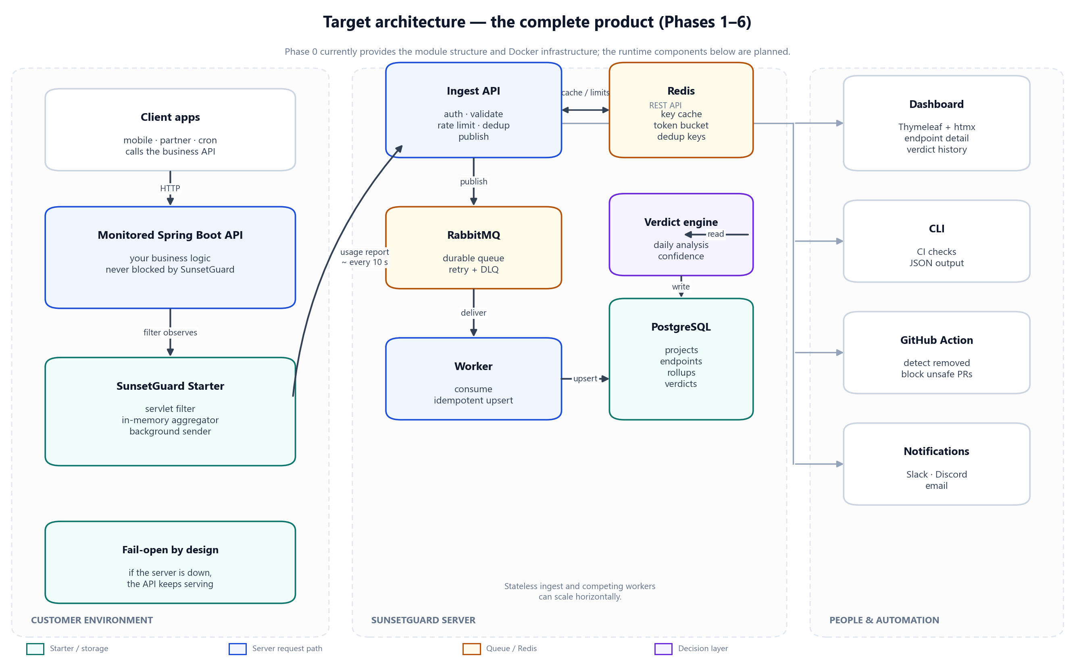
Figure 2 — Target architecture. The starter lives inside the customer service; the server owns ingestion, storage, and decisions.
There are three useful ways to read the diagram. Left to right shows the journey from customer traffic to a human decision. Top to bottom shows the difference between the request path (fast, local) and the background path (network, queue, database). Inside the server shows the separation between the synchronous ingest edge and the asynchronous worker.

4.3 One request, traced
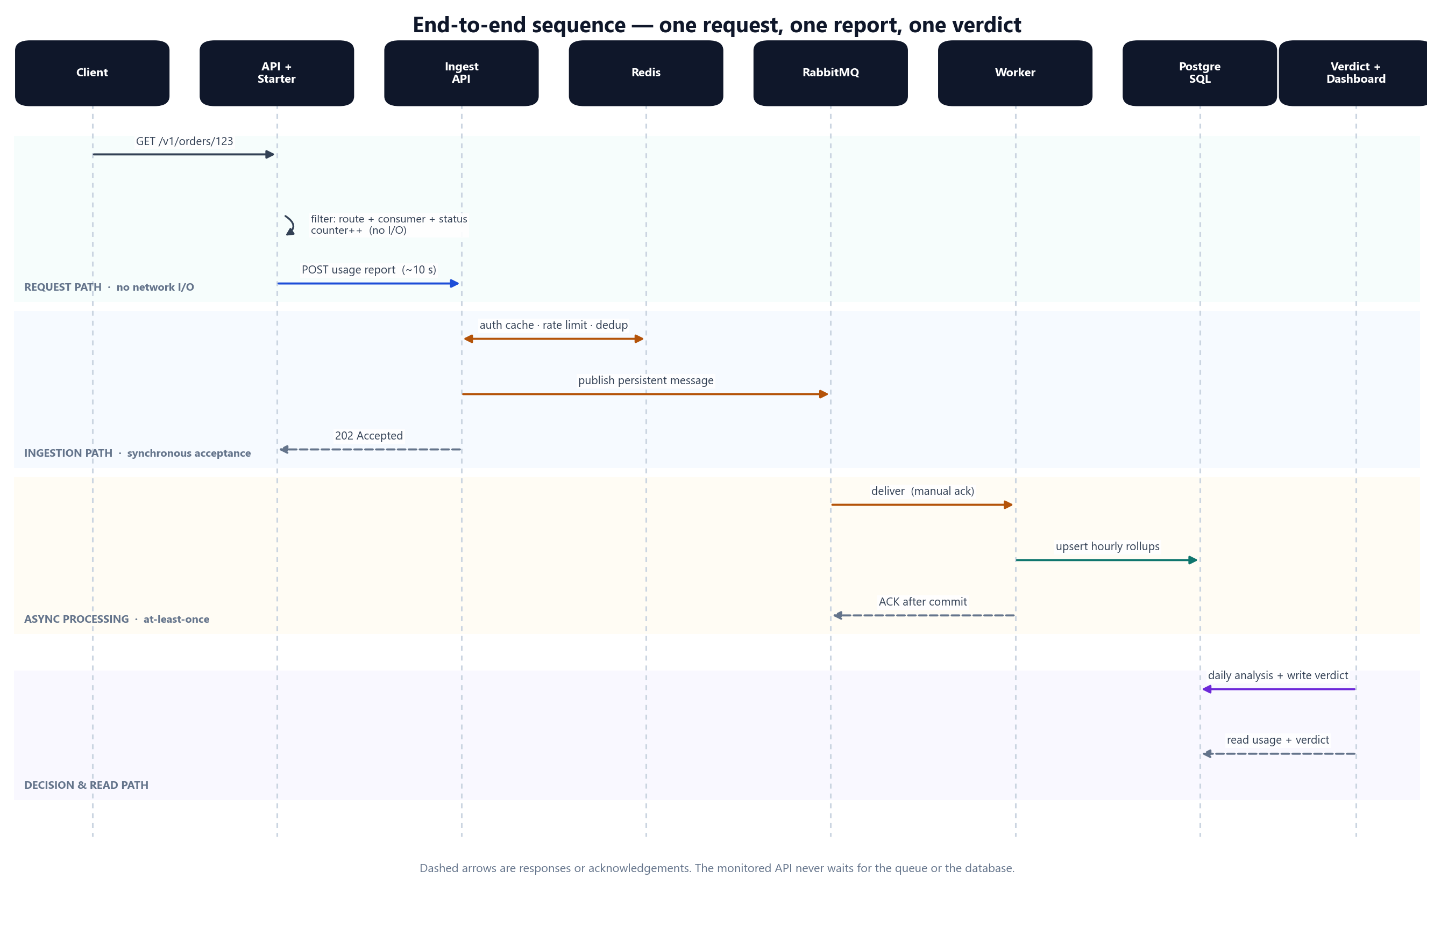
Figure 3 — Sequence view. The monitored API never waits for Redis, RabbitMQ, PostgreSQL, or the verdict engine.
Imagine an Android app on version 2.3 calls GET /v1/orders/123. The app sends a header such as X-Client-Id: android-app/2.3. The monitored API handles the request normally. The SunsetGuard filter wraps the request, resolves the route template /v1/orders/{id}, records the consumer as android-app version 2.3, notes the response class (2xx), and increments an in-memory counter. The client receives its order. Nothing in the response waited for SunsetGuard.
Every ten seconds the starter snapshots the counters, resets them, and sends a report. The report contains aggregates, not individual requests. This is the key design choice that makes the system affordable.
Illustrative usage report — one aggregate row per endpoint, consumer, and status class
{
"reportId": "8f14e45f-ea0b-4c3f-9a1e-7d2c6b5a1024",
"service": "orders-api",
"instance": "orders-api-7c9f",
"windowStart": "2026-10-26T10:00:00Z",
"windowEnd": "2026-10-26T10:00:10Z",
"aggregates": [
{
"method": "GET",
"route": "/v1/orders/{id}",
"consumer": { "app": "android-app", "version": "2.3" },
"status2xx": 409,
"status4xx": 3,
"status5xx": 0
}
]
}

The server authenticates the API key, applies the Redis token bucket, checks the report ID for duplicates, validates the payload, and publishes a message to RabbitMQ. It returns 202 Accepted once the message is safely queued. A worker consumes the message, writes an idempotent upsert, and acknowledges it. The resulting row is small: one hourly bucket for one endpoint and one consumer.
Illustrative stored rollup — many requests collapsed into one additive row
usage_hourly(
endpoint_id = 42,
consumer_id = 17,
bucket_start = 2026-10-26 10:00:00+00,
status_2xx = 409,
status_4xx = 3,
status_5xx = 0
)

The dashboard reads that row (and its daily rollup) and shows the endpoint as DEPRECATED, the consumer as android-app v2.3, the last call as “just now”, and the verdict as IN_USE. The team now has a name to contact and a number to watch.

4.4 What the server does with a report
1. Authenticate. Resolve the API key to a project. The key is stored as a hash; the plaintext is never stored.
2. Rate-limit. Apply a Redis token bucket per key so one buggy client cannot flood the ingest API.
3. Deduplicate. Use the report ID with SET NX and a TTL. A duplicate returns success but is not processed twice.
4. Validate. Check required fields, size limits, numeric bounds, aggregate count, and timestamp skew.
5. Publish. Send a persistent message to RabbitMQ with publisher confirms. Return 202 only after the broker accepts it.
6. Consume. A worker reads the message with a bounded prefetch and manual acknowledgements.
7. Upsert. In one transaction, write the hourly rollup, update the consumer registry, and record the report ID.
8. Acknowledge. ACK only after the transaction commits. On a transient failure, NACK and retry; on poison, route to the DLQ.
The order matters. Authentication before rate limiting prevents anonymous abuse. Deduplication before validation avoids wasting work on replays. Publishing before acknowledging the client keeps the synchronous edge short. ACK after commit prevents data loss.

4.5 What the dashboard shows
Table 14 — Proposed dashboard views and the question each one answers
View | Question it answers | Typical content
Endpoint list | Which endpoints are deprecated or risky? | Method, route, state, last call, verdict, active consumers
Endpoint detail | Who is still calling this? | Consumer table, 7/30-day trend, verdict reasons, confidence
Consumer detail | What else does this consumer depend on? | Endpoints called, versions, first/last seen, owner contact
Verdict history | Why did the answer change? | Timestamp, verdict, confidence, reasons, actor, override note
Project overview | How much deprecation debt do we have? | Counts by state, aging endpoints, unsafe removals blocked

4.6 The pull-request path
1. A developer opens a pull request that removes GET /v1/orders/{id}.
2. The GitHub Action checks out the diff and extracts removed route definitions.
3. It calls the SunsetGuard API to look up each removed route and its current verdict.
4. If the endpoint is IN_USE, the action posts a comment with the consumer list and call count.
5. The check fails, so the merge is blocked unless a reviewer explicitly overrides it.
6. The override is recorded with a reason, so the decision is auditable later.
THE WHOLE FLOW IN ONE SENTENCE
A request is counted locally, reported as an aggregate, authenticated and queued by the server, stored as a rollup by a worker, analysed by a scheduled engine, and turned into a decision that a human or a CI check can act on.

5. Time, delay, and failure behaviour
A deprecation decision is a function of time. The system must show what happened in the last ten seconds and what happened over the last ninety days — without ever making the monitored API wait.

5.1 The first ten seconds
Table 15 — The first ten seconds of a newly monitored endpoint
Moment | What is happening | What the user sees
Request arrives | The filter records route, consumer, and status; a counter increments. | Nothing yet; the API responds normally.
0–10 seconds | More requests increment the same counters in memory. | Still nothing; no network I/O.
10 seconds | The sender snapshots and resets the counters, then posts a report. | A report is in flight.
10–11 seconds | The server authenticates, rate-limits, deduplicates, and publishes. | 202 Accepted; the data is queued.
11–15 seconds | A worker upserts the rollup into PostgreSQL. | The dashboard can show fresh traffic.
Next daily run | The verdict engine re-evaluates the endpoint. | A new verdict and confidence may appear.

5.2 From ten seconds to ninety days
Table 16 — The time horizons that make the verdict meaningful
Horizon | Data available | Question it answers
10 seconds | In-memory counters | Is traffic happening right now?
1 minute | Hourly rollups (current bucket) | Which consumers are active today?
1 day | Hourly + first daily rollup | How much traffic did we see yesterday?
1 week | Seven daily buckets | Is usage declining or stable?
30 days | A month of daily data | Is there a seasonal or monthly pattern?
90 days | A full observation window | Is removal safe at high confidence?

The system does not need per-request precision for any of these questions. It needs consumer identity, additive counts, and enough history. That is why the client aggregates and the server stores rollups.

5.3 Why the request path stays fast
Table 17 — The performance contract of the starter
Design choice | Effect on the monitored API | Trade-off
In-memory counters | No database or network call in the request path | Last few seconds can be lost on a crash
LongAdder-style counters | Low contention under concurrent requests | Slightly more complex than a plain map
Background sender | Network latency never blocks the request | Reporting is delayed by up to ~10 seconds
Bounded buffer | Memory cannot grow without limit | Oldest aggregates may be dropped during a long outage
Fail-open switch | A SunsetGuard outage does not break the API | Monitoring data may be incomplete
Route templates | Bounded cardinality and useful grouping | Requires access to the matched handler pattern

5.4 What happens when something breaks
Table 18 — Failure matrix — the monitored API is never the blast radius
Failure | Impact on the monitored API | System behaviour | Recovery
SunsetGuard server down | None | Starter buffers briefly, retries, then drops oldest | Buffer refills when the server returns
Redis down | None | Ingest fails closed to protect the database; starter retries | Restore Redis; queued reports resume
RabbitMQ down | None | Ingest returns 503; no direct database spike | Restore broker; retry with backoff
PostgreSQL down | None | Worker NACKs and retries; queue depth grows | Restore database; drain queue
Worker down | None | Queue depth grows; data is delayed, not lost | Start more workers
Clock skew | None | Server rejects reports outside the accepted window | Fix NTP; resend from the starter buffer

5.5 What is lost by design
• Exact request timestamps. Counts are bucketed, typically to the hour after storage.
• Request-level correlation IDs. The system does not try to reconstruct individual requests.
• Response-time distributions. That is an APM concern, not a deprecation concern.
• The last few seconds before a crash. At most one aggregation window of unsent counts.
• Consumers that cannot be identified. They fall into an _unknown bucket, which weakens the verdict.
PART III · HOW THE SYSTEM IS BUILT

6. System architecture
The architecture is best understood as a small, embeddable client, a stateless ingest edge, an asynchronous worker, a durable source of truth, and a decision layer that reads from it.

6.1 Architectural style
SunsetGuard is a modular monolith server plus an embeddable client library, with asynchronous workers. The server is one Spring Boot application, but its packages are separated by responsibility: API, domain, service, worker, and configuration. The starter is a separate JAR because it must be published and embedded in other services. The worker runs in the same deployable unit for the MVP, but its code is isolated so it can be split out later.
Table 19 — Architectural alternatives and the trade-off that ruled them out
Option | Why it was not chosen for the MVP | What is used instead
Full microservices | Too much operational overhead for a solo developer and an 8 GB laptop | Modular monolith with clear package boundaries
Single process, no queue | A traffic spike would hit PostgreSQL directly | Ingest edge plus RabbitMQ plus worker
Library only, no server | No shared history, no cross-service view, no dashboard | Starter plus central server
Gateway plugin only | Forces a specific gateway and misses lifecycle decisions | Framework-level starter plus independent server

6.2 Three planes
Table 20 — The three planes and what each one optimises for
Plane | Purpose | Components | Priority
Data plane | Observe traffic and move reports | Starter, ingest API, Redis, RabbitMQ, worker | Never slow the customer API
Control plane | Store and manage the model | PostgreSQL, projects, endpoints, consumers, API keys | Correctness and tenant isolation
Decision plane | Turn data into action | Verdict engine, dashboard, CLI, GitHub Action, notifications | Explainability and freshness

Separating the planes makes the trade-offs clearer. The data plane is allowed to lose a little data to stay fast. The control plane is not allowed to lose data or leak it across tenants. The decision plane is allowed to be a little stale, but it must explain itself.

6.3 Component catalogue
Table 21 — Components, responsibilities, and delivery phase
Component | Responsibility | Technology | Status
Starter | Observe requests, aggregate counts, send reports, add deprecation headers | Spring Boot, servlet filter | Planned — Phase 2
Ingest API | Authenticate, rate-limit, deduplicate, validate, publish | Spring MVC, Bean Validation | Planned — Phase 3
Redis | API-key cache, token bucket, dedup keys, locks | Redis 7, Lettuce | Planned — Phase 3
RabbitMQ | Buffer reports, retry failures, dead-letter poison messages | RabbitMQ 3.13, Spring AMQP | Planned — Phase 3
Worker | Consume reports, upsert rollups, update consumers, ACK | Spring AMQP, JPA | Planned — Phase 3
PostgreSQL | Source of truth for tenants, registry, usage, verdicts | PostgreSQL 16, Flyway, JPA | Planned — Phase 1/3
Verdict engine | Analyse usage and produce explainable verdicts | Spring Scheduling, Java | Planned — Phase 4
Dashboard | Human-readable endpoint and consumer views | Thymeleaf, htmx | Planned — Phase 5
CLI | Scriptable checks and JSON output | Picocli, OkHttp, Jackson | Planned — Phase 6
GitHub Action | Detect unsafe removals in pull requests | Docker action, REST API | Planned — Phase 6
Notifications | Slack, Discord, and email alerts | Webhooks, SMTP | Planned — Phase 4

6.4 Request path versus background path
Table 22 — The two paths have different budgets and different failure rules
Property | Request path | Background path
Trigger | Every monitored API request | Every aggregation window (~10 s)
Work done | Resolve route, resolve consumer, increment a counter | Snapshot, serialize, HTTP POST, queue, database upsert
Network calls | None | One report, then asynchronous processing
Latency budget | Microseconds | Seconds are acceptable
Failure behaviour | Fail-open | Retry, buffer, then drop oldest
Scaling unit | The monitored service itself | Ingest API and workers independently

6.5 Deployment topology
The local topology is Docker Compose: PostgreSQL, Redis, and RabbitMQ on a shared network, with the server running from Maven or an IDE. A production topology can start as a single application VM or container platform with managed PostgreSQL, Redis, and RabbitMQ. The ingest API is stateless, so it can be replicated behind a load balancer. Workers are competing consumers, so adding instances increases throughput without coordination.
Table 23 — Deployment options from laptop to production
Environment | Topology | Purpose
Local | Three containers + server on the host | Development and debugging
Demo | One server container + three managed services | Public demo and integration testing
Production | Load-balanced ingest, N workers, managed database/cache/broker | Availability and scale
CI | Testcontainers or service containers | Real dependencies in integration tests

6.6 What scales independently
• Ingest API. Stateless; add instances behind a load balancer.
• Workers. Competing consumers; add instances to drain the queue faster.
• PostgreSQL. Indexes, partitioning, read replicas, and connection pooling before sharding.
• Redis. A single instance is enough for the MVP; cluster or managed service for larger workloads.
• RabbitMQ. Quorum queues and more consumers; shard by project only if necessary.
• Dashboard. Read-only and cache-friendly; scale separately if it becomes hot.
The starter scales with the monitored service. It has no shared state, so there is no coordination cost. Each instance reports its own aggregates; the server combines them.

6.7 Architectural invariants
Table 24 — The rules that should survive refactoring
Invariant | What it means | How it is protected
Fail-open client | The monitored API never depends on SunsetGuard availability | Bounded buffer, background sender, no blocking I/O
Idempotent ingest | A repeated report cannot double-count | Report ID dedup plus worker receipt table
Tenant isolation | A project cannot read another project's data | Project-scoped repositories and authorization checks
Bounded cardinality | A buggy client cannot create unlimited rows | Caps on endpoints and consumers; _other bucket
Explainable verdict | Every decision has reasons and confidence | Stored reason list and policy version
Auditable history | Verdict changes are never silently overwritten | Append-only verdict history
No raw PII | IP addresses and user agents are not stored verbatim | Hashing or omission; retention policy

ARCHITECTURE IN ONE SENTENCE
“A fail-open client aggregates locally; a stateless ingest edge protects the database with Redis and RabbitMQ; a worker writes additive rollups; a scheduled engine turns those rollups into an explainable verdict.”

7. Components in detail
Each component has one job. The boundaries are deliberately narrow so the system can be understood, tested, and replaced one piece at a time.

7.1 SunsetGuard starter
The starter is the only code that runs inside the customer's service. It has three responsibilities: observe the request, aggregate the observation, and report it. It also adds standard deprecation headers when an endpoint is annotated. It must be small, predictable, and impossible to blame for a production incident.
Table 25 — The starter's internal responsibilities
Part | Responsibility | Design note
Auto-configuration | Register the filter, aggregator, sender, and properties | Enabled by default; can be switched off
Servlet filter | Resolve route, consumer, and status; increment a counter | Runs after Spring's handler mapping
Consumer resolver | Turn headers, JWT claims, API keys, or user-agent into a stable identity | Ordered fallback chain; _unknown last
Aggregator | Thread-safe counters keyed by endpoint + consumer + status class | Snapshot-and-reset every window
Sender | Serialize, POST, retry, buffer, circuit-break | Runs on a background scheduler
Deprecation annotation | Declare sunset date and replacement route | Adds Deprecation, Sunset, and Link headers

7.2 Ingest API
The ingest API is the front door. It is intentionally thin: authenticate, protect, validate, and publish. It does not write usage rows directly. That separation lets the database absorb a burst at its own pace and lets the API return quickly.
• Authentication resolves a hashed API key to a project.
• Rate limiting uses a Redis token bucket per key or project.
• Deduplication uses the report ID to make retries safe.
• Validation enforces schema, size, count, and timestamp bounds.
• Publishing uses a persistent message and publisher confirms.

7.3 Redis
Table 26 — Redis usage. Key names are illustrative until Phase 3.
Use | Key pattern (illustrative) | TTL | Why Redis
API-key cache | sg:key:{prefix} | 5–15 min | Avoid a database hit on every ingest
Rate limit | sg:rl:{project}:{minute} | 1–2 min | Atomic token bucket across instances
Deduplication | sg:dedup:{reportId} | 24 h | SET NX is a fast idempotency guard
Distributed lock | sg:lock:{resource} | Short | Prevent duplicate scheduled work
Verdict cache | sg:verdict:{endpointId} | Minutes | Fast dashboard reads

Redis is never the source of truth. If it is lost, the system can rebuild its keys from PostgreSQL. That rule keeps the architecture honest: the cache can fail, the database cannot.

7.4 RabbitMQ
RabbitMQ decouples the ingest edge from the database. It absorbs bursts, supports retries, and gives the system a place to park poison messages. The topology is a durable queue, a dead-letter exchange, and a retry path with bounded attempts. Messages are persistent and consumers use manual acknowledgements.
Table 27 — Proposed RabbitMQ topology (Phase 3)
Element | Proposed name | Purpose
Exchange | sunsetguard.usage | Route usage reports to the queue
Queue | usage-reports | Durable buffer between ingest and worker
Routing key | usage.report | Direct or topic routing
Dead-letter exchange | sunsetguard.dlx | Receive messages that cannot be processed
Dead-letter queue | usage-reports.dlq | Inspect, alert, and replay
Retry path | delayed retry queue or TTL | Backoff before another attempt

7.5 Worker
The worker is where correctness matters most. It reads a message, starts a database transaction, writes the hourly rollup, updates the consumer registry, records the report ID, commits, and only then acknowledges the message. If the transaction fails, the message is retried. If the same message arrives twice, the report ID receipt makes it a no-op.
1. Deserialize and validate the message envelope.
2. Check the report receipt table; if present, ACK and stop.
3. Begin a transaction.
4. Upsert the hourly rollup by (endpoint_id, consumer_id, bucket_start).
5. Update the consumer's last_seen and metadata.
6. Insert the report receipt.
7. Commit, then ACK.

7.6 PostgreSQL
PostgreSQL is the source of truth. It stores tenants, API keys, the endpoint registry, consumers, additive usage rollups, and verdict history. The design favours narrow, append-only fact tables with unique constraints that make upserts safe. Indexes are chosen for the two hot reads: “usage for this endpoint over time” and “who called this consumer?”

7.7 Verdict engine
The verdict engine is a scheduled job, not a request-time calculation. It reads the usage facts, applies the project's policy, and writes a verdict with confidence and reasons. It only writes a new history row when the answer changes or when a daily snapshot is due. That keeps the audit trail useful instead of noisy.

7.8 Dashboard
The dashboard is server-rendered with Thymeleaf and enhanced with htmx. There is no separate frontend build, no Node toolchain, and no API-only SPA. That keeps the project focused on backend engineering while still giving the user fast, interactive pages.

7.9 CLI and GitHub Action
The CLI is a thin client over the server API. It is designed for scripts and CI: stable exit codes, JSON output, and no interactive prompts by default. The GitHub Action uses the same API to inspect removed routes and fail a pull request when an endpoint is still in use.

7.10 Notifications
Notifications are deliberately simple: a small set of events, a template per channel, and a retry policy. Slack and Discord use webhooks; email uses SMTP. The notification path must never block a verdict or an ingest request.

7.11 How the components interact
Table 28 — Interaction styles and their justification
Interaction | Style | Why
Starter → ingest | Synchronous HTTP | Simple, firewall-friendly, easy to retry
Ingest → Redis | Synchronous, short timeout | Fast shared state for auth, limits, dedup
Ingest → RabbitMQ | Asynchronous publish with confirm | Decouple and absorb bursts
Worker → PostgreSQL | Synchronous transaction | Correctness and idempotency
Verdict engine → PostgreSQL | Scheduled batch | Cheap, repeatable, explainable
Dashboard → server | Read-only HTTP | No direct database access from the browser

BOUNDARY RULE
If a component can be removed without changing the customer's API response, it belongs outside the request path. That is why aggregation, reporting, queueing, and verdict calculation are all background work.

8. Maven modules and code organisation
The multi-module build is the skeleton of the project. It separates the server, the embeddable client, the command-line tool, and the demo service before any of them contain code.

8.1 Module map
Table 29 — The four modules and the parent
Module | Artifact | Purpose | Key dependencies | Status
Parent | sunsetguard-parent | Shared versions and build configuration | Spring Boot BOM, Testcontainers BOM | Built
Server | sunsetguard-server | Ingest API, workers, verdict engine, dashboard | Web, JPA, Redis, AMQP, Security, Thymeleaf, Flyway | POM only
Starter | sunsetguard-spring-boot-starter | Client library embedded in monitored services | Spring Boot, Web, configuration processor | POM only
CLI | sunsetguard-cli | Command-line client for scripts and CI | Picocli, OkHttp, Jackson | POM only
Demo | sunsetguard-demo-orders | Example orders API for end-to-end testing | Web, Lombok, test | POM only

8.2 Parent POM
The parent POM centralises versions so the modules do not drift. It imports the Spring Boot dependency BOM and the Testcontainers BOM, sets Java 25 as the source and target, and manages Lombok, Picocli, JaCoCo, and the Spring Boot Maven plugin. The result is one place to upgrade a framework or a test library.
A few of the versions managed by the parent POM
<properties>
<java.version>25</java.version>
<spring-boot.version>4.1.2</spring-boot.version>
<testcontainers.version>1.20.2</testcontainers.version>
<lombok.version>1.18.34</lombok.version>
<picocli.version>4.7.6</picocli.version>
</properties>

8.3 Server module
The server is where the runtime product will live. The intended package structure is:
Table 30 — Proposed server package layout
Package | Responsibility | Example classes
api | REST controllers and request/response models | UsageReportController, EndpointController
domain | Entities, repositories, and value objects | Project, Endpoint, UsageHourly
service | Business logic and transactions | IngestService, VerdictService, ApiKeyService
worker | RabbitMQ listeners and retry handling | UsageReportListener, DeadLetterListener
config | Security, Redis, RabbitMQ, scheduling | SecurityConfig, RabbitConfig
web | Thymeleaf controllers and view models | DashboardController

8.4 Starter module
The starter must stay small. Its intended package structure is:
Table 31 — Proposed starter package layout
Package | Responsibility
filter | Servlet filter and request observation
identity | Consumer resolution from headers, JWT, API key, or user-agent
aggregator | Thread-safe counters and snapshot/reset
sender | HTTP client, retry, buffer, circuit breaker
annotation | @DeprecatedEndpoint and header writing
config | Auto-configuration and properties

8.5 CLI and demo modules
The CLI is a Picocli application with commands such as endpoints list, endpoints show, verdict, and check. The demo orders module is a small Spring Boot API with v1 and v2 order endpoints. It exists to prove the whole loop: install the starter, generate traffic, see the endpoint in the dashboard, and watch the verdict.
CURRENT REALITY
The modules currently contain POMs, not source directories. mvn clean install succeeds because there is nothing to compile yet. Phase 1 is where the server module gets its first Java package, migration, and test.
PART IV · INTERROGATE THE DESIGN

9. The data model
The data model is deliberately small. Six core tables answer four questions: who is allowed to report, which endpoint was called, who called it, and what should we do about it.

9.1 What the model must answer
• Identity: which project owns this endpoint, and which API key reported it?
• Usage: how many requests, from which consumer, in which hour and day?
• Change: is usage rising, falling, or gone — and when was the consumer last seen?
• Decision: what is the current verdict, when did it change, and why?
Everything else is secondary. The model avoids storing one row per request. That single decision keeps the database small enough to run on a laptop and makes the rollup tables the centre of the design.

9.2 The six core tables
Table 32 — The six core tables and the rule that protects each one
Table | What it holds | Key constraint | Status
projects | Tenant name, slug, plan, created time | Unique slug | Planned — Phase 1
api_keys | Hashed key, display prefix, scopes, last used | Unique key hash; belongs to one project | Planned — Phase 1
endpoints | HTTP method, route template, lifecycle state, deprecation metadata | Unique (project, method, route) | Planned — Phase 1
consumers | Application name, version, owner contact, first/last seen | Unique (project, app, version) | Planned — Phase 1
usage_hourly | Additive request/error counts per endpoint, consumer, hour | Unique (endpoint, consumer, bucket) | Planned — Phase 3
verdict_history | Verdict, confidence, reasons, calculation time | Append-only; newest row wins | Planned — Phase 4

usage_daily is the second rollup grain and is written from the hourly rows or directly from reports. Keeping two grains is a deliberate trade: hourly answers “what changed this afternoon?”, daily answers “is this dying over the last quarter?” without scanning millions of hourly rows.

9.3 Keys, grain, and idempotency
A rollup row is identified by endpoint, consumer, and time bucket. The counters inside it are additive: the worker adds the report's counts to the existing row. Additive writes are fast, but they have one enemy — the duplicate delivery. If the same report is applied twice, the dashboard silently over-counts.
The defence is layered. Redis rejects a repeated report_id inside a short window. PostgreSQL then inserts the report_id into a small ingest_receipts table inside the same transaction as the rollup update. If the insert conflicts, the worker skips the update. Redis handles the common case cheaply; the database handles the rare case correctly.
Table 33 — Idempotency is enforced at two layers, not one
Risk | Control | Why this layer
Same report sent twice by the client | Redis SETNX on report_id, 24-hour TTL | Cheap, fast, absorbs retries
Worker crashes after update, before ACK | ingest_receipts unique key in the same transaction | Durable exactly-once effect
Two workers process the same message | Database unique constraint, not application lock | Correct even under a race
Clock skew between instances | Bucket by report window, not arrival time | Counts land in the intended hour

9.4 The upsert that does the work
Illustrative rollup upsert — the receipt insert runs in the same transaction
INSERT INTO usage_hourly
(endpoint_id, consumer_id, bucket_start, request_count, error_count, last_seen_at)
VALUES (:endpoint_id, :consumer_id, :bucket_start, :requests, :errors, :last_seen)
ON CONFLICT (endpoint_id, consumer_id, bucket_start)
DO UPDATE SET
request_count = usage_hourly.request_count + EXCLUDED.request_count,
error_count = usage_hourly.error_count + EXCLUDED.error_count,
last_seen_at = GREATEST(usage_hourly.last_seen_at, EXCLUDED.last_seen_at);

9.5 Cardinality is the real scaling risk
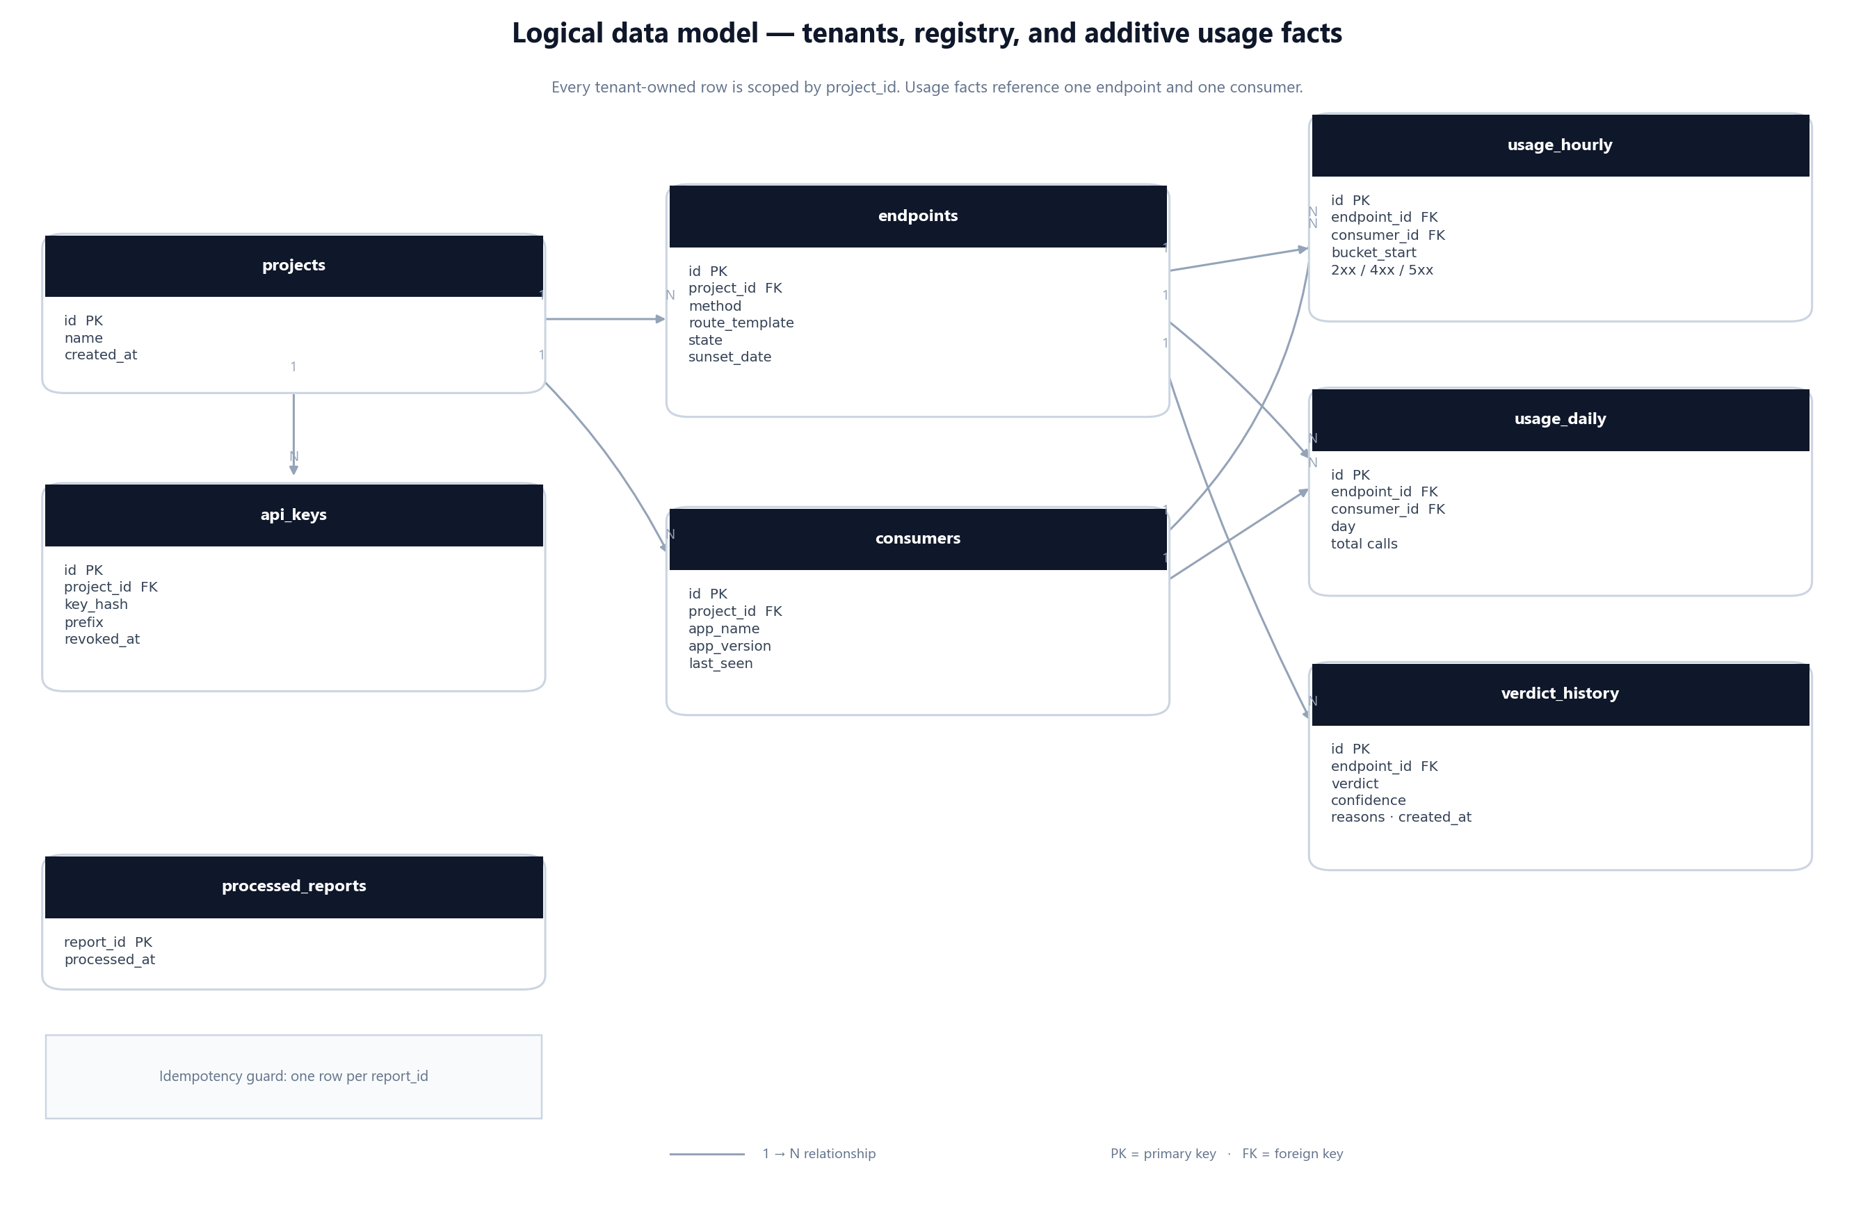
Figure 4 — Proposed entity relationships. Every row carries a project scope; rollups point at one endpoint and one consumer.
• Cap endpoints per service per day. A buggy client that generates random paths must not create a million rows. Overflow goes to a single _unknown endpoint and raises an alert.
• Cap consumers per project. Beyond a configured limit, new app/version pairs collapse into _other rather than growing without bound.
• Normalise routes. Store /orders/{id}, never /orders/92831. The starter resolves the route template, not the raw path.
• Do not store raw events. There is no per-request table to grow forever; only aggregates and receipts.
GET /api/v1/usage can therefore answer in milliseconds on a modest dataset. A project with 200 endpoints, 50 consumers, and 90 days of hourly data has at most 21.6 million hourly rows — large, but partitionable by month and comfortably handled by PostgreSQL with the right index.

9.6 Retention and growth
Table 34 — Proposed retention policy — a design decision, not a configured job
Data | Recommended retention | Reason
usage_hourly | 90 days | Supports weekly and monthly trend charts without unbounded growth
usage_daily | 2 years | Long enough to prove an endpoint is dead across seasons
verdict_history | Indefinite | Audit trail for “why did we delete this?”
ingest_receipts | 7 to 30 days | Only needs to outlive client retries
API keys | Until revoked | Rotation keeps history; revocation is soft-delete

INTERVIEW ANGLE
If asked why there is no raw request table, say: “Because the product does not need individual requests. It needs trends and last-seen times. Aggregating on the client reduces write volume by 100× to 10,000×, and keeping only rollups keeps the database operable on a laptop.” Then mention the trade-off: you cannot reproduce a single request after the fact, and you must control cardinality explicitly.

10. Technology choices, one by one
Every technology in SunsetGuard earns its place by solving a specific problem. If an interviewer asks “why this and not that?”, the answer should be a trade-off, not a preference.
Table 35 — The stack at a glance — each row is a deliberate trade
Layer | Choice | The job it does | What it costs
Language | Java 25 | Long-term support, modern language features, strong hiring market | Newer than many corporate runtimes
Framework | Spring Boot 4.1 | Auto-configuration, DI, web, scheduling, AMQP, Actuator | Startup time and memory footprint
Database | PostgreSQL 16 | ACID transactions, upserts, partitioning, JSONB, proven operations | Requires schema discipline and migrations
Cache | Redis 7 | Token bucket, dedup keys, API-key cache, locks | Another service to operate and secure
Queue | RabbitMQ 3.13 | Durable buffering, retries, dead-letter queues, routing | Less natural than Kafka for replay at huge scale
Dashboard | Thymeleaf + htmx | Server-rendered pages with no JavaScript build step | Less interactive than a SPA
Testing | JUnit 5 + Testcontainers | Real PostgreSQL, Redis, and RabbitMQ in tests | Slower test startup than mocks
Build | Maven | Multi-module builds, familiar to enterprise Java teams | More verbose than Gradle
CI | GitHub Actions | Build, test, coverage, container scan | Vendor-coupled workflow

10.1 PostgreSQL: the source of truth
SunsetGuard needs transactions more than it needs scale. A report touches a receipt, a rollup, and a consumer's last-seen time; those writes must succeed or fail together. PostgreSQL gives that for free, plus ON CONFLICT for additive upserts, partial indexes for “active endpoints only”, and declarative partitioning when usage_hourly grows. The same database can also hold JSONB for flexible verdict reasons without adding a second store.

10.2 Redis: speed at the edge
Redis sits in front of the database on the hot path. It caches API-key lookups, runs a token bucket per key, and remembers recently seen report IDs. None of that data is the source of truth. If Redis is lost, the system falls back to the database for authentication and accepts a small duplicate risk until the cache warms. That is why Redis is allowed to be ephemeral.

10.3 RabbitMQ instead of Kafka
This is the most common interview question about the stack, and ADR-001 answers it directly. The workload is a stream of small reports that need buffering, retry, and poison-message handling — not long-term replay or stream processing. RabbitMQ uses roughly 150–200 MB in the local stack; Kafka typically needs 600–800 MB or more. On an 8 GB development laptop, that difference decides the project. RabbitMQ also makes per-message acknowledgement and dead-lettering easy to demonstrate, which is exactly what the MVP needs.
WHEN I WOULD CHOOSE KAFKA
If SunsetGuard needed multi-day replay, event sourcing, or several independent consumers of the same raw stream, Kafka would be the better fit. The honest answer is: “RabbitMQ matches the current workload and hardware; Kafka would match a different, larger workload.” That shows judgement instead of tribalism.

10.4 Thymeleaf and htmx: boring on purpose
The dashboard is a tool for engineers, not a consumer product. Server-rendered HTML with htmx gives partial updates, progressive enhancement, and no Node build pipeline. A solo developer can ship it in a week and debug it with browser dev tools. A React SPA would add a second toolchain, a second deployment, and authentication complexity for very little user benefit at this stage.

10.5 Java 25 and Maven
Java 25 is the latest LTS line used by the project. It signals that the codebase is current and gives access to records, pattern matching, virtual threads, and a stronger standard library. Maven is chosen because the project is multi-module and because enterprise Java teams read Maven without explanation. The parent POM pins versions once, so the server, starter, CLI, and demo cannot drift apart.

10.6 What I would reconsider at larger scale
Table 36 — Revisit points, not predictions — each would be triggered by evidence
If this became… | First change | Why
100× traffic | Partition usage_hourly by month; add read replicas | Writes stay append-only; reads dominate dashboards
A multi-region product | Regional ingest, global control plane | Keep report latency low; centralise identity
A real-time product | Stream processing instead of hourly rollups | Sub-minute decisions need a different pipeline
A pure library | Drop the server; emit OpenTelemetry metrics | Some teams want no new SaaS dependency
A gateway-first product | Plugin for Envoy or Kong | Observe traffic where it already flows

11. Security, reliability, and scale
A deprecation tracker sees metadata about internal traffic. That is sensitive but not as sensitive as request bodies. The design minimises what it collects, scopes every row to a tenant, and assumes the monitored API must keep working even when SunsetGuard does not.

11.1 Threat model in one page
Table 37 — Threats, controls, and the phase that delivers each control
Threat | Control | Status
Stolen API key | Hashed storage, prefix-only display, rotation, scopes, rate limit | Planned — Phases 1 and 3
Cross-tenant data leak | project_id on every aggregate; repository-level scoping; isolation tests | Planned — Phase 1
Forged usage report | Authenticated ingest, schema validation, per-key quota, anomaly checks | Planned — Phase 3
Replay or duplicate | Redis dedup plus durable ingest_receipts unique key | Planned — Phase 3
Sensitive path data | Route templates only; no query strings, bodies, or raw IPs | Design choice
Malicious payload size | Request size limit, bounded arrays, cardinality caps | Planned — Phase 3
Dashboard account takeover | Session auth, CSRF protection, secure cookies, optional SSO later | Planned — Phase 5

11.2 API keys and tenant isolation
An API key is generated once, shown once, and stored as a hash. The database keeps a short prefix so a human can identify the key in the UI without being able to reconstruct it. Verification hashes the presented key and compares in constant time. Keys carry scopes (ingest, read, admin) so a monitoring agent cannot delete an endpoint or read another project's data.
Tenant isolation is enforced in depth: every aggregate row has a project_id, every repository method requires it, and integration tests attempt cross-tenant reads to prove the boundary. A single missing WHERE project_id = ? is the classic multi-tenant bug, so the test suite treats it as a first-class failure.

11.3 Privacy by minimisation
• Store the route template, not the concrete path. /orders/{id} is useful; /orders/12345 is not.
• Never collect request or response bodies, query strings, cookies, or authorization headers.
• Consumer identity comes from an explicit header or starter configuration, not from fingerprinting.
• If IP addresses are ever collected, hash them with a rotating salt and document the retention period.
• Provide a project-level delete and export path so a team can honour data requests.

11.4 Reliability: fail-open, retry, and dead-letter
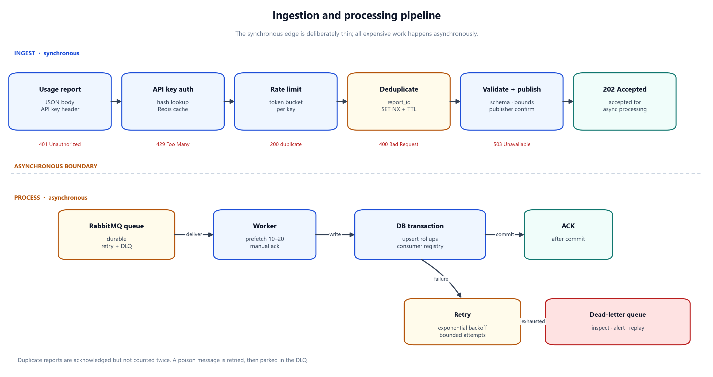
Figure 5 — The ingest pipeline. Authentication and validation happen before the queue; retries and a dead-letter queue protect the worker.
Table 38 — Failure matrix — the monitored API is never the blast radius
Failure | Behaviour | Recovery
SunsetGuard server down | Starter keeps counting; sender retries with backoff | Buffer drains when the server returns
Redis down | Authentication falls back to PostgreSQL; dedup degrades | Cache warms automatically; alert fires
RabbitMQ down | Ingest returns 503; client buffers | Queue reconnects; no customer request is affected
Worker crash | Message is unacknowledged and redelivered | Idempotent receipt prevents double counting
Poison message | Rejected after bounded retries | Dead-letter queue for inspection and replay
PostgreSQL slow | Queue absorbs the burst; worker throughput drops | Scale workers; add indexes; page on queue depth

11.5 Observability
Table 39 — Observability plan — designed now, instrumented in Phase 7
Signal | What to record | Why it matters
Metrics | Ingest rate, 4xx/5xx, queue depth, worker lag, report age, verdict duration | Detect saturation before users notice
Logs | Structured JSON with project, endpoint, report ID, and outcome | Debug one report without scanning everything
Traces | Ingest → queue → worker → database spans | Find where latency or failure is introduced
Health | Liveness, readiness, dependency checks | Let the platform restart the right component
Audit | Key creation, rotation, endpoint deletion, verdict override | Answer “who changed this?”

11.6 Scaling path
Table 40 — Scale in stages, driven by a measured bottleneck
Stage | Likely bottleneck | First move | Do not do yet
Laptop / demo | Nothing | Keep it simple | Kubernetes
First real team | Database writes during bursts | Batch upserts, tune indexes, add worker instances | Sharding
Many services | Queue depth and dashboard reads | Partition hourly data, add read replica, cache dashboard queries | Microservices split
Many tenants | Noisy neighbour | Per-project quotas, fair queueing, plan limits | Per-tenant databases
Global | Report latency and data residency | Regional ingest, central control plane | Multi-master writes

11.7 Safety before automation
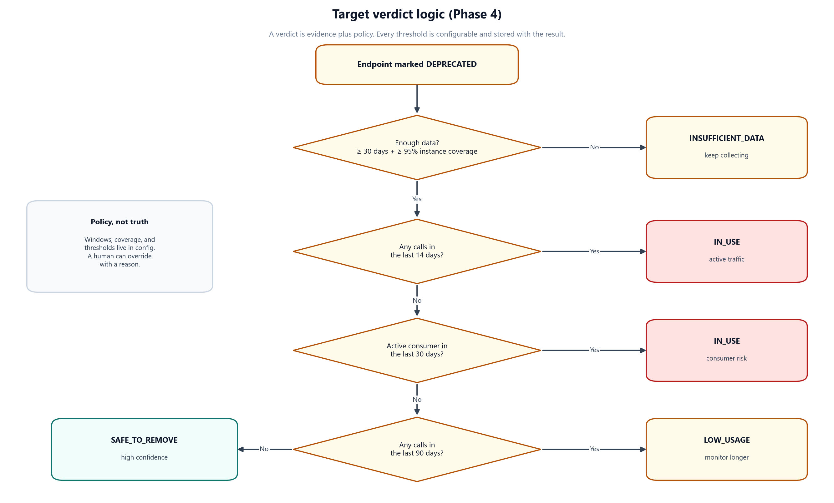
Figure 6 — How evidence becomes a verdict. Low confidence never becomes a delete recommendation; it becomes “keep collecting”.
The verdict engine never deletes anything. It produces a recommendation, a confidence level, and the reasons behind them. A human approves removal. The GitHub Action can block a pull request, but it cannot merge one. That separation is a safety property, not a missing feature.

11.8 Open design questions
• API-key hashing: SHA-256 is sufficient for high-entropy random keys; Argon2 is unnecessary and slower. Recommended: SHA-256 plus a pepper.
• Verdict thresholds: start with 30 days of coverage, zero requests in 14 days, and no active consumers. Make them per-project settings, not constants.
• Consumer identity: prefer an explicit X-SunsetGuard-Consumer header set by the starter; fall back to a configured application name.
• Clock authority: trust the server's receive time for the bucket, but keep the client's window for diagnostics.
• Retention: hourly for 90 days is a starting point; make it configurable before the first paying user.
THE DESIGN ANSWER
“Security is mostly about collecting less. I store route templates and aggregates, scope every row to a project, hash API keys, and never store bodies or query strings. Reliability is mostly about failing open: the monitored API keeps serving, and SunsetGuard is allowed to lose a monitoring window. Safety is mostly about keeping a human in the loop: the system recommends, it does not delete.”
PART V · BUILD, TEST, AND DELIVER

12. Running SunsetGuard locally
The Phase 0 repository is designed to be cloned, started, and inspected in under an hour. Today that means infrastructure and a build; after Phase 1 it will also mean a running server.

12.1 Prerequisites
Table 41 — What to install before the first build
Tool | Version | Why it is needed
Java JDK | 25 (Temurin) | Compiles and runs every module
Maven | 3.9 or newer | Multi-module build and dependency management
Docker Desktop | 24 or newer, WSL 2 on Windows | Runs PostgreSQL, Redis, and RabbitMQ
Git | Any current version | Clone and version control
RAM | 8 GB minimum; 16 GB comfortable | Docker services plus IDE and build

On Windows, install Java and Maven before Docker, then restart the terminal so PATH changes take effect. Verify each tool with java --version, mvn --version, and docker --version before continuing.

12.2 First run, in order
The Phase 0 happy path — step 4 becomes available after Phase 1
# 1. Clone the repository
git clone https://github.com/rohanmeshram/SunsetGuard.git
cd SunsetGuard

# 2. Start PostgreSQL 16, Redis 7, and RabbitMQ 3.13
docker compose up -d
docker compose ps # wait for "healthy"

# 3. Build all four modules
mvn clean install -DskipTests

# 4. Phase 1 and later: start the server
mvn -pl sunsetguard-server spring-boot:run

The first Maven build downloads dependencies and can take five to ten minutes. Later builds are much faster. If the build succeeds, the foundation is working even though no application code exists yet.

12.3 Ports, credentials, and endpoints
Table 42 — Local services and the values a contributor needs
Service | Address | Credentials | Notes
PostgreSQL | localhost:5432 | sunsetguard / sunsetguard_dev_password | Database sunsetguard
Redis | localhost:6379 | No password in local Compose | Development only
RabbitMQ AMQP | localhost:5672 | sunsetguard / sunsetguard_dev_password | Used by server and worker
RabbitMQ UI | http://localhost:15672 | Same credentials | Inspect queues and messages
SunsetGuard server | http://localhost:8080 | Planned API key auth | Available after Phase 1
Dashboard | http://localhost:8080 | Planned session auth | Available after Phase 5

LOCAL ONLY
These credentials are development defaults committed to Docker Compose. They must never be reused in a deployed environment. A production deployment needs generated secrets, TLS, network restrictions, and a secret manager.

12.4 Troubleshooting the common failures
Table 43 — Problems a new contributor is most likely to hit
Symptom | Likely cause | Fix
mvn is not recognised | Maven is not on PATH | Add MAVEN_HOME\bin; open a new terminal
Cannot connect to Docker daemon | Docker Desktop is not running | Start Docker Desktop; wait for “running”
Port 5432 already in use | A local PostgreSQL service is running | Stop it or change the host port in Compose
Port 15672 already in use | Another RabbitMQ instance | Stop it or remap the management port
Build fails in a module | Command run outside the repository root | Run mvn clean install from the root
Testcontainers cannot start | Docker unavailable or low memory | Start Docker; allocate at least 4 GB

12.5 What works today, and what does not
Table 44 — Set expectations before a demo — the distinction is part of the story
Action | Today | After Phase 1+
docker compose up -d | Starts all three services | Same
mvn clean install | Succeeds with empty modules | Compiles and tests real code
Open the dashboard | Nothing is served | Endpoint list and detail pages
Add the starter to a service | Artifact exists but is empty | Auto-configuration and request filter
Send a usage report | No ingest endpoint yet | Accepted, queued, and rolled up

13. Testing, CI, and quality gates
The test strategy follows the risk profile: pure logic gets fast unit tests, infrastructure gets real dependencies through Testcontainers, and the end-to-end loop gets a small number of deliberate tests.

13.1 The test pyramid
Table 45 — Test levels and the risk each one buys down
Level | What it covers | Tooling | Target
Unit | Aggregation, route normalisation, verdict rules, key hashing | JUnit 5, AssertJ | Fast; most tests
Slice | Controllers, repositories, JSON contracts | Spring Boot test slices | Moderate
Integration | Ingest → RabbitMQ → worker → PostgreSQL | Testcontainers | Few, high value
Contract | Request/response shape used by starter and CLI | JSON schema or snapshot | Every public endpoint
End-to-end | Demo service → starter → server → dashboard | Docker Compose or Testcontainers | One or two smoke paths
Performance | Filter overhead, ingest throughput, queue drain | JMH, Gatling or k6 | Phase 7

Mocks are used for time and failure injection, not for databases. A repository test against an in-memory database proves very little; a test against the same PostgreSQL image used in production proves the SQL, the constraint, and the transaction behaviour.

13.2 The first tests to write
1. Aggregation window: counts from multiple threads are merged without loss, and a snapshot resets cleanly.
2. Route normalisation: /orders/123 and /orders/456 map to /orders/{id}; query strings are ignored.
3. Idempotent ingest: the same report_id twice produces one set of counts, even with two workers.
4. Tenant isolation: project A cannot read project B's endpoint, usage, or verdict.
5. Verdict boundaries: zero traffic with low coverage yields INSUFFICIENT_DATA, never SAFE_TO_REMOVE.
6. Fail-open: when the server is unavailable, the monitored request still returns its normal response.

13.3 What CI does today
Table 46 — The GitHub Actions workflow as it exists in Phase 0
Step | Command or action | Current meaning
Checkout | actions/checkout@v4 | Fetch the repository
JDK 25 | actions/setup-java@v4, Temurin | Reproducible Java version
Build | mvn clean install -DskipTests | All modules compile and install
Unit tests | mvn test | Runs when tests exist
Integration tests | mvn verify -DskipUnitTests | Runs when integration tests exist
Coverage | mvn jacoco:report | Produces the report; no threshold yet
Dependency scan | Trivy filesystem scan + SARIF upload | Find vulnerable dependencies
Formatting | mvn spotless:check (non-blocking) | Advisory until the codebase stabilises

The workflow is real, but its value grows with the code. Right now it proves that the build is reproducible. After Phase 1 it starts proving behaviour, and after Phase 3 it exercises the pipeline against real services.

13.4 Quality gates worth adding
Table 47 — Proposed gates — deliberately stricter only where the risk is high
Gate | Rule | When
Coverage | Line coverage ≥ 70% for domain and service packages | Phase 3
Mutation testing | Pitest on the verdict engine only | Phase 4
Dependency scan | No critical vulnerability with a fix available | Phase 7
Container scan | Trivy image scan on every release | Phase 7
API compatibility | OpenAPI diff fails on an unplanned breaking change | Phase 6
Load smoke | Ingest p95 under 50 ms at the target rate | Phase 7

13.5 Release and versioning
• Semantic versioning. The server, starter, and CLI share a version until they need to diverge.
• Immutable artifacts. Tag v0.1.0; publish the starter to Maven Central and images to GHCR.
• Changelog discipline. Every user-visible change gets an entry under Added, Changed, Fixed, or Security.
• Compatibility promise. The starter follows Spring Boot's supported lines; breaking changes need a major version.
• Rollback plan. A release is a versioned container plus a reversible Flyway migration; no destructive migration in the same release.
WHAT TO SAY ABOUT TESTS TODAY
“The test stack and CI workflow are in place, but there are no runtime tests yet because there is no runtime code. The first tests I will write are the aggregation window, route normalisation, idempotent ingest, and tenant isolation. Those four cover the highest-risk assumptions in the design.”

14. Roadmap, risks, and next steps
The plan is phased so that every phase produces something demonstrable. The riskiest assumptions are tested early, before the dashboard or the CLI is allowed to consume time.

14.1 The phase plan
Table 48 — The 12-week plan - each phase has a demonstration, not just a task list
Phase | Weeks | Deliverable | Exit test
0. Foundation | 1 | Repository, Compose, CI, ADRs, docs | mvn clean install passes
1. Server core | 2–3 | Projects, API keys, endpoints, Flyway, isolation tests | CRUD works across two tenants
2. Starter | 4–5 | Filter, aggregation, sender, auto-configuration | Demo service reports real traffic
3. Pipeline | 6–7 | Ingest, Redis, RabbitMQ, worker, rollups | Report reaches PostgreSQL once
4. Verdicts | 8 | Scheduled engine, confidence, notifications | Verdict changes with evidence
5. Dashboard | 9 | Endpoint list, detail, trend, consumer view | “Who calls this?” answered in under a minute
6. CLI + Action | 10 | Scriptable checks and PR blocking | Unsafe removal fails a pull request
7. Hardening | 11 | Metrics, load tests, security review | Measured numbers, no critical findings
8. Launch | 12 | Docs, demo, v0.1.0 release | A stranger can run it from the README

14.2 Critical path
The critical path is Phase 1 → Phase 2 → Phase 3. Nothing on the dashboard, in the CLI, or in the verdict engine can be validated until a real report travels from a real service into PostgreSQL. The dashboard is tempting because it looks impressive, but building it before the pipeline would produce a beautiful view of data that does not exist.
1. Prove a project and an API key can be created and authenticated.
2. Prove the starter can count requests without changing response behaviour.
3. Prove a report is accepted once, queued, consumed, and stored idempotently.
4. Only then add the verdict, the dashboard, and the integrations.

14.3 Risks and mitigations
Table 49 — The risks that could actually stop the project, and the response
Risk | Likelihood | Impact | Mitigation
Scope creep before v0.1.0 | High | High | Phase exit tests; defer anything not on the critical path
Filter slows the monitored API | Medium | High | Microbenchmark early; no I/O on the request path
Duplicate counts | Medium | High | Redis dedup plus durable receipt; integration test
Cardinality explosion | Medium | High | Per-project caps and _other buckets from day one
Verdict is wrong or overconfident | Medium | High | Conservative thresholds; reasons; human approval
Solo-developer burnout | Medium | Medium | One demonstrable outcome per phase; publish progress
Spring Boot version drift | Low | Medium | Parent POM pins versions; upgrade deliberately
Demo environment cost | Low | Low | Local only; hosting is optional and not a phase

14.4 Definition of done for v0.1.0
• A new user can clone, start Compose, build, and open the dashboard by following the README.
• The demo orders service reports traffic through the starter with no code changes beyond configuration.
• An endpoint's consumers, trend, and last-seen time are visible within one aggregation window.
• A verdict is produced with a confidence level and at least three human-readable reasons.
• The CLI returns a non-zero exit code for an in-use endpoint, and the GitHub Action blocks the pull request.
• The happy path is covered by integration tests, and the README contains measured numbers, not placeholders.
• The repository has a license, a changelog, a contribution guide, and a reproducible release.

14.5 The next 30, 60, and 90 days
Table 50 — A realistic cadence for a solo developer working part-time
Window | Focus | Proof of progress
Next 30 days | Phase 1 and the start of Phase 2 | Two tenants, real keys, and a working filter
Next 60 days | Phase 3 and Phase 4 | A report reaches PostgreSQL and a verdict changes
Next 90 days | Phase 5 and Phase 6 | Dashboard, CLI, and a blocked pull request

THE HONEST ROADMAP ANSWER
“The foundation is done. The next milestone is not the dashboard; it is one real report from one real service landing in PostgreSQL exactly once. Once that works, everything else is presentation and policy. That is the order I would defend in a review.”
PART VI · INTERVIEW WORKBOOK

15. Presenting the project
You will rarely get to explain SunsetGuard from beginning to end without interruption. Prepare three versions — thirty seconds, two minutes, and five minutes — and keep the same spine in all of them.

15.1 The 30-second answer
SAY THIS
“SunsetGuard is an open-source tool for retiring deprecated APIs safely. A Spring Boot starter counts endpoint usage by consumer inside the monitored service, sends compact aggregates every ten seconds, and a server turns them into hourly and daily rollups. A verdict engine then says whether an endpoint is safe to remove, with confidence and reasons. It is fail-open, multi-tenant, and designed to run on a laptop. The repository currently contains the Phase 0 foundation; the pipeline is the next set of phases.”

15.2 The two-minute walkthrough
Start with the pain: every team has an endpoint nobody wants to own, and deleting it is scary because the consumers are invisible. SunsetGuard makes them visible. A starter inside the service records the route template and a consumer identifier, aggregates locally for about ten seconds, and posts one report. That client-side aggregation is the key design choice: it reduces write volume by 100× to 10,000× and keeps the request path free of network calls.
The server authenticates the report with an API key, applies a Redis-backed rate limit and deduplication, and publishes it to RabbitMQ. A worker consumes it, writes an idempotent upsert into hourly and daily rollups, and updates the consumer's last-seen time. A scheduled verdict engine reads those facts and produces a state — safe to remove, in use, low usage, or insufficient data — with a confidence score and reasons. The dashboard, CLI, and GitHub Action all read the same verdict.
The engineering story is the trade-offs: RabbitMQ instead of Kafka for an 8 GB laptop, rollups instead of raw events for operability, fail-open instead of strong consistency on the request path, and a human approval step instead of automatic deletion. The repository today has the four-module build, Docker Compose, CI, and two ADRs; the runtime code is planned phase by phase.

15.3 The five-minute whiteboard story
1. Problem. Deprecated endpoints are easy to create and hard to remove. Logs show requests, not decisions.
2. Users. Backend teams, platform teams, engineering managers, and the person who has to approve deletion.
3. Client. A Spring Boot starter counts by route template and consumer, then reports an aggregate every ten seconds.
4. Edge. The ingest API authenticates, validates, rate-limits, deduplicates, and publishes to RabbitMQ.
5. Pipeline. A worker writes idempotent hourly and daily rollups to PostgreSQL.
6. Decision. A scheduled engine applies recency, active-consumer, trend, and coverage rules to produce a verdict.
7. Surfaces. Dashboard for investigation, CLI for scripts, GitHub Action for pull requests, notifications for reach.
8. Properties. Fail-open, idempotent, multi-tenant, bounded cardinality, and explainable.
9. Status. Phase 0 foundation is built; Phases 1-8 are the plan. Name the next milestone honestly.

15.4 Draw it in this order
A whiteboard answer should be built in layers, not drawn as a finished diagram. Start with the monitored API and the starter, then add the server, then the queue and worker, then the database, then the decision layer, and finally the surfaces. Add arrows only when you explain the direction of data. This keeps the interviewer following the story instead of reading a wall of boxes.
Table 51 — A whiteboard sequence that survives interruptions
Layer | Draw | Say
1. Customer service | One box labelled “orders API” | “This is the service that still has the old endpoint.”
2. Starter | A small box inside it | “The starter observes requests and aggregates locally.”
3. Ingest edge | A box to the right | “One report every ten seconds, authenticated by API key.”
4. Queue + worker | Queue between edge and worker | “The queue absorbs bursts; the worker owns the database write.”
5. Database | Cylinder below the worker | “Rollups, not raw events; idempotent upserts.”
6. Verdict | Box reading the database | “Scheduled, explainable, never deletes anything.”
7. Surfaces | Dashboard, CLI, Action | “All three read the same verdict.”

15.5 When they ask “is it actually built?”
Table 52 — Scripts for the status question — never improvise a claim
Question | Answer that stays honest
“Is this a real project or a design?” | “Both. The foundation is real and in the repository; the runtime pipeline is designed and scheduled. I can show you the POMs, Compose file, CI workflow, and ADRs now, and the phase plan for the rest.”
“How many users?” | “Zero production users today. The demo service is the first intended user, and v0.1.0 is the milestone that makes it usable by someone else.”
“What have you measured?” | “Nothing yet beyond the build. The latency and throughput numbers in the design are targets, and Phase 7 is where they become measurements.”
“Why so much documentation?” | “Because the hard part is the decisions, not the syntax. The ADRs let a reviewer challenge the design before I spend weeks implementing it.”
“What is the hardest part left?” | “Making ingest correct under retries and races, and making the verdict conservative enough to trust. Those are Phase 3 and Phase 4.”

15.6 Questions to ask the interviewer
• “How does your team decide an API is safe to remove today?”
• “Do you have a deprecation policy, or is it ad hoc per team?”
• “Where does observability live — gateway, service mesh, or application?”
• “What would make a tool like this untrustworthy for you?”
• “How much operational overhead is acceptable for a developer tool?”

16. Forty-five interview questions
Cover the answer column, say your version out loud, then compare. The goal is not to memorise wording; it is to remember the shape of each answer and the trade-off behind it.
HOW TO USE THIS BANK
Answer in three beats: what it does, why this choice, what it costs. If you cannot name the cost, you do not yet own the decision. Where the feature is planned, say “planned” before the interviewer discovers it.

16.1 Product and problem
Question | Answer
1. What is SunsetGuard in one sentence? | A tool that shows which consumers still call a deprecated API endpoint and produces an evidence-based safe-to-remove verdict.
2. What problem does it solve? | The uncertainty before deleting an old endpoint: teams cannot tell which apps, versions, or jobs still depend on it, so they keep dead code forever or delete it blindly.
3. Why not just search the logs? | Logs answer “what happened?” but are expensive to query, retain poorly, and rarely carry a stable consumer identity. They do not produce a decision or an audit trail.
4. Why not use an API gateway? | A gateway only sees traffic that passes through it. It misses internal calls, direct service traffic, and background jobs, and it does not manage the deprecation lifecycle.
5. Who is the user? | Backend and platform engineers who own the endpoint, engineering managers who approve removal, and release engineers who want a pull-request check.
6. How is this different from an APM? | APM explains latency and errors across a request. SunsetGuard answers a narrower question — who still depends on this route, and can we remove it — with a lifecycle and a verdict.
7. What is the core insight? | Usage should be aggregated where it is generated, and a removal decision should be a first-class, explainable artefact rather than a log search.

16.2 Architecture
Question | Answer
8. Walk me through the architecture. What are the main parts? | A starter inside the monitored service aggregates by route and consumer; a stateless ingest API authenticates, rate-limits, deduplicates, and publishes to RabbitMQ; a worker writes hourly and daily rollups to PostgreSQL; a scheduled verdict engine reads them; dashboard, CLI, and GitHub Action consume the verdict.
9. Why a starter plus a server? | The starter sees traffic at the source without a gateway requirement; the server provides shared history, cross-service views, and central policy. A library alone has no memory; a server alone cannot see inside every service.
10. Why client-side aggregation? | It removes per-request network I/O and reduces report volume by roughly 100× to 10,000×. The cost is a delay of one window and the loss of individual request detail, which the product does not need.
11. Why RabbitMQ over Kafka? | The workload needs buffering, retries, and dead-letter handling, not replay or stream processing. RabbitMQ uses roughly 150–200 MB versus Kafka's 600–800 MB, which matters on an 8 GB laptop. ADR-001 records the decision.
12. Why Redis if PostgreSQL is already there? | Redis handles hot, disposable state: API-key cache, token bucket, and dedup keys. Putting those in PostgreSQL would add write load and latency to the database that must stay correct.
13. Why a modular monolith? | One deployable is easier for a solo developer to build, test, and operate, while package boundaries keep API, domain, service, worker, and config separate. The worker can be split out later if throughput demands it.
14. What happens on the request path? | Resolve the route template, resolve the consumer identity, increment an in-memory counter, and return. No network call, no lock, no database. The filter is wrapped so a monitoring failure can never fail the request.
15. What happens after a report arrives? | Authenticate, validate, rate-limit, deduplicate, publish to RabbitMQ, return 202. The worker consumes, inserts a durable receipt, upserts the hourly and daily rollups, updates last-seen, and acknowledges.
16. What is the verdict engine? | A scheduled job that applies policy to usage facts: recency, active consumers, trend, and data coverage. It writes a state, confidence, and reasons, and only appends history when the answer changes or a daily snapshot is due.

16.3 Data and consistency
Question | Answer
17. Why rollups instead of raw events? | Raw events grow with traffic and are expensive to query. Rollups keep the database small, make trends fast, and match the product's questions. The cost is that individual requests cannot be reconstructed.
18. How do you prevent double counting? | Two layers: Redis rejects a repeated report ID in a short window, and a durable ingest_receipts unique key is inserted in the same transaction as the rollup update. A duplicate conflicts and is skipped.
19. What is the schema? | Projects, API keys, endpoints, consumers, hourly and daily usage rollups, and verdict history. Every row is scoped to a project; rollups point at one endpoint and one consumer.
20. How do you handle late reports? | Bucket by the report's declared window, not arrival time, and accept a bounded lateness window. Older reports are rejected or counted separately so a delayed batch cannot rewrite months of history.
21. How do you control cardinality? | Cap endpoints per service per day and consumers per project, normalise routes to templates, and collapse overflow into _unknown or _other. Without caps, one buggy client can create millions of rows.
22. What is the retention policy? | Proposed: hourly for 90 days, daily for two years, verdict history indefinitely, and ingest receipts for 7–30 days. Retention is a product decision, not just an operations setting.
23. How do you handle time zones? | Store everything in UTC and bucket on UTC boundaries. Convert only for display. The client's window is diagnostic; the server's bucket is authoritative.
24. How do you scale writes? | Batch upserts, keep transactions short, partition hourly data by month, add worker instances as competing consumers, and add a read replica for dashboards before considering sharding.

16.4 Reliability and scale
Question | Answer
25. What if SunsetGuard is down? | The monitored API keeps serving. The starter keeps counting, the sender retries with backoff, and a bounded buffer drops the oldest aggregates if the outage is long. A monitoring gap is acceptable; a customer outage is not.
26. What if Redis is down? | Authentication falls back to PostgreSQL, deduplication degrades, and rate limiting becomes conservative or temporarily unavailable. The system stays correct at the cost of speed and some duplicate risk.
27. What if RabbitMQ is down? | Ingest returns 503 and the client buffers. No customer request is affected. The queue reconnects and the buffer drains; if it overflows, the oldest reports are lost by design.
28. What if a worker crashes? | The message is unacknowledged and redelivered. The durable receipt makes the retry a no-op if the transaction committed, so a crash cannot double count.
29. What is a poison message? | A message that always fails processing, usually due to malformed or incompatible data. After bounded retries it is rejected to a dead-letter queue for inspection, alerting, and replay.
30. How do you scale ingest? | The ingest API is stateless, so add instances behind a load balancer. Scale workers independently as competing consumers. Scale PostgreSQL with indexes, batching, partitioning, and read replicas.
31. How do you know it is healthy? | Metrics for ingest rate, errors, queue depth, worker lag, report age, and verdict duration; structured logs keyed by report ID; traces across ingest, queue, worker, and database; and health endpoints for each dependency.

16.5 Security and privacy
Question | Answer
32. How are API keys stored? | Generate a high-entropy random key, show it once, store only a SHA-256 hash plus a short display prefix, and compare in constant time. High entropy makes a slow password hash unnecessary.
33. How do you isolate tenants? | Every aggregate row carries a project_id, every repository query requires it, and integration tests attempt cross-tenant reads. Isolation is enforced in depth, not by a single controller check.
34. What data do you collect? | Route templates, HTTP method, consumer app and version, counts, error counts, and timestamps. No bodies, query strings, cookies, authorization headers, or raw IP addresses.
35. How do you prevent forged reports? | Authenticated ingest with scoped API keys, schema validation, request-size limits, per-key quotas, and anomaly checks on volume and cardinality. A forged report can only affect its own project.
36. What about dashboard security? | Session authentication, CSRF protection, secure and HTTP-only cookies, role-based access, and audit logging for key and endpoint changes. SSO can come later for larger teams.

16.6 Trade-offs and alternatives
Question | Answer
37. Why not build on OpenTelemetry? | OpenTelemetry is excellent for traces and metrics, but it does not model endpoint lifecycle, consumer ownership, or a removal verdict. A future version could emit OTel metrics as an additional signal.
38. Why not Prometheus and Grafana? | They are better at time-series exploration and alerting, but they do not provide the deprecation workflow, tenant model, or pull-request decision. SunsetGuard could export metrics to them rather than replace them.
39. Why not use a SaaS product? | The project is a learning and portfolio vehicle for end-to-end backend design, and it must run locally with no vendor account. A SaaS would hide exactly the pipeline being demonstrated.
40. What would you change at 10× traffic? | Partition hourly data, batch more aggressively, add worker instances, add a read replica for dashboards, and introduce per-project quotas. I would not split into microservices until a measured boundary demands it.
41. What is the biggest weakness? | The verdict is only as good as the coverage and the consumer identity. If a service omits the starter or reports a vague consumer name, the system can be confidently wrong. That is why low coverage forces INSUFFICIENT_DATA.

16.7 Project and process
Question | Answer
42. What is built today? | The Phase 0 foundation: parent and four module POMs, Docker Compose for PostgreSQL, Redis, and RabbitMQ, a GitHub Actions build and scan workflow, two ADRs, and the documentation set. No runtime Java code yet.
43. What was the hardest decision? | Client-side aggregation. It gives the biggest efficiency win but gives up per-request detail and adds a delay. ADR-002 records the alternatives, and the fail-open contract makes the trade acceptable.
44. What would you do differently? | I would write the first vertical slice — one endpoint, one report, one rollup — before polishing documentation. The foundation is valuable, but a working slice would have validated the assumptions sooner.
45. What did you learn? | That the hard parts of backend work are boundaries and failure modes: what to aggregate, where to put idempotency, what may fail open, and how to keep a multi-tenant query honest. The code is the easy part once those are decided.

17. Numbers, stories, and resume material
Interviewers remember specifics. Keep a small set of numbers, three decision stories, and a few honest resume lines ready. Mark every target as a target until it has been measured.

17.1 Numbers worth remembering
Table 53 — The numbers to quote — and the honesty label for each one
Number | What it means | Measured or target?
1,000 req/s | About 86.4 million requests per day for one busy service | Illustrative workload
10 seconds | Default client aggregation window | Design default
8,640 reports/day | Reports from one service at a 10-second window | Arithmetic
100× to 10,000× | Reduction in writes versus one event per request | Design estimate
150–200 MB | Approximate RabbitMQ footprint in the local stack | Observed range
600–800 MB+ | Approximate Kafka footprint for a comparable local setup | Observed range
30 days | Minimum observation window for high confidence | Proposed policy
14 days | Zero-traffic window before a safe verdict | Proposed policy
90 days | Hourly rollup retention | Proposed policy
2 years | Daily rollup retention | Proposed policy
8 GB | Target development laptop memory | Design constraint
Under 1 ms | Target filter overhead per request | Target, not measured
Under 50 ms | Target p95 ingest latency | Target, not measured

17.2 Three decision stories

Story 1 — Aggregate at the client
Situation: reporting every request would generate 86 million writes a day for a single busy service. Decision: aggregate for ten seconds in the starter and send one report. Result: a 100× to 10,000× reduction in write volume, no network call on the request path, and a deliberate ten-second delay. Cost: no per-request detail, so the product asks trend questions instead of forensic ones.

Story 2 — RabbitMQ instead of Kafka
Situation: the project must run on an 8 GB laptop and demonstrate real messaging patterns. Decision: RabbitMQ, because the workload needs buffering, retries, and dead-lettering rather than replay. Result: a local stack that fits the hardware and a simpler operational story. Cost: weaker replay and stream-processing ergonomics, documented in ADR-001.

Story 3 — Fail open on purpose
Situation: a monitoring tool must never become the reason a customer request fails. Decision: wrap the filter, keep counters local, retry in the background, and drop the oldest data when the buffer is full. Result: a clear blast-radius boundary: SunsetGuard can lose a monitoring window but cannot take down the monitored API. Cost: the dashboard can be incomplete, so the UI must show data freshness.

17.3 Resume bullets
Now — accurate for the Phase 0 repository:
• Designed SunsetGuard, an API deprecation tracker (Java 25, Spring Boot 4.1, PostgreSQL, Redis, RabbitMQ) that identifies remaining consumers and produces a safe-to-remove verdict.
• Built a four-module Maven foundation with Docker Compose, GitHub Actions CI, Trivy scanning, and two Architecture Decision Records covering messaging and client-side aggregation.
• Defined a multi-tenant data model with hourly and daily rollups, idempotent ingest, bounded cardinality, and a fail-open client contract.
After Phase 8 — rewrite these with real measurements:
• Implemented an ingest pipeline with client-side aggregation, Redis deduplication, RabbitMQ retries, and idempotent PostgreSQL upserts.
• Measured sustained ingest throughput and p95 latency with Gatling on commodity hardware, and published the results in the README.
• Shipped an auto-configured Spring Boot starter, a Picocli CLI, a GitHub Action that blocks unsafe removals, and a Thymeleaf + htmx dashboard.

17.4 Red flags to avoid
Table 54 — Phrases that invite a challenge - and the stronger replacement
Do not say | Say instead
“I built the whole pipeline.” | “I designed the pipeline and built the Phase 0 foundation; Phases 1-8 are the implementation plan.”
“It is microservices.” | “It is a modular monolith with an embeddable client and asynchronous workers.”
“Kafka is better, so I would use Kafka.” | “RabbitMQ fits this workload and hardware; Kafka fits replay and stream processing.”
“Exactly-once delivery.” | “At-least-once delivery with idempotent effects enforced by a durable receipt.”
“It replaces logs and APM.” | “It answers a different question: who depends on this route, and can we remove it?”
“Latency is under a millisecond.” | “The target is under a millisecond; it has not been measured yet.”
“The verdict is always right.” | “The verdict is conservative and explainable; low coverage produces insufficient data, and a human approves removal.”

17.5 Final rehearsal checklist
• Draw the architecture from memory in under three minutes, including the direction of every arrow.
• State the status in one sentence before anyone asks: foundation built, runtime planned.

Glossary
Terms are defined as they are used in this guide. Where a term has a broader meaning in the industry, the definition here is the one that matters for SunsetGuard.
Table 55 — Plain-language glossary
Term | Meaning in this project
Aggregation window | The interval — about ten seconds by default — during which the starter accumulates counts before sending one report.
API key | A high-entropy secret issued to a project. Only its hash and a display prefix are stored.
Cardinality | The number of distinct values in a dimension. Here, unique endpoints and consumers; uncontrolled growth is the main data risk.
Competing consumers | Multiple worker instances reading from the same queue. Each message is delivered to one of them.
Confidence | A score that expresses how much evidence supports a verdict. Low confidence must not become a delete recommendation.
Consumer | The application or client that calls an endpoint, identified by app name and version.
Coverage | The proportion of expected traffic and time for which the system has usable data. Sparse coverage forces INSUFFICIENT_DATA.
Dead-letter queue (DLQ) | A queue for messages that repeatedly fail processing, so they can be inspected without blocking the main queue.
Deduplication | Rejecting a report that has already been processed, usually by a unique report identifier.
Deprecation | The state in which an endpoint still works but is scheduled for removal. It is a lifecycle state, not just a comment.
Fail-open | A failure mode in which the monitored API continues serving even when SunsetGuard is unavailable.
Flyway | A migration tool that applies versioned SQL scripts to the database in order.
Idempotency | The property that repeating an operation has the same effect as performing it once.
Ingest | The process of accepting, validating, and queueing a usage report.
Multi-tenancy | Serving multiple projects from one deployment while keeping their data isolated.
p95 | The 95th percentile: 95% of observations are at or below this value. Used for latency targets.
Quorum queue | A RabbitMQ queue replicated across nodes for durability and availability.
Rollup | A pre-aggregated table of counts per time bucket, endpoint, and consumer.
Route template | The parameterised form of a path, such as /orders/{id}, which avoids storing unique identifiers.
Sunset | The planned date and state after which an endpoint is removed or returns a gone response.
Testcontainers | A library that starts real dependencies in Docker for integration tests.
Thymeleaf | A server-side HTML template engine used for the dashboard.
htmx | A small JavaScript library that lets HTML elements issue partial requests and swap in responses without a SPA.
Token bucket | A rate-limiting algorithm that refills tokens over time and spends one per request.
Trivy | A vulnerability scanner for dependencies, filesystems, and container images.
Upsert | An insert that updates the existing row on a key conflict, used for additive rollups.
Verdict | The system's recommendation — safe to remove, in use, low usage, or insufficient data — with confidence and reasons.
ADR | Architecture Decision Record: a short document capturing a decision, its context, and its consequences.

Appendices
These appendices collect the concrete shapes a reviewer is most likely to ask for: the planned API surface, an illustrative schema, configuration keys, and the Phase 0 evidence trail. Everything here is a design proposal unless it is explicitly marked as built.

Appendix A — Proposed API surface
Table 56 — Planned REST surface — paths may change before Phase 3
Method and path | Purpose | Auth
POST /api/v1/ingest/reports | Accept one aggregated usage report | Ingest-scoped API key
GET /api/v1/endpoints | List endpoints with state, last seen, and request count | Read-scoped key or session
GET /api/v1/endpoints/{id} | Endpoint detail with consumers and deprecation metadata | Read-scoped key or session
GET /api/v1/endpoints/{id}/usage | Hourly or daily series for a time range | Read-scoped key or session
GET /api/v1/endpoints/{id}/verdict | Current verdict, confidence, and reasons | Read-scoped key or session
POST /api/v1/endpoints/{id}/deprecate | Set deprecation date and sunset metadata | Admin-scoped key or session
GET /api/v1/endpoints/{id}/check | CI-friendly safe-to-remove check | Read-scoped key
POST /api/v1/projects | Create a tenant | Admin
POST /api/v1/projects/{id}/keys | Issue and rotate API keys | Admin

Example report (request)
Illustrative payload — compact, additive, and free of raw paths
POST /api/v1/ingest/reports
Authorization: Bearer sg_live_7f3c...
Content-Type: application/json

{
"report_id": "0f8fad5b-d9cb-469f-a165-70867728950e",
"service": "orders-api",
"instance": "orders-api-7c9f",
"window_start": "2026-10-26T10:00:00Z",
"window_end": "2026-10-26T10:00:10Z",
"endpoints": [
{
"method": "GET",
"route": "/api/v1/orders/{id}",
"deprecated": true,
"consumers": [
{ "app": "android-app", "version": "2.3.1", "requests": 412, "errors": 3 },
{ "app": "partner-sync", "version": "1.0.0", "requests": 27, "errors": 0 }
]
}
]
}

Example response
The server acknowledges after validation and queueing, not after the database write
HTTP/1.1 202 Accepted
Content-Type: application/json

{
"report_id": "0f8fad5b-d9cb-469f-a165-70867728950e",
"status": "queued",
"accepted_at": "2026-10-26T10:00:10.184Z"
}

Appendix B — Illustrative schema
Illustrative DDL — Flyway migrations begin in Phase 1; columns may evolve
CREATE TABLE endpoints (
id BIGSERIAL PRIMARY KEY,
project_id BIGINT NOT NULL REFERENCES projects(id),
method VARCHAR(10) NOT NULL,
route VARCHAR(500) NOT NULL,
state VARCHAR(20) NOT NULL DEFAULT 'ACTIVE',
deprecated_at TIMESTAMPTZ,
sunset_at TIMESTAMPTZ,
created_at TIMESTAMPTZ NOT NULL DEFAULT now(),
UNIQUE (project_id, method, route)
);

CREATE TABLE usage_hourly (
endpoint_id BIGINT NOT NULL REFERENCES endpoints(id),
consumer_id BIGINT NOT NULL REFERENCES consumers(id),
bucket_start TIMESTAMPTZ NOT NULL,
request_count BIGINT NOT NULL DEFAULT 0,
error_count BIGINT NOT NULL DEFAULT 0,
last_seen_at TIMESTAMPTZ NOT NULL,
PRIMARY KEY (endpoint_id, consumer_id, bucket_start)
);

CREATE TABLE ingest_receipts (
report_id UUID PRIMARY KEY,
project_id BIGINT NOT NULL REFERENCES projects(id),
received_at TIMESTAMPTZ NOT NULL DEFAULT now()
);

Appendix C — Configuration reference
Table 57 — Proposed starter configuration — the public contract to stabilise before v0.1.0
Key | Default | What it controls
sunsetguard.enabled | true | Turns the starter on or off without removing the dependency
sunsetguard.server-url | http://localhost:8080 | Ingest base URL
sunsetguard.api-key | — | Project API key; use a secret store in production
sunsetguard.aggregation-window | 10s | How long the starter accumulates before sending
sunsetguard.buffer-size | 100 | Maximum queued reports before the oldest are dropped
sunsetguard.connect-timeout | 2s | Connection timeout for the sender
sunsetguard.read-timeout | 5s | Read timeout for the sender
sunsetguard.consumer-header | X-SunsetGuard-Consumer | Header that identifies the calling app
sunsetguard.route-exclusions | /actuator/** | Paths that should never be counted
sunsetguard.sample-rate | 1.0 | Optional sampling for extremely high-volume services

Appendix D — Phase 0 evidence and references

What a reviewer can inspect today
• Parent pom.xml plus four module POMs: server, starter, CLI, and demo orders.
• docker-compose.yml with PostgreSQL 16, Redis 7, and RabbitMQ 3.13, including health checks.
• .github/workflows/build.yml with build, test, coverage, Trivy scan, and SARIF upload.
• adr/ADR-001-rabbitmq-over-kafka.md and adr/ADR-002-client-side-aggregation.md.
• README.md, QUICKSTART.md, CONTRIBUTING.md, CHANGELOG.md, docs/SETUP.md, and the Phase 0 checklist.

Primary sources
• Spring Boot reference documentation — auto-configuration, Actuator, AMQP, scheduling.
• PostgreSQL documentation — INSERT … ON CONFLICT, partitioning, indexes, transaction isolation.
• RabbitMQ documentation — acknowledgements, publisher confirms, quorum queues, dead-lettering.
• Redis documentation — expiry, atomic operations, and token-bucket patterns.
• Google SRE Book — service level objectives, graceful degradation, and postmortems.
• OpenTelemetry documentation — metrics, traces, logs, and semantic conventions.
To verify any claim in this guide, start with README.md, QUICKSTART.md, docs/SETUP.md, the Phase 0 checklist, and the two ADRs. Those files are the evidence trail; this document is the narrative around them.

