Dashboard – Developer Notes
Notes for each screen are written directly under it. Claims screens are marked and are the priority.
Dashboard / Executive Summary
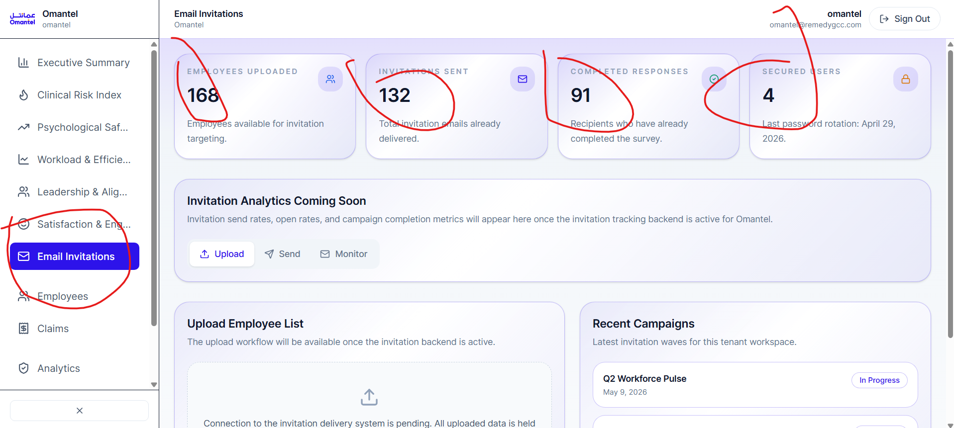
Please reset every value on this page to zero. It should start empty, with no demo/placeholder numbers.
Analytics (Scanner Results)
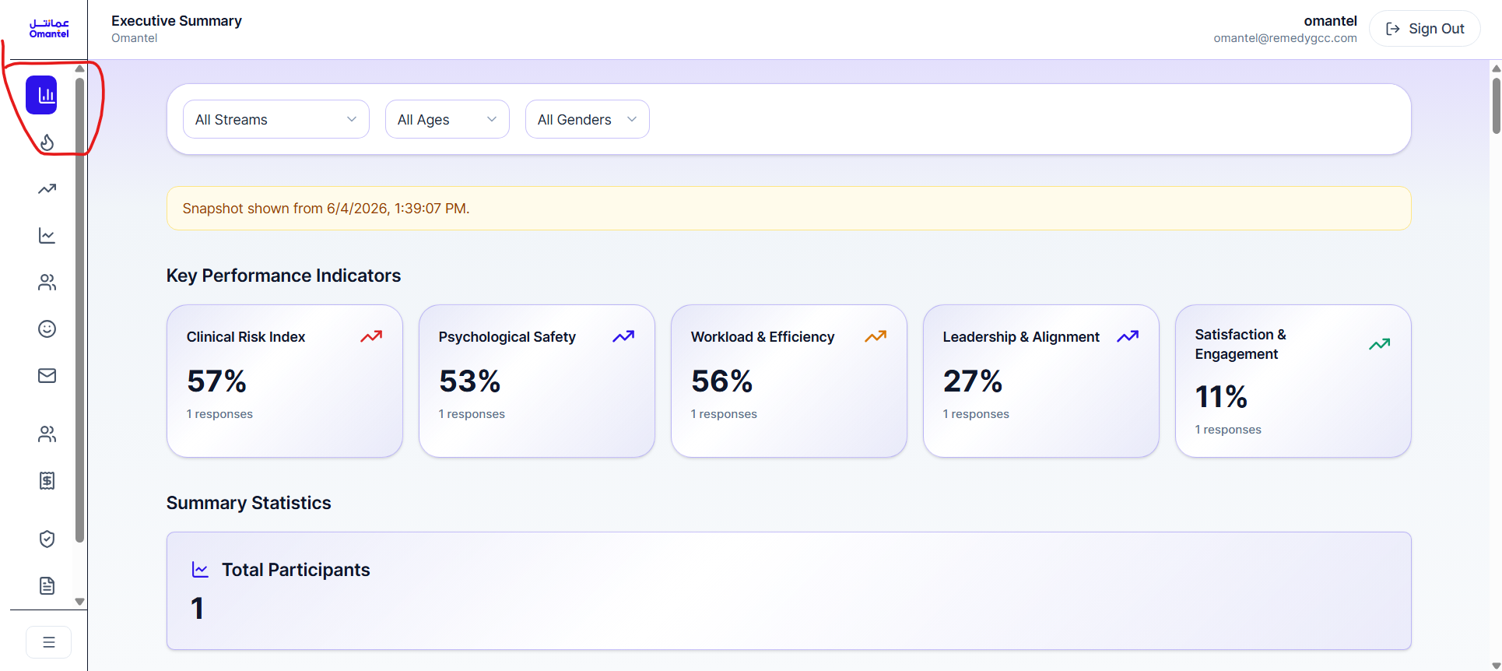
This section needs to be fixed.
Side Menu / Navigation
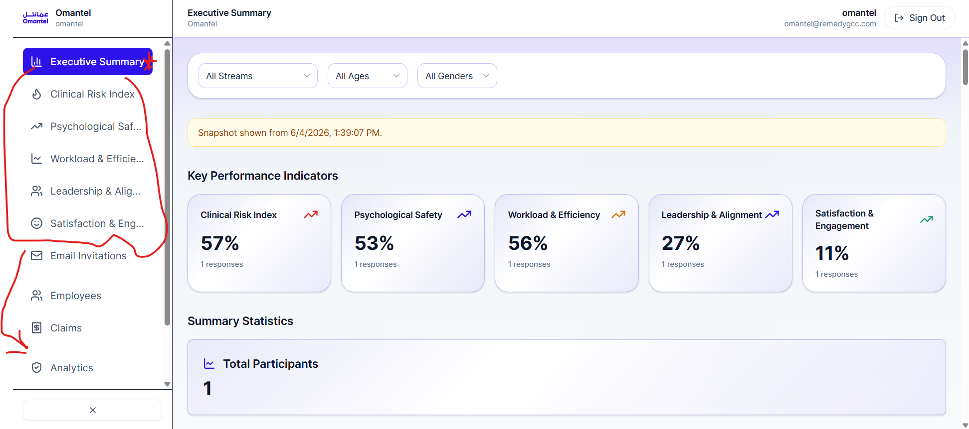
When you click "Executive Summary," it should expand a slider/dropdown that shows its sub-categories.
Also please reorder the menu items so the order is:
– Executive Summary
– Claims (second)
– Employees (third)
– Email Invitation (last)
[Page to remove]
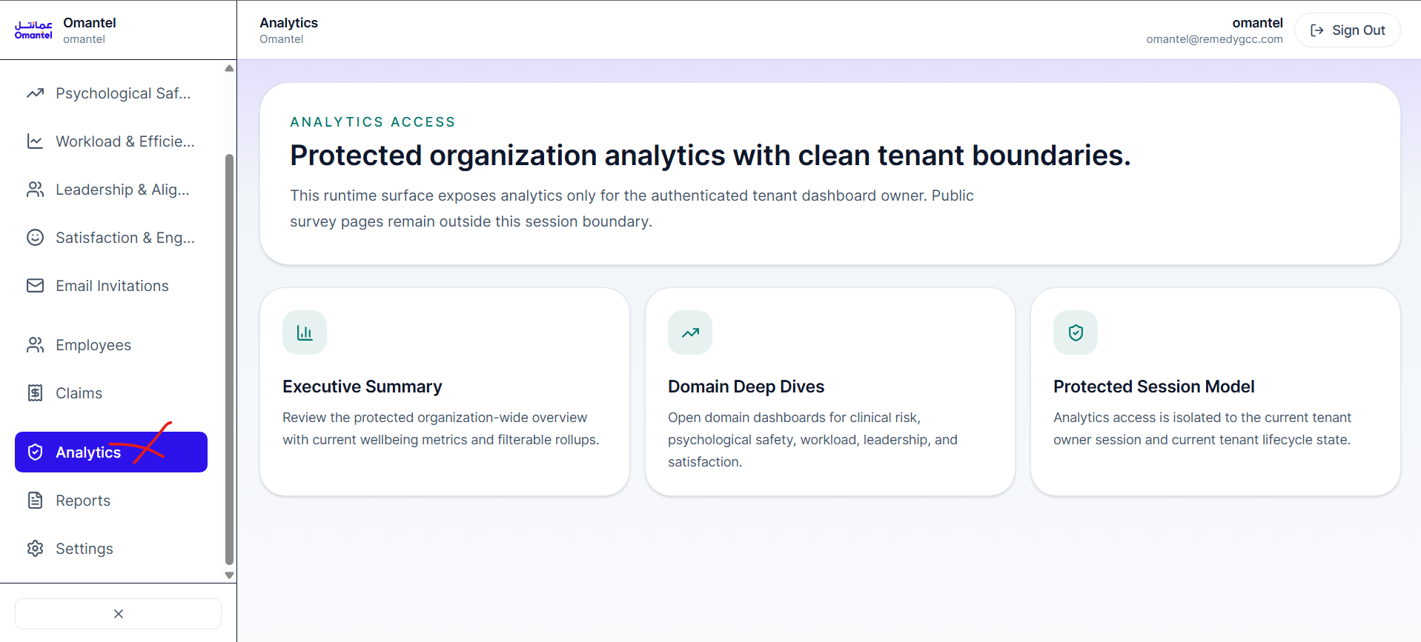
Please delete this page entirely.
[Coming-soon page]
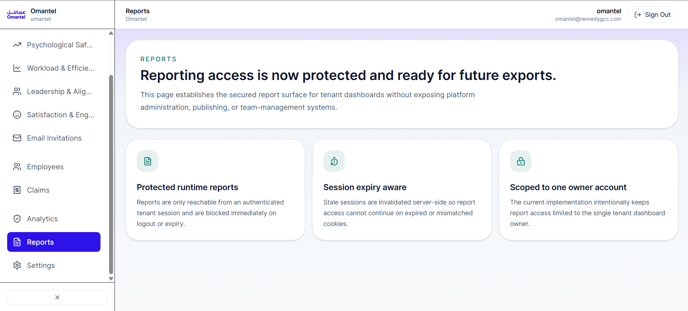
This page should just say "Coming Soon."
Email Invitation
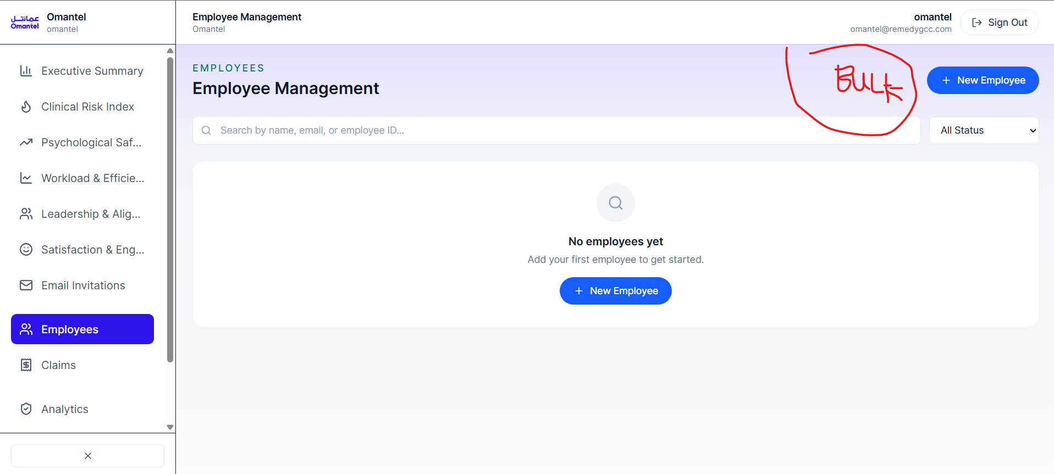
Please add two ways to add emails:
– Bulk import – add many emails at once. These emails get saved in the system.
– Manual single import – add one email at a time, individually.
Import Employees (Authorized List)
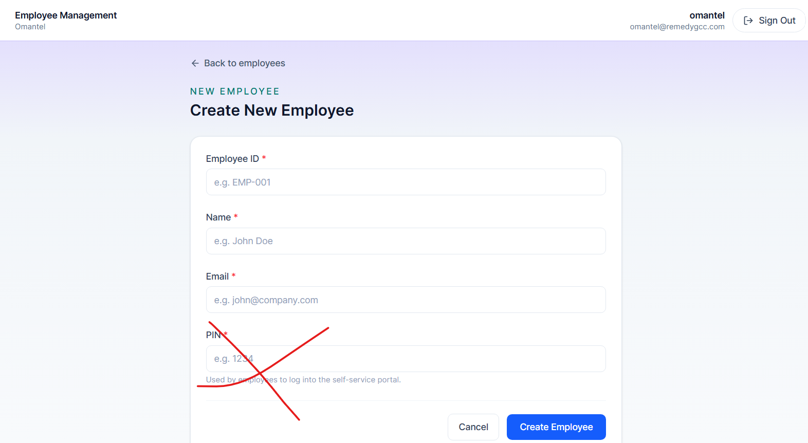
Everything here is good except the PIN.
For the Excel option: it should be a downloadable Excel template that we send to our clients. The client fills in all of their employees' emails, names, and employee IDs into that sheet, uploads it, and then those employees are added to the system in bulk.
IMPORTANT – what this list is for:
This list is what authorizes employees to sign up for their organization. When someone signs up for the platform, they must use an email that is on this authorized list. Every email has to be approved from that specific company's authorized list on their dashboard. This is how we make sure the employees signing up all belong to that specific company and that everything is done correctly.
Employees List
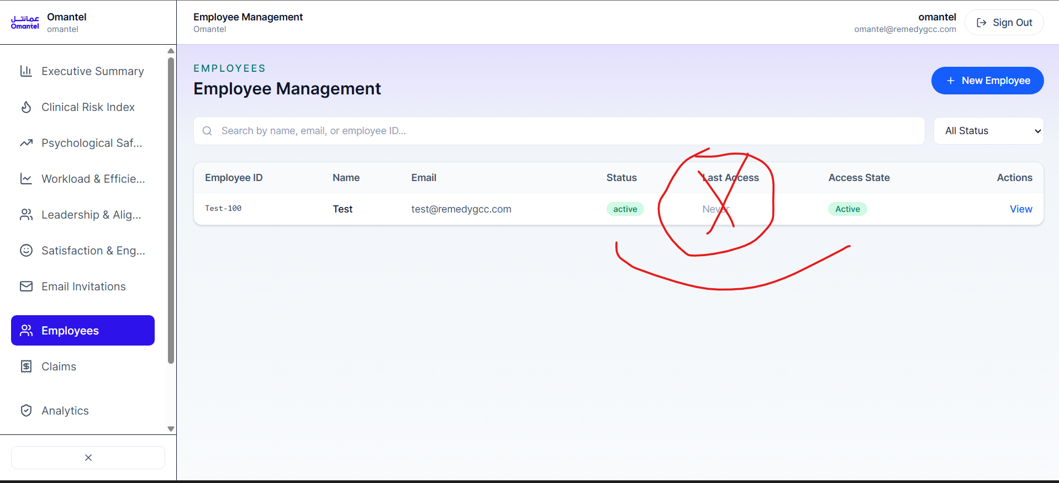
Please remove the "Last Access" column.
Also – what is the difference between "Status" and "Access State"? They look like they might be the same thing. Please clarify or merge them.
Employee Management
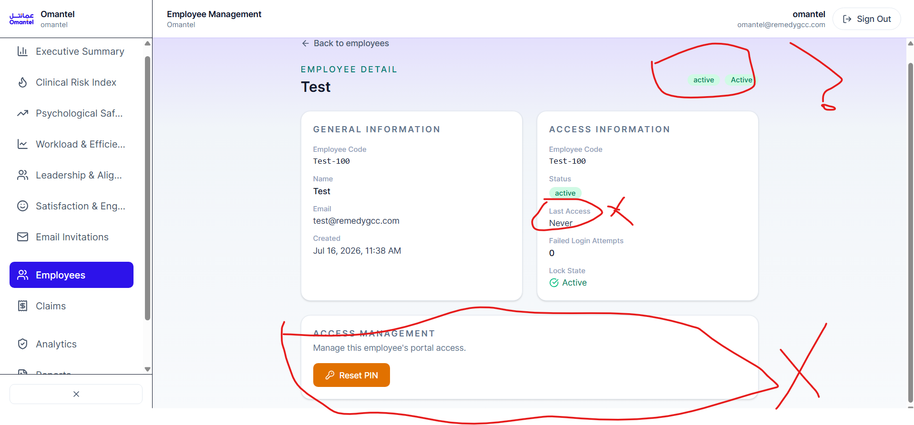
We'll go ahead with passwords. An organization must NOT be able to change an employee's password – only the super admin ("Remedy Dashboard") should be able to do that.
Please remove the two "Active" labels (there seem to be duplicates). Also, what is "Lock State" for?
Please add a Delete option and a Suspend option, for when an employee is fired or suspended:
– Suspended = the employee can't access the platform until the employer un-suspends them. Once un-suspended, they can access again.
Please also add a filter on this page to show suspended employees.
CLAIMS – Claim Submission Form
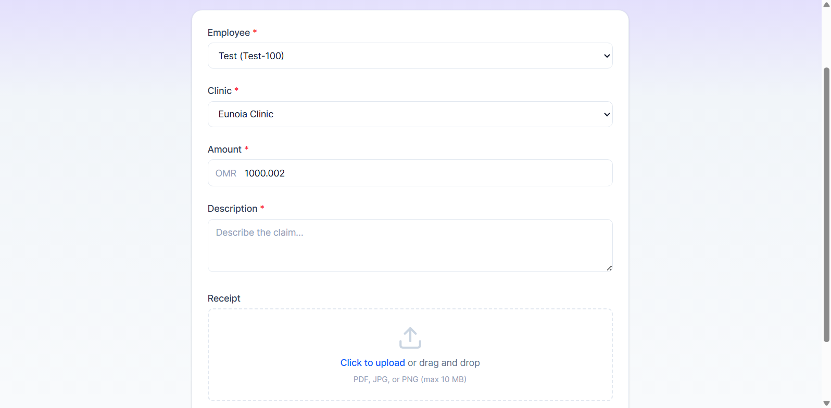
Please add the following fields to this form:
– "How many sessions?" – with a slider underneath it.
– "Type of session?" – tags the user can select (they can choose more than one): Intake Session, Assessment, Individual, Follow-up.
– "Who was this session for?" – options: Myself, Family member, Other. If Other, let them specify.
– "Contact number" – a country-code selector plus a phone-number field.
– "Bank account number" and "Which bank?" – with a slider/dropdown to choose the bank.
– Receipt upload – when they upload the receipt, show a disclaimer/warning that says: "Please make sure everything is visible, and that your name does not show."
CLAIMS – Claim Detail / Actions
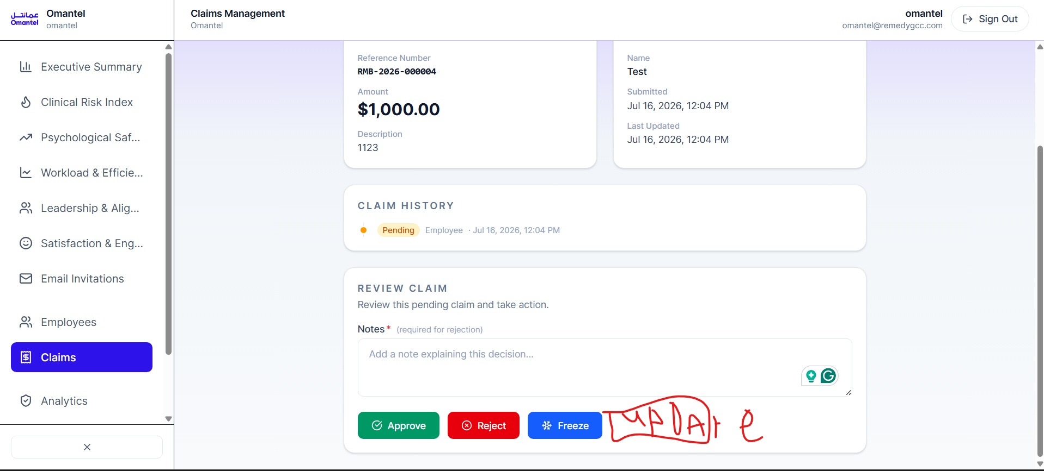
There should be an "Update" button, and it should be the FIRST button – the rest go underneath it.
"Update" is the ability to send a progress update to the employee or clinic, for example: "Currently with finance," or later "Almost done."
CLAIMS – Anonymity
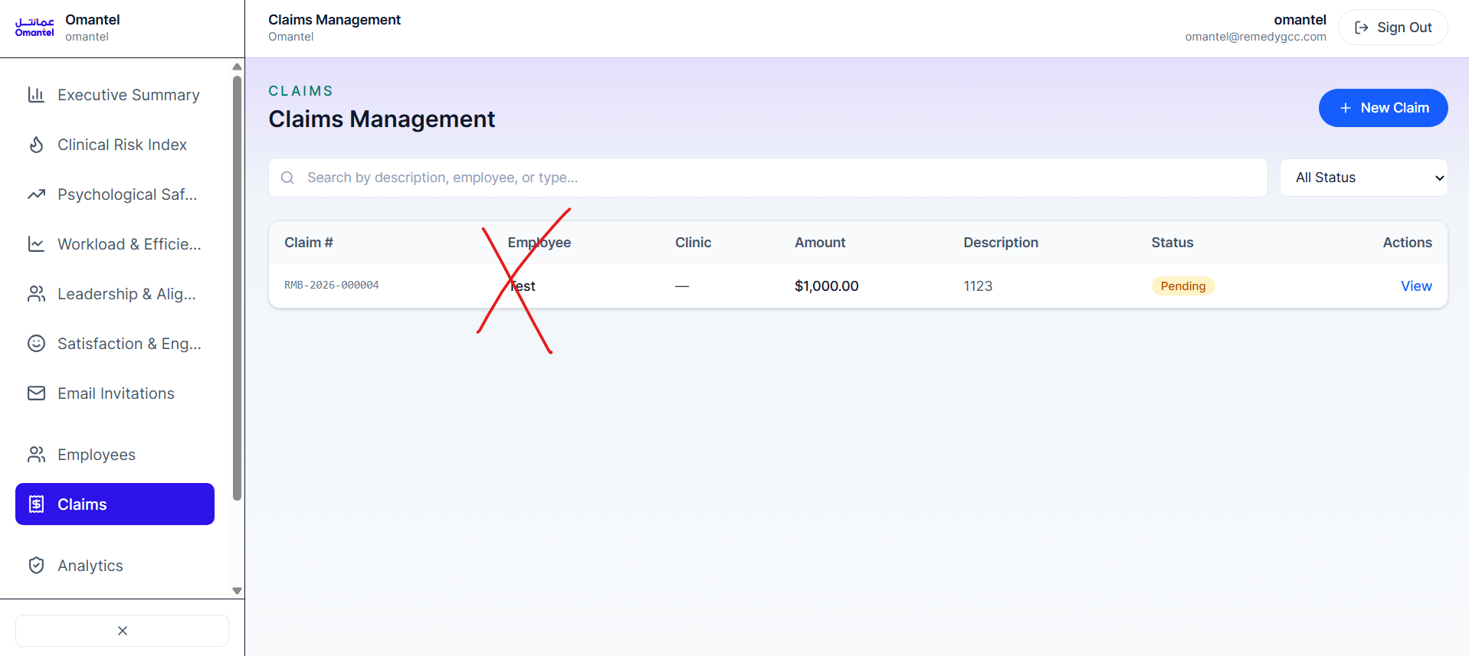
You MUST remove the name from the organizational dashboard. This has to stay anonymous.
CLAIMS – Claims List (multi-select)
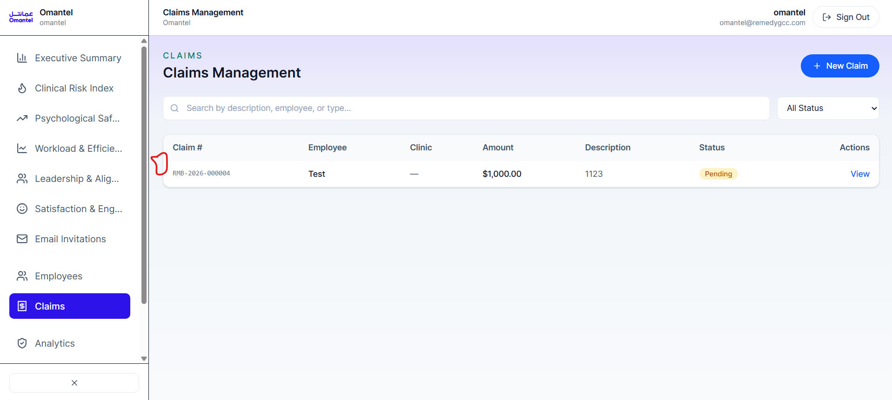
Please add a checkbox for multi-select, and also a "Select All" button.
"Select All" should only apply to the current filter. Example: if I filter by "Pending," then "Select All" selects all the Pending claims only.
CLAIMS – Main Claims Page (statuses & budget) ★ MAIN PAGE
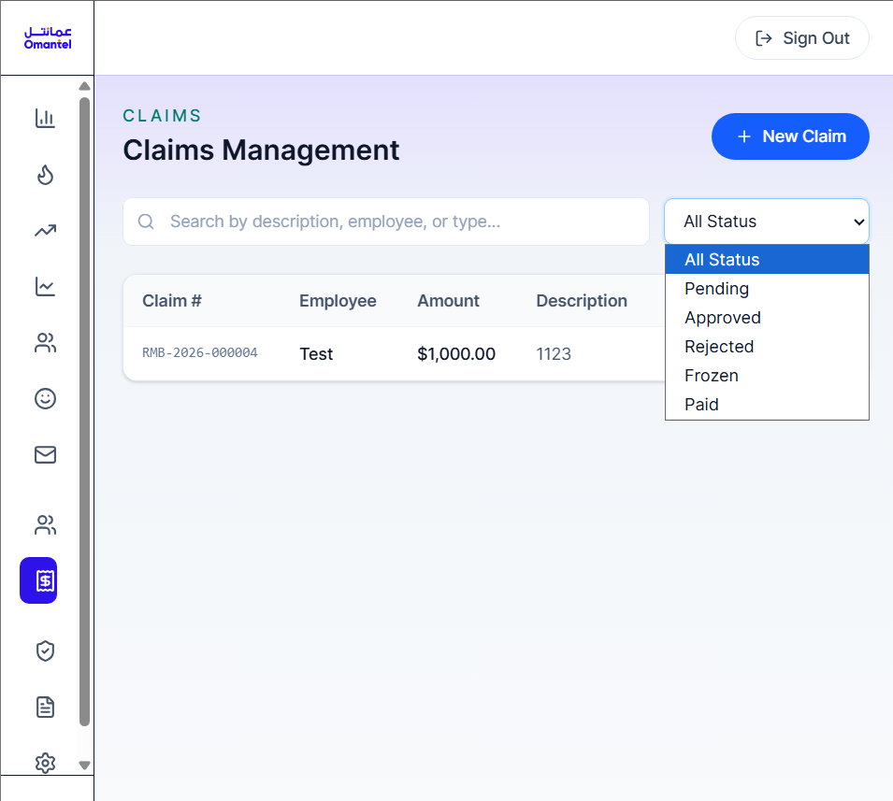
This is the main page. It should hold a lot of options and information.
Statuses should be: Pending, In Progress, Frozen, Approved, Rejected, Paid. Here is what each one means:
– Pending – invoices that haven't been touched yet. This is the beginning of everything.
– In Progress – currently being checked. This tells both the employee and the clinic "your invoice is being looked at."
– Frozen – when we need more answers and are checking the validity. This is where we can ask questions.
– Approved – the claim is good to go, but has not been paid yet.
– Rejected – the organization rejected it, for specific reasons.
– Paid – done, no issues.
Flow of a claim:
Pending → In Progress → then it can go to Frozen (more questions), Rejected (we won't accept it), or Approved (you're good to go). After Approved comes Paid.
Bulk actions:
I should be able to select many claims and update them together. Example: select all Pending and "Make In Progress." With Approved claims, I should be able to do a mass update such as "Reached finance" or "Reached Remedy."
Budget:
Add a budget box at the top of the page, e.g. "Budget: 14,000." When I move claims forward, I should see the budget go down. While a claim is Pending it shows as reduced (reserved) but not permanent; once it is Approved, the amount comes down permanently. Please also add a "Top Up" option to adjust or add to the budget.
Filters & sorting:
– Timeline filters – from this date to this date.
– By default, approvals/claims should always show the latest invoices first.
– Also add the reverse option – e.g. "oldest pending first" / sort by last approved.
Summary counts:
Show totals on the page: total number of invoices, and how many are Approved vs Pending vs Rejected vs In Progress vs Frozen.
More features to add to this page:
Claim reference ID:
Give every claim a short reference code (e.g. #CLM-0421). Because names are hidden, both sides need this code to refer to a specific claim in Chat or Requests. Without it, "which invoice do you mean?" becomes a problem once we have a lot of claims.
Mandatory reason on Reject and Freeze:
Whoever rejects or freezes a claim must type a reason before it goes through. This protects us (every decision is documented) and it's the information the employee/clinic needs anyway.
Aging indicator:
Show how long each claim has been sitting in its current status, and highlight the old ones (e.g. Pending for more than 7 days). This stops claims from getting stuck silently.
Budget split (three figures, not one):
Instead of a single budget number, show three: Available, Committed (approved but not yet paid), and Paid. "Committed vs Paid" is usually where budgets get confusing, so keep them separate.
Auto-notification on status change:
Send an automatic notification whenever a claim changes status (In Progress, Frozen, Approved, etc.), so the employee/clinic is told right away. Otherwise the Chat and Requests tabs carry all the communication load.
Automatic invoice maker:
Based on the budget and the number of sessions, the system should generate an invoice automatically. We then want to turn this into a reusable template.
How the invoice works – important, it's a bit different because of our company structure:
This is a VENDOR invoice, and WE (the platform / Remedy) are the vendor. The auto-generated invoice is OUR invoice, addressed to the company, showing the total amount. The company sends that money to us. We then distribute it out to all the individual clinics. So it is one single, consolidated invoice from us to the company – NOT each clinic invoicing the company directly.
NOTE: I already have an invoice template that works well. I'll share it with you so you can build this from it.
CLAIMS – Claim History / Edit
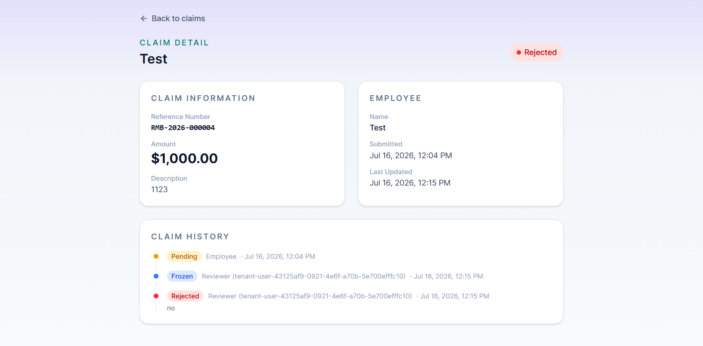
Please let me keep editing a claim even after I reject it, including from the claim history. We should still be able to keep sending updates if needed.
CLAIMS – Tabs (Chat & Requests)
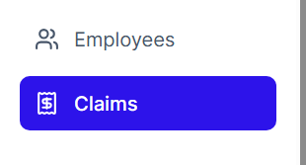
Please add these tabs:
– Chat – lets the employee or clinic chat with the person who rejects, approves, or freezes the claim.
– Requests – a request is when a clinic or employee wants to check if something is possible. Likey we want to do an asspement butt its 1000, which is quite expensive, can we do it ? then the comany can respond with any of the things provided, From their own dashboard they can send a request/message to the organization. The organization can then reject it, approve it, or move it to chat / freeze it for extra info.
Employee, clinic, and super admin

Login / Sign-up Page
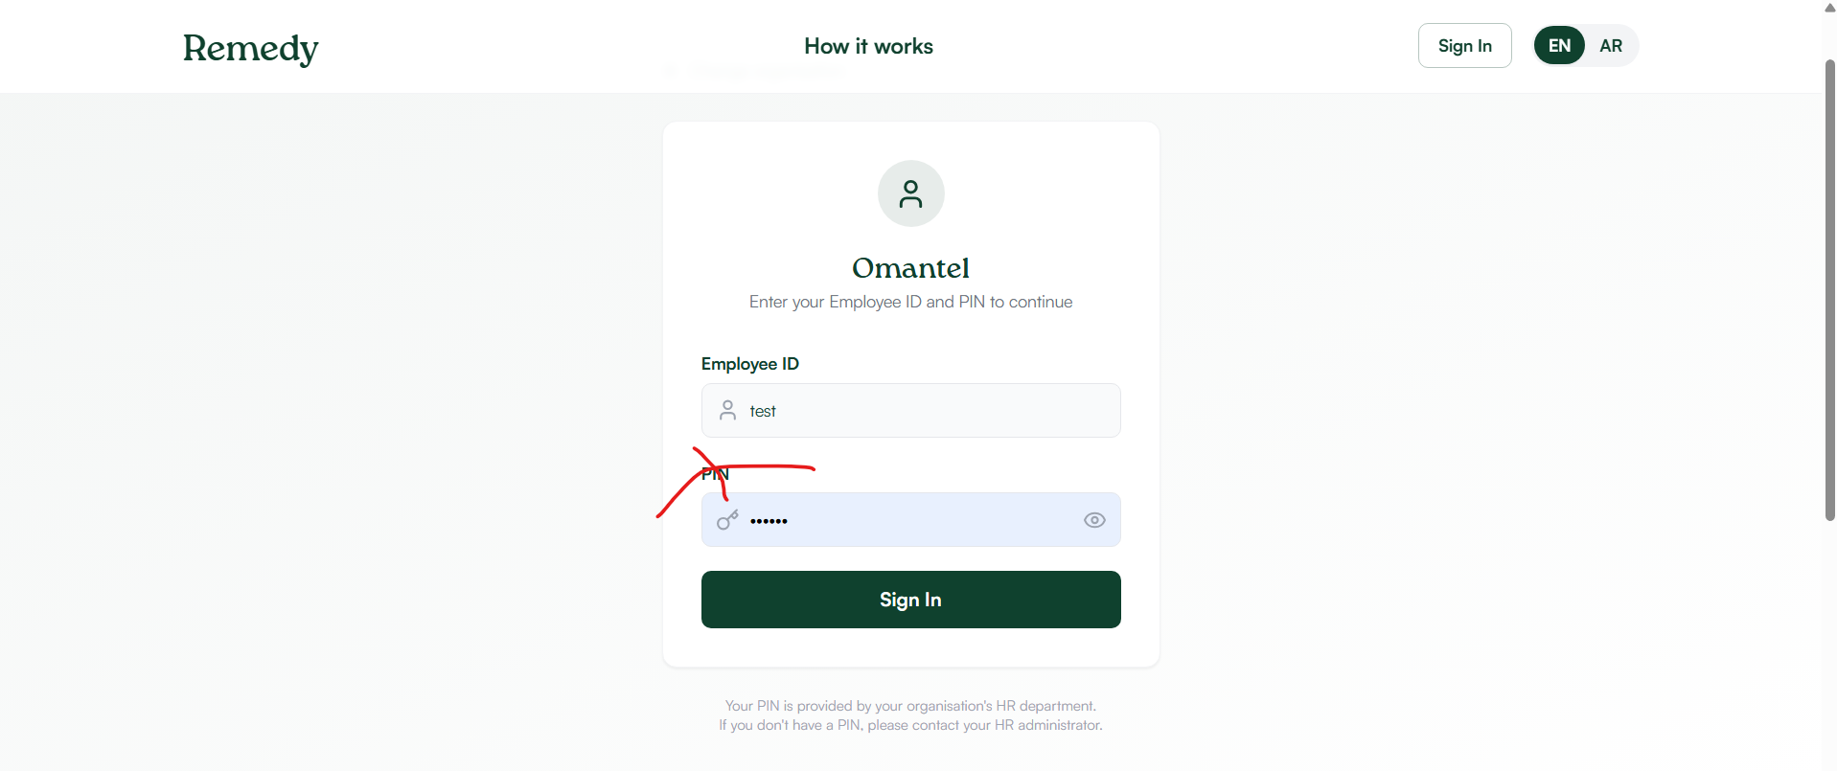
This must use a PASSWORD, not a PIN.
We need a proper sign-up page. Fields: work email, organization, employee ID, and password.
After sign-up, a confirmation email must be sent to the user's email address (so we stay compliant and don't get into trouble).
Employees and clinics must also fill in extra details when signing up: bank information and contact number.
Two types of login – important, we plan to open the platform to the public:
We need two sign-up / login types:
– "Part of an organization" – the user belongs to a company. During sign-up they must choose their organization, and their email must be on that organization's authorized list (see the authorized-list note earlier in this document).
– "Normal login" (public / individual) – a user who is not tied to any organization.
On the sign-up page the user picks which type they are. If they are part of an organization, they must select that organization during sign-up.
Account / Profile Page
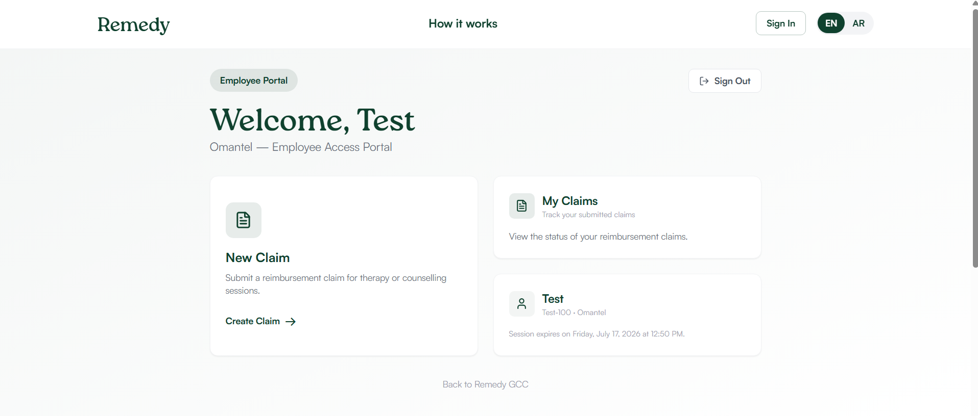
Please add chat here.
Also let the user edit their own information here – password and bank details.
Clinic Dashboard ★ CRITICAL – CURRENTLY MISSING
There is currently no clinic dashboard, and this is critical. Without it, a clinic cannot submit claims, chat, or do anything on their side. Clinics must have their own dashboard.
The clinic dashboard needs:
– Submit claims – the clinic can raise claims (the same claims flow, from the clinic's side).
– Chat – with the organization / the reviewer who approves, rejects, or freezes a claim.
– Requests – ask the organization whether something is possible.
– Choose organization – a clinic may work with more than one organization, so they need to select or switch between organizations (or pick one).
Super Admin – Remedy Dashboard (Payouts)
In our own super-admin dashboard, I need a view of all APPROVED claims where the payment is ready to be sent, showing each clinic's bank account details. This lets me send all the payments in one go, directly from us through the bank.
This is the payout / distribution side of the vendor-invoice flow: the company pays us one consolidated total, and from here we pay it out to all the individual clinics.
Employee Page – please also make sure it has
A few things the employee's own page/dashboard should include:
– See their own claims and the current status of each (their history).
– Submit a new claim.
– Chat and Requests (same as the tabs above).
– Edit their profile: password, bank details, and contact number.
– Notifications – the employee is told when a claim changes status (ties to the auto-notification feature).
– Each claim shows its reference ID (ties to the claim reference ID feature).
Other things worth deciding
A few things I'd suggest we lock down – flagging them here so they don't get missed:
– Forgot / reset password flow – needed now that we're using passwords and opening to the public.
– Who sees what – confirm the anonymity boundaries: the organization does not see employee names; make sure the clinic and employee views follow the same rules.

