How Odoo MRP Solves Raw Material Stock Mismatch Problems
Rohan Raj | Mar 15, 2026
Introduction
Maintaining accurate raw material inventory is a common challenge in manufacturing. Most manufacturers running on spreadsheets, standalone accounting software, or disconnected systems face situations where the stock recorded in the system does not match the actual quantity available in the warehouse. These raw material stock mismatches can disrupt production schedules, delay deliveries, and create confusion for inventory and production teams.
While the Inventory module tracks stock levels, the Odoo Manufacturing module (MRP) plays a critical role in preventing these mismatches during the production.
This documentation explains how Odoo Manufacturing helps prevent raw material stock mismatches during production.
Understanding Raw Material Stock Mismatch
A raw material stock mismatch occurs when the quantity of materials recorded in the system differs from the actual quantity available in the warehouse.
For example, a company manufacturing office desks may have a system record showing 100 tables in stock, while the warehouse physically has only 85 tables. When production begins, this discrepancy can cause delays because the required materials are not available.
Such mismatches typically occur due to:
- Manual stock updates
- Material consumption without being recorded
- Untracked scrap or damaged materials
- Inaccurate production planning
Odoo Manufacturing addresses these challenges by tightly integrating manufacturing activities with inventory management.
1. Bill of Materials (BoM) Standardizes Material Usage
A Bill of Materials (BoM) in Odoo defines the exact raw materials required to produce a finished product.
For example, to manufacture a wooden table, the BoM may specify:
- 5 wood planks
- 10 screws
To create a new BoM,
Go to Manufacturing → Products → Bills of Materials → New
Select a product and add it’s required components and quantity
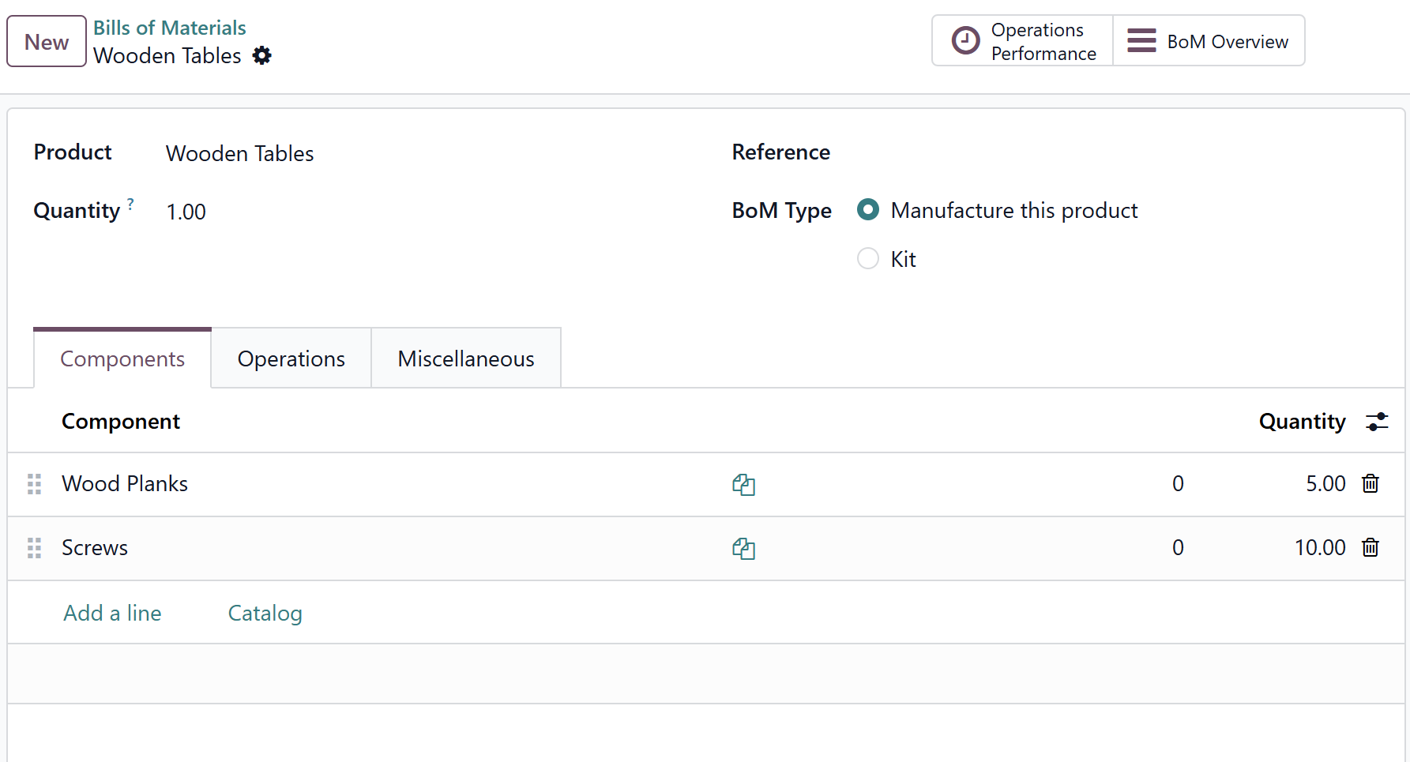

When a manufacturing order is created for the product mentioned in BoM, Odoo automatically calculates the total quantity of raw materials required based on the BoM.
By defining standardized material requirements, BoMs help prevent inconsistencies such as incorrect material usage or missing component records during production.
2. Completed Manufacturing Orders Automatically Record Materials Consumed
In Odoo, Once an MO is completed, Odoo deducts consumed materials and adds the finished product to inventory.
This automation eliminates manual stock adjustments and reduces the risk of raw material stock mismatches.
3. Automatic Stock Reservation via Manufacturing Orders
When a manufacturing order is confirmed, Odoo checks whether the required raw materials are available and reserves them for that specific production order.
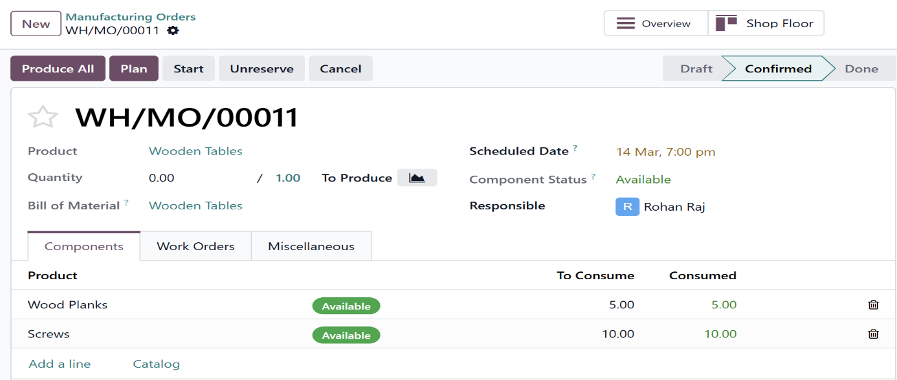
This reservation ensures that the required materials are allocated to the manufacturing order and are no longer available for other operations, preventing the same raw materials from being accidentally allocated to multiple operations
4. Scrap and Unbuild Orders Automatically Update Inventory
When a component or finished product is found defective during or after manufacturing, you can record a scrap order directly from the manufacturing order. Odoo immediately removes the scrapped quantity from inventory and logs it against that specific MO — no separate stock adjustment needed.
Open a Manufacturing Order → Click on gear icon → Scrap
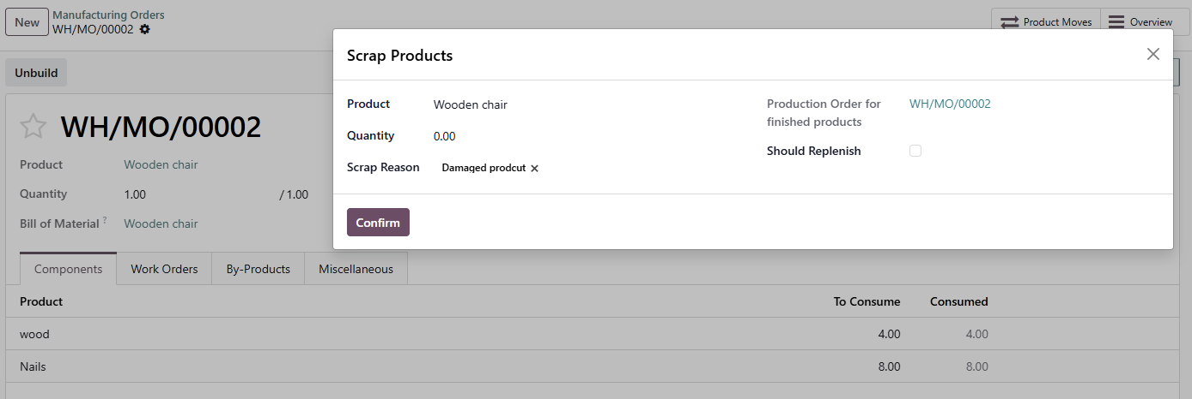

Similarly, if a finished product needs to be disassembled and its components returned to stock you can click on Unbuild button on the MO. Once confirmed, Odoo reverses the manufacturing entry, removes the finished product from inventory, and adds the individual components back to stock.
Open a Manufacturing Order → Click on Unbuild button → Unbuild

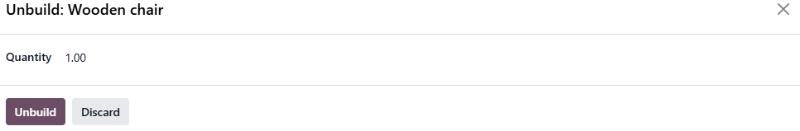
Both scrap and unbuild orders create inventory moves automatically. This means your raw material and finished goods stock levels stay accurate without any manual correction
5. Traceability Improves Raw Material Tracking
Odoo Manufacturing also provides lot and serial number tracking for raw materials.
This enables manufacturers to track:
- which batch of raw material was used
- which manufacturing order consumed it
- which finished products were produced from it
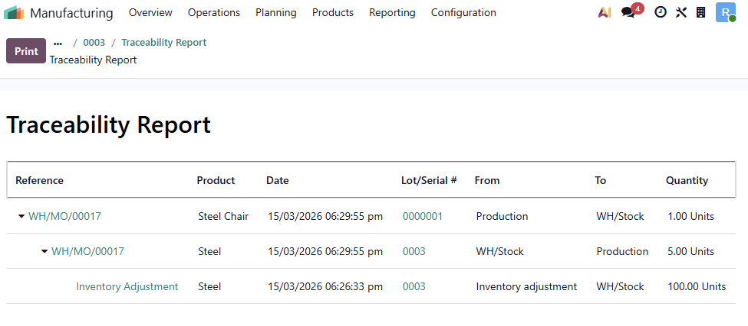
With complete traceability, businesses can quickly identify the source of discrepancies and maintain better control over inventory.

Raw material stock mismatches are not a warehouse problem or a production problem in isolation — they are a data integration problem. Spreadsheets and disconnected systems cannot solve them because the gap between where data is recorded and where production actually happens is too wide. Odoo MRP closes that gap by making inventory, purchasing, and production a single connected system. The result is inventory data that reflects reality — and production schedules that don't fall apart when someone checks the shelf.
At Infintor Solutions, we've helped businesses across the globe configure and customise Odoo to match their exact manufacturing workflows.
For expert Odoo implementation and consulting, contact us at infintor.com.

