RICHFIELD GRADUATE INSTITUTE OF TECHNOLOGY
Faculty of Information Technology
Bachelor of Science in Information Technology (BSc IT) | IT Project (Year 3), Semester 2 2026
HireTrack
Applicant Tracking & Resource Allocation System
Phase 5: Implementation (Sections 5.1 to 5.5)
Item | Detail
Project title | HireTrack: Applicant Tracking & Resource Allocation System
Group members | Rohan Naik (402311822)  Nadhir Mahomed (402110343)  Joshua S Pillay (402200878)  Sheik Kader (402413277)  Tiara Govender (402306095)  Rudo Fourie (402410352)
Institution | Richfield Graduate Institute of Technology
Qualification | BSc IT, IT Project (Year 3)
Supervisor | Rhumani (RhumaniM@richfield.ac.za)
Date | 11 November 2026
Source code | https://github.com/RohanRajaramNaik/hiretrack

Table of Contents
5.1 Introduction 4
5.1.1 Purpose of the Implementation Phase 4
5.1.2 Scope of this release 4
5.1.3 Technology stack and reasons 4
5.2 Coding 6
5.2.1 System architecture 6
5.2.2 Module breakdown 7
5.2.3 Database schema 7
5.2.4 Key code excerpts 9
5.2.5 Coding standards, validation and error handling 12
5.2.6 Security measures 12
5.2.7 User interface 12
5.3 Testing 24
5.3.1 Approach 24
5.3.2 Unit and integration results 24
5.3.3 Coverage 25
5.3.4 Performance 26
5.3.5 Debugging and code improvement 26
5.4 System Testing 27
5.4.1 Approach and requirements 27
5.4.2 Test cases 29
5.4.3 Evaluation of the testing results 33
5.4.4 Defects found and how they were fixed 33
5.4.5 Limitations 34
5.4.6 Recommendations 34
5.5 Installation 35
5.5.1 Summary 35
5.5.2 Steps 35
5.5.3 Verification on a clean copy 35
Conclusion 36
References 36
Appendix A: Core Backend Source Code 37
backend/app/main.py 37
backend/app/models.py 38
backend/app/security.py 42
backend/app/engine/scoring.py 43
backend/app/engine/skills.py 47
backend/app/engine/embeddings.py 49
backend/app/engine/pipeline.py 50
backend/app/engine/allocation.py 52
backend/app/services/match_service.py 52
backend/app/services/pipeline_service.py 55
backend/app/services/resource_service.py 58

5.1 Introduction

5.1.1 Purpose of the Implementation Phase
The Implementation Phase turns the System Design (Phase 4, 30 October 2026) into working, tested and installable software. It answers three questions: does the system do what the requirements say, does it do it reliably and fast enough, and can someone else install and run it from the repository alone.
This document covers the five parts the Faculty guidelines require for this phase: coding (5.2), testing (5.3), system testing with test cases and an evaluation of the results (5.4), and installation (5.5).

5.1.2 Scope of this release
The Design phase narrowed the first release to the candidate-job matching engine and listed user accounts, the applicant pipeline and the recruiter dashboard as future scope. The Proposal (28 August 2026), however, described HireTrack as a full applicant tracking and resource allocation system. Because the matching engine was finished early, the group brought the Proposal's remaining objectives into this release. The matching engine was kept exactly as designed and became one module of the larger system.
Area | Status in Design (Phase 4) | Status in this release
Candidate and job management, four-part scoring, ranking, CSV export, backups | In scope | Built as designed; job location and open/closed status added
User accounts and roles (JWT + bcrypt) | Future scope | Built: Administrator, Recruiter (HR), Resource Manager
Applicant pipeline with audit history | Future scope | Built: Applied, Screened, Interview, Offer, Hired, Rejected
Recruiter dashboard | Future scope | Built: key counts and five charts
Uploading CV files | Future scope | Built: PDF, Word and text CVs pre-fill the form
Bulk import | Not planned | Built: CSV and Excel with a per-row error report
Resource allocation (staff, projects, utilisation) | Proposal title only | Built: allocations by percentage and date with no over-booking
Multi-user access over a network | Future scope | Still future scope (runs on 127.0.0.1)
Table 5.1: Scope of the release compared with the Design phase
The requirements were extended to match. FR1 to FR13 and NFR1 to NFR8 from the Analysis phase still apply. FR14 to FR26 and NFR9 to NFR10 were added for the new modules and are listed in Section 5.4.1.

5.1.3 Technology stack and reasons
The stack is the one chosen in the Planning and Design phases. No paid service or cloud platform is used.
Layer | Technology | Why it was chosen
Frontend | React 18, Vite 5, Tailwind CSS 3 | Component model suits many similar screens; Vite builds fast; Tailwind keeps one consistent visual style without a heavy component library.
Backend | Python 3.11, FastAPI, Pydantic 2, Uvicorn | The matching engine and the model library are Python. FastAPI validates every request from type hints and generates API documentation at /docs.
Data access | SQLAlchemy 2 ORM | Bound parameters only (no SQL injection), and the same models define the tables and their constraints.
Database | SQLite | One file, no server to install, supports foreign keys and CHECK constraints, easy to back up.
Matching | sentence-transformers all-MiniLM-L6-v2 | Small (about 90 MB), runs on an ordinary CPU, works offline, free. Finds candidates who describe the work in different words.
Security | bcrypt (passlib), PyJWT | Industry-standard password hashing and signed, expiring sessions, as planned in the Proposal.
Import | openpyxl, pypdf | Read Excel files and PDF CVs without Microsoft Office.
Testing | pytest, pytest-cov, Vitest, React Testing Library, Playwright | One tool per level: unit and API (pytest), screens (Vitest), full journeys in a real browser (Playwright).
Table 5.2: Technology stack
The system follows the linear life cycle with iterative build cycles chosen in Planning: each module was built, unit tested and reviewed before the next one started, and the full suites were re-run after every change.

5.2 Coding
The complete source code is published in the GitHub repository https://github.com/RohanRajaramNaik/hiretrack. It contains the backend, the frontend, the seed data, the tests, the start scripts, README.md and INSTALLATION_GUIDE.md. The key excerpts below are explained in this section, and the full listing of the core backend files is in Appendix A.

5.2.1 System architecture
HireTrack is a three-tier client-server system that runs on one computer (Figure 5.1). The browser shows a React single-page application. It talks to a FastAPI server over HTTP using JSON. The server keeps everything in a SQLite file. In normal use the server also serves the built screens, so the whole system uses one port.
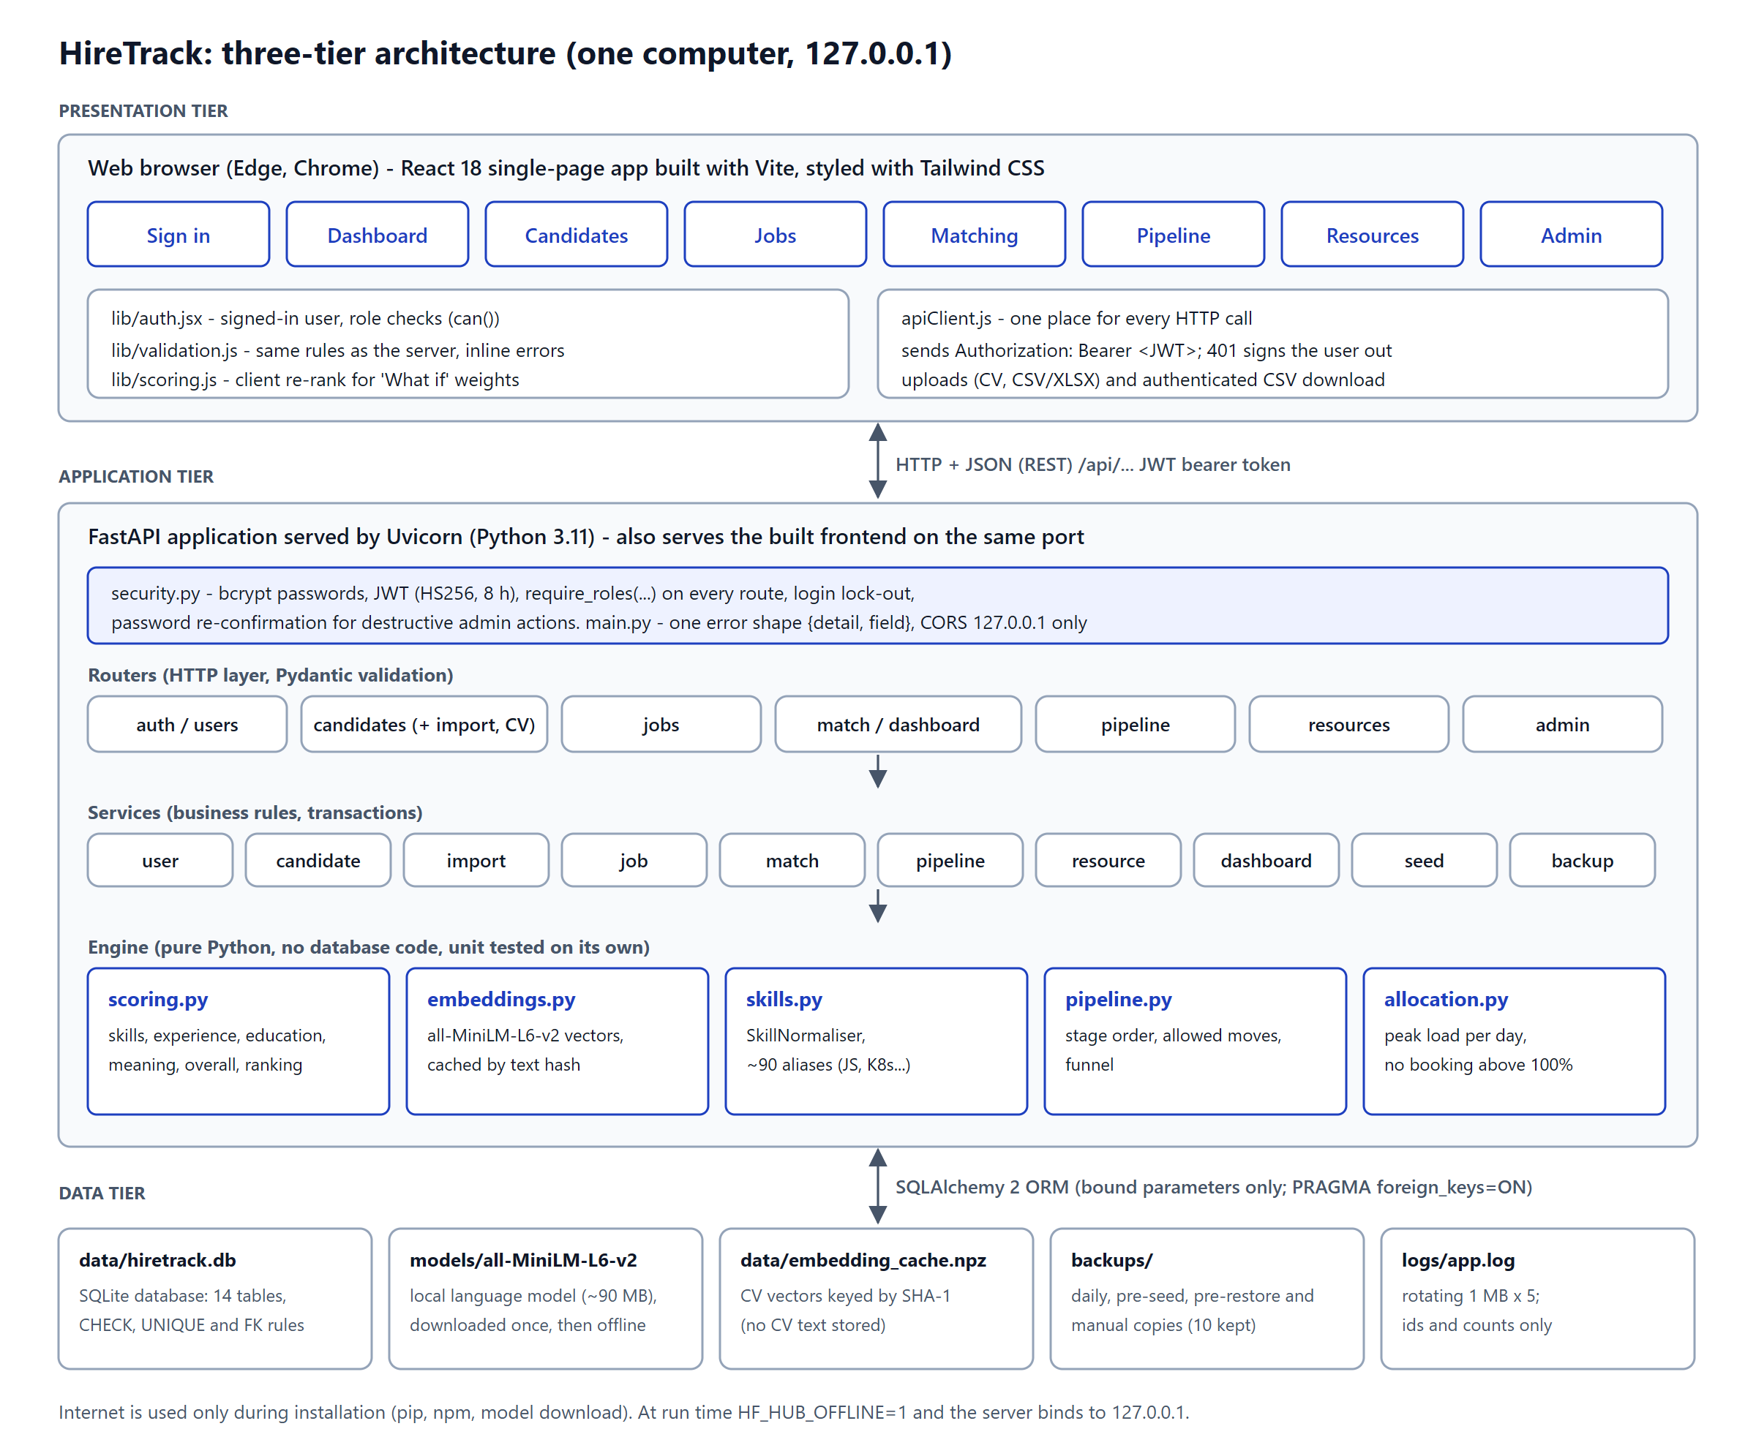
Figure 5.1: Three-tier architecture of HireTrack
Inside the server the code is layered. Routers handle HTTP and validation, services hold the business rules and the database transactions, and the engine modules hold pure rules with no database code. This means the rules that matter most (scoring, stage changes, allocation limits) can be tested on their own in milliseconds.

5.2.2 Module breakdown
Module | Main files | Responsibility | Requirements
M1 Accounts and security | security.py, routers/auth.py, services/user_service.py, pages/Login.jsx, lib/auth.jsx | Sign-in, sessions, role checks, user administration, password change and lock-out | FR14, FR15, NFR9
M2 Candidate management | services/candidate_service.py, services/import_service.py, pages/Candidates.jsx, ImportPanel.jsx | Candidate CRUD and search; CV text extraction; CSV/Excel import | FR1, FR2, FR12, FR16, FR17
M3 Job specifications | services/job_service.py, pages/Jobs.jsx | Job CRUD with skills, location, status and weights | FR3, FR4
M4 Matching engine | engine/scoring.py, engine/embeddings.py, engine/skills.py, services/match_service.py, pages/Results.jsx | Four scores, overall score, ranking, explanations, what-if re-ranking, CSV export | FR5 to FR10, FR13, NFR1, NFR7
M5 Applicant pipeline | engine/pipeline.py, services/pipeline_service.py, pages/Pipeline.jsx | Applications, stage rules, audit history, shortlist from results, hire into staff pool | FR18 to FR21
M6 Resource allocation | engine/allocation.py, services/resource_service.py, pages/Resources.jsx | Staff, projects, allocations, no booking above 100%, utilisation and bench | FR22 to FR24
M7 Dashboard | services/dashboard_service.py, pages/Dashboard.jsx, components/Charts.jsx | Key counts, funnel, applicants per job, utilisation, hires per month, activity | FR25
M8 Administration | services/seed_service.py, services/backup_service.py, routers/admin.py, pages/Admin.jsx, seed/ | Seed datasets, backups, integrity-checked restore | FR11, FR26
Table 5.3: Modules, files and the requirements each one covers

5.2.3 Database schema
The database extends the Phase 4 design (Figure 5.2). The seven tables from the design are unchanged apart from two columns on the job specification (location and status) and two optional contact columns on the candidate. Seven tables were added for accounts, the pipeline and resource allocation. The design is in Third Normal Form: each non-key column depends only on its table's key, lists are stored in link tables, and lookups (education level, skill) are separate tables.
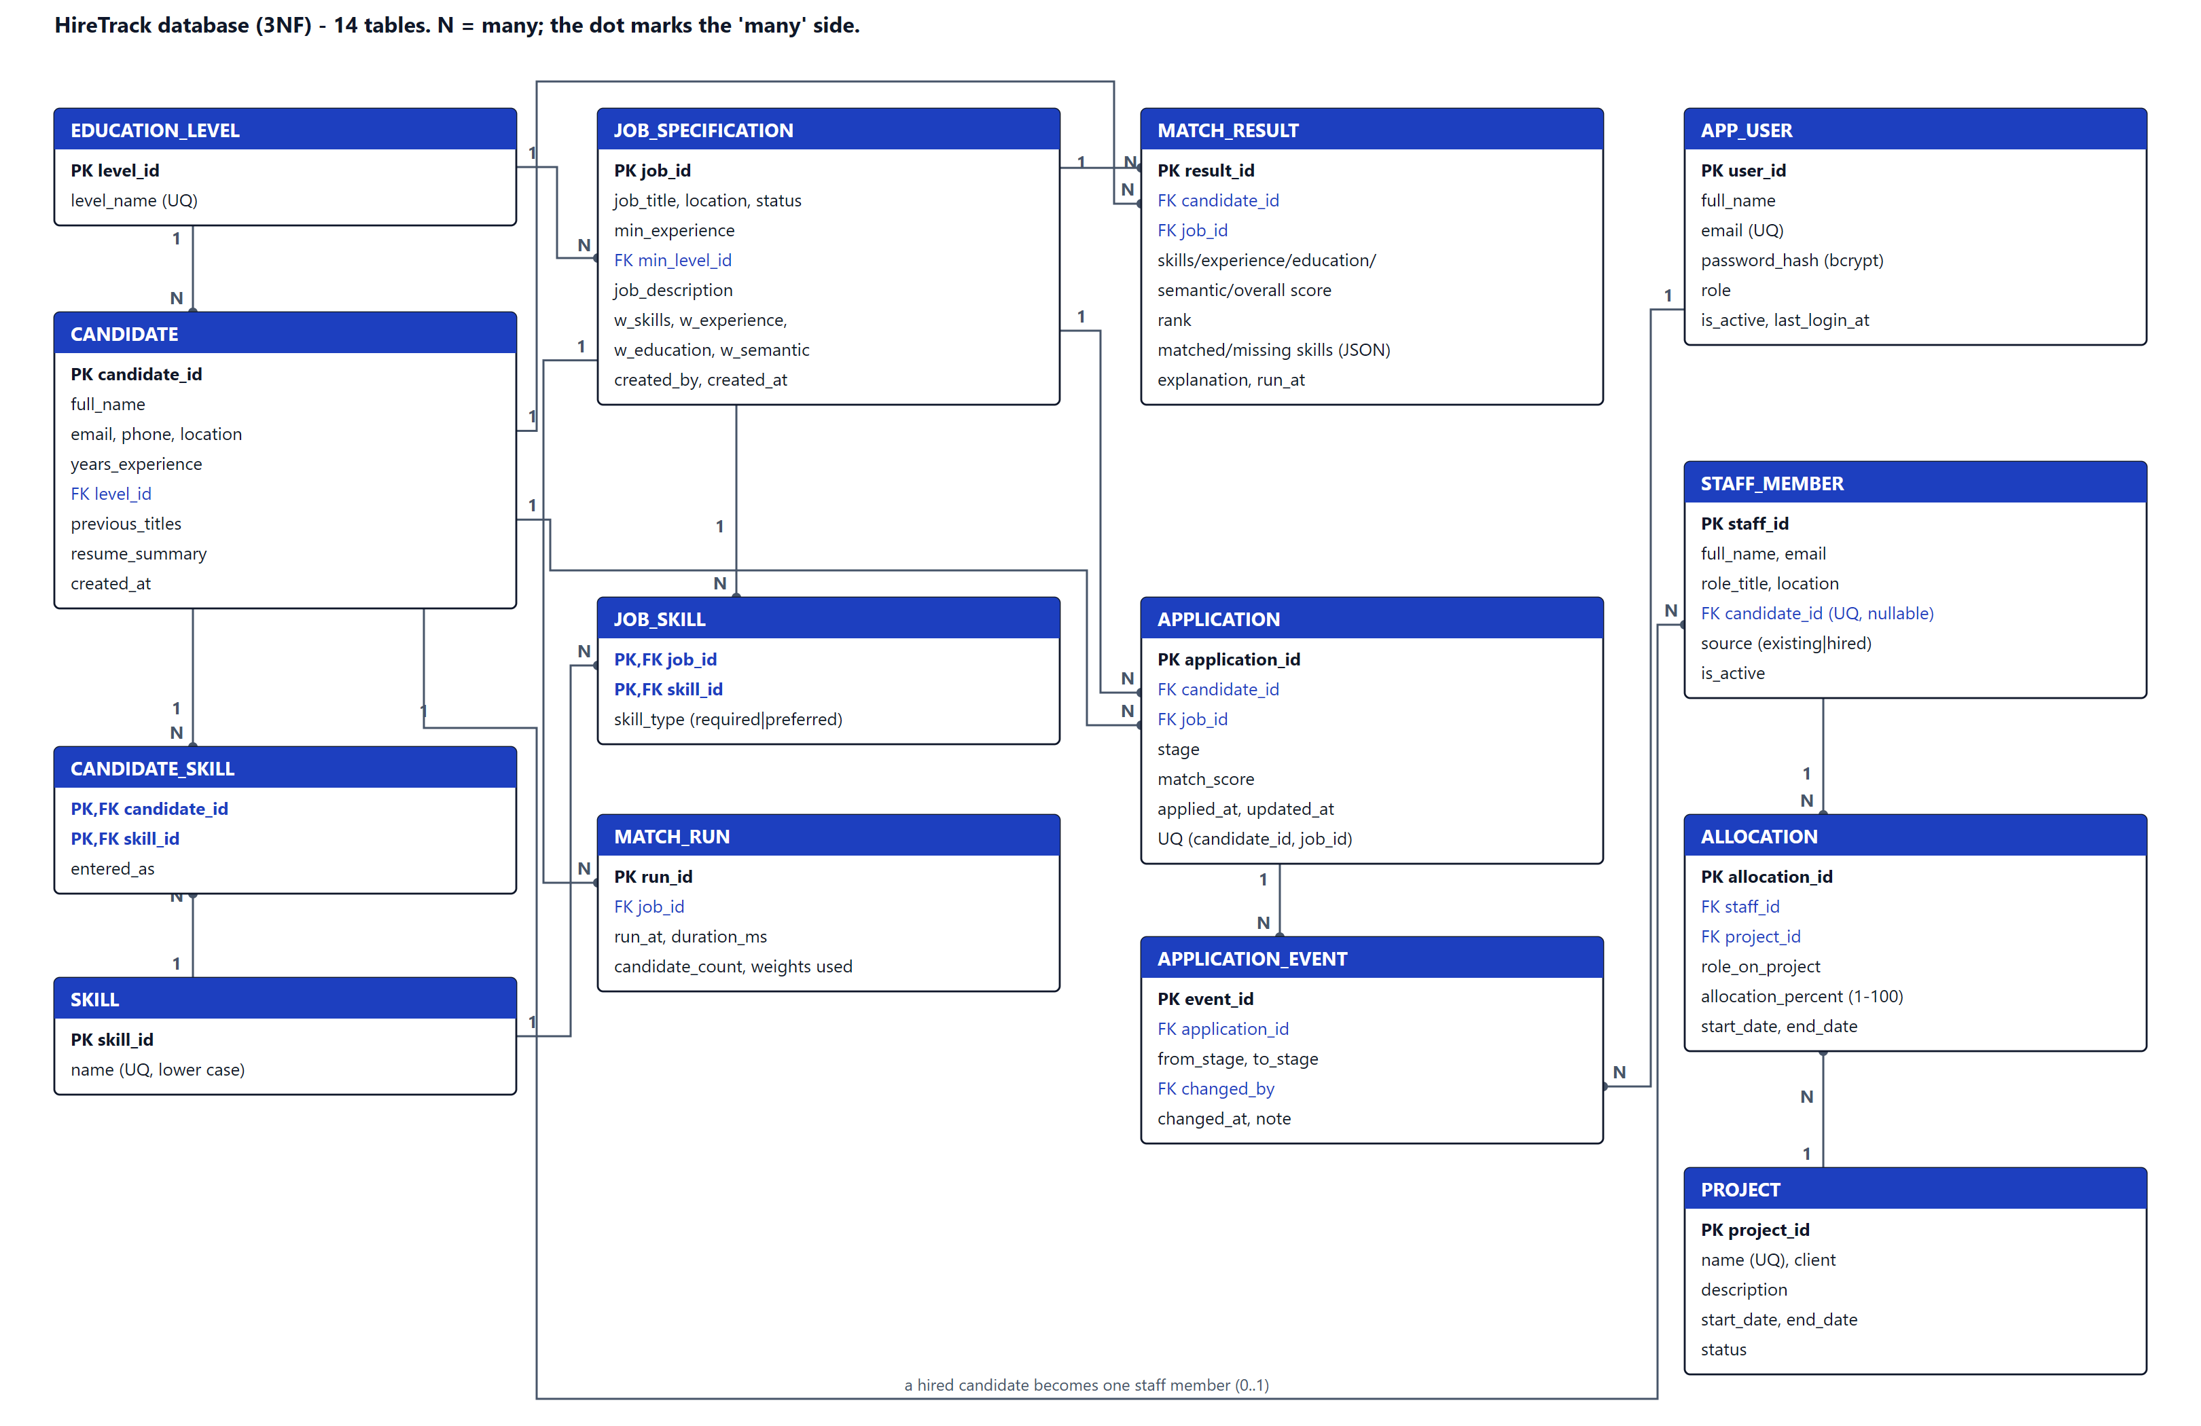
Figure 5.2: Entity-relationship diagram (14 tables)
Table | Purpose | Key rules (enforced by the database) | Rows in seed
app_user | Sign-in accounts | email UNIQUE and lower case; role IN (admin, recruiter, resource_manager) | 3
candidate | Talent pool | name 2-100 characters; years 0-50; summary 20-3000 characters | 600
job_specification | Roles to fill | location 2-80 characters; status IN (open, closed); weights 0-100 and total = 100 | 33
application | Candidate applying for a job | stage IN (6 stages); UNIQUE (candidate_id, job_id); cascades with candidate and job | 847
application_event | Audit history of stage changes | one row per change; changed_by kept as SET NULL if a user is removed | 1906
staff_member | People who can be allocated | candidate_id UNIQUE (a hire becomes one staff member); source IN (existing, hired) | 73
project | Client projects | name UNIQUE; end_date >= start_date; status IN (planned, active, on_hold, completed) | 12
allocation | Share of a person's time on a project | allocation_percent 1-100; end_date >= start_date; the 100% daily limit is enforced by the service | 102
Table 5.4: New and changed tables (the other six are as in the Design phase)
An existing database from the Phase 4 build is upgraded automatically when the server starts: missing columns are added with safe defaults, missing tables are created and the default accounts are added if there are none. Restoring an old backup goes through the same step.

5.2.4 Key code excerpts
The excerpts below are copied from the source files. Each shows a rule the requirements depend on.

a) Skills score (FR5)
Required skills are worth 80 points and preferred skills 20. Skills are compared after normalisation, so "JS" on a CV matches "JavaScript" on a job. The function returns which skills matched and which are missing, which the results screen shows.
backend/app/engine/scoring.py
def skills_score(candidate_skills: Sequence[str], required: Sequence[str], preferred: Sequence[str]) -> SkillMatch:
"""Required skills are worth 80 points, preferred 20.

With no preferred skills, required skills are worth the full 100.
Inputs must already be canonical (see SkillNormaliser).
"""
have = set(candidate_skills)
matched_req = [s for s in required if s in have]
missing_req = [s for s in required if s not in have]
matched_pref = [s for s in preferred if s in have]
missing_pref = [s for s in preferred if s not in have]

if not required:
req_part = 0.0
elif preferred:
req_part = len(matched_req) / len(required) * REQUIRED_SHARE
else:
req_part = len(matched_req) / len(required) * 100
pref_part = len(matched_pref) / len(preferred) * PREFERRED_SHARE if preferred else 0.0

return SkillMatch(
score=round1(clamp(req_part + pref_part)),
matched_required=matched_req,
missing_required=missing_req,
matched_preferred=matched_pref,
missing_preferred=missing_pref,
)

b) Overall score (FR9)
The overall score is a weighted average of the four scores. It is calculated in whole tenths with round-half-up, so the browser's instant "what if" re-ranking, which uses the same method in JavaScript, always agrees with the server to the last decimal.
backend/app/engine/scoring.py
def overall_score(skills: float, experience: float, education: float, semantic: float, weights: Weights) -> float:
"""Weighted average of the four components, rounded to 1 decimal.

Computed in integer tenths so the browser's "what if" re-ranking (which
uses the same integer method) always agrees with the server exactly.
"""
tenths = [int(round(c * 10)) for c in (skills, experience, education, semantic)]
ws = (weights.skills, weights.experience, weights.education, weights.semantic)
total = sum(t * w for t, w in zip(tenths, ws)) # in (tenths x percent)
return ((total + 50) // 100) / 10 # round half up back to tenths

c) Pipeline stage rules (FR18)
An application moves forward one stage at a time or is rejected. Hired and Rejected are final, except that a rejection can be reopened at the stage it was rejected from. The function raises an error with a reason that the screen shows to the user.
backend/app/engine/pipeline.py
def check_move(current: str, target: str, reopen_to: str | None = None) -> None:
"""Raise StageError with a plain-English reason if current -> target is not allowed."""
if target not in ALL_STAGES:
raise StageError(f"Unknown stage '{target}'")
if current == target:
raise StageError(f"The application is already at {LABELS[current]}")
if current in FINAL and not (current == REJECTED and target == reopen_to):
raise StageError(f"{LABELS[current]} is a final stage and cannot be changed")
if target not in allowed_moves(current, reopen_to):
nxt = next_stage(current)
hint = f" The next stage is {LABELS[nxt]}." if nxt else ""
raise StageError(f"Cannot move from {LABELS[current]} to {LABELS[target]}.{hint}")

d) Changing a stage: audit history and hiring (FR19, FR21)
The stage change and its history row are written in the same transaction, so the history can never disagree with the current stage. A move to Hired also creates the staff record.
backend/app/services/pipeline_service.py
def change_stage(db: Session, application_id: int, data: StageChangeIn, user: User) -> Application:
app = get_application(db, application_id)
try:
rules.check_move(app.stage, data.stage, _rejected_from(app))
except rules.StageError as exc:
raise AppError(str(exc), field="stage", status_code=422) from exc
if data.stage == "hired" and app.job.status != "open":
raise AppError("This job is closed, so nobody else can be hired for it", field="stage", status_code=422)
now = utcnow()
app.events.append(
ApplicationEvent(
from_stage=app.stage, to_stage=data.stage, changed_by=user.user_id, changed_at=now, note=data.note or None
)
)
app.stage = data.stage
app.updated_at = now
if data.stage == "hired":
_ensure_staff(db, app)
db.commit()
log.info("Application id=%s moved to %s by user id=%s", application_id, data.stage, user.user_id)
db.expire_all()
return get_application(db, application_id)

e) Preventing over-allocation (FR23)
A person's load can only change on the day a booking starts or the day after one ends. The check therefore looks only at those days instead of every day in the range, and reports the first day the limit would be broken.
backend/app/engine/allocation.py
def peak_load(bookings: Iterable[Booking], start: date, end: date) -> tuple[int, date | None]:
"""Highest total load on any day in [start, end], and the first day it happens.

Load only changes on a booking's start day or the day after its end, so it
is enough to check those days (a sweep), not every day in the range.
"""
inside = [b for b in bookings if overlaps(b.start, b.end, start, end)]
if not inside:
return 0, None
days = {start}
for b in inside:
if start <= b.start <= end:
days.add(b.start)
after = b.end + timedelta(days=1)
if start <= after <= end:
days.add(after)
best, best_day = 0, None
for d in sorted(days):
load = load_on(inside, d)
if load > best:
best, best_day = load, d
return best, best_day

f) Role-based access on the server (FR14, NFR9)
Every route declares the roles it allows. The check runs on the server, so hiding a button in the browser is never the only protection.
backend/app/security.py
def require_roles(*roles: str):
"""Dependency factory: allow only users whose role is in `roles` (else 403)."""

def _check(user=Depends(current_user)):
if user.role not in roles:
log.warning("Denied user id=%s role=%s (needs %s)", user.user_id, user.role, "/".join(roles))
raise Forbidden("Your role does not have access to this action.")
return user

return _check

backend/app/routers/pipeline.py
@router.post("/{application_id}/stage", response_model=ApplicationOut)

g) Bulk import validation (FR17)
Each row of an imported file is checked with exactly the same Pydantic model as the Add Candidate form. Bad rows are reported with their row number; good rows are saved together in one transaction.
backend/app/services/import_service.py (import_candidates)
for i, row in enumerate(rows, start=2): # row 1 is the header
try:
data = CandidateIn(**_to_input(row))
except ValidationError as exc:
field, msg = _friendly(exc.errors()[0])
errors.append(ImportRowError(row=i, field=field, message=msg))
continue
if data.email and (data.email in existing_emails or data.email in seen_in_file):
skipped += 1
continue
if data.email:
seen_in_file.add(data.email)
valid.append(data)

5.2.5 Coding standards, validation and error handling
- Naming and layout. Python follows PEP 8 with type hints; JavaScript uses one component per file. Files are named after what they hold (pipeline_service.py, Pipeline.jsx).
- Comments. Every module starts with a docstring explaining its job and its rules. Comments explain why, not what (for example why scores are calculated in tenths).
- Three layers of validation (NFR6). The screen checks input as it is typed (lib/validation.js); Pydantic checks every request on the server; database CHECK, UNIQUE and FOREIGN KEY rules are the last line of defence.
- One error shape. Every API error is {"detail": "...", "field": "..."}. The screens use the field name to show the message under the right input.
- Transactions. Matching, import, seeding and stage changes write everything or nothing; any error rolls back.
- Parameter passing. Routers receive validated schema objects and pass them to service functions together with the database session and the signed-in user, so services never read HTTP data directly.
- Efficiency. CV embeddings are calculated once and cached in memory and on disk; candidates are loaded with selectinload to avoid one query per row; the candidate table is virtualised so 2,600 rows scroll smoothly.

5.2.6 Security measures
Threat | Control
Stolen passwords | Only bcrypt hashes are stored (12 rounds). Passwords need 8+ characters with a letter and a number.
Guessing passwords | Five failed sign-ins lock that email for 60 seconds. The same message is shown for a wrong email or password.
Using the system without signing in | Every API route except /api/health needs a signed JWT (HS256, 8-hour expiry). The secret is generated on first run and kept in data/.jwt_secret.
Doing more than the role allows | require_roles(...) on every route (36 role and endpoint combinations tested). Screens hide what a role cannot use.
Accidental data loss | Loading a dataset or restoring a backup needs the administrator's password again. A safety backup is taken first; restore runs PRAGMA integrity_check.
SQL injection / XSS | SQLAlchemy bound parameters only; React escapes all text; no dangerouslySetInnerHTML.
Spreadsheet formula injection | CSV export prefixes cells that start with =, +, - or @.
Network exposure | The server binds to 127.0.0.1; CORS allows only the local addresses.
Privacy (POPIA) | Only fictitious data; logs hold ids and counts, never CV text; scoring never reads name, email, age or gender.
Table 5.5: Security controls

5.2.7 User interface
The screens use one neutral palette with a single blue accent, green only for Run Match and red only for destructive actions. Every page uses the same header, table and side-panel patterns. The menu shows only what the signed-in role can use in the order a user meets them, from sign-in to administration (Figures 5.3 to 5.20).
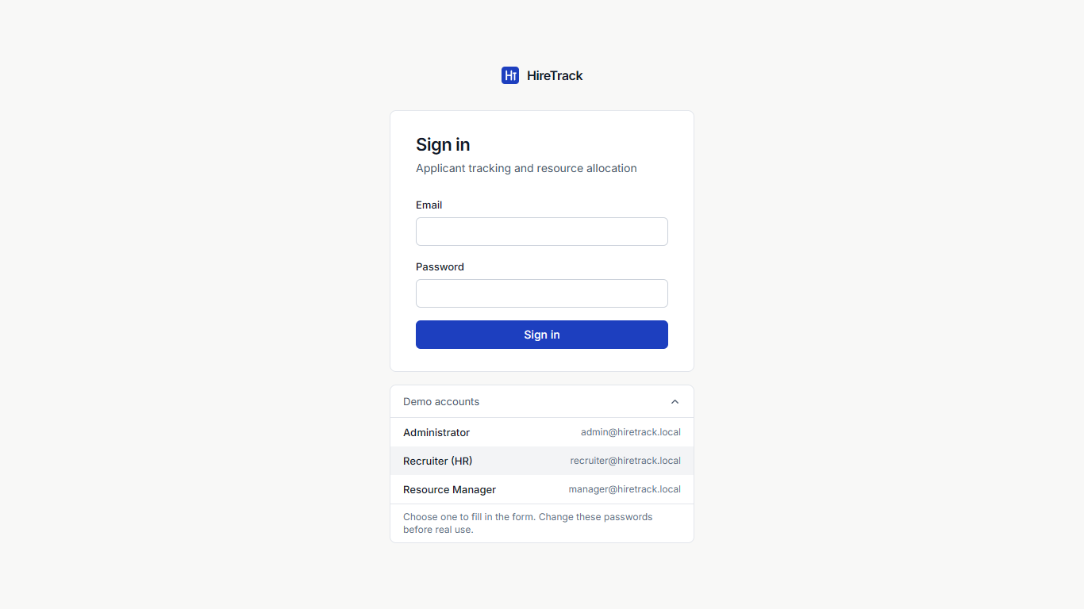
Figure 5.3: Sign-in screen with the demo accounts expanded
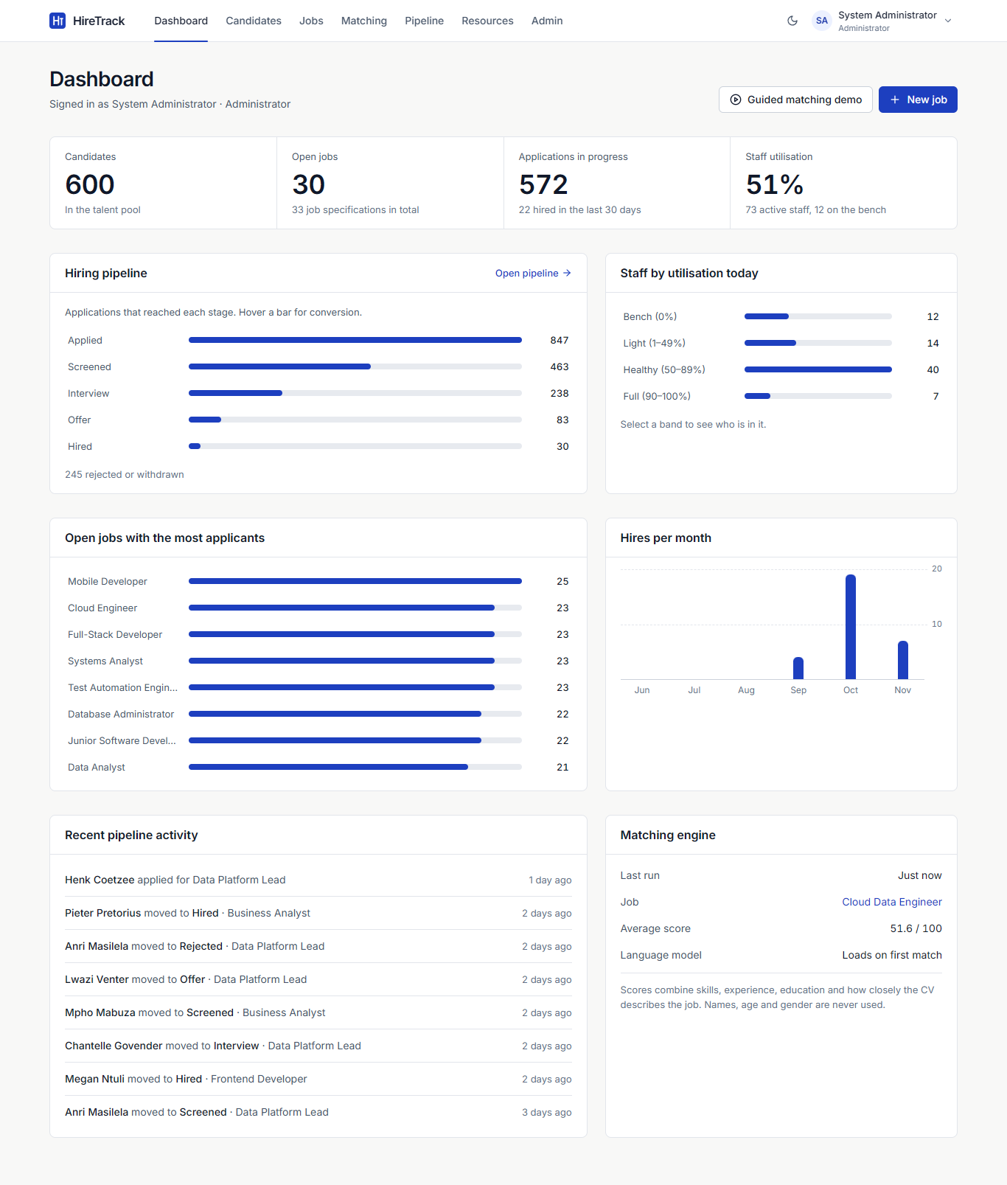
Figure 5.4: Dashboard (Administrator): key counts, pipeline funnel, utilisation, applicants per job, hires per month
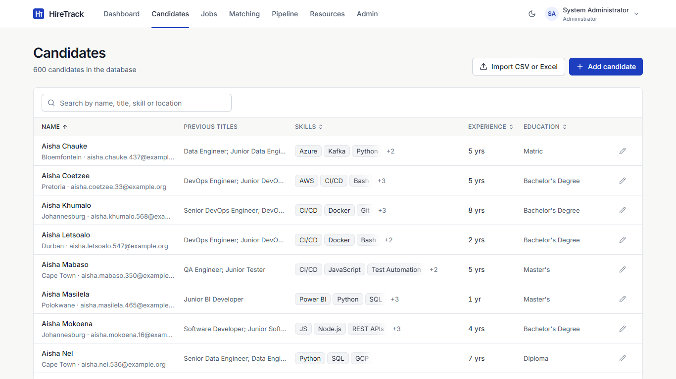
Figure 5.5: Candidate list with search and filters (600 seeded candidates)
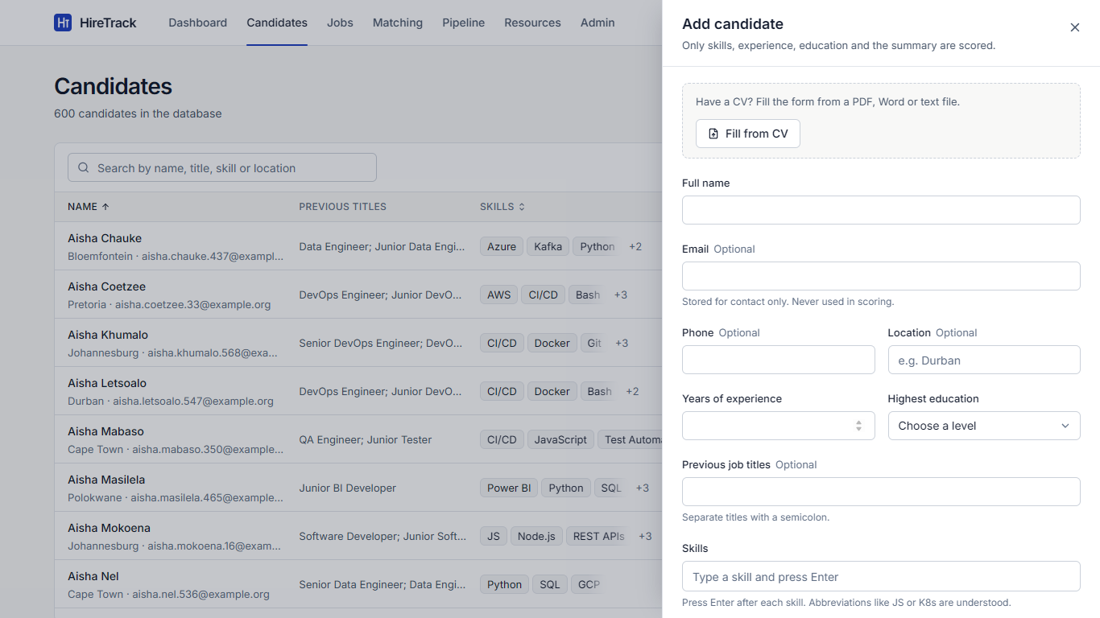
Figure 5.6: Add Candidate panel with "Fill from CV"
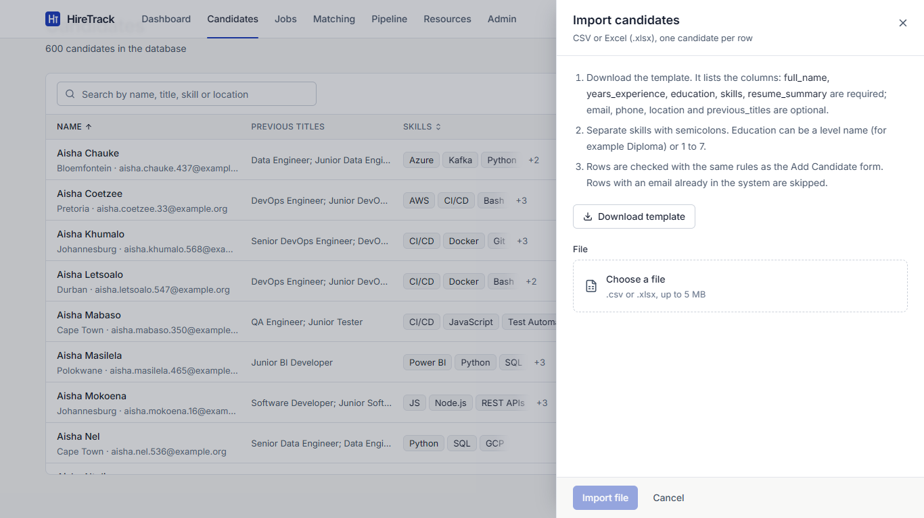
Figure 5.7: Bulk import of candidates from CSV or Excel
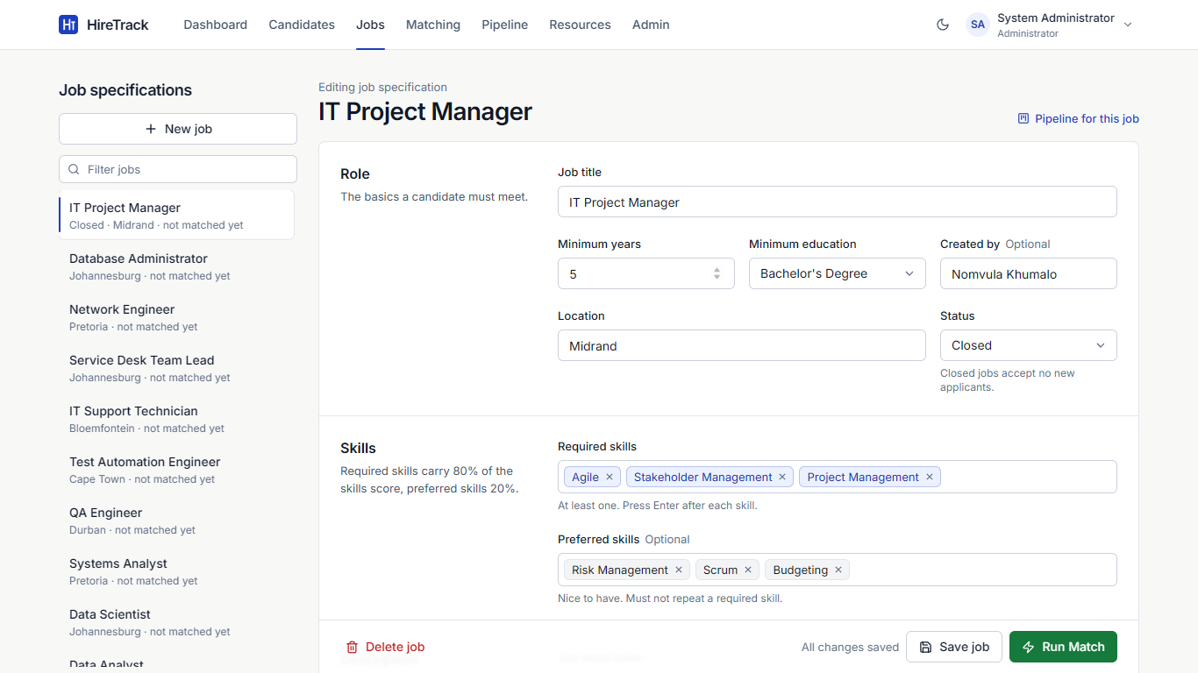
Figure 5.8: Job specification with location, status, skills and weights
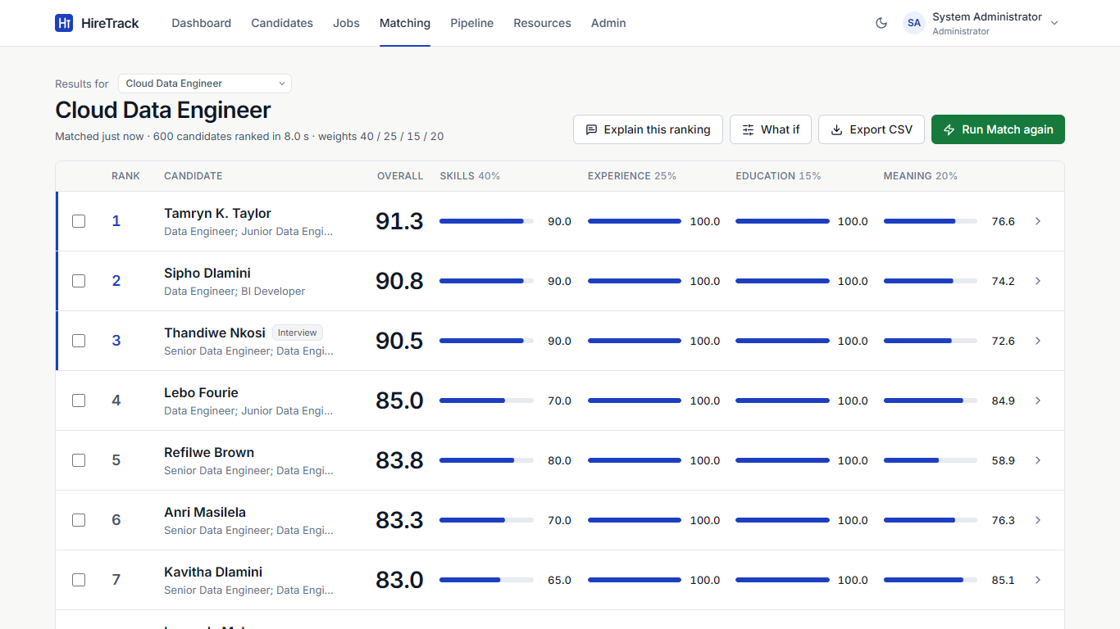
Figure 5.9: Ranked results for Cloud Data Engineer; a pipeline stage badge shows candidates already applied
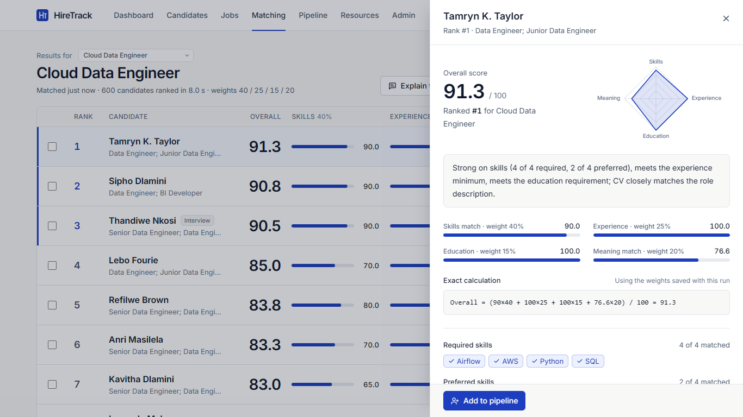
Figure 5.10: Score breakdown with the exact calculation and "Add to pipeline"
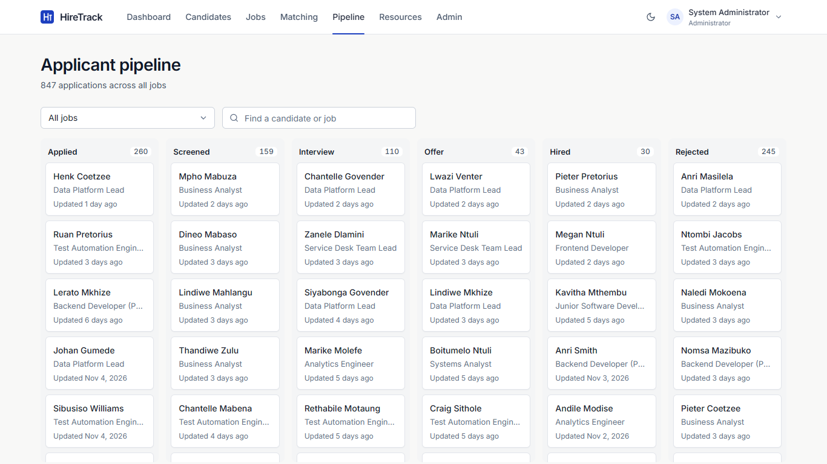
Figure 5.11: Applicant pipeline across all jobs
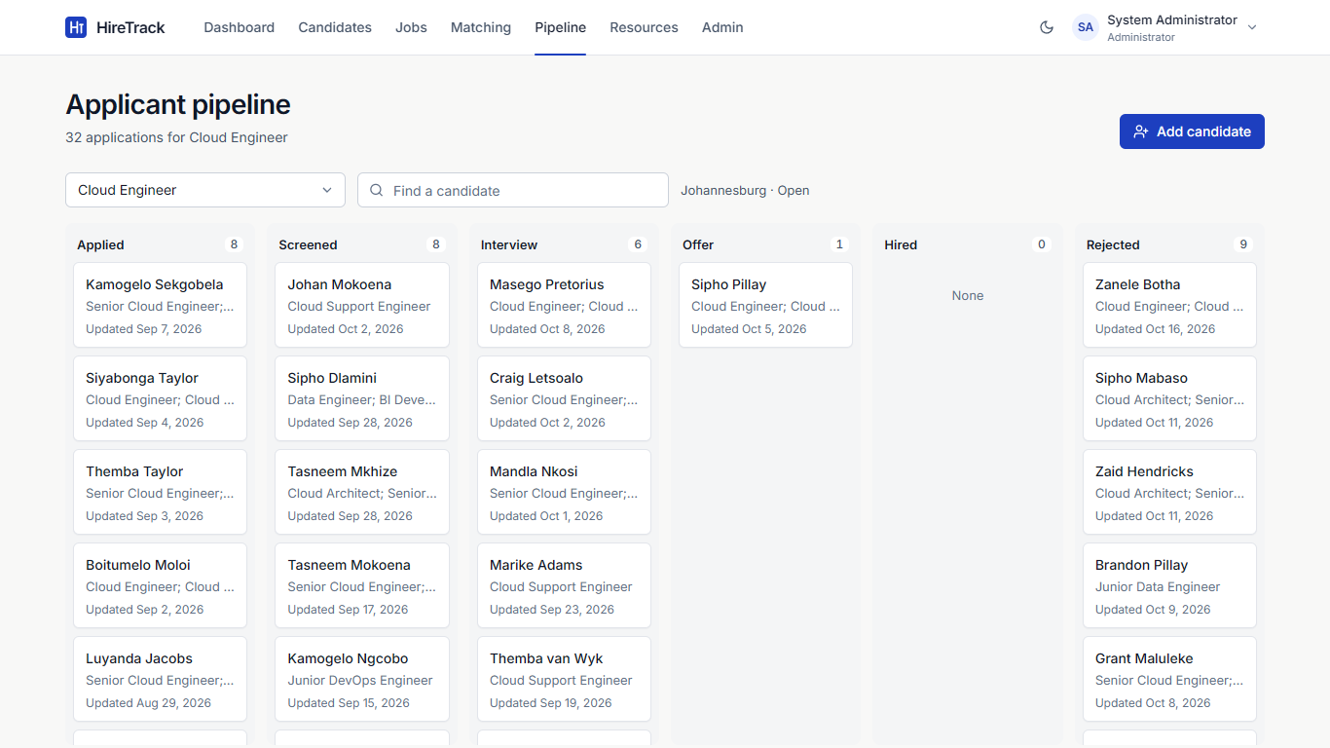
Figure 5.12: Applicant pipeline board for one job
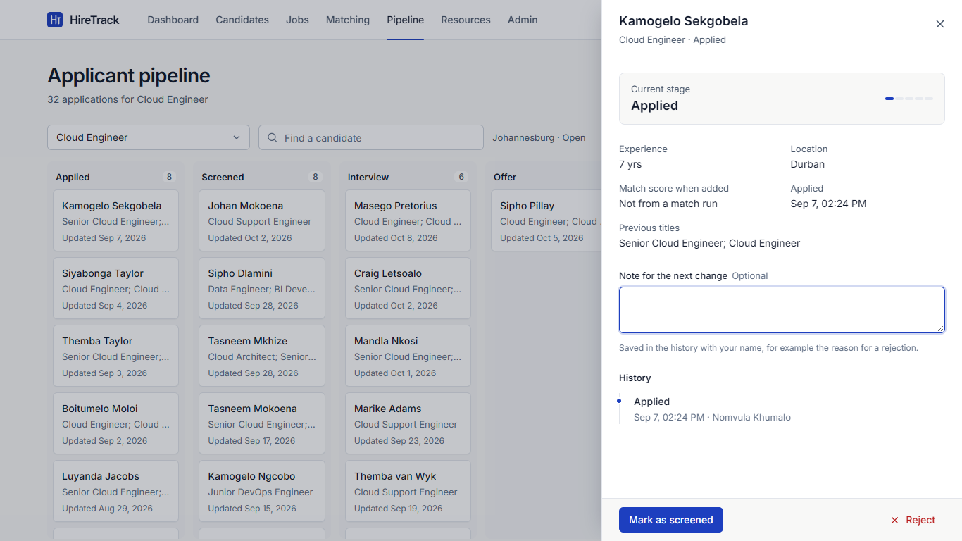
Figure 5.13: Application detail: stage actions, note and audit history
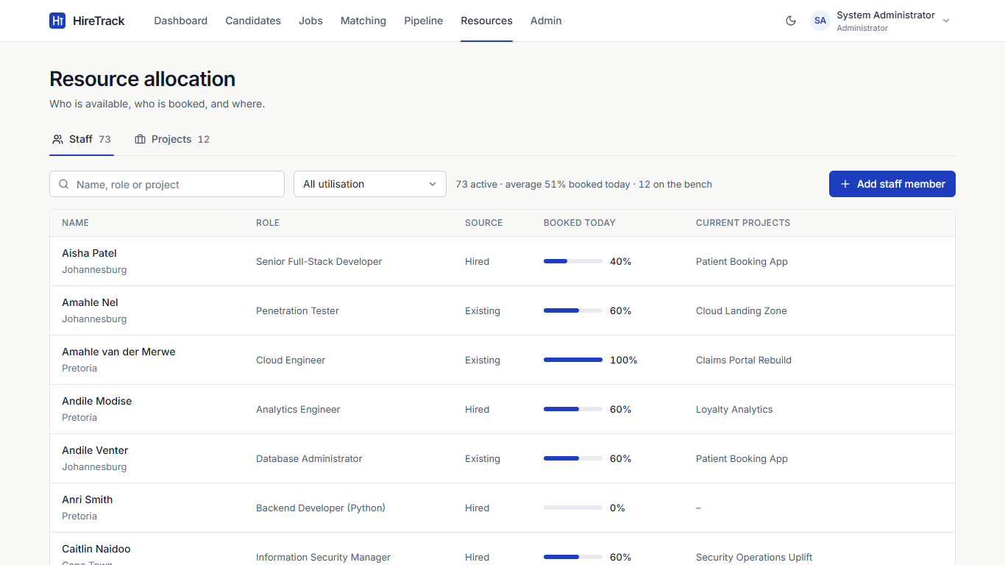
Figure 5.14: Staff utilisation in the Resources screen
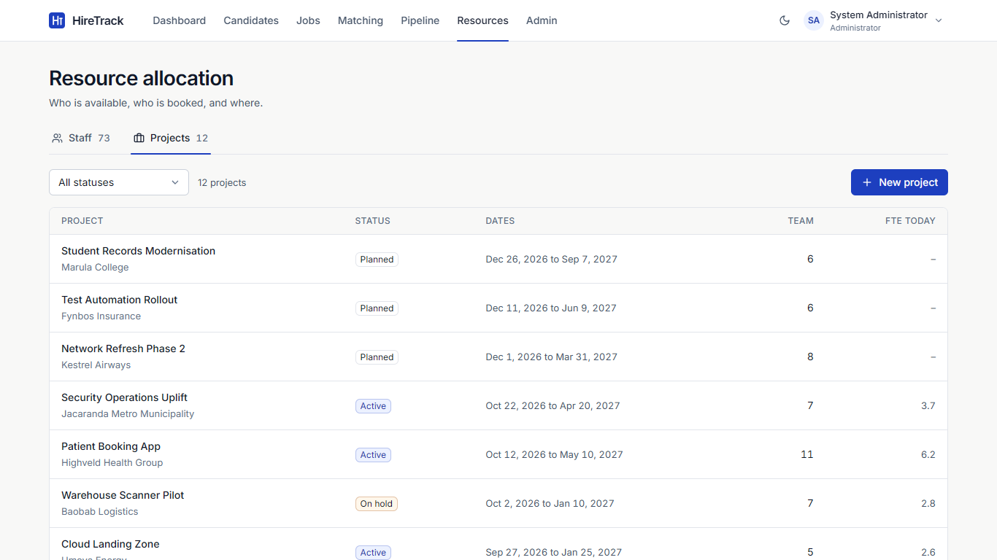
Figure 5.15: Client projects with team size and booked capacity
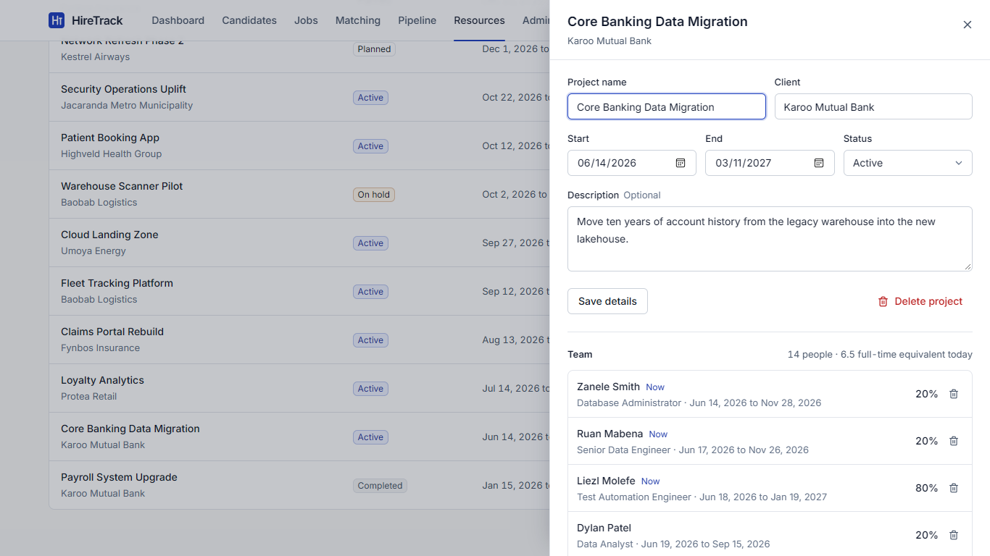
Figure 5.16: Project detail with team allocations
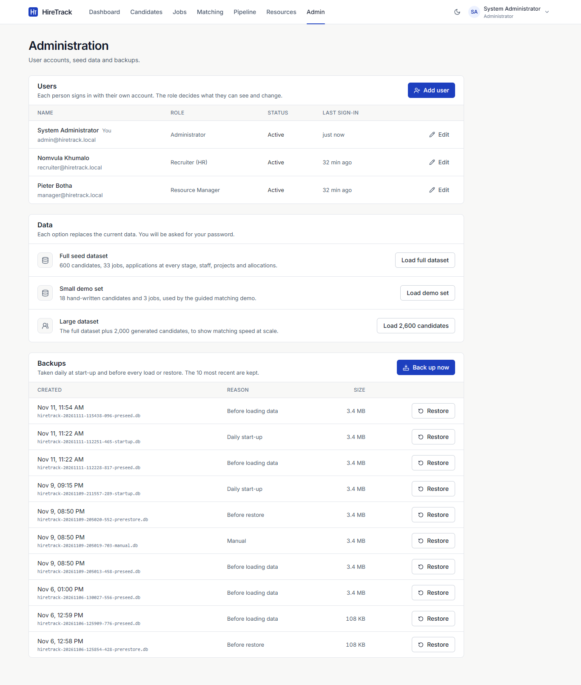
Figure 5.17: Administration: users, datasets and backups
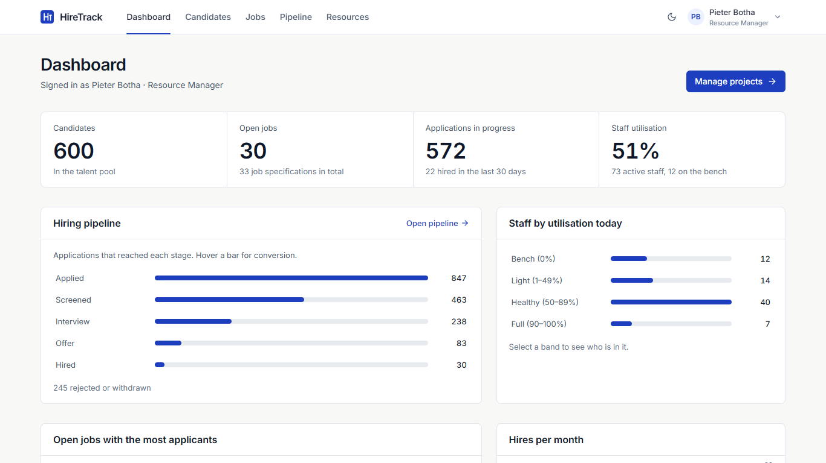
Figure 5.18: Dashboard seen by a Resource Manager (menu limited to that role)
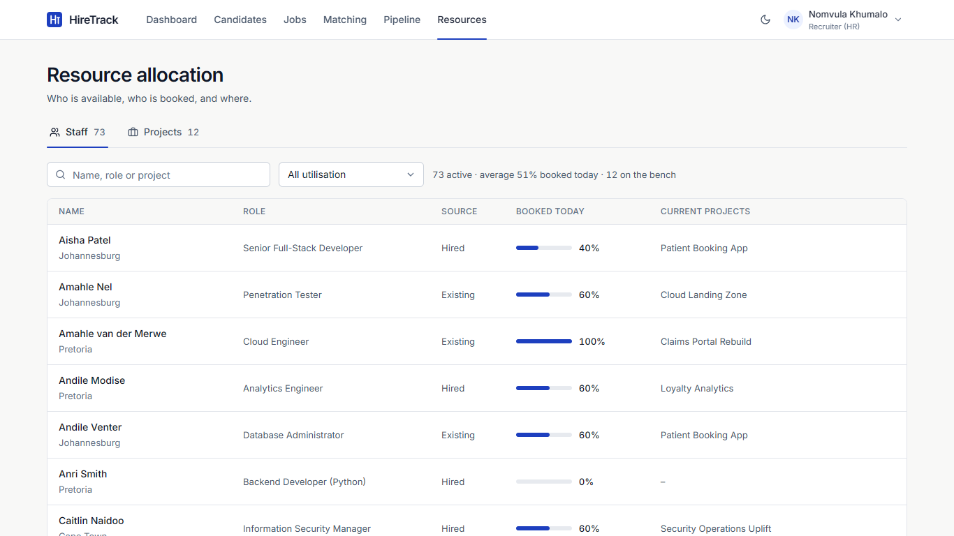
Figure 5.19: A Recruiter sees Resources read-only
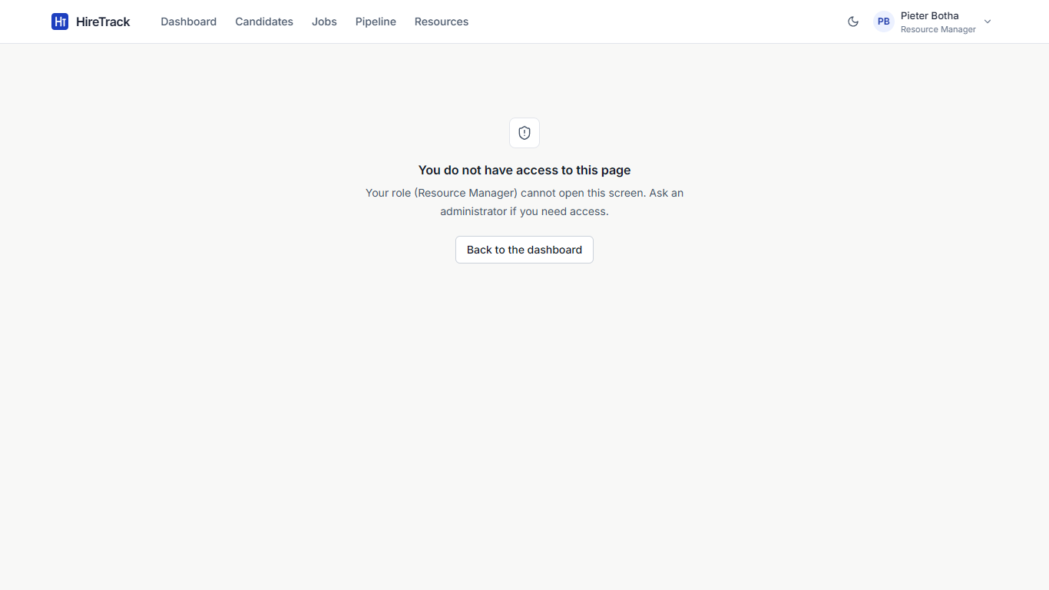
Figure 5.20: A Resource Manager opening the Matching page is refused

5.3 Testing

5.3.1 Approach
Testing followed the test pyramid: many fast unit tests of the rules, a solid layer of API integration tests, component tests of the screens, and a smaller number of end-to-end journeys in a real browser (Section 5.4). All tests are automated and repeatable.
Level | What is tested | Tool | How it is isolated
Unit | Scoring, skill normalisation, pipeline rules, allocation maths, database constraints | pytest | Pure functions; constraint tests use a temporary database
Integration | Every API endpoint, sign-in and roles, import, seed, dashboard, CLI | pytest + FastAPI TestClient | A new temporary data folder per run; every test starts from an empty database with the three accounts
Component | Sign-in, role-based menus, dashboard, pipeline, resources, import, admin, form logic | Vitest + React Testing Library | The API module is replaced with mocks
System / end-to-end | Complete user journeys (TC-01 to TC-22) | Playwright in Edge and Chrome | Own server on port 8010 with a freshly seeded database
Performance | Match speed at 50, 600 and 2,600 candidates | pytest with the real model | HIRETRACK_REAL_MODEL=1
Table 5.6: Testing levels and tools
Fast tests use a deterministic word-hashing embedder instead of the language model, so the 330 backend tests run in under a minute. Password hashing uses 4 bcrypt rounds in tests instead of 12. The performance tests switch the real model back on.

5.3.2 Unit and integration results
Test file | Level | Tests | Passed | Covers
unit/test_scoring.py | Unit | 69 | 69 | Four scores, weights, rounding, ranking and tie-breaks, aliases, explanations, fairness
unit/test_pipeline_rules.py | Unit | 22 | 22 | Stage order, allowed moves, reopen, funnel
unit/test_allocation_rules.py | Unit | 21 | 21 | Overlaps, daily load, peak load, over-allocation messages, bands
unit/test_models.py | Unit | 21 | 21 | CHECK, UNIQUE and FK rules; cascades; schema upgrade
integration/test_api.py | Integration | 54 | 54 | Candidates, jobs, matching, CSV, backups, seeding, demo
integration/test_auth.py | Integration | 64 | 64 | Sign-in, lock-out, tokens, passwords, users, role matrix
integration/test_pipeline_api.py | Integration | 23 | 23 | Applications, stage changes, hiring, shortlist from results
integration/test_resources_api.py | Integration | 20 | 20 | Staff, projects, allocations, utilisation
integration/test_import.py | Integration | 20 | 20 | CSV and Excel import, CV parsing (txt, docx, pdf)
integration/test_seed_dashboard.py | Integration | 9 | 9 | Seed sizes, determinism, legal histories, dashboard
integration/test_cli.py | Integration | 4 | 4 | Password reset tool
integration/test_performance.py | Integration | 3 | 3 | Speed at 50, 600 and 2,600 candidates
Total backend |  | 330 | 330 | 100% pass
frontend src/test (3 files) | Component | 49 | 49 | Screens with mocked API, form validation, re-ranking
Table 5.7: Unit, integration and component test results (final run)

5.3.3 Coverage
Backend line coverage is 95% (2614 of 2748 lines), above the 70% target. The lines not covered are mainly the one-off model download script and error branches that need a missing model or a damaged disk to reach. Frontend line coverage from the component tests is 50.6%; the matching screens are exercised by the end-to-end journeys instead.
Package | Lines | Covered | Coverage
app (core: models, schemas, security, main) | 889 | 827 | 93%
app/engine | 422 | 392 | 93%
app/routers | 240 | 240 | 100%
app/services | 1197 | 1155 | 96%
Total | 2748 | 2614 | 95%
Table 5.8: Backend line coverage by package (pytest-cov)
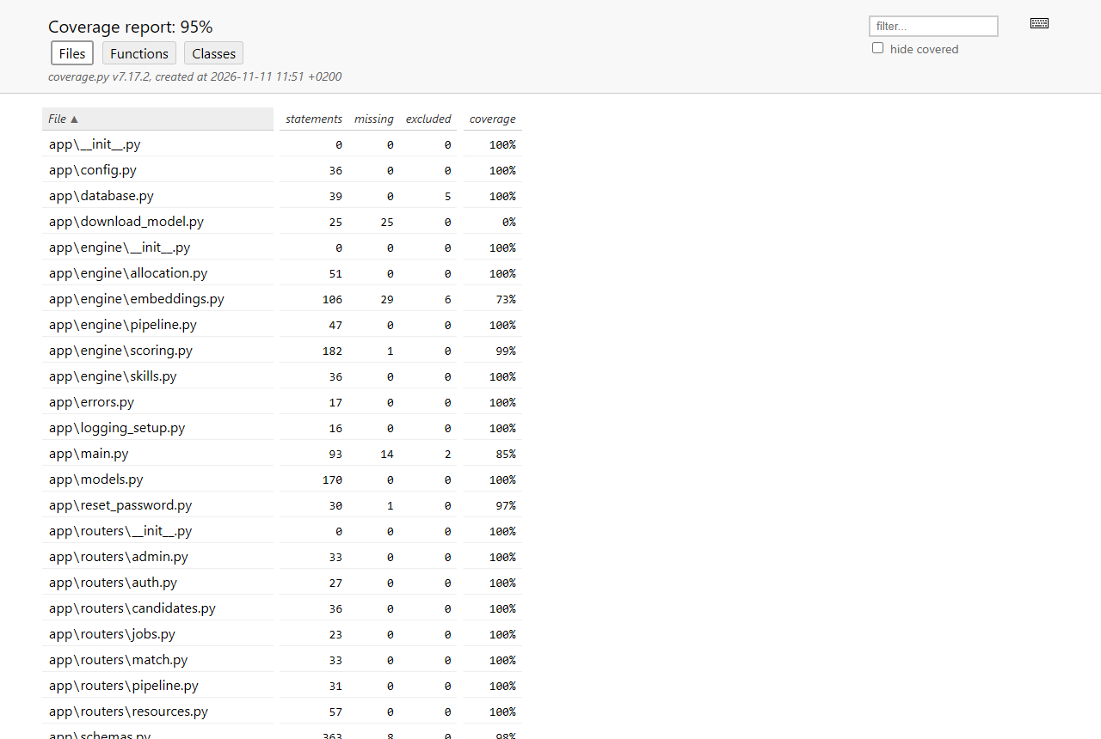
Figure 5.21: pytest-cov HTML report

5.3.4 Performance
Scenario (real all-MiniLM-L6-v2 model, 16-thread laptop CPU) | Time | Target
50 candidates, nothing cached | 0.52 s | < 5 s
600 candidates, warm cache (score + save + reload) | 0.16 s | < 5 s
600 candidates re-ranked through the screen (Playwright TC-13) | 0.69 s | < 5 s
2,600 candidates, warm cache | 0.93 to 1.06 s | < 5 s
First match after loading 600 new CVs (each CV read once) | 8 to 11 s | one-off
Reading 2,600 new CVs in the background after loading | 20.1 s | one-off
Table 5.9: Matching speed

5.3.5 Debugging and code improvement
Testing found seven product defects, all fixed (Section 5.4.4). Two changes improved the code beyond the fixes: the CV parser gained a vocabulary of common skills so it works on an empty database, and the seed data generator was rewritten so stage dates, hires and allocations look like a real company's history. Every fix was followed by a full re-run of all suites.

5.4 System Testing

5.4.1 Approach and requirements
System testing checks the finished system against the requirements, through the screens and the API, as a user would use it. Each test case below is traced to one or more requirements and to the automated test that runs it. The 22 Playwright journeys (TC-01 to TC-22) drive Microsoft Edge against a freshly seeded server; TC-23 to TC-36 check requirements through the API and unit suites; TC-27 and TC-37 were done by hand on a clean copy of the submission.
ID | Requirement
FR1 | Add a candidate with name, contact details, location, experience, education, skills, previous titles and CV summary
FR2 | View, search, edit and delete candidates
FR3 | Create and edit a job specification: title, location, status, skills (required/preferred), minimum experience and education, description
FR4 | Adjust the four scoring weights per job; they must total 100%
FR5-FR8 | Calculate skills, experience, education and meaning (embedding similarity) scores
FR9 | Combine the scores into a weighted overall score and rank every candidate
FR10 | Show each candidate's score breakdown, matched and missing skills and the exact calculation
FR11 | Seed or reset realistic demonstration data (500+ candidates, 30+ jobs)
FR12 | Reject invalid input with a clear message and save nothing
FR13 | Export ranked results to CSV
FR14 | Sign in with a personal account; three roles (Administrator, Recruiter (HR), Resource Manager) with role-based access
FR15 | Administrator manages user accounts; users change their own password
FR16 | Capture a CV file (PDF, Word, text) to pre-fill the candidate profile
FR17 | Bulk import candidates from CSV or Excel with a per-row error report
FR18 | Track each application through Applied, Screened, Interview, Offer, Hired or Rejected under fixed rules
FR19 | Keep an audit history of every stage change (who, when, note)
FR20 | Add shortlisted candidates from match results to a job's pipeline
FR21 | A hired candidate joins the staff pool
FR22 | Manage staff and client projects
FR23 | Allocate staff to projects by percentage and dates without booking anyone above 100%
FR24 | Show utilisation per person and who is on the bench
FR25 | Dashboard with key counts and charts
FR26 | Back up and restore the database
NFR1 | Performance: ranking 500+ candidates returns within 5 seconds
NFR2 | Runs on one computer, offline after installation
NFR3 | Usability: consistent screens, inline errors, keyboard and screen-reader access
NFR4 | Maintainability: business rules in separate, unit-tested modules
NFR5 | Privacy: only fictitious data; scoring never uses name, age or gender
NFR6 | Reliability: invalid data rejected at screen, API and database level
NFR7 | Transparency: every ranking explainable from visible scores
NFR8 | Compatibility: current Edge and Chrome
NFR9 | Security: hashed passwords, signed tokens, role checks on the server, lock-out, confirmed destructive actions
NFR10 | Quality: automated test coverage of at least 70% of backend code
Table 5.10: Requirements tested (FR14 to FR26 and NFR9 to NFR10 added in this phase)
Test environment: Windows 11 laptop, 16-thread CPU, no GPU; Python 3.11.18; Node.js 20.16; Microsoft Edge and Google Chrome (current); screen 1366 x 768. Test data: the full seed dataset (600 candidates, 33 jobs, about 850 applications, 73 staff, 12 projects), plus records created by the tests themselves.

5.4.2 Test cases
ID | Req. | Description | Preconditions | Steps | Test data | Expected result | Actual result | Pass/ Fail
TC-01 | FR14, NFR9 | Sign-in with a wrong password is refused | App running; default accounts exist | 1. Open the sign-in page  2. Enter the admin email and a wrong password  3. Select Sign in | admin@hiretrack.local / not-the-password1 | Message 'Incorrect email or password'; user stays on the sign-in page | Message shown under the password field; dashboard not opened | Pass
TC-02 | FR14 | Each role signs in and sees only its menu items | Default accounts exist | 1. Sign in as each role in turn  2. Read the main menu  3. Sign out | admin, recruiter, manager accounts | Admin: 7 items incl. Admin. Recruiter: no Admin. Resource Manager: no Matching, no Admin | Menus matched exactly for all three roles | Pass
TC-03 | FR14, NFR9 | Role checks are enforced by the server, not only hidden in the screen | Signed in as Recruiter | 1. Open /admin by URL  2. Call GET /api/users with the recruiter's token | Recruiter token | Screen says 'You do not have access to this page'; API returns 403 | Access message shown; API returned 403 | Pass
TC-04 | FR14 | Signing out ends the session | Signed in as Resource Manager | 1. Open the account menu, select Sign out  2. Open /resources by URL | - | Sign-in page shown again | Sign-in page shown | Pass
TC-05 | FR1, FR12, NFR6 | Invalid candidate data is refused with a message under each field | Signed in as Recruiter | 1. Candidates > Add candidate  2. Leave name, education, skills empty; years = -2  3. Select Add candidate | years_experience = -2 | Four inline messages; nothing saved; count stays 600 | 'Full name is required', 'cannot be less than 0', 'Choose an education level', 'Add at least one skill'; count 600 | Pass
TC-06 | FR1, FR2 | Add, search, edit and delete a candidate | Signed in as Recruiter; 600 candidates | 1. Add a candidate with skills Python and K8s  2. Search by name  3. Edit years to 5  4. Delete and confirm | Name 'Zinhle Test <id>', Durban, 4 years, Bachelor's | Count 601 after add; search shows 1 of 601; edit saved; count back to 600 after delete | As expected; K8s stored as kubernetes and shown as typed | Pass
TC-07 | FR16 | A CV file pre-fills the candidate form | Add Candidate panel open | 1. Select Fill from CV  2. Choose a .txt CV | CV with name, email, phone and 'Airflow pipelines in Python and SQL on AWS' | Name, email, phone, summary filled; skills added as chips; nothing saved yet | All fields filled; chips Airflow, Python, SQL, AWS. (First run: chips were lower case - defect D1, fixed) | Pass
TC-08 | FR17 | Bulk CSV import keeps valid rows and reports bad rows | Signed in as Recruiter | 1. Import CSV or Excel  2. Choose a file with 2 valid rows and 1 row with years = -1  3. Import file | 3-row CSV | 2 imported, 1 error 'row 4, Years, Cannot be less than 0'; count 602 | Imported 2, errors table showed row 4; count 602 | Pass
TC-09 | FR3, FR4 | Create a job; Run Match is locked until the weights total 100% | Signed in as Recruiter | 1. Jobs > New job, fill title, location, skills, description  2. Set skills weight to 35 (total 95%)  3. Set it back to 40  4. Save | Python Developer, Cape Town, 3 years | At 95% a warning shows and Run Match is disabled; at 100% it is enabled; job saved | Warning '(now 95%)' and disabled button; enabled at 100%; saved | Pass
TC-10 | FR5-FR8, FR9, FR10, NFR7 | Run a match and read the breakdown | Full seed data loaded | 1. Open Cloud Data Engineer  2. Run Match  3. Open the top candidate | 600+ candidates | All candidates ranked; breakdown shows four scores, skills and 'Overall = (...) / 100 = x' | 602 ranked; top 50 shown; calculation shown and reproduces the overall score | Pass
TC-11 | FR4, FR9, NFR7 | What-if weights re-rank without saving | Results open | 1. What if  2. Set Meaning to 60% | semantic weight 60 | List re-ranks; 'Showing what-if ranking' label; saved run unchanged | Re-ranked instantly with the label shown | Pass
TC-12 | FR13, FR20 | Shortlist into the pipeline and export CSV | Results open | 1. Tick 2 candidates not yet in the pipeline  2. Add to pipeline  3. Export CSV | 2 candidates | Toast '2 candidates added'; CSV named hiretrack-cloud-data-engineer-<date>.csv with 600+ rows | As expected; CSV header and 603 lines checked | Pass
TC-13 | NFR1 | Re-running a 600-candidate match through the screen takes under 5 s | Model loaded, CVs cached | 1. Results > Run Match again  2. Time until 'Match complete' | 602 candidates | Under 5 seconds | 0.68 s end to end (Edge) | Pass
TC-14 | FR18, FR19, FR21 | Move an applicant from Applied to Hired with notes | Candidate applied to Cloud Engineer | 1. Open the card  2. For each stage add a note and select the next action | Notes for each move | Stage advances one step at a time; history shows 5 entries with notes and user; person appears in Staff as Hired | As expected | Pass
TC-15 | FR18, FR19 | Stages cannot be skipped; a rejection can be reopened | An application at Applied | 1. POST stage=offer  2. Reject with a note  3. Reopen | - | API 422 'next stage is Screened'; rejected then back at Applied; note kept in history | As expected | Pass
TC-16 | FR14, FR18 | A Resource Manager can view but not change the pipeline | Signed in as Resource Manager | 1. Pipeline  2. Open any card | - | History visible; no stage buttons | No action buttons shown; API also returns 403 | Pass
TC-17 | FR22, FR23, FR24 | Create a project, allocate staff, block over-allocation | Signed in as Resource Manager | 1. Add staff member  2. New project (active)  3. Allocate 70%  4. Try another 50% on the same dates | 70% then 50% | First saved (0.7 FTE); second refused: 'most you can add for these dates is 30%'; staff list shows 70% | As expected | Pass
TC-18 | FR22, FR12 | Project end date before start date is refused | New project panel | 1. Start = today+30, End = today+1  2. Create project | - | 'End date cannot be before the start date'; nothing saved | As expected | Pass
TC-19 | FR24 | Bench filter shows only unallocated staff | Seed data loaded | 1. Open /resources?band=bench | - | Every row shows 0% | All rows 0% | Pass
TC-20 | FR25, NFR3 | Dashboard shows key counts and charts; bars are usable by keyboard | Seed data loaded | 1. Sign in as Admin  2. Check tiles and charts  3. Select the Bench bar | - | 4 tiles and 5 chart panels; selecting Bench opens the filtered staff list | As expected. (First run: bars were hidden from keyboard/screen readers - defect D2, fixed) | Pass
TC-21 | FR15 | An administrator creates a user who can then sign in | Signed in as Admin | 1. Admin > Add user (Recruiter)  2. Sign out  3. Sign in as the new user | hr.<id>@hiretrack.local / Welcome123 | User created; sign-in succeeds with the Recruiter menu | As expected | Pass
TC-22 | FR26, FR11, NFR9 | Manual backup; data reset needs the admin's password | Signed in as Admin | 1. Back up now  2. Load demo set with a wrong password  3. Cancel | wrong-password1 | Backup listed; 'Incorrect password'; data unchanged | As expected | Pass
TC-23 | FR11 | Seed script builds the realistic dataset | Empty database | 1. python seed/seed_database.py | - | 600 candidates, 33 jobs (30 open), 500+ applications with legal histories, staff, 12 projects, no one above 100% | 600 candidates, 33 jobs, 847 applications, 1,906 events, 73 staff, 12 projects, 102 allocations; all histories legal | Pass
TC-24 | FR26 | Restore refuses a corrupt or unknown backup file | Admin | 1. Restore a damaged file  2. Restore a path with ../ | corrupt .db; '../../data/hiretrack.db' | Integrity check fails, nothing restored; traversal refused | As expected | Pass
TC-25 | FR15, NFR9 | There is always one active administrator; users cannot deactivate themselves | Admin | 1. Change the only admin to Recruiter  2. Deactivate own account | - | Both refused with a reason | As expected | Pass
TC-26 | NFR1 | Ranking speed with the real model | Real all-MiniLM-L6-v2 model | Run tests/integration/test_performance.py with HIRETRACK_REAL_MODEL=1 | 50, 600 and 2,600 candidates | Each warm match under 5 s | 50 uncached: 0.52 s; 600 warm: 0.16 s; 2,600 warm: 0.93-1.06 s; one-off encoding of 2,600 CVs 20.1 s | Pass
TC-27 | NFR2 | The app runs with no internet connection | Fresh install from a copy of the repository | 1. Start the server with HF_HUB_OFFLINE=1 and an unreachable proxy  2. Sign in and run a match | HTTP(S)_PROXY=http://127.0.0.1:9 | Everything works; no outbound connection needed | Match ran and results loaded with all network access blocked | Pass
TC-28 | FR5-FR8, FR9, NFR5, NFR7 | Scoring ignores personal details | - | Score two candidates identical except name and email | - | Identical scores; name used only as the final tie-break | As expected | Pass
TC-29 | NFR6 | Database constraints reject bad data written directly | - | Insert bad rows through the ORM, bypassing the API | years -1, weights 110%, allocation 0%, duplicate application | IntegrityError for every case | As expected (21 cases) | Pass
TC-30 | NFR9 | Five failed sign-ins lock the account for 60 s | - | 1. Five wrong passwords  2. Correct password | - | 429 'Too many failed sign-in attempts' | As expected | Pass
TC-31 | NFR9 | Expired or forged tokens are refused | - | Call /api/auth/me with an expired and a garbage token | - | 401 with 'expired' / 'sign in' | As expected | Pass
TC-32 | NFR9 | Passwords are stored only as bcrypt hashes | - | Read app_user.password_hash | - | Every value starts with $2b$; no plain text | As expected | Pass
TC-33 | NFR6, FR12 | Search text cannot inject SQL | Candidates exist | Search for x' OR '1'='1 | - | No rows matched; no error | As expected | Pass
TC-34 | NFR8 | Full journey suite in a second browser | Chrome installed | HT_BROWSER=chrome npx playwright test | 22 journeys | All pass | 22 of 22 passed in Chrome | Pass
TC-35 | NFR10 | Backend coverage at least 70% | - | pytest --cov=app | - | >= 70% | 95% line coverage | Pass
TC-36 | NFR4 | Business rules can be tested without a database | - | Run tests/unit (scoring, pipeline, allocation) | - | All pass with no server or database | 133 unit tests passed | Pass
TC-37 | Installation | Fresh install from a copy of the repository on a clean folder | Python 3.11, Node 20 | Clone, run start.bat, sign in | - | App installs, seeds and opens at http://127.0.0.1:<port> | See Installation section: completed and verified | Pass
Table 5.11: System test cases (also in system_testing/Test_Cases.xlsx with the automated test for each case)

5.4.3 Evaluation of the testing results
Pass rate. All 37 system test cases passed on the final runs: 22 of 22 end-to-end journeys in Edge and 22 of 22 in Chrome, 330 of 330 backend tests and 49 of 49 frontend tests, 401 automated tests in total. Every requirement from FR1 to FR26 and NFR1 to NFR10 is covered by at least one passing case (traceability sheet in Test_Cases.xlsx).
Not first-time results. The first end-to-end run passed 14 of 22 (64%); the first backend run passed 322 of 326. Each failure was investigated and classified as a product defect, a test defect or a test-environment issue. Raw outputs of every run are kept in testing/results.
Suite | First run | Final run
Backend (pytest) | 322 / 326 | 330 / 330
Frontend (Vitest) | 45 / 46 | 49 / 49
End-to-end, Edge (Playwright) | 14 / 22 | 22 / 22
End-to-end, Chrome (Playwright) | not run | 22 / 22
Table 5.12: Pass rate from first to final run
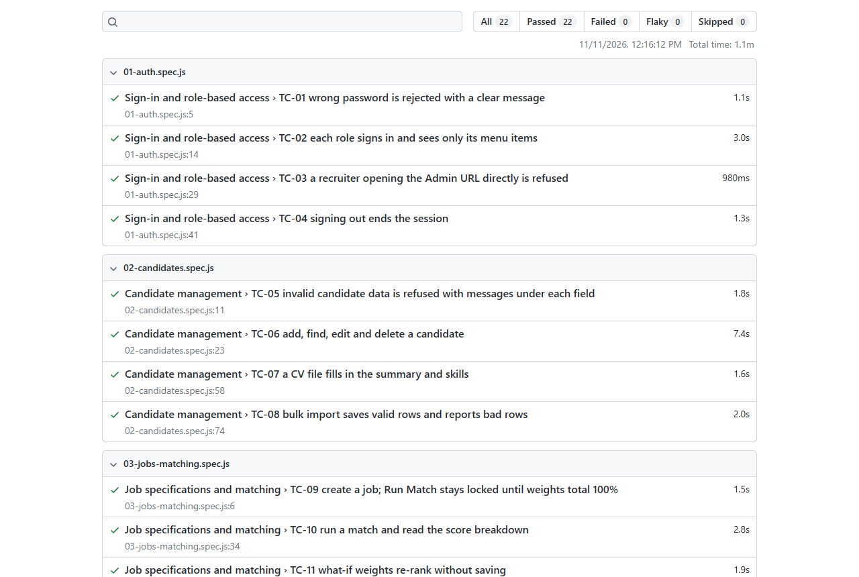
Figure 5.22: Playwright HTML report of the final end-to-end run

5.4.4 Defects found and how they were fixed
ID | Found by | Defect | Fix
D1 | TC-07 | Skills read from a CV appeared as lower-case chips | Converted to display labels before adding them to the form
D2 | TC-20 | Clickable dashboard bars were hidden from keyboard and screen-reader users | Made real buttons with names; component test added
D3 | test_import | CV parsing found no skills on a new, empty database | Built-in vocabulary of common skills plus the alias table
D4 | Screenshot review | Seed data unrealistic: same timestamps, hires with other open offers, 59% of staff on the bench | Dates spread over time, a hire withdraws other applications, bench about 1 in 8
D5 | Screenshot review | "170% booked today" on a project read as over-booking | Shown as full-time equivalents (1.7 FTE)
D6 | Manual test | start.bat busy-port check never fired | Replaced the regular expression with plain findstr filters
D7 | Fresh install | start.bat could not find Python 3.11 installed outside PATH | PYTHON override added to both start scripts and documented
Table 5.13: Product defects
Nine test defects were also fixed (for example ambiguous locators, an expected count that ignored records created by an earlier test, and an expectation of 29 open jobs where 30 is correct). Two test-environment issues were found. First, the end-to-end server had switched off the model warm-up the real app performs at start-up, so the first match was slow. It now starts exactly like the real app. Second, under automation Microsoft Edge holds a finished blob download open, which hung the next test. The CSV test now captures the file at the last browser step in Edge, while Chrome performs the full save.

5.4.5 Limitations
- Firefox and Safari were not tested; Edge and Chrome were.
- Usability was judged by review and accessibility checks, not by observing real recruiters.
- The first match after loading new CVs takes longer than 5 seconds because each CV is read once by the model; later matches take under a second.
- SQLite and a server bound to 127.0.0.1 suit one user at a time; concurrent load was not tested.
- Frontend component coverage is 50.6%; the older matching screens rely on end-to-end tests.
- Scanned (image-only) CVs cannot be read; there is no OCR.
- Seed data is generated, so match quality on real CVs has not been measured.

5.4.6 Recommendations
- Add Firefox and other screen sizes to the Playwright run.
- Hold a short usability session with two or three recruiters, using the test journeys as tasks.
- Move to PostgreSQL and a lab-network server before several recruiters use it at once, and add a load test.
- Add component tests for the Candidates, Jobs and Results screens.
- Encode CVs in the background as soon as they are imported or edited, so the first match is never cold.
- Add OCR for scanned CVs and compare match rankings with recruiter shortlists.

5.5 Installation

5.5.1 Summary
HireTrack installs on one Windows or macOS computer with a single command. The full, step-by-step guide with manual installation, test commands and troubleshooting is INSTALLATION_GUIDE.md in the repository.
Prerequisite | Version
Python | 3.11 (64-bit)
Node.js and npm | 18 or later (tested with 20.16)
Browser | Microsoft Edge or Google Chrome
Disk / memory | about 3 GB free; 4 GB RAM minimum, 8 GB recommended
Internet | During installation only
Table 5.14: Prerequisites

5.5.2 Steps
- Clone the repository and open it: git clone https://github.com/RohanRajaramNaik/hiretrack.git then cd hiretrack. (Alternatively use Code, Download ZIP on the repository page.)
- Windows: run start.bat. macOS/Linux: run chmod +x start.sh then ./start.sh.
- The first run creates the Python virtual environment and installs the packages, downloads the language model (about 90 MB), builds the screens, and creates and seeds the database. Later runs start in a few seconds and work offline.
- Open http://127.0.0.1:8000 (the script opens it) and sign in with one of the accounts below.
Role | Email | Password
Administrator | admin@hiretrack.local | Admin@123
Recruiter (HR) | recruiter@hiretrack.local | Recruiter@123
Resource Manager | manager@hiretrack.local | Manager@123
Table 5.15: Default accounts (change the passwords before real use)
Options: PORT (another port), PYTHON (path to Python 3.11 if not on PATH) and HT_NO_BROWSER. The database can be re-seeded at any time with python seed/seed_database.py or from the Admin screen.

5.5.3 Verification on a clean copy
The guide was verified by doing a fresh installation from a copy of the repository contents in a new temporary folder on the test laptop, with no virtual environment, no node_modules, no model and no database. start.bat was run on port 8002. It installed the packages, downloaded the model, built the frontend, seeded 600 candidates and 33 jobs, and started the server. All three accounts signed in, a match ran, and the dashboard, pipeline and resources screens loaded. The server was then restarted with HF_HUB_OFFLINE=1 and all HTTP and HTTPS traffic sent to an unreachable proxy. Matching and every screen still worked, which confirms NFR2 (offline after installation). The install log is in testing/results/fresh-install-log.txt.

Conclusion
The Implementation Phase delivered a complete, working HireTrack. The matching engine from the Design phase is built exactly to its specification and explains every score. Around it, the system now has the remaining objectives of the Proposal: personal accounts with three roles, an applicant pipeline with a full audit history, resource allocation that cannot over-book anyone, bulk import and CV capture, and a dashboard. The database seeds itself with 600 candidates, 33 jobs and a realistic hiring and project history.
The system was tested at four levels with 401 automated tests and 37 traced system test cases. Every requirement passed on the final runs, with 95% backend coverage, and a 600-candidate match takes well under one second once CVs are cached. Testing found and fixed seven product defects; the remaining limitations (browser range, cold first match, single-user database) are documented with recommendations. A fresh installation from the submitted files was verified with one command.

References
FastAPI (2026) FastAPI documentation. Available at: https://fastapi.tiangolo.com (Accessed: 6 November 2026).
Jones, M., Bradley, J. and Sakimura, N. (2015) JSON Web Token (JWT), RFC 7519. Internet Engineering Task Force.
Meta Platforms (2026) React documentation. Available at: https://react.dev (Accessed: 6 November 2026).
Microsoft (2026) Playwright documentation. Available at: https://playwright.dev (Accessed: 10 November 2026).
OWASP Foundation (2021) OWASP Top 10. Available at: https://owasp.org/Top10/ (Accessed: 6 November 2026).
Reimers, N. and Gurevych, I. (2019) 'Sentence-BERT: Sentence embeddings using Siamese BERT-networks', Proceedings of EMNLP-IJCNLP 2019, pp. 3982-3992.
Republic of South Africa (2013) Protection of Personal Information Act 4 of 2013. Pretoria: Government Printer.
Richfield Graduate Institute of Technology (2026) IT Project Guidelines, Semester 2 2026. Faculty of Information Technology.
SQLAlchemy (2026) SQLAlchemy 2.0 documentation. Available at: https://docs.sqlalchemy.org (Accessed: 6 November 2026).
SQLite (2026) SQLite online backup API. Available at: https://www.sqlite.org/backup.html (Accessed: 6 November 2026).
Schwalbe, K. (2019) Information Technology Project Management. 9th edn. Boston: Cengage Learning.

Appendix A: Core Backend Source Code
Full listing of the core backend files, copied from the repository (https://github.com/RohanRajaramNaik/hiretrack) at the time of submission. Line numbers are those of each file.

backend/app/main.py
Application entry point: routers, middleware, static serving.
1 """HireTrack FastAPI application.
2
3 Development: uvicorn app.main:app --host 127.0.0.1 --port 8000 --reload (Vite on 5173)
4 Production: npm run build in frontend/, then the same uvicorn command serves
5 the built frontend and the API on http://127.0.0.1:8000
6 """
7 from __future__ import annotations
8
9 import logging
10 from contextlib import asynccontextmanager
11
12 from fastapi import FastAPI, Request
13 from fastapi.exceptions import RequestValidationError
14 from fastapi.middleware.cors import CORSMiddleware
15 from fastapi.responses import FileResponse, JSONResponse
16 from fastapi.staticfiles import StaticFiles
17 from sqlalchemy.exc import IntegrityError
18 from starlette.exceptions import HTTPException as StarletteHTTPException
19
20 from .config import settings
21 from .database import init_db
22 from .errors import AppError
23 from .logging_setup import setup_logging
24 from .routers import admin, auth, candidates, jobs, match, pipeline, resources
25
26 log = logging.getLogger("hiretrack")
27
28 FIELD_LABELS = {
29 "full_name": "Full name",
30 "resume_summary": "Resume summary",
31 "job_title": "Job title",
32 "job_description": "Job description",
33 "years_experience": "Years of experience",
34 "min_experience": "Minimum experience",
35 "level_id": "Education level",
36 "min_level_id": "Minimum education",
37 "location": "Location",
38 "role_title": "Role",
39 "allocation_percent": "Allocation",
40 "start_date": "Start date",
41 "end_date": "End date",
42 "name": "Name",
43 "client": "Client",
44 "password": "Password",
45 "email": "Email",
46 }
47
48
49 @asynccontextmanager
50 async def lifespan(_app: FastAPI):
51 setup_logging()
52 settings.ensure_dirs()
53 init_db()
54 if not settings.disable_startup_backup:
55 from .services import backup_service, seed_service
56
57 try:
58 backup_service.startup_backup()
59 except Exception: # pragma: no cover
60 log.exception("Start-up backup failed")
61 seed_service.warm_embeddings_async()
62 log.info("HireTrack started on %s:%s", settings.host, settings.port)
63 yield
64
65
66 app = FastAPI(title="HireTrack: Applicant Tracking & Resource Allocation", version="2.0.0", lifespan=lifespan)
67
68 app.add_middleware(
69 CORSMiddleware,
70 allow_origins=settings.cors_origins,
71 allow_methods=["GET", "POST", "PUT", "DELETE"],
72 allow_headers=["Content-Type", "Authorization", "X-Confirm-Password"],
73 )
74
75
76 # ----------------------------------------------------------------- errors
77 def _friendly(err: dict) -> tuple[str, str | None]:
78 """Turn one Pydantic error into (message, field) in plain English."""
79 loc = [str(p) for p in err.get("loc", []) if p not in ("body", "query", "path")]
80 field = loc[0] if loc else None
81 ctx = err.get("ctx") or {}
82 original = ctx.get("error")
83 if original is not None and getattr(original, "field", None):
84 return str(original), original.field
85 label = FIELD_LABELS.get(field or "", (field or "Value").replace("_", " ").capitalize())
86 t = err.get("type", "")
87 if t == "missing":
88 return f"{label} is required", field
89 if t == "string_too_short":
90 n = ctx.get("min_length")
91 return (f"{label} is required" if n == 1 else f"{label} must be at least {n} characters"), field
92 if t == "string_too_long":
93 return f"{label} must be {ctx.get('max_length')} characters or fewer", field
94 if t in ("greater_than_equal", "greater_than"):
95 return f"{label} cannot be less than {ctx.get('ge', ctx.get('gt'))}", field
96 if t in ("less_than_equal", "less_than"):
97 return f"{label} cannot be more than {ctx.get('le', ctx.get('lt'))}", field
98 msg = err.get("msg", "Invalid value")
99 return msg.removeprefix("Value error, "), field
100
101
102 @app.exception_handler(RequestValidationError)
103 async def _validation_handler(_req: Request, exc: RequestValidationError):
104 errors = exc.errors()
105 detail, field = _friendly(errors[0]) if errors else ("Invalid request", None)
106 return JSONResponse(status_code=422, content={"detail": detail, "field": field})
107
108
109 @app.exception_handler(AppError)
110 async def _app_error_handler(_req: Request, exc: AppError):
111 return JSONResponse(status_code=exc.status_code, content={"detail": exc.detail, "field": exc.field})
112
113
114 @app.exception_handler(IntegrityError)
115 async def _integrity_handler(_req: Request, exc: IntegrityError):
116 log.warning("Integrity error: %s", exc.orig)
117 return JSONResponse(status_code=409, content={"detail": "That change conflicts with existing data", "field": None})
118
119
120 @app.exception_handler(StarletteHTTPException)
121 async def _http_handler(_req: Request, exc: StarletteHTTPException):
122 return JSONResponse(status_code=exc.status_code, content={"detail": str(exc.detail), "field": None})
123
124
125 # ----------------------------------------------------------------- routes
126 app.include_router(auth.router)
127 app.include_router(candidates.router)
128 app.include_router(jobs.router)
129 app.include_router(match.router)
130 app.include_router(admin.router)
131 app.include_router(pipeline.router)
132 app.include_router(resources.router)
133
134
135 @app.get("/api/health")
136 def health() -> dict:
137 return {"status": "ok"}
138
139
140 @app.api_route("/api/{rest:path}", methods=["GET", "POST", "PUT", "DELETE"], include_in_schema=False)
141 def api_not_found(rest: str):
142 """Unknown API paths always get the standard error shape, whatever the method."""
143 return JSONResponse(status_code=404, content={"detail": "Not found", "field": None})
144
145
146 # ---------------------------------------------------- built frontend (SPA)
147 _dist = settings.frontend_dist
148 if (_dist / "index.html").exists():
149 if (_dist / "assets").exists():
150 app.mount("/assets", StaticFiles(directory=_dist / "assets"), name="assets")
151
152 @app.get("/{full_path:path}", include_in_schema=False)
153 def spa(full_path: str):
154 if full_path.startswith("api/"):
155 return JSONResponse(status_code=404, content={"detail": "Not found", "field": None})
156 candidate = (_dist / full_path).resolve()
157 if full_path and candidate.is_file() and _dist.resolve() in candidate.parents:
158 return FileResponse(candidate)
159 return FileResponse(_dist / "index.html")

backend/app/models.py
Database tables and constraints.
1 """ORM models (3NF). CHECK constraints mirror the validation rules exactly."""
2 from __future__ import annotations
3
4 from datetime import date, datetime, timezone
5
6 from sqlalchemy import (
7 JSON,
8 Boolean,
9 CheckConstraint,
10 Date,
11 DateTime,
12 Float,
13 ForeignKey,
14 Index,
15 Integer,
16 String,
17 Text,
18 UniqueConstraint,
19 )
20 from sqlalchemy.orm import Mapped, mapped_column, relationship
21
22 from .database import Base
23
24
25 def utcnow() -> datetime:
26 return datetime.now(timezone.utc).replace(tzinfo=None)
27
28
29 class EducationLevel(Base):
30 __tablename__ = "education_level"
31 level_id: Mapped[int] = mapped_column(Integer, primary_key=True)
32 level_name: Mapped[str] = mapped_column(String(40), unique=True, nullable=False)
33 __table_args__ = (CheckConstraint("level_id BETWEEN 1 AND 7", name="ck_level_range"),)
34
35
36 class Skill(Base):
37 __tablename__ = "skill"
38 skill_id: Mapped[int] = mapped_column(Integer, primary_key=True, autoincrement=True)
39 # Stored lowercase + trimmed (enforced by SkillNormaliser and the CHECK below).
40 name: Mapped[str] = mapped_column(String(60), unique=True, nullable=False)
41 __table_args__ = (
42 CheckConstraint("name = lower(trim(name)) AND length(name) > 0", name="ck_skill_normalised"),
43 )
44
45
46 class Candidate(Base):
47 __tablename__ = "candidate"
48 candidate_id: Mapped[int] = mapped_column(Integer, primary_key=True, autoincrement=True)
49 full_name: Mapped[str] = mapped_column(String(100), nullable=False)
50 email: Mapped[str | None] = mapped_column(String(254), nullable=True)
51 phone: Mapped[str | None] = mapped_column(String(30), nullable=True)
52 location: Mapped[str | None] = mapped_column(String(80), nullable=True)
53 years_experience: Mapped[float] = mapped_column(Float, nullable=False)
54 level_id: Mapped[int] = mapped_column(ForeignKey("education_level.level_id"), nullable=False)
55 previous_titles: Mapped[str | None] = mapped_column(String(500), nullable=True)
56 resume_summary: Mapped[str] = mapped_column(Text, nullable=False)
57 created_at: Mapped[datetime] = mapped_column(DateTime, default=utcnow, nullable=False)
58
59 level: Mapped[EducationLevel] = relationship(lazy="joined")
60 skills: Mapped[list["CandidateSkill"]] = relationship(
61 back_populates="candidate", cascade="all, delete-orphan", passive_deletes=True
62 )
63
64 __table_args__ = (
65 CheckConstraint("length(trim(full_name)) BETWEEN 2 AND 100", name="ck_cand_name"),
66 CheckConstraint("years_experience BETWEEN 0 AND 50", name="ck_cand_years"),
67 CheckConstraint("length(resume_summary) BETWEEN 20 AND 3000", name="ck_cand_summary"),
68 Index("ix_candidate_name", "full_name"),
69 )
70
71
72 class CandidateSkill(Base):
73 __tablename__ = "candidate_skill"
74 candidate_id: Mapped[int] = mapped_column(
75 ForeignKey("candidate.candidate_id", ondelete="CASCADE"), primary_key=True
76 )
77 skill_id: Mapped[int] = mapped_column(ForeignKey("skill.skill_id", ondelete="CASCADE"), primary_key=True)
78 # What the user actually typed (e.g. "JS" for javascript). Lets the results
79 # screen explain alias matches. Depends on the full key, so 3NF holds.
80 entered_as: Mapped[str | None] = mapped_column(String(60), nullable=True)
81
82 candidate: Mapped[Candidate] = relationship(back_populates="skills")
83 skill: Mapped[Skill] = relationship(lazy="joined")
84
85
86 class JobSpecification(Base):
87 __tablename__ = "job_specification"
88 job_id: Mapped[int] = mapped_column(Integer, primary_key=True, autoincrement=True)
89 job_title: Mapped[str] = mapped_column(String(100), nullable=False)
90 created_by: Mapped[str | None] = mapped_column(String(100), nullable=True)
91 location: Mapped[str] = mapped_column(String(80), nullable=False, default="Johannesburg")
92 # open = accepting applicants; closed = filled or withdrawn
93 status: Mapped[str] = mapped_column(String(10), nullable=False, default="open")
94 min_experience: Mapped[float] = mapped_column(Float, nullable=False, default=0)
95 min_level_id: Mapped[int] = mapped_column(ForeignKey("education_level.level_id"), nullable=False)
96 job_description: Mapped[str] = mapped_column(Text, nullable=False)
97 w_skills: Mapped[int] = mapped_column(Integer, nullable=False, default=40)
98 w_experience: Mapped[int] = mapped_column(Integer, nullable=False, default=25)
99 w_education: Mapped[int] = mapped_column(Integer, nullable=False, default=15)
100 w_semantic: Mapped[int] = mapped_column(Integer, nullable=False, default=20)
101 created_at: Mapped[datetime] = mapped_column(DateTime, default=utcnow, nullable=False)
102
103 min_level: Mapped[EducationLevel] = relationship(lazy="joined")
104 skills: Mapped[list["JobSkill"]] = relationship(
105 back_populates="job", cascade="all, delete-orphan", passive_deletes=True
106 )
107
108 __table_args__ = (
109 CheckConstraint("length(trim(job_title)) BETWEEN 2 AND 100", name="ck_job_title"),
110 CheckConstraint("length(trim(location)) BETWEEN 2 AND 80", name="ck_job_location"),
111 CheckConstraint("status IN ('open','closed')", name="ck_job_status"),
112 CheckConstraint("min_experience BETWEEN 0 AND 50", name="ck_job_min_exp"),
113 CheckConstraint("length(job_description) BETWEEN 20 AND 5000", name="ck_job_desc"),
114 CheckConstraint("w_skills BETWEEN 0 AND 100", name="ck_w_skills"),
115 CheckConstraint("w_experience BETWEEN 0 AND 100", name="ck_w_experience"),
116 CheckConstraint("w_education BETWEEN 0 AND 100", name="ck_w_education"),
117 CheckConstraint("w_semantic BETWEEN 0 AND 100", name="ck_w_semantic"),
118 CheckConstraint("w_skills + w_experience + w_education + w_semantic = 100", name="ck_w_total"),
119 )
120
121
122 class JobSkill(Base):
123 __tablename__ = "job_skill"
124 job_id: Mapped[int] = mapped_column(
125 ForeignKey("job_specification.job_id", ondelete="CASCADE"), primary_key=True
126 )
127 skill_id: Mapped[int] = mapped_column(ForeignKey("skill.skill_id", ondelete="CASCADE"), primary_key=True)
128 skill_type: Mapped[str] = mapped_column(String(10), nullable=False)
129
130 job: Mapped[JobSpecification] = relationship(back_populates="skills")
131 skill: Mapped[Skill] = relationship(lazy="joined")
132
133 __table_args__ = (CheckConstraint("skill_type IN ('required','preferred')", name="ck_skill_type"),)
134
135
136 class MatchResult(Base):
137 __tablename__ = "match_result"
138 result_id: Mapped[int] = mapped_column(Integer, primary_key=True, autoincrement=True)
139 candidate_id: Mapped[int] = mapped_column(
140 ForeignKey("candidate.candidate_id", ondelete="CASCADE"), nullable=False
141 )
142 job_id: Mapped[int] = mapped_column(
143 ForeignKey("job_specification.job_id", ondelete="CASCADE"), nullable=False
144 )
145 skills_score: Mapped[float] = mapped_column(Float, nullable=False)
146 experience_score: Mapped[float] = mapped_column(Float, nullable=False)
147 education_score: Mapped[float] = mapped_column(Float, nullable=False)
148 semantic_score: Mapped[float] = mapped_column(Float, nullable=False)
149 overall_score: Mapped[float] = mapped_column(Float, nullable=False)
150 rank: Mapped[int] = mapped_column(Integer, nullable=False)
151 # {"required": [...], "preferred": [...], "aliases": {"js": "javascript"}}
152 matched_skills: Mapped[dict] = mapped_column(JSON, nullable=False)
153 # {"required": [...], "preferred": [...]}
154 missing_skills: Mapped[dict] = mapped_column(JSON, nullable=False)
155 run_at: Mapped[datetime] = mapped_column(DateTime, nullable=False)
156 # Snapshot of the plain-English explanation and keyword-search notes at run
157 # time, so they always agree with the stored scores.
158 explanation: Mapped[str | None] = mapped_column(Text, nullable=True)
159 insights: Mapped[list | None] = mapped_column(JSON, nullable=True)
160
161 candidate: Mapped[Candidate] = relationship(lazy="joined")
162
163 __table_args__ = (
164 CheckConstraint("skills_score BETWEEN 0 AND 100", name="ck_mr_skills"),
165 CheckConstraint("experience_score BETWEEN 0 AND 100", name="ck_mr_exp"),
166 CheckConstraint("education_score BETWEEN 0 AND 100", name="ck_mr_edu"),
167 CheckConstraint("semantic_score BETWEEN 0 AND 100", name="ck_mr_sem"),
168 CheckConstraint("overall_score BETWEEN 0 AND 100", name="ck_mr_overall"),
169 CheckConstraint("rank >= 1", name="ck_mr_rank"),
170 UniqueConstraint("candidate_id", "job_id", "run_at", name="uq_mr_cand_job_run"),
171 Index("ix_match_result_job_run", "job_id", "run_at"),
172 )
173
174
175 class MatchRun(Base):
176 """Metadata for one matching run (an addition to the brief's schema).
177
178 Stores the weights actually used and how long the run took, so the Results
179 screen stays truthful even if the job specification is edited afterwards.
180 """
181
182 __tablename__ = "match_run"
183 run_id: Mapped[int] = mapped_column(Integer, primary_key=True, autoincrement=True)
184 job_id: Mapped[int] = mapped_column(
185 ForeignKey("job_specification.job_id", ondelete="CASCADE"), nullable=False
186 )
187 run_at: Mapped[datetime] = mapped_column(DateTime, nullable=False)
188 duration_ms: Mapped[int] = mapped_column(Integer, nullable=False)
189 candidate_count: Mapped[int] = mapped_column(Integer, nullable=False)
190 w_skills: Mapped[int] = mapped_column(Integer, nullable=False)
191 w_experience: Mapped[int] = mapped_column(Integer, nullable=False)
192 w_education: Mapped[int] = mapped_column(Integer, nullable=False)
193 w_semantic: Mapped[int] = mapped_column(Integer, nullable=False)
194
195 __table_args__ = (
196 UniqueConstraint("job_id", "run_at", name="uq_run_job_time"),
197 CheckConstraint("w_skills + w_experience + w_education + w_semantic = 100", name="ck_run_w_total"),
198 )
199
200
201 # --------------------------------------------------------------------------
202 # Phase 5 additions: user accounts, applicant pipeline, resource allocation
203 # --------------------------------------------------------------------------
204 ROLES = ("admin", "recruiter", "resource_manager")
205 STAGES = ("applied", "screened", "interview", "offer", "hired", "rejected")
206 PROJECT_STATUSES = ("planned", "active", "on_hold", "completed")
207
208
209 class User(Base):
210 """A person who logs in. The role decides which screens and actions they get."""
211
212 __tablename__ = "app_user"
213 user_id: Mapped[int] = mapped_column(Integer, primary_key=True, autoincrement=True)
214 full_name: Mapped[str] = mapped_column(String(100), nullable=False)
215 email: Mapped[str] = mapped_column(String(254), unique=True, nullable=False)
216 password_hash: Mapped[str] = mapped_column(String(100), nullable=False)
217 role: Mapped[str] = mapped_column(String(20), nullable=False)
218 is_active: Mapped[bool] = mapped_column(Boolean, nullable=False, default=True)
219 created_at: Mapped[datetime] = mapped_column(DateTime, default=utcnow, nullable=False)
220 last_login_at: Mapped[datetime | None] = mapped_column(DateTime, nullable=True)
221
222 __table_args__ = (
223 CheckConstraint("role IN ('admin','recruiter','resource_manager')", name="ck_user_role"),
224 CheckConstraint("email = lower(trim(email))", name="ck_user_email_lower"),
225 )
226
227
228 class Application(Base):
229 """One candidate applying for one job, and where that application stands."""
230
231 __tablename__ = "application"
232 application_id: Mapped[int] = mapped_column(Integer, primary_key=True, autoincrement=True)
233 candidate_id: Mapped[int] = mapped_column(
234 ForeignKey("candidate.candidate_id", ondelete="CASCADE"), nullable=False
235 )
236 job_id: Mapped[int] = mapped_column(
237 ForeignKey("job_specification.job_id", ondelete="CASCADE"), nullable=False
238 )
239 stage: Mapped[str] = mapped_column(String(12), nullable=False, default="applied")
240 # Overall match score when the candidate was added from a match run.
241 match_score: Mapped[float | None] = mapped_column(Float, nullable=True)
242 applied_at: Mapped[datetime] = mapped_column(DateTime, default=utcnow, nullable=False)
243 updated_at: Mapped[datetime] = mapped_column(DateTime, default=utcnow, nullable=False)
244
245 candidate: Mapped[Candidate] = relationship(lazy="joined")
246 job: Mapped[JobSpecification] = relationship(lazy="joined")
247 events: Mapped[list["ApplicationEvent"]] = relationship(
248 back_populates="application",
249 cascade="all, delete-orphan",
250 passive_deletes=True,
251 order_by="ApplicationEvent.event_id",
252 )
253
254 __table_args__ = (
255 CheckConstraint(
256 "stage IN ('applied','screened','interview','offer','hired','rejected')", name="ck_app_stage"
257 ),
258 CheckConstraint("match_score IS NULL OR match_score BETWEEN 0 AND 100", name="ck_app_score"),
259 UniqueConstraint("candidate_id", "job_id", name="uq_app_cand_job"),
260 Index("ix_application_job_stage", "job_id", "stage"),
261 )
262
263
264 class ApplicationEvent(Base):
265 """Audit trail: every stage change, who made it and when. Rows are never edited."""
266
267 __tablename__ = "application_event"
268 event_id: Mapped[int] = mapped_column(Integer, primary_key=True, autoincrement=True)
269 application_id: Mapped[int] = mapped_column(
270 ForeignKey("application.application_id", ondelete="CASCADE"), nullable=False
271 )
272 from_stage: Mapped[str | None] = mapped_column(String(12), nullable=True)
273 to_stage: Mapped[str] = mapped_column(String(12), nullable=False)
274 changed_by: Mapped[int | None] = mapped_column(
275 ForeignKey("app_user.user_id", ondelete="SET NULL"), nullable=True
276 )
277 changed_at: Mapped[datetime] = mapped_column(DateTime, default=utcnow, nullable=False)
278 note: Mapped[str | None] = mapped_column(String(500), nullable=True)
279
280 application: Mapped[Application] = relationship(back_populates="events")
281 user: Mapped[User | None] = relationship(lazy="joined")
282
283
284 class StaffMember(Base):
285 """Someone who can be allocated to projects: existing staff or a hired candidate."""
286
287 __tablename__ = "staff_member"
288 staff_id: Mapped[int] = mapped_column(Integer, primary_key=True, autoincrement=True)
289 full_name: Mapped[str] = mapped_column(String(100), nullable=False)
290 email: Mapped[str | None] = mapped_column(String(254), nullable=True)
291 role_title: Mapped[str] = mapped_column(String(100), nullable=False)
292 location: Mapped[str | None] = mapped_column(String(80), nullable=True)
293 # Set when the person was hired through the pipeline.
294 candidate_id: Mapped[int | None] = mapped_column(
295 ForeignKey("candidate.candidate_id", ondelete="SET NULL"), nullable=True, unique=True
296 )
297 source: Mapped[str] = mapped_column(String(10), nullable=False, default="existing")
298 is_active: Mapped[bool] = mapped_column(Boolean, nullable=False, default=True)
299 created_at: Mapped[datetime] = mapped_column(DateTime, default=utcnow, nullable=False)
300
301 allocations: Mapped[list["Allocation"]] = relationship(
302 back_populates="staff", cascade="all, delete-orphan", passive_deletes=True
303 )
304
305 __table_args__ = (
306 CheckConstraint("length(trim(full_name)) BETWEEN 2 AND 100", name="ck_staff_name"),
307 CheckConstraint("source IN ('existing','hired')", name="ck_staff_source"),
308 )
309
310
311 class Project(Base):
312 __tablename__ = "project"
313 project_id: Mapped[int] = mapped_column(Integer, primary_key=True, autoincrement=True)
314 name: Mapped[str] = mapped_column(String(100), nullable=False, unique=True)
315 client: Mapped[str] = mapped_column(String(100), nullable=False)
316 description: Mapped[str | None] = mapped_column(Text, nullable=True)
317 start_date: Mapped[date] = mapped_column(Date, nullable=False)
318 end_date: Mapped[date] = mapped_column(Date, nullable=False)
319 status: Mapped[str] = mapped_column(String(10), nullable=False, default="planned")
320 created_at: Mapped[datetime] = mapped_column(DateTime, default=utcnow, nullable=False)
321
322 allocations: Mapped[list["Allocation"]] = relationship(
323 back_populates="project", cascade="all, delete-orphan", passive_deletes=True
324 )
325
326 __table_args__ = (
327 CheckConstraint("length(trim(name)) BETWEEN 2 AND 100", name="ck_project_name"),
328 CheckConstraint("end_date >= start_date", name="ck_project_dates"),
329 CheckConstraint("status IN ('planned','active','on_hold','completed')", name="ck_project_status"),
330 )
331
332
333 class Allocation(Base):
334 """A share of one staff member's time on one project for a date range."""
335
336 __tablename__ = "allocation"
337 allocation_id: Mapped[int] = mapped_column(Integer, primary_key=True, autoincrement=True)
338 staff_id: Mapped[int] = mapped_column(ForeignKey("staff_member.staff_id", ondelete="CASCADE"), nullable=False)
339 project_id: Mapped[int] = mapped_column(ForeignKey("project.project_id", ondelete="CASCADE"), nullable=False)
340 role_on_project: Mapped[str | None] = mapped_column(String(100), nullable=True)
341 allocation_percent: Mapped[int] = mapped_column(Integer, nullable=False)
342 start_date: Mapped[date] = mapped_column(Date, nullable=False)
343 end_date: Mapped[date] = mapped_column(Date, nullable=False)
344
345 staff: Mapped[StaffMember] = relationship(back_populates="allocations", lazy="joined")
346 project: Mapped[Project] = relationship(back_populates="allocations", lazy="joined")
347
348 __table_args__ = (
349 CheckConstraint("allocation_percent BETWEEN 1 AND 100", name="ck_alloc_percent"),
350 CheckConstraint("end_date >= start_date", name="ck_alloc_dates"),
351 Index("ix_allocation_staff", "staff_id"),
352 )

backend/app/security.py
Password hashing, tokens, role checks, lock-out.
1 """Authentication and role-based access control.
2
3 - Passwords are stored only as bcrypt hashes (passlib).
4 - After login the browser receives a signed JWT (HS256) that it sends back in
5 the Authorization header. The token carries the user id and role and expires
6 after TOKEN_HOURS hours.
7 - Every protected route declares the roles it allows with require_roles(...).
8 - Destructive admin actions (reset data, restore a backup) also need the
9 admin's password again in the X-Confirm-Password header.
10 """
11 from __future__ import annotations
12
13 import logging
14 import os
15 import secrets
16 import threading
17 import time
18 from datetime import datetime, timedelta, timezone
19
20 import jwt
21 from fastapi import Depends, Header
22 from passlib.context import CryptContext
23 from sqlalchemy.orm import Session
24
25 from .config import settings
26 from .database import get_db
27 from .errors import AppError, Forbidden, Unauthorized
28
29 log = logging.getLogger("hiretrack.security")
30 # 12 rounds in normal use; tests lower it (HIRETRACK_BCRYPT_ROUNDS=4) to stay fast.
31 pwd_context = CryptContext(
32 schemes=["bcrypt"], deprecated="auto", bcrypt__rounds=int(os.getenv("HIRETRACK_BCRYPT_ROUNDS", "12"))
33 )
34
35 TOKEN_HOURS = 8
36 ALGORITHM = "HS256"
37
38 ROLE_LABELS = {"admin": "Administrator", "recruiter": "Recruiter (HR)", "resource_manager": "Resource Manager"}
39
40 # Shorthand role groups used by the routers.
41 ANY_ROLE = ("admin", "recruiter", "resource_manager")
42 HIRING = ("admin", "recruiter")
43 RESOURCING = ("admin", "resource_manager")
44 ADMIN = ("admin",)
45
46
47 # ------------------------------------------------------------------ passwords
48 def hash_password(password: str) -> str:
49 return pwd_context.hash(password)
50
51
52 def verify_password(password: str | None, password_hash: str | None) -> bool:
53 if not password or not password_hash:
54 return False
55 try:
56 return pwd_context.verify(password, password_hash)
57 except (ValueError, TypeError):
58 return False
59
60
61 # ---------------------------------------------------------------- JWT secret
62 _secret_lock = threading.Lock()
63 _secret: str | None = None
64
65
66 def jwt_secret() -> str:
67 """JWT_SECRET from .env, otherwise a random secret kept in data/.jwt_secret.
68
69 Generating it on first run means a fresh install needs no manual step, and
70 keeping it in a file means logins survive a restart.
71 """
72 global _secret
73 if settings.jwt_secret:
74 return settings.jwt_secret
75 with _secret_lock:
76 if _secret:
77 return _secret
78 path = settings.data_dir / ".jwt_secret"
79 if path.exists():
80 _secret = path.read_text(encoding="utf-8").strip()
81 if not _secret:
82 _secret = secrets.token_urlsafe(48)
83 path.write_text(_secret, encoding="utf-8")
84 return _secret
85
86
87 def create_token(user_id: int, role: str, hours: float = TOKEN_HOURS) -> str:
88 now = datetime.now(timezone.utc)
89 payload = {"sub": str(user_id), "role": role, "iat": now, "exp": now + timedelta(hours=hours)}
90 return jwt.encode(payload, jwt_secret(), algorithm=ALGORITHM)
91
92
93 def decode_token(token: str) -> dict:
94 try:
95 return jwt.decode(token, jwt_secret(), algorithms=[ALGORITHM])
96 except jwt.ExpiredSignatureError as exc:
97 raise Unauthorized("Your session has expired. Please sign in again.") from exc
98 except jwt.InvalidTokenError as exc:
99 raise Unauthorized("Please sign in to continue.") from exc
100
101
102 # ------------------------------------------------------- login rate limiting
103 # Simple in-memory lockout: 5 failed attempts for one email locks it for 60 s.
104 MAX_FAILS = 5
105 LOCK_SECONDS = 60
106 _fails: dict[str, list[float]] = {}
107 _fails_lock = threading.Lock()
108
109
110 def check_not_locked(email: str) -> None:
111 with _fails_lock:
112 recent = [t for t in _fails.get(email, []) if time.monotonic() - t < LOCK_SECONDS]
113 _fails[email] = recent
114 if len(recent) >= MAX_FAILS:
115 wait = int(LOCK_SECONDS - (time.monotonic() - recent[0])) + 1
116 raise AppError(
117 f"Too many failed sign-in attempts. Try again in {wait} seconds.", field="password", status_code=429
118 )
119
120
121 def record_failure(email: str) -> None:
122 with _fails_lock:
123 _fails.setdefault(email, []).append(time.monotonic())
124
125
126 def clear_failures(email: str) -> None:
127 with _fails_lock:
128 _fails.pop(email, None)
129
130
131 # ---------------------------------------------------------- dependencies
132 def current_user(authorization: str | None = Header(default=None), db: Session = Depends(get_db)):
133 """FastAPI dependency: the logged-in, active user (or 401)."""
134 from .models import User
135
136 if not authorization or not authorization.lower().startswith("bearer "):
137 raise Unauthorized("Please sign in to continue.")
138 payload = decode_token(authorization.split(" ", 1)[1].strip())
139 try:
140 user_id = int(payload.get("sub", ""))
141 except ValueError as exc:
142 raise Unauthorized("Please sign in to continue.") from exc
143 user = db.get(User, user_id)
144 if user is None or not user.is_active:
145 raise Unauthorized("This account is no longer active.")
146 return user
147
148
149 def require_roles(*roles: str):
150 """Dependency factory: allow only users whose role is in `roles` (else 403)."""
151
152 def _check(user=Depends(current_user)):
153 if user.role not in roles:
154 log.warning("Denied user id=%s role=%s (needs %s)", user.user_id, user.role, "/".join(roles))
155 raise Forbidden("Your role does not have access to this action.")
156 return user
157
158 return _check
159
160
161 def require_confirmed_admin(
162 x_confirm_password: str | None = Header(default=None),
163 user=Depends(require_roles(*ADMIN)),
164 ):
165 """Admin AND the admin's own password re-entered (for destructive actions)."""
166 if not verify_password(x_confirm_password, user.password_hash):
167 log.warning("Rejected destructive admin action: password not confirmed (user id=%s)", user.user_id)
168 raise Unauthorized("Incorrect password", field="password")
169 return user

backend/app/engine/scoring.py
Four scores and the overall score.
1 """HireTrack matching engine: pure scoring functions.
2
3 This module has NO database or web code, so every rule can be unit tested on
4 its own. The service layer turns ORM rows into the plain dataclasses below,
5 calls `score_candidates`, and saves the result.
6
7 How a candidate is scored against a job (each component is 0-100):
8
9 Skills (required matched / required) x 80 + (preferred matched / preferred) x 20
10 If the job has no preferred skills, required skills count for the full 100.
11 Experience 100 if years >= minimum (or minimum is 0), else years / minimum x 100
12 Education 100 if candidate level >= minimum level, else level / minimum x 100
13 Semantic cosine similarity of CV summary vs job description embeddings,
14 negatives clipped to 0, x 100
15 Overall (skills x w_skills + experience x w_experience
16 + education x w_education + semantic x w_semantic) / 100
17
18 Every component is rounded to 1 decimal place (half up) *before* the overall
19 score is calculated, so the calculation shown on screen reproduces exactly.
20
21 Ranking: overall descending, then skills descending, then name A-Z.
22
23 FAIRNESS: scoring only ever reads skills, years of experience, education level
24 and the CV summary text. Name, email, age, gender and race are never inputs to
25 any score. The name is used only as the final alphabetical tie-break so that
26 the order is stable and predictable.
27 """
28 from __future__ import annotations
29
30 from collections.abc import Callable, Sequence
31 from dataclasses import dataclass, field
32 from decimal import ROUND_HALF_UP, Decimal
33
34 import numpy as np
35 from sklearn.metrics.pairwise import cosine_similarity
36
37 # --------------------------------------------------------------------------
38 # Constants
39 # --------------------------------------------------------------------------
40 REQUIRED_SHARE = 80 # points available for required skills when preferred exist
41 PREFERRED_SHARE = 20 # points available for preferred skills
42 DEFAULT_WEIGHTS = {"skills": 40, "experience": 25, "education": 15, "semantic": 20}
43
44 EDUCATION_NAMES = {
45 1: "Matric",
46 2: "Higher Certificate",
47 3: "Diploma",
48 4: "Bachelor's Degree",
49 5: "Honours",
50 6: "Master's",
51 7: "Doctorate",
52 }
53
54 # Thresholds for the plain-English explanation and the keyword-miss callout.
55 # all-MiniLM-L6-v2 cosine similarities for genuinely related CV/job pairs sit
56 # roughly between 0.45 and 0.75, so the bands are set on that scale.
57 SEMANTIC_CLOSE = 55.0
58 SEMANTIC_RELATED = 40.0
59 KEYWORD_MISS_SEMANTIC_MIN = 60.0 # "high" semantic score
60 KEYWORD_MISS_SKILLS_MAX = 60.0 # "low" skills score
61
62
63 # --------------------------------------------------------------------------
64 # Helpers
65 # --------------------------------------------------------------------------
66 def round1(value: float) -> float:
67 """Round to 1 decimal place, half up (2.25 -> 2.3), unlike Python's banker's round."""
68 return float(Decimal(str(value)).quantize(Decimal("0.1"), rounding=ROUND_HALF_UP))
69
70
71 def clamp(value: float, low: float = 0.0, high: float = 100.0) -> float:
72 return max(low, min(high, value))
73
74
75 def fmt_num(value: float) -> str:
76 """90.0 -> '90', 62.3 -> '62.3' (for readable formulas)."""
77 return f"{value:.1f}".rstrip("0").rstrip(".")
78
79
80 # --------------------------------------------------------------------------
81 # Inputs / outputs
82 # --------------------------------------------------------------------------
83 class WeightError(ValueError):
84 """Raised when scoring weights are out of range or do not total 100."""
85
86
87 @dataclass(frozen=True)
88 class Weights:
89 skills: int = DEFAULT_WEIGHTS["skills"]
90 experience: int = DEFAULT_WEIGHTS["experience"]
91 education: int = DEFAULT_WEIGHTS["education"]
92 semantic: int = DEFAULT_WEIGHTS["semantic"]
93
94 @property
95 def total(self) -> int:
96 return self.skills + self.experience + self.education + self.semantic
97
98 def validate(self) -> "Weights":
99 for name in ("skills", "experience", "education", "semantic"):
100 v = getattr(self, name)
101 if not isinstance(v, int) or isinstance(v, bool) or not 0 <= v <= 100:
102 raise WeightError(f"Each weight must be a whole number from 0 to 100 ({name} is {v})")
103 if self.total != 100:
104 raise WeightError(f"Weights must add up to 100% (now {self.total}%)")
105 return self
106
107
108 @dataclass
109 class JobCriteria:
110 required: list[str] # canonical skill names
111 preferred: list[str]
112 min_experience: float
113 min_level: int
114 description: str
115 weights: Weights = field(default_factory=Weights)
116
117
118 @dataclass
119 class CandidateProfile:
120 candidate_id: int
121 skills: list[str] # canonical skill names
122 years_experience: float
123 level: int
124 resume_summary: str
125 # Only used for the final alphabetical tie-break, never for scoring.
126 full_name: str = ""
127 # canonical -> what was originally typed, e.g. {"javascript": "JS"}
128 skills_as_entered: dict[str, str] = field(default_factory=dict)
129
130
131 @dataclass
132 class SkillMatch:
133 score: float
134 matched_required: list[str]
135 missing_required: list[str]
136 matched_preferred: list[str]
137 missing_preferred: list[str]
138
139
140 @dataclass
141 class CandidateScore:
142 candidate_id: int
143 full_name: str
144 skills: float
145 experience: float
146 education: float
147 semantic: float
148 overall: float
149 skill_match: SkillMatch
150 alias_hits: dict[str, str] # canonical -> as entered, for matched skills only
151 explanation: str = ""
152 keyword_insights: list[str] = field(default_factory=list)
153 rank: int = 0
154
155
156 # --------------------------------------------------------------------------
157 # Validation rules shared with the API layer
158 # --------------------------------------------------------------------------
159 def validate_skill_lists(required: Sequence[str], preferred: Sequence[str]) -> None:
160 """A job needs >= 1 required skill and preferred must not repeat a required one."""
161 if not required:
162 raise ValueError("Add at least one required skill")
163 overlap = sorted(set(required) & set(preferred))
164 if overlap:
165 raise ValueError(f"Preferred skills repeat required skills: {', '.join(overlap)}")
166
167
168 # --------------------------------------------------------------------------
169 # Component scores
170 # --------------------------------------------------------------------------
171 def skills_score(candidate_skills: Sequence[str], required: Sequence[str], preferred: Sequence[str]) -> SkillMatch:
172 """Required skills are worth 80 points, preferred 20.
173
174 With no preferred skills, required skills are worth the full 100.
175 Inputs must already be canonical (see SkillNormaliser).
176 """
177 have = set(candidate_skills)
178 matched_req = [s for s in required if s in have]
179 missing_req = [s for s in required if s not in have]
180 matched_pref = [s for s in preferred if s in have]
181 missing_pref = [s for s in preferred if s not in have]
182
183 if not required:
184 req_part = 0.0
185 elif preferred:
186 req_part = len(matched_req) / len(required) * REQUIRED_SHARE
187 else:
188 req_part = len(matched_req) / len(required) * 100
189 pref_part = len(matched_pref) / len(preferred) * PREFERRED_SHARE if preferred else 0.0
190
191 return SkillMatch(
192 score=round1(clamp(req_part + pref_part)),
193 matched_required=matched_req,
194 missing_required=missing_req,
195 matched_preferred=matched_pref,
196 missing_preferred=missing_pref,
197 )
198
199
200 def experience_score(years: float, minimum: float) -> float:
201 """100 if the candidate meets the minimum (or there is none), else pro rata."""
202 if minimum <= 0 or years >= minimum:
203 return 100.0
204 return round1(clamp(max(years, 0) / minimum * 100))
205
206
207 def education_score(level: int, min_level: int) -> float:
208 """100 if the candidate's level is at or above the minimum, else level / minimum x 100."""
209 if level >= min_level:
210 return 100.0
211 return round1(clamp(level / min_level * 100))
212
213
214 def semantic_scores(job_vector: np.ndarray, candidate_matrix: np.ndarray) -> np.ndarray:
215 """Cosine similarity of each CV embedding to the job embedding, as 0-100.
216
217 Negative similarities (opposite meaning) are treated as 0.
218 """
219 if candidate_matrix.shape[0] == 0:
220 return np.zeros(0)
221 sims = cosine_similarity(job_vector.reshape(1, -1), candidate_matrix)[0]
222 return np.clip(sims, 0.0, None) * 100.0
223
224
225 def overall_score(skills: float, experience: float, education: float, semantic: float, weights: Weights) -> float:
226 """Weighted average of the four components, rounded to 1 decimal.
227
228 Computed in integer tenths so the browser's "what if" re-ranking (which
229 uses the same integer method) always agrees with the server exactly.
230 """
231 tenths = [int(round(c * 10)) for c in (skills, experience, education, semantic)]
232 ws = (weights.skills, weights.experience, weights.education, weights.semantic)
233 total = sum(t * w for t, w in zip(tenths, ws)) # in (tenths x percent)
234 return ((total + 50) // 100) / 10 # round half up back to tenths
235
236
237 def calculation_string(score: CandidateScore, weights: Weights) -> str:
238 """Human-readable formula, e.g. 'Overall = (90×40 + 100×25 + 80×15 + 62.3×20) / 100 = 86.5'."""
239 parts = [
240 f"{fmt_num(score.skills)}×{weights.skills}",
241 f"{fmt_num(score.experience)}×{weights.experience}",
242 f"{fmt_num(score.education)}×{weights.education}",
243 f"{fmt_num(score.semantic)}×{weights.semantic}",
244 ]
245 return f"Overall = ({' + '.join(parts)}) / 100 = {score.overall:.1f}"
246
247
248 # --------------------------------------------------------------------------
249 # Plain-English explanation
250 # --------------------------------------------------------------------------
251 def _years(n: float) -> str:
252 n_txt = fmt_num(n)
253 return f"{n_txt} year" if n_txt == "1" else f"{n_txt} years"
254
255
256 def explain(
257 skill_match: SkillMatch,
258 years: float,
259 min_experience: float,
260 level: int,
261 min_level: int,
262 semantic: float,
263 ) -> str:
264 """One jargon-free sentence describing why a candidate scored as they did."""
265 n_req = len(skill_match.matched_required) + len(skill_match.missing_required)
266 got = len(skill_match.matched_required)
267 n_pref = len(skill_match.matched_preferred) + len(skill_match.missing_preferred)
268
269 if n_req and got == n_req:
270 skills = f"strong on skills ({got} of {n_req} required"
271 elif n_req and got / n_req >= 0.5:
272 skills = f"partial skills match ({got} of {n_req} required"
273 else:
274 skills = f"weak skills match ({got} of {n_req} required"
275 if n_pref:
276 skills += f", {len(skill_match.matched_preferred)} of {n_pref} preferred"
277 skills += ")"
278
279 if min_experience <= 0:
280 exp = "no experience minimum applies"
281 elif years >= min_experience:
282 exp = "meets the experience minimum"
283 elif years <= 0:
284 exp = f"no experience yet against the {fmt_num(min_experience)}-year minimum"
285 else:
286 exp = f"{_years(min_experience - years)} short of the {fmt_num(min_experience)}-year minimum"
287
288 gap = min_level - level
289 if gap <= 0:
290 edu = "meets the education requirement"
291 elif gap == 1:
292 edu = "one level below the education requirement"
293 else:
294 edu = f"{gap} levels below the education requirement"
295
296 if semantic >= SEMANTIC_CLOSE:
297 sem = "CV closely matches the role description"
298 elif semantic >= SEMANTIC_RELATED:
299 sem = "CV is broadly related to the role"
300 else:
301 sem = "CV describes different work"
302
303 sentence = f"{skills}, {exp}, {edu}; {sem}."
304 return sentence[0].upper() + sentence[1:]
305
306
307 def keyword_insights(skill_match: SkillMatch, semantic: float, skills: float, alias_hits: dict[str, str]) -> list[str]:
308 """Reasons a plain keyword search would have missed or under-rated this candidate."""
309 notes: list[str] = []
310 for canonical, entered in alias_hits.items():
311 notes.append(f'Listed "{entered}", which a keyword search for "{canonical}" would not find.')
312 if semantic >= KEYWORD_MISS_SEMANTIC_MIN and skills < KEYWORD_MISS_SKILLS_MAX:
313 n_req = len(skill_match.matched_required) + len(skill_match.missing_required)
314 notes.append(
315 f"Their CV describes this kind of work in different words: meaning match is "
316 f"{fmt_num(semantic)} while only {len(skill_match.matched_required)} of {n_req} "
317 f"required skills match by name."
318 )
319 return notes
320
321
322 # --------------------------------------------------------------------------
323 # Whole run
324 # --------------------------------------------------------------------------
325 def score_candidate(job: JobCriteria, cand: CandidateProfile, semantic_raw: float) -> CandidateScore:
326 """Score one candidate given its pre-computed semantic similarity (0-100)."""
327 sm = skills_score(cand.skills, job.required, job.preferred)
328 exp = experience_score(cand.years_experience, job.min_experience)
329 edu = education_score(cand.level, job.min_level)
330 sem = round1(clamp(semantic_raw))
331 overall = overall_score(sm.score, exp, edu, sem, job.weights)
332
333 matched = set(sm.matched_required) | set(sm.matched_preferred)
334 alias_hits = {
335 c: entered
336 for c, entered in cand.skills_as_entered.items()
337 if c in matched and entered and entered.strip().lower() != c
338 }
339 return CandidateScore(
340 candidate_id=cand.candidate_id,
341 full_name=cand.full_name,
342 skills=sm.score,
343 experience=exp,
344 education=edu,
345 semantic=sem,
346 overall=overall,
347 skill_match=sm,
348 alias_hits=alias_hits,
349 explanation=explain(sm, cand.years_experience, job.min_experience, cand.level, job.min_level, sem),
350 keyword_insights=keyword_insights(sm, sem, sm.score, alias_hits),
351 )
352
353
354 def rank_scores(scores: list[CandidateScore]) -> list[CandidateScore]:
355 """Sort by overall desc, skills desc, name A-Z (then id, for full determinism) and set rank."""
356 ordered = sorted(scores, key=lambda s: (-s.overall, -s.skills, s.full_name.casefold(), s.candidate_id))
357 for i, s in enumerate(ordered, start=1):
358 s.rank = i
359 return ordered
360
361
362 def score_candidates(
363 job: JobCriteria,
364 candidates: Sequence[CandidateProfile],
365 embed: Callable[[Sequence[str]], np.ndarray],
366 ) -> list[CandidateScore]:
367 """Score and rank every candidate for one job.
368
369 `embed` maps a list of texts to an (n, dim) matrix. The job description is
370 encoded once; candidate summaries are encoded in one batch (and cached by
371 the embedder between runs).
372 """
373 job.weights.validate()
374 validate_skill_lists(job.required, job.preferred)
375 if not candidates:
376 return []
377 job_vec = embed([job.description])[0]
378 cand_mat = embed([c.resume_summary for c in candidates])
379 sems = semantic_scores(job_vec, cand_mat)
380 return rank_scores([score_candidate(job, c, float(s)) for c, s in zip(candidates, sems)])

backend/app/engine/skills.py
Skill normalisation and aliases.
1 """Skill normalisation.
2
3 Recruiters and candidates write the same skill many ways ("JS", "javascript",
4 "Java Script "). Everything is reduced to one canonical, lowercase form before
5 it is stored or compared, so "JS" on a CV matches "JavaScript" on a job.
6 """
7 from __future__ import annotations
8
9 import re
10 from collections.abc import Iterable
11
12 # alias -> canonical. Keys and values must already be lowercase/space-collapsed.
13 ALIASES: dict[str, str] = {
14 # Languages
15 "js": "javascript",
16 "java script": "javascript",
17 "ecmascript": "javascript",
18 "es6": "javascript",
19 "ts": "typescript",
20 "py": "python",
21 "python3": "python",
22 "python 3": "python",
23 "golang": "go",
24 "csharp": "c#",
25 "c sharp": "c#",
26 "cpp": "c++",
27 "dotnet": ".net",
28 "dot net": ".net",
29 ".net core": ".net",
30 "asp.net core": "asp.net",
31 "vb": "visual basic",
32 "vba": "excel vba",
33 # Frameworks / runtimes
34 "node": "node.js",
35 "nodejs": "node.js",
36 "node js": "node.js",
37 "reactjs": "react",
38 "react.js": "react",
39 "react js": "react",
40 "vuejs": "vue",
41 "vue.js": "vue",
42 "angularjs": "angular",
43 "nextjs": "next.js",
44 "next js": "next.js",
45 "expressjs": "express",
46 "express.js": "express",
47 "springboot": "spring boot",
48 "sklearn": "scikit-learn",
49 "scikit learn": "scikit-learn",
50 # Data
51 "postgres": "postgresql",
52 "psql": "postgresql",
53 "postgre sql": "postgresql",
54 "mssql": "sql server",
55 "ms sql": "sql server",
56 "microsoft sql server": "sql server",
57 "t-sql": "tsql",
58 "mongo": "mongodb",
59 "elastic": "elasticsearch",
60 "apache spark": "spark",
61 "pyspark": "spark",
62 "apache kafka": "kafka",
63 "apache airflow": "airflow",
64 "dbt core": "dbt",
65 "ms excel": "excel",
66 "microsoft excel": "excel",
67 "powerbi": "power bi",
68 "pbi": "power bi",
69 "ms power bi": "power bi",
70 "etl/elt": "etl",
71 "data warehouse": "data warehousing",
72 "dwh": "data warehousing",
73 # AI / ML
74 "ml": "machine learning",
75 "dl": "deep learning",
76 "ai": "artificial intelligence",
77 "nlp": "natural language processing",
78 "genai": "generative ai",
79 "llm": "large language models",
80 "llms": "large language models",
81 # Cloud / DevOps
82 "k8s": "kubernetes",
83 "kube": "kubernetes",
84 "amazon web services": "aws",
85 "microsoft azure": "azure",
86 "ms azure": "azure",
87 "google cloud": "gcp",
88 "google cloud platform": "gcp",
89 "cicd": "ci/cd",
90 "ci cd": "ci/cd",
91 "gh actions": "github actions",
92 "iac": "infrastructure as code",
93 "docker compose": "docker",
94 "linux admin": "linux",
95 # Practices
96 "rest": "rest apis",
97 "rest api": "rest apis",
98 "restful": "rest apis",
99 "restful apis": "rest apis",
100 "oop": "object-oriented programming",
101 "tdd": "test-driven development",
102 "ux": "ux design",
103 "ui/ux": "ux design",
104 "pm": "project management",
105 "ba": "business analysis",
106 "bpmn 2.0": "bpmn",
107 "uml diagrams": "uml",
108 "pen testing": "penetration testing",
109 "pentesting": "penetration testing",
110 "siem tools": "siem",
111 "itil v4": "itil",
112 "itil4": "itil",
113 }
114
115 _SPACE_RE = re.compile(r"\s+")
116
117
118 class SkillNormaliser:
119 """Turns free-text skill names into canonical lowercase names."""
120
121 def __init__(self, aliases: dict[str, str] | None = None) -> None:
122 self.aliases = dict(ALIASES if aliases is None else aliases)
123
124 @staticmethod
125 def clean(raw: str) -> str:
126 """Lowercase, trim and collapse internal whitespace (no alias lookup)."""
127 return _SPACE_RE.sub(" ", (raw or "").strip().lower())
128
129 def normalise(self, raw: str) -> str:
130 """Canonical form of one skill. Returns "" for blank input."""
131 cleaned = self.clean(raw).strip(" ,;")
132 return self.aliases.get(cleaned, cleaned)
133
134 def is_alias(self, raw: str) -> bool:
135 """True when the raw text was rewritten by the alias table (e.g. JS)."""
136 cleaned = self.clean(raw)
137 return cleaned in self.aliases and self.aliases[cleaned] != cleaned
138
139 def normalise_many(self, raws: Iterable[str]) -> list[str]:
140 """Normalise a list, dropping blanks and duplicates, keeping first-seen order."""
141 seen: set[str] = set()
142 out: list[str] = []
143 for raw in raws:
144 name = self.normalise(raw)
145 if name and name not in seen:
146 seen.add(name)
147 out.append(name)
148 return out
149
150 def normalise_with_source(self, raws: Iterable[str]) -> list[tuple[str, str]]:
151 """Like normalise_many but keeps what the user originally typed.
152
153 Returns [(canonical, as_entered)]. Used to show "JS was read as
154 JavaScript" in the results explanation.
155 """
156 seen: set[str] = set()
157 out: list[tuple[str, str]] = []
158 for raw in raws:
159 name = self.normalise(raw)
160 if name and name not in seen:
161 seen.add(name)
162 out.append((name, (raw or "").strip()))
163 return out
164
165
166 normaliser = SkillNormaliser()

backend/app/engine/embeddings.py
Language-model embeddings and cache.
1 """Sentence embeddings for the semantic score.
2
3 Loads all-MiniLM-L6-v2 from the local models/ folder (CPU only, offline) and
4 caches every embedding in memory, keyed by the exact text. Re-running a match
5 or matching 2,000 candidates against a second job only encodes text that has
6 never been seen before, in batches.
7
8 If the model is missing (not yet downloaded) or disabled for tests, a small
9 deterministic bag-of-words hashing embedder is used so the app keeps working;
10 a warning is logged and /api/stats reports which embedder is active.
11 """
12 from __future__ import annotations
13
14 import hashlib
15 import logging
16 import re
17 import threading
18 from collections.abc import Sequence
19
20 import numpy as np
21
22 from ..config import settings
23
24 log = logging.getLogger("hiretrack.embeddings")
25
26 _WORD_RE = re.compile(r"[a-z0-9+#.]+")
27
28
29 class HashingEmbedder:
30 """Fallback: signed feature hashing of word unigrams + bigrams, L2-normalised."""
31
32 name = "hashing-fallback"
33 dim = 384
34
35 def encode(self, texts: Sequence[str]) -> np.ndarray:
36 out = np.zeros((len(texts), self.dim), dtype=np.float32)
37 for i, text in enumerate(texts):
38 words = _WORD_RE.findall(text.lower())
39 grams = words + [f"{a} {b}" for a, b in zip(words, words[1:])]
40 for g in grams:
41 h = int.from_bytes(hashlib.md5(g.encode()).digest()[:4], "little")
42 out[i, h % self.dim] += 1.0 if (h >> 31) & 1 else -1.0
43 norm = np.linalg.norm(out[i])
44 if norm:
45 out[i] /= norm
46 return out
47
48
49 class Embedder:
50 """Thread-safe, cached text -> vector encoder.
51
52 The cache is keyed by the SHA-1 of the text (so no CV text is held twice or
53 written to disk) and persisted to data/embedding_cache.npz, so CV summaries
54 are only ever encoded once, even across restarts.
55 """
56
57 def __init__(self) -> None:
58 self._model = None
59 self._backend_name = "not-loaded"
60 self._cache: dict[str, np.ndarray] = {}
61 self._lock = threading.Lock()
62 self._dirty = False
63
64 @staticmethod
65 def _key(text: str) -> str:
66 return hashlib.sha1(text.encode("utf-8")).hexdigest()
67
68 @property
69 def _cache_file(self):
70 return settings.data_dir / "embedding_cache.npz"
71
72 # -- model loading -----------------------------------------------------
73 def _load(self) -> None:
74 if self._model is not None:
75 return
76 if settings.disable_model:
77 self._model, self._backend_name = HashingEmbedder(), HashingEmbedder.name
78 return
79 local = settings.model_dir / "all-MiniLM-L6-v2"
80 try:
81 from sentence_transformers import SentenceTransformer
82
83 if not (local / "model.safetensors").exists():
84 raise FileNotFoundError(f"{local} not found. Run: python -m app.download_model")
85 self._model = SentenceTransformer(str(local), device="cpu")
86 self._backend_name = "all-MiniLM-L6-v2"
87 log.info("Loaded sentence-transformers model from %s", local)
88 self._load_disk_cache()
89 except Exception as exc: # pragma: no cover - depends on environment
90 log.warning("Semantic model unavailable (%s); using hashing fallback", exc)
91 self._model, self._backend_name = HashingEmbedder(), HashingEmbedder.name
92
93 def _load_disk_cache(self) -> None:
94 try:
95 if self._cache_file.exists():
96 with np.load(self._cache_file, allow_pickle=False) as z:
97 if str(z["model"]) != self._backend_name:
98 return
99 for k, v in zip(z["keys"], z["vectors"]):
100 self._cache[str(k)] = v
101 log.info("Loaded %d cached embeddings from disk", len(self._cache))
102 except Exception: # pragma: no cover - a corrupt cache is simply rebuilt
103 log.warning("Embedding cache unreadable; it will be rebuilt")
104 self._cache.clear()
105
106 def save(self) -> None:
107 """Write the cache to disk if anything new was encoded (real model only)."""
108 with self._lock:
109 if not self._dirty or isinstance(self._model, HashingEmbedder) or not self._cache:
110 return
111 keys = np.array(list(self._cache.keys()))
112 vectors = np.vstack(list(self._cache.values())).astype(np.float32)
113 tmp = self._cache_file.with_suffix(".tmp.npz")
114 np.savez(tmp, keys=keys, vectors=vectors, model=np.array(self._backend_name))
115 tmp.replace(self._cache_file)
116 self._dirty = False
117 log.info("Saved %d embeddings to disk cache", len(keys))
118
119 @property
120 def backend_name(self) -> str:
121 return self._backend_name
122
123 def warm_up(self) -> None:
124 with self._lock:
125 self._load()
126
127 # -- encoding ------------------------------------------------------------
128 def encode(self, texts: Sequence[str], batch_size: int = 64) -> np.ndarray:
129 """Return an (n, dim) matrix of L2-normalised embeddings for `texts`.
130
131 Only texts missing from the cache are sent to the model, in batches.
132 """
133 with self._lock:
134 self._load()
135 keys = [self._key(t) for t in texts]
136 missing = {}
137 for k, t in zip(keys, texts):
138 if k not in self._cache and k not in missing:
139 missing[k] = t
140 if missing:
141 todo = list(missing.values())
142 if isinstance(self._model, HashingEmbedder):
143 vecs = self._model.encode(todo)
144 else:
145 vecs = self._model.encode(
146 todo,
147 batch_size=batch_size,
148 convert_to_numpy=True,
149 normalize_embeddings=True,
150 show_progress_bar=False,
151 )
152 for k, v in zip(missing.keys(), vecs):
153 self._cache[k] = np.asarray(v, dtype=np.float32)
154 self._dirty = True
155 if not texts:
156 return np.zeros((0, 384), dtype=np.float32)
157 return np.vstack([self._cache[k] for k in keys])
158
159 def cached(self, texts: Sequence[str]) -> int:
160 """How many of `texts` are already encoded (for the "preparing" status)."""
161 return sum(1 for t in texts if self._key(t) in self._cache)
162
163 def cache_size(self) -> int:
164 return len(self._cache)
165
166 def clear_cache(self) -> None:
167 with self._lock:
168 self._cache.clear()
169
170
171 embedder = Embedder()

backend/app/engine/pipeline.py
Pipeline stage rules.
1 """Applicant pipeline rules (pure Python, no database code).
2
3 Stages run in a fixed order:
4
5 applied -> screened -> interview -> offer -> hired
6
7 An application can move forward ONE stage at a time, or be rejected from any
8 stage that is still open. "hired" and "rejected" are final. A rejected
9 application can be reopened, which puts it back at the stage it was rejected
10 from, so a mistake can be undone without losing the audit history.
11 """
12 from __future__ import annotations
13
14 FLOW: tuple[str, ...] = ("applied", "screened", "interview", "offer", "hired")
15 REJECTED = "rejected"
16 ALL_STAGES: tuple[str, ...] = (*FLOW, REJECTED)
17 FINAL: frozenset[str] = frozenset({"hired", REJECTED})
18
19 LABELS = {
20 "applied": "Applied",
21 "screened": "Screened",
22 "interview": "Interview",
23 "offer": "Offer",
24 "hired": "Hired",
25 "rejected": "Rejected",
26 }
27
28
29 class StageError(ValueError):
30 """Raised when a stage change is not allowed."""
31
32
33 def next_stage(stage: str) -> str | None:
34 """The stage after this one in the normal flow, or None at the end."""
35 if stage not in FLOW:
36 return None
37 i = FLOW.index(stage)
38 return FLOW[i + 1] if i + 1 < len(FLOW) else None
39
40
41 def allowed_moves(stage: str, reopen_to: str | None = None) -> list[str]:
42 """Stages an application at `stage` may move to.
43
44 reopen_to is the stage a rejected application was rejected from.
45 """
46 if stage not in ALL_STAGES:
47 raise StageError(f"Unknown stage '{stage}'")
48 if stage == REJECTED:
49 return [reopen_to] if reopen_to in FLOW and reopen_to != "hired" else []
50 if stage == "hired":
51 return []
52 moves = [next_stage(stage)]
53 moves.append(REJECTED)
54 return [m for m in moves if m]
55
56
57 def check_move(current: str, target: str, reopen_to: str | None = None) -> None:
58 """Raise StageError with a plain-English reason if current -> target is not allowed."""
59 if target not in ALL_STAGES:
60 raise StageError(f"Unknown stage '{target}'")
61 if current == target:
62 raise StageError(f"The application is already at {LABELS[current]}")
63 if current in FINAL and not (current == REJECTED and target == reopen_to):
64 raise StageError(f"{LABELS[current]} is a final stage and cannot be changed")
65 if target not in allowed_moves(current, reopen_to):
66 nxt = next_stage(current)
67 hint = f" The next stage is {LABELS[nxt]}." if nxt else ""
68 raise StageError(f"Cannot move from {LABELS[current]} to {LABELS[target]}.{hint}")
69
70
71 def furthest_stage(stage: str, rejected_from: str | None) -> str:
72 """The furthest stage in the normal flow an application got to.
73
74 A rejected application counts as having reached the stage it was rejected at.
75 """
76 if stage == REJECTED:
77 return rejected_from if rejected_from in FLOW else "applied"
78 return stage
79
80
81 def funnel(furthest: dict[str, int], current: dict[str, int]) -> list[dict]:
82 """Build the funnel rows shown on the dashboard.
83
84 furthest: {stage: number of applications whose furthest stage is this one}
85 current: {stage: number of applications sitting at this stage right now}
86 "reached" = applications that got to this stage or any later one.
87 "conversion" = reached / reached at the previous stage, as a percentage.
88 """
89 out = []
90 prev = None
91 for i, stage in enumerate(FLOW):
92 reached = sum(furthest.get(s, 0) for s in FLOW[i:])
93 conv = round(reached / prev * 100, 1) if prev else None
94 out.append(
95 {
96 "stage": stage,
97 "label": LABELS[stage],
98 "current": current.get(stage, 0),
99 "reached": reached,
100 "conversion": conv,
101 }
102 )
103 prev = reached
104 out.append(
105 {
106 "stage": REJECTED,
107 "label": LABELS[REJECTED],
108 "current": current.get(REJECTED, 0),
109 "reached": None,
110 "conversion": None,
111 }
112 )
113 return out

backend/app/engine/allocation.py
Allocation and utilisation rules.
1 """Resource allocation maths (pure Python, no database code).
2
3 A staff member's load on a given day is the sum of allocation_percent for every
4 allocation that covers that day. Nobody may be booked above 100% on any day.
5 Utilisation is the load on the reference day (normally today).
6 """
7 from __future__ import annotations
8
9 from dataclasses import dataclass
10 from datetime import date, timedelta
11 from typing import Iterable
12
13 MAX_LOAD = 100
14
15
16 @dataclass(frozen=True)
17 class Booking:
18 percent: int
19 start: date
20 end: date
21 allocation_id: int | None = None
22
23
24 def overlaps(a_start: date, a_end: date, b_start: date, b_end: date) -> bool:
25 return a_start <= b_end and b_start <= a_end
26
27
28 def load_on(bookings: Iterable[Booking], day: date) -> int:
29 """Total percent booked on one day."""
30 return sum(b.percent for b in bookings if b.start <= day <= b.end)
31
32
33 def peak_load(bookings: Iterable[Booking], start: date, end: date) -> tuple[int, date | None]:
34 """Highest total load on any day in [start, end], and the first day it happens.
35
36 Load only changes on a booking's start day or the day after its end, so it
37 is enough to check those days (a sweep), not every day in the range.
38 """
39 inside = [b for b in bookings if overlaps(b.start, b.end, start, end)]
40 if not inside:
41 return 0, None
42 days = {start}
43 for b in inside:
44 if start <= b.start <= end:
45 days.add(b.start)
46 after = b.end + timedelta(days=1)
47 if start <= after <= end:
48 days.add(after)
49 best, best_day = 0, None
50 for d in sorted(days):
51 load = load_on(inside, d)
52 if load > best:
53 best, best_day = load, d
54 return best, best_day
55
56
57 def check_new_booking(existing: Iterable[Booking], new: Booking, ignore_id: int | None = None) -> None:
58 """Raise ValueError if adding `new` would put anyone above 100% on any day."""
59 if new.end < new.start:
60 raise ValueError("End date cannot be before the start date")
61 if not 1 <= new.percent <= MAX_LOAD:
62 raise ValueError("Allocation must be between 1% and 100%")
63 others = [b for b in existing if ignore_id is None or b.allocation_id != ignore_id]
64 combined = [*others, new]
65 peak, day = peak_load(combined, new.start, new.end)
66 if peak > MAX_LOAD:
67 already = peak - new.percent
68 raise ValueError(
69 f"This would book the person at {peak}% on {day:%d %b %Y} "
70 f"(already {already}% allocated). The most you can add for these dates is {MAX_LOAD - already}%."
71 )
72
73
74 def utilisation_band(percent: int) -> str:
75 """Label used on screen and in the dashboard chart."""
76 if percent <= 0:
77 return "bench"
78 if percent < 50:
79 return "light"
80 if percent < 90:
81 return "healthy"
82 return "full"

backend/app/services/match_service.py
Matching run, ranking and export.
1 """Runs the matching engine for a job and persists/reads results.
2
3 The engine itself (engine/scoring.py) knows nothing about the database. This
4 service loads rows, converts them into engine inputs, and saves every result
5 for a run in ONE transaction (rolled back entirely on any error).
6 """
7 from __future__ import annotations
8
9 import csv
10 import io
11 import logging
12 import time
13
14 from sqlalchemy import func, select
15 from sqlalchemy.orm import Session, selectinload
16
17 from ..engine.embeddings import embedder
18 from ..engine.scoring import (
19 CandidateProfile,
20 JobCriteria,
21 Weights,
22 calculation_string,
23 score_candidates,
24 )
25 from ..errors import AppError
26 from ..models import Candidate, CandidateSkill, MatchResult, MatchRun, utcnow
27 from ..schemas import ResultRow, ResultsOut, RunInfo
28 from .job_service import get_job, job_out
29
30 log = logging.getLogger("hiretrack.match")
31
32
33 def _profiles(db: Session) -> list[CandidateProfile]:
34 cands = db.scalars(
35 select(Candidate).options(selectinload(Candidate.skills).joinedload(CandidateSkill.skill))
36 ).all()
37 return [
38 CandidateProfile(
39 candidate_id=c.candidate_id,
40 skills=[cs.skill.name for cs in c.skills],
41 years_experience=c.years_experience,
42 level=c.level_id,
43 resume_summary=c.resume_summary,
44 full_name=c.full_name, # tie-break only
45 skills_as_entered={cs.skill.name: (cs.entered_as or cs.skill.name) for cs in c.skills},
46 )
47 for c in cands
48 ]
49
50
51 def run_match(db: Session, job_id: int) -> ResultsOut:
52 job = get_job(db, job_id)
53 weights = Weights(job.w_skills, job.w_experience, job.w_education, job.w_semantic)
54 criteria = JobCriteria(
55 required=[s.skill.name for s in job.skills if s.skill_type == "required"],
56 preferred=[s.skill.name for s in job.skills if s.skill_type == "preferred"],
57 min_experience=job.min_experience,
58 min_level=job.min_level_id,
59 description=job.job_description,
60 weights=weights,
61 )
62 started = time.perf_counter()
63 profiles = _profiles(db)
64 if not profiles:
65 raise AppError("There are no candidates to match. Add candidates or load the demo data first.")
66 scores = score_candidates(criteria, profiles, embedder.encode)
67 duration_ms = int((time.perf_counter() - started) * 1000)
68 try:
69 embedder.save() # keep newly encoded CVs for next time (no-op if nothing new)
70 except Exception: # pragma: no cover
71 log.warning("Could not save embedding cache")
72
73 run_at = utcnow()
74 try:
75 db.add(
76 MatchRun(
77 job_id=job_id,
78 run_at=run_at,
79 duration_ms=duration_ms,
80 candidate_count=len(scores),
81 w_skills=weights.skills,
82 w_experience=weights.experience,
83 w_education=weights.education,
84 w_semantic=weights.semantic,
85 )
86 )
87 db.add_all(
88 [
89 MatchResult(
90 candidate_id=s.candidate_id,
91 job_id=job_id,
92 skills_score=s.skills,
93 experience_score=s.experience,
94 education_score=s.education,
95 semantic_score=s.semantic,
96 overall_score=s.overall,
97 rank=s.rank,
98 matched_skills={
99 "required": s.skill_match.matched_required,
100 "preferred": s.skill_match.matched_preferred,
101 "aliases": s.alias_hits,
102 },
103 missing_skills={
104 "required": s.skill_match.missing_required,
105 "preferred": s.skill_match.missing_preferred,
106 },
107 explanation=s.explanation,
108 insights=s.keyword_insights,
109 run_at=run_at,
110 )
111 for s in scores
112 ]
113 )
114 db.commit()
115 except Exception:
116 db.rollback()
117 log.exception("Saving match results failed for job id=%s; rolled back", job_id)
118 raise
119 log.info("Match run job id=%s candidates=%d duration_ms=%d", job_id, len(scores), duration_ms)
120 return get_results(db, job_id)
121
122
123 def latest_run(db: Session, job_id: int) -> MatchRun | None:
124 return db.scalar(select(MatchRun).where(MatchRun.job_id == job_id).order_by(MatchRun.run_at.desc()).limit(1))
125
126
127 def latest_scores(db: Session, job_id: int) -> dict[int, float]:
128 """{candidate_id: overall score} from the latest run for a job (empty if never run)."""
129 run = latest_run(db, job_id)
130 if run is None:
131 return {}
132 rows = db.execute(
133 select(MatchResult.candidate_id, MatchResult.overall_score).where(
134 MatchResult.job_id == job_id, MatchResult.run_at == run.run_at
135 )
136 ).all()
137 return {cid: score for cid, score in rows}
138
139
140 def get_results(db: Session, job_id: int) -> ResultsOut:
141 job = get_job(db, job_id)
142 run = latest_run(db, job_id)
143 if run is None:
144 return ResultsOut(job=job_out(db, job), run=None, results=[])
145 weights = Weights(run.w_skills, run.w_experience, run.w_education, run.w_semantic)
146 rows = db.scalars(
147 select(MatchResult)
148 .where(MatchResult.job_id == job_id, MatchResult.run_at == run.run_at)
149 .order_by(MatchResult.rank)
150 ).all()
151 from ..models import Application
152
153 stages = dict(
154 db.execute(select(Application.candidate_id, Application.stage).where(Application.job_id == job_id)).all()
155 )
156 out: list[ResultRow] = []
157 for r in rows:
158 c = r.candidate
159 m, x = r.matched_skills or {}, r.missing_skills or {}
160 out.append(
161 ResultRow(
162 result_id=r.result_id,
163 rank=r.rank,
164 candidate_id=r.candidate_id,
165 full_name=c.full_name,
166 previous_titles=c.previous_titles,
167 years_experience=c.years_experience,
168 level_name=c.level.level_name,
169 location=c.location,
170 pipeline_stage=stages.get(r.candidate_id),
171 skills_score=r.skills_score,
172 experience_score=r.experience_score,
173 education_score=r.education_score,
174 semantic_score=r.semantic_score,
175 overall_score=r.overall_score,
176 matched={"required": m.get("required", []), "preferred": m.get("preferred", [])},
177 missing={"required": x.get("required", []), "preferred": x.get("preferred", [])},
178 aliases=m.get("aliases", {}),
179 explanation=r.explanation or "",
180 insights=r.insights or [],
181 calculation=_calc(r, weights),
182 )
183 )
184 return ResultsOut(
185 job=job_out(db, job),
186 run=RunInfo(
187 run_at=run.run_at,
188 duration_ms=run.duration_ms,
189 candidate_count=run.candidate_count,
190 w_skills=run.w_skills,
191 w_experience=run.w_experience,
192 w_education=run.w_education,
193 w_semantic=run.w_semantic,
194 ),
195 results=out,
196 )
197
198
199 def _calc(r: MatchResult, w: Weights) -> str:
200 from types import SimpleNamespace
201
202 ns = SimpleNamespace(
203 skills=r.skills_score,
204 experience=r.experience_score,
205 education=r.education_score,
206 semantic=r.semantic_score,
207 overall=r.overall_score,
208 )
209 return calculation_string(ns, w)
210
211
212 def _csv_safe(value) -> str:
213 """Prevent spreadsheet formula injection in exported cells."""
214 text = "" if value is None else str(value)
215 return "'" + text if text[:1] in ("=", "+", "-", "@", "\t", "\r") else text
216
217
218 def results_csv(db: Session, job_id: int) -> tuple[str, str]:
219 res = get_results(db, job_id)
220 if res.run is None:
221 raise AppError("This job has not been matched yet. Run a match first.", status_code=404)
222 buf = io.StringIO()
223 w = csv.writer(buf)
224 w.writerow(
225 [
226 "Rank", "Candidate", "Overall", "Skills", "Experience", "Education", "Semantic",
227 "Matched required", "Missing required", "Matched preferred", "Missing preferred",
228 "Explanation", "Calculation",
229 ]
230 )
231 for r in res.results:
232 w.writerow(
233 [_csv_safe(v) for v in (
234 r.rank, r.full_name, r.overall_score, r.skills_score, r.experience_score,
235 r.education_score, r.semantic_score,
236 "; ".join(r.matched.required), "; ".join(r.missing.required),
237 "; ".join(r.matched.preferred), "; ".join(r.missing.preferred),
238 r.explanation, r.calculation,
239 )]
240 )
241 slug = "".join(ch if ch.isalnum() else "-" for ch in res.job.job_title.lower()).strip("-")
242 fname = f"hiretrack-{slug}-{res.run.run_at:%Y%m%d-%H%M}.csv"
243 return buf.getvalue(), fname
244
245
246 def stats(db: Session) -> dict:
247 from ..models import JobSpecification
248
249 n_cand = db.scalar(select(func.count(Candidate.candidate_id))) or 0
250 n_jobs = db.scalar(select(func.count(JobSpecification.job_id))) or 0
251 last = db.scalar(select(MatchRun).order_by(MatchRun.run_at.desc()).limit(1))
252 avg = None
253 title = None
254 if last is not None:
255 avg = db.scalar(
256 select(func.avg(MatchResult.overall_score)).where(
257 MatchResult.job_id == last.job_id, MatchResult.run_at == last.run_at
258 )
259 )
260 title = db.scalar(select(JobSpecification.job_title).where(JobSpecification.job_id == last.job_id))
261 return {
262 "candidates": n_cand,
263 "jobs": n_jobs,
264 "last_run_at": last.run_at if last else None,
265 "last_run_job_title": title,
266 "last_run_job_id": last.job_id if last else None,
267 "average_score": round(avg, 1) if avg is not None else None,
268 "embedder": embedder.backend_name,
269 }

backend/app/services/pipeline_service.py
Applications, stage changes and hiring.
1 """Applicant pipeline: applications, stage changes and the audit trail.
2
3 Every stage change writes an ApplicationEvent row in the same transaction as
4 the change itself, so the history can never disagree with the current stage.
5 Moving an application to "hired" also adds the person to the staff pool, so a
6 Resource Manager can allocate them to projects straight away.
7 """
8 from __future__ import annotations
9
10 import logging
11
12 from sqlalchemy import func, or_, select
13 from sqlalchemy.orm import Session, selectinload
14
15 from ..engine import pipeline as rules
16 from ..errors import AppError, Conflict, NotFound
17 from ..models import Application, ApplicationEvent, Candidate, JobSpecification, StaffMember, User, utcnow
18 from ..schemas import ApplicationEventOut, ApplicationIn, ApplicationOut, BulkApplicationIn, StageChangeIn
19
20 log = logging.getLogger("hiretrack.pipeline")
21
22
23 def _rejected_from(app: Application) -> str | None:
24 """The stage this application was at when it was rejected (for reopening)."""
25 for ev in reversed(app.events):
26 if ev.to_stage == rules.REJECTED:
27 return ev.from_stage
28 return None
29
30
31 def to_out(app: Application, with_events: bool = False) -> ApplicationOut:
32 c = app.candidate
33 events = None
34 if with_events:
35 events = [
36 ApplicationEventOut(
37 event_id=e.event_id,
38 from_stage=e.from_stage,
39 to_stage=e.to_stage,
40 changed_by_name=e.user.full_name if e.user else None,
41 changed_at=e.changed_at,
42 note=e.note,
43 )
44 for e in app.events
45 ]
46 return ApplicationOut(
47 application_id=app.application_id,
48 candidate_id=app.candidate_id,
49 candidate_name=c.full_name,
50 candidate_titles=c.previous_titles,
51 candidate_location=c.location,
52 years_experience=c.years_experience,
53 job_id=app.job_id,
54 job_title=app.job.job_title,
55 stage=app.stage,
56 match_score=app.match_score,
57 applied_at=app.applied_at,
58 updated_at=app.updated_at,
59 allowed_moves=rules.allowed_moves(app.stage, _rejected_from(app)),
60 events=events,
61 )
62
63
64 def _query():
65 return select(Application).options(selectinload(Application.events).joinedload(ApplicationEvent.user))
66
67
68 def list_applications(
69 db: Session, job_id: int | None = None, stage: str | None = None, search: str | None = None
70 ) -> list[ApplicationOut]:
71 q = _query().join(Application.candidate)
72 if job_id is not None:
73 q = q.where(Application.job_id == job_id)
74 if stage:
75 q = q.where(Application.stage == stage)
76 if search and search.strip():
77 term = f"%{search.strip().lower()}%"
78 q = q.where(
79 or_(
80 func.lower(Candidate.full_name).like(term),
81 func.lower(func.coalesce(Candidate.previous_titles, "")).like(term),
82 )
83 )
84 q = q.order_by(Application.updated_at.desc(), Application.application_id.desc())
85 return [to_out(a) for a in db.scalars(q).unique().all()]
86
87
88 def get_application(db: Session, application_id: int) -> Application:
89 app = db.scalar(_query().where(Application.application_id == application_id))
90 if app is None:
91 raise NotFound(f"Application {application_id} not found")
92 return app
93
94
95 def _check_refs(db: Session, candidate_id: int, job_id: int) -> JobSpecification:
96 if db.get(Candidate, candidate_id) is None:
97 raise NotFound(f"Candidate {candidate_id} not found", field="candidate_id")
98 job = db.get(JobSpecification, job_id)
99 if job is None:
100 raise NotFound(f"Job {job_id} not found", field="job_id")
101 if job.status != "open":
102 raise AppError("This job is closed and is not accepting applicants", field="job_id", status_code=422)
103 return job
104
105
106 def create_application(db: Session, data: ApplicationIn, user: User) -> Application:
107 _check_refs(db, data.candidate_id, data.job_id)
108 exists = db.scalar(
109 select(Application.application_id).where(
110 Application.candidate_id == data.candidate_id, Application.job_id == data.job_id
111 )
112 )
113 if exists:
114 raise Conflict("This candidate is already in the pipeline for this job", field="candidate_id")
115 now = utcnow()
116 app = Application(
117 candidate_id=data.candidate_id,
118 job_id=data.job_id,
119 stage="applied",
120 match_score=data.match_score,
121 applied_at=now,
122 updated_at=now,
123 )
124 app.events.append(
125 ApplicationEvent(from_stage=None, to_stage="applied", changed_by=user.user_id, changed_at=now, note=data.note)
126 )
127 db.add(app)
128 db.commit()
129 log.info("Application id=%s created (candidate=%s job=%s)", app.application_id, data.candidate_id, data.job_id)
130 return get_application(db, app.application_id)
131
132
133 def bulk_add(db: Session, data: BulkApplicationIn, user: User) -> dict:
134 """Add several candidates (e.g. a shortlist from Results) to one job's pipeline.
135
136 Candidates already in the pipeline for this job are skipped, not errors.
137 The match score from the latest run is stored with each new application.
138 """
139 from .match_service import latest_scores
140
141 job = db.get(JobSpecification, data.job_id)
142 if job is None:
143 raise NotFound(f"Job {data.job_id} not found", field="job_id")
144 if job.status != "open":
145 raise AppError("This job is closed and is not accepting applicants", field="job_id", status_code=422)
146 ids = list(dict.fromkeys(data.candidate_ids))
147 known = set(db.scalars(select(Candidate.candidate_id).where(Candidate.candidate_id.in_(ids))))
148 missing = [i for i in ids if i not in known]
149 if missing:
150 raise NotFound(f"Candidate {missing[0]} not found", field="candidate_ids")
151 already = set(
152 db.scalars(
153 select(Application.candidate_id).where(Application.job_id == job.job_id, Application.candidate_id.in_(ids))
154 )
155 )
156 scores = latest_scores(db, job.job_id)
157 now = utcnow()
158 added = 0
159 for cid in ids:
160 if cid in already:
161 continue
162 app = Application(
163 candidate_id=cid, job_id=job.job_id, stage="applied", match_score=scores.get(cid), applied_at=now, updated_at=now
164 )
165 app.events.append(
166 ApplicationEvent(
167 from_stage=None, to_stage="applied", changed_by=user.user_id, changed_at=now, note="Added from match results"
168 )
169 )
170 db.add(app)
171 added += 1
172 db.commit()
173 log.info("Bulk-added %d applications to job id=%s", added, job.job_id)
174 return {"added": added, "skipped": len(ids) - added}
175
176
177 def _ensure_staff(db: Session, app: Application) -> StaffMember:
178 """Create a staff record for a hired candidate (once)."""
179 staff = db.scalar(select(StaffMember).where(StaffMember.candidate_id == app.candidate_id))
180 if staff is None:
181 c = app.candidate
182 staff = StaffMember(
183 full_name=c.full_name,
184 email=c.email,
185 role_title=app.job.job_title,
186 location=c.location or app.job.location,
187 candidate_id=c.candidate_id,
188 source="hired",
189 )
190 db.add(staff)
191 else:
192 staff.is_active = True
193 staff.role_title = app.job.job_title
194 return staff
195
196
197 def change_stage(db: Session, application_id: int, data: StageChangeIn, user: User) -> Application:
198 app = get_application(db, application_id)
199 try:
200 rules.check_move(app.stage, data.stage, _rejected_from(app))
201 except rules.StageError as exc:
202 raise AppError(str(exc), field="stage", status_code=422) from exc
203 if data.stage == "hired" and app.job.status != "open":
204 raise AppError("This job is closed, so nobody else can be hired for it", field="stage", status_code=422)
205 now = utcnow()
206 app.events.append(
207 ApplicationEvent(
208 from_stage=app.stage, to_stage=data.stage, changed_by=user.user_id, changed_at=now, note=data.note or None
209 )
210 )
211 app.stage = data.stage
212 app.updated_at = now
213 if data.stage == "hired":
214 _ensure_staff(db, app)
215 db.commit()
216 log.info("Application id=%s moved to %s by user id=%s", application_id, data.stage, user.user_id)
217 db.expire_all()
218 return get_application(db, application_id)
219
220
221 def delete_application(db: Session, application_id: int) -> None:
222 app = get_application(db, application_id)
223 if app.stage == "hired":
224 raise AppError("A hired application cannot be deleted; it is part of the staff record", status_code=422)
225 db.delete(app)
226 db.commit()
227 log.info("Deleted application id=%s", application_id)
228
229
230 def stage_counts(db: Session, job_id: int | None = None) -> dict[str, int]:
231 q = select(Application.stage, func.count(Application.application_id)).group_by(Application.stage)
232 if job_id is not None:
233 q = q.where(Application.job_id == job_id)
234 return {stage: n for stage, n in db.execute(q).all()}
235
236
237 def funnel(db: Session) -> list[dict]:
238 current = stage_counts(db)
239 # For rejected applications, find the stage they were rejected from.
240 rows = db.execute(
241 select(ApplicationEvent.application_id, ApplicationEvent.from_stage)
242 .join(Application, Application.application_id == ApplicationEvent.application_id)
243 .where(Application.stage == rules.REJECTED, ApplicationEvent.to_stage == rules.REJECTED)
244 .order_by(ApplicationEvent.event_id)
245 ).all()
246 rejected_from = {app_id: frm for app_id, frm in rows} # last rejection wins
247 furthest: dict[str, int] = {}
248 for stage, n in current.items():
249 if stage != rules.REJECTED:
250 furthest[stage] = furthest.get(stage, 0) + n
251 for frm in rejected_from.values():
252 s = rules.furthest_stage(rules.REJECTED, frm)
253 furthest[s] = furthest.get(s, 0) + 1
254 return rules.funnel(furthest, current)

backend/app/services/resource_service.py
Staff, projects and allocations.
1 """Resource allocation: staff pool, projects, allocations and utilisation.
2
3 Utilisation is worked out for a reference day (today by default) from the
4 allocations that cover that day on projects that are planned or active.
5 Allocations on completed or on-hold projects do not count towards anyone's load.
6 """
7 from __future__ import annotations
8
9 import logging
10 from datetime import date
11
12 from sqlalchemy import func, select
13 from sqlalchemy.orm import Session, selectinload
14
15 from ..engine.allocation import Booking, check_new_booking, load_on, utilisation_band
16 from ..errors import AppError, Conflict, NotFound
17 from ..models import Allocation, Project, StaffMember
18 from ..schemas import AllocationIn, AllocationOut, ProjectIn, ProjectOut, StaffIn, StaffOut
19
20 log = logging.getLogger("hiretrack.resources")
21
22 COUNTING = ("planned", "active") # project statuses that use up a person's time
23
24
25 def today() -> date:
26 return date.today()
27
28
29 # ------------------------------------------------------------------- staff
30 def _bookings(allocs: list[Allocation]) -> list[Booking]:
31 return [
32 Booking(a.allocation_percent, a.start_date, a.end_date, a.allocation_id)
33 for a in allocs
34 if a.project.status in COUNTING
35 ]
36
37
38 def staff_to_out(s: StaffMember, on: date | None = None) -> StaffOut:
39 on = on or today()
40 load = load_on(_bookings(s.allocations), on)
41 current = sorted(
42 {a.project.name for a in s.allocations if a.start_date <= on <= a.end_date and a.project.status in COUNTING}
43 )
44 return StaffOut(
45 staff_id=s.staff_id,
46 full_name=s.full_name,
47 email=s.email,
48 role_title=s.role_title,
49 location=s.location,
50 source=s.source,
51 candidate_id=s.candidate_id,
52 is_active=s.is_active,
53 utilisation=load,
54 band=utilisation_band(load) if s.is_active else "inactive",
55 current_projects=current,
56 )
57
58
59 def _staff_query():
60 return select(StaffMember).options(selectinload(StaffMember.allocations).joinedload(Allocation.project))
61
62
63 def list_staff(db: Session, search: str | None = None, band: str | None = None, on: date | None = None) -> list[StaffOut]:
64 q = _staff_query().order_by(func.lower(StaffMember.full_name))
65 if search and search.strip():
66 term = f"%{search.strip().lower()}%"
67 q = q.where(func.lower(StaffMember.full_name).like(term) | func.lower(StaffMember.role_title).like(term))
68 rows = [staff_to_out(s, on) for s in db.scalars(q).unique().all()]
69 if band:
70 rows = [r for r in rows if r.band == band]
71 return rows
72
73
74 def get_staff(db: Session, staff_id: int) -> StaffMember:
75 s = db.scalar(_staff_query().where(StaffMember.staff_id == staff_id))
76 if s is None:
77 raise NotFound(f"Staff member {staff_id} not found")
78 return s
79
80
81 def create_staff(db: Session, data: StaffIn) -> StaffMember:
82 s = StaffMember(
83 full_name=data.full_name,
84 email=data.email,
85 role_title=data.role_title,
86 location=data.location or None,
87 is_active=data.is_active,
88 source="existing",
89 )
90 db.add(s)
91 db.commit()
92 log.info("Created staff id=%s", s.staff_id)
93 return get_staff(db, s.staff_id)
94
95
96 def update_staff(db: Session, staff_id: int, data: StaffIn) -> StaffMember:
97 s = get_staff(db, staff_id)
98 s.full_name = data.full_name
99 s.email = data.email
100 s.role_title = data.role_title
101 s.location = data.location or None
102 s.is_active = data.is_active
103 db.commit()
104 db.expire_all()
105 return get_staff(db, staff_id)
106
107
108 def delete_staff(db: Session, staff_id: int) -> None:
109 s = get_staff(db, staff_id)
110 db.delete(s)
111 db.commit()
112 log.info("Deleted staff id=%s", staff_id)
113
114
115 # ---------------------------------------------------------------- projects
116 def alloc_to_out(a: Allocation, on: date | None = None) -> AllocationOut:
117 on = on or today()
118 return AllocationOut(
119 allocation_id=a.allocation_id,
120 staff_id=a.staff_id,
121 staff_name=a.staff.full_name,
122 staff_role=a.staff.role_title,
123 project_id=a.project_id,
124 project_name=a.project.name,
125 role_on_project=a.role_on_project,
126 allocation_percent=a.allocation_percent,
127 start_date=a.start_date,
128 end_date=a.end_date,
129 is_current=a.start_date <= on <= a.end_date,
130 )
131
132
133 def project_to_out(p: Project, with_allocations: bool = False) -> ProjectOut:
134 on = today()
135 current = [a for a in p.allocations if a.start_date <= on <= a.end_date]
136 return ProjectOut(
137 project_id=p.project_id,
138 name=p.name,
139 client=p.client,
140 description=p.description,
141 start_date=p.start_date,
142 end_date=p.end_date,
143 status=p.status,
144 team_size=len({a.staff_id for a in p.allocations}),
145 allocated_percent=sum(a.allocation_percent for a in current),
146 allocations=(
147 [alloc_to_out(a, on) for a in sorted(p.allocations, key=lambda a: (a.start_date, a.staff.full_name))]
148 if with_allocations
149 else None
150 ),
151 )
152
153
154 def _project_query():
155 return select(Project).options(selectinload(Project.allocations).joinedload(Allocation.staff))
156
157
158 def list_projects(db: Session, status: str | None = None) -> list[ProjectOut]:
159 q = _project_query().order_by(Project.start_date.desc(), Project.name)
160 if status:
161 q = q.where(Project.status == status)
162 return [project_to_out(p) for p in db.scalars(q).unique().all()]
163
164
165 def get_project(db: Session, project_id: int) -> Project:
166 p = db.scalar(_project_query().where(Project.project_id == project_id))
167 if p is None:
168 raise NotFound(f"Project {project_id} not found")
169 return p
170
171
172 def _name_taken(db: Session, name: str, except_id: int | None = None) -> bool:
173 q = select(Project.project_id).where(func.lower(Project.name) == name.lower())
174 if except_id is not None:
175 q = q.where(Project.project_id != except_id)
176 return db.scalar(q) is not None
177
178
179 def create_project(db: Session, data: ProjectIn) -> Project:
180 if _name_taken(db, data.name):
181 raise Conflict("A project with this name already exists", field="name")
182 p = Project(**data.model_dump())
183 db.add(p)
184 db.commit()
185 log.info("Created project id=%s", p.project_id)
186 return get_project(db, p.project_id)
187
188
189 def update_project(db: Session, project_id: int, data: ProjectIn) -> Project:
190 p = get_project(db, project_id)
191 if _name_taken(db, data.name, except_id=project_id):
192 raise Conflict("A project with this name already exists", field="name")
193 outside = [a for a in p.allocations if a.start_date < data.start_date or a.end_date > data.end_date]
194 if outside:
195 raise AppError(
196 f"{len(outside)} allocation(s) fall outside the new dates. Change or remove them first.",
197 field="start_date",
198 status_code=422,
199 )
200 for k, v in data.model_dump().items():
201 setattr(p, k, v)
202 db.commit()
203 db.expire_all()
204 return get_project(db, project_id)
205
206
207 def delete_project(db: Session, project_id: int) -> None:
208 p = get_project(db, project_id)
209 db.delete(p)
210 db.commit()
211 log.info("Deleted project id=%s", project_id)
212
213
214 # ------------------------------------------------------------- allocations
215 def _validate_allocation(db: Session, data: AllocationIn, ignore_id: int | None = None) -> tuple[StaffMember, Project]:
216 staff = get_staff(db, data.staff_id)
217 project = get_project(db, data.project_id)
218 if not staff.is_active:
219 raise AppError("This staff member is inactive and cannot be allocated", field="staff_id", status_code=422)
220 if project.status == "completed":
221 raise AppError("This project is completed; allocations cannot be added", field="project_id", status_code=422)
222 if data.start_date < project.start_date or data.end_date > project.end_date:
223 raise AppError(
224 f"Dates must fall within the project ({project.start_date:%d %b %Y} to {project.end_date:%d %b %Y})",
225 field="start_date",
226 status_code=422,
227 )
228 if project.status in COUNTING:
229 try:
230 check_new_booking(
231 _bookings(staff.allocations),
232 Booking(data.allocation_percent, data.start_date, data.end_date),
233 ignore_id=ignore_id,
234 )
235 except ValueError as exc:
236 raise AppError(str(exc), field="allocation_percent", status_code=422) from exc
237 return staff, project
238
239
240 def get_allocation(db: Session, allocation_id: int) -> Allocation:
241 a = db.get(Allocation, allocation_id)
242 if a is None:
243 raise NotFound(f"Allocation {allocation_id} not found")
244 return a
245
246
247 def create_allocation(db: Session, data: AllocationIn) -> Allocation:
248 _validate_allocation(db, data)
249 a = Allocation(**data.model_dump())
250 db.add(a)
251 db.commit()
252 log.info("Allocated staff id=%s to project id=%s at %s%%", data.staff_id, data.project_id, data.allocation_percent)
253 db.expire_all()
254 return get_allocation(db, a.allocation_id)
255
256
257 def update_allocation(db: Session, allocation_id: int, data: AllocationIn) -> Allocation:
258 a = get_allocation(db, allocation_id)
259 _validate_allocation(db, data, ignore_id=allocation_id)
260 for k, v in data.model_dump().items():
261 setattr(a, k, v)
262 db.commit()
263 db.expire_all()
264 return get_allocation(db, allocation_id)
265
266
267 def delete_allocation(db: Session, allocation_id: int) -> None:
268 a = get_allocation(db, allocation_id)
269 db.delete(a)
270 db.commit()
271 log.info("Deleted allocation id=%s", allocation_id)
272
273
274 def list_allocations(db: Session, staff_id: int | None = None, project_id: int | None = None) -> list[AllocationOut]:
275 q = select(Allocation).order_by(Allocation.start_date.desc())
276 if staff_id is not None:
277 q = q.where(Allocation.staff_id == staff_id)
278 if project_id is not None:
279 q = q.where(Allocation.project_id == project_id)
280 return [alloc_to_out(a) for a in db.scalars(q).unique().all()]
281
282
283 # --------------------------------------------------------------- summary
284 def utilisation_summary(db: Session, on: date | None = None) -> dict:
285 staff = [s for s in list_staff(db, on=on) if s.is_active]
286 bands = {"bench": 0, "light": 0, "healthy": 0, "full": 0}
287 for s in staff:
288 bands[s.band] += 1
289 avg = round(sum(s.utilisation for s in staff) / len(staff), 1) if staff else None
290 return {"active_staff": len(staff), "average_utilisation": avg, "bands": bands}

