RICHFIELD GRADUATE INSTITUTE OF TECHNOLOGY
Faculty of Information Technology
Bachelor of Science in Information Technology (BSc IT) | IT Project (Year 3), Semester 2 2026
HireTrack
Applicant Tracking & Resource Allocation System
Phase 5: Implementation (Sections 5.1 to 5.5)
Item | Detail
Project title | HireTrack: Applicant Tracking & Resource Allocation System
Student number | 402311822
Institution | Richfield Graduate Institute of Technology
Qualification | BSc IT, IT Project (Year 3)
Supervisor | Rhumani
Date | 11 November 2026

Table of Contents
5.1 Introduction 3
5.1.1 Purpose of the Implementation Phase 3
5.1.2 Scope of this release 3
5.1.3 Technology stack and reasons 3
5.2 Coding 5
5.2.1 System architecture 5
5.2.2 Module breakdown 5
5.2.3 Database schema 6
5.2.4 Key code excerpts 8
5.2.5 Coding standards, validation and error handling 11
5.2.6 Security measures 11
5.2.7 User interface 11
5.3 Testing 19
5.3.1 Approach 19
5.3.2 Unit and integration results 19
5.3.3 Coverage 20
5.3.4 Performance 21
5.3.5 Debugging and code improvement 21
5.4 System Testing 22
5.4.1 Approach and requirements 22
5.4.2 Test cases 24
5.4.3 Evaluation of the testing results 28
5.4.4 Defects found and how they were fixed 28
5.4.5 Limitations 29
5.4.6 Recommendations 29
5.5 Installation 30
5.5.1 Summary 30
5.5.2 Steps 30
5.5.3 Verification on a clean copy 30
Conclusion 31
References 31

5.1 Introduction

5.1.1 Purpose of the Implementation Phase
The Implementation Phase turns the System Design (Phase 4, 30 October 2026) into working, tested and installable software. It answers three questions: does the system do what the requirements say, does it do it reliably and fast enough, and can someone else install and run it from the submitted files alone.
This document covers the five parts the Faculty guidelines require for this phase: coding (5.2), testing (5.3), system testing with test cases and an evaluation of the results (5.4), and installation (5.5).

5.1.2 Scope of this release
The Design phase narrowed the first release to the candidate-job matching engine and listed user accounts, the applicant pipeline and the recruiter dashboard as future scope. The Proposal (28 August 2026), however, described HireTrack as a full applicant tracking and resource allocation system. Because the matching engine was finished early, the group brought the Proposal's remaining objectives into this release. The matching engine was kept exactly as designed and became one module of the larger system.
Area | Status in Design (Phase 4) | Status in this release
Candidate and job management, four-part scoring, ranking, CSV export, backups | In scope | Built as designed; job location and open/closed status added
User accounts and roles (JWT + bcrypt) | Future scope | Built: Administrator, Recruiter (HR), Resource Manager
Applicant pipeline with audit history | Future scope | Built: Applied, Screened, Interview, Offer, Hired, Rejected
Recruiter dashboard | Future scope | Built: key counts and five charts
Uploading CV files | Future scope | Built: PDF, Word and text CVs pre-fill the form
Bulk import | Not planned | Built: CSV and Excel with a per-row error report
Resource allocation (staff, projects, utilisation) | Proposal title only | Built: allocations by percentage and date with no over-booking
Multi-user access over a network | Future scope | Still future scope (runs on 127.0.0.1)
Table 5.1: Scope of the release compared with the Design phase
The requirements were extended to match. FR1 to FR13 and NFR1 to NFR8 from the Analysis phase still apply. FR14 to FR26 and NFR9 to NFR10 were added for the new modules and are listed in Section 5.4.1.

5.1.3 Technology stack and reasons
The stack is the one chosen in the Planning and Design phases. No paid service or cloud platform is used.
Layer | Technology | Why it was chosen
Frontend | React 18, Vite 5, Tailwind CSS 3 | Component model suits many similar screens; Vite builds fast; Tailwind keeps one consistent visual style without a heavy component library.
Backend | Python 3.11, FastAPI, Pydantic 2, Uvicorn | The matching engine and the model library are Python. FastAPI validates every request from type hints and generates API documentation at /docs.
Data access | SQLAlchemy 2 ORM | Bound parameters only (no SQL injection), and the same models define the tables and their constraints.
Database | SQLite | One file, no server to install, supports foreign keys and CHECK constraints, easy to back up.
Matching | sentence-transformers all-MiniLM-L6-v2 | Small (about 90 MB), runs on an ordinary CPU, works offline, free. Finds candidates who describe the work in different words.
Security | bcrypt (passlib), PyJWT | Industry-standard password hashing and signed, expiring sessions, as planned in the Proposal.
Import | openpyxl, pypdf | Read Excel files and PDF CVs without Microsoft Office.
Testing | pytest, pytest-cov, Vitest, React Testing Library, Playwright | One tool per level: unit and API (pytest), screens (Vitest), full journeys in a real browser (Playwright).
Table 5.2: Technology stack
The system follows the linear life cycle with iterative build cycles chosen in Planning: each module was built, unit tested and reviewed before the next one started, and the full suites were re-run after every change.

5.2 Coding

5.2.1 System architecture
HireTrack is a three-tier client-server system that runs on one computer (Figure 5.1). The browser shows a React single-page application. It talks to a FastAPI server over HTTP using JSON. The server keeps everything in a SQLite file. In normal use the server also serves the built screens, so the whole system uses one port.
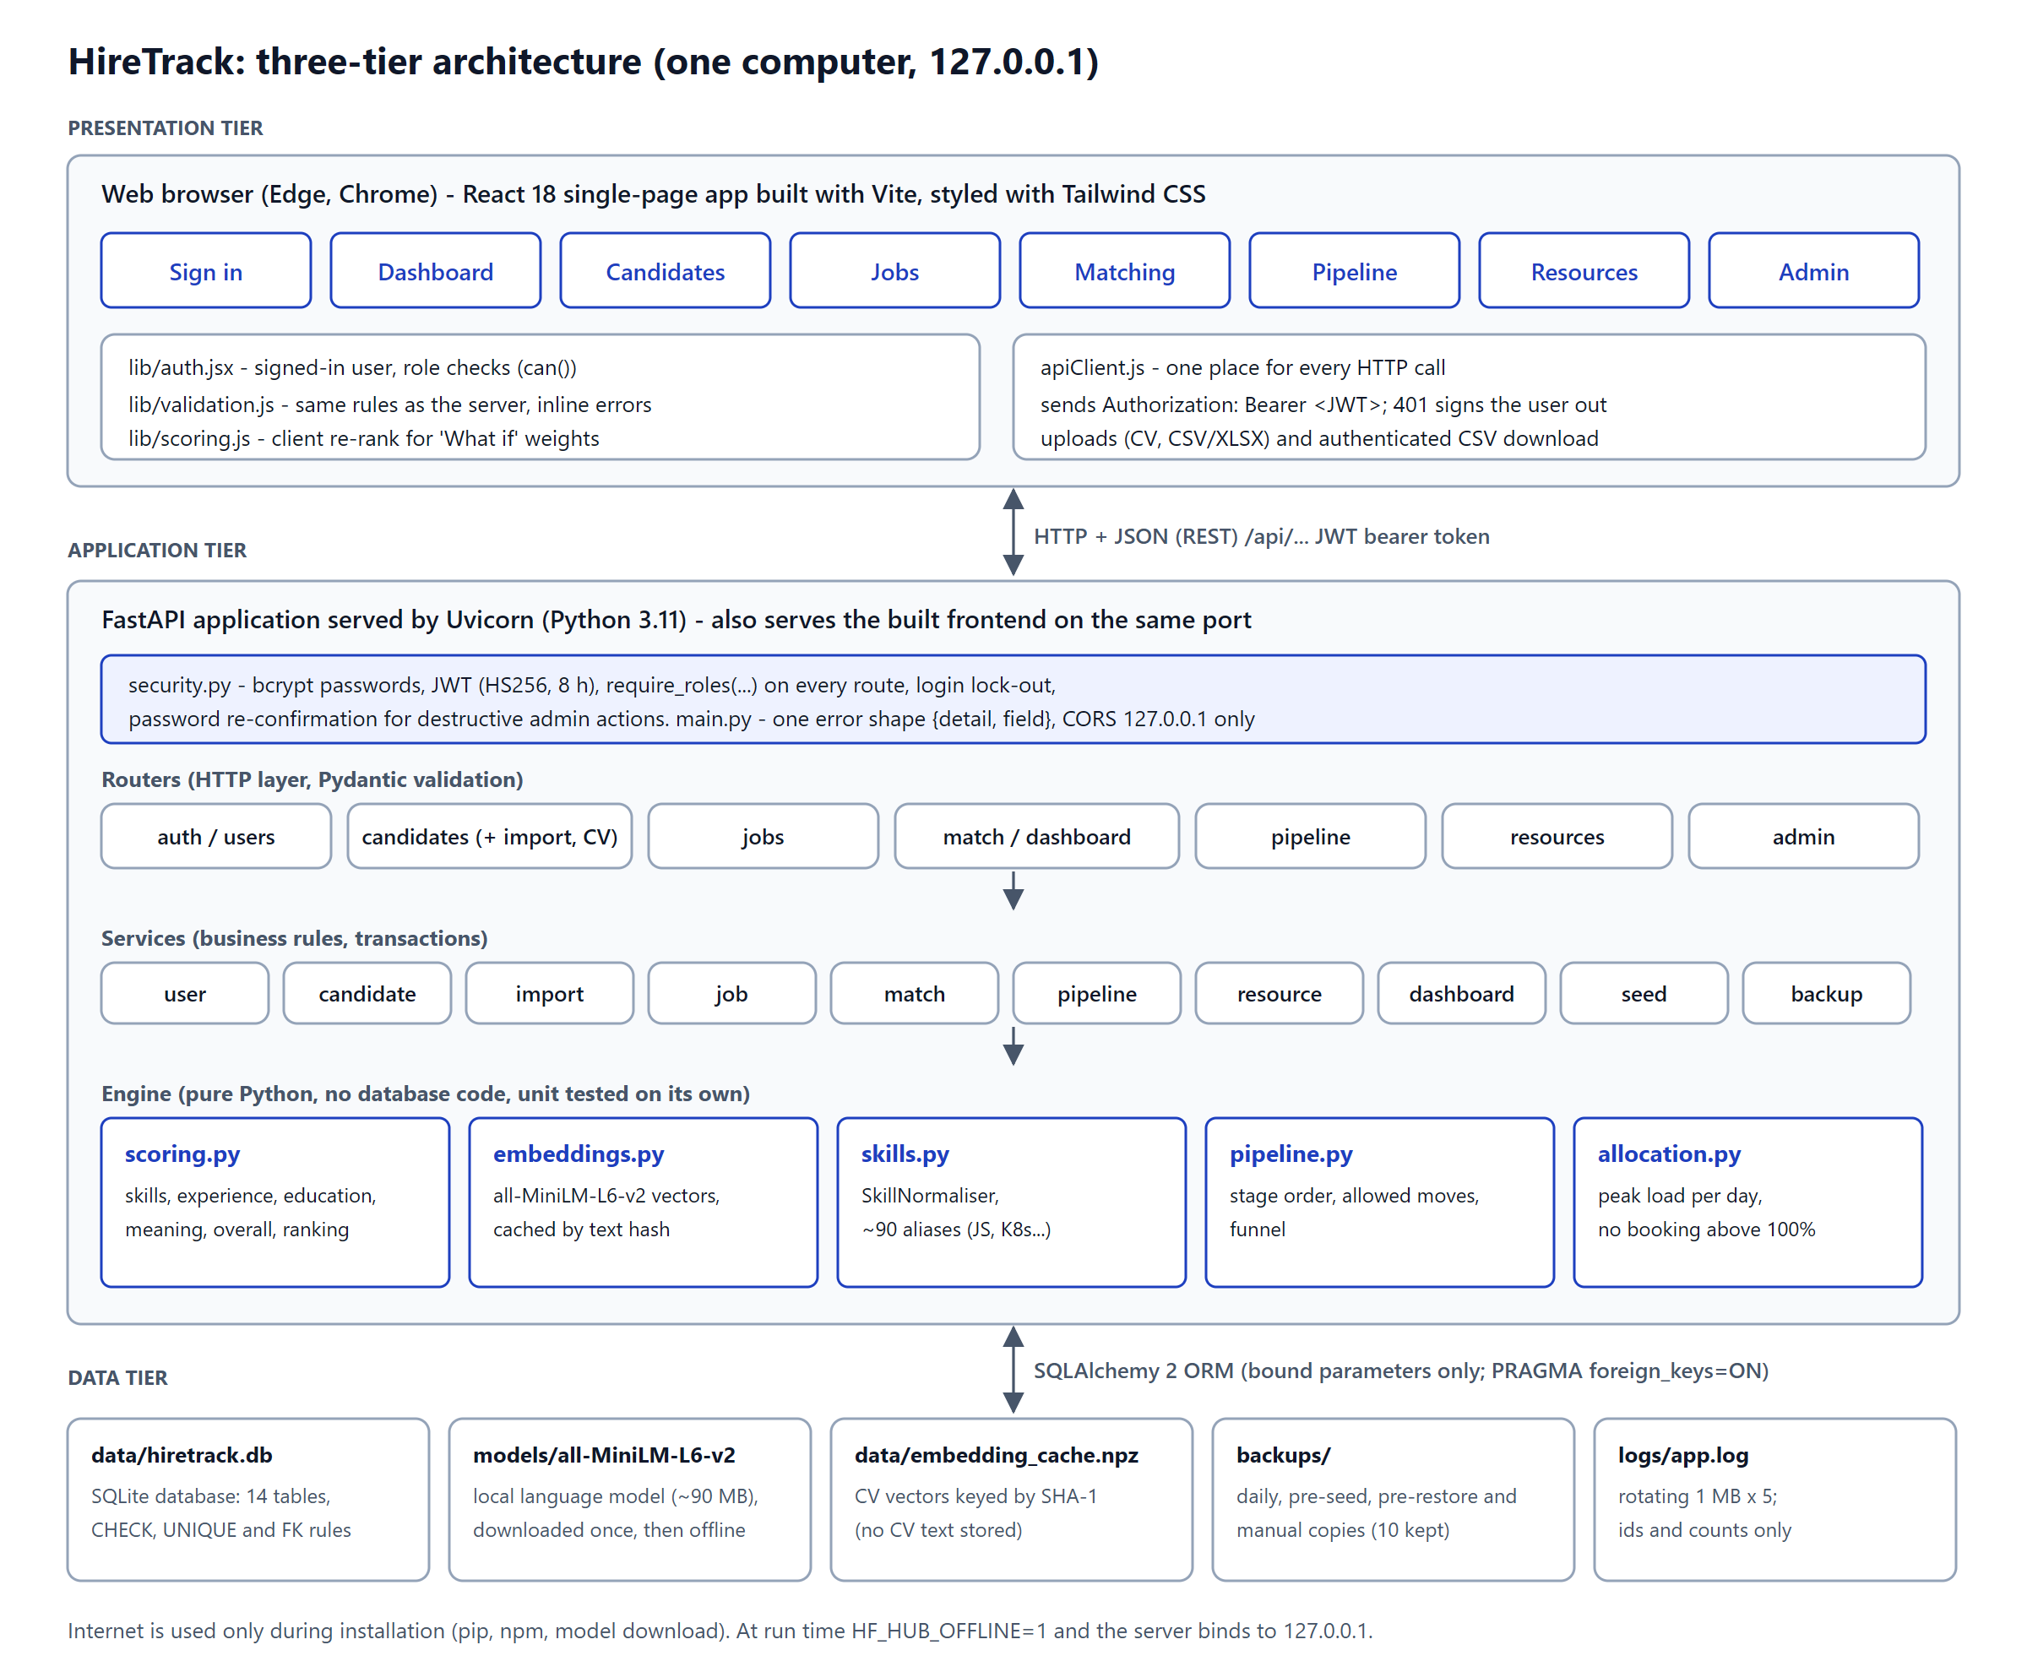
Figure 5.1: Three-tier architecture of HireTrack
Inside the server the code is layered. Routers handle HTTP and validation, services hold the business rules and the database transactions, and the engine modules hold pure rules with no database code. This means the rules that matter most (scoring, stage changes, allocation limits) can be tested on their own in milliseconds.

5.2.2 Module breakdown
Module | Main files | Responsibility | Requirements
M1 Accounts and security | security.py, routers/auth.py, services/user_service.py, pages/Login.jsx, lib/auth.jsx | Sign-in, sessions, role checks, user administration, password change and lock-out | FR14, FR15, NFR9
M2 Candidate management | services/candidate_service.py, services/import_service.py, pages/Candidates.jsx, ImportPanel.jsx | Candidate CRUD and search; CV text extraction; CSV/Excel import | FR1, FR2, FR12, FR16, FR17
M3 Job specifications | services/job_service.py, pages/Jobs.jsx | Job CRUD with skills, location, status and weights | FR3, FR4
M4 Matching engine | engine/scoring.py, engine/embeddings.py, engine/skills.py, services/match_service.py, pages/Results.jsx | Four scores, overall score, ranking, explanations, what-if re-ranking, CSV export | FR5 to FR10, FR13, NFR1, NFR7
M5 Applicant pipeline | engine/pipeline.py, services/pipeline_service.py, pages/Pipeline.jsx | Applications, stage rules, audit history, shortlist from results, hire into staff pool | FR18 to FR21
M6 Resource allocation | engine/allocation.py, services/resource_service.py, pages/Resources.jsx | Staff, projects, allocations, no booking above 100%, utilisation and bench | FR22 to FR24
M7 Dashboard | services/dashboard_service.py, pages/Dashboard.jsx, components/Charts.jsx | Key counts, funnel, applicants per job, utilisation, hires per month, activity | FR25
M8 Administration | services/seed_service.py, services/backup_service.py, routers/admin.py, pages/Admin.jsx, seed/ | Seed datasets, backups, integrity-checked restore | FR11, FR26
Table 5.3: Modules, files and the requirements each one covers

5.2.3 Database schema
The database extends the Phase 4 design (Figure 5.2). The seven tables from the design are unchanged apart from two columns on the job specification (location and status) and two optional contact columns on the candidate. Seven tables were added for accounts, the pipeline and resource allocation. The design is in Third Normal Form: each non-key column depends only on its table's key, lists are stored in link tables, and lookups (education level, skill) are separate tables.
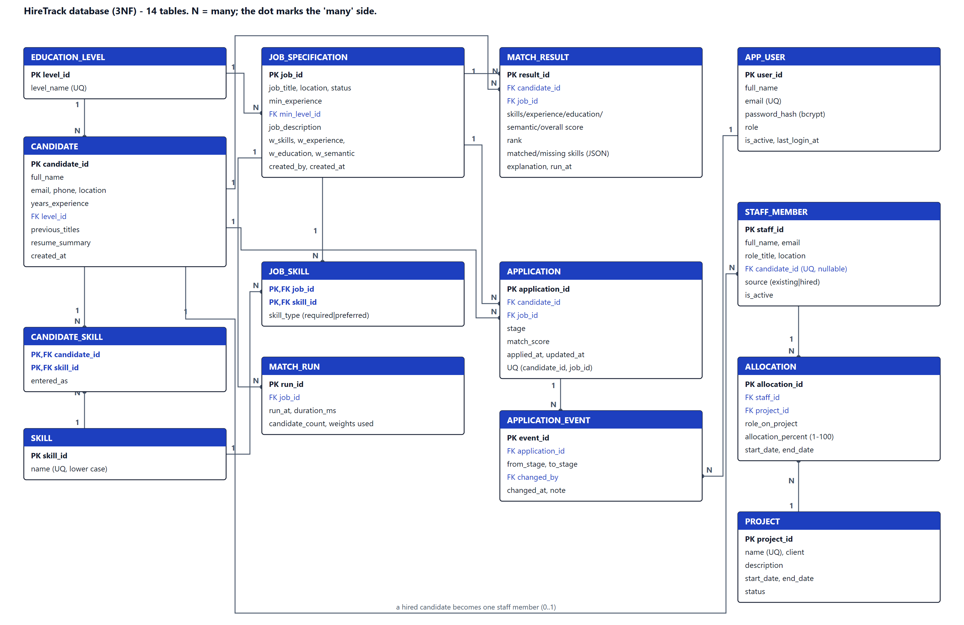
Figure 5.2: Entity-relationship diagram (14 tables)
Table | Purpose | Key rules (enforced by the database) | Rows in seed
app_user | Sign-in accounts | email UNIQUE and lower case; role IN (admin, recruiter, resource_manager) | 3
candidate | Talent pool | name 2-100 characters; years 0-50; summary 20-3000 characters | 600
job_specification | Roles to fill | location 2-80 characters; status IN (open, closed); weights 0-100 and total = 100 | 33
application | Candidate applying for a job | stage IN (6 stages); UNIQUE (candidate_id, job_id); cascades with candidate and job | 847
application_event | Audit history of stage changes | one row per change; changed_by kept as SET NULL if a user is removed | 1906
staff_member | People who can be allocated | candidate_id UNIQUE (a hire becomes one staff member); source IN (existing, hired) | 73
project | Client projects | name UNIQUE; end_date >= start_date; status IN (planned, active, on_hold, completed) | 12
allocation | Share of a person's time on a project | allocation_percent 1-100; end_date >= start_date; the 100% daily limit is enforced by the service | 102
Table 5.4: New and changed tables (the other six are as in the Design phase)
An existing database from the Phase 4 build is upgraded automatically when the server starts: missing columns are added with safe defaults, missing tables are created and the default accounts are added if there are none. Restoring an old backup goes through the same step.

5.2.4 Key code excerpts
The excerpts below are copied from the source files. Each shows a rule the requirements depend on.

a) Skills score (FR5)
Required skills are worth 80 points and preferred skills 20. Skills are compared after normalisation, so "JS" on a CV matches "JavaScript" on a job. The function returns which skills matched and which are missing, which the results screen shows.
backend/app/engine/scoring.py
def skills_score(candidate_skills: Sequence[str], required: Sequence[str], preferred: Sequence[str]) -> SkillMatch:
"""Required skills are worth 80 points, preferred 20.

With no preferred skills, required skills are worth the full 100.
Inputs must already be canonical (see SkillNormaliser).
"""
have = set(candidate_skills)
matched_req = [s for s in required if s in have]
missing_req = [s for s in required if s not in have]
matched_pref = [s for s in preferred if s in have]
missing_pref = [s for s in preferred if s not in have]

if not required:
req_part = 0.0
elif preferred:
req_part = len(matched_req) / len(required) * REQUIRED_SHARE
else:
req_part = len(matched_req) / len(required) * 100
pref_part = len(matched_pref) / len(preferred) * PREFERRED_SHARE if preferred else 0.0

return SkillMatch(
score=round1(clamp(req_part + pref_part)),
matched_required=matched_req,
missing_required=missing_req,
matched_preferred=matched_pref,
missing_preferred=missing_pref,
)

b) Overall score (FR9)
The overall score is a weighted average of the four scores. It is calculated in whole tenths with round-half-up, so the browser's instant "what if" re-ranking, which uses the same method in JavaScript, always agrees with the server to the last decimal.
backend/app/engine/scoring.py
def overall_score(skills: float, experience: float, education: float, semantic: float, weights: Weights) -> float:
"""Weighted average of the four components, rounded to 1 decimal.

Computed in integer tenths so the browser's "what if" re-ranking (which
uses the same integer method) always agrees with the server exactly.
"""
tenths = [int(round(c * 10)) for c in (skills, experience, education, semantic)]
ws = (weights.skills, weights.experience, weights.education, weights.semantic)
total = sum(t * w for t, w in zip(tenths, ws)) # in (tenths x percent)
return ((total + 50) // 100) / 10 # round half up back to tenths

c) Pipeline stage rules (FR18)
An application moves forward one stage at a time or is rejected. Hired and Rejected are final, except that a rejection can be reopened at the stage it was rejected from. The function raises an error with a reason that the screen shows to the user.
backend/app/engine/pipeline.py
def check_move(current: str, target: str, reopen_to: str | None = None) -> None:
"""Raise StageError with a plain-English reason if current -> target is not allowed."""
if target not in ALL_STAGES:
raise StageError(f"Unknown stage '{target}'")
if current == target:
raise StageError(f"The application is already at {LABELS[current]}")
if current in FINAL and not (current == REJECTED and target == reopen_to):
raise StageError(f"{LABELS[current]} is a final stage and cannot be changed")
if target not in allowed_moves(current, reopen_to):
nxt = next_stage(current)
hint = f" The next stage is {LABELS[nxt]}." if nxt else ""
raise StageError(f"Cannot move from {LABELS[current]} to {LABELS[target]}.{hint}")

d) Changing a stage: audit history and hiring (FR19, FR21)
The stage change and its history row are written in the same transaction, so the history can never disagree with the current stage. A move to Hired also creates the staff record.
backend/app/services/pipeline_service.py
def change_stage(db: Session, application_id: int, data: StageChangeIn, user: User) -> Application:
app = get_application(db, application_id)
try:
rules.check_move(app.stage, data.stage, _rejected_from(app))
except rules.StageError as exc:
raise AppError(str(exc), field="stage", status_code=422) from exc
if data.stage == "hired" and app.job.status != "open":
raise AppError("This job is closed, so nobody else can be hired for it", field="stage", status_code=422)
now = utcnow()
app.events.append(
ApplicationEvent(
from_stage=app.stage, to_stage=data.stage, changed_by=user.user_id, changed_at=now, note=data.note or None
)
)
app.stage = data.stage
app.updated_at = now
if data.stage == "hired":
_ensure_staff(db, app)
db.commit()
log.info("Application id=%s moved to %s by user id=%s", application_id, data.stage, user.user_id)
db.expire_all()
return get_application(db, application_id)

e) Preventing over-allocation (FR23)
A person's load can only change on the day a booking starts or the day after one ends. The check therefore looks only at those days instead of every day in the range, and reports the first day the limit would be broken.
backend/app/engine/allocation.py
def peak_load(bookings: Iterable[Booking], start: date, end: date) -> tuple[int, date | None]:
"""Highest total load on any day in [start, end], and the first day it happens.

Load only changes on a booking's start day or the day after its end, so it
is enough to check those days (a sweep), not every day in the range.
"""
inside = [b for b in bookings if overlaps(b.start, b.end, start, end)]
if not inside:
return 0, None
days = {start}
for b in inside:
if start <= b.start <= end:
days.add(b.start)
after = b.end + timedelta(days=1)
if start <= after <= end:
days.add(after)
best, best_day = 0, None
for d in sorted(days):
load = load_on(inside, d)
if load > best:
best, best_day = load, d
return best, best_day

f) Role-based access on the server (FR14, NFR9)
Every route declares the roles it allows. The check runs on the server, so hiding a button in the browser is never the only protection.
backend/app/security.py
def require_roles(*roles: str):
"""Dependency factory: allow only users whose role is in `roles` (else 403)."""

def _check(user=Depends(current_user)):
if user.role not in roles:
log.warning("Denied user id=%s role=%s (needs %s)", user.user_id, user.role, "/".join(roles))
raise Forbidden("Your role does not have access to this action.")
return user

return _check

backend/app/routers/pipeline.py
@router.post("/{application_id}/stage", response_model=ApplicationOut)

g) Bulk import validation (FR17)
Each row of an imported file is checked with exactly the same Pydantic model as the Add Candidate form. Bad rows are reported with their row number; good rows are saved together in one transaction.
backend/app/services/import_service.py (import_candidates)
for i, row in enumerate(rows, start=2): # row 1 is the header
try:
data = CandidateIn(**_to_input(row))
except ValidationError as exc:
field, msg = _friendly(exc.errors()[0])
errors.append(ImportRowError(row=i, field=field, message=msg))
continue
if data.email and (data.email in existing_emails or data.email in seen_in_file):
skipped += 1
continue
if data.email:
seen_in_file.add(data.email)
valid.append(data)

5.2.5 Coding standards, validation and error handling
- Naming and layout. Python follows PEP 8 with type hints; JavaScript uses one component per file. Files are named after what they hold (pipeline_service.py, Pipeline.jsx).
- Comments. Every module starts with a docstring explaining its job and its rules. Comments explain why, not what (for example why scores are calculated in tenths).
- Three layers of validation (NFR6). The screen checks input as it is typed (lib/validation.js); Pydantic checks every request on the server; database CHECK, UNIQUE and FOREIGN KEY rules are the last line of defence.
- One error shape. Every API error is {"detail": "...", "field": "..."}. The screens use the field name to show the message under the right input.
- Transactions. Matching, import, seeding and stage changes write everything or nothing; any error rolls back.
- Parameter passing. Routers receive validated schema objects and pass them to service functions together with the database session and the signed-in user, so services never read HTTP data directly.
- Efficiency. CV embeddings are calculated once and cached in memory and on disk; candidates are loaded with selectinload to avoid one query per row; the candidate table is virtualised so 2,600 rows scroll smoothly.

5.2.6 Security measures
Threat | Control
Stolen passwords | Only bcrypt hashes are stored (12 rounds). Passwords need 8+ characters with a letter and a number.
Guessing passwords | Five failed sign-ins lock that email for 60 seconds. The same message is shown for a wrong email or password.
Using the system without signing in | Every API route except /api/health needs a signed JWT (HS256, 8-hour expiry). The secret is generated on first run and kept in data/.jwt_secret.
Doing more than the role allows | require_roles(...) on every route (36 role and endpoint combinations tested). Screens hide what a role cannot use.
Accidental data loss | Loading a dataset or restoring a backup needs the administrator's password again. A safety backup is taken first; restore runs PRAGMA integrity_check.
SQL injection / XSS | SQLAlchemy bound parameters only; React escapes all text; no dangerouslySetInnerHTML.
Spreadsheet formula injection | CSV export prefixes cells that start with =, +, - or @.
Network exposure | The server binds to 127.0.0.1; CORS allows only the local addresses.
Privacy (POPIA) | Only fictitious data; logs hold ids and counts, never CV text; scoring never reads name, email, age or gender.
Table 5.5: Security controls

5.2.7 User interface
The screens use one neutral palette with a single blue accent, green only for Run Match and red only for destructive actions. Every page uses the same header, table and side-panel patterns. The menu shows only what the signed-in role can use (Figures 5.3 to 5.12).
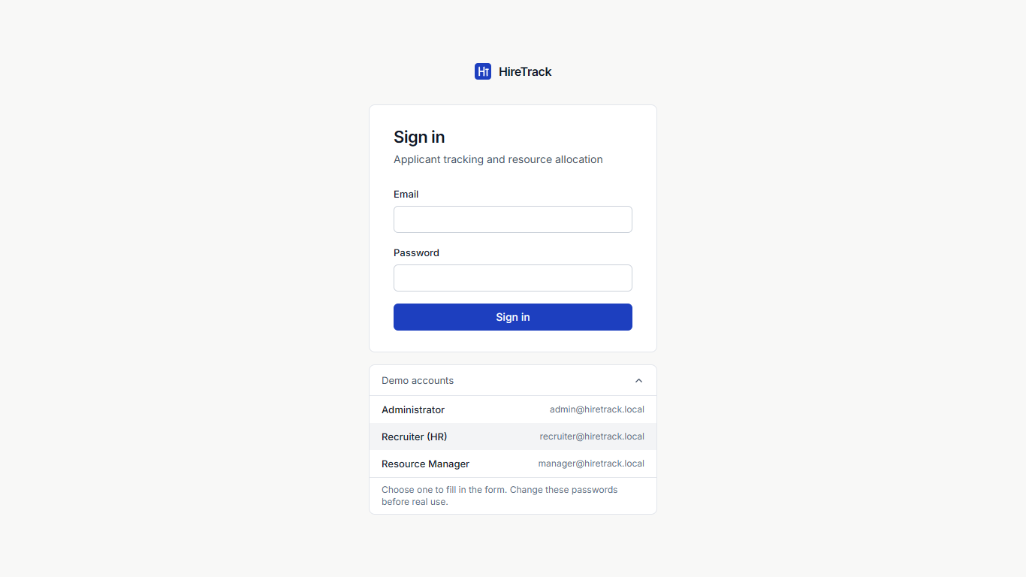
Figure 5.3: Sign-in screen with the demo accounts expanded
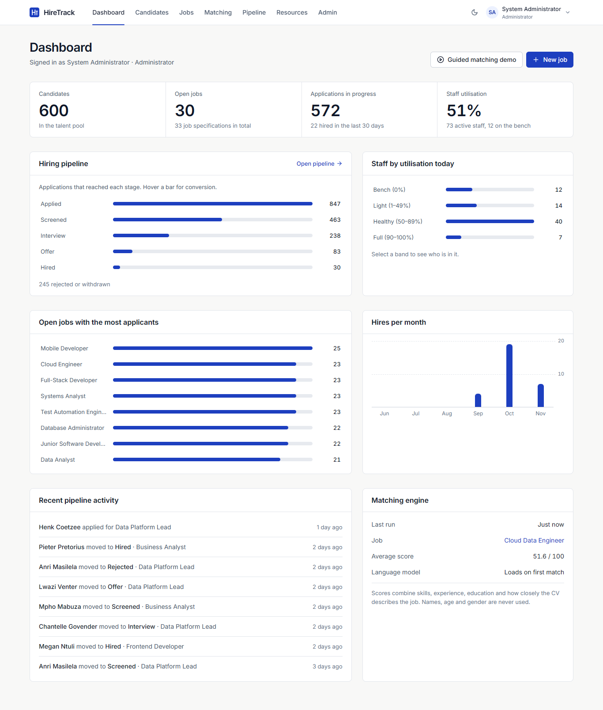
Figure 5.4: Dashboard (Administrator): key counts, pipeline funnel, utilisation, applicants per job, hires per month
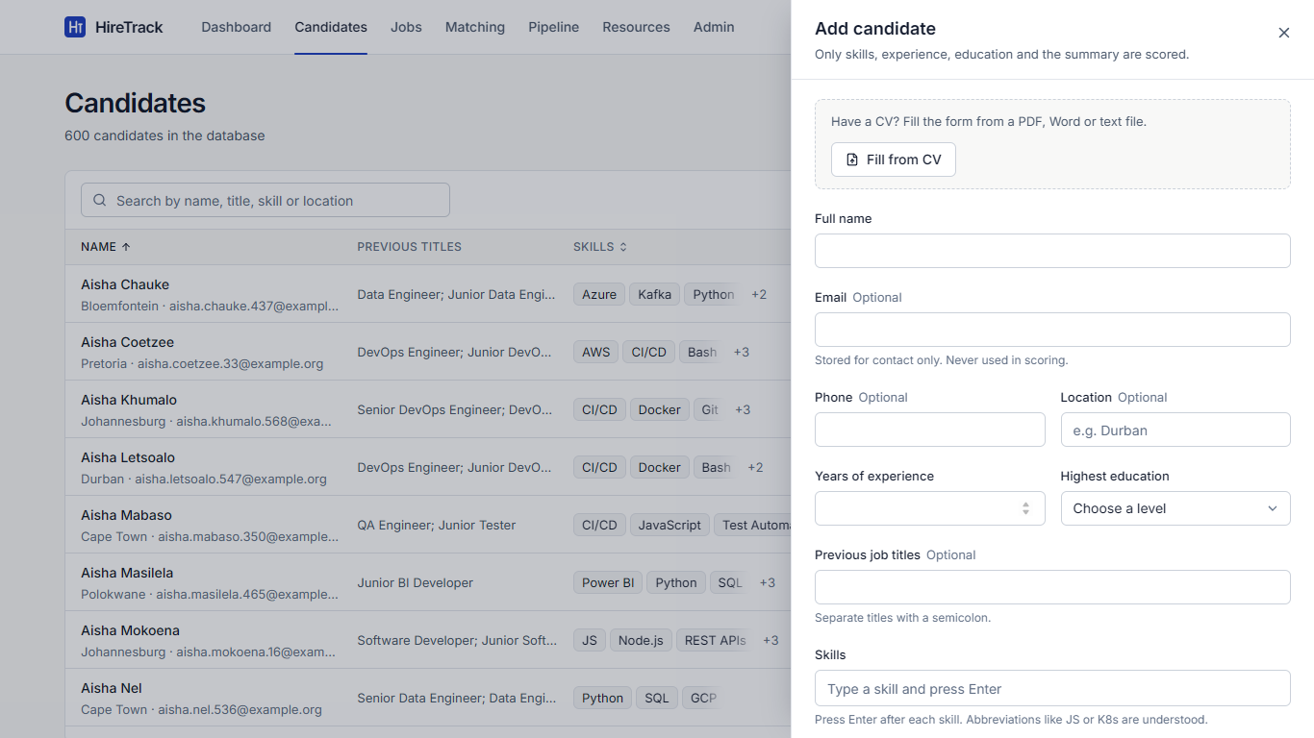
Figure 5.5: Add Candidate panel with "Fill from CV"
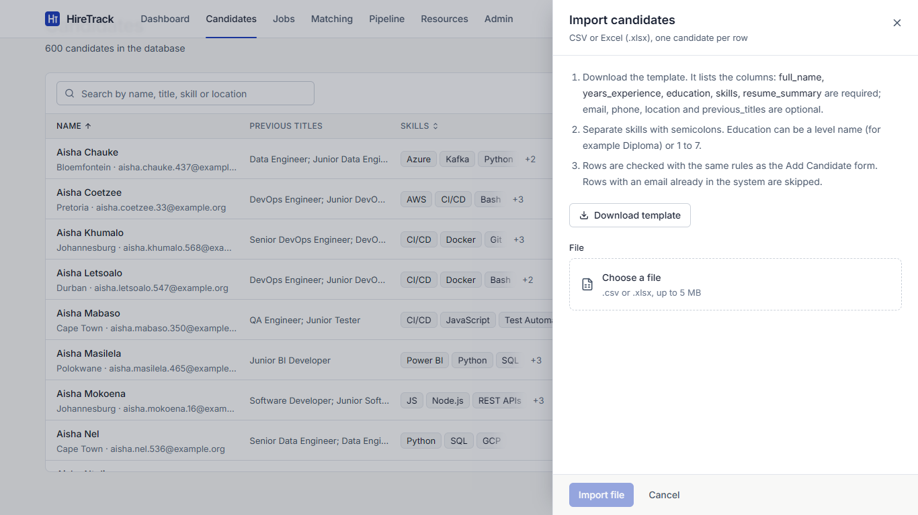
Figure 5.6: Bulk import of candidates from CSV or Excel
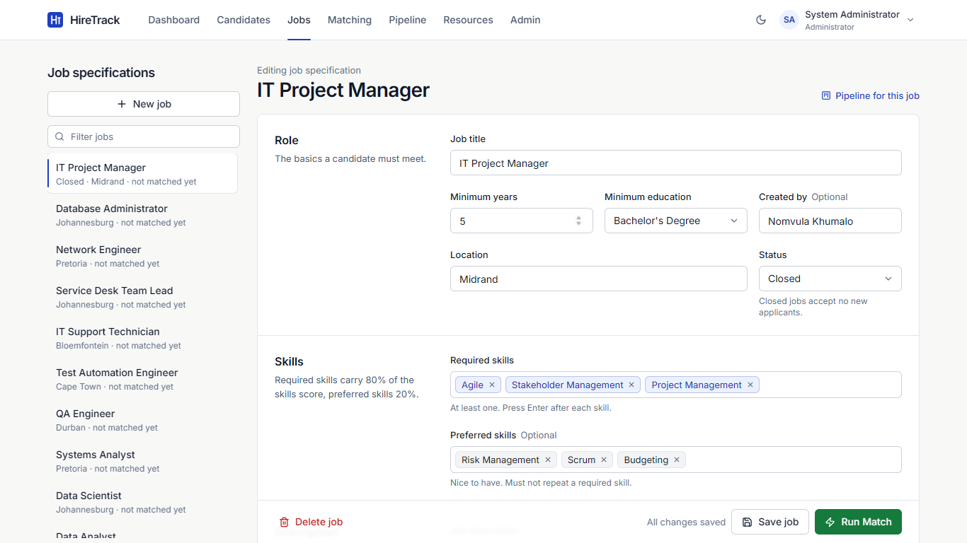
Figure 5.7: Job specification with location, status, skills and weights
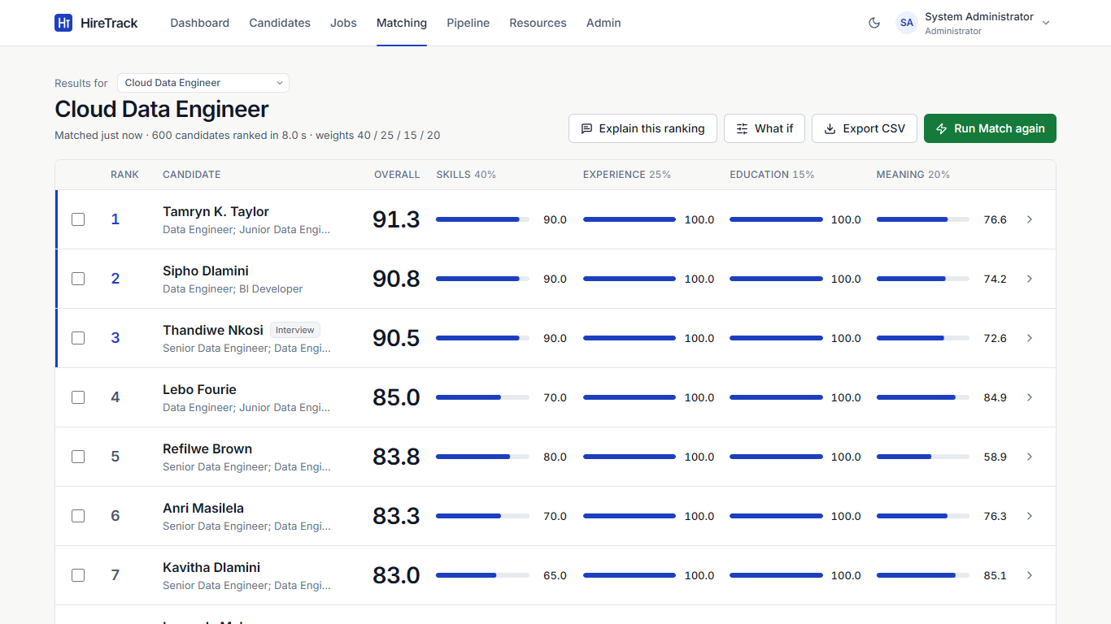
Figure 5.8: Ranked results for Cloud Data Engineer; a pipeline stage badge shows candidates already applied
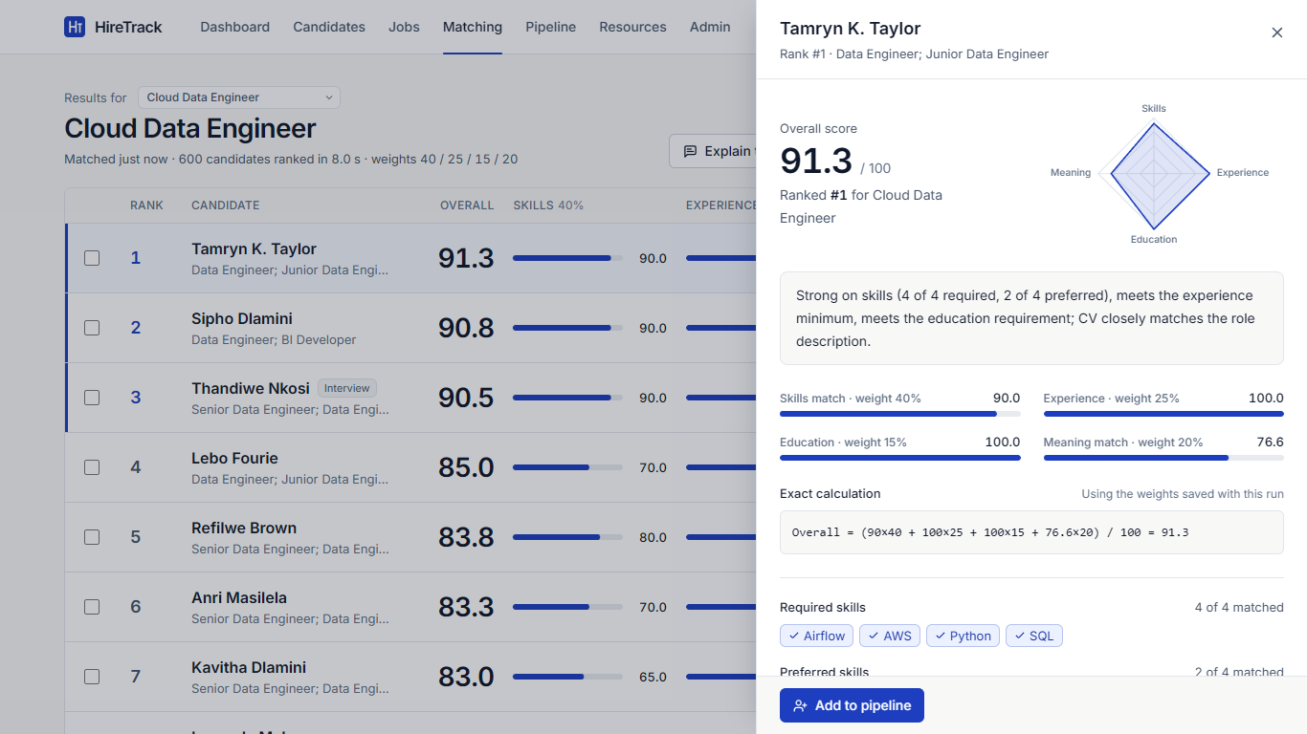
Figure 5.9: Score breakdown with the exact calculation and "Add to pipeline"
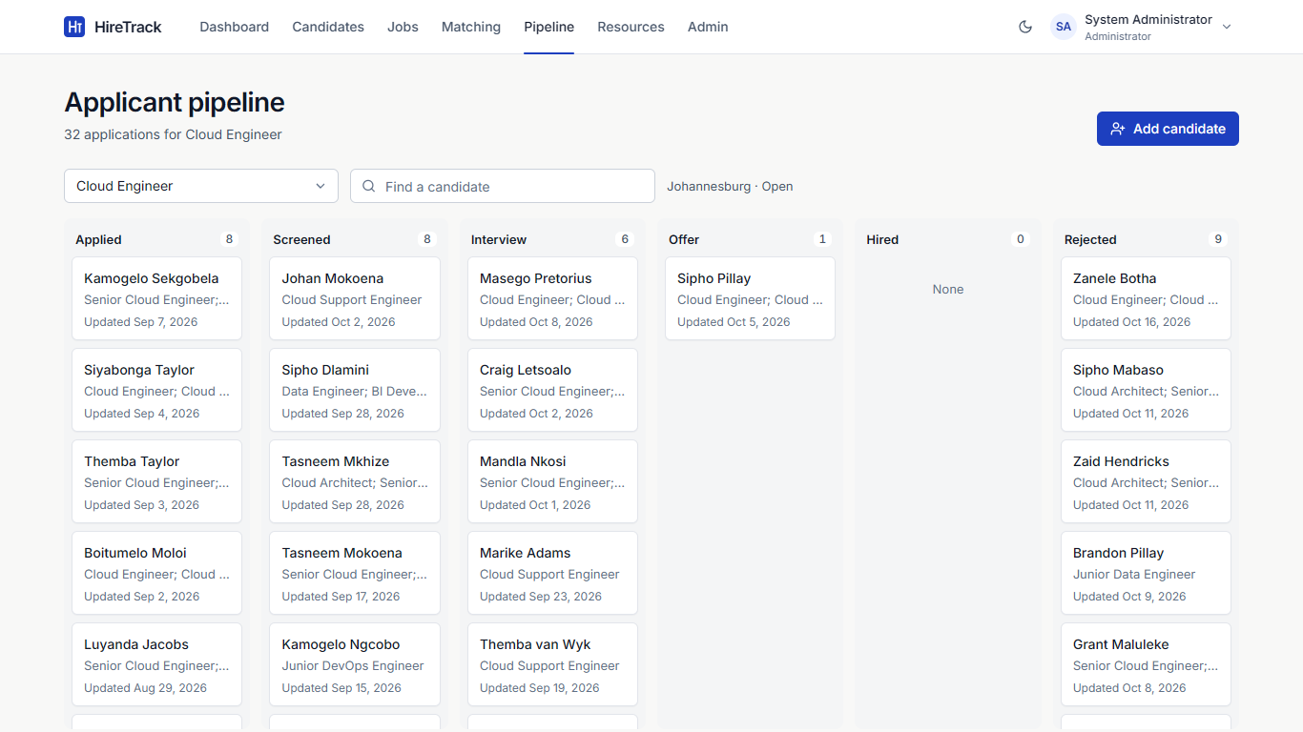
Figure 5.10: Applicant pipeline board for one job
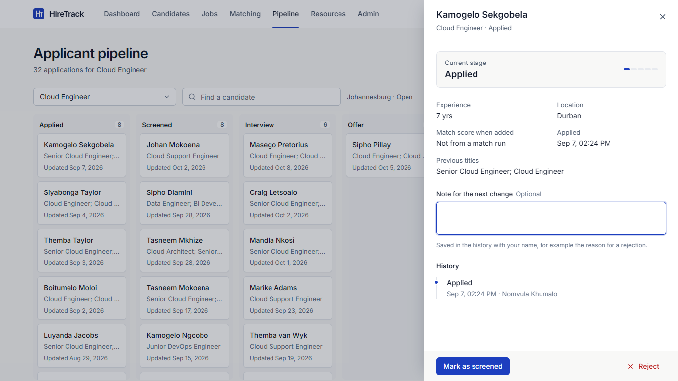
Figure 5.11: Application detail: stage actions, note and audit history
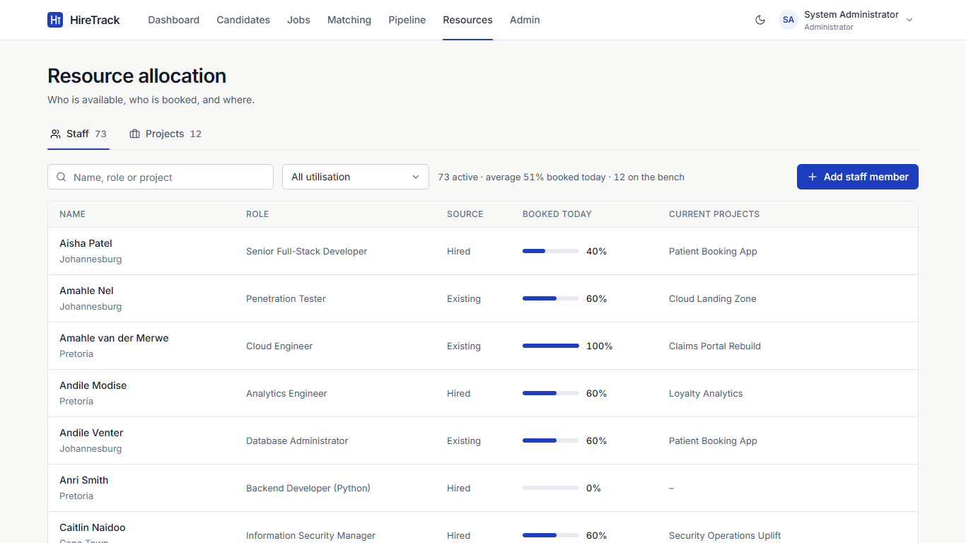
Figure 5.12: Staff utilisation in the Resources screen
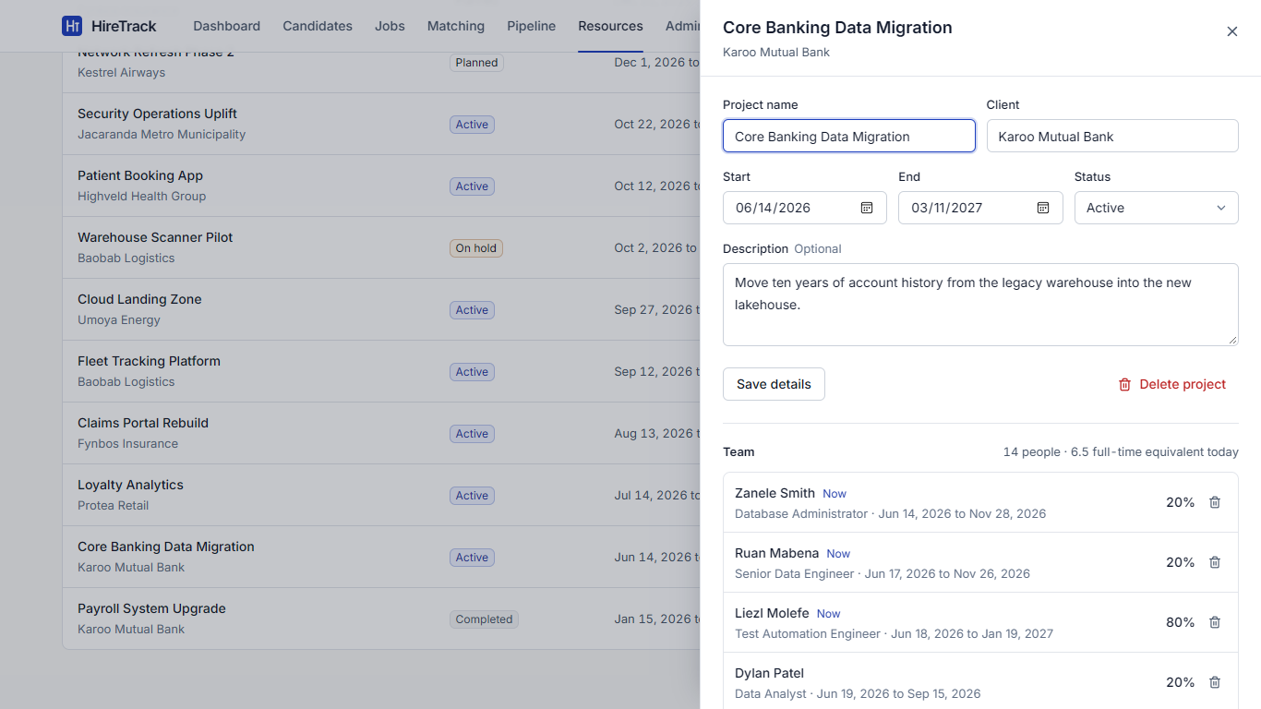
Figure 5.13: Project detail with team allocations
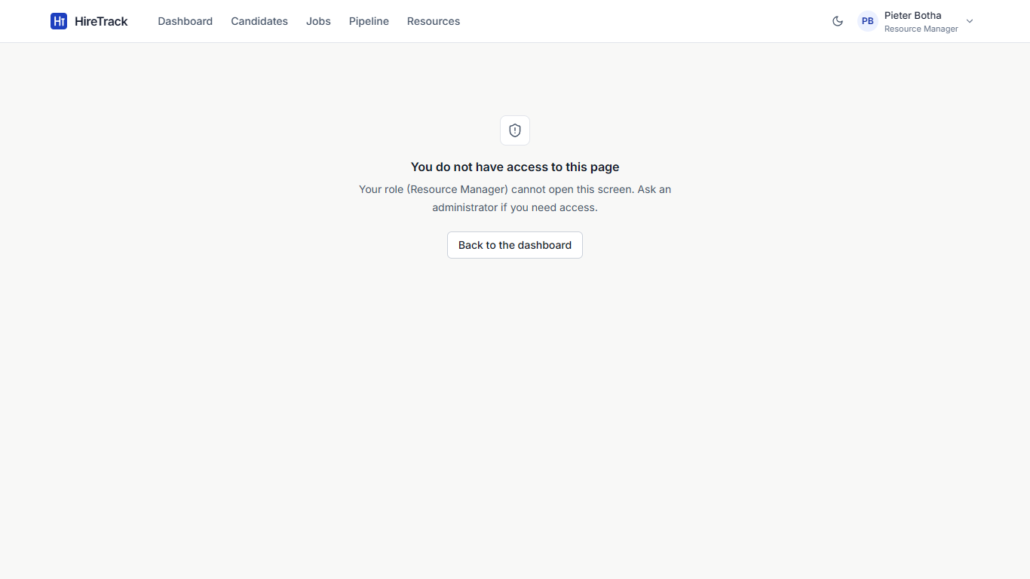
Figure 5.14: A Resource Manager opening the Matching page is refused

5.3 Testing

5.3.1 Approach
Testing followed the test pyramid: many fast unit tests of the rules, a solid layer of API integration tests, component tests of the screens, and a smaller number of end-to-end journeys in a real browser (Section 5.4). All tests are automated and repeatable.
Level | What is tested | Tool | How it is isolated
Unit | Scoring, skill normalisation, pipeline rules, allocation maths, database constraints | pytest | Pure functions; constraint tests use a temporary database
Integration | Every API endpoint, sign-in and roles, import, seed, dashboard, CLI | pytest + FastAPI TestClient | A new temporary data folder per run; every test starts from an empty database with the three accounts
Component | Sign-in, role-based menus, dashboard, pipeline, resources, import, admin, form logic | Vitest + React Testing Library | The API module is replaced with mocks
System / end-to-end | Complete user journeys (TC-01 to TC-22) | Playwright in Edge and Chrome | Own server on port 8010 with a freshly seeded database
Performance | Match speed at 50, 600 and 2,600 candidates | pytest with the real model | HIRETRACK_REAL_MODEL=1
Table 5.6: Testing levels and tools
Fast tests use a deterministic word-hashing embedder instead of the language model, so the 330 backend tests run in under a minute. Password hashing uses 4 bcrypt rounds in tests instead of 12. The performance tests switch the real model back on.

5.3.2 Unit and integration results
Test file | Level | Tests | Passed | Covers
unit/test_scoring.py | Unit | 69 | 69 | Four scores, weights, rounding, ranking and tie-breaks, aliases, explanations, fairness
unit/test_pipeline_rules.py | Unit | 22 | 22 | Stage order, allowed moves, reopen, funnel
unit/test_allocation_rules.py | Unit | 21 | 21 | Overlaps, daily load, peak load, over-allocation messages, bands
unit/test_models.py | Unit | 21 | 21 | CHECK, UNIQUE and FK rules; cascades; schema upgrade
integration/test_api.py | Integration | 54 | 54 | Candidates, jobs, matching, CSV, backups, seeding, demo
integration/test_auth.py | Integration | 64 | 64 | Sign-in, lock-out, tokens, passwords, users, role matrix
integration/test_pipeline_api.py | Integration | 23 | 23 | Applications, stage changes, hiring, shortlist from results
integration/test_resources_api.py | Integration | 20 | 20 | Staff, projects, allocations, utilisation
integration/test_import.py | Integration | 20 | 20 | CSV and Excel import, CV parsing (txt, docx, pdf)
integration/test_seed_dashboard.py | Integration | 9 | 9 | Seed sizes, determinism, legal histories, dashboard
integration/test_cli.py | Integration | 4 | 4 | Password reset tool
integration/test_performance.py | Integration | 3 | 3 | Speed at 50, 600 and 2,600 candidates
Total backend |  | 330 | 330 | 100% pass
frontend src/test (3 files) | Component | 49 | 49 | Screens with mocked API, form validation, re-ranking
Table 5.7: Unit, integration and component test results (final run)

5.3.3 Coverage
Backend line coverage is 95% (2614 of 2748 lines), above the 70% target. The lines not covered are mainly the one-off model download script and error branches that need a missing model or a damaged disk to reach. Frontend line coverage from the component tests is 50.6%; the matching screens are exercised by the end-to-end journeys instead.
Package | Lines | Covered | Coverage
app (core: models, schemas, security, main) | 889 | 827 | 93%
app/engine | 422 | 392 | 93%
app/routers | 240 | 240 | 100%
app/services | 1197 | 1155 | 96%
Total | 2748 | 2614 | 95%
Table 5.8: Backend line coverage by package (pytest-cov)
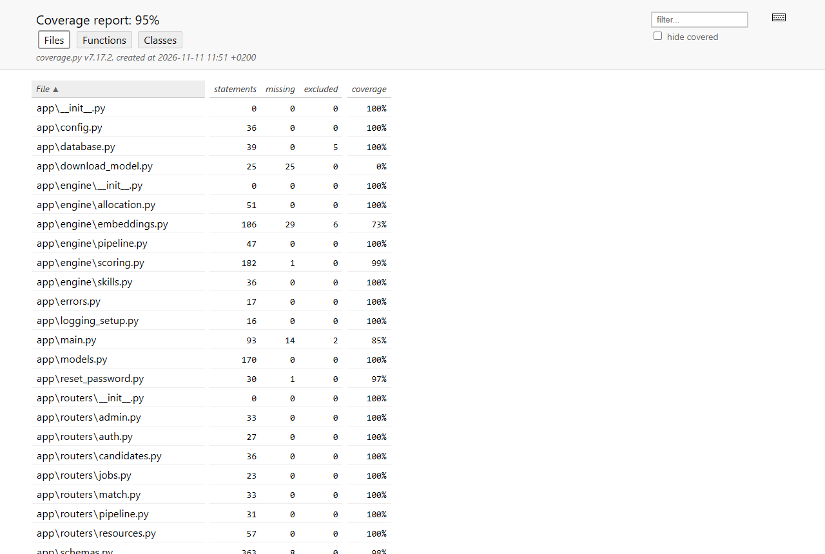
Figure 5.15: pytest-cov HTML report

5.3.4 Performance
Scenario (real all-MiniLM-L6-v2 model, 16-thread laptop CPU) | Time | Target
50 candidates, nothing cached | 0.52 s | < 5 s
600 candidates, warm cache (score + save + reload) | 0.16 s | < 5 s
600 candidates re-ranked through the screen (Playwright TC-13) | 0.69 s | < 5 s
2,600 candidates, warm cache | 0.93 to 1.06 s | < 5 s
First match after loading 600 new CVs (each CV read once) | 8 to 11 s | one-off
Reading 2,600 new CVs in the background after loading | 20.1 s | one-off
Table 5.9: Matching speed

5.3.5 Debugging and code improvement
Testing found seven product defects, all fixed (Section 5.4.4). Two changes improved the code beyond the fixes: the CV parser gained a vocabulary of common skills so it works on an empty database, and the seed data generator was rewritten so stage dates, hires and allocations look like a real company's history. Every fix was followed by a full re-run of all suites.

5.4 System Testing

5.4.1 Approach and requirements
System testing checks the finished system against the requirements, through the screens and the API, as a user would use it. Each test case below is traced to one or more requirements and to the automated test that runs it. The 22 Playwright journeys (TC-01 to TC-22) drive Microsoft Edge against a freshly seeded server; TC-23 to TC-36 check requirements through the API and unit suites; TC-27 and TC-37 were done by hand on a clean copy of the submission.
ID | Requirement
FR1 | Add a candidate with name, contact details, location, experience, education, skills, previous titles and CV summary
FR2 | View, search, edit and delete candidates
FR3 | Create and edit a job specification: title, location, status, skills (required/preferred), minimum experience and education, description
FR4 | Adjust the four scoring weights per job; they must total 100%
FR5-FR8 | Calculate skills, experience, education and meaning (embedding similarity) scores
FR9 | Combine the scores into a weighted overall score and rank every candidate
FR10 | Show each candidate's score breakdown, matched and missing skills and the exact calculation
FR11 | Seed or reset realistic demonstration data (500+ candidates, 30+ jobs)
FR12 | Reject invalid input with a clear message and save nothing
FR13 | Export ranked results to CSV
FR14 | Sign in with a personal account; three roles (Administrator, Recruiter (HR), Resource Manager) with role-based access
FR15 | Administrator manages user accounts; users change their own password
FR16 | Capture a CV file (PDF, Word, text) to pre-fill the candidate profile
FR17 | Bulk import candidates from CSV or Excel with a per-row error report
FR18 | Track each application through Applied, Screened, Interview, Offer, Hired or Rejected under fixed rules
FR19 | Keep an audit history of every stage change (who, when, note)
FR20 | Add shortlisted candidates from match results to a job's pipeline
FR21 | A hired candidate joins the staff pool
FR22 | Manage staff and client projects
FR23 | Allocate staff to projects by percentage and dates without booking anyone above 100%
FR24 | Show utilisation per person and who is on the bench
FR25 | Dashboard with key counts and charts
FR26 | Back up and restore the database
NFR1 | Performance: ranking 500+ candidates returns within 5 seconds
NFR2 | Runs on one computer, offline after installation
NFR3 | Usability: consistent screens, inline errors, keyboard and screen-reader access
NFR4 | Maintainability: business rules in separate, unit-tested modules
NFR5 | Privacy: only fictitious data; scoring never uses name, age or gender
NFR6 | Reliability: invalid data rejected at screen, API and database level
NFR7 | Transparency: every ranking explainable from visible scores
NFR8 | Compatibility: current Edge and Chrome
NFR9 | Security: hashed passwords, signed tokens, role checks on the server, lock-out, confirmed destructive actions
NFR10 | Quality: automated test coverage of at least 70% of backend code
Table 5.10: Requirements tested (FR14 to FR26 and NFR9 to NFR10 added in this phase)
Test environment: Windows 11 laptop, 16-thread CPU, no GPU; Python 3.11.18; Node.js 20.16; Microsoft Edge and Google Chrome (current); screen 1366 x 768. Test data: the full seed dataset (600 candidates, 33 jobs, about 850 applications, 73 staff, 12 projects), plus records created by the tests themselves.

5.4.2 Test cases
ID | Req. | Description | Preconditions | Steps | Test data | Expected result | Actual result | Pass/ Fail
TC-01 | FR14, NFR9 | Sign-in with a wrong password is refused | App running; default accounts exist | 1. Open the sign-in page  2. Enter the admin email and a wrong password  3. Select Sign in | admin@hiretrack.local / not-the-password1 | Message 'Incorrect email or password'; user stays on the sign-in page | Message shown under the password field; dashboard not opened | Pass
TC-02 | FR14 | Each role signs in and sees only its menu items | Default accounts exist | 1. Sign in as each role in turn  2. Read the main menu  3. Sign out | admin, recruiter, manager accounts | Admin: 7 items incl. Admin. Recruiter: no Admin. Resource Manager: no Matching, no Admin | Menus matched exactly for all three roles | Pass
TC-03 | FR14, NFR9 | Role checks are enforced by the server, not only hidden in the screen | Signed in as Recruiter | 1. Open /admin by URL  2. Call GET /api/users with the recruiter's token | Recruiter token | Screen says 'You do not have access to this page'; API returns 403 | Access message shown; API returned 403 | Pass
TC-04 | FR14 | Signing out ends the session | Signed in as Resource Manager | 1. Open the account menu, select Sign out  2. Open /resources by URL | - | Sign-in page shown again | Sign-in page shown | Pass
TC-05 | FR1, FR12, NFR6 | Invalid candidate data is refused with a message under each field | Signed in as Recruiter | 1. Candidates > Add candidate  2. Leave name, education, skills empty; years = -2  3. Select Add candidate | years_experience = -2 | Four inline messages; nothing saved; count stays 600 | 'Full name is required', 'cannot be less than 0', 'Choose an education level', 'Add at least one skill'; count 600 | Pass
TC-06 | FR1, FR2 | Add, search, edit and delete a candidate | Signed in as Recruiter; 600 candidates | 1. Add a candidate with skills Python and K8s  2. Search by name  3. Edit years to 5  4. Delete and confirm | Name 'Zinhle Test <id>', Durban, 4 years, Bachelor's | Count 601 after add; search shows 1 of 601; edit saved; count back to 600 after delete | As expected; K8s stored as kubernetes and shown as typed | Pass
TC-07 | FR16 | A CV file pre-fills the candidate form | Add Candidate panel open | 1. Select Fill from CV  2. Choose a .txt CV | CV with name, email, phone and 'Airflow pipelines in Python and SQL on AWS' | Name, email, phone, summary filled; skills added as chips; nothing saved yet | All fields filled; chips Airflow, Python, SQL, AWS. (First run: chips were lower case - defect D1, fixed) | Pass
TC-08 | FR17 | Bulk CSV import keeps valid rows and reports bad rows | Signed in as Recruiter | 1. Import CSV or Excel  2. Choose a file with 2 valid rows and 1 row with years = -1  3. Import file | 3-row CSV | 2 imported, 1 error 'row 4, Years, Cannot be less than 0'; count 602 | Imported 2, errors table showed row 4; count 602 | Pass
TC-09 | FR3, FR4 | Create a job; Run Match is locked until the weights total 100% | Signed in as Recruiter | 1. Jobs > New job, fill title, location, skills, description  2. Set skills weight to 35 (total 95%)  3. Set it back to 40  4. Save | Python Developer, Cape Town, 3 years | At 95% a warning shows and Run Match is disabled; at 100% it is enabled; job saved | Warning '(now 95%)' and disabled button; enabled at 100%; saved | Pass
TC-10 | FR5-FR8, FR9, FR10, NFR7 | Run a match and read the breakdown | Full seed data loaded | 1. Open Cloud Data Engineer  2. Run Match  3. Open the top candidate | 600+ candidates | All candidates ranked; breakdown shows four scores, skills and 'Overall = (...) / 100 = x' | 602 ranked; top 50 shown; calculation shown and reproduces the overall score | Pass
TC-11 | FR4, FR9, NFR7 | What-if weights re-rank without saving | Results open | 1. What if  2. Set Meaning to 60% | semantic weight 60 | List re-ranks; 'Showing what-if ranking' label; saved run unchanged | Re-ranked instantly with the label shown | Pass
TC-12 | FR13, FR20 | Shortlist into the pipeline and export CSV | Results open | 1. Tick 2 candidates not yet in the pipeline  2. Add to pipeline  3. Export CSV | 2 candidates | Toast '2 candidates added'; CSV named hiretrack-cloud-data-engineer-<date>.csv with 600+ rows | As expected; CSV header and 603 lines checked | Pass
TC-13 | NFR1 | Re-running a 600-candidate match through the screen takes under 5 s | Model loaded, CVs cached | 1. Results > Run Match again  2. Time until 'Match complete' | 602 candidates | Under 5 seconds | 0.68 s end to end (Edge) | Pass
TC-14 | FR18, FR19, FR21 | Move an applicant from Applied to Hired with notes | Candidate applied to Cloud Engineer | 1. Open the card  2. For each stage add a note and select the next action | Notes for each move | Stage advances one step at a time; history shows 5 entries with notes and user; person appears in Staff as Hired | As expected | Pass
TC-15 | FR18, FR19 | Stages cannot be skipped; a rejection can be reopened | An application at Applied | 1. POST stage=offer  2. Reject with a note  3. Reopen | - | API 422 'next stage is Screened'; rejected then back at Applied; note kept in history | As expected | Pass
TC-16 | FR14, FR18 | A Resource Manager can view but not change the pipeline | Signed in as Resource Manager | 1. Pipeline  2. Open any card | - | History visible; no stage buttons | No action buttons shown; API also returns 403 | Pass
TC-17 | FR22, FR23, FR24 | Create a project, allocate staff, block over-allocation | Signed in as Resource Manager | 1. Add staff member  2. New project (active)  3. Allocate 70%  4. Try another 50% on the same dates | 70% then 50% | First saved (0.7 FTE); second refused: 'most you can add for these dates is 30%'; staff list shows 70% | As expected | Pass
TC-18 | FR22, FR12 | Project end date before start date is refused | New project panel | 1. Start = today+30, End = today+1  2. Create project | - | 'End date cannot be before the start date'; nothing saved | As expected | Pass
TC-19 | FR24 | Bench filter shows only unallocated staff | Seed data loaded | 1. Open /resources?band=bench | - | Every row shows 0% | All rows 0% | Pass
TC-20 | FR25, NFR3 | Dashboard shows key counts and charts; bars are usable by keyboard | Seed data loaded | 1. Sign in as Admin  2. Check tiles and charts  3. Select the Bench bar | - | 4 tiles and 5 chart panels; selecting Bench opens the filtered staff list | As expected. (First run: bars were hidden from keyboard/screen readers - defect D2, fixed) | Pass
TC-21 | FR15 | An administrator creates a user who can then sign in | Signed in as Admin | 1. Admin > Add user (Recruiter)  2. Sign out  3. Sign in as the new user | hr.<id>@hiretrack.local / Welcome123 | User created; sign-in succeeds with the Recruiter menu | As expected | Pass
TC-22 | FR26, FR11, NFR9 | Manual backup; data reset needs the admin's password | Signed in as Admin | 1. Back up now  2. Load demo set with a wrong password  3. Cancel | wrong-password1 | Backup listed; 'Incorrect password'; data unchanged | As expected | Pass
TC-23 | FR11 | Seed script builds the realistic dataset | Empty database | 1. python seed/seed_database.py | - | 600 candidates, 33 jobs (30 open), 500+ applications with legal histories, staff, 12 projects, no one above 100% | 600 candidates, 33 jobs, 847 applications, 1,906 events, 73 staff, 12 projects, 102 allocations; all histories legal | Pass
TC-24 | FR26 | Restore refuses a corrupt or unknown backup file | Admin | 1. Restore a damaged file  2. Restore a path with ../ | corrupt .db; '../../data/hiretrack.db' | Integrity check fails, nothing restored; traversal refused | As expected | Pass
TC-25 | FR15, NFR9 | There is always one active administrator; users cannot deactivate themselves | Admin | 1. Change the only admin to Recruiter  2. Deactivate own account | - | Both refused with a reason | As expected | Pass
TC-26 | NFR1 | Ranking speed with the real model | Real all-MiniLM-L6-v2 model | Run tests/integration/test_performance.py with HIRETRACK_REAL_MODEL=1 | 50, 600 and 2,600 candidates | Each warm match under 5 s | 50 uncached: 0.52 s; 600 warm: 0.16 s; 2,600 warm: 0.93-1.06 s; one-off encoding of 2,600 CVs 20.1 s | Pass
TC-27 | NFR2 | The app runs with no internet connection | Fresh install from the zip | 1. Start the server with HF_HUB_OFFLINE=1 and an unreachable proxy  2. Sign in and run a match | HTTP(S)_PROXY=http://127.0.0.1:9 | Everything works; no outbound connection needed | Match ran and results loaded with all network access blocked | Pass
TC-28 | FR5-FR8, FR9, NFR5, NFR7 | Scoring ignores personal details | - | Score two candidates identical except name and email | - | Identical scores; name used only as the final tie-break | As expected | Pass
TC-29 | NFR6 | Database constraints reject bad data written directly | - | Insert bad rows through the ORM, bypassing the API | years -1, weights 110%, allocation 0%, duplicate application | IntegrityError for every case | As expected (21 cases) | Pass
TC-30 | NFR9 | Five failed sign-ins lock the account for 60 s | - | 1. Five wrong passwords  2. Correct password | - | 429 'Too many failed sign-in attempts' | As expected | Pass
TC-31 | NFR9 | Expired or forged tokens are refused | - | Call /api/auth/me with an expired and a garbage token | - | 401 with 'expired' / 'sign in' | As expected | Pass
TC-32 | NFR9 | Passwords are stored only as bcrypt hashes | - | Read app_user.password_hash | - | Every value starts with $2b$; no plain text | As expected | Pass
TC-33 | NFR6, FR12 | Search text cannot inject SQL | Candidates exist | Search for x' OR '1'='1 | - | No rows matched; no error | As expected | Pass
TC-34 | NFR8 | Full journey suite in a second browser | Chrome installed | HT_BROWSER=chrome npx playwright test | 22 journeys | All pass | 22 of 22 passed in Chrome | Pass
TC-35 | NFR10 | Backend coverage at least 70% | - | pytest --cov=app | - | >= 70% | 95% line coverage | Pass
TC-36 | NFR4 | Business rules can be tested without a database | - | Run tests/unit (scoring, pipeline, allocation) | - | All pass with no server or database | 133 unit tests passed | Pass
TC-37 | Installation | Fresh install from the zip on a clean folder | Python 3.11, Node 20 | Unzip, run start.bat, sign in | - | App installs, seeds and opens at http://127.0.0.1:<port> | See Installation section: completed and verified | Pass
Table 5.11: System test cases (also in system_testing/Test_Cases.xlsx with the automated test for each case)

5.4.3 Evaluation of the testing results
Pass rate. All 37 system test cases passed on the final runs: 22 of 22 end-to-end journeys in Edge and 22 of 22 in Chrome, 330 of 330 backend tests and 49 of 49 frontend tests, 401 automated tests in total. Every requirement from FR1 to FR26 and NFR1 to NFR10 is covered by at least one passing case (traceability sheet in Test_Cases.xlsx).
Not first-time results. The first end-to-end run passed 14 of 22 (64%); the first backend run passed 322 of 326. Each failure was investigated and classified as a product defect, a test defect or a test-environment issue. Raw outputs of every run are kept in testing/results.
Suite | First run | Final run
Backend (pytest) | 322 / 326 | 330 / 330
Frontend (Vitest) | 45 / 46 | 49 / 49
End-to-end, Edge (Playwright) | 14 / 22 | 22 / 22
End-to-end, Chrome (Playwright) | not run | 22 / 22
Table 5.12: Pass rate from first to final run
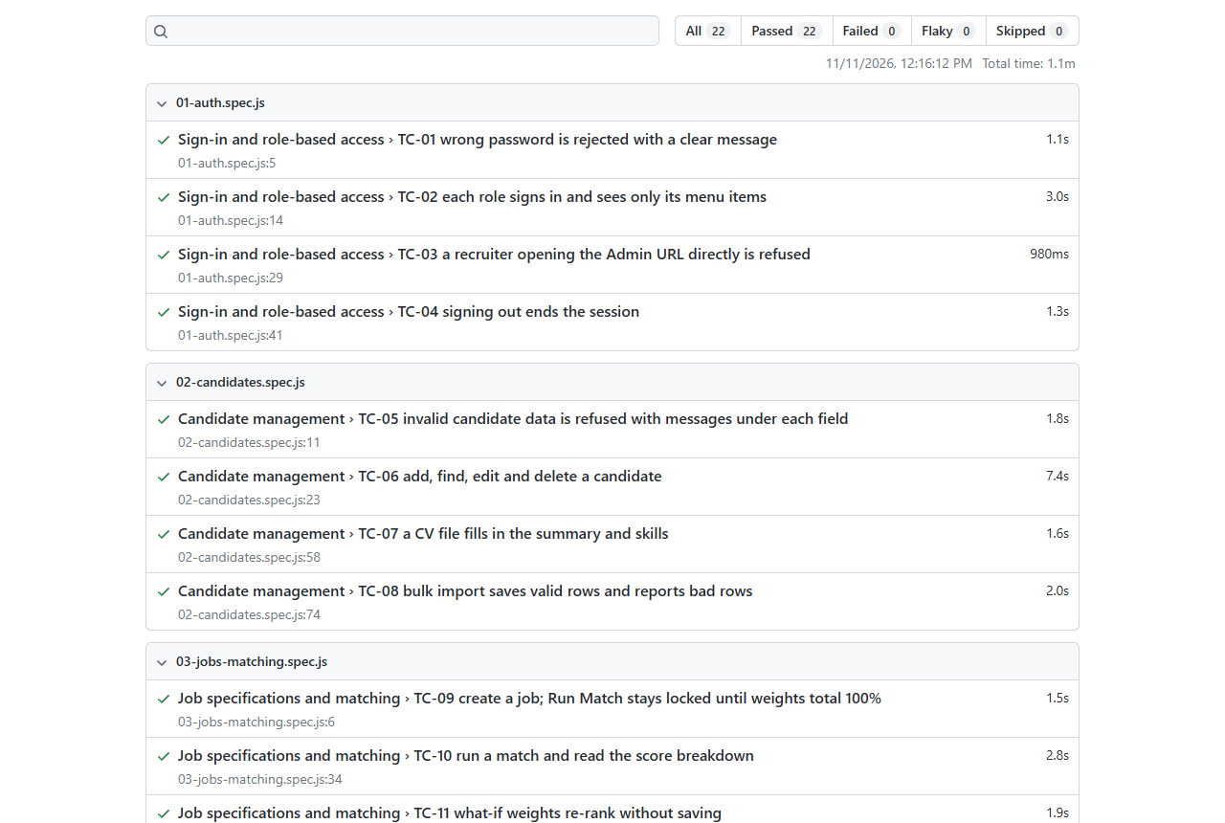
Figure 5.16: Playwright HTML report of the final end-to-end run

5.4.4 Defects found and how they were fixed
ID | Found by | Defect | Fix
D1 | TC-07 | Skills read from a CV appeared as lower-case chips | Converted to display labels before adding them to the form
D2 | TC-20 | Clickable dashboard bars were hidden from keyboard and screen-reader users | Made real buttons with names; component test added
D3 | test_import | CV parsing found no skills on a new, empty database | Built-in vocabulary of common skills plus the alias table
D4 | Screenshot review | Seed data unrealistic: same timestamps, hires with other open offers, 59% of staff on the bench | Dates spread over time, a hire withdraws other applications, bench about 1 in 8
D5 | Screenshot review | "170% booked today" on a project read as over-booking | Shown as full-time equivalents (1.7 FTE)
D6 | Manual test | start.bat busy-port check never fired | Replaced the regular expression with plain findstr filters
D7 | Fresh install | start.bat could not find Python 3.11 installed outside PATH | PYTHON override added to both start scripts and documented
Table 5.13: Product defects
Nine test defects were also fixed (for example ambiguous locators, an expected count that ignored records created by an earlier test, and an expectation of 29 open jobs where 30 is correct). Two test-environment issues were found. First, the end-to-end server had switched off the model warm-up the real app performs at start-up, so the first match was slow. It now starts exactly like the real app. Second, under automation Microsoft Edge holds a finished blob download open, which hung the next test. The CSV test now captures the file at the last browser step in Edge, while Chrome performs the full save.

5.4.5 Limitations
- Firefox and Safari were not tested; Edge and Chrome were.
- Usability was judged by review and accessibility checks, not by observing real recruiters.
- The first match after loading new CVs takes longer than 5 seconds because each CV is read once by the model; later matches take under a second.
- SQLite and a server bound to 127.0.0.1 suit one user at a time; concurrent load was not tested.
- Frontend component coverage is 50.6%; the older matching screens rely on end-to-end tests.
- Scanned (image-only) CVs cannot be read; there is no OCR.
- Seed data is generated, so match quality on real CVs has not been measured.

5.4.6 Recommendations
- Add Firefox and other screen sizes to the Playwright run.
- Hold a short usability session with two or three recruiters, using the test journeys as tasks.
- Move to PostgreSQL and a lab-network server before several recruiters use it at once, and add a load test.
- Add component tests for the Candidates, Jobs and Results screens.
- Encode CVs in the background as soon as they are imported or edited, so the first match is never cold.
- Add OCR for scanned CVs and compare match rankings with recruiter shortlists.

5.5 Installation

5.5.1 Summary
HireTrack installs on one Windows or macOS computer with a single command. The full, step-by-step guide with manual installation, test commands and troubleshooting is INSTALLATION_GUIDE.md (and .pdf) in the submission folder.
Prerequisite | Version
Python | 3.11 (64-bit)
Node.js and npm | 18 or later (tested with 20.16)
Browser | Microsoft Edge or Google Chrome
Disk / memory | about 3 GB free; 4 GB RAM minimum, 8 GB recommended
Internet | During installation only
Table 5.14: Prerequisites

5.5.2 Steps
- Unzip 402311822_HireTrack_Phase5_Implementation.zip and open source_code.
- Windows: run start.bat. macOS/Linux: run chmod +x start.sh then ./start.sh.
- The first run creates the Python virtual environment and installs the packages, downloads the language model (about 90 MB), builds the screens, and creates and seeds the database. Later runs start in a few seconds and work offline.
- Open http://127.0.0.1:8000 (the script opens it) and sign in with one of the accounts below.
Role | Email | Password
Administrator | admin@hiretrack.local | Admin@123
Recruiter (HR) | recruiter@hiretrack.local | Recruiter@123
Resource Manager | manager@hiretrack.local | Manager@123
Table 5.15: Default accounts (change the passwords before real use)
Options: PORT (another port), PYTHON (path to Python 3.11 if not on PATH) and HT_NO_BROWSER. The database can be re-seeded at any time with python seed/seed_database.py or from the Admin screen.

5.5.3 Verification on a clean copy
The guide was verified by doing a fresh installation from the submission contents in a new temporary folder on the test laptop, with no virtual environment, no node_modules, no model and no database. start.bat was run on port 8002. It installed the packages, downloaded the model, built the frontend, seeded 600 candidates and 33 jobs, and started the server. All three accounts signed in, a match ran, and the dashboard, pipeline and resources screens loaded. The server was then restarted with HF_HUB_OFFLINE=1 and all HTTP and HTTPS traffic sent to an unreachable proxy. Matching and every screen still worked, which confirms NFR2 (offline after installation). The install log is in testing/results/fresh-install-log.txt.

Conclusion
The Implementation Phase delivered a complete, working HireTrack. The matching engine from the Design phase is built exactly to its specification and explains every score. Around it, the system now has the remaining objectives of the Proposal: personal accounts with three roles, an applicant pipeline with a full audit history, resource allocation that cannot over-book anyone, bulk import and CV capture, and a dashboard. The database seeds itself with 600 candidates, 33 jobs and a realistic hiring and project history.
The system was tested at four levels with 401 automated tests and 37 traced system test cases. Every requirement passed on the final runs, with 95% backend coverage, and a 600-candidate match takes well under one second once CVs are cached. Testing found and fixed seven product defects; the remaining limitations (browser range, cold first match, single-user database) are documented with recommendations. A fresh installation from the submitted files was verified with one command.

References
FastAPI (2026) FastAPI documentation. Available at: https://fastapi.tiangolo.com (Accessed: 6 November 2026).
Jones, M., Bradley, J. and Sakimura, N. (2015) JSON Web Token (JWT), RFC 7519. Internet Engineering Task Force.
Meta Platforms (2026) React documentation. Available at: https://react.dev (Accessed: 6 November 2026).
Microsoft (2026) Playwright documentation. Available at: https://playwright.dev (Accessed: 10 November 2026).
OWASP Foundation (2021) OWASP Top 10. Available at: https://owasp.org/Top10/ (Accessed: 6 November 2026).
Reimers, N. and Gurevych, I. (2019) 'Sentence-BERT: Sentence embeddings using Siamese BERT-networks', Proceedings of EMNLP-IJCNLP 2019, pp. 3982-3992.
Republic of South Africa (2013) Protection of Personal Information Act 4 of 2013. Pretoria: Government Printer.
Richfield Graduate Institute of Technology (2026) IT Project Guidelines, Semester 2 2026. Faculty of Information Technology.
SQLAlchemy (2026) SQLAlchemy 2.0 documentation. Available at: https://docs.sqlalchemy.org (Accessed: 6 November 2026).
SQLite (2026) SQLite online backup API. Available at: https://www.sqlite.org/backup.html (Accessed: 6 November 2026).
Schwalbe, K. (2019) Information Technology Project Management. 9th edn. Boston: Cengage Learning.

