


Project- High Level Design

On

Non-Profit Quiz/Tutor Bot

CourseName: GenAI

InstitutionName:MedicapsUniversity–DatagamiSkillBasedCourse

StudentName(s)&EnrolmentNumber(s):

Srno | StudentName | EnrolmentNumber
01 | Rohan Singh Rajput | EN22CS301819
02 | Payal Tiwari | EN22CS301702
03 | Sagar Hedav | EN22CS301837
04 | Parvaj Khan | EN22CS301697
05 | Prayag Holker | EN22CS301751

Group Name: Group12D7
ProjectNumber:GAI-35
Industry Mentor Name: Rishabh Tripathi UniversityMentorName: Dr. Hemlata patel
AcademicYear:2025-2026

1. Introduction
The Non-Profit Educational Bot is an AI-based learning system designed to help non-profit staff and volunteers improve their understanding of donor communication. Instead of using traditional training methods like manuals, this system provides an interactive platform where users can practice real-life scenarios through quizzes and receive instant feedback. The bot uses advanced AI to not only check answers but also explain mistakes based on internal organizational rules, creating a continuous learning loop.

1.1 Scope of the Document
This document explains the overall architecture and working of the system. It includes details about the user interface, backend services, AI integration, and the use of Retrieval-Augmented Generation (RAG) for processing internal PDF documents. It also describes how the system generates quizzes and evaluates responses. However, advanced features like user authentication and long-term data storage are considered future improvements and are not fully covered in this version.

1.2 Intended Audience
This document is useful for software developers, system architects, and project evaluators. It helps developers understand how to build the system, assists architects in planning the structure, and provides stakeholders with a clear idea of how the system works and ensures data privacy.

1.3 System Overview
The system follows a two-layer architecture consisting of a frontend and a backend. The frontend is built using Streamlit, which provides an interactive user interface for quizzes and chat. The backend is developed using FastAPI, which handles all logic and communication with external services. The system also uses a vector database (ChromaDB) to store internal documents and an AI model (Google Gemini) to generate and evaluate content. The backend acts as a bridge between the user interface, database, and AI model.

2. System Design

2.1 Application Design
The system follows a client-server architecture to ensure scalability and separation of concerns. The frontend handles user interaction, such as displaying quizzes and collecting answers. The backend processes these inputs, communicates with the AI model, and returns results. The data layer uses a vector database to store and retrieve relevant information from internal documents, which helps the AI provide accurate and context-based responses.

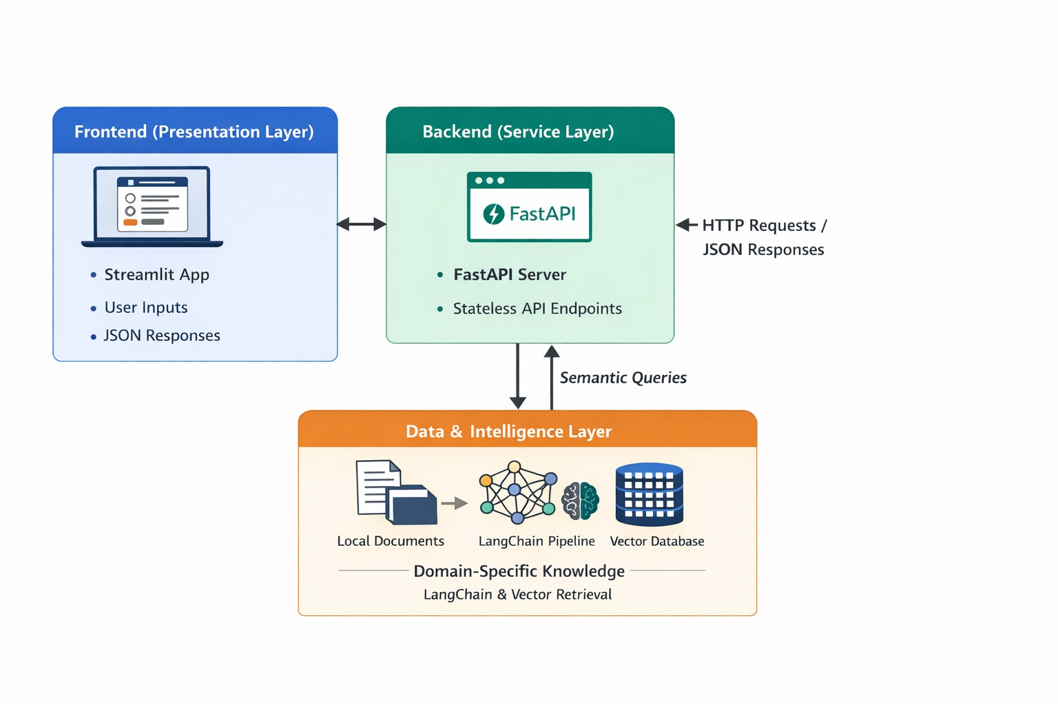

2.2 Process Flow
The system works in two main workflows. In the first workflow, the user enters a donor email into the system. The frontend sends this data to the backend, which then asks the AI model to generate quiz questions. These questions are returned in a structured format and displayed on the user interface. In the second workflow, the user submits answers to the quiz. The backend retrieves relevant rules from the database and sends them along with the user’s answers to the AI model. The AI evaluates the responses and provides a score along with detailed feedback and suggestions for improvement.
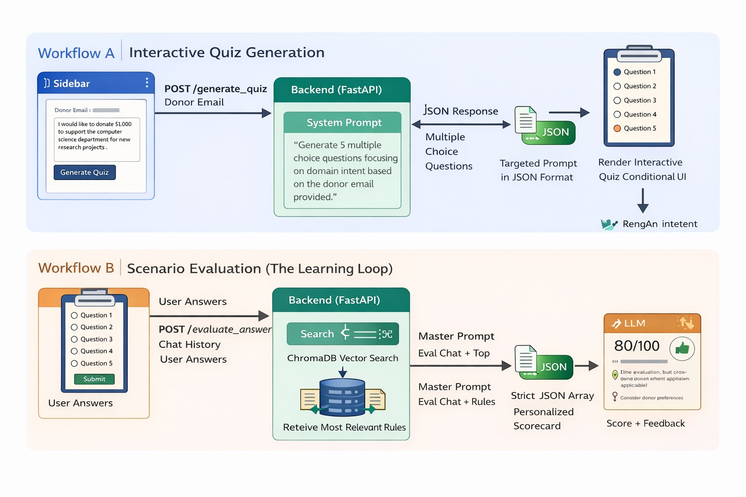

2.3 Information Flow
Data in the system flows in the form of JSON between different components. The user sends input data to the backend through the frontend. The backend processes this data and queries the vector database to find relevant information. It then sends a structured prompt to the AI model, which returns the response. Finally, the backend sends the processed result back to the frontend for display.

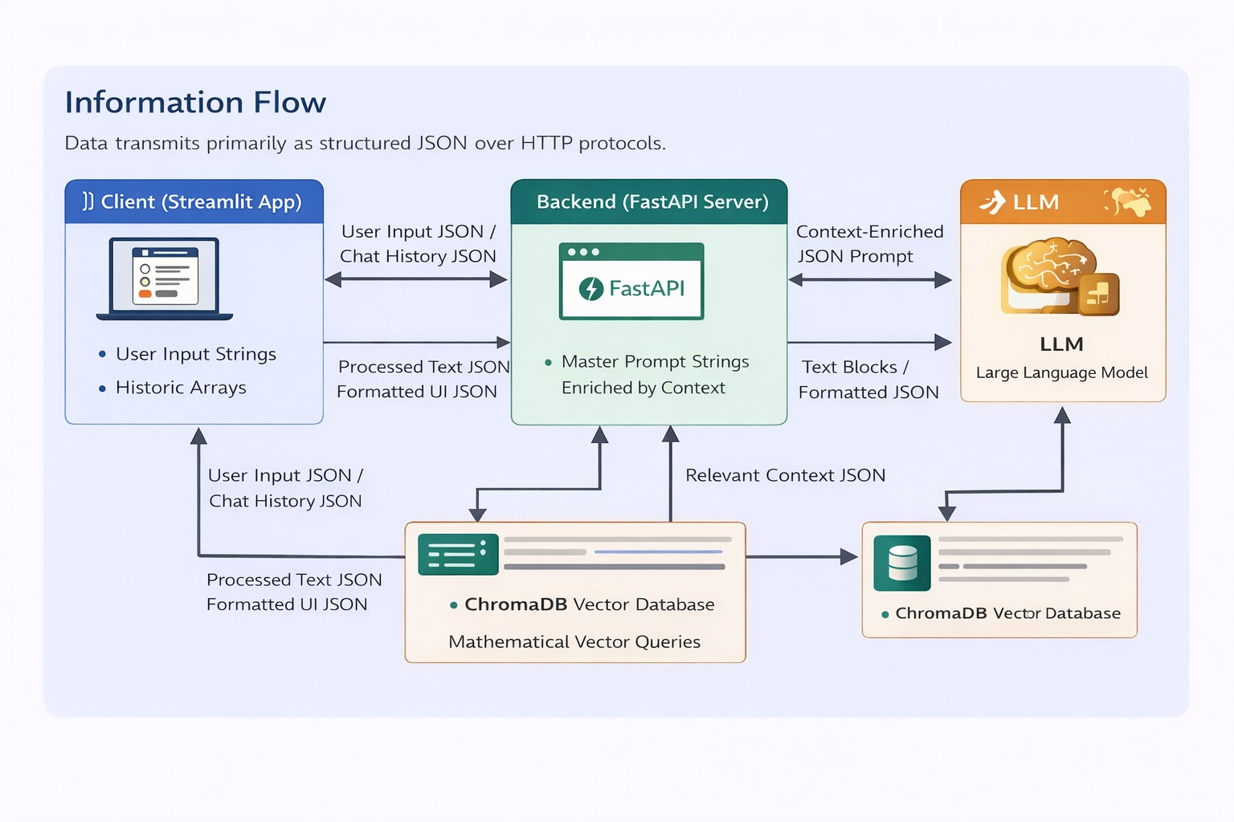

2.4 Components Design
The system is divided into multiple independent components. The frontend handles the user interface and interaction. The backend API manages requests and responses. The AI service module is responsible for communicating with the AI model and generating outputs. The database module manages document storage and retrieval using vector embeddings. Each component works independently, making the system easy to maintain and scale.

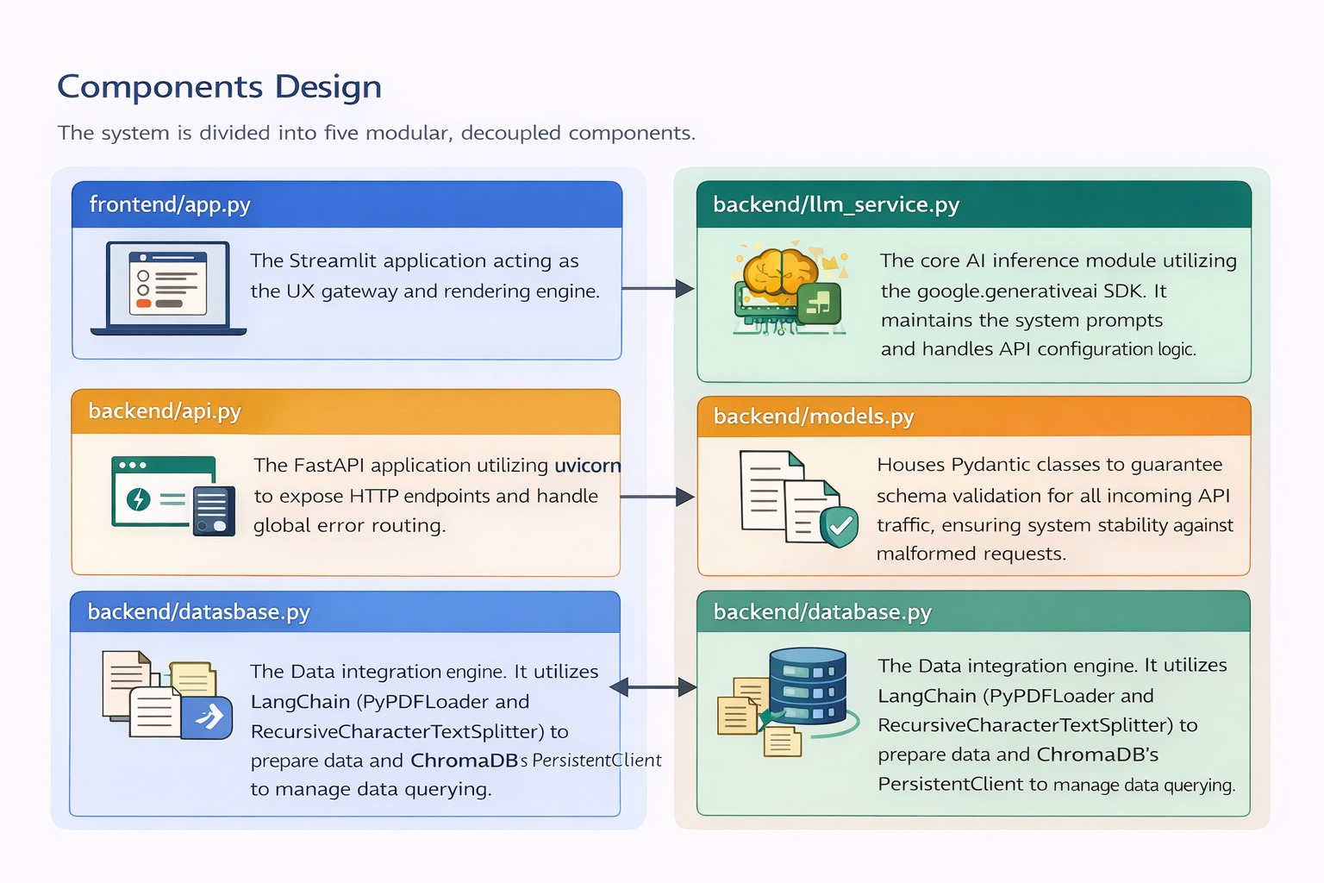

2.5 Key Design Considerations
The system is designed with a decoupled architecture, meaning the frontend and backend are separate and can be updated independently. It uses chunking techniques to divide large documents into smaller parts so that the AI can process them efficiently. The backend is stateless, meaning it does not store user session data, which improves scalability and performance. All important context is passed from the frontend during each request.

2.6 API Catalogue
The system provides two main APIs. The first API generates quiz questions based on the donor email provided by the user. The second API evaluates the user’s answers and provides feedback. Both APIs use JSON format for sending and receiving data, ensuring smooth communication between frontend and backend.

3. Data Design

3.1 Data Model
The system stores internal documents as vector embeddings in the database. These embeddings represent the meaning of the text in numerical form, allowing the system to perform similarity searches. The documents are divided into smaller chunks to improve accuracy and performance.

3.2 Data Access Mechanism
The backend reads PDF documents from a local directory and processes them using specialized tools. These documents are converted into vectors and stored in the database. When needed, the system retrieves the most relevant data based on the user’s input.

3.3 Data Retention Policies
The vector data is stored permanently in the system to avoid repeated processing. However, user session data such as quiz answers and chat history is stored temporarily in the frontend and is cleared when the session ends.

3.4 Data Migration
The system automatically checks if the database is empty during startup. If no data is found, it processes all available documents and stores them in the database. This ensures that the system is always ready to use without manual setup.

4. Interfaces
The system provides a simple and user-friendly web interface. Users can input donor emails, take quizzes, and view results. The interface includes a sidebar for input and a main section for displaying quizzes and feedback.

5. State and Session Management
The frontend manages user session data using temporary storage, which keeps track of quizzes and interactions. The backend does not store any session data, making it stateless and scalable.

6. Caching
The system uses the vector database as a caching mechanism. Once documents are processed and stored, they do not need to be processed again. This improves performance and reduces response time.

7. Non-Functional Requirements

7.1 Security Aspects
The system ensures security by storing API keys in environment variables and not exposing them in the code. All sensitive data is processed locally, reducing the risk of data leakage.

7.2 Performance Aspects
The system is designed to handle multiple users efficiently. It uses asynchronous processing to improve speed and reduce delays. By sending only relevant data to the AI model, it reduces processing time and cost.

