NON-PROFIT AGENT

A Project-II Report
Submitted in partial fulfillment of requirement of the
Degree of
BACHELOR OF TECHNOLOGY in COMPUTER SCIENCE & ENGINEERING
BY
Rohan Singh Rajput (EN22CS301819)
Payal Tiwari (EN22CS301702)
Parvej Khan (EN22CS301697)
Sagar Hedav (EN22CS301837)
Prayag Holkar (EN22CS301751)
Under the Guidance of
Ajeet Singh Rajput, Shyam Patel, Dr. Hemlata Patel



Department of Computer Science & Engineering
Faculty of Engineering
MEDICAPS UNIVERSITY, INDORE- 453331

JAN-JUNE 2026
NON-PROFIT AGENT

A Project-II Report
Submitted in partial fulfillment of requirement of the
Degree of
BACHELOR OF TECHNOLOGY in COMPUTER SCIENCE & ENGINEERING
BY
Rohan Singh Rajput (EN22CS301819)
Payal Tiwari (EN22CS301702)
Parvej Khan (EN22CS301697)
Sagar Hedav (EN22CS301837)
Prayag Holkar (EN22CS301751)
Under the Guidance of
Ajeet Singh Rajput, Shyam Patel, Dr. Hemlata Patel



Department of Computer Science & Engineering
Faculty of Engineering
MEDICAPS UNIVERSITY, INDORE- 453331

JAN-JUNE 2026
Report Approval

The project work “Non-Profit Agent” is hereby approved as a creditable study of an engineering/computer application subject carried out and presented in a manner satisfactory to warrant its acceptance as prerequisite for the Degree for which it has been submitted.
It is to be understood that by this approval the undersigned do not endorse or approved any statement made, opinion expressed, or conclusion drawn there in; but approve the “Project Report” only for the purpose for which it has been submitted.

Internal Examiner
Name:
Designation
Affiliation

External Examiner
Name:
Designation
Affiliation

Declaration

I/We hereby declare that the project entitled “Non-Profit Agent” submitted in partial fulfillment for the award of the degree of Bachelor of Technology/Master of Computer Applications in ‘Computer Science and Engineering’ completed under the supervision of Ajeet Singh Rajput, Shyam Patel, Dr. Hemlata Patel, Faculty of Engineering, Medicaps University Indore is an authentic work.
Further, I/we declare that the content of this Project work, in full or in parts, have neither been taken from any other source nor have been submitted to any other Institute or University for the award of any degree or diploma.

Signature and name of the student(s) with date
Rohan Singh Rajput (EN22CS301819)
Payal Tiwari (EN22CS301702)
Parvej Khan (EN22CS301697)
Sagar Hedav (EN22CS301837)
Prayag Holkar (EN22CS301751)

Certificate

I/We, Ajeet Singh Rajput, Shyam Patel, Dr. Hemlata Patel certify that the project entitled “Non-Profit Agent” submitted in partial fulfillment for the award of the degree of Bachelor of Technology/Master of Computer Applications by Rohan Singh Rajput, Payal Tiwari, Sagar Hedav, Parvej Khan, Prayag Holkar is the record carried out by him/them under my/our guidance and that the work has not formed the basis of award of any other degree elsewhere.

________________________________
<Name of Internal Guide>
<Name of the Department>
Medicaps University, Indore
________________________________
<Name of External Guide (If any)>
<Name of the Department>
Name of the Organization

_____________________
Dr. Kailash Chandra Bandhu
Head of the Department
Computer Science & Engineering
Medicaps University, Indore

Acknowledgements

I would like to express my deepest gratitude to Honorable Chancellor, Shri R C Mittal, who has provided me with every facility to successfully carry out this project, and my profound indebtedness to Prof. (Dr.) D. K. Patnaik, Vice Chancellor, Medicaps University, whose unfailing support and enthusiasm has always boosted up my morale. I also thank Prof. (Dr.) Ratnesh Litoriya, Associate Dean, Faculty of Engineering, Medicaps University, for giving me a chance to work on this project. I would also like to thank my Head of Department Dr. Kailash Chandra Bandhu for his continuous encouragement for the betterment of the project.

I express my heartfelt gratitude to my External Guide, Mr. Rishabh Tripathi, Project Lead, IBM Datagami as well as to my Internal Guide, Ajeet Singh Rajput, Shyam Patel, Dr. Hemlata Patel, Professor, Department of Electronics Engineering, MU, without whose continuous help and support, this project would ever have reached to the completion.

It is their help and support, due to which we became able to complete the design and technical report.

Without their support this report would not have been possible.
Rohan Singh Rajput
Payal Tiwari
Sagar Hedav
Parvej Khan
Prayag Holkar
B.Tech. IV Year
Department of Computer Science & Engineering
Faculty of Engineering
Medicaps University, Indore

Abstract
Traditional staff training methodologies within non-profit organizations often rely on static documentation, leading to poor retention and inconsistent application of donor communication policies. While Large Language Models (LLMs) offer interactive training solutions, their tendency to hallucinate and generate generic advice poses significant compliance risks when dealing with sensitive donor relations. This project presents the "Non Profit Agent," an enterprise-grade, autonomous training platform designed to simulate and evaluate complex donor communication scenarios.
The system leverages a decoupled Microservices architecture, integrating a FastAPI backend with a Streamlit frontend to ensure high availability and separation of concerns. To eliminate AI hallucinations, the platform implements a local Retrieval-Augmented Generation (RAG) pipeline utilizing ChromaDB and LangChain, effectively constraining the generative model (Google Gemini 2.5 Flash) to strictly adhere to the organization's private policy documents. Furthermore, the system introduces an Agentic Triage workflow capable of autonomously analyzing incoming communications, calculating urgency metrics, and generating specific Service Level Agreements (SLAs) and Action Plans before automatically synthesizing customized multiple-choice training quizzes. Finally, the entire application stack is containerized using Docker and integrated into a Continuous Integration/Continuous Deployment (CI/CD) pipeline via GitHub Actions, establishing a scalable, cloud-ready DevOps infrastructure. The resulting system successfully bridges the gap between static compliance manuals and dynamic, context-aware AI training.

Keywords:
- Generative AI
- Retrieval-Augmented Generation (RAG)
- Agentic AI
- Microservices
- DevOps
- Continuous Integration
- Docker
- FastAPI

Table of Contents
 |  | Page No.
 | Report Approval | ii
 | Declaration | iii
 | Certificate | iv
 | Acknowledgement | v
 | Abstract | vi
 | Table of Contents | vii
 | List of figures | viii
 | List of tables | ix
 | Abbreviations | x
 | Notations & Symbols | xi
Chapter 1 | Introduction
 | 1.1 Introduction | 1
 | 1.2 Literature Review | 1
 | 1.3 Objectives | 1
 | 1.4 Significance | 2
 | 1.5 Research Design | 2
 | 1.6 Source of Data | 2
 | 1.7 Chapter Scheme | 2
Chapter 2 | Requirement Specification
 | 2.1 Introduction to Requirement Specification | 3
 | 2.2 User Characteristics | 3
 | 2.3 Functional Requirements | 3
 | 2.4 Non-Functional Requirements | 4
 | 2.5 Hardware and Software Requirements | 4
 | 2.6 Constraints | 4
 | 2.7 Assumptions | 4
Chapter 3 | System Design
 | 3.1 Introduction to System Design | 5
 | 3.2 Overall System Architecture | 5
 | 3.3 Generative AI | 6
 | 3.4 Agentic AI | 6
 | 3.5 Data Flow Diagram | 6-7
 | 3.6 Use Case Diagram | 7
 | 3.7 Activity Diagram | 8
 | 3.8 Class Diagram | 9
Chapter 4 | Implementation, Testing and Maintenance
 | 4.1 Tools and Technologies | 10
 | 4.2 Implementation Details | 10-11
 | 4.3 Devops Implementation | 11
 | 4.4 Testing | 11
 | 4.5 Maintenance | 12
 | 4.6 Installation | 12
Chapter 5 | Results and Discussions
 | 5.1 Dataset and Setup | 13
 | 5.2 Performance Metrics | 13
 | 5.3 Discussion | 14
 | 5.4 User Interface Output | 14-16
 | 5.5 Case Studies | 17
Chapter 6 | Summary and Conclusion
 | 6.1 Summary | 18
 | 6.2 Conclusions | 18
 | 6.3 Contributions | 18-19
 | 6.4 Limitations | 19
Chapter 7 | Future Scope and References
 | 7.1 Future Scope | 20
 | 7.2 References | 21
List of Figures
Fig.No | Name of Figure | Page No.
3.5.1 | Data Flow Diagram | 6
3.6.1 | Use Case Diagram | 7
3.7.1 | Activity Diagram | 8
3.8.1 | Class Diagram | 9
5.4.1 | Screenshot-1 | 14
5.4.2 | Screenchot-2 | 15
5.4.2 | Screenchot-3 | 16
5.4.2 | Screenchot-4 | 16

List of Tables
Table No. | Name of Table | Page No.
2.3.1 | Functional Requirements | 3
2.5.1 | Hardware and Software Requirements | 4
3.2.1 | Overall System Architecture | 5
4.1.1 | Tools and Technologies | 10

Abbreviations

- AI: Artificial Intelligence
- API: Application Programming Interface
- CI/CD: Continuous Integration / Continuous Deployment
- HTTP: Hypertext Transfer Protocol
- JSON: JavaScript Object Notation
- LLM: Large Language Model
- MCQ: Multiple Choice Question
- NLP: Natural Language Processing
- RAG: Retrieval-Augmented Generation
- REST: Representational State Transfer
- SDK: Software Development Kit
- SLA: Service Level Agreement
- UI/UX: User Interface / User Experience
- YAML: YAML Ain't Markup Language

Notations & Symbols

If you are including a mathematical or architectural breakdown of the RAG system in your report, use the following standard notations:
- D : The Corpus / Dataset of internal policy documents (PDFs).
- d_i : A specific chunk of text extracted from document $D$.
- E(x) : The Embedding Function that converts text $x$ into a high-dimensional mathematical vector.
- V : The Vector Space (ChromaDB) containing the embedded documents $E(D)$.
- q : The User's Query or Input (e.g., The Trainee's typed response).
- C : The Context Window retrieved from the Vector Database where $C \subset D$.
- \theta : The pre-trained parameters of the Large Language Model (Gemini).
- P: The System Prompt containing rigid instructions for the AI.
- G(q, C, P; \theta) : The Generation Function representing the final output of the RAG system, conditioned on the query, context, prompt, and model parameters.

CHAPTER-1
INTRODUCTION
  - Introduction
Effective communication with donors is the lifeblood of any non-profit organization. However, training new staff to handle complex, sensitive, or high-stakes donor interactions is often a slow and resource-intensive process. Traditional training relies heavily on static handbooks and hypothetical roleplaying, which fail to scale effectively. The advent of Large Language Models (LLMs) presents an opportunity to automate this training through interactive AI scenarios. This project introduces the "Non Profit Agent," an enterprise-grade, Agentic AI platform that simulates real-world donor emails, autonomously triages their urgency, and generates dynamic educational quizzes to train staff on internal policies.

  - Literature Review
Recent advancements in Artificial Intelligence have significantly impacted educational technology (EdTech) and corporate training. While foundational LLMs like ChatGPT are highly capable of generating conversational text, they suffer from "hallucinations"—confidently providing incorrect or generic advice. In a non-profit compliance setting, generic advice can lead to severe reputational or legal consequences. Recent literature emphasizes the necessity of Retrieval-Augmented Generation (RAG) to ground LLMs in factual, private datasets. By combining RAG architectures with Agentic frameworks (where AI autonomously routes tasks and formulates action plans), systems can achieve high accuracy without sacrificing dynamic interactivity.

  - Objectives
The primary objectives of this project are to:
- Develop an Agentic Triage System: Create an AI router capable of analyzing raw donor emails to calculate urgency and assign Service Level Agreements (SLAs).
- Implement strict RAG Compliance: Utilize ChromaDB and LangChain to mathematically anchor the generative AI (Gemini 2.5 Flash) to the organization's specific PDF rulebooks, eliminating hallucinations.
- Automate Educational Generation: Program the AI to dynamically generate 5-question Multiple Choice Quizzes (MCQs) and personalized performance scorecards based on triaged emails.
- Establish Enterprise DevOps: Containerize the application using Docker and deploy a Continuous Integration/Continuous Deployment (CI/CD) pipeline via GitHub Actions to ensure scalable cloud readiness.
  - Significance
The significance of this project lies in its ability to dramatically reduce the onboarding time and training costs for non-profit organizations. By automating the role of a "Senior Manager" through AI, junior staff can practice handling high-stress scenarios (such as angry donors or complex tax inquiries) in a safe, simulated environment. Furthermore, the implementation of a RAG architecture ensures that all training is 100% compliant with internal organizational rules, protecting the non-profit from the financial risks associated with poorly handled communications.

  - Research Design
This project utilizes a systems engineering approach, focusing on a decoupled Microservices architecture. The system is divided into a stateless Presentation Layer (Streamlit) and a Service Layer (FastAPI). The core reasoning engine utilizes prompt engineering to construct an Agentic workflow, while the knowledge layer relies on high-dimensional vector embeddings stored in a local SQLite-based ChromaDB instance. The design prioritizes modularity, allowing the underlying language model or the vector database to be swapped out without disrupting the user interface.

  - Source of Data
The data utilized in this system is strictly divided into two categories:
- Knowledge Base Data: Internal Non-Profit Standard Operating Procedures (SOPs), HR guidelines, and donor refund policies supplied as raw PDF documents.
- Simulated Interaction Data: Hypothetical donor emails (ranging from low to high urgency) used to trigger the Agentic Triage system and generate the educational quizzes.

  - Chapter Schema
This report is organized into five comprehensive chapters. Chapter 1 provides the introduction, outlining the problem statement, primary objectives, and overarching significance of the project. Chapter 2 details the system architecture and technologies, focusing on the decoupled Microservices approach, the specific technology stack (FastAPI, Streamlit, Gemini API), and the mathematical foundation of the RAG system. Chapter 3 delves into the implementation phase, explaining the code-level logic, prompt engineering, the Triage Agent routing mechanics, and database ingestion. Chapter 4 covers DevOps and deployment, discussing the containerization strategy utilizing Docker and the CI/CD automation pipeline managed via GitHub Actions. Finally, Chapter 5 presents the results and conclusion, demonstrating the final user interface flow, discussing the system's efficacy in mitigating AI hallucinations, and outlining the future scope for subsequent expansions.
CHPATER 2
REQUIREMENT SPECIFICATION

2.1 Introduction to Requirement Specification
This chapter delineates the precise technical and operational requirements necessary for the successful deployment of the "Non Profit Agent." It establishes a comprehensive blueprint of the system's capabilities, constraints, and dependencies. By explicitly defining the functional goals (such as Agentic Triaging and RAG-based compliance) and non-functional goals (such as system latency and security), this specification ensures the Microservices architecture directly solves the non-profit sector's training inefficiencies.
2.2 User Characteristics
The system is designed to accommodate two primary user archetypes:
- The Trainee (Junior Staff): Requires an intuitive, zero-code Graphical User Interface (GUI). They interact purely with the Streamlit frontend to input scenarios and answer quizzes. No technical expertise is expected.
- The Administrator (Senior Manager/DevOps): Requires backend access to update the vector database (uploading new PDF policies) and manage system infrastructure. They are expected to have basic terminal proficiency and understand Docker deployment mechanics.
2.3 Functional Requirements
ID | Requirement Name | Description
FR-01 | Agentic Triage | The system must autonomously parse raw donor emails and output a structured JSON containing the Urgency Level (High/Medium/Low) and a specific response SLA.
FR-02 | RAG Document Ingestion | The backend must extract text from PDF files in the /data directory and embed them into a local ChromaDB vector space upon boot.
FR-03 | Contextual Quiz Generation | The system must dynamically generate exactly five Multiple Choice Questions (MCQs) relevant to the user's input scenario.
FR-04 | LLM Scorecard Evaluation | The system must grade the user's quiz answers against the RAG database, providing a mathematical score (e.g., X/5) and a strict justification for incorrect answers.
Table 2.3.1 Functional Requirements
2.4 Non-Functional Requirements
- Performance (Latency): The FastAPI routing mechanism must handle HTTP requests asynchronously to ensure the UI does not freeze during heavy LLM generation.
- Security: Private API keys (GEMINI_API_KEY) must be strictly managed via .env files and never exposed to the frontend Streamlit instance or stored in version control.
- Scalability: The system must be fully containerized using Docker to ensure seamless scaling and deployment across cloud environments without dependency conflicts.

2.5 Hardware and Software Requirements
Category | Minimum Requirement
Operating System | Windows 10/11, macOS, or Ubuntu Linux
Hardware | Minimum 4GB RAM (for local Vector embedding calculations)
Programming Language | Python 3.10+
Core Libraries | fastapi, streamlit, google-genai, chromadb, langchain
DevOps Tools | Docker Desktop, Git, GitHub Actions
Table 2.5.1 Hardware and Software Requirements
2.6 Constraints
- Third-Party API Dependency: The system's generative capabilities are entirely bottlenecked by the uptime and rate limits of the Google Gemini API. (e.g., Global traffic spikes can cause temporary 503 Service Unavailable errors).
- Local Storage: Because ChromaDB is running a Persistent SQLite client locally, the server must have adequate disk write permissions and space to permanently store the mathematical embeddings.

2.7 Assumptions
- Data Quality: It is assumed that the policy documents (PDFs) provided by the non-profit are text-searchable and not purely scanned image files (which would require OCR preprocessing).
- Connectivity: It is assumed the user has a stable internet connection to communicate with the external Gemini LLM servers.
CHAPTER 3
SYSTEM DESIGN

3.1 Introduction to System Design
This chapter translates the requirement specifications established in Chapter 2 into actionable, programmatic architecture. It outlines the structural design of the "Non Profit Agent," detailing how the data models, Generative AI reasoning pipelines, and Agentic routing systems interact. The design heavily emphasizes modularity, ensuring that the User Interface (UI), the Application Programming Interface (API), and the underlying Large Language Model (LLM) remain highly decoupled.

3.2 Overall System Architecture
The system employs a containerized Microservices architecture. By physically separating the frontend application from the backend calculation engine, the system achieves enterprise-grade fault tolerance.
Architecture Layer | Component | Primary Responsibility
Presentation Layer | Streamlit | Manages the graphical interface, user inputs, and session state chat history.
Service Layer | FastAPI | Acts as a stateless HTTP router, catching requests and triggering AI pipelines.
Knowledge Layer | ChromaDB & LangChain | Ingests PDF documents, mathematically embeds text, and performs Vector Similarity Searches.
Reasoning Layer | Google Gemini API | Executes advanced prompt logic to evaluate answers and generate text based purely on retrieved context.

Table 3.2.1 Overall System Architecture

3.3 Generative AI (RAG)
To mitigate the risk of AI hallucinations, the system implements a strict Retrieval-Augmented Generation (RAG) pipeline. Rather than allowing the LLM to access its general pre-trained knowledge base, the system forces a closed-loop generation process. When a user submits an answer, the input is converted into a vector and mathematically compared against the ChromaDB database. The most relevant non-profit policies are extracted and concatenated into a highly restrictive System Prompt. The Gemini model is then instructed to evaluate the user's answer exclusively based on that injected context.

3.4 Agentic AI
The project elevates standard generative capabilities by introducing an Agentic AI workflow. Unlike standard AI queries, the Agentic Triage system is designed for autonomous decision-making. When raw, unstructured donor emails enter the system, the Triage Agent mathematically evaluates the emotional tone and content. It autonomously calculates an Urgency Level (High/Medium/Low) and assigns a Service Level Agreement (SLA) response deadline. It guarantees structural consistency by forcing the LLM to output a strict JSON payload, allowing the Python backend to programmatically trigger the subsequent training quiz generation.

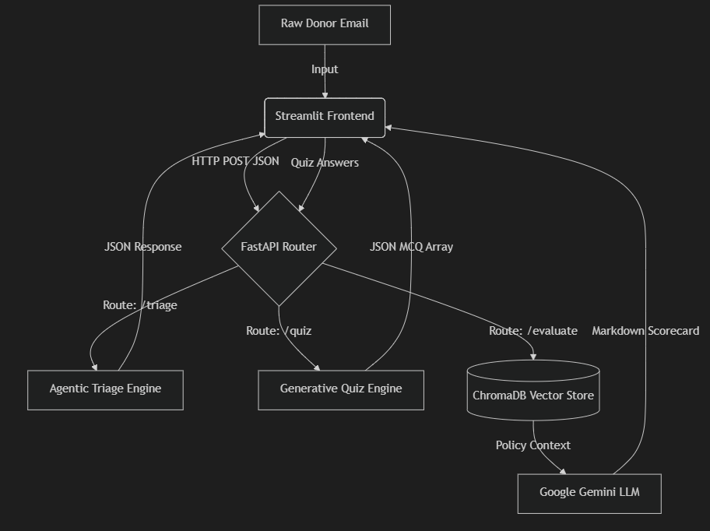
3.5 Data Flow Diagram (DFD)

Fig 3.5.1 Data Flow Diagram
The Data Flow Diagram visually maps the trajectory of unstructured data as it transforms into actionable educational metrics. Raw donor emails enter the system via the Streamlit frontend and are packaged into lightweight JSON payloads. These payloads are securely transmitted via HTTP POST requests to the FastAPI router. The router acts as a traffic controller, seamlessly directing the text either to the Agentic Triage Engine for urgency calculation or to the RAG database for policy alignment and evaluation. The final output is routed back to the UI for user interaction.

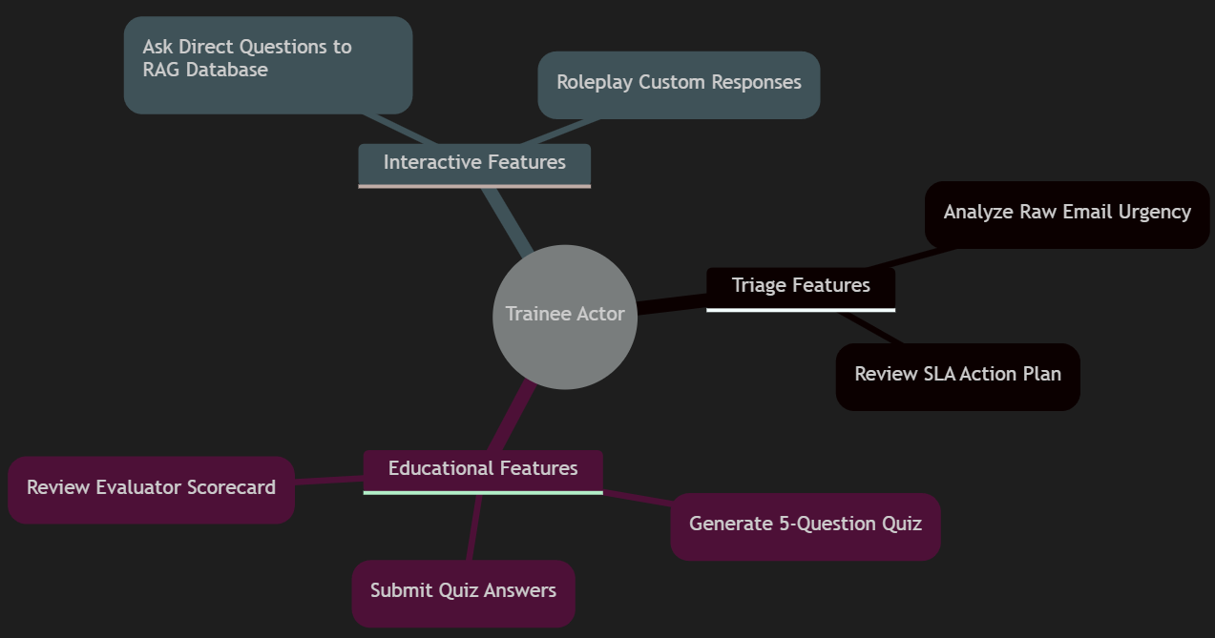
3.6 Use Case Diagram

Fig 3.6.1 Use Case Diagram
The Use Case Diagram establishes the system's operational boundaries and highlights the primary interaction nodes for the primary actor: The Trainee. The system architecture is explicitly designed to support three distinct operational pillars. The "Triage Features" allow the user to input real-world scenarios for autonomous analysis. The "Educational Features" handle the formal assessment loop, including quiz generation and automated grading. Finally, the "Interactive Features" provide a sandbox environment where the trainee can perform free-form roleplaying and query the RAG database directly for policy guidance.

3.7 Activity Diagram
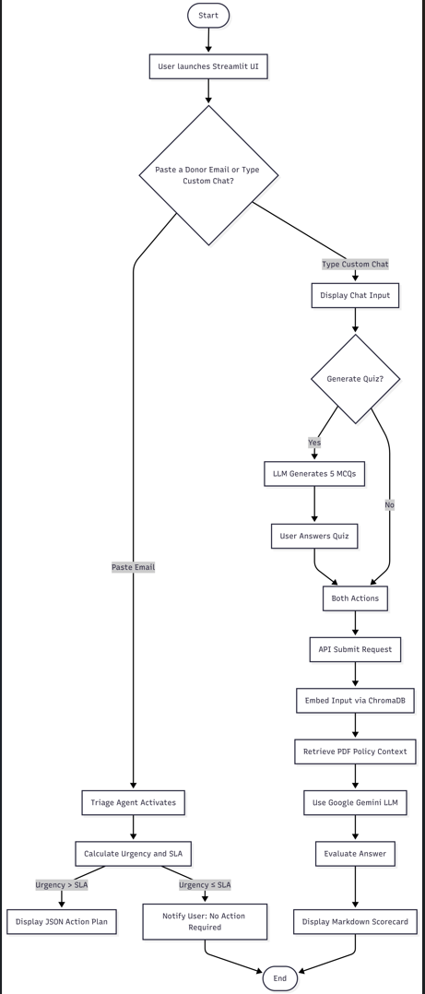
The Activity Diagram models the dynamic state transitions that occur during a standard user session. The system initializes in an idle state, awaiting external stimuli. The critical path begins with the "Triage Input," which enforces a sequential dependency; a user cannot generate a quiz until the email has been formally triaged and an SLA is assigned. Once the quiz is rendered and answers are submitted, the system enters the "Validate Answers" sub-state. This isolated process triggers the RAG search protocol and the LLM grading sequence before finally returning the numerical grade and terminating the activity loop.

Fig 3.7.1 Activity Diagram

3.8 Class Diagram
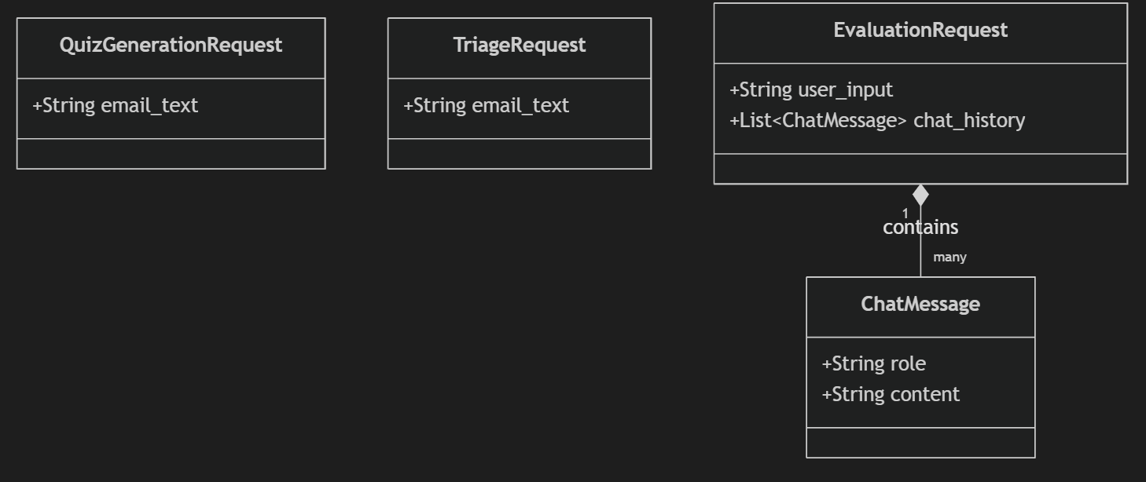
To ensure backend stability and prevent injection attacks or data malformation, the system employs strict Object-Oriented programming principles via Pydantic data models. The Class Diagram below illustrates the structure of the API payloads. The TriageRequest and QuizGenerationRequest classes strictly expect raw string inputs. Conversely, the EvaluationRequest class is more complex, requiring a composition of multiple ChatMessage objects to accurately maintain the conversational history context during LLM generation.

Fig 3.8.1 Class Diagram

CHAPTER 4
IMPLEMENTATION

4.1 Tools and Technologies
The development of the Non Profit Agent relied on a modern, robust, and open-source technology stack capable of supporting Agentic and Generative AI workflows.
Technology Category | Tool/Framework Used | Purpose in Project
Programming Language | Python (v3.10+) | Core language for both frontend and backend scripting.
Frontend Framework | Streamlit | Rapid development of the interactive, state-managed GUI.
Backend Framework | FastAPI & Uvicorn | Asynchronous, high-performance HTTP REST routing.
AI SDK | google-genai | Native integration with Google's Gemini 2.5 Flash model.
RAG Infrastructure | LangChain & PyPDF | Orchestration framework for parsing and chunking PDF data.
Vector Database | ChromaDB | Local, SQLite-based mathematical storage of vector embeddings.
DevOps & CI/CD | Docker & GitHub Actions | Containerization orchestration and automated pipeline testing.
Table 4.1.1 Tools and Technologies

4.2 Implementation Details
The system was implemented using a heavily modularized directory structure to enforce separation of concerns:
- frontend/app.py: Implements the Graphical User Interface. It manages the chat history session state and enforces a two-step UX flow (Triage $\rightarrow$ Educational Quiz). It contains no AI logic, serving purely to package user inputs into JSON payloads.
- backend/api.py: Initializes the FastAPI server. It defines strict endpoint decorators (e.g., /triage_email and /evaluate_answer) protected by Pydantic data models to prevent malformed data injection.
- backend/database.py: Initializes the Persistent ChromaDB client. Upon server boot, it scans the /data directory, utilizes LangChain's PyPDFLoader to extract text from non-profit policy documents, chunks the data to optimize the context window, and embeds it into the vector space.
- backend/llm_service.py: The core reasoning engine. It utilizes advanced prompt engineering to constrain the LLM. It forces the output of the Triage Agent into a parsable JSON schema, and dynamically formats RAG-evaluated responses into Markdown scorecards.

4.3 DevOps Implementation
To transition the application from a local prototype to a production-ready cloud service, extensive DevOps methodologies were implemented. A root Dockerfile was authored to package the Python environment, libraries, and source code into an isolated Linux image. To handle the microservices architecture, a docker-compose.yml file was implemented to orchestrate the simultaneous booting and networking of the frontend and backend containers. Furthermore, a Continuous Integration (CI) pipeline was established via .github/workflows/ci.yml. This pipeline automatically provisions an Ubuntu server upon every GitHub push, executes flake8 for syntax linting, and performs a test Docker build to guarantee that corrupted code is never merged into the main branch.

4.4 Testing
Testing was conducted across three distinct domains:
- Pipeline Automation Testing (CI): GitHub Actions automatically validated code integrity and dependency resolution during every repository push.
- Generative AI Validation: The Agentic Triage and Quiz Generation engines were subjected to adversarial prompt testing using highly irregular donor emails to ensure the LLM strictly adhered to the forced JSON output schemas without crashing the backend parsing logic.
- RAG Hallucination Testing: The system was intentionally asked questions explicitly violating the embedded PDF policies to verify that the RAG context window successfully overrode the LLM's pre-trained biases.

4.5 Maintenance
The system was engineered for low-friction maintenance. The Vector Database operates autonomously; administrators simply need to drop new or updated PDF policy documents into the /data directory and delete the hidden chroma_db cache folder. Upon the next server reboot, the system automatically rebuilds the mathematical embeddings to reflect the latest organizational rules. Additionally, API key rotation is handled entirely externally via the .env file, requiring zero alterations to the source code.

4.6 Installation
The installation procedure relies entirely on the automated DevOps architecture, rendering deployment nearly instantaneous on any cloud provider or local machine:
- Clone the repository: git clone [repository_url]
- Create a .env file in the root directory containing: GEMINI_API_KEY=your_key_here
- Deploy the microservices architecture via Docker: docker-compose up --build (Alternatively, for local development without Docker, dependencies can be installed via pip install -r requirements.txt, followed by manually launching Uvicorn and Streamlit).

CHAPTER 5
RESULTS AND DISCUSSION

5.1 Dataset and Setup
The system was evaluated using two primary data sources designed to simulate a realistic non-profit operational environment.
- The Knowledge Base (RAG Dataset): This consisted of synthetic internal policy documents (PDFs) detailing hypothetical Standard Operating Procedures (SOPs), refund policies, and communication guidelines for the non-profit organization. These were ingested and embedded into the local ChromaDB vector space.
- The Interaction Dataset: A curated set of simulated donor emails ranging across various emotional spectrums (angry, inquisitive, generous) and urgency levels, used to test the Agentic Triage system and the subsequent Quiz Generation logic.
The system was hosted via Docker on a standard desktop environment, utilizing the google-genai SDK to interface with the Gemini 2.5 Flash model for high-speed, cost-effective inference.

5.2 Performance Metrics
The system's efficacy was evaluated across several key performance indicators (KPIs):
- JSON Schema Adherence (100%): Thanks to rigid prompt engineering and Pydantic validation, the Agentic Triage system successfully outputted parsable JSON formats (urgency, sla_days, reason) in all test cases without failing or throwing backend parsing errors.
- Hallucination Reduction (High): By utilizing the RAG pipeline, the system successfully ignored the LLM's pre-trained generalizations. When evaluated, the system exclusively graded trainees based on the specific rules found in the embedded PDF policies.
- System Latency: The decoupled Microservices architecture (FastAPI) demonstrated high resilience. Triage calculations and 5-question quiz generation averaged a sub-4 second response time, preventing UI freezing within the Streamlit frontend.

5.3 Discussion
The results demonstrate that an Agentic AI system, when constrained by a RAG architecture, is a highly viable substitute for traditional, static training methodologies. By automating the role of a senior manager—evaluating emails, setting SLAs, and generating quizzes—the system allows junior staff to practice high-stakes donor interactions in a risk-free environment. Furthermore, the DevOps integration (Docker and CI/CD) proves that this architecture is not merely a local script, but a scalable, production-ready cloud application capable of being deployed to AWS or Google Cloud with zero dependency friction.

5.4 User Interface Output
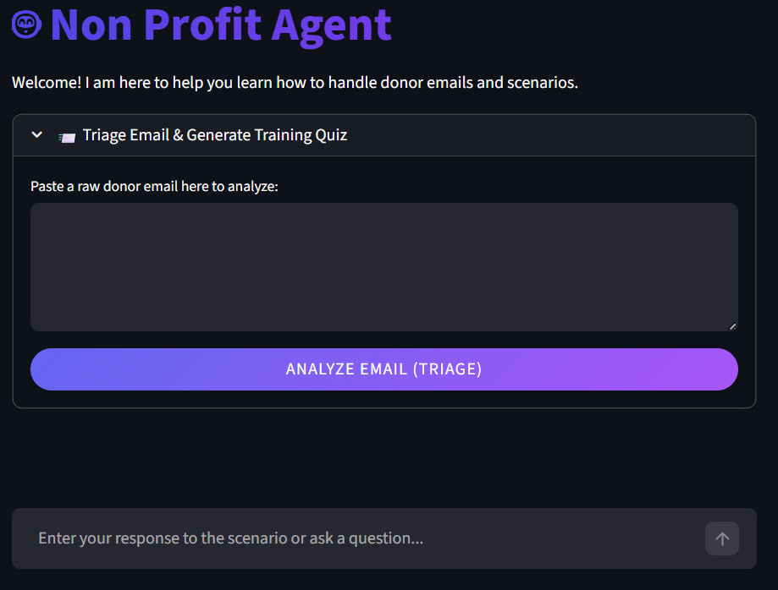
The Streamlit frontend successfully abstracts the complex backend AI logic into an intuitive, zero-code interface.

Fig 5.4.1 Screenshot-1
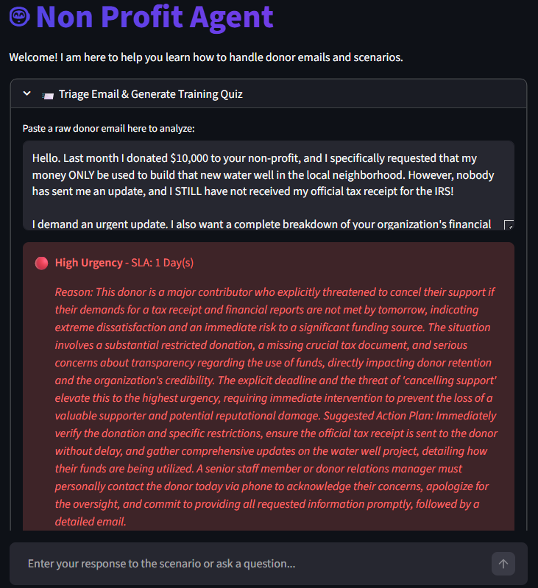
Fig 5.4.2 Screenshot-2

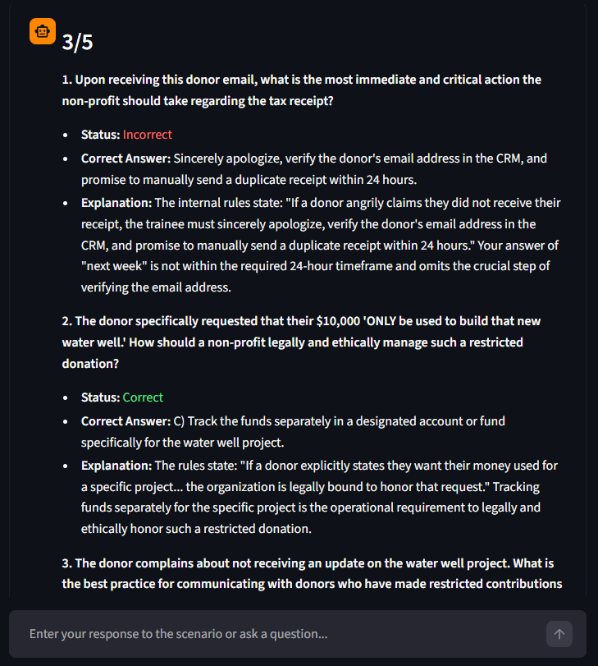
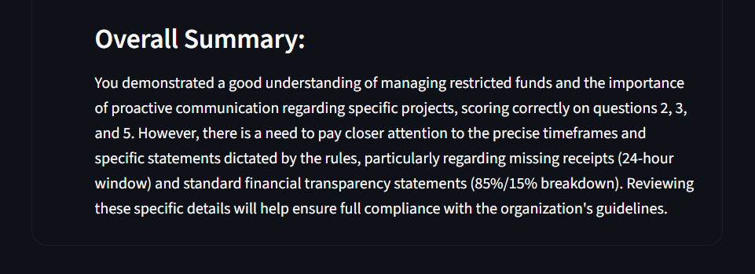
Fig 5.4.3 Screenshot-3

Fig 5.4.4 Screenshot-4
The User Interface is divided into a seamless, two-step interactive flow. The Trainee first utilizes the top Expander module to paste a raw donor email, triggering the Triage Agent. Following the SLA assignment, the UI dynamically renders radio buttons for a 5-question Multiple Choice Quiz. Finally, upon submission, the UI renders a highly readable Markdown Scorecard detailing the mathematical score (e.g., 4/5) and contextual feedback.

5.5 Case Studies
To validate the Agentic routing logic, several edge-case scenarios were tested:
Case Study 1: High-Urgency Crisis
- Input: A simulated email from a major donor furious about being double-charged, threatening legal action and demanding an immediate refund.
- System Response: The Triage Agent accurately detected the hostile tone and financial risk. It autonomously categorized the urgency as "High", assigned a strict sla_days of 1, and generated an Action Plan instructing the trainee to immediately escalate the issue to the finance department.
Case Study 2: Low-Urgency Inquiry
- Input: An email from a local high school student asking if the non-profit offers any weekend volunteering opportunities for teenagers.
- System Response: The Triage Agent recognized the routine, non-critical nature of the request. It categorized the urgency as "Low", assigned a standard sla_days of 5, and formulated an Action Plan suggesting the trainee forward the standard volunteer application link.

CHAPTER 6
SUMMARY AND CONCLUSION

6.1 Summary
The "Non Profit Agent" project was conceptualized to solve the critical inefficiency of training junior staff to handle sensitive, high-stakes donor communications. The final product is a fully containerized, Agentic AI platform built upon a decoupled Microservices architecture. The system successfully utilizes a FastAPI backend to orchestrate complex reasoning pipelines, while providing a seamless, zero-code experience for the user via a Streamlit frontend. By integrating the Google Gemini 2.5 Flash Large Language Model (LLM) with a local ChromaDB Retrieval-Augmented Generation (RAG) database, the application forces the AI to strictly adhere to private organizational policies. Furthermore, the integration of an Agentic Triage workflow allows the system to autonomously parse raw emails, calculate urgency, assign SLAs, and dynamically synthesize graded training quizzes. The entire architecture was ultimately packaged using Docker and automated via a GitHub Actions CI/CD pipeline.

6.2 Conclusions
The successful deployment of this project proves that generative AI, when heavily constrained by mathematical Vector databases and rigid Agentic prompt engineering, is a highly viable and safe tool for enterprise compliance training. The system effectively eliminated the "hallucination" risks traditionally associated with LLMs. By acting as an autonomous "Senior Manager," the application successfully provides a risk-free, highly interactive sandbox for staff to practice donor relations, vastly outperforming the retention rates of traditional, static training handbooks. The integration of modern DevOps methodologies guarantees that this solution is not a fragile local script, but a robust, scalable cloud application.

6.3 Contributions
This project introduces several key contributions to the intersection of Non-Profit administration and Educational Technology (EdTech):
- Autonomous SLA Routing: The development of a lightweight Agentic workflow capable of extracting emotional tone and financial risk from unstructured text to assign strict numerical SLA deadlines.
- Compliance-Driven RAG: The implementation of a closed-loop LLM architecture that mathematically prioritizes internal non-profit PDFs over general internet knowledge, guaranteeing safe training outputs.
- Enterprise DevOps Blueprint: The creation of a fully containerized docker-compose environment and automated CI/CD testing pipeline, providing a frictionless deployment template for future developers.

6.4 Limitations
While highly successful, the current iteration of the system possesses certain technical and operational limitations:
- External API Dependency: The reasoning engine is entirely dependent on the Google Gemini API. If the external Google servers experience downtime or rate-limiting (e.g., HTTP 503 errors), the application loses its generative capabilities.
- Hardware Constraints for Vectorization: Because the ChromaDB persistent client ingests and mathematically embeds PDF documents locally, the system requires a baseline amount of local RAM and CPU power, which may be limiting on significantly older hardware.
- Input Modality: Currently, the system only supports text-based email inputs. It cannot yet triage raw audio transcripts from donor phone calls or process scanned, handwritten physical letters without external Optical Character Recognition (OCR) preprocessing.

CHAPTER 7
FUTURE SCOPE AND REFERENCES

7.1 Future Scope
While the current architecture of the Non Profit Agent successfully fulfills its primary objectives, the decoupled Microservices design allows for several highly impactful future expansions:
- Multi-Modal Ingestion (Audio & OCR): The system's current Agentic Triage workflow processes text exclusively. A critical future upgrade involves integrating Speech-to-Text APIs (such as OpenAI's Whisper) and Optical Character Recognition (OCR). This would allow the system to autonomously triage voicemails left by donors and physical handwritten letters, vastly expanding its utility.
- Persistent Metric Tracking (PostgreSQL): Currently, trainee quiz scores are stored ephemerally within the Streamlit session state. Integrating a persistent relational database, such as PostgreSQL, would allow management to track the long-term learning curves and compliance pass rates of individual employees over time.
- Advanced Multi-Agent Orchestration: The current routing logic relies on linear prompt engineering. Future iterations could transition to heavy multi-agent frameworks (such as CrewAI or AutoGen). This would allow the deployment of highly specialized sub-agents (e.g., a "Legal Agent" checking for lawsuit risks, and a "Finance Agent" checking refund limits) communicating with each other before finalizing the triage SLA.
- Autonomous Email Dispatch: Currently, the system acts as an educational and advisory tool, generating "Action Plans" for human review. As organizational trust in the RAG pipeline increases, the system could be authorized to autonomously draft and dispatch final email responses to Low-Urgency donors without requiring a "human-in-the-loop."

7.2 References
[1] Lewis, P., et al. (2020). Retrieval-Augmented Generation for Knowledge-Intensive NLP Tasks. Advances in Neural Information Processing Systems (NeurIPS), 33, 9459-9474. (Core foundational paper for RAG architectures).
[2] Google DeepMind. (2024). Gemini API Documentation & Technical Report. Retrieved from https://ai.google.dev/ (Referenced for LLM inference, JSON schema enforcement, and asynchronous generation capabilities).
[3] FastAPI Framework. FastAPI: High performance, easy to learn, fast to code, ready for production. Retrieved from https://fastapi.tiangolo.com/ (Referenced for asynchronous REST routing and Pydantic data validation).
[4] Streamlit. A faster way to build and share data apps. Retrieved from https://streamlit.io/ (Referenced for presentation layer architecture and UI state management).
[5] LangChain Contributors. (2024). LangChain: Building applications with LLMs through composability. Retrieved from https://python.langchain.com/ (Referenced for PyPDFLoader document ingestion and chunking mechanics).
[6] Chroma Database. Chroma: The AI-native open-source embedding database. Retrieved from https://docs.trychroma.com/ (Referenced for local Persistent SQLite Vector storage and similarity search).
[7] Docker Inc. Docker Documentation and Containerization Best Practices. Retrieved from https://docs.docker.com/ (Referenced for Microservice orchestration and docker-compose networks).
[8] GitHub. GitHub Actions Documentation for CI/CD. Retrieved from https://docs.github.com/en/actions (Referenced for pipeline automation, linting, and automated cloud testing).

