**Project Progress Report on**



**Marks Evaluation System using Advanced Web-Based Technologies**



**Submitted in partial fulfilment of the requirement for the award of the degree of**

**BACHELOR OF TECHNOLOGY**

**IN**

**COMPUTER SCIENCE & ENGINEERING (Software Engineering)**

**Submitted by:**

**Rahul Rawat** **2015093**

**Siddhartha Singh** **2015105**

**Shivank Kunwar** **2015103**

**Somya Malgudi** **2015106**

***Under the Guidance of***

**Ms. Tanusha Mittal**

**Assistant Professor**

**Project Team ID: MP22SE08**

**Project Progress Report No: 1**



**Department of Computer Science and Engineering**

**Graphic Era (Deemed to be University)**

**Dehradun, Uttarakhand**

**2022-23**



**CANDIDATE’S DECLARATION**

We hereby certify that the work which is being presented in the Synopsis entitled **“Marks Evaluation System using Advanced Web-Based Technologies”** in partial fulfilment of the requirements for the award of the Degree of Bachelor of Technology in Computer Science and Engineering **(Software Engineering)** in the Department of Computer Science and Engineering of the Graphic Era (Deemed to be University), Dehradun shall be carried out by the undersigned under the supervision of **Ms. Tanusha Mittal, Assistant Professor**, Department of Computer Science and Engineering, Graphic Era (Deemed to be University), Dehradun.

Rahul Rawat 2015093

Siddhartha Singh 2015105

Shivank Kunwar 2015103

Somya Malgudi 2015106

The above-mentioned students shall be working under the supervision of the undersigned on the **“Marks Evaluation System using Advanced Web-Based Technologies”**

­

**Supervisor** **Head of Department**

**Examination**

**Name of the Examiners: Signature with Date**

1.

2.

**Work Satisfactory:** YES/NO

**Table of Contents**

|  |  |  |
| --- | --- | --- |
| **Chapter No.** | **Description** | **Page No.** |
| Chapter 1 | Introduction and Problem Statement | **4** |
| Chapter 2 | Objectives | **6** |
| Chapter 3 | Project Work Carried Out | **7** |
| Chapter 4 | Future Work Plan | **9** |
| Chapter 5 | Weekly Task | **10** |
|  | References |  |

**Chapter 1**

**Introduction and Problem Statement**

In the following sections, a brief introduction and the problem statement for the work has been included.

* 1. **Introduction**

The primary purpose of assessment and evaluation is to improve student learning. Information gathered through assessment and evaluations helps teachers to identify students’ difficulties as well as to detect weaknesses in particular subjects. Assessment and evaluations are important tools for adapting curriculum and instructional approaches to students’ needs and for determining the overall effectiveness of programs and classroom practices. Assessment is the process of gathering information from a variety of sources (including assignments, projects, and a midterm) that accurately reflect how well students are achieving the curriculum expectations. As part of assessment, teachers provide students with descriptive feedback that guides their effort towards improvement.

Assessment and evaluation strategies are based on the provincial curriculum expectations and on the achievement level descriptions and categories in the achievement chart. Assessment and evaluation strategies are varied in nature, administered over a period of time and designed to provide opportunities for students to demonstrate the full range of their learning. In addition, teachers will use both their professional judgment and student observations in evaluating specific criteria and achievement

Information gathered through an assessment helps teachers determine students’ strengths and weaknesses as well as their overall understanding of course material. In addition, an assessment helps educators adjust their teaching methods to insure the maximum amount of effective learning for each student.

An assessment is the process of gathering information from a variety of products, observations and conversations that accurately reflects how well a student is achieving the curriculum expectations in a course.

As part of an assessment, teachers provide students with descriptive feedback that guides their efforts towards improvement. Evaluation refers to the process of judging the quality of student work based on established criteria and assigning a value to represent that quality. In Ontario secondary schools, the value assigned is in the form of a percentage grade.

* 1. **Problem Statement**

The problem statement for the present work can be stated as follows:

Manual calculation of marks is done at many institutions. Due to manual calculation, there can be many human errors which may affect the final marks and grades in the end. Even if the error has been found out it becomes very difficult to search that error in the data of thousands of other students and rectify it.

This system admin can control the subjects, classes, type of examination and with many other functionalities which eases admin to enter details of the student. The admin must just enter the marks and calculated results will be provided according to the class and the type of examination the student sat for.

Student evaluation process is a tedious work, and it requires utmost concentration. One marks up or down can alter the final marks and percentage of that student. So, by developing this system the work gets easier and chances of error decreases by huge amount.

**Chapter 2**

**Objectives**

* The main objective of the student marks evaluation system is to reduce manual work and time. It is difficult and time-consuming to manually compute results i.e (marks), publishing them, and displaying results on notice boards. To avoid this problem, we have planned to mitigate this problem.
* To implement machine learning algorithms on database to find out student’s weaknesses and compute marks optimally.
* To give all the powers to admin to add, delete, modify data and student can only view data and their area of improvement.

**Chapter 3**

**Project Work Carried Out**

We are offering a robust system that will be simple, inexpensive, visually appealing, and efficient in terms of time. Our suggested approach will aid admin in reaching their goals by bridging the gap between admin (Teachers or Professors) and students. The system will also have a section that can extract the details of students that will help them analyse their progress.

The project is in mid stage now where the sources are better realized for further development and few objectives are turning into functional objectives. The project has two major stake holders i.e. student and admin. Currently we are working on the major side of the project that the admin side. To make system secure the Admin and Student has to go through an authentication system.



**Fig.3.1 Data flow diagram of Web Based Evaluation**

The working of the project is dependent on a particular admin and his set of database. Application administrators (app admins) views and manage student data in the application. App admins can also add and configure details of student like class schedule, subject, exam type etc, assign applications to end users, and create a particular student profile.

**3.1 Admin Login Page**

Developed a distinct page for handling the authentication of the application to display a personalised dashboard according to the information provided by the Admin. Frontend technologies like HTML, CSS are used for the development of the Login page. Two component Email and password are extracted for authentication via a PHP based authentication model.

**3.2 Admin Home page**

An admin homepage displays the summary of the published results, Exam details, Student details, and details about Subject and classes. Routing components like Student, Exam, Classes, logout etc components are present.

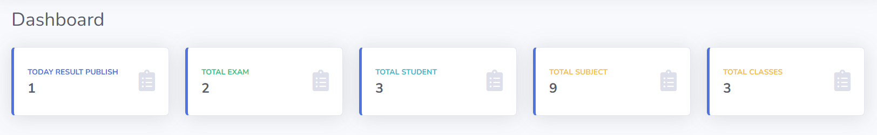

**Fig.3.2 Admin Home Page**

**3.3 Classes Component**

In this component we can add classes under those classes we can add subjects. These Subjects can be edited and also their statuses can be enabled or disabled.

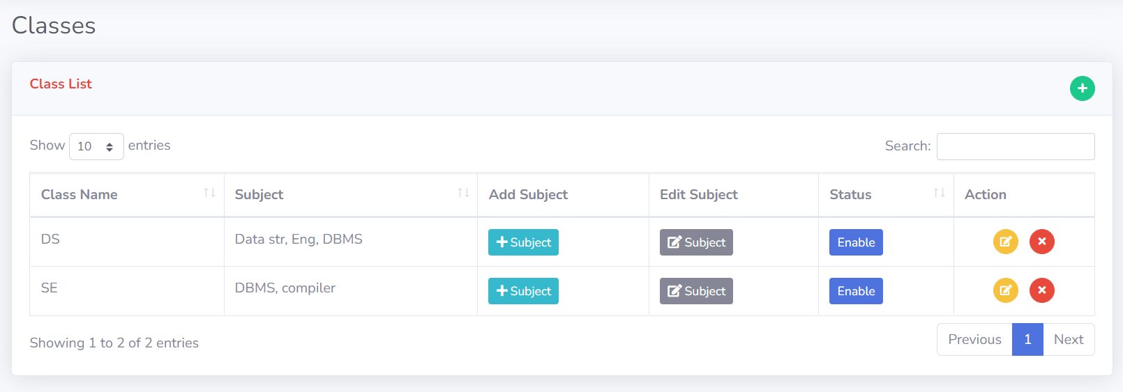

**Fig.3.3 Class component**

**Chapter 4**

**Future Work Plan**

The future work plan of our project are as follows:

|  |  |  |
| --- | --- | --- |
| **Sl. No.** | **Work Description** | **Duration in Days** |
| **1** | To integrate admin panel with SQL backend | 10 |
| **2** | To create User friendly and efficient admin side dashboard | 8 |
| **3** | To create a dashboard for students that is user friendly to view data | 7 |
| **4** | To implement machine learning algorithms on database to find out student’s weaknesses and compute marks optimally | 10 |
| **5** | To test the application to find repeatability,  accuracy, and effectiveness. | 10 |

**Chapter 5**

**Weekly Task**

The report of project work allocated by the supervisor is as follows:

|  |  |  |  |  |  |
| --- | --- | --- | --- | --- | --- |
| **Week No.** | **Date:**  **From-To** | **Work Allocated** | **Work Completed**  **(Yes/No)** | **Remarks** | **Guide Signature** |
| 1 | 08/10/2022-  14/10/2022 | Requirement analysis phase of the application | Yes |  |  |
| 2 | 14/10/2022-  16/10/2022 | To study the web Based Technology to be used. | Yes |  |  |
| 3 | 7/10/2022-  21/10/2022 | To design the UI of admin Dashboard | Yes |  |  |
| 4 | 24/10/2022-  28/10/2022 | Implementation of web Technologies to create class component | Yes |  |  |
| 5 | 31/10/2022-  08/11/2022 | To develop a secure SQL structure for the backend of application | Yes |  |  |

**References**

1. Alatawi, Salem & Syed Abdullah, Norris & Miskon, Suraya & Ghabban, Drfahad. (2020). Current Situation of Students’ Portal and Their needs: A Case Study in Saudi Arabia Universities: Students Perspective. International Journal of Advanced Trends in Computer Science and Engineering. 9. 8075- 8080. 10.30534/ijatcse/2020/167952020.
2. Abdelhakim, Mohamed Noureldin & Carmichael, James & Ahmad, Sayed. (2011). Quality evaluation of university web portals: a student perspective. Int. J. of Information and Operations Management Education. 4. 229 - 243. 10.1504/IJIOME.2011.044563.
3. Soms, Nisha & .S, Prashanth & Preethika, P & Kumar, Deepak. (2021). Student Project Management System.
4. Dill, David. (2003). The Regulation of Academic Quality: An Assessment of University Evaluation Systems with Emphasis on the United States.
5. Keller, J.M., Blatt, B., Plack, M., Gaba, N.D. and Greenberg, L., 2012. Using a commercially available web-based evaluation system to enhance residents' teaching. *Journal of graduate medical education* , *4* (1), pp.64-67.
6. Czajkowski, Michael & Foster, Cheryl & Hewett, Thomas & Casacio, Joseph & Regli, William & Sperber, Heike. (2001). A student project in software evaluation. ACM Sigcse Bulletin. 33. 13-16. 10.1145/377435.377446.
7. Sheremetov, Leonid & Peredo-Valderrama, R. & Balladares-Ocaña, L.. (2006). Student evaluation system for WBE based on learning components and agent technology. 68-73.
8. W. Ben Khalifa, D. Souilem and M. Neji, "An Evaluation System of Students (Applied in Primary School in Tunisia)," 2017 IEEE/ACS 14th International Conference on Computer Systems and Applications (AICCSA), 2017, pp. 1385-1390, doi: 10.1109/AICCSA.2017.68.